Supplementary information
Figure 1
Conditional Scatterplots for all Continuous Variables Included in Model 2
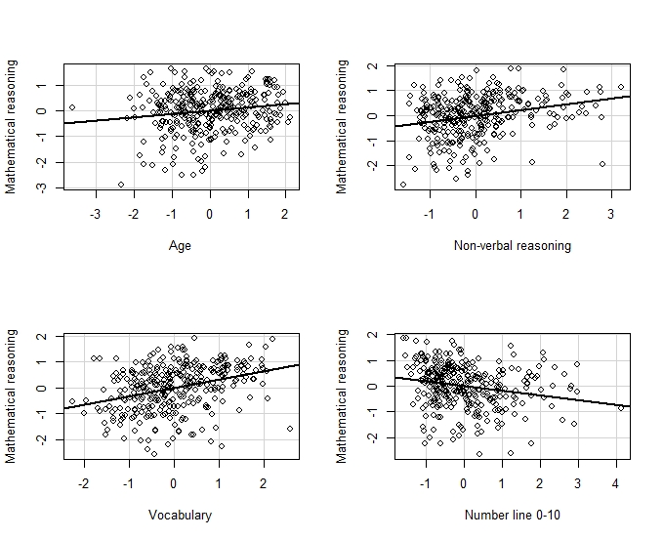
Note. Each plot reflects the relationship between the named predictor and mathematical reasoning after accounting for all other predictors included in Model 2.

Figure 2
Conditional Scatterplots for all Continuous Variables Included in Model 3
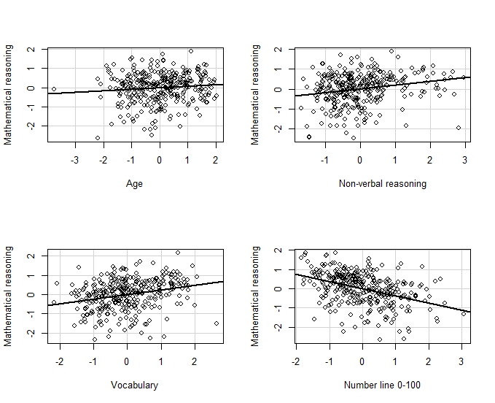
Note. Each plot reflects the relationship between the named predictor and mathematical reasoning after accounting for all other predictors included in Model 3.

Table 1
Quantile Regression Results with Only Number Line as Predictor
 | 10th percentile |  | 25th percentile |  | 50th percentile |  | 75th percentile |  | 90th percentile
 | Estimate | SE | Estimate | SE | Estimate | SE | Estimate | SE | Estimate | SE
For 0-10 number range
Intercept | -1.420*** | .161 | -.640*** | .083 | .107 | .072 | .730*** | .064 | 1.153*** | .070
Number Line 0-10 | -.246* | .109 | -.477*** | .087 | -.314*** | .082 | -.283*** | .074 | -.200* | .081
AIC | 1137.70 |  | 1007.35 |  | 925.84 |  | 907.10 |  | 931.21
For 0-100 number range
Intercept | -1.229*** | .119 | -.572*** | .075 | .123 | .069 | .633*** | .056 | 1.020*** | .043
Number line 0-100 | -.665*** | .112 | -.570*** | .072 | -.572*** | .070 | -.482*** | .059 | -.405*** | .045
AIC | 1055.16 |  | 940.17 |  | 858.28 |  | 828.77 |  | 848.77
Note. Number line was entered as z scores and smaller values represent better performance.
*p < .05. **p < .01. ***p < .001.

