Supplementary Material
Measure of Student Engagement
The German version (UWES-D9; Gusy et al., 2019) of the Utrecht Work Engagement Inventory Student Form contains 9 items and three subscales: vigor (VI; “I feel strong and vigorous when I’m studying or going to class”), dedication (DE; “My study inspires me”), and absorption (AB; “I feel happy when I am studying intensely”) on a 6-point-scale (0-never to 6-always). Higher scores indicated higher engagement.
Gusy and colleagues (2019) calculated Cronbach’s alpha as .86 and the intra-class correlation as .91. For our data, the fit indices of confirmatory factor analysis (CFA) for academic engagement indicated fit of the variables in the model (χ²(19) = 157.138, p < .001, χ2/df = 8.270, RMSEA= .074 [90% CI .064 - .085], SRMR= .021, GFI= .97, TLI = .97, CFI= .98, IFI= .98); with significant factor loadings ranged from .694 to .891, indicating strong convergent validity (see below). These results support using the three engagement dimensions as distinct yet related constructs.

Table S2. Scalar Estimates and Standardized Regression Weights
 |  |  | Estimate | SE | C.R. | p | β
Engagement_3 | <--- | Vigor | 1.000 |  |  |  | .757
Engagement_5 | <--- | Vigor | 1.135 | .033 | 33.927 | *** | .891
Engagement_8 | <--- | Vigor | 1.137 | .034 | 33.892 | *** | .883
Engagement_1 | <--- | Dedication | 1.000 |  |  |  | .809
Engagement_6 | <--- | Dedication | 1.142 | .032 | 35.724 | *** | .862
Engagement_7 | <--- | Dedication | 1.079 | .036 | 30.215 | *** | .762
Engagement_2 | <--- | Absorption | 1.000 |  |  |  | .788
Engagement_4 | <--- | Absorption | .993 | .034 | 29.333 | *** | .748
Engagement_9 | <--- | Absorption | 1.063 | .040 | 26.781 | *** | .694

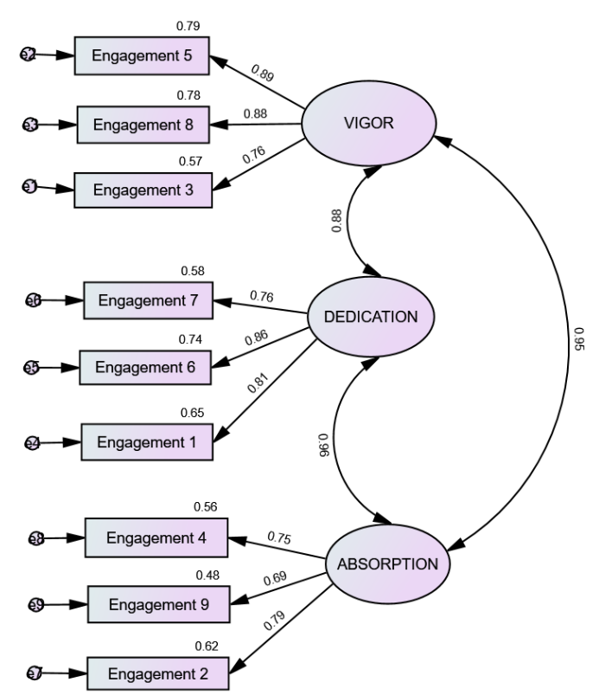
Figure S1. Confirmatory Factor Analysis Results

