Investigating changes in university students’ academic engagement and their relationships with motivation and performance: a longitudinal study based on latent change score analysis during the COVID-19 pandemic – Supplemental Material

Univariate LCS models of the Academic Engagement Dimensions
In Table S1, we report the results of the LCS analyses for each of the six AE factors. Overall, all the models present satisfactory fit indices. The complete models are reported in Figures S1-S6

Table S1. Fit indices for the univariate LCS models in Figure 1 of the six dimensions of engagement
Engagement dimension | χ² | DF | χ²/df | IFI | TLI | CFI | RMSEA
University value and sense of belonging | 39.542 | 33 | 1.198 | 0.991 | 0.987 | 0.991 | 0.031
Value of the university course | 82.841 | 59 | 1.404 | 0.987 | 0.979 | 0.987 | 0.044
Perception of the capability to persist in the university choice | 26.126 | 10 | 2.613 | 0.94 | 0.908 | 0.939 | 0.088
Engagement with the university professors | 23.264 | 10 | 2.326 | 0.961 | 0.941 | 0.961 | 0.080
Engagement with the university peers | 26.764 | 19 | 1.409 | 0.99 | 0.985 | 0.99 | 0.044
Relationship between university and relational net | 13.269 | 8 | 1.659 | 0.99 | 0.982 | 0.99 | 0.056
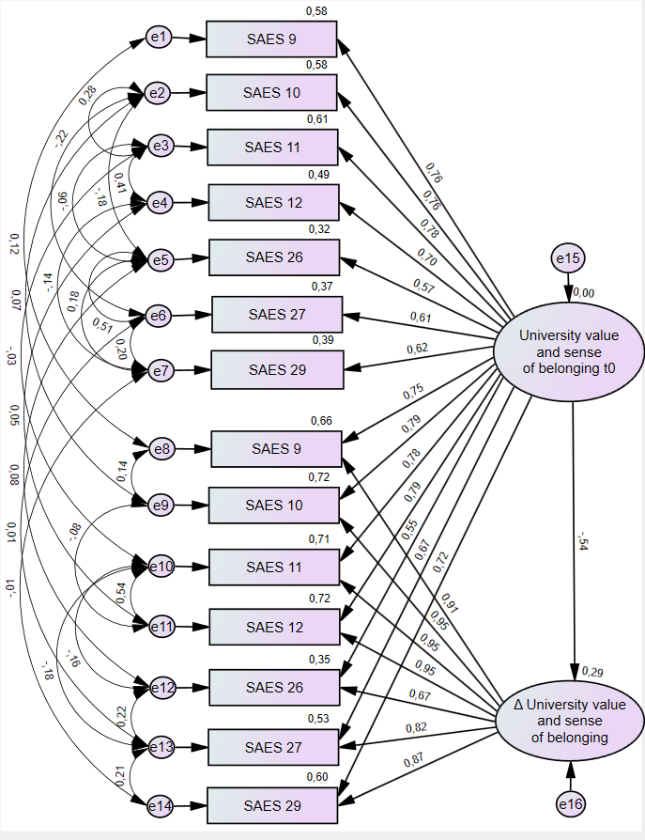 | 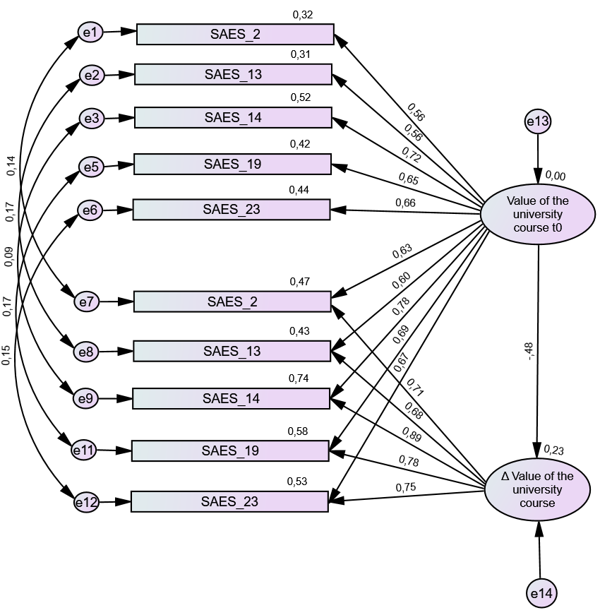
Figure S1. LCS model of the University value and sense of belonging dimension | Figure S2. LCS model of the Value of the university course dimension
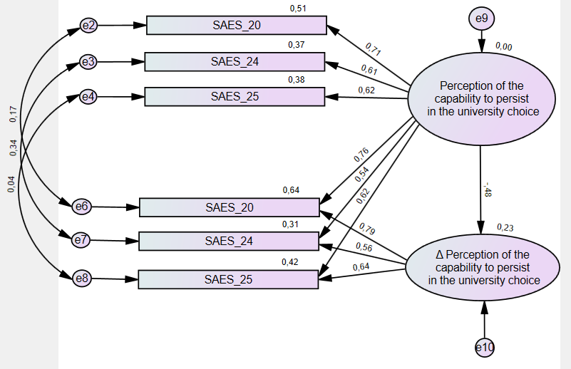 | 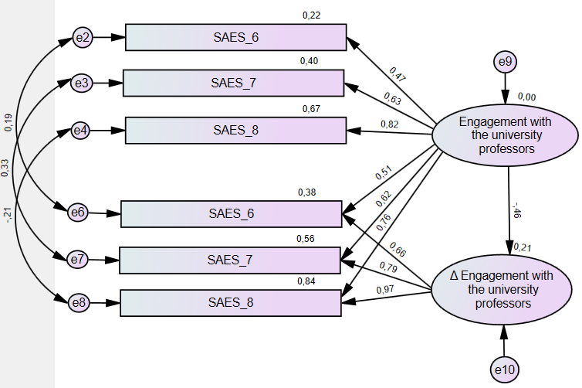
Figure S3. LCS model of the Perception of the capability to persist in the university choice dimension | Figure S4. LCS model of the Engagement with the university professors dimension
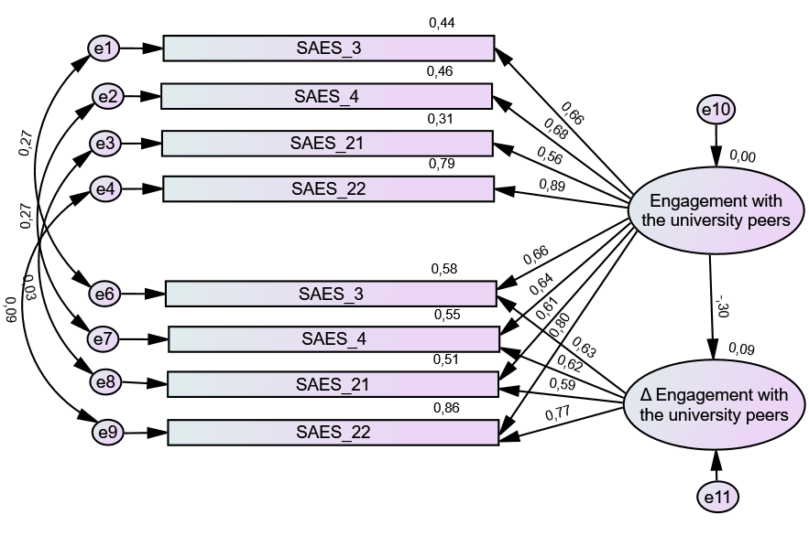 | 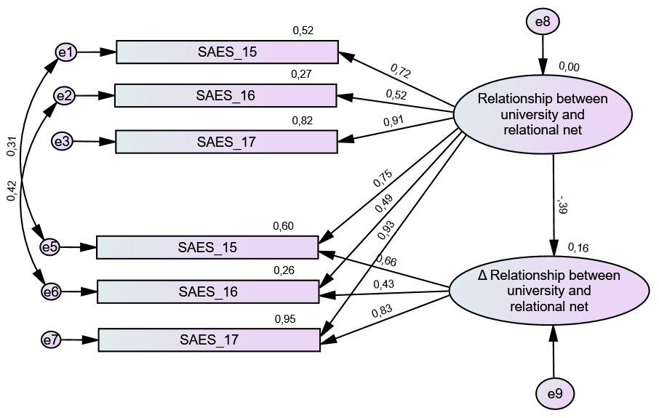
Figure S5. LCS model of the Engagement with the university peers dimension | Figure S6. LCS model of the Relationship between university and relational net dimension. Note that one covariance was not included due to an overfitting of the item SAES 17

Modified Univariate LCS models of the Academic Engagement Dimensions

Table S2 and Table S3 report the results of the LCS analyses for each of the six AE factors when adding the RAI and ECTS as observed variables, respectively

Table S2. Fit indices for the LCS models of the six dimensions of engagement modified by adding the observed variable RAI as predictor
Engagement dimension | χ² | DF | χ²/df | IFI | TLI | CFI | RMSEA
University value and sense of belonging | 51.542 | 41 | 1.257 | 0.986 | 0.981 | 0.986 | 0.035
Value of the university course | 110.198 | 71 | 1.552 | 0.980 | 0.969 | 0.979 | 0.052
Perception of the capability to persist in the university choice | 32.442 | 14 | 2.317 | 0.942 | 0.911 | 0.931. | 0.080
Engagement with the university professors | 25.383 | 14 | 1.813 | 0.968 | 0.951 | 0.967 | 0.063
Engagement with the university peers | 40.928 | 25 | 1.637 | 0.980 | 0.971 | 0.980 | 0.055
Relationship between university and relational net | 23.621 | 12 | 1.968 | 0,978 | 0.963 | 0.979 | 0.068

Table S3. Fit indices for the LCS models of the six dimensions of engagement modified by adding the observed variable performance as measured by the number of ECTS at t1 as dependent variable
Engagement dimension | χ² | DF | χ²/df | IFI | TLI | CFI | RMSEA
University value and sense of belonging | 53.554 | 41 | 1.306 | 0.983 | 0.976 | 0.982 | 0.038
Value of the university course | 93.639 | 71 | 1.319 | 0.988 | 0.981 | 0.987 | 0.039
Perception of the capability to persist in the university choice | 19.193 | 12 | 1.599 | 0.975 | 0.955 | 0.974 | 0.054
Engagement with the university professors | 14.014 | 13 | 1.078 | 0.997 | 0.995 | 0.997 | 0.019
Engagement with the university peers | 33.602 | 25 | 1.344 | 0.989 | 0.984 | 0.989 | 0.041
Relationship between university and relational net | 22.773 | 12 | 1.898 | 0.981 | 0.966 | 0.980 | 0.066

