  - Appendixes - Supplementary Material

1 Crossover design with distribution of students 1
2 Additional exercise descriptions from correlation-causality bias tests 1
2.1 Exercises on causality with text CA_T 2
2.2 Exercises on causality with graph GA_G 2
2.3 Exercises on coincidence with text CO_T 3
2.4 Exercises on coincidence with graph CO_G 4
2.5 Exercises on hidden cause with text CC _T 5
2.6 Exercises on hidden cause with graph CC _G 6
2.7 Exercises on reversed causality with text CI_T 7
3 Additional exercise descriptions from confirmation bias tests 8
3.1 Exercises on beliefs in confirmation bias 8
3.2 Exercises on the Wason task (1960) in confirmation bias tests 9
4 Additional exercise descriptions from vigilance in source checking tests 10
4.1 Exercises on appeal to authority bias and source validity 10
4.2 English versions of the exercises on appeal to authority and source validity 11
5 Sequence plan 15
6 Example of a lesson 18

Crossover design with distribution of students

Table 1
Summary of the crossover experimental design and distribution of students
Group | Experimental GROUP 1 (N=47) |  |  |  |  |  | Experimental GROUP 2 (N=46)
Class | French Grade 5 (N=15) |  | BIL5A  (N=20) |  | Grade 5/3  (N=12) |  | BIL5B  (N=20) |  | Grade 5/2  (N=13) |  | Grade 5/3  (N=13)
Sub-group | 1A (N=8) | 1B  (N=7) | 1A (N=10) | 1B (N=10) | 1A (N=6) | 1B  (N=6) | 2A (N=10) | 2B (N=10) | 2A (N=6) | 2B  (N=7) | 2A (N=7) | 2B  (N=6)
Pre-Test | Test 1 French | Test 2  French | Test 1  English | Test 2  English | Test 1  English | Test 2 English | Test 2 French | Test 1  French | Test 2 English | Test 1 English | Test 2 English | Test 1 English
Lesson | Material 1  French |  | Material 1  English |  | Material 1  English |  | Material 2  French |  | Material 2  English |  | Material 2  English
Post-Test | Tests 1 & 2  French |  | Tests 1 & 2  English |  | Tests 1 & 2  English |  | Tests 2 & 1  French |  | Tests 2 & 1  English |  | Tests 2 & 1  English

Additional exercise descriptions from correlation-causality bias tests

The tests were divided into two sections.
First, students were assessed on their ability to identify different types of correlation through two types of items:
- Causality (CA): a correlation corresponding to causality: cause-and-effect relationship
o 1 CA_T exercise with text and an illustration
o 1 CA_G exercise with a text and a graph
- Coincidence (CO): a correlation corresponding to a coincidence
o 1 CO_T exercise with a text and an illustration
o 1 CO_G exercise with a text and a graph
- Hidden cause (CC): a correlation involving a hidden cause or confounding variable
o 1 CC_T exercise with text and an illustration
o 1 CC_G exercise with text and a graph
- Reverse cause (RC): a correlation corresponding to reverse causality: the cause-and-effect relationship is the opposite of that stated or that can be perceived spontaneously.

We assessed students' ability to correctly identify the nature of correlations using two types of items: a situation described in a text and a situation described in a graph. Students had to choose one of the answers provided:
- 1 answer proposing the correct correlation,
- 1 or 2 answers proposing an incorrect correlation
- possibly 1 answer proposing an absence of link or a lack of information preventing the identification of the nature of the correlation.
Students could only choose one answer. It would have been interesting to ask open-ended questions so that they could explain their choice, but due to the amount of data to be analysed, we opted for a multiple-choice questionnaire.
Questions 3, 4, 5, 6, and 8 of the CC1 test are based on the thesis by Scheibling-Sève (2019).
Although we realised after the pre-tests that some of the wording needed to be revised, we did not make any changes because it was important to keep the pre-tests and post-tests identical in order to obtain usable data.

Exercises on causality with text CA_T

Figure 1: English versions of exercises with text on causality
No table of figures entries found. | Answers | Code | TEST CC2 | Answers | Code
Ex 2  A newspaper investigates the evolution of increased temperature and water consumption. We can see that both are increasing at the same time.  What can we deduce from this? | Causality:  We can deduce that the rise in temperature is the cause of the increase in water consumption. | 2 | Ex 2  A newspaper investigates the evolution of increased temperatures and the sale of fans. It can be seen that both are increasing at the same time.  What can we deduce from this? | Causality:  We can deduce that the rise in temperatures is the cause of the increase in the sale of fans. | 2
 | No link:  We cannot deduce anything, there is not enough information. | 1 |  | No link:  We cannot deduce anything, there is not enough information. | 1
 | Erroneous correlation (reversed causality):  We can deduce that the increase in water consumption is the cause of the rise in temperatures. | 0 |  | Erroneous correlation (reversed causality):  We can deduce that the increase in the sale of fans is the cause of the rise in temperatures. | 0

Exercises on causality with graph GA_G

Figure 2: English versions of exercises with graphs on causality
TEST CC1 | Answers | Code | TEST CC2 | Answers | Code
Ex 3  Here is a graph.  We can observe the height of the grass as a function of the number of days that go by.  What can we deduce from this graph? | Causality:  Plus les jours passent, plus l'herbe pousse. | 2 | Ex 3  Here's a graph.  It shows the sales of ice cream in dollars as a function of the outside temperature.  What can you tell from this graph? | Causality:  The warmer it gets, the more ice cream sales increase. | 2
 | No link:  There is no link between the number of days that go by and the height of the grass. | 1 |  | No link:  There's no real link between ice cream sales and temperature. | 1
 | Erroneous correlation (reversed causality):  The more the grass grows, the more days go by. | 0 |  | Erroneous correlation (reversed causality):  The higher the ice cream sales, the warmer it gets. | 0

Exercises on coincidence with text CO_T

Figure 3: English versions of exercises with text on causality
TEST CC1 | Answers | Code | TEST CC2 | Answers | Code
Ex 4  A newspaper investigates the link between the height of 10 year old children and global warming, in France.  The temperature rose by 3 degrees between 1910 and today.  The height of 10-year-old children rose by 9cm between 1910 and today.  We asked 3 people who read the paper to answer this question:  "Why did the children's height rise between 1910 and today?"  Who do you agree with? | Coincidence:  The second answers: "I don't think there is really a link, we need to check." | 2 | Ex 4  I put on my favorite socks with cats on them and got a good mark in maths.  What can I deduce from this? | Coincidence:  I don't think there's any connection between wearing my favorite socks with cats on them and getting a good grade in maths. | 2
 | Erroneous correlation (causality):  The first person answers: "I think that it is the rise in temperatures that made children today taller."  Erroneous identification (causality):  The third answers: "I think that it is the rise in children's height that made temperatures rise. " | 0 |  | Erroneous correlation (causality):  I think I got a good grade thanks to my socks. They brought me luck. | 0

Exercises on coincidence with graph CO_G

Figure 4: English versions of exercises with graphs on coincidence
TEST CC1 | Answers | Code | TEST CC2 | Answers | Code
Ex 5  Here is a graph.  We can observe the number of people killed by spiders in the world as a function of the amount of rainfall in the United States.  What can you deduce from this graph? | Coincidence:  There seems to be no real link between rainfall in the United States and the risk of dying of a spiderbite in the world. | 2 | Ex 5  Here's a graph.  It shows the average global temperature as a function of the number of pirates. You can see the years corresponding to each point.  What can you deduce from this graph? | Coincidence:  There's no real link between warmer temperatures and the disappearance of pirates. | 2
 | Erroneous correlation (causality):  The more people die of spiderbite in the world and the more it rains in the United States.  Erroneous correlation (causality):  When it rains in the United States, there is a greater risk of dying from a spiderbite in the world. | 0 |  | Erroneous correlation (causality):  Global warming is the cause of the disappearance of pirates.  Erroneous correlation (causality):  The disappearance of pirates is the cause of global warming. | 0

Exercises on hidden cause with text CC _T

Figure 5: English versions of exercises with text on hidden cause
TEST CC1 | Answers | Code | TEST CC2 | Answers | Code
Ex 6  A newspaper investigates the link between playing games and being tired when waking up.  3 people who read the paper suggested an explanation to the question: Why are certain children more tired than others? | Hidden cause:  The third thinks that the children who did an activity for 3 hours are more tired than those who did an activity for 1 hour. | 2 | Ex 7  There are more babies born in villages where there are storks.  What can you deduce from this? | Hidden cause:  Storks prefer to nest in villages rather than in large towns, and there are also more births in villages than in towns. | 2
 | No link:  The second doesn't see a link between playing before going to bed and being tired when waking up. | 1 |  | No link:  There is no real link between the presence of storks and the number of births. | 1
 | Unproven causality:  The first person thinks that the children who play before going to bed are more tired than those who read before going to bed. | 0 |  | Unproven causality:  Storks bring babies.  Erroneous causality:  Babies attract storks. | 0

Exercises on hidden cause with graph CC _G

Figure 6: English versions of exercises with graphs on hidden cause
TEST CC1 | Answers | Code | TEST CC2 | Answers | Code
Ex 7  Here is a graph based on primary school students.  We can observe the number of mistakes in a spelling test as a function of the foot size of the students. | Hidden cause:  Students who have bigger feet are older and therefore make less mistakes in the spelling test. | 2 | Ex 6  Here's a graph.  It shows that the number of sharks attacks and the amount of ice cream sales evolve in the same way.  What can you deduce of this graph ? | Hidden cause:  In July, when it's hot, more people eat ice cream and more people swim in the ocean (which increases the risk of shark attacks). The link between these phenomena is summer. | 2
 | No link:  I do not think there is a link between the number of mistakes in a spelling test and the footsize of students. | 1 |  | No link:  I don't think there's any link between the number of ice creams sold and shark attacks. | 1
 | Erroneous correlation (causality):  It is footsize that determines the number of mistakes in the spelling test. | 0 |  | Erroneous correlation (causality):  The more ice cream you eat, the more likely you are to be attacked by a shark. | 0

Exercises on reversed causality with text CI_T

Figure 7: English versions of exercises with graphs on reversed causality
TEST CC1 | Answers | Code | TEST CC2 | Answers | Code
Ex 8  A newspaper investigates the link between height and being a professional basketball player.  We ask 3 people who read the article to answer the following question: Why are professional basketball players taller than the average person?  Who do you agree with? | Reversed causality:  The third person says it is because being tall is an advantage in basketball, therefore when you are taller it is easier to become a professional basketball player. | 2 | Ex 8  A newspaper investigates the link between height and being a professional horse jockey.  Three people who have read the article are asked to answer the following question: Why are professional horse jockeys shorter than the average man?  Which of them do you agree with? | Reversed causality:  The third person replies that being short is an advantage in horse racing, so when you're short, it's easier to become a professional horse jockey. | 2
 | No link:  The second person says there is no link between height and being a good basketball player. | 1 |  | No link:  The second answers that there is no link between height and being a professional horse jockey. | 1
 | Erroneous correlation:  The first person says it is because the more you play basketball the taller you become. Professional basketball players have much more training and therefore are taller than the average. | 0 |  | Erroneous correlation:  The first person replies that it's because we practice horse racing that we grow less. Professional jockeys have trained a lot, so they're shorter than average. | 0

Additional exercise descriptions from confirmation bias tests

Exercises on beliefs in confirmation bias

Figure 8: English versions of exercises on beliefs in the confirmation bias
BC1 | Réponses | Code | BC2 | Réponses | Code
Ex2  My neighbor thinks that vegetables should be planted according to the moon so that they grow faster.  What article would you recommend she read to see if she's right to believe this? | Challenge BC:  Does gardening with the moon really work? | 2 | Ex2  My friend thinks we only use 10% of our brain.  Which article would you advise him to read to check if what he thinks is true? | Challenge BC  False ideas about the brain | 2
 | Nothing to do with it:  How to arrange your vegetables in the garden | 1 |  | Nothing to do with it:  How to feed your brain well | 1
 | Biased:  How to garden successfully with the moon | 0 |  | Biased:  How to use more than 10% of your brain | 0
Ex 3  My neighbor thinks the Earth is flat. What Internet research would you advise him to do? | Challenge BC  Evidence that the earth is round | 2 | Ex3  My friend thinks that boys are better at maths than girls.  What Internet research would you advise her to do? | Challenge BC  Girls are better at maths than boys | 2
 | Biased:  Evidence that the earth is flat | 0 |  | Challenge BC  Girls are better at maths than boys | 2
 |  |  |  | Biased:  Boys are better at maths than girls | 0

Exercises on the Wason task (1960) in confirmation bias tests

Figure 9: English versions of exercises on Wason task in the confirmation bias
 | Responses challenging the confirmation bias | Biased responses
BC1 - Ex4  I have invented a rule. Here is a sequence of numbers that follows my rule: 2 - 4 - 6.  You must try to guess my rule by suggesting sequences of numbers to see if they follow my rule or not.  You can choose two of the following:  8-10-12 / 6-4-2 / 1-3-5 / 14-20-50 | Two pairs challenge the intuitive rule of ‘counting in twos’  6-4-2 and 8-10-12  6-4-2 and 1-3-5  Three pairs challenge the rule of ‘counting in ascending order’  6-4-2 and 14-20-50  6-4-2 and 8-10-12  6-4-2 and 1-3-5 | One pair confirms the intuitive rule of ‘counting in twos’  8-10-12 and 1-3-5  Three pairs confirm the rule ‘count in ascending order’  8-10-12 and 14-20-50  1-3-5 and 14-20-50  8-10-12 and 1-3-5
BC2 - Ex4  I've invented a rule. Here's a sequence of letters that respects my rule: B - D – F.  You must try to guess my rule by proposing sequences of letters to see if they respect my rule or not.  You're allowed to choose 2 of the following:  G-P-W / H-J-L / Z-M-A / A-C-E | Two pairs challenge the intuitive rule of ‘naming letters moving forward in twos’  A-C-E and Z-M-A  H-J-L and Z-M-A  3 pairs challenge the rule of ‘naming letters in alphabetical order’  G-P-W and Z-M-A  A-C-E and Z-M-A  H-J-L and Z-M-A | One pair confirms the intuitive rule of ‘naming letters moving forward in twos’  A-C-E and H-J-L  Three pairs confirm the intuitive rule of ‘naming letters in alphabetical order’  G-P-W et H-J-L  G-P-W et A-C-E  H-J-L et A-C-E

Additional exercise descriptions from vigilance in source checking tests

Exercises on appeal to authority bias and source validity
The tests are inspired by an activity from La Main à la pâte called ‘Le bracelet du pouvoir’ (see the website https://fondation-lamap.org) offered to students at the end of primary school in France, which corresponds to the age of our sample.
The aim is to assess students' ability to distinguish between personal opinions and those based on a scientific approach, to differentiate between the types of ‘evidence’ supporting a statement (in the form of reported testimony) and to classify them on the basis of their quality.
To do this, based on the consideration of an object supposedly endowed with miraculous properties (the power bracelet), students must consider different arguments concerning it provided by various sources. They must decide who to trust and on what criteria.
They must select the relevant arguments to assess the trust they can or cannot place in each source.
The last question asks them to choose from among the various sources whose opinion they would need to decide whether or not to buy a bracelet.
They are told that they can choose one or more sources.
The main message to take away from the activity proposed by lamap is as follows: "It is not always possible to verify a statement for yourself through experimentation. We therefore turn to others, but it is important to recognise which sources are reliable. There must be multiple sources that point in the same direction, based on scientific experience and supported by experts in the field.”

To facilitate analysis, we have coded the criteria. Example: P+ means popular, P- means not popular; ES+ means based on scientific studies, ES- means not based on scientific studies; etc. (Figure)

Figure 10: Coding of argument reliability criteria
Criteria for the reliability of arguments
Popularity | P+ | P-
Personal experience - Use | EP+ | EP-
Falls within the field of expertise | DE+ | DE-
Commercial Interest | IC+ | IC-
Refers to scientific studies | ES+ | ES-
Inventor / Vendors | IV
Personal opinion | AP
I know them | C+ | C-
Number | N+

Next, the arguments were classified according to their relevance in terms of inspiring trust in the source or raising suspicion about them (Figure 11).
Figure 11: Ranking of criteria according to their relevance in inspiring trust or raising suspicion
Relevant arguments for granting trust |  |  | DE+ | IC- | ES+
Arguments that are not relevant to granting trust | P+ / P- | EP+ |  |  |  | IV | AP | C+ | N+
Relevant arguments for not granting trust |  | EP+  If exclusive | DE- | IC+ | ES-
Irrelevant arguments for not granting trust | P- / P+ | EP- |  |  |  |  |  | C-

The criteria for passing the test are:
- Correct identification of reliable sources (sources highlighted in yellow) based on the three relevant arguments for granting trust (in dark green)
o The source refers to scientific studies
o The bracelet falls within the source's area of expertise
o The source has no commercial interest in the product
- Choice of several sources (last question) and possibly the need for more information. The two sources that students can trust are shown in green.
The relevant selection criteria are shown in colour, based on the classification illustrated in Figure 28.

English versions of the exercises on appeal to authority and source validity

Figure 12:English version of the exercises appeal to authority bias and source validity – Test SAA1
 | T1S1  Cristolfo is a famous football player.  He has a lot of followers on social media.  He says he uses the bracelet regularly and has noticed the positive effects.  He has not participated in any scientific study to evaluate the benefits of the  bracelet.  His opinion is only based on his personal experience. |  | T1S2  Kate Morris, the inventor of the bracelet, uses it regularly.  She is not on social media and does not look to be famous.  She has a commercial interest in the bracelet as she gets money for each  bracelet sold.  She is not interested in carrying out scientific studies on the bracelet, her  opinion is enough for her.  She has invented a lot of different products. |  | T1S3  Mrs Clark, a science teacher at my school, is very appreciated by her  students and colleagues.  She does not use social media and does not look to become famous.  She has never worn the bracelet.  She is interested in scientific studies on the bracelet.  As a science teacher, she stays up to date on scientific progress and she  thinks she can give her opinion on it. |  | T1S4  Dr Giwindi is a renowned doctor; he has many followers on social media.  He has written books and won prizes.  He has never worn the bracelet.  He has no commercial interest in the bracelet.  He is interested in scientific studies on the bracelet.  As a doctor, he knows well this type of study which allows to measure the  effect of medicines on physical characteristics like strength. |  | T1S5  My friend uses social media and she has many followers.  She told me she has worn the bracelet and found it had positive effects.  She does not know any scientific studies on the bracelet.  She has no personal interest ig the bracelet.  She has her personal opinion and has not discussed it with other people.
Inspires my trust because:  (You can tick multiple options)  Coded 1 | He is popular | P+ | She is not looking to become famous | P- | She is not looking to become famous | P- | He is known on social media | P+ | She is popular and I know her | P+
 | He refers to his personal experience | EP+ | She is referring to her personal experience since she wears it regularly | EP+ | She has read scientific studies on the bracelet | ES+ | He has the knowledge required to evaluate whether the bracelet works | DE+ | She has used it and has her personal opinion | EP+
 | The product is within his field of expertise as a professional athlete. | DE+ | She invented it so she knows if it works or not | IV | As a science teacher, she has the required knowledge to evaluate if the bracelet works | DE+ | He has no financial interest | IC- | She has no financial interest | IC-
 | He has no commercial interest in the product. | IC-
Not inspire my trust because:  (You can tick multiple options)  Coded 0 | He only refers to his personal experience | EP+ | She is interested in gaining money, not knowing whether it works | IC+ | She has never worn the bracelet | EP- | He has never worn the bracelet | EP- | She only has her personal opinion | EP+
 | He does not refer to scientific studies | ES- | She does not want scientific studies to evaluate the effects of her bracelet | ES- | She is not on social media | P- | I do not know him | P- | She does not know any scientific studies on the bracelet | ES-
 | He is not an expert | DE- |  |  | She is a science teacher, not a bracelet specialist | DE ? |  |  | She is not an expert in the field | DE-
 |  |  |  |  |  |  |  |  | She is popular on social media | P+

We could distinguish between levels of relevance for the selection criteria. For example, the criterion ‘has read scientific studies on the subject’ seems more relevant for selecting someone to trust than the criterion ‘does not seek to be popular’.
Students had the possibility to also choose a box : “another reason” and to indicate what this ther reason was.
Figure 13: English version of the exercises appeal to authority bias and source validity – Test SAA2
 | T2S1  Kerry Petty is a famous singer.  She has a huge number of followers on social networks.  She says she's heard of the bracelet but has never used it.  She has no commercial interest in it, nor does she know the company that  produces it.  She has a personal opinion on the bracelet but hasn't cited any scientific  studies.  As a singer, she's not very interested in issues of strength, so the bracelet  isn't really her thing. |  | T2S2  The bracelet sellers are people who form a group and work for different  companies on the Internet. They are anonymous, no one knows who they  are.  They say they do not use the bracelet outside work.  They have a commercial interest in the bracelet, as they earn money for  every bracelet they sell.  They are not aware of any scientific studies on the bracelet.  They sell lots of different products. |  | T2S3  "Science Made Easy" is a famous TV show.  The show's presenters are not bracelet users, nor do they have any  commercial interest in the bracelet.  They invite scientists who have worked on the bracelet.  They ensure the reliability of the information and the expertise of their  guests. |  | T2S4  Dr. Mia Damidon is the first African-American woman in space.  Her latest post on Instagram has been liked 800 times.  In an interview, she said she used the bracelet in space as part of a  scientific experiment.  She has no commercial interest in the bracelet.  She bases her opinion on several experimental research studies.  She considers the power bracelet to be within her area of expertise: she is  not only an astronaut and engineer, but also a medical doctor, and is  interested in the effects of space travel on the body. |  | T2S5  The sport team of my school  They are famous in my school, and they have won lots of competition.  They have used the bracelet. They found that the bracelet had a negative  effect: it reduced their strength.  They have no interest in criticising the bracelet.  They didn't tell me about any scientific studies on the bracelet, they didn't  test the bracelet rigorously, just used it.  All group members share the same opinion.  They consider power bracelets to be their domain: as athletes, increasing  their strength and evaluating it is part of their experience. *
Inspires my trust because:  (You can tick multiple options)  Coded 1 | She is popular | P+ | They are not looking to become famous | P- | They're on television | P+ | She is known on social networks | P+ | They are popular in my school | P+
 | She has a personal opinion on it | E | They can refer to their personal experience | EP+ | They base their opinion on the opinions of scientific experts specialising in the field | ES+ | She has the necessary knowledge to judge whether the bracelet works | DE+ | They have used it | EP+
 | She has no commercial interest in it | IC- | They sell it, so they must know whether it works or not | V | They have no commercial interest in it | IC- | She has no commercial interest in it | IC- | They say that they are expert in the domain | DE ?
 |  |  | There are many of them | N+ | The are several of them | N+ | She bases her opinion on her personal experience. | EP+ | They all have the same opinion | N+
 |  |  |  |  |  |  | She bases her opinion on several experimental research studies | ES+ | They have no interest in criticising the bracelet
Not inspire my trust because:  (You can tick multiple options)  Coded 0 | She has never worn it | EP- | They're interested in making money, not whether or not it works | IC+ | They have never worn the bracelet | EP- | She bases her opinion on her personal expérience | EP- | They haven't tested it rigorously | EP
 | She does not mention scientific studies | ES- | They have not investigated whether scientific studies have been carried out on the  product they sell | ES- | I don't watch this TV show | C- | She is not very popular on social media | P- | They don't know any scientific studies about the bracelet. | ES-
 | She is not an expert | DE- | They wear it only at works | EP- | They are not on social networks | P- | I don't know her | C- | I don't think that they really are expert in the domain | DE-
 |  |  | They sell lots of different products |  | They are not expert themselves | DE-
 |  |  | I don't know them | C-

Sequence plan

S1 | Introduction | Visual Thinking Routine about CT : What do you think you know about CT ? What questions do you have about CT ? How might you explore your questions about CT ?  Definition of CT: gathering the initial conceptions of the students about CT  To explain what is coming up  Plan of the sequence : 8 sessions and 4 topics  Pre and post tests  Anonymisation  Questions from students
S2 | Pre-tests | Subgroups 1A and 2B seat test 1  Subgroups 2A and 1B seat test 2
S3 | Correlation-Causation bias  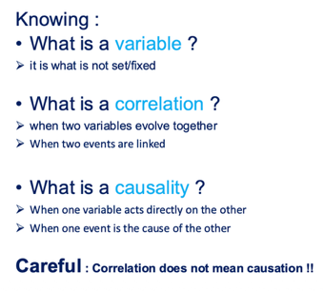  Objective  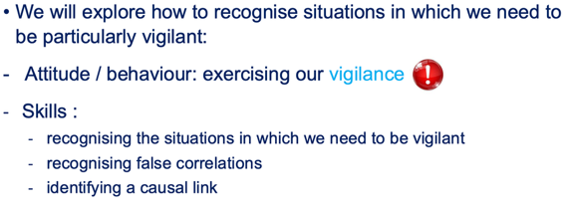  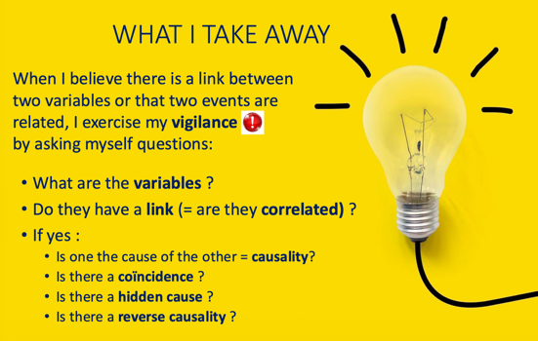  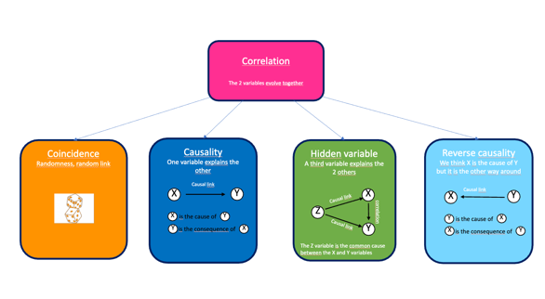  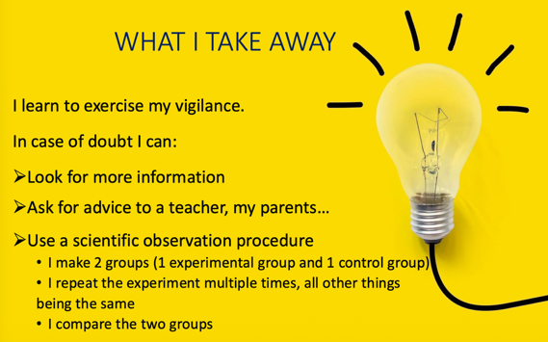 | Lesson 1  Few insights into how our minds work  Some vocabulary : automatism, vigilance  Knowledge - Attitude / behaviour - Skills  Begining of the correction of one of the pretest :  Test 1 :  - Causation:  - Text: Increase of temperature and water consumption  - Graph: Height of the grass and number of days that go by  - Coincidence:  - Text: Height of ten-year-old children and global warming  - Graph: Number of people killed by spiders and amount of rainfall in the US  Test 2 :  - Causation:  - Text: Increase in temperature and sales of fans  - Graph: Ice cream sales and outdoor temperature  - Coincidence:  - Text: Favourite socks and good marks in maths  - Graph: Global average temperatures and number of pirates
S4 |  | Lesson 2  Reminder  Quizz on vocabulary and discussion about why it is important to recognise illusion of causality in our everyday life  Correction of homework  End of correction of one of the pre-test.  Test 1 :  - Hidden cause :  - Text: Playing games and being tired  - Graph: Number of mistakes in spelling test and size of the foot  - Reverse causation :  - Text: Height and being a professional basketball player  Test 2 :  - Hidden cause:  - Text: Number of births and presence of storks  - Graph: Ice cream sales and number of shark attacks  - Reverse causation:  - Text: Height and being a professional horse jockey  What I take away  Experimental procedure. Examples :  - Sleeping with a winter hat cures cold  - Crowing of the rooster and sunrise  What I take away  Homework : Exercise our vigilance with more examples.
S5 | Confirmation bias  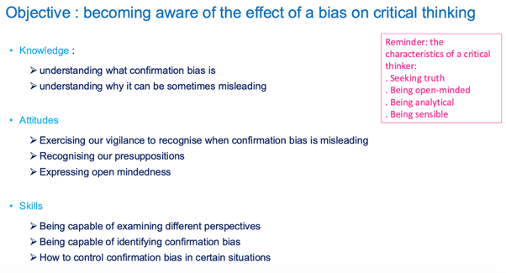  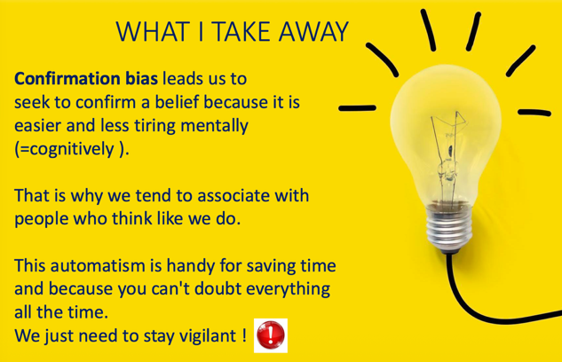 | Lesson 1  Correction of homework  Presentation of the knowledge, skills and attitudes that we are going to study  Some vocabulary : bias and confirmation bias  Two videos  Correction of the pre-tests : 2 common beliefs  Test 1 :  - Gardening with the moon  - The Earth is flat  Test 2 :  - We only use 10% of our brain  - Boys are better at maths than girls
S6 |  | Lesson 2  Correction of homework on correlation-causation bias + confirmation bias in everyday life  Game based on the Wason task 2-4-6 : «Discover my rule »  What I take away  Questions to ask ourselves in order to better control the confirmation bais.  Let’s exercise our vigilance and learn to control confirmation bias : attitudes to adopt.
S7 | Argument from authority fallacy and source checking  Objective  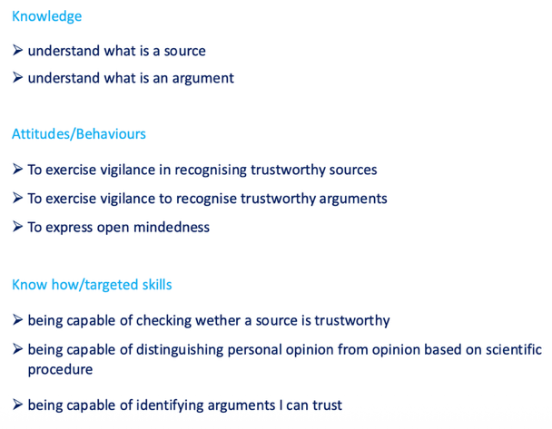  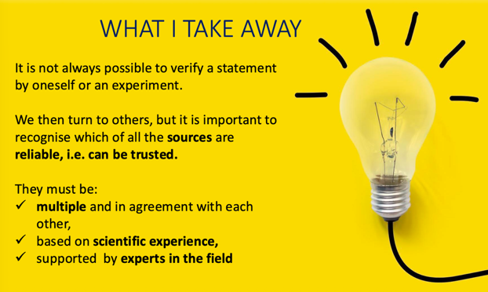 | Lesson 1  Correction of homework on correlation-causation bias  Vocabulary : sources, source of information, argument  Knowledge – Attitudes – Skills  Pre-test correction : The Power bracelet  Five sources of information with arguments to be discussed in pairs or small groups, then in the whole class to decide which sources can be trusted and why:  Test 1:  Mrs Clark the science teacher, Dc Giwindi a renowned doctor (sources to be trusted)  Cristolfo the famous football player, Kate Morris the inventor of the bracelet, my friend  Test 2:  The presenters of a famous tv show about Science, Mia Damidon an astronaut (sources to be trusted)  Kerry Petty a famous singer, the bracelet sellers, the sport team of my school
S8 |  | Lesson 2  Correction of homework : research on internet in link with confirmation bais – experimental protocol  Discussion :  - Which arguments can be trusted?  - Relevant arguments for trust  - Arguments that are not relevant to establishing trust  - Which arguments should make us suspiscious?  What I take away
S9 | Other activities | Correction of homework on correlation-causation bias  This lesson on flexibility and creativity is not displayed here
S10  S11 | Post-tests | All students sit both tests.  Subgroups 1A and 2B sit first test1 (the same as the pre-test) then test 2  Subgroups 2A and 1B sit first test 2 (the same as the pre-test) then test 1
S12 | Conclusion | Visual Thinking Routine about CT: What did you think you knew about CT? What have you learnt about CT? What questions do you still have about CT?  Questions from students

Example of a lesson
