Supplementary Information

Mining Operations
Mount Lyell copper mine is situated 2 km north of Queenstown, western Tasmania (Fig. 1). The high-grade, polymetallic deposit was established in 1893 and mined until 2014. The Mount Lyell Mining & Railway Company (MLMRC) operated the mine from 1893 until 1994. During this phase, mining was conducted in 10 principal open cuts and underground mines (i.e. Mount Lyell (Iron Blow) and South Lyell, North Lyell, Royall Tharsis, Lyell Comstock, Crown Lyell and Twelve West, West Lyell open cut, Razorback, Cape Horn, Prince Lyell, and Lyell Tharsis), accounting for an area of approximately 13 km². West Lyell was the largest open cut among them (McQuade et al., 1995). In 1995, Mount Lyell was acquired by Gold Mines of Australia, which was later renamed Copper Mines of Tasmania (CMT) and taken over by Sterlite Industries in 1999. In 2014, CMT was placed on care and maintenance and has remained so to date (Australian Broadcasting Corporation, 2014). Nonetheless, mine dewatering continues.
Total production for the field is 1.9 Mt Cu, 1.9 M Oz Au, 28 M Oz Ag from 150 Mt ore (source mine records, 2022). From 1916, the mine operation involved a concentration process that included grinding and chemical flotation (Locher, 1997).

Geology and Mineralisation
The Mount Lyell region hosts the largest Cu deposits in the Cambrian Mt Read volcanic belt, and is considered to be a subsurface replacement style VHMS system (Supplementary Figure 1; Keith Douglas Corbett, 2001). The most economically important ore deposits in the Mount Lyell field are disseminated chalcopyrite-pyrite orebodies with alteration assemblages dominated by quartz-sericite or quartz-chlorite-sericite (i.e., Prince Lyell, Cape Horn, Lyell Comstock in part, and Western Tharsis; Walshe and Solomon, 1981). The first deposit mined, Iron Blow, consisted mostly of massive pyrite-chalcopyrite. There are also small lenses of polymetallic pyritic sphalerite-galena rich massive sulfide in the Lyell Comstock area at the northern end of the field (Seymour et al., 2006). The western Tharsis deposit consists of concentrically and vertically zoned alteration assemblages centred on the mineralisation, with a lower and central quartz-chlorite-sericite zone passing upward and outward in turn into pyritic quartz-pyrophyllite ± topaz ± fluorite ± zunyite ± woodhouseite with local bornite-bearing zones and a pyritic quartz-sericite assemblage (Huston and Kamprad, 2001).
The highest-grade ores are in the North Lyell area and consist of coarse-grained bornite with chalcopyrite and minor pyrite in brecciated chert ± pyrophyllite ± barite ± hematite or quartz-sericite schist at or near the contact between the altered Central Volcanic Complex (CVC) and the Owen Conglomerate, which may be locally hematized (Seymour et al., 2006). Mineralisation of the Mount Lyell region is complex and drivers are debated in the literature. Solomon et al. (1987) suggested that these high-grade ores may have formed during Devonian deformation by mixing of metamorphic fluids from volcanic rocks and conglomerate. Others have proposed that the ores of the field formed in the Cambrian, synchronous with volcanism (K. D. Corbett, 2001; Huston and Kamprad, 2001).

Waste Characteristics
The waste material discharged in the Queen River includes 95 Mt of tailings, 10 Mt of topsoil, 1.4 Mt of smelter slag and runoff from waste rock (Locher, 1997). In addition, the high rainfall of the region together with surface and underground waters percolating over the exposed surfaces of pyrite contributed to generation of AMD at the mine site, which was pumped into the Queen River. The bulk AMD originated from legacy waste piles with high pyrite concentrations (>10%), open cuts, and underground workings (McQuade et al., 1995). When mining operations temporarily ceased in 1994, it was estimated that Cu loads in the effluent water leaving the mine site were in excess of 2000 kg·day⁻¹ (McQuade et al., 1995).
During and after mining operations, storm flow events deposited a great amount of tailings-rich sediment along the banks of the King River and formed a delta at the confluence with Macquarie Harbour (Fig. 1). In 1992, the King River was dammed to generate hydroelectric power, which has influenced the transport, deposition, and remobilisation of tailings in the King River (Locher, 1997). Supplemental Table S-1 summarizes the events that influenced the Queen and King River regime from the start of mining operations in 1893 until its closure in 2014.
Environmental controls and regulations were not established in the early days of operation at Mount Lyell (Koehnken, 1997). In 1973, the Environment Protection Act established emission limits for industrial discharges into fresh water in Tasmania but Mount Lyell was issued with a Ministerial Exemption in 1974. This agreement continued until the mine closed in 1994 (Koehnken, 1997). As a result, from 1916 to 1994, waste materials were discharged into Haulage Creek, feeding into the Queen River, and ultimately carried down the King River (Locher, 1997). Riverine disposal ceased in 1995 when CMT constructed the Princess Creek tailings storage facility with a forward projection to contain all the tailings generated for 60 years (McQuade et al., 1995; Koehnken, 1997). Despite not being responsible for the environmental damage caused by or resulting from previous operations, as outlined in the Copper Mines of Tasmania Pty Ltd (Agreement) Act 1999, CMT have continued to actively manage AMD from the site to the extent of their current operations (EPA Tasmania, 2013). CMT are fully compliant with the environmental management of their wastes with regards to Act 1999 and their operations have been highly regulated, operating to best practice as required by their licenses. The AMD for which CMT is currently responsible for is blended with their alkaline tailings in their tailings storage facility.

Environmental Regulations and Exemptions
Queenstown is situated in the physiographic region of Tasmania known as the Western Ranges, where a temperate maritime climate prevails and topographic highs are capped by quartzite and conglomerate units (Corbett, 1976). Many of the mountains in this region exhibit relict Quaternary glacial landforms including cirque lakes, moraines, and glacial erratics (McQuade et al., 1995). Queenstown is ≈300 m above sea level and is situated within the King River catchment. The Mount Lyell mine site straddles the divide between the Queen River and the upper King River catchments (Koehnken, 1997).
The Queen and King Rivers flow south-westward into Macquarie Harbour (Fig. 1), which has a surface area of ≈275 km² and is connected to the ocean by a narrow channel mouth of a few hundred meters known as Hell’s Gates (Locher, 1997). The Queen River catchment is ≈79 km² and receives drainage from the north and west of Queenstown, as well as the town and Mount Lyell mine site. The Queen River is the only major tributary of the King River and has a steep gradient above the confluence (1:82). The King River catchment is 809 km² with Lake Burbury capturing about 60% of the runoff of the catchment (Locher, 1997). The mean annual flow of the Queen River is 165 x 10⁶ m³, and the King River annual flow is 1.8 × 10⁹ m³ (Locher, 1997)(Koehnken, 1996). Figure 2 shows the main tributaries of the segment of the Queen–King River system under investigation in this study.
Queenstown is one of the wettest locations in Tasmania with an average annual rainfall of 2408.2 mm (Bureau of Meteorology, 2021). Summers are cool (8.2 to 20.8 °C) with mild winters (12 to 3.2 °C) and light snowfall occurring several times per year (Bureau of Meteorology, 2021). The influence of westerly winds known as the “Roaring Forties” produce west to east variations in cloudiness and rainfall across the state (McQuade et al., 1995).

Supplemental Table S-1. Summary of key events in the Mount Lyell region that impacted the Queen–King river system (modified after McQuade et al., 1995; Locher, 1997).
Year | Events
1893 | MLMRC was created with ore shipped to Europe for direct smelting
1896 | First furnace for pyritic smelting commissioned in Queenstown
1916 | Grinding and flotation were implemented to process the ore; waste products (tailings, topsoil, smelted slag, and AMD) discharge commenced at Haulage Creek
1992 | King River dammed to generate hydroelectric power at the Crotty Dam
1994 | Mining operations ceased at Mount Lyell
1995 | Mine reopened with MLMRC taken over by CMT. Riverine tailings disposal ceased after a tailings dam construction.
1996 | Construction of the John Butter Power Station ceased flood events in the King River due to regulated water flow for power generation
2014 | CMT was placed on care and maintenance
2016 | Flooding of Prince Lyell

Supplemental Table S-2. Water quality measurements at the Queen and King rivers and Macquarie Harbour delta between 2008 and 2021and calculated statistics (abbreviations: HC – Haulage Creek)
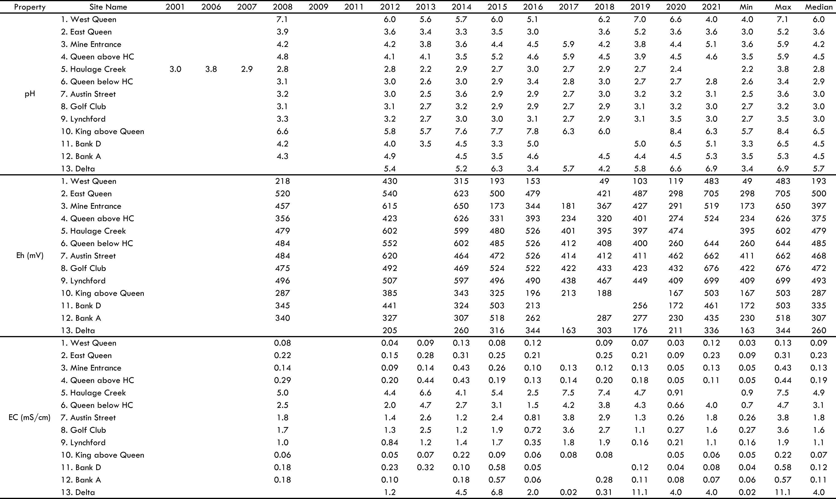
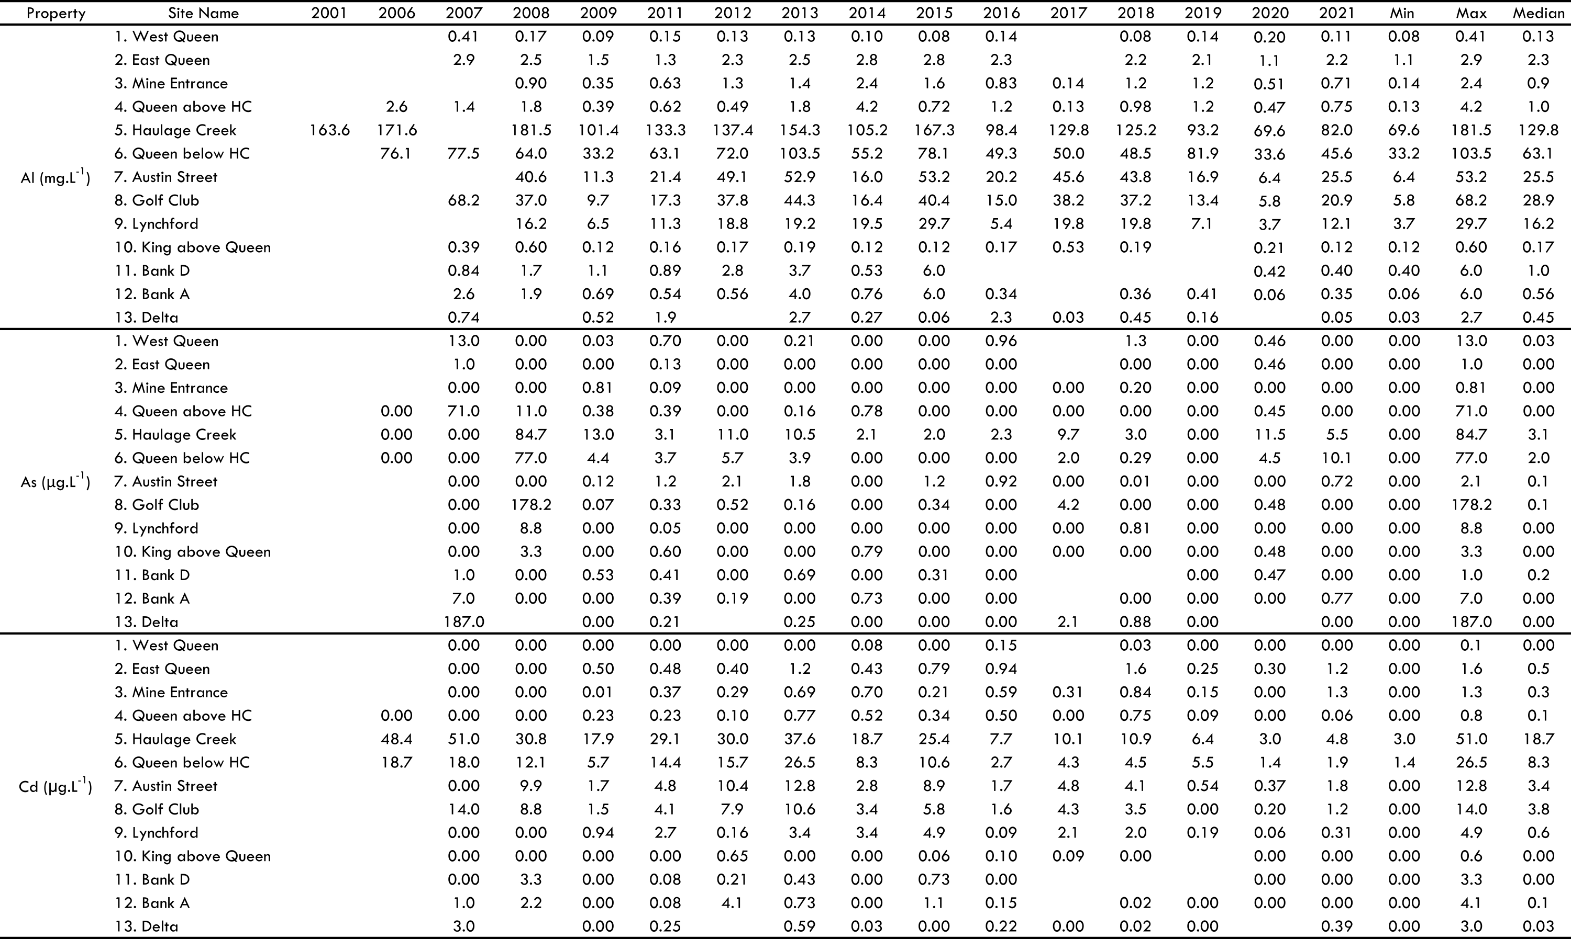
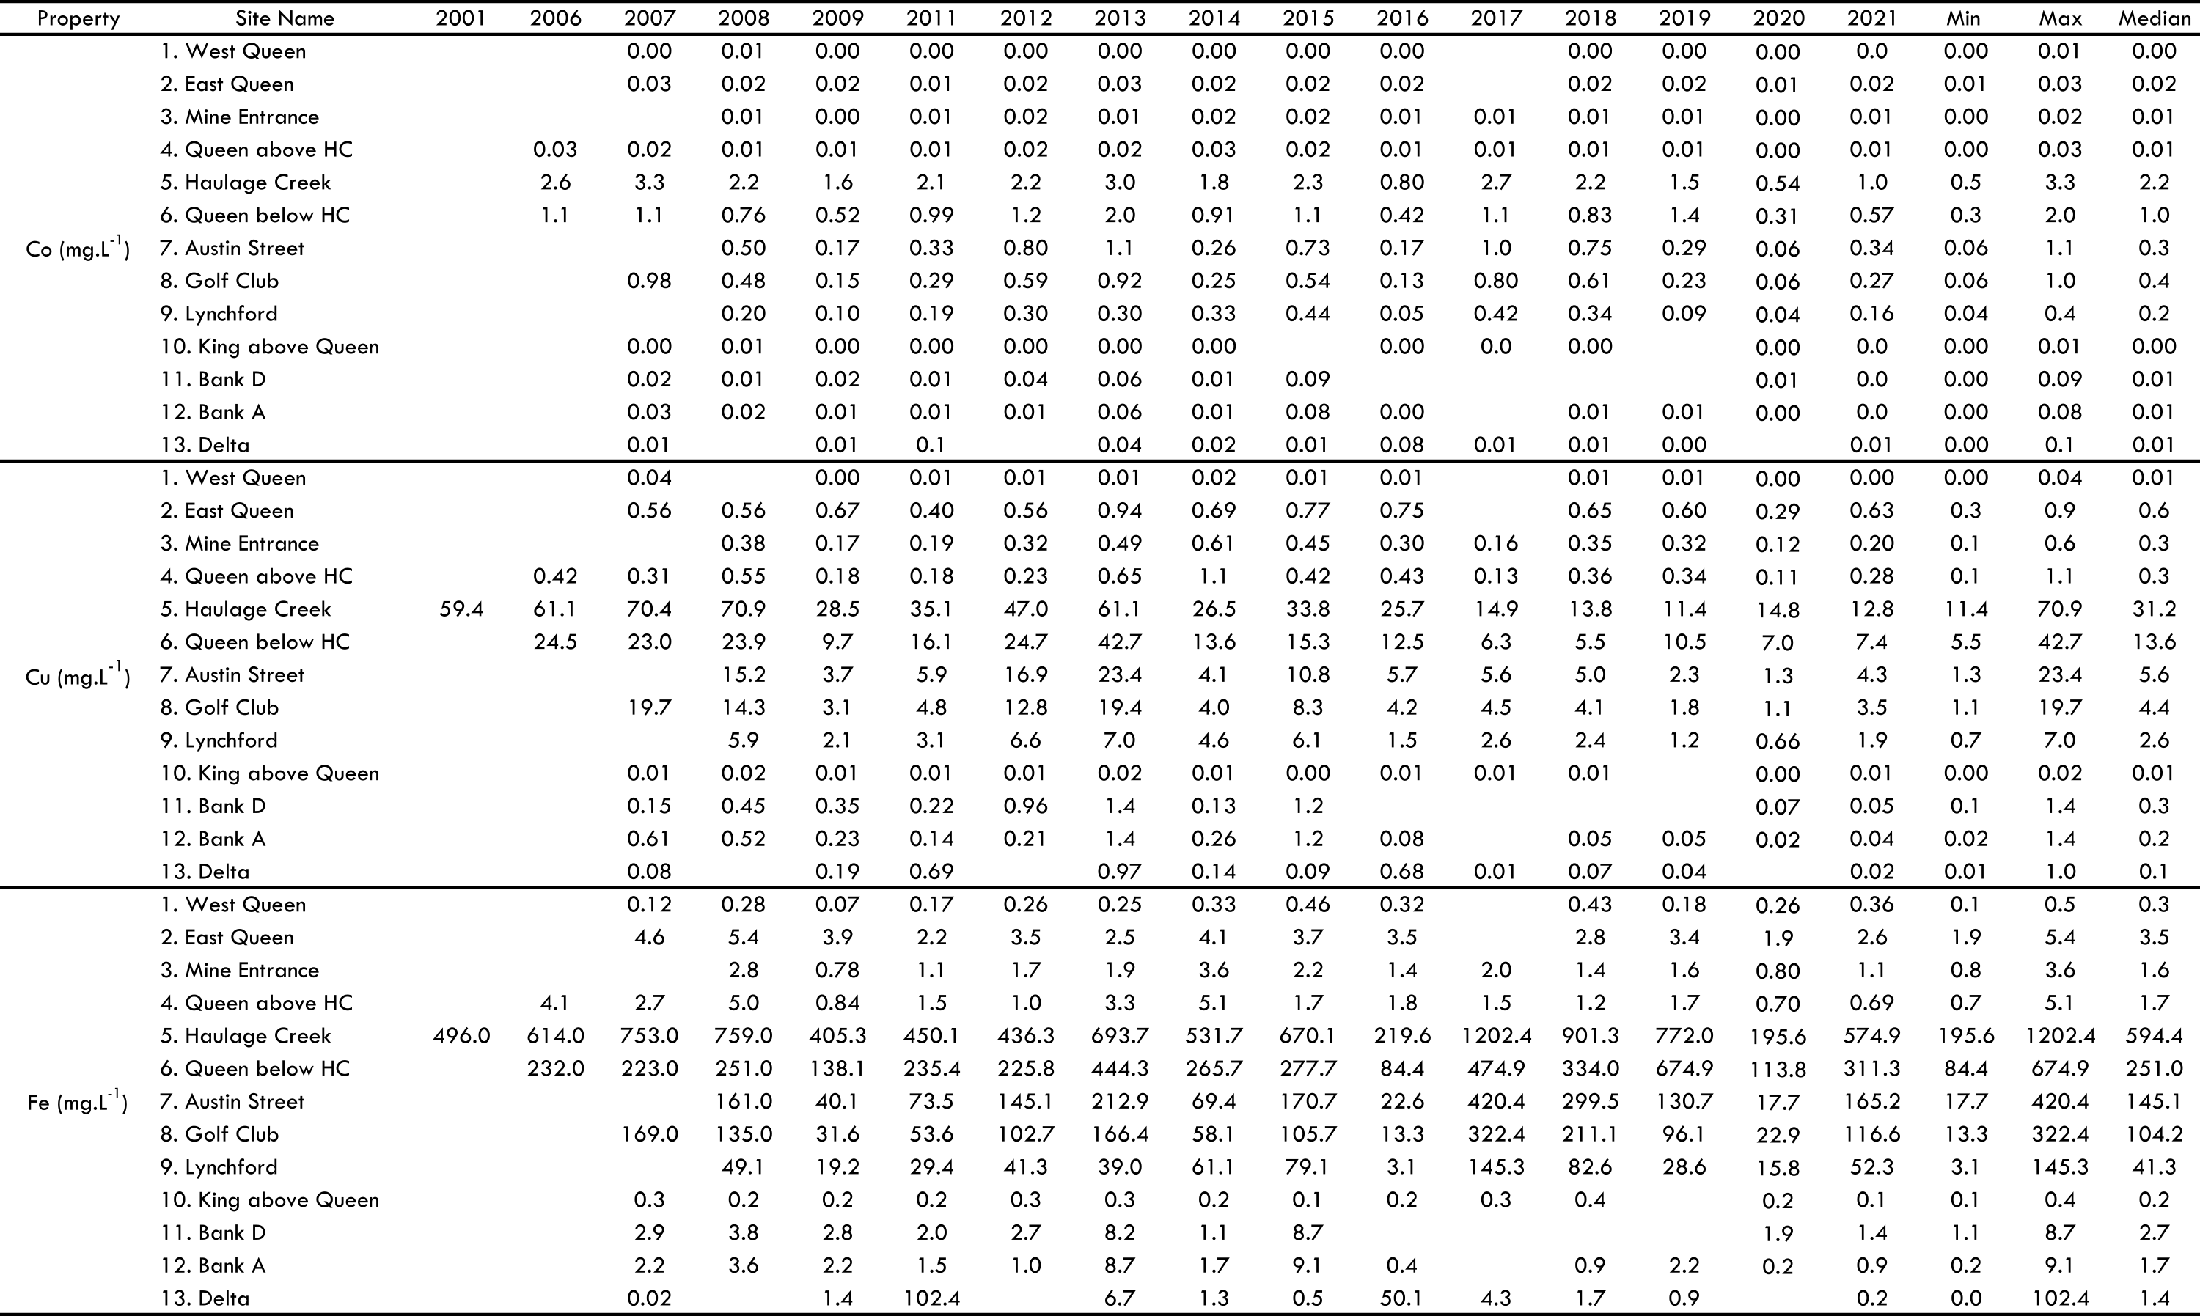
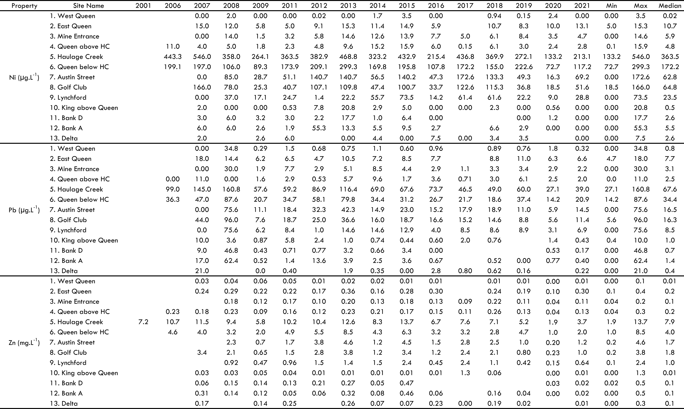
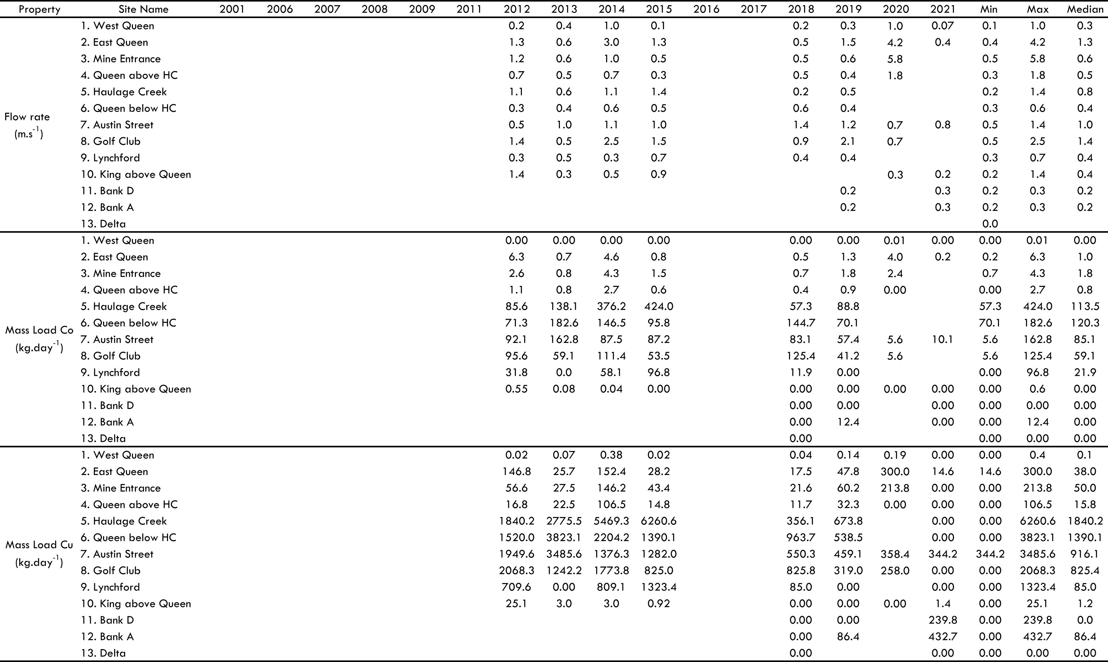

Supplemental Table S-3. Recommended water quality guidelines for pH, EC, and metal(loid)s in Australia
Water Guidelines |  | pH |  |  | EC (mS/cm) |  |  | Metal(loid)s (mg·L⁻¹)
Water Guidelines |  | Lower limit | Upper limit |  | Lower limit | Upper limit |  | Al | Co | Cu | Fe | Zn
Water Guidelines |  | 6.5 | 8 |  | 0.125 | 2.2 |  | 0.08 | 0.05 | 0.0018 | 0.2 | 0.015

Supplemental Table S-4. Base metal(loid) measured in sediments in 2018 by pXRF in mg·kg⁻¹and S measured by Elemental Analyser in wt% statistics (abbreviations: HC – Haulage Creek; BDL – below detection limits)
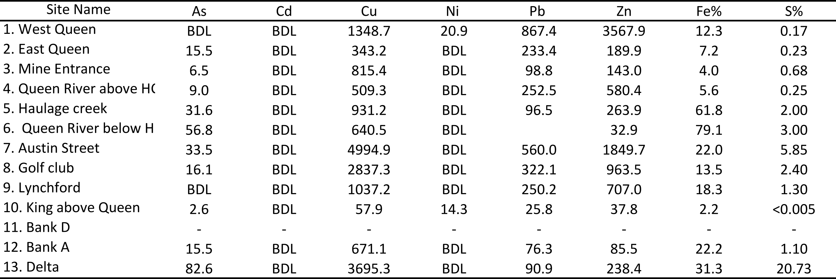
Supplemental Table S-5. Recommended sediment quality guidelines in Australia
Sediment Guidelines |  | As (mg·kg⁻¹) |  |  | Cu (mg·kg⁻¹) |  |  | Zn (mg·kg⁻¹) |  |  | Pb (mg·kg⁻¹)
Sediment Guidelines |  | ISQG low | ISQG high |  | ISQG low | ISQG high |  | ISQG low | ISQG high |  | ISQG low | ISQG high
Sediment Guidelines |  | 20 | 70 |  | 65 | 270 |  | 200 | 410 |  | 50 | 220

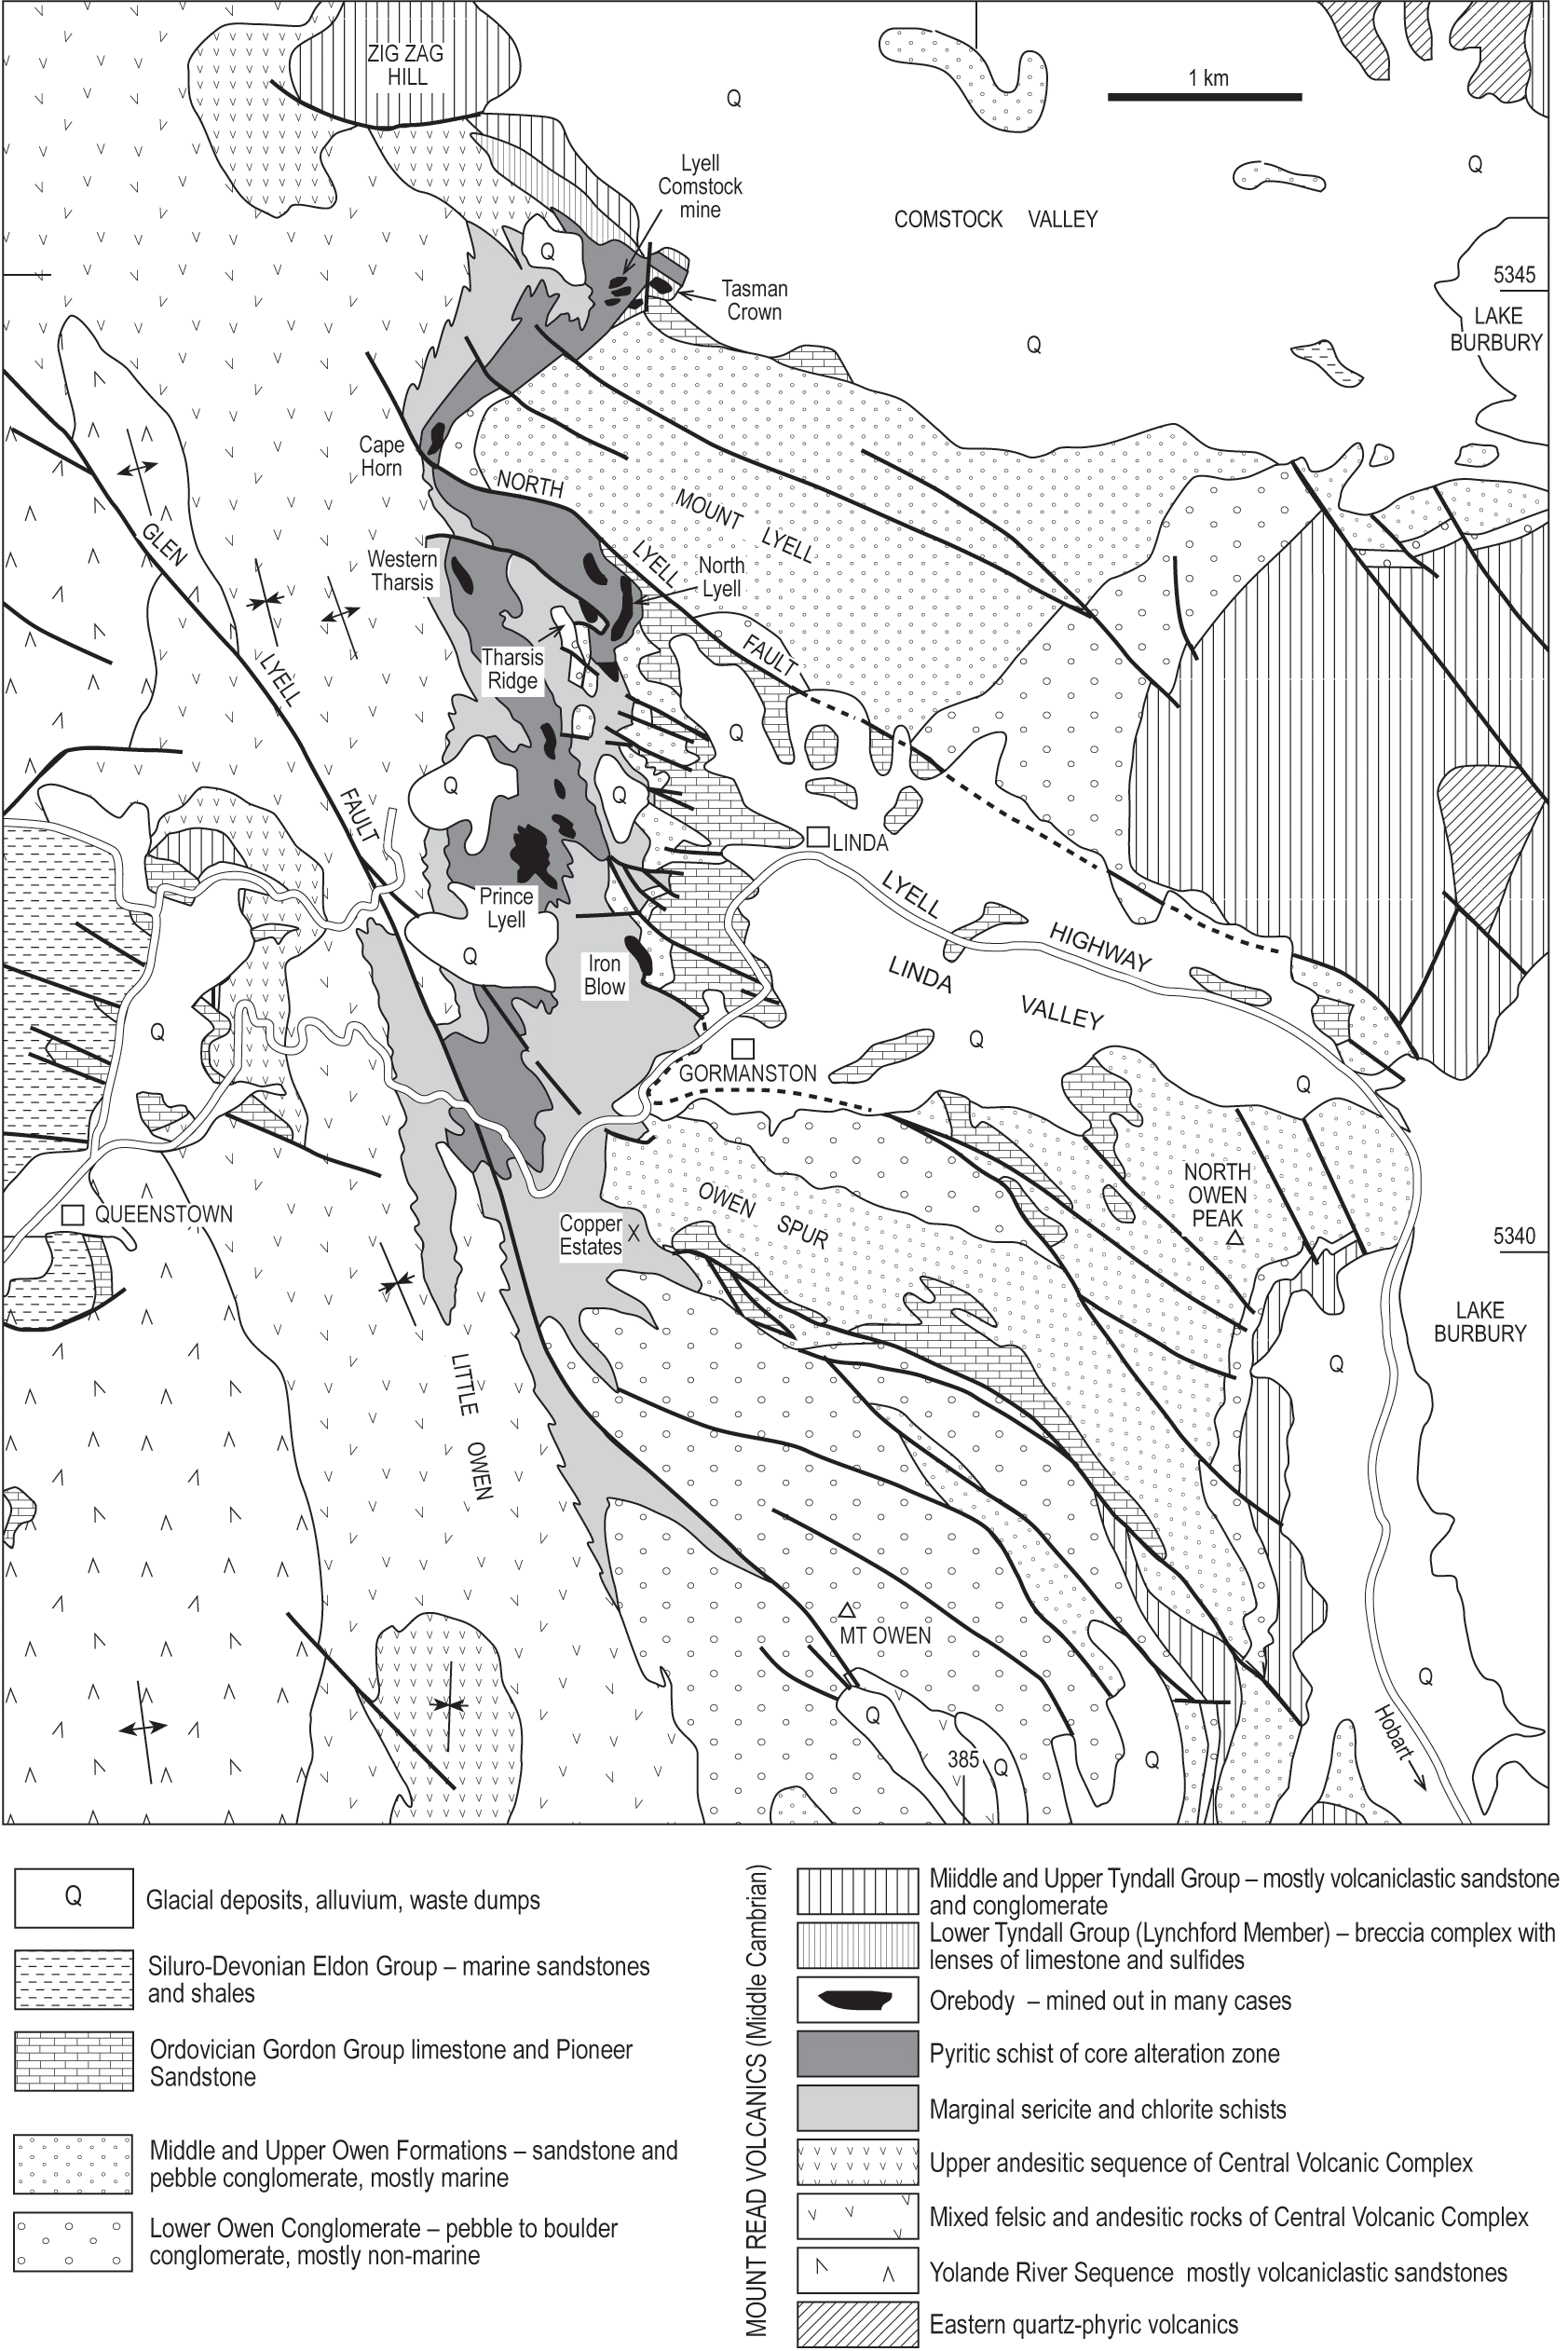
Supplemental Figure 1 – Geologic map of the Mount Lyell mines area (K. D. Corbett, 2001)
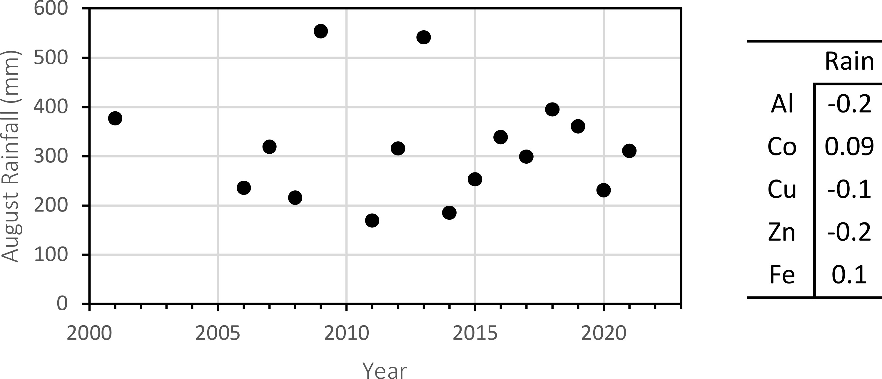
Supplemental Figure 2. August rainfall (prior to sampling) at Queenstown for each year and correlation between rainfall X dissolved metals.

References

Australian Broadcasting Corporation, 2014, Mount Lyell copper mine: Look back at key dates in the history of Australia's oldest mining field, https://www.abc.net.au/news/2014-07-09/mount-lyell-timeline/5581684, Accessed 16 April 2021,
Bureau of Meteorology, 2021, Climate statistics for Australian locations, Queenstown, http://www.bom.gov.au/climate/averages/tables/cw_097034_All.shtml, Accessed 6 July 2021,
Corbett, K., 1976, Notes on the volcanic stratigraphy and Cambro-Ordovician relationships in the Mt Jukes area: Unpublished Report Department of Mines Tasmania, v. 49.
Corbett, K. D., 2001, The geology of the Mount Lyell mines area, Tasmania: a re-interpretation based on studies at Lyell Comstock, North Lyell and the Iron Blow area. Research master thesis, University of Tasmania 72 p.
Corbett, K. D., 2001, New mapping and interpretations of the Mount Lyell mining district, Tasmania: A large hybrid Cu-Au system with an exhalative Pb-Zn top: Economic Geology, v. 96, no. 5, p. 1089-1122, 1554-0774. https://doi.org/10.2113/gsecongeo.96.5.1089
EPA Tasmania, 2013, Mt Lyell acid drainage remediation, https://epa.tas.gov.au/epa/water/remediation-programs/mt-lyell-acid-drainage-remediation, Accessed 21 April 2021,
Huston, D. L., and Kamprad, J., 2001, Zonation of alteration facies at Western Tharsis: implications for the genesis of Cu-Au deposits, Mount Lyell field, Western Tasmania: Economic Geology, v. 96, no. 5, p. 1123-1132. https://doi.org/10.2113/gsecongeo.96.5.1123
Koehnken, L., 1997, Mount Lyell remediation: final report, Mount Lyell Remediation Research and Demonstration Program. Supervising scientist report, v. 126, 93 p.
Locher, H., 1997, Sediment transport in the King River, Tasmania. Mount Lyell remediation research and demonstration program. Supervising Scientist Report, v. 120, p. 124.
McQuade, C. V., Johnston, J. F., and Innes, S. M., 1995, Mount Lyell Remediation: review of historical literature and data on the sources and quality of effluent from the Mount Lyell lease site: Supervising Scientist Report, 0642243034. v. 104, p. 78.
Seymour, D., Green, G., and Calver, C., 2006, The geology and mineral deposits of Tasmania: a summary, Tasmanian Department of Infrastructure, Energy and Resources, v. 72, 32 p.
Solomon, M., Vokes, F., and Walshe, J., 1987, Chemical remobilization of volcanic-hosted sulphide deposits at Rosebery and Mt. Lyell, Tasmania: Ore Geology Reviews, v. 2, no. 1-3, p. 173-190. https://doi.org/10.1016/0169-1368(87)90027-8
Walshe, J., and Solomon, M., 1981, An investigation into the environment of formation of the volcanic-hosted Mt. Lyell copper deposits using geology, mineralogy, stable isotopes, and a six-component chlorite solid solution model: Economic Geology, v. 76, no. 2, p. 246-284.

