Table S-1. Field characterization of AMD samples
AMD | pH | C.E. (mS/cm) | ORP (mV)
P0 | 2.2 | 3.9 | 693
P5 | 4.6 | 3.3 | 588
P9 | 6.2 | 2.8 | 481

Table S-2. Quality control for XRF Analysis
 | Mg | Al | Si | Ca | Fe | Mn
NIST2710a (mg/kg) | 7,340 | 59,500 | 311,000 | 9,640 | 43,200 | 2,140
Media (XFR) (mg/kg) | 7,232 | 58,234 | 315,321 | 9,780 | 42,373 | 2,121
Recoveries (%) | 98.5 | 97.9 | 101.4 | 101.5 | 98.1 | 99.1
CV (%) | 1.1 | 2.3 | 5.3 | 9.2 | 1.3 | 0.03
NIST2711a (mg/kg) | 10,700 | 67,200 | 314,000 | 24,200 | 28,200 | 675
Media (XFR) (mg/kg) | 9,780 | 66,345 | 311,675 | 23,876 | 27,653 | 698
Recoveries (%) | 91.4 | 98.7 | 99.3 | 98.7 | 98.1 | 103.4
CV (%) | 3.2 | 1.1 | 3.4 | 5.4 | 1.2 | 0.23

Table S-3. Combinations of factorial experiment of Cd2+ and Zn2+ sorption on R3 waste
P0-T1-C1 | P5-T1-C1 | P9-T1-C1
P0-T1-C2 | P5-T1-C2 | P9-T1-C2
P0-T1-C3 | P5-T1-C3 | P9-T1-C3
P0-T2-C1 | P5-T2-C1 | P9-T2-C1
P0-T2-C2 | P5-T2-C2 | P9-T2-C2
P0-T2-C3 | P5-T2-C3 | P9-T2-C3
P0-T3-C1 | P5-T3-C1 | P9-T3-C1
P0-T3-C2 | P5-T3-C2 | P9-T3-C2
P0-T3-C3 | P5-T3-C3 | P9-T3-C3

P0=Sample of AMD from the first pond (pH=2.9) of the pre-treatment with addition of local calcareous shales; P5=AMD from the intermediate pond (pH=4.8) and P9=AMD from the final pond (pH=6.3)
T = agitation time, T1=20´axial agitation; T2=60´ axial agitation and T3=1,080´ no agitation
C = concentration of R3 waste C1=1.5 g R3 waste; C2 =2.5 g and C3 =3.0 g

Table S-4. Contact times and waste mass/AMD volume ratios calculated by the Minitab Software for the R3 and R6 wastes and the ponds P0, P5, and P9
Code | Contact time (hours) | Ratio (g Mn-waste/mL AMD)
C1T3 | 72 | 0.189/15
C2T2 | 24 | 0.5/15
C2T4 | 120 | 0.5/15
C3T1 | 4.12 | 1.25/15
C3T3 | 72 | 1.25/15
C3T5 | 139.88 | 1.25/15
C4T2 | 24 | 2.0/15
C4T4 | 120 | 2.0/15
C5T3 | 72 | 2.31/15

Table S-5. Qualitative pH, EC and carbonate testing of Mn wastes
Code | pH | E.C. (mS/cm) | HCl reaction
R3 | 10.5(±) 0.5 | 263 | Strong reaction
R6 | 8.6(±) 0.5 | 7,810 | No reaction

Table S-6. Elemental Concentration of Mn wastes (ICP-OES)
Code | mg/kg
Code | Al | As | Cr | Cu | Fe | Mn | Pb | Zn
LOD (mg/kg) | 6 | 12 | 1 | 1 | 6 | 1 | 12 | 1
R3 | 3,142(±) 221 | < LOD | <LOD | <LOD | 40,214 (±) 2,574 | 310,296(±) 30,347 | 55(±) 4 | 89(±) 6
R6 | 1,729(±) 122 | 50(±) 5 | <LOD | <LOD | 57,815 (±) 3,700 | 335,427 (±) 32,805 | < LOD | 204(±) 14

Table S-7. XRF Analysis of R3 and R6 Mn wastes (mass%)
Code | MgO | Al₂O₃ | SiO₂ | SO₃ | CaO | Fe₂O₃ | MnO | Others | Sum
R3 | 5.4(±) 0.5 | 8.5 (±) 0.8 | 21 (±) 2 | 3.7(±) 0.3 | 7.8(±) 0.7 | 12(±) 1 | 40(±) 4 | 1.7 | 100
R6 | 5.5(±) 0.5 | 5.4 (±) 0.5 | 17 (±) 2 | 5.1(±) 0.5 | 10(±) 1 | 13(±) 1 | 43(±) 4 | 1.2 | 100

Table S-8. Results of the factorial experiment with R3
Parameter |  | pH | Al (mg/L) | As (mg/L) | Cd (mg/L) | Fe (mg/L) | Mn (mg/L) | Pb (mg/L) | Zn (mg/L)
LOD (mg/L) |  | pH | 0.2 | 0.3 | 0.1 | 0.1 | 0.2 | 0.02 | 0.1
PL (mg/L) |  | 5 to 10 | NR | 0.2 | 0.2 | NR | NR | 0.2 | 10
P0 non treated AMD |  | 2.9 | 445 (±) 31.3 | <LOD | 2.8(±) 0.2 | 263(±) 16 | 364(±) 36 | <LOD | 4,830(±) 322
Treatment code | P0-T1-C1 | 6.4 (±) 0.3 | 1.5(±) 0.1 | <LOD | 2.3(±) 0.2 | 1.6(±) 0.1 | 78.2(±) 7.6 | <LOD | 330(±) 22
Treatment code | P0-T1-C2 | 6.5 (±) 0.2 | 0.4(±) 0.03 | <LOD | 1.3(±)0.1 | 1(±) 0.1 | 79.1(±) 7.7 | <LOD | 283(±) 19
Treatment code | P0-T1-C3 | 6.8 (±) 0.2 | 0.5(±) 0.04 | <LOD | 0.8(±) 0.1 | 2(±) 0.1 | 82.1(±) 8 | <LOD | 95(±) 6.3
Treatment code | P0-T2-C1 | 6.1 (±) 0.4 | 2.0(±) 0.2 | <LOD | 2.4(±) 0.2 | 7.6(±) 0.5 | 89.6(±) 8.8 | <LOD | 334(±) 22
Treatment code | P0-T2-C2 | 6.5 (±) 0.2 | 0.2(±) 0.02 | <LOD | 1.4(±) 0.1 | 0.1(±) 0.01 | 79.9(±) 7.8 | <LOD | 107(±) 7
Treatment code | P0-T2-C3 | 6.7 (±) 0.1 | 0.2(±) 0.02 | <LOD | 0.7 (±)0.1 | 0.4(±) 0.2 | 83.4(±) 8.2 | <LOD | 251(±) 17
Treatment code | P0-T3-C1 | 5.8 (±) 0.3 | 0.7(±) 0.1 | <LOD | 2.4(±) 0.2 | 2.3(±) 0.2 | 84(±) 8.2 | <LOD | 334(±) 22
Treatment code | P0-T3-C2 | 6.6 (±) 0.4 | 0.2(±) 0.02 | <LOD | 1.2(±) 0.1 | 1(±) 0.1 | 82.7(±) 8.1 | <LOD | 106(±) 7
Treatment code | P0-T3-C3 | 6.6 (±) 0.2 | <LOD | <LOD | 0.6(±) 0.04 | <LOD | 85.1(±) 8.3 | <LOD | 239(±) 16
P5 intermedial pre-treated AMD |  | 4.8 | 4.6(±) 0.3 | <LOD | 2.5(±)0.2 | 0.2(±) 0.01 | 347(±) 34 | <LOD | 3,600(±) 240
Treatment code | P5-T1-C1 | 6.5 (±) 0.3 | 0.8(±) 0.1 | <LOD | 1.2(±) 0.1 | 3.6(±) 0.2 | 53.1(±)5.2 | <LOD | 238(±) 16
Treatment code | P5-T1-C2 | 6.7 (±) 0.2 | 0.2(±) 0.02 | <LOD | 0.5(±) 0.04 | 0.4(±) 0.03 | 50.2(±) 4.9 | <LOD | 84.7(±) 5.7
Treatment code | P5-T1-C3 | 6.9 (±) 0.3 | <LOD | <LOD | 0.2(±) 0.02 | <LOD | 52.1(±) 5.1 | <LOD | 65.3(±) 4.4
Treatment code | P5-T2-C1 | 6.4 (±) 0.5 | 0.2(±) 0.02 | <LOD | 1.7(±) 0.1 | 0.4(±) 0.02 | 35.3(±) 3.4 | <LOD | 262(±)18
Treatment code | P5-T2-C2 | 6.5 (±) 0.3 | 0.2(±) 0.02 | <LOD | 0.9(±) 0.1 | <LOD | 41(±) 4 | <LOD | 94.4(±) 6.3
Treatment code | P5-T2-C3 | 6.8 (±) 0.1 | 0.2(±) 0.02 | <LOD | 0.4(±) 0.03 | <LOD | 46.5(±) 4.6 | <LOD | 85.4(±) 5.7
Treatment code | P5-T3-C1 | 6.4 (±) 0.2 | <LOD | <LOD | 1.6(±) 0.1 | <LOD | 36.3(±) 3.6 | <LOD | 256(±) 17
Treatment code | P5-T3-C2 | 6.6 (±) 0.3 | <LOD | <LOD | 0.7(±) 0.1 | <LOD | 43.8(±) 4.3 | <LOD | 92.4(±) 6.2
Treatment code | P5-T3-C3 | 6.8 (±) 0.4 | <LOD | <LOD | 0.3(±) 0.02 | 0.3(±)0.02 | 50.9(±) 4.9 | <LOD | 79.7(±) 5.3
P9 final pre-treated AMD |  | 6.3 | <LOD | <LOD | 0.4(±) 0.03 | <LOD | 279(±) 27 | <LOD | 1,110 (±) 74
Treatment code | P9-T1-C1 | 6.7 (±) 0.1 | <LOD | <LOD | <LOD | 0.1(±)0.01 | 24.1(±)2.4 | <LOD | 34.5(±) 2.3
Treatment code | P9-T1-C2 | 7.3 (±) 0.3 | <LOD | <LOD | <LOD | <LOD | 23.2(±) 2.3 | <LOD | 14.9(±) 1
Treatment code | P9-T1-C3 | 7.4 (±) 0.2 | <LOD | <LOD | <LOD | <LOD | 18.5(±) 1.8 | <LOD | 3.8(±) 0.3
Treatment code | P9-T2-C1 | 6.4 (±) 0.4 | 0.2(±) 0.02 | <LOD | <LOD | 0.2(±) 0.01 | 21.7(±) 2.1 | <LOD | 44.4(±) 2.9
Treatment code | P9-T2-C2 | 6.7 (±) 0.2 | 0.2(±) 0.02 | <LOD | <LOD | 0.6(±)0.04 | 26.1(±) 2.6 | <LOD | 35.4(±) 2.4
Treatment code | P9-T2-C3 | 7.4 (±) 0.4 | <LOD | <LOD | <LOD | 0.1(±) 0.01 | 23.7(±) 2.3 | <LOD | 9.7(±) 0.7
Treatment code | P9-T3-C1 | 7.0 (±) 0.3 | 0.2(±) 0.02 | <LOD | <LOD | 0.9(±) 0.1 | 26.3(±) 2.6 | <LOD | 43.5(±) 2.9
Treatment code | P9-T3-C2 | 6.5 (±) 0.2 | 0.3(±) 0.02 | <LOD | <LOD | 1.2(±)0.1 | 29.2(±) 2.9 | <LOD | 25.8(±) 1.7
Treatment code | P9-T3-C3 | 7.0 (±) 0.3 | <LOD | <LOD | <LOD | <LOD | 25.8(±) 2.5 | <LOD | 7.2(±) 0.5

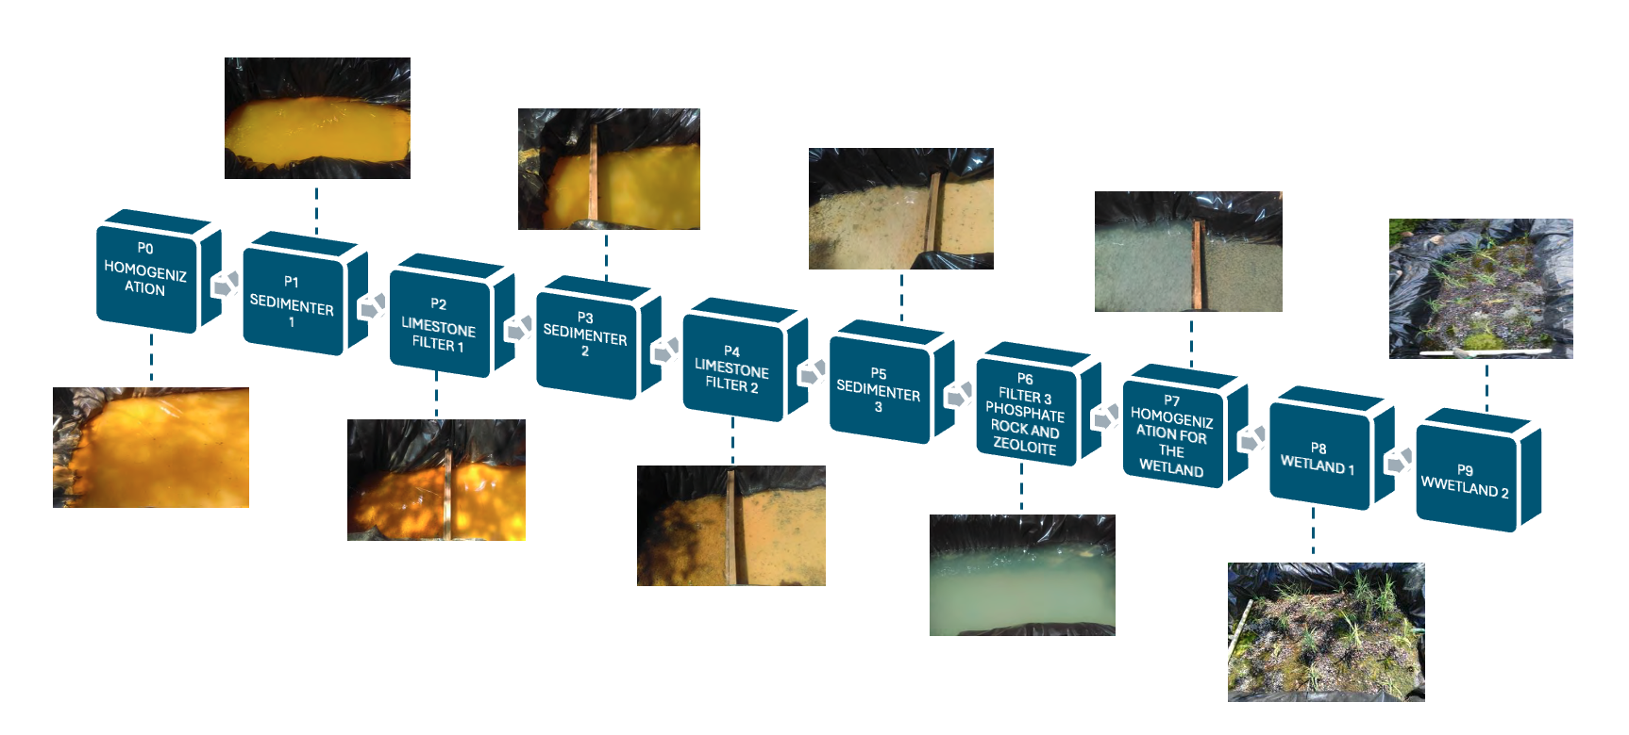
Figure S-1. Pre-treatment system

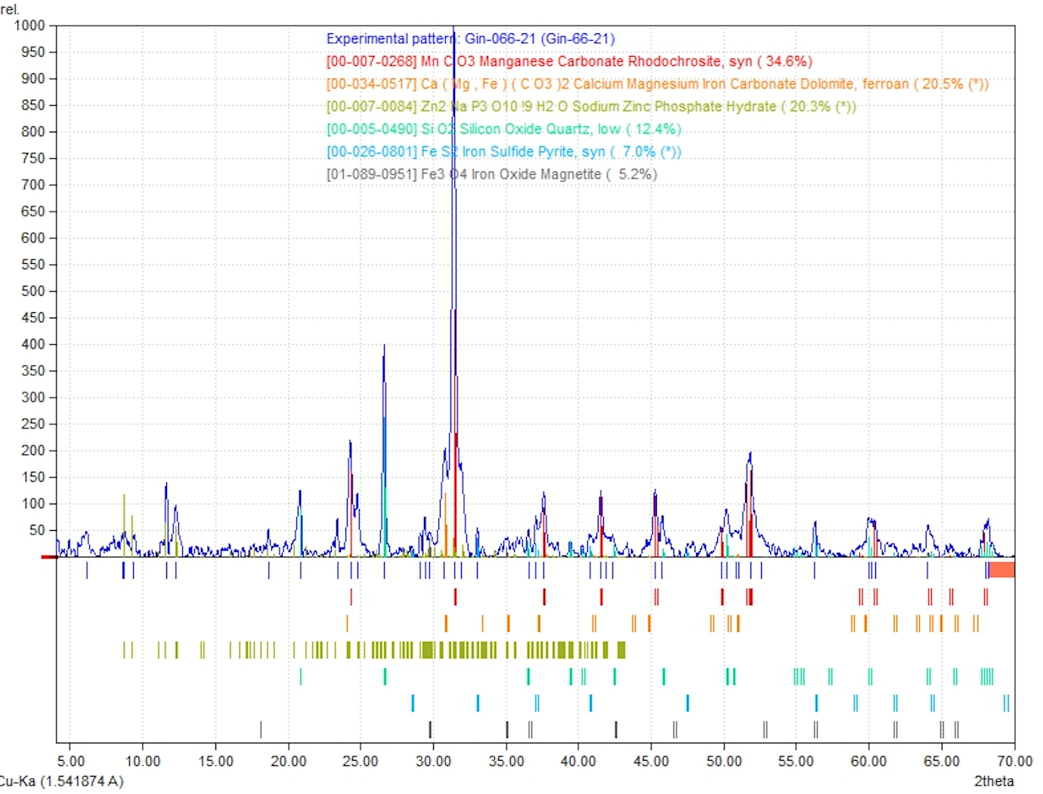
Figure S-2. XRD of R3 waste

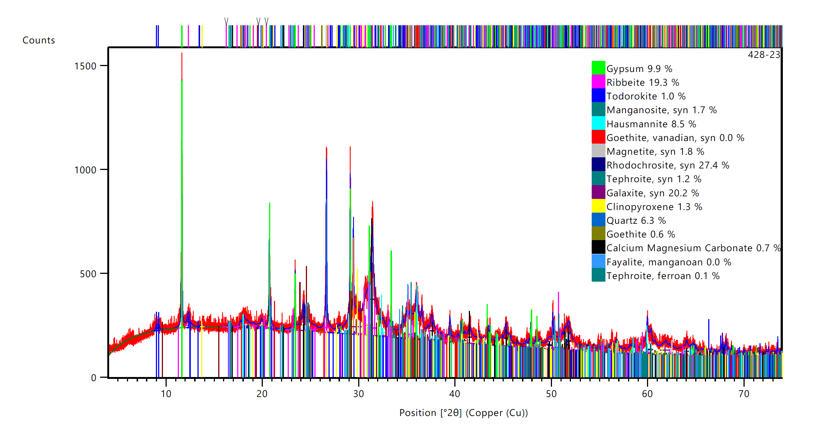
Figure S-3. XRD of R6 waste

Table S-9. Results of the sequential extraction of the Mn residues from three of the trials carried out to absorb Cd2+ and Zn2+ from AMD
Trial | Element |  | Cd | Mn | Zn | Metal concentration in waste |  |  | Sequential extraction (%)
Trial | LOD (mg/L) |  | 0.1 | 0.2 | 0.1
Trial | LOD(mg/kg) |  | 0.8 | 1.7 | 0.8
Trial | MPL (permissible level) (mg/L) |  | 0.2 | non-regulated | 10 | Cd | Mn | Zn | Cd | Mn | Zn
Trial | MPL (permissible level) (mg/kg)* |  | 1.7 | non-regulated | 83 | mg/kg |  |  | mg/100g
P9-T1-C3 | Exchangeable | 8 mL MgCl₂ 1M/1g | 0.2 | 117 | 6 | 3.5 | 312,468 | 9,308 | 4.8 | 0 | 0.1
P9-T1-C3 | Bound to carbonates | 8 mL NaOOC-CH3 1M/1g | 0.6 | 892 | 77 | 3.5 | 312,468 | 9,308 | 16.7 | 0 | 0.8
P9-T1-C3 | Bound to Fe, Mn oxides | (20 mL Na-ditionite 0.3M +Na citrate 0.175M+citric acid 0.025M)/1g | 0.3 | 1310 | 15 | 3.5 | 312,468 | 9,308 | 7.1 | 0 | 0.2
P9-T1-C3 | Residual | (10 mL HF + 2 mL HClO4) /1g | 2.5 | 3.5 | 3.5 | 3.5 | 312,468 | 9,308 | 71.4 | 100 | 99
P9-T1-C3 | Releasable metal concentration (**) |  | 1 | 0 | 0.04 | 3.5 | 312,468 | 9,308 | 28.6 | 0 | 1.1
P9-T2-C3 | Exchangeable | 8 mL MgCl₂ 1M/1g | 0.3 | 152 | 6 | 3.5 | 312,425 | 9,258 | 7.1 | 0.1 | 0.1
P9-T2-C3 | Bound to carbonates | 8 mL NaOOC-CH3 1M/1g | 0.6 | 925 | 69 | 3.5 | 312,425 | 9,258 | 16.7 | 0.3 | 0.8
P9-T2-C3 | Bound to Fe, Mn oxides | (20 mL Na-ditionite 0.3M +Na citrate 0.175M+citric acid 0.025M)/1g | 0.3 | 1303 | 15 | 3.5 | 312,425 | 9,258 | 7.1 | 0.4 | 0.2
P9-T2-C3 | Residual | (10 mL HF + 2 mL HClO4) /1g | 2.4 | 3.5 | 3.5 | 3.5 | 312,425 | 9,258 | 69 | 99 | 99
P9-T2-C3 | Releasable metal concentration (**) |  | 1.1 | 0.03 | 0.03 | 3.5 | 312,425 | 9,258 | 31 | 0.8 | 1
P9-T3-C3 | Exchangeable | 8 mL MgCl₂ 1M/1g | 0.2 | 92 | 5 | 3.5 | 312,407 | 9,279 | 4.8 | 0.03 | 0.1
P9-T3-C3 | Bound to carbonates | 8 mL NaOOC-CH3 1M/1g | 0.7 | 925 | 78 | 3.5 | 312,407 | 9,279 | 19 | 0.3 | 0.8
P9-T3-C3 | Bound to Fe, Mn oxides | (20 mL Na-ditionite 0.3M +Na citrate 0.175M+citric acid 0.025M)/1g | 0.3 | 1299 | 17 | 3.5 | 312,407 | 9,279 | 7.1 | 0.4 | 0.2
P9-T3-C3 | Residual | (10 mL HF + 2 mL HClO4) /1g | 2.4 | 3.5 | 3.5 | 3.5 | 312,407 | 9,279 | 69 | 99 | 99
P9-T3-C3 | Releasable metal concentration (**) |  | 1.1 | 0.03 | 0.04 | 3.5 | 312,407 | 9,279 | 31 | 0.7 | 1.1
(*) This value was calculated using a solid/solution ratio of 3g/25 mL, the same as the sequential extraction.
(**) Maximum concentration by kg of waste released on 8.3L of water (0.0083 m3)

