Supplementary Information
Ocean Dynamics
Effects of Vertical Mixing on the Lake Michigan Food Web: An Application of a Linked End-to-End Earth System Model Framework

Zhang H¹, Mason DM², Boucher NW³, Rutherford ES^{2*}, Cannon DJ⁴, Kessler J², Fujisake-Manome A⁴, Wang J², Fulton, EA⁵

¹ Eureka Aquatic Research, LLC., Ann Arbor, MI, USA
² NOAA Great Lakes Environmental Research Laboratory, Ann Arbor, MI, USA
³ Michigan Statet University Department of Fisheries and Wildlife, East Lansing, MI, USA
⁴ University of Michigan Cooperative Institute for Great Lakes Research, Ann Arbor, MI, USA
⁵ CSIRO Oceans & Atmosphere, Hobart, TAS, Australia

*Corresponding author: Ed.Rutherford@noaa.gov

In this Supplementary Information, we provide an overview of the Lake Michigan Atlantis Ecosystem Model, including hydrodynamic input, equations, data and data sources and model calibration.

1. Lake Michigan Atlantis Ecosystem Model
The Atlantis Ecosystem framework supports a deterministic, dynamic, 3-dimensional, end-to-end model that integrates physics, biology, fisheries, management, assessment and economics (Audzijonyte et al. 2017a, 2017b). The framework uses nitrogen as its primary currency and has been widely used and developed (or is in current development) for more than 30 coastal ecosystems including temperate marine, polar (Antarctic and Arctic), tropical coral reefs, estuaries and large freshwater lakes (Weijerman et al., 2016). The model structure contains five modules: a hydrographic module, an ecology module, and three management and human use modules (harvest sub-model, assessment sub-model, and economics sub-model). Major physical forcings to our Lake Michigan Atlantis Ecosystem Model, including 3-dimensional water temperature and mass exchange for every 6 hours, were provided by a 3-dimensional hydrodynamic model, Lake Michigan Finite Volume Community Ocean Model, or GL-FVCOM.
1.1 Lake Michigan Finite Volume Community Ocean Model
Hydrodynamic forcing for Atlantis was provided by GL-FVCOM, a spherical-coordinate, unstructured-grid hydrodynamic model designed to solve primitive (i.e., hydrostatic) equations. GL-FVCOM, which includes both ice modules (CICE: Hunke & Dukowicz 1997) and wind-wave mixing boundary conditions (Hu and Wang 2010), was originally implemented by Bai et al. (2013), who modified the original FVCOM initially developed by Chen et al. (2003, 2006, 2013). In the current study, GL-FVCOM was run as a hindcast model and forced with reanalysis data (i.e. North American Regional Reanalysis; 1979 - 2021). The model domain included both Lake Michigan and Lake Huron (3 - 5 km horizontal resolution), which are joined through the Straits of Mackinac. Lake depths were sourced from NOAAs National Centers for Environmental Information (https://www.ngdc.noaa.gov/mgg/greatlakes/), which provides bathymetry data at a resolution of 3 arc-seconds (~90m cell size). The GL-FVCOM was previously calibrated and validated in Lake Michigan, and was able to reproduce observed current, ice, and thermal structure patterns in the lake (e.g., Bai et al. 2013, Cannon et al. 2023). An example of simulated seasonal surface currents and surface temperatures is shown in Figure SI-1.
In this study, modeled water column temperatures, vertical velocities, and horizontal current speeds were extracted from GL-FVCOM simulations (1994 - 2021) and used as input for the hydrologic module in Atlantis (Figure SI-2). First, natural neighbor interpolation was used to interpolate unstructured model output to a structured grid (horizontal resolution: 90 arc-seconds; ~2km), which was required for further processing using codes provided by CSIRO (i.e. SSAM_Physics and HYDROCONSTRUCT). Structured GL-FVCOM data were then processed in Matlab using SSAM_Physics and HYDROCONSTRUCT, which are designed to average hydrodynamic model outputs over Atlantis boxes and compute horizontal and vertical advective fluxes between model cells. Output variables (advective fluxes: flow.nc, temperature structure: temp.nc) were used directly as Atlantis model inputs.
Three-dimensional turbulent vertical diffusivity (VTD) coefficients (K_{z}) simulated using GL-FVCOM were used to inform the vertical mixing scenarios investigated in this study. VTD coefficients were volume averaged over the entire lake at each time step, providing insight into the annual mixing cycle in Lake Michigan (Figure 1, main manuscript). After initial testing in Atlantis, a minimum mixing rate of K_{z-min}=10⁻⁵ m²/s was selected to ensure model stability, and a sinusoidal seasonal mixing parameterization was developed to replicate observed mixing cycles based on the day of year (doy, Eqn SI-1). Mixing scenarios were implemented directly in Atlantis using a modified turbulent vertical diffusion module, with the assumption that VTD coefficients were constant across depth. Additional modifications to account for depth variable VTD coefficients were beyond the scope of the current study, but are planned for future work (see Discussion in the main manuscript).
$K_{z-seasonal }=10^{-5}exp(\frac{ln(750)}{2}[sin(\frac{2π(doy+75)}{366})+1])$ (Eqn SI-1)
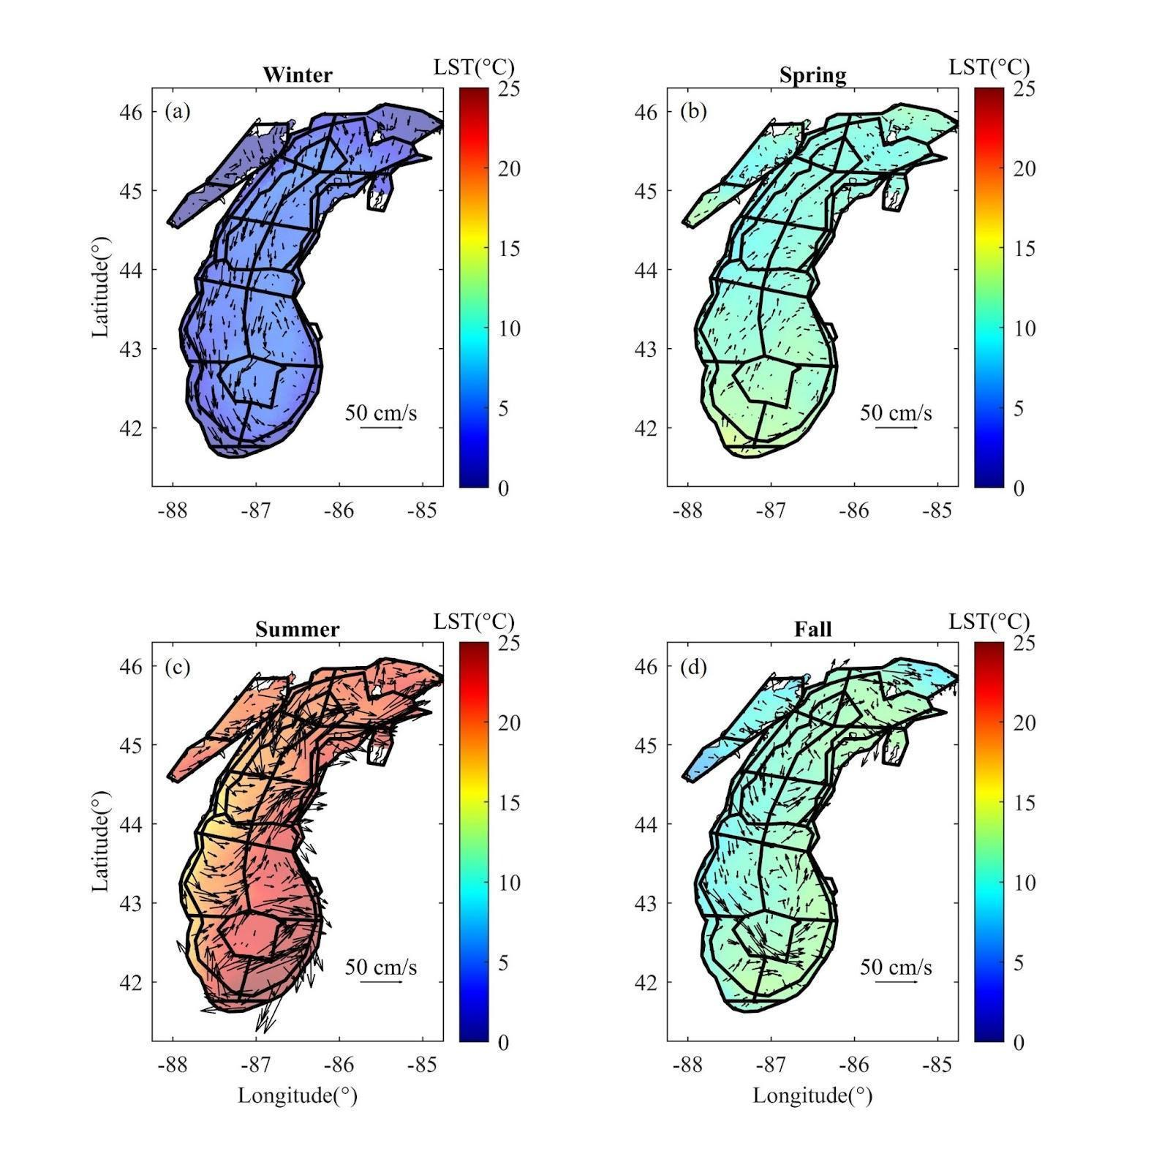
Figure SI-1. Seasonal surface temperatures and currents as simulated using GL-FVCOM. Seasonal averages were computed using daily data from 2010 averaged over 3-month increments (Winter: January--March; Spring: April-June; Summer: July-September; Fall: October-December). Average surface temperatures are represented with colored shading, and mean surface current magnitudes and directions are indicated with arrows. Atlantis model boxes (bold solid lines) are included for reference.

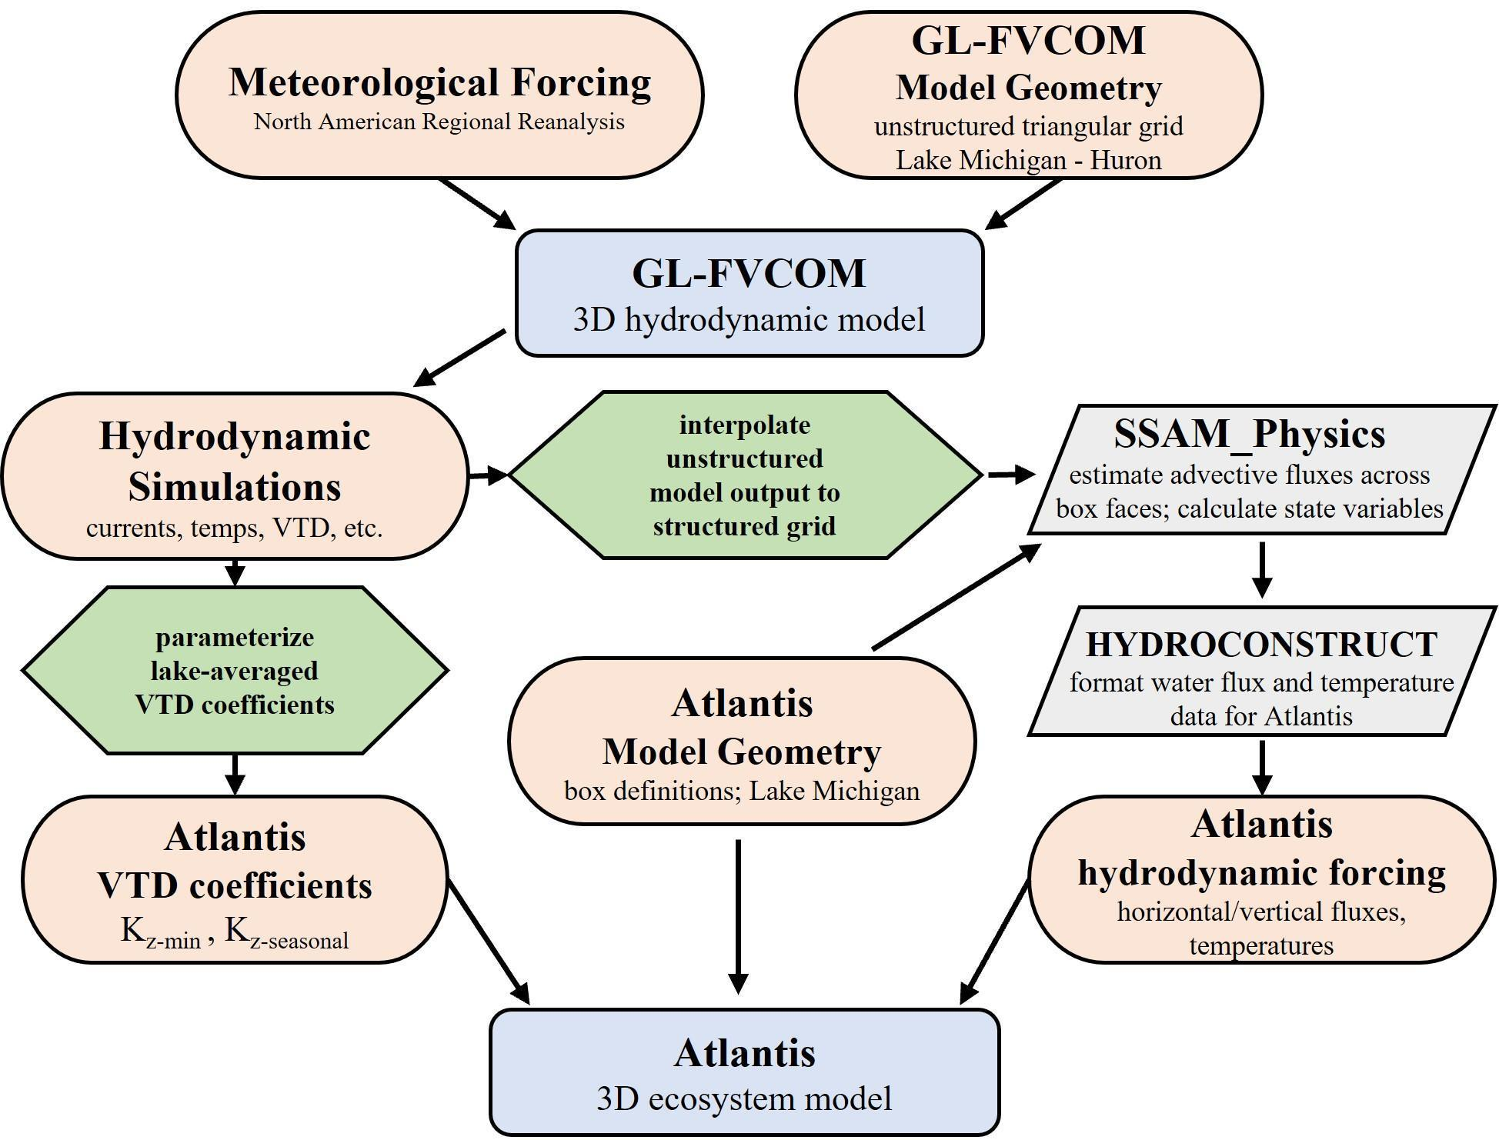
Figure SI-2. Flow diagram for preparing Atlantis input hydrodynamic forcing files. Orange ovals represent input/output variables, green hexagons represent processing steps, blue boxes represent models, and gray parallelograms represent processing programs provided by CSIRO. ‘VTD’ refers to vertical turbulent diffusivity and GL-FVCOM is the Great Lakes Finite Volume Community Ocean Model.
1.2. Ecology module
For the ecology module, we adopted the Atlantis Ecosystem Model of the linked model system (Figure SI-3), which is the focus of this study. Complete details and governing equations of Atlantis are available in two user manuals (living documents): overview of physics and biology (Audzijonyte et al. 2017a) and socio-economics (Audzijonyte et al. 2017b); and summarized in Link et al. (2010). Updates and improvements to Atlantis can be found at its wiki website.
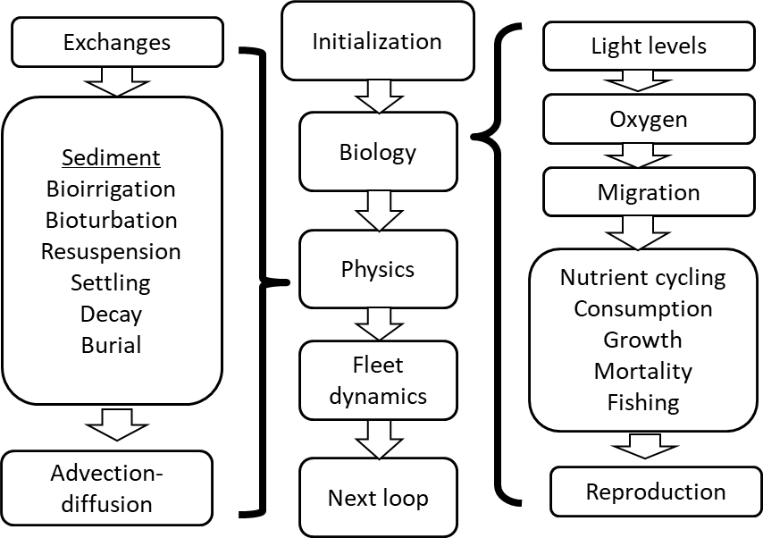
Figure SI-3. Flow diagram for the submodules of physics and ecology in the Atlantis Ecosystem Model.

1.2.1. Spatial Domain and Design
The 3-dimensional model domain was divided into 34 irregular polygons with an additional boundary box (Figure SI-4), and up to 6 depth layers with an additional sediment layer (Figure SI-5). Polygons were defined by lake bathymetry (nearshore: depths less than 30m; offshore: between 30-110m isobath; and deeper than 110m isobath), tributary inputs, state boundaries, and pre-existing fish management statistical districts (Madenjian 2019). Nutrients were added to the system at the nearshore polygons to represent major sources of nutrient loading into the lake.

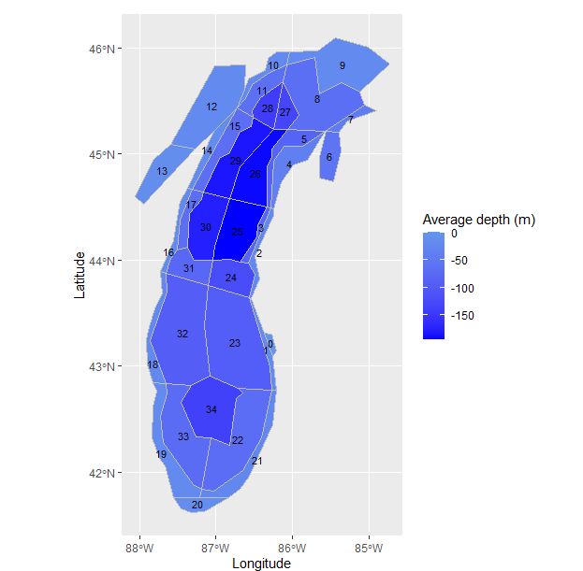
Figure SI-4. Horizontal polygons for the Lake Michigan Atlantis Model. Polygon 0 is a boundary box.

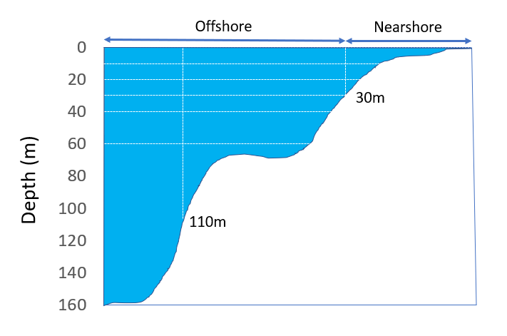
Figure SI-5. Depth strata (horizontal white dashed lines) and horizontal delineation of nearshore and offshore regions (vertical white dashed lines). The sediment layer is not illustrated but is represented as a 1m vertical cell beneath the deepest average depth for each polygon.

1.2.2. Temporal Domain
The initial conditions of the model were determined using the years 1994-1998. Physical, chemical and biological data supporting parameter estimation are from these years as described below. Model simulations began on January 1, 1994 and were projected 100 years into the future on a 12-hour time step.

2. Equations, Parameters and Variables
General equations and parameter values used in the Lake Michigan Atlantis Ecosystem Model (LMAM) are given below. For further model details see Fulton (2001) and Audzijonyte et al. (2017a).

2.1 Nutrients
Nitrogen, phosphorus and silica are explicitly simulated in the model. We simulated phytoplankton as nanoplankton and picoplankton, and didn’t explicitly simulate diatoms as a group. Thus, silica was not considered as a limiting nutrient factor and did not influence phytoplankton growth, and silica equation and parameter values are not presented in this document. Nitrogen is the currency in the Atlantis model. Phosphorus simulation was implemented for our simulation of the Lake Michigan freshwater ecosystem. The nitrogen to phosphorus Redfield ratio (16:1) was used for all organisms and detritus to convert nitrogen to phosphorus for Lake Michigan dynamics.
In addition to the riverine nutrient loads, and gain and loss due to physical mixing, the rate of change for nitrogen NH₄ -N (NH) and NO₃-N + NO₂-N (NO) in a model cell is given by:
$\frac{d(NH)}{dt}=-\sum_{i=1}^{p}{A_{i}}+\sum_{j=1}^{c}{E_{j}}-S+D$ (Eqn SI-2)
$A_{{NH}_{4}}=G⋅\frac{NH}{K_{DIN}+NH}⋅\frac{K_{DIN}+DIN}{DIN}$
$\frac{d(NO)}{dt}=-\sum_{i=1}^{p}{A_{i}}+S$ (Eqn SI-3)
$A_{NO}=G⋅\frac{NO}{K_{DIN}+DIN}⋅\frac{K_{DIN}}{K_{DIN}+NH}⋅(1+\frac{K_{DIN}}{DIN})$
where A is the rate of NH uptake or NO by primary producer i, p is the number of groups of primary producers, E is excretion of NH by consumer j, c is the number of consumer groups, S is the quantity of NH converted to NO by bacteria, D is the quantity of NH produced from denitrification, G is the growth of primary producers, $K_{DIN}$is the half-saturation coefficient for nitrogen uptake. DIN is the sum of NH and NO.

Soluble reactive phosphorus (SRP) concentration is calculated by modifying the phosphorus module in Bierman and Dolan (1981).
$\frac{d(SRP)}{dt}=-\sum_{i=1}^{p}{A_{i}}+\sum_{i=1}^{p}{M_{SRP,i}}+D_{TOP}$ (Eqn SI-4)
$A_{SRP}=min(A_{in},{A_{ext})}_{}$
$A_{in}=G⋅P_{in}+G⋅(P_{in,max}-P_{in})*P_{uptake,max}$
$A_{ext}=SRP⋅P_{uptake,max}$
Where $A_{SRP}$ is the rate of SRP uptake by primary producer i, $A_{in}$and $A_{ext}$ are the rates of SRP uptake based on internal SRP and external SRP concentration, respectively. $P_{in}$ phosphorus concentration in algal cells, $P_{in,max}$ is the maximum internal phosphorus concentration, $P_{uptake,max}$ is the maximum phosphorus uptake rate, M_{SRP} is the quantity of SRP released due to algal mortality ; and D_{TOP} is the quantity of SRP released through decay of total organic phosphorus (TOP).
Total organic phosphorus (TOP) is calculated as
$$\frac{d(TOP)}{dt}=-D_{TOP}+\sum_{i=1}^{p}{M_{TOP,i}}$$
Where D_{TOP} is the quantity of phosphorus transformed to SRP. M_{TOP,i} is the quantity of TOP released into the water column due to the mortality of algal i.
Phosphorus simulation in Atlantis does not include phosphorus recycling through consumers or detritus. Given Lake Michigan is an oligotrophic lake, consumers are more of a phosphorus sink than source due to physiological stoichiometry (Sterner 1990). Detritus has a higher sinking rate and slow phosphorus release rate, so this phosphorus source likely is accumulated in the bottom water column layer and on the lake bottom. Thus, we used the mix-deep setting in the Atlantis model so that bioavailable nutrients (i.e. NH4, NO3+NO2, and SRP) in the deep layer (>60 m for our study) will be replenished to initial levels. Long-term monitoring data by United States Environmental Protection Agency’s Great Lakes National Program Office (GLNPO) also support our approach, which showed that total dissolved phosphorus in the deep water (>60 m) has been relatively stable since 2000, but total phosphorus (including particulate phosphorus) has been decreasing in recent years, perhaps due to mussel filtration.

2.2 Primary producers

The rate of change for primary producers ($PP$) was tracked as an aggregate biomass pool and is a function of growth, various sources of mortality (lysis, density-independence, density dependence, and grazing), and various limiting factors (nutrients, light, water temperature, and space), and is defined by:
$\frac{d\left(PP\right)}{dt}=G-M-\sum_{j=1}^{n}{{GR}_{j}}$ (Eqn SI-5)
where $G$ is growth rate (mg N d⁻¹), M is all sources of mortality (mg N d⁻¹) except for grazing, $GR$ is grazing rate by grazers j (mg N d⁻¹), and n is the number of grazers.

Growth rate for primary producers is:
$G=(GMAX×PP)∙δ_{L}∙δ_{N}∙δ_{S}∙T_{corr}$ (Eqn SI-6)
$δ_{L}=\left(\frac{{IRR}_{d}}{K_{IRR}}, 1\right)$ (Eqn SI-7)
${IRR}_{d}={IRR}_{0}∙e^{(-K_{d}∙Z)})$ (Eqn SI-8)
$$K_{d}=k_{w}+k_{ls}+k_{PN}∙\sum_{i}{}{PP}_{i}+k_{DON}∙B_{DON}+k_{D}∙\left(B_{DL}+B_{DR}\right)+k_{SED}∙B_{SED}$$
(Eqn SI- 9)
$δ_{N}=min⁡(\frac{DIN}{K_{DIN}+DIN},\frac{SRP}{K_{SRP}+SRP})$ (Eqn SI-10)
$δ_{S}=(1-\frac{PP}{S_{max}×S_{area}}$) (Eqn SI-11)
$T_{corr}=ln(2)⋅0.851⋅{1.06}^{T}⋅e^{-\frac{{|T-T_{ref}|}^{3}}{1000.0}}$ (Eqn SI-12)

where $GMAX$is maximum growth rate (d⁻¹), δ is the coefficient for limitation with respect to light (L), nutrients (N), and space (S, only applied to epibenthic primary producers, e.g., macroalgae in our model), Tcorr is the influence of water temperature on growth; PP is the producer biomass (mg N m⁻³); IRR is photosynthetic available radiation (PAR) at the depth (d) of the primary producer (W m⁻²), which is a function of surface light intensity IRR₀, water depth Z, light attenuation coefficient Kd. k is light attenuation rate due to water W, phytoplankton PP, dissolved organic matter in nitrogen DON, and detritus. k_{ls} is background light attenuation rate due to inorganic matter not considered in the model. DIN (dissolved inorganic nitrogen, NH+NO), and SRP (soluble reactive phosphorus) are concentrations in the water column (mg m⁻³); K_{x} ($IRR, DIN, and SRP$) is the half-saturation coefficient for the respective process. S_{max} is the maximum biomass (mg N m⁻²) in a polygon; S_{area} is the proportion of the polygon covered with suitable habitat. T is water temperature ($C)$, and T_{ref} is the reference temperature.

Mortality rate for primary producers is modeled as:
$M=M_{Lysis}+M_{Lin}$ (Eqn SI-13)
$M_{Lysis}=\frac{K_{LYS}×PP}{δ_{N}+0.1}$ (Eqn SI-14)
$M_{Lin}=mL×PP$ (Eqn SI-15)

where $M_{Lysis}$ is losses due to lysis, $M_{Lin}$ is linear mortality (density-independent), K_{LYS} is the lysis rate, and $mL$ is the linear mortality rate. Only $M_{Lysis}$ is applied to primary producers in the water column, while both $M_{Lysis}$ and $M_{Lin}$ are applied to epibenthic primary producers.

2.3 Bacteria
Similar to that of primary producers, the rate of change for pelagic and benthic bacteria ($BA$) is tracked as
$\frac{d\left(BA\right)}{dt}=G-M_{Lin}-\sum_{j=1}^{n}{{GR}_{j}}$ (Eqn SI-16)

Growth rate (G) for pelagic or benthic bacteria is given by:
$G=(GMAX×BA)×max\left(0, {\left(1-\frac{BA}{{(τ}_{DL}×{DL)+(τ}_{DR}×DR)}\right)}^{3}\right)$ (Eqn SI-17)

where $GMAX$ for bacteria represents the maximum temperature-dependent daily growth rate, $BA$ is the biomass of bacteria, 𝜓 is the exponent dictating the reduction in growth as the bacterial pool approaches its maximum attainable level, DL and DR are the labile and refractory detrital pools, and $τ_{DL }$and $τ_{DR }$ are the maximum possible biomass of $BA$ per grade of detritus. See Table SI-1 for parameter values for primary producers and bacteria.

Table SI-1. Primary producers and bacteria with basic life history parameterization where GMAX is maximum growth rate (d⁻¹), Lys is a scalar coefficient for the Lysis function (d⁻¹), mL is a scalar coefficient for the linear mortality function (d⁻¹), S_{max} (mg N m⁻²) is the maximum biomass a polygon can hold, S_{area} is the proportion of the cell covered with suitable habitat, K_{DIN} (mg N m⁻³), and K_{SRP} (mg m⁻³) are the half-saturation coefficients for their respective processes. K_{IRR} (W m⁻²) is saturating light intensity, P_{in, max} is the maximum internal phosphorus concentration, P_{uptake, max} is the maximum phosphorus uptake rate “-” reflects the parameter was not used for the corresponding model group. Superscription letters indicate data sources, but all values in the table are for post-calibration.
Model group | Nanoplankton | Picoplankton | Macroalgae | Pelagic bacteria | Benthic bacteria
Spatial Units | m⁻³ | m⁻³ | m⁻² | m⁻³ | m⁻²
GMAX | 1.8ª | 0.2ª | 1.53^{b} | 1.35^{c} | 0.679^{d}
K_{DIN} | 180^{d} | 120^{d} | 180^{d} | - | -
K_{SRP} | 1e | 0.7e | 125^{b} | - | -
P_{in,max} | 0.065^{f} | 0.065^{f} | 0.065^{f} | - | -
P_{uptake,max} | 0.065^{f} | 0.065^{f} | 0.065^{f} | - | -
K_{IRR} | 120ª | 120ª | 50^{b} | - | -
S_{max} | - | - | 35000^{b} | - | -
T_{ref} | 20^{d} | 15^{d} | 17^{b} | 10^{d} | 5^{d}
K_{LYS} | 0.001^{d} | 0.01^{d} | 0.01^{d} | - | -
mL | - | - | 0.2^{d} | 1E-4^{d} | 1E-5^{d}
τ_{DL} | - | - | - | 0.7^{d} | 0.7^{d}
Τ_{DR} | - | - | - | 0.8^{d} | 0.8^{d}
- Bowie et al. (1985); b. Tomlinson et al. (2010); c. Rutherford et al. (2021); d. this study; e. Scavia et al. (1988); f. Atlantis model default values

2.4 Invertebrates
Protozoa, zooplankton and benthic invertebrates (IV) are modeled as biomass pools and are affected by growth, predation, and other sources of mortality. The overall dynamics are tracked as an aggregate biomass pool and is given by:
$\frac{d\left(IV\right)}{dt}=G-\sum_{j=1}^{n}{M_{j}}-mL⋅IV-mQ⋅{IV}^{2}$ (Eqn SI-18)
where $G$ is growth of invertebrate, $M_{j}$ is mortality due to predator j, n is the number of predators, $mL$ is linear mortality rate (density-independent), and $mQ$ is quadratic mortality rate (density-dependent).

Growth rate is modeled as
$G={(E}_{j}^{l}∙\sum_{k=1}^{l}{{GR}_{kj}^{}}+E_{j}^{f}∙\sum_{h=1}^{f}{{GR}_{hj}^{}}{+E}_{j}^{d}∙\sum_{x=1}^{d}{{GR}_{xj}^{}}+E_{j}^{r}∙\sum_{y=1}^{r}{{GR}_{yj}^{}})⋅gs$ (Eqn SI-19)

where $E_{j }^{l}$is assimilation rate of predator j on live food, $E_{j}^{f}$is assimilation rate of predator j on macroalgae, $E_{j}^{d}$is assimilation rate of predator j on labile detritus, $E_{j}^{r}$ is the assimilation rate of predator j on refractory detritus. ${GR}_{xj}$ is the biomass of prey x that is consumed by predator j. gs are external scalars to modify growth due to factors not included in the model.

Consumption by predator j on prey i (${GR}_{ij}^{}$) is modeled as a modified Hollings Type II functional response curve as a function of predator biomass (B_{j}, mgN m⁻³), available biomass of prey i to predator j ($B_{ij}^{*}$, mgN m⁻³), diet composition, clearance rate ($C_{j}$ in units of mg mgN⁻¹ day⁻¹), and the maximum ingestion rate (P_{MAXj}).
${GR}_{ij}=\frac{B_{ij}^{*}∙B_{j}∙C_{j}}{1+\frac{C_{j}}{P_{MAXj}}(E_{j}^{l}∙\sum_{k=1}^{l}{B_{kj}^{*}}+E_{j}^{f}∙\sum_{h=1}^{f}{B_{hj}^{*}}{+E}_{j}^{d}∙\sum_{x=1}^{d}{B_{xj}^{*}}+E_{j}^{r}∙\sum_{y=1}^{r}{B_{yj}^{*}})}$ (Eqn SI-20)
where $B_{ij}^{*}$is available prey i to predator j, and is calculated as a product of prey biomass and the biomass fraction ($p_{ij})$ of prey i available to predator j
$B_{ij}^{*}=p_{ij}⋅B_{i}$
See Table SI-2 for invertebrate parameters, while $p_{ij}$ values are listed in the worksheet ‘PreyAvail’ in the online file ‘ParameterValues.xlsx’.

Table SI-2. Invertebrate functional groups with basic life history parameterization where GMAX is maximum growth rate (mg N d⁻¹), C is maximum grazing rate (mg mgN⁻¹ d⁻¹), mL is a scalar coefficient for the linear mortality function (d⁻¹), mQ is the quadratic mortality rate (d⁻¹). Superscription letters indicate the initial data sources, but values in the table are for post-calibration.
Model group | Spatial Units | GMAXª | Cª | mL^{b} | mQ^{b}
Protozoa | m⁻³ | 0.59 | 1.74 | 9E-3 | 1E-4
Copepods | m⁻³ | 0.06 | 0.26 | 4E-3 | 5E-5
Herbivorous cladocerans | m⁻³ | 0.12 | 0.35 | 6E-3 | 1E-4
Predatory cladocerans | m⁻³ | 0.14 | 0.53 | 3E-3 | 5E-5
Mysis | m⁻³ | 0.0204 | 0.054 | 2E-5 | 1E-7
Rotifers | m⁻³ | 0.18 | 1.02 | 3E-3 | 1E-4
Amphipoda | m⁻² | 0.016 | 0.25 | 5E-4 | 5E-6
Dreissena | m⁻² | 0.004 | 0.032 | 2E-4 | 5E-7
Chironomids | m⁻² | 0.019 | 0.101 | 1E-4 | 5E-6
Diporeia | m⁻² | 0.016 | 0.25 | 1E-5 | 1E-6
Oligochaete | m⁻² | 0.012 | 0.06 | 1E-3 | 5E-6
a. Rutherford et al. (2021); b. Calibration from this study

2.5 Vertebrates
Change in vertebrate biomass (fish) is divided into age classes and tracked as abundance and weight. Change in biomass was modeled as a function of growth rate, predation, movement, linear and quadratic mortality, and fishing mortality for each age group of each fish such that:
$\frac{dV}{dt}=G-\sum_{j=1}^{n}{M_{j}}-M_{Lin}-M_{Quad}-M_{F}+IM$ (Eqn SI-21)
where V is vertebrate biomass for each age for each species, M_{j} is mortality due to predator j, $M_{Lin}$ is linear mortality, $M_{Quad}$ is quadratic mortality, $M_{F}$ is fishing mortality, and IM is net migration (immigration – emigration).

Growth rate per age for each vertebrate group is similar to that for invertebrates (Eqn SI-20). Vertebrate groups also include additional terms to allocate growth between structural (hard body parts, i.e., bones) and reserve (soft body tissue, somatic and gonadal tissue) nitrogen pools. Flux through these pools is defined by:
$\frac{d\left(RN\right)}{dt}=(1-λ)G-Sp$ (Eqn SI-22)
$\frac{d\left(SN\right)}{dt}=λG$ (Eqn SI-23)
$Sp=(\left(W_{sp}∙FSP-KSPA\right)-\left(W_{sp}-W\right))∙Num∙FSPB$ (Eqn SI-24)
where RN is nitrogen reserve, SN is structural nitrogen, λ( ≥ 0) is the fraction of assimilated energy allocated to SN, Sp is assimilated energy allocated to spawn. W_{sp} is the optimal weight for spawn, W is the simulated weight of an individual. FSP is the proportion of weight-for-spawn used for spawn, KSPA is a constant used by the spawning formulation. Num is the number of individuals in an age group, and FSPB is the proportion of mature reproducing individuals in the age group. RN can change with time, e.g., decreases after a spawning event, and changes can become negative; however, SN cannot decrease. Total vertebrate weight is then RN+SN.
Fish are modeled as age-structured populations. Some of the parameters are age-specific, including biomass or numbers at age, maximum ingestion rates, and consumption rates (see tables in worksheets of “MaximumIngest” and “Consumption” in the ParameterValues.xlsx); other parameters are needed specifically for juvenile and adult stages including linear mortality rates, quadratic mortality rates and prey availability (see tables in worksheets of “mL_mQ” and “PreyAvail” in the ParameterValues.xlsx). To initialize a fish population, we distributed total fish biomass (Table 1) to different ages based on fish total instantaneous mortality rate (Z, y⁻¹) and individual weight-at-age. Individual fish weights-at-age were adopted from literature (e.g., Chinook Salmon) or calculated based on length-at-age and length-weight relationship (Table SI-3). Fish maximum consumption and maximum ingestion rates and prey availability were initiated based on the consumption to biomass ratios, production to biomass ratios and diet matrix in a Lake Michigan Ecopath with Ecosim model (Rutherford et al. 2021).

Table SI-3. Vertebrate life history parameters for each fish species. Z is population instantaneous mortality rate (y⁻¹), L_{inf} (cm) and K are from the von Bertalanffy length-age relationship (used to parameterize initial size structure), “a” and “b” are from the length-weight relationship (W=aL^{b}), “A_{M}” is age at maturity, and “A_{max}” is maximum age. Superscription letters indicate data sources, but all values in the table are post-calibration. ‘-’ indicates the parameters were not used for Chinook Salmon.

Common name | Zª | Linf | K | a^{f} | b^{f} | A_{M} | A_{max}
Alewife | 1.60 | 19.6^{b} | 0.58^{b} | -5.289 | 3.0637 | 3^{b} | 6^{g}
Bloater | 0.70 | 32.9^{b} | 0.20^{b} | -5.429 | 3.111 | 3^{b} | 9^{l}
Rainbow Smelt | 1.20 | 27.0^{b} | 0.49^{b} | -5.1212 | 2.9641 | 3^{b} | 5^{m}
Slimy Sculpin | 1.51 | 25.1^{c} | 0.08^{c} | -5.299-3 | 3.252 | 2^{h} | 7^{h}
Deepwater Sculpin | 1.13 | 29.8^{c} | 0.07^{c} | -5.299-3 | 3.252 | 2^{i} | 7^{i}
Round Goby | 1.6 | 25.9^{d} | 0.38^{d} | -5.4046 | 3.2674 | 2^{j} | 6^{j}
Lake Whitefish | 0.72 | 65.4^{b} | 0.33^{b} | -5.794 | 3.2918 | 4^{b} | 15^{n}
Yellow Perch | 1.64 | 47.2^{b} | 0.13^{b} | -5.3347 | 3.1729 | 3^{b} | 10º
Walleye | 0.21 | 57.1^{b} | 0.27^{b} | -5.1418 | 3.0361 | 4ª | 12^{p}
Burbot | 0.25 | 84.8^{d} | 0.12^{d} | -5.2148 | 3.0389 | 4^{k} | 12^{q}
Lake Trout | 0.65 | 98.9e | 0.18e | -5.519 | 3.1788 | 3e | 16^{r}
Steelhead | 0.52 | 85.1e | 0.66e | -5.1477 | 3.0525 | 3e | 8^{s}
Chinook Salmon | 1.13 | 99.9e | 0.50e | -^{g} | -^{g} | 3e | 5e
Coho Salmon | 0.74 | 110.9e | 0.21e | -6.169 | 3.427 | 2e | 3e
      - Rutherford et al. (2021); b. He and Stewart (2002); c. Isaac (2010); d. Zhu at DFO Canada, unpublished data (personal communication); e. Rutherford 1997; f. Schneider et al. (2000); g. Age-specific weight from Tsehaye et al. (2014a); h. Gray et al. (2018); i. COSEWIC (2006); j. Kornis et al. (2012); k. Bruesewitz (1990); l. Bunnell et al. (2006); m. Tsehaye et al. (2014b); n. Pothoven et al. (2001); o. Wilberg et al. (2005); p. Kapuscinski et al. (2010); q. Rudstam et al. (1995); r. Madenjian et al. (1998); s. Seelbach (1993)

2.6 Spawning and recruitment
Recruitment (RC, mg N) was parameterized as a function of spawner biomass (Sp, mg N) using the FSR package in R (https://fishr.wordpress.com/books/ifar/), and coefficients for the model types used for each species are listed in Table SI-4. The Beverton-Holt recruitment function (BH) is:
$Rc=\frac{Sp⋅α}{Sp+β}$, (Eqn SI-25)
and the Ricker recruitment function (R) is:
$Rc=Sp∙e^{α(1-\frac{Sp}{β})}$ (Eqn SI-26)

Biomass of adults (Yearling-and-older, assuming a 1:1 ratio of males to females) and recruits (Young-of-Year) were from bottom trawl surveys for Alewife, Bloater, Rainbow Smelt, Round Goby and Yellow Perch (D. Bunnell at USGS Great Lakes Science Center, personal communication). Lake Whitefish age-4 and age-3 data were obtained from a report on status of Lake Whitefish in Lake Michigan (Modeling Subcommittee, Technical Fisheries Committee 2011). We used annual instantaneous mortality rate (Z) and biomass of fish in 1994 to generate YOY abundance. Spawning biomass was obtained directly from the report. Burbot spawner data were obtained from Lake Erie (Stapanian et al. 2010) for age-4 and age-5 and older spawners. Similar to that for Lake Whitefish, we used annual instantaneous mortality rate and biomass of age-4 and age-5 to generate biomass for YOY burbot and spawners (defined as age 3+). Biomass of spawners and abundance of smolts for salmonines were obtained from a population modeling study (Rutherford 1997). For fish species lacking age and spawner data, we tried both BH and R recruitment functions and tuned the parameters (α, β) based on observed time series of fish biomass (i.e., Slimy Sculpin and Deepwater Sculpin) or tuned the parameters to keep the population sustained when we did not have access to a time series of fish biomass (i.e., for Lake Michigan Walleye).

Table SI-4. Parameter values of coefficients (α, β) used in the Beverton-Holt (BH) or Ricker (R) recruitment functions for fish species in the Lake Michigan Atlantis model. Sp is spawner biomass (mg N). Sources of data used to calibrate the recruitment model functions and estimate model coefficients are listed above in SI text.

Species | α | β | Model
Alewife | -0.45 | -2.44E+11 | R
Bloater | -4.5 | -4.18E+12 | R
Rainbow Smelt | -0.90 | -3.43E+10 | R
Slimy sculpin | 4.0E+12 | 2.93E+09 | BH
Deepwater sculpin | 5.0E+13 | 2.93E+11 | BH
Round Goby | -8.17 | -6.08E+12 | R
Lake Whitefish | 2.5E+10 | 1.84E+11 | BH
Yellow Perch | 1.15E+10 | 3.82E+09 | BH
Walleye | 1.5E+7 | 1.20E+11 | BH
Burbot | -3.61 | -1.65E+10 | R
Lake Trout | - | - | -
Steelhead | 8.00E+7 | 4.39E+8 | BH
Chinook | 3.75E8 | 7.14E10 | BH
Coho | -6.03 | -2.07E+11 | R

3. Model Calibration and Performance
We followed the calibration steps suggested by Atlantis model developers: 1) No species goes extinct, except those whose extinctions were observed in the field during the simulation periods; 2) simulated vertebrates have reasonable sizes-at-age; 3) compare model simulation with historical observations if available; 4) for species with no historical observations, make sure the simulated population dynamics are reasonable; 5) if spatial distributions are available, compare modeled spatial distributions with observed distributions. In particular, we focused on the calibration of nanoplankton, the base of the food web, and on upper trophic levels, especially Alewife, Chinook Salmon, Coho Salmon, and Lake Trout; key drivers of Lake Michigan’s economically valuable recreational fisheries and a current focus of fisheries managers.
3.1 Lake wide calibration
The biomass time series for calibration included plankton and benthic invertebrate groups from Environmental Protection Agency (EPA) Great Lake National Program Office (GLNPO) monitoring program, extra data for dreissenid mussels from NOAAs Great Lakes Environmental Research Laboratory and surveys by US EPA, prey fish survey data from the United States Geological Survey Great Lakes Science Center (USGS-GLSC), a food web model by Kao et al. (2018), and salmonine biomass trends from Rogers et al. (2014) and prey/predator ratio modeling (MSU Quantitative Fisheries Center 2021). Skill assessments include comparisons of means and standard deviations between observations and simulated values, and root mean error sums of squares (RMSE_{i}) that normalized by the mean biomass of observations of each model group (Table SI-7).
Mean biomass was calculated for observation time series (x) and simulation (y) as:
$x_{mean}=\frac{1}{N}\sum_{i=1}^{N}{(x_{i})}$, $y_{mean}=\frac{1}{N}\sum_{i=1}^{N}{(y_{i})}$ (Eqn SI-27)
Standard deviation of biomass was calculated as
${σx}_{}=\sqrt{\frac{{\sum_{i=1}^{N}{(x_{i}-x_{mean})}}^{2}}{N}}$, ${σy}_{}=\sqrt{\frac{\sum_{i=1}^{N}{{(y_{i}-y_{mean})}^{2}}}{N}}$ (Eqn SI-28)
Normalized root mean square errors were calculated as:
$R{MSE}_{i}={\left[\frac{1}{N}\sum_{i=1}^{N}{(y_{i}-{x_{i})^{2}}_{}}\right]}^{1/2}/x_{mean}$ (Eqn SI-29)
Model simulated biomass for 21 model groups was compared to field estimates of lake-wide biomass, including 9 model groups of lower trophic levels (Figure SI-6) and 12 fish species (Figure SI-7).

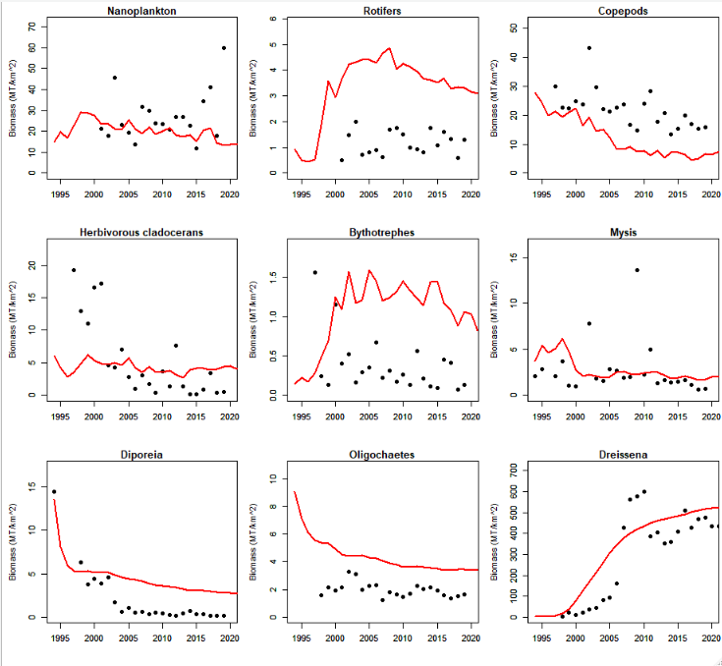
Figure SI-6. Comparisons between Atlantis model simulations (red line) and observations (black dots) for lower trophic groups.
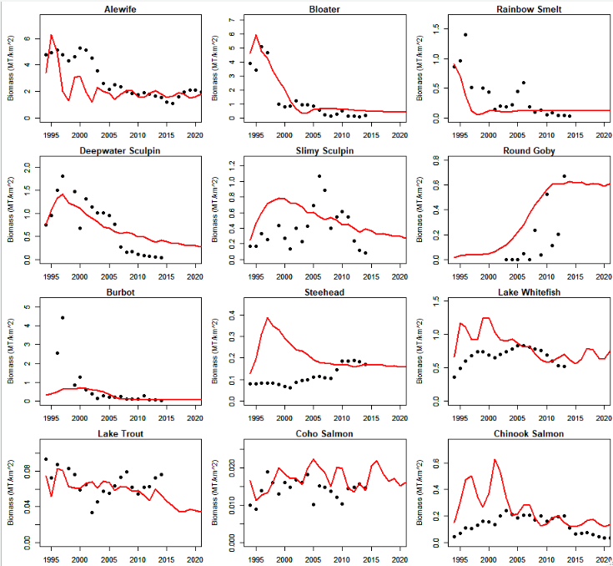
Figure SI-7. Comparisons between biomass simulations (red lines) and observations (black dots) for fish groups.

Table SI-7. Model skill assessment. Mean biomass (std) for observed and simulated biomass of Lake Michigan food web groups. RMSE is a root mean square error between simulated biomass and observed biomass and then normalized by the mean observed biomass.
 | Observations | Simulations | RMSE
Nanoplankton | 26.9 (11.76) | 19.8 (3.19) | 0.13
Rotifers | 1.2 (0.46) | 4 (0.47) | 0.19
Copepods | 22.0 (6.63) | 11.3 (6.01) | 0.40
Cladocerans | 5.3 (5.99) | 4.3 (0.83) | 0.19
Bythotrephes | 0.4 (0.35) | 1.2 (0.32) | 0.17
Mysis | 2.7 (2.79) | 2.8 (1.27) | 0.16
Diporeia | 2.0 (3.26) | 4.4 (2.18) | 0.14
Oligochaetes | 2.0 (0.51) | 4.1 (0.61) | 0.13
Dreissena | 303.8 (205.63) | 358.4 (165.91) | 0.07
Alewife | 2.9 (1.43) | 2.2 (1.11) | 0.12
Bloater | 1.3 (1.59) | 1.6 (1.78) | 0.11
Rainbow Smelt | 0.4 (0.37) | 0.2 (0.22) | 0.34
Deepwater Sculpin | 0.7 (0.57) | 0.8 (0.31) | 0.09
Slimy Sculpin | 0.4 (0.26) | 0.6 (0.15) | 0.13
Round Goby | 0.2 (0.23) | 0.4 (0.19) | 0.21
Burbot | 0.7 (1.12) | 0.3 (0.26) | 0.73
Steelhead | 0.1 (0.04) | 0.2 (0.07) | 0.16
Lake Whitefish | 0.7 (0.12) | 0.9 (0.21) | 0.08
Lake Trout | 0.07 (0.01) | 0.06 (0.01) | 0.05
Coho Salmon | 0.014 (0.003) | 0.02 (0.003) | 0.06
Chinook Salmon | 0.13 (0.06) | 0.3 (0.14) | 0.13
Total |  |  | 3.79

4. Results – species/group specific changes in response to S_M and C5_M
Figure SI-8. Percent change in species or taxa biomass under a scenario of sinusoidal VTD (S_M) relative to a baseline scenario of constant low VTD (C5-M) for fish (a) and lower trophic levels (b), with dreissenid mussels included in the model simulations (open bars, “M”) or excluded from the model simulations (gray bars, “no M”). Horizontal dotted lines represent the assumed level of significant difference in food web group biomass between sinusoidal VTD and low constant VTD: absolute values from 0 to 10% = negligible difference, absolute values from 10-19% = intermediate difference, and absolute value ≥20% = large difference. Values listed in (b) are the actual percentage changes in biomass above baseline for Mysis and herbivorous cladoceran.
References
Audzijonyte A, Gorton R, Kaplan A, Fulton EA (2017a) Atlantis user’s guide part I: General overview, physics & ecology. The Commonwealth Scientific and Industrial Research Organisation, Hobart, Australia.
Audzijonyte A, Gorton R, Kaplan A, Fulton EA (2017b) Atlantis user’s guide part II: Socio-Economics. The Commonwealth Scientific and Industrial Research Organisation, Hobart, Australia.
Bai X, Wang J, Schwab DJ, Yang Y, Luo L, Leshkevich GA, Liu S (2013) Modeling 1993-2008 climatology of seasonal general circulation and thermal structure in the Great Lakes using FVCOM. Ocean Modelling DOI:10.1016/j.ocemod.2013.02.003
Bierman Jr VJ, Dolan DM (1981) Modeling of phytoplankton-nutrient dynamics in Saginaw Bay, Lake Huron. Journal of Great Lakes Research 7:409-439
Bowie GL, Mills WB, Porcella DB, Campbell CL, Pagenkopf JR, Rupp GL, Johnson KM, Chan PWH, Gherini SA (1985) Rates, constants, and kinetics formulations in surface water quality modeling (second edition). EPA/600/3-85/040. Athens, Geogia.
Bruesewitz RE (1990) Population dynamics of burbot (Lota lota) in western Lake Michigan and Green Bay. Thesis, University of Wisconsin. Stevens Point
Bunnell DB, Madenjian CP, Claramunt RM (2006) Long-term changes of the Lake Michigan fish community following the reduction of exotic alewife (Alosa pseudoharengus). Canadian Journal of Fisheries and Aquatic Sciences 63:2434-2446
Cannon D, Fujisaki-Manome A, Wang J, Kessler J, Chu P (2023) Modeling changes in ice dynamics and subsurface thermal structure in Lake Michigan-Huron between 1979 - 2021. Ocean Dynamics this issue
Chen C, Liu H, & Beardsley RC (2003) An unstructured grid, finite-volume, three-dimensional, primitive equations ocean model: application to coastal ocean and estuaries. Journal of atmospheric and oceanic technology 20(1):159-186
Chen C, Beardsley R, Cowles G (2006) An unstructured grid, Finite-Volume Coastal Ocean Model (FVCOM) system. Oceanography 19:78–89 https://doi.org/10.5670/oceanog.2006.92
Chen C, Beardsley RC, Cowles G, Qi J, Lai Z, Gao G, Stuebe D, Xu Q et al (2013) An unstructured-grid, finite-volume community ocean model: FVCOM user manual. Sea Grant College Program, Massachusetts Institute of Technology. Cambridge, MA, USA
COSEWIC, 2006. COSEWIC assessment and update status report on the Deepwater Sculpin Myoxocephalus thompsonii (Western and Great Lakes-Western St. Lawrence populations) in Canada. Committee on the Status of Endangered Wildlife in Canada. Ottawa. vii + 39 pp. www.sararegistry.gc.ca/status/status_e.cfm
Fulton EA (2001) The effects of model structure and complexity on the behavior and performance of marine ecosystem models. Dissertation, University of Tasmania, Hobart, Tasmania, Australia.
Gray MA, Curry RA, Arciszewski TJ, Munkittrick KR, Brasfield SM (2018) The biology and ecology of slimy sculpin: A recipe for effective environmental monitoring. FACETS 3:103-127
He JX, Stewart DJ (2002) A stage-explicit expression of the von Bertalanffy growth model for understanding age at first reproduction of Great Lakes fishes. Canadian Journal of Fisheries and Aquatic Sciences 59:250-261
Hu H, Wang J (2010) Modeling effects of tidal and wave mixing on circulation and thermohaline structures in the Bering Sea: Process studies, Journal of Geophysical Research 115: C01006,doi:10.1029/2008JC005175
Hunke EC, Dukowicz JK (1997) An elastic–viscous–plastic model for sea ice dynamics. Journal of Physical Oceanography 27(9):1849-1867
Isaac EJ (2010) An evaluation of the importance of Mysis relicta to the Lake Superior fish community. Thesis. University of Minnesota.
Kao YC, Rogers MW, Bunnell DB (2018) Evaluating stocking efficacy in an ecosystem undergoing oligotrophication. Ecosystems 21:600-618
Kapuscinski KL, Zorn TG, Schneeberger PJ, O'Neal RP, Eggold BT (2010) The status of Lake Michigan Walleye stock. In: Roseman E, Kocovsky PM, Vandergoot CS (ed) Status of Walleye in the Great Lakes: Proceedings of the 2006 Symposium. Great Lakes Fish. Comm. Tech. Rep. 69. pp. 1044
Kornis MS, Mercado-Silva N, Vander Zanden MJ (2012) Twenty years of invasion: A review of round goby Neogobius melanostomus biology, spread and ecological implications. Journal of Fish Biology 80:235-285
Link JS, Fulton EA, Gamble RJ (2010) The northeast US application of ATLANTIS: A full system model exploring marine ecosystem dynamics in a living marine resource management context. Progress in Oceanography 87:214-234
Madenjian CP, DeSorcie TJ, Stedman RM (1998) Maturity schedules of lake trout in Lake Michigan. Journal of Great Lakes Research 24:404-410
Madenjian CP [ed] (2019) The state of Lake Michigan in 2016. Great Lakes Fishery Commission Special Publication. http://www.glfc.org/pubs/SpecialPubs/Sp19_01.pdf (accessed 12 Nov 2021)
Modeling Subcommittee Technical Fisheries Committee (2011) Technical Fisheries Committee Administrative Report 2011: Status of Lake Trout and Lake Whitefish populations in the 1836 Treaty-Ceded Waters of Lakes Superior, Huron and Michigan, with recommended yield and effort levels for 2011. http://www.michigan.gov/greatlakesconsentdecree
Pothoven SA, Nalepa TF, Schneeberger PJ, Brandt SB (2001) Changes in diet and body condition of lake whitefish in southern Lake Michigan associated with changes in benthos. North American Journal of Fisheries Management 21:876-883
Rogers MW, Bunnell DB, Madenjian CP, Warner DM (2014) Lake Michigan offshore ecosystem structure and food web changes from 1987 to 2008. Canadian Journal of Fisheries and Aquatic Sciences 71:1072-1086
Rudstam LG, Peppard PE, Fratt TW, Bruesewitz RE, Coble DW, Copes FA, Kitchell JF (1995) Prey consumption by the Burbot (Lota Lota) population in Green Bay, Lake Michigan, based on a bioenergetics model. Canadian Journal of Fisheries and Aquatic Sciences 52:1074-1082
Rutherford, E.S. 1997. Evaluation of natural reproduction, stocking rates, and fishing regulations for Steelhead Oncorhynchus mykiss, Chinook salmon O. tshawytscha, and coho salmon O. kisutch in Lake Michigan. Federal Aid in Sport Fish Restoration, Project F-35-R-22, Final Report, Fisheries Division, Michigan Department of Natural Resources, Ann Arbor, Mich.
Rutherford ES, Zhang H, Kao YC, Mason DM, Shakoor A, Bouma-Gregson K, Breck JT, Lodge DM, Chadderton WL (2021) Potential effects of bigheaded carps on four Laurentian Great Lakes Food Webs. North American Journal of Fisheries Management 41:999-1019
Stapanian MA, Witzel LD, Cook A (2010) Recruitment of burbot (Lota lota L.) in Lake Erie: an empirical modelling approach. Ecology of Freshwater Fish 19:326-337
Scavia D, Lang GA, Kitchell JF (1988) Dynamics of Lake Michigan plankton: A model evaluation of nutrient Loading, competition, and predation. Canadian Journal of Fisheries and Aquatic Sciences 45:165-177
Schneider JC, Laarman PW, Gowing H (2000) Chapter 17: Length-weight relationships. In: Schneider JC (ed) Manual of fisheries survey methods II: with periodic updates. Michigan Department of Natural Resources, Fisheries Special Report 25, Ann Arbor
Seelbach PW (1993) Population biology of Steelhead in a stable-flow, low-gradient tributary of Lake Michigan. Transactions of the American Fisheries Society 122:179-198
Stapanian, M. A., L. D. Witzel, and A. Cook. 2010. Recruitment of burbot (Lota lota L.) in Lake Erie: an empirical modelling approach. Ecology of Freshwater Fish 19:326-337
Sterner RW (1990) The ratio of nitrogen to phosphorus resupplied by herbivores: zooplankton and the algal competitive arena. The American Naturalist 136:209-229
Tomlinson LM, Auer MT, Bootsma HA, Owens EM (2010) The Great Lakes Cladophora Model: Development, testing, and application to Lake Michigan. Journal of Great Lakes Research 36:287-297
Tsehaye I, Jones ML, Bence JR, Brenden TO, Madenjian CP, Warner DM (2014a) A multispecies statistical age-structured model to assess predator-prey balance: Application to an intensively managed Lake Michigan pelagic fish community. Canadian Journal of Fisheries and Aquatic Sciences 71:627-644
Tsehaye I, Jones ML, Brenden TO, Bence JR, Claramunt RM (2014b) Changes in the salmonine community of Lake Michigan and their implications for predator–prey balance, Transactions of the American Fisheries Society 143(2):420-437
Weijerman M, Link J, Fulton E, Olsen E, Townsend H, Gaichas S, Hansen C, Skern-Mauritzen M, Kaplan I, Gamble R (2016) Atlantis ecosystem model summit: report from a workshop. Ecological Modelling 335:35-38
Wilberg MJ, Bence JR, Eggold BT, Makauskas D, Clapp DF (2005) Yellow Perch dynamics in southwestern Lake Michigan during 1986-2002. North American Journal of Fisheries Management 25:1130-1152

Updates on living document: https://research.csiro.au/atlantis/home/useful-references/
https://wiki.csiro.au/confluence/display/Atlantis/Atlantis+Ecosystem+Model+Home+Page

