Supplementary information
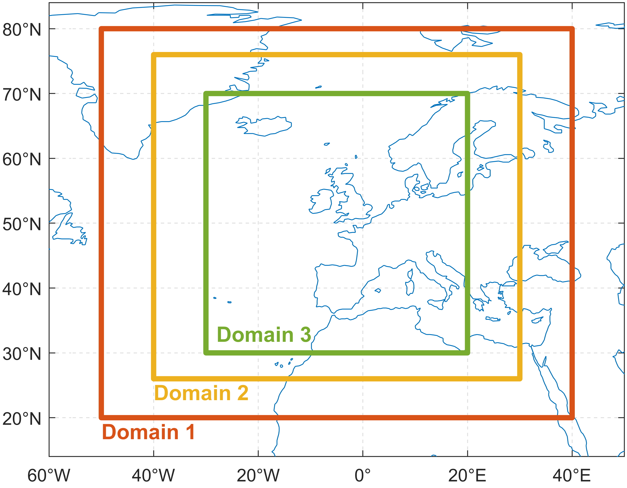
Fig. S1 The three spatial domains tested in this work

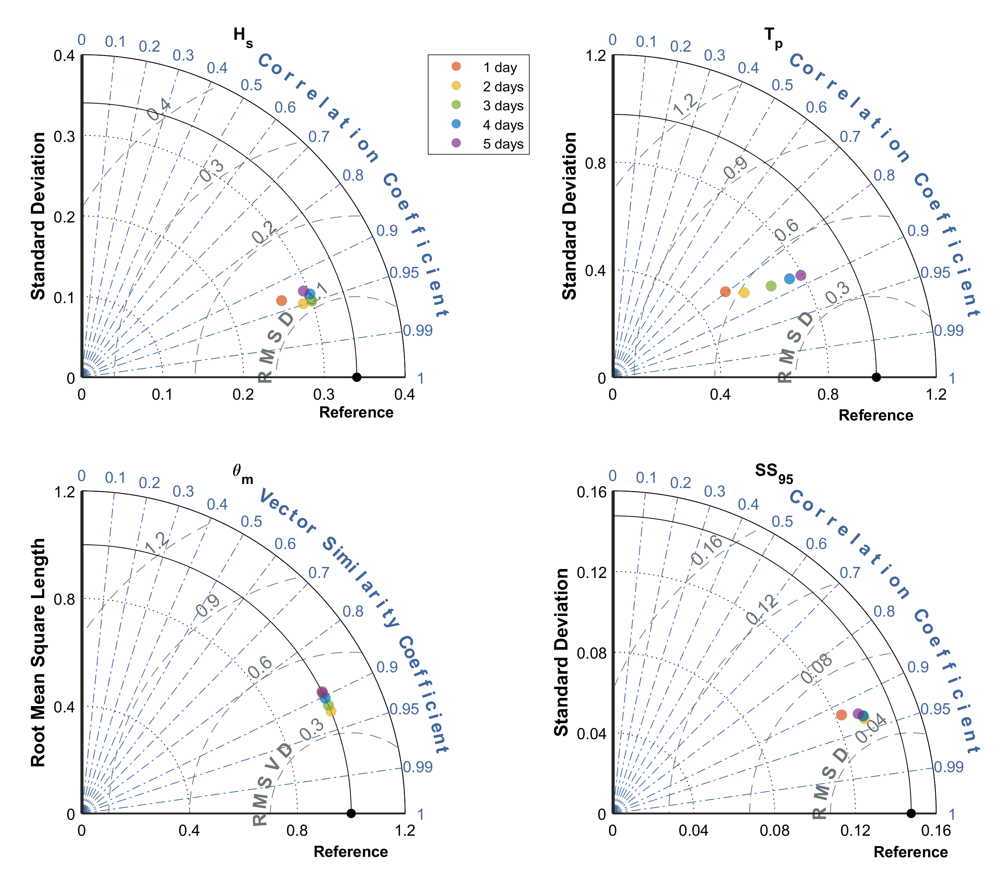
Fig. S2 Diagrams for comparing model performance in estimating total wave and storm surge conditions with different temporal coverages
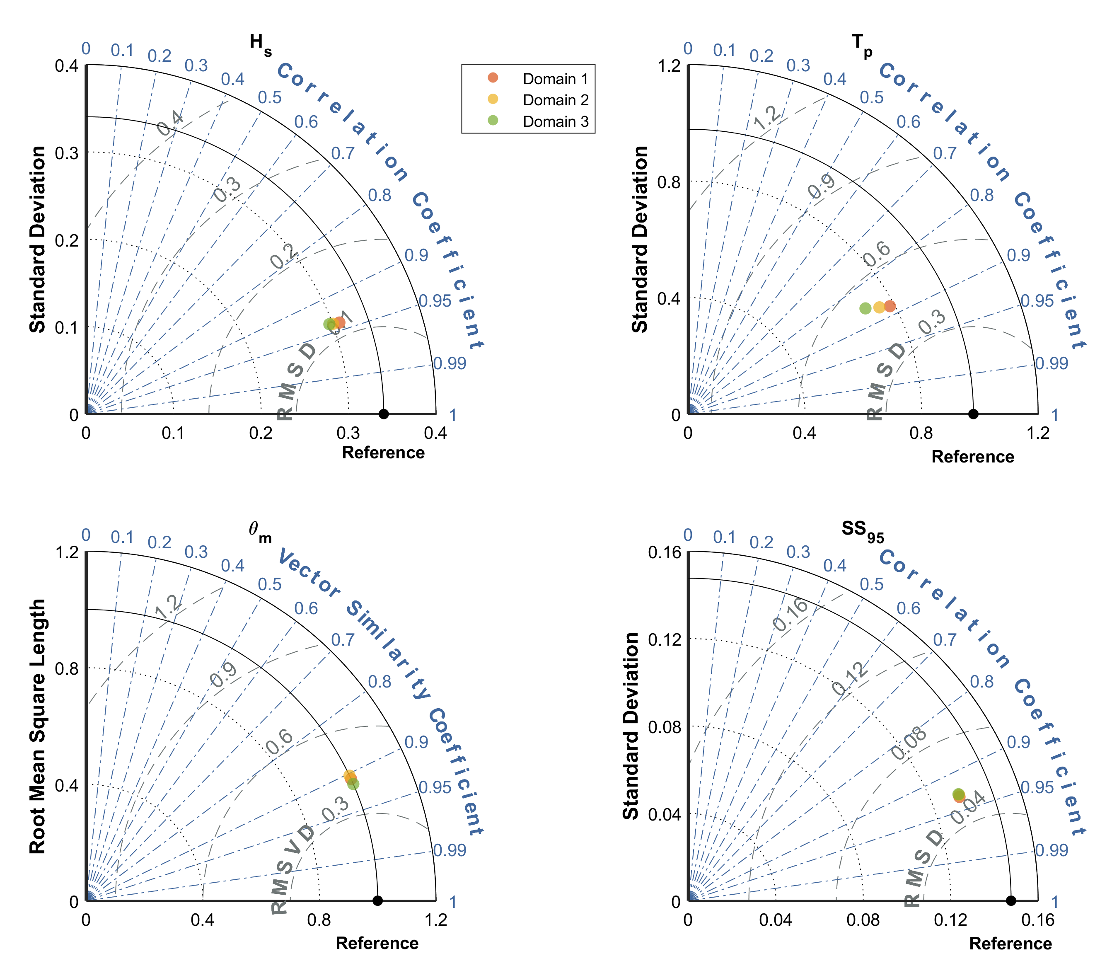
Fig. S3 Diagrams for comparing model performance in estimating total wave and storm surge conditions with different spatial domains
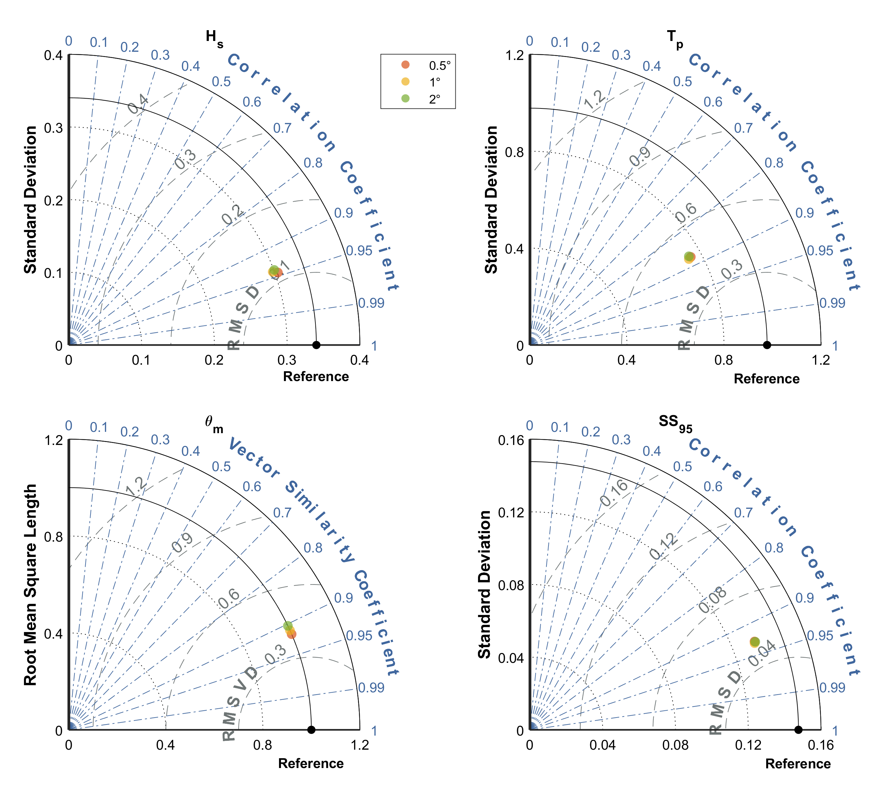
Fig. S4 Diagrams for comparing model performance in estimating total wave and storm surge conditions with different spatial resolutions of the predictor
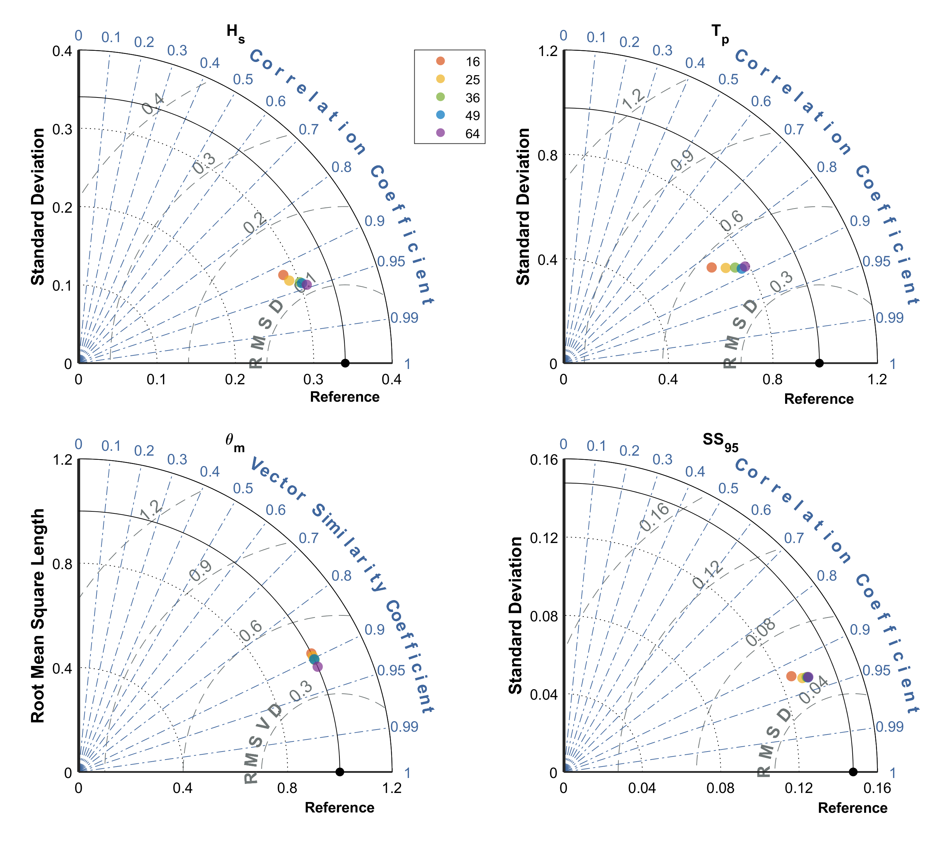
Fig. S5 Diagrams for comparing model performance in estimating total wave and storm surge conditions with different numbers of WTs
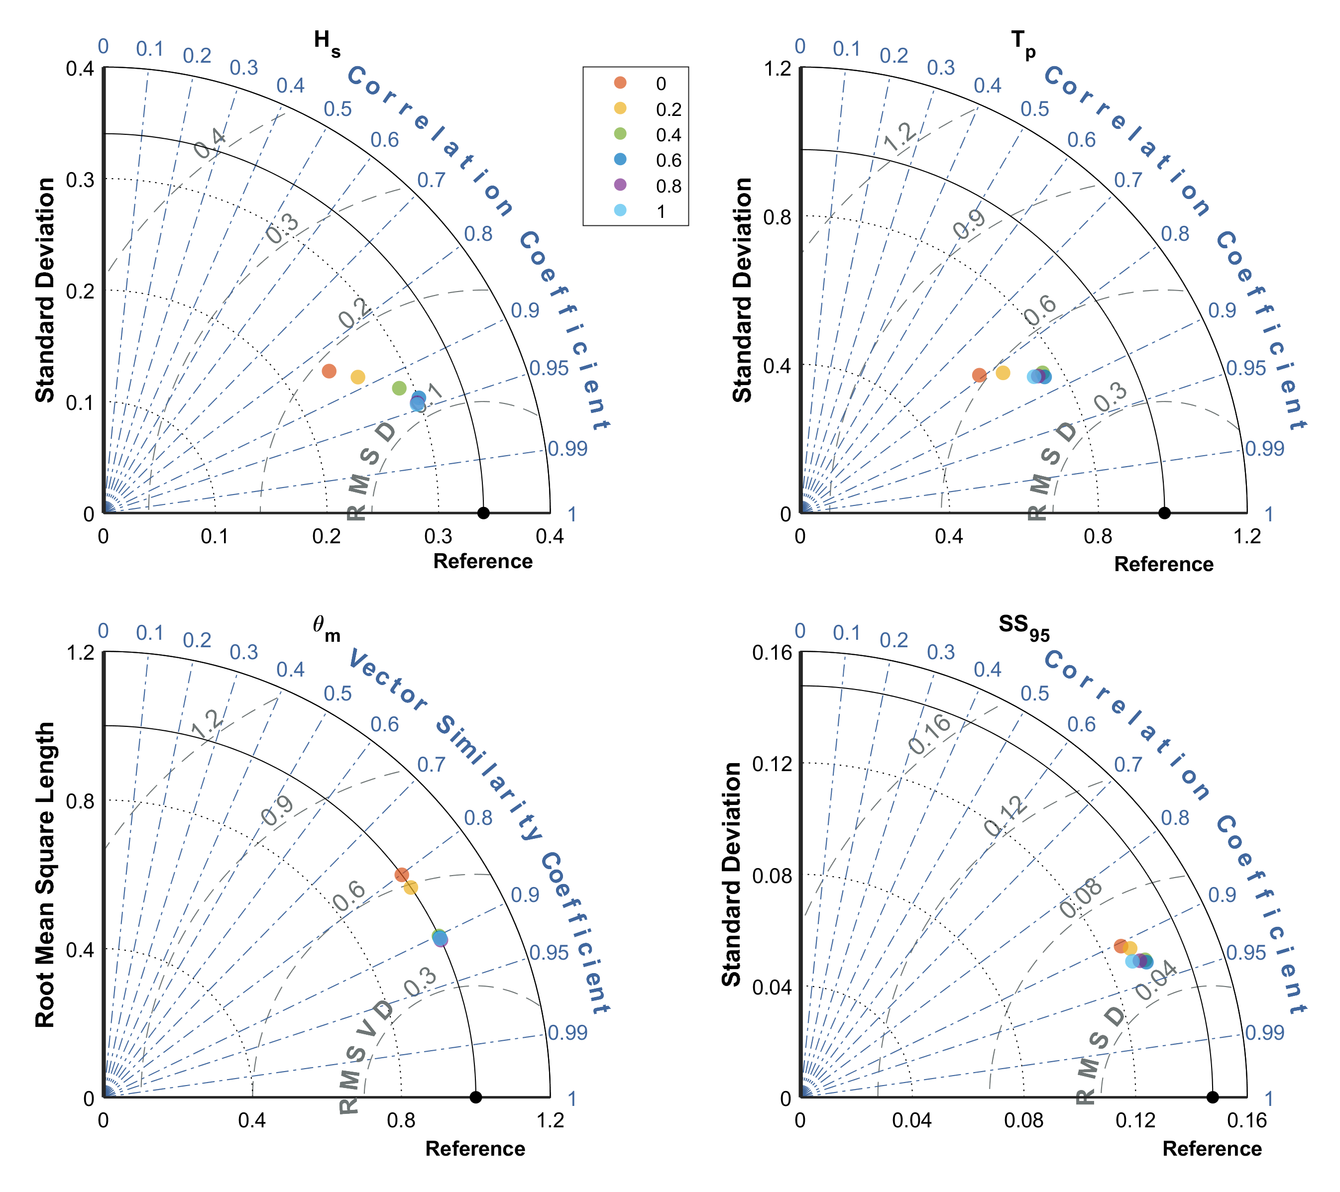
Fig. S6 Diagrams for comparing model performance in estimating total wave and storm surge conditions with different α values

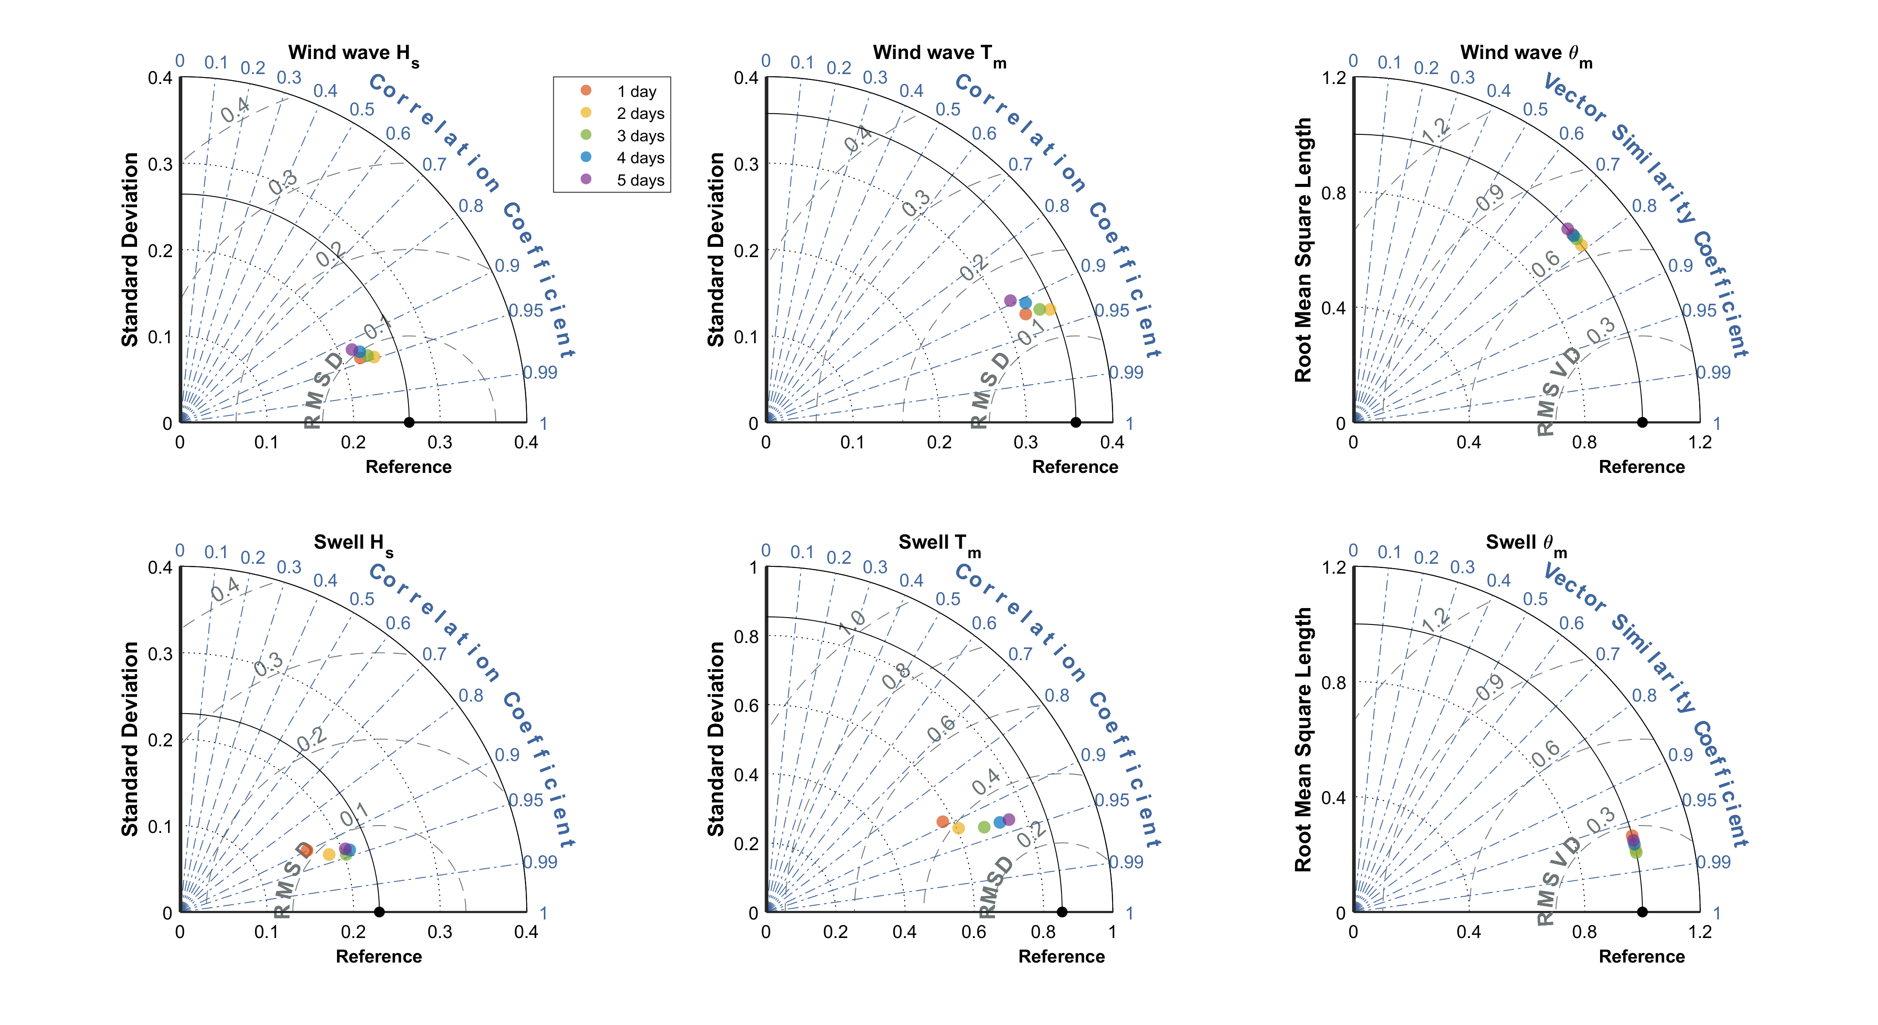
Fig. S7 Diagrams for comparing model performance in estimating wind wave and swell variables with different temporal coverages

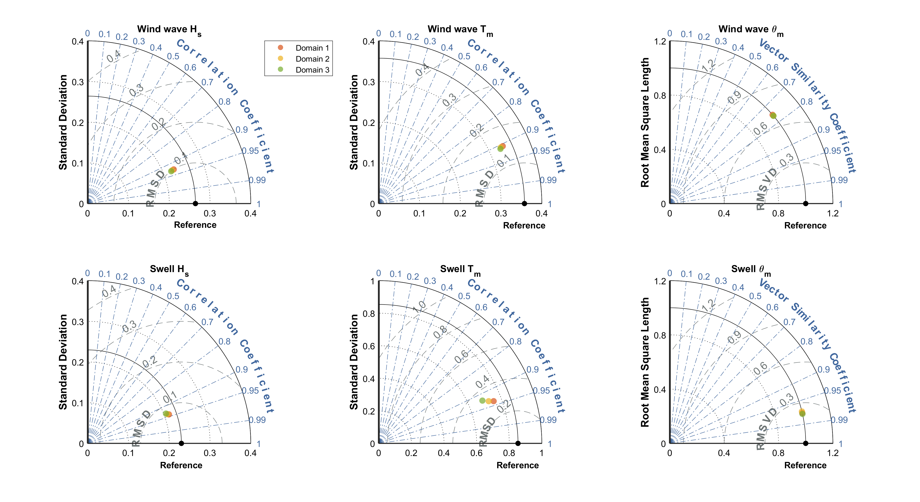
Fig. S8 Diagrams for comparing model performance in estimating wind wave and swell variables with different spatial domains
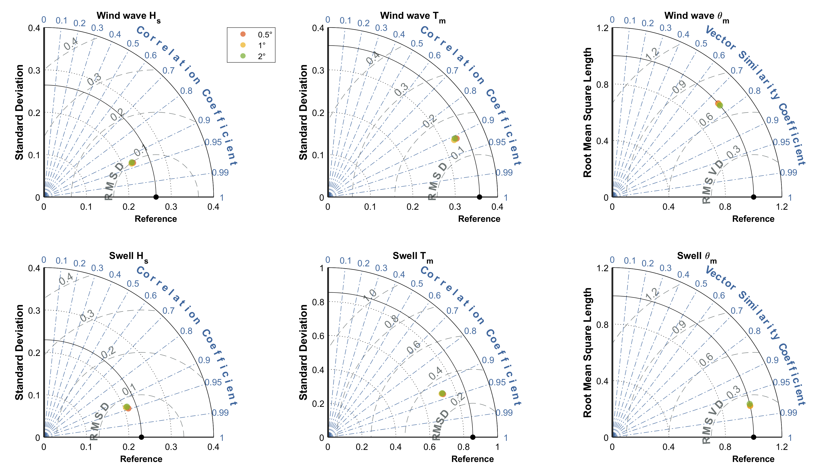
Fig. S9 Diagrams for comparing model performance in estimating wind wave and swell variables with different spatial resolutions of the predictor

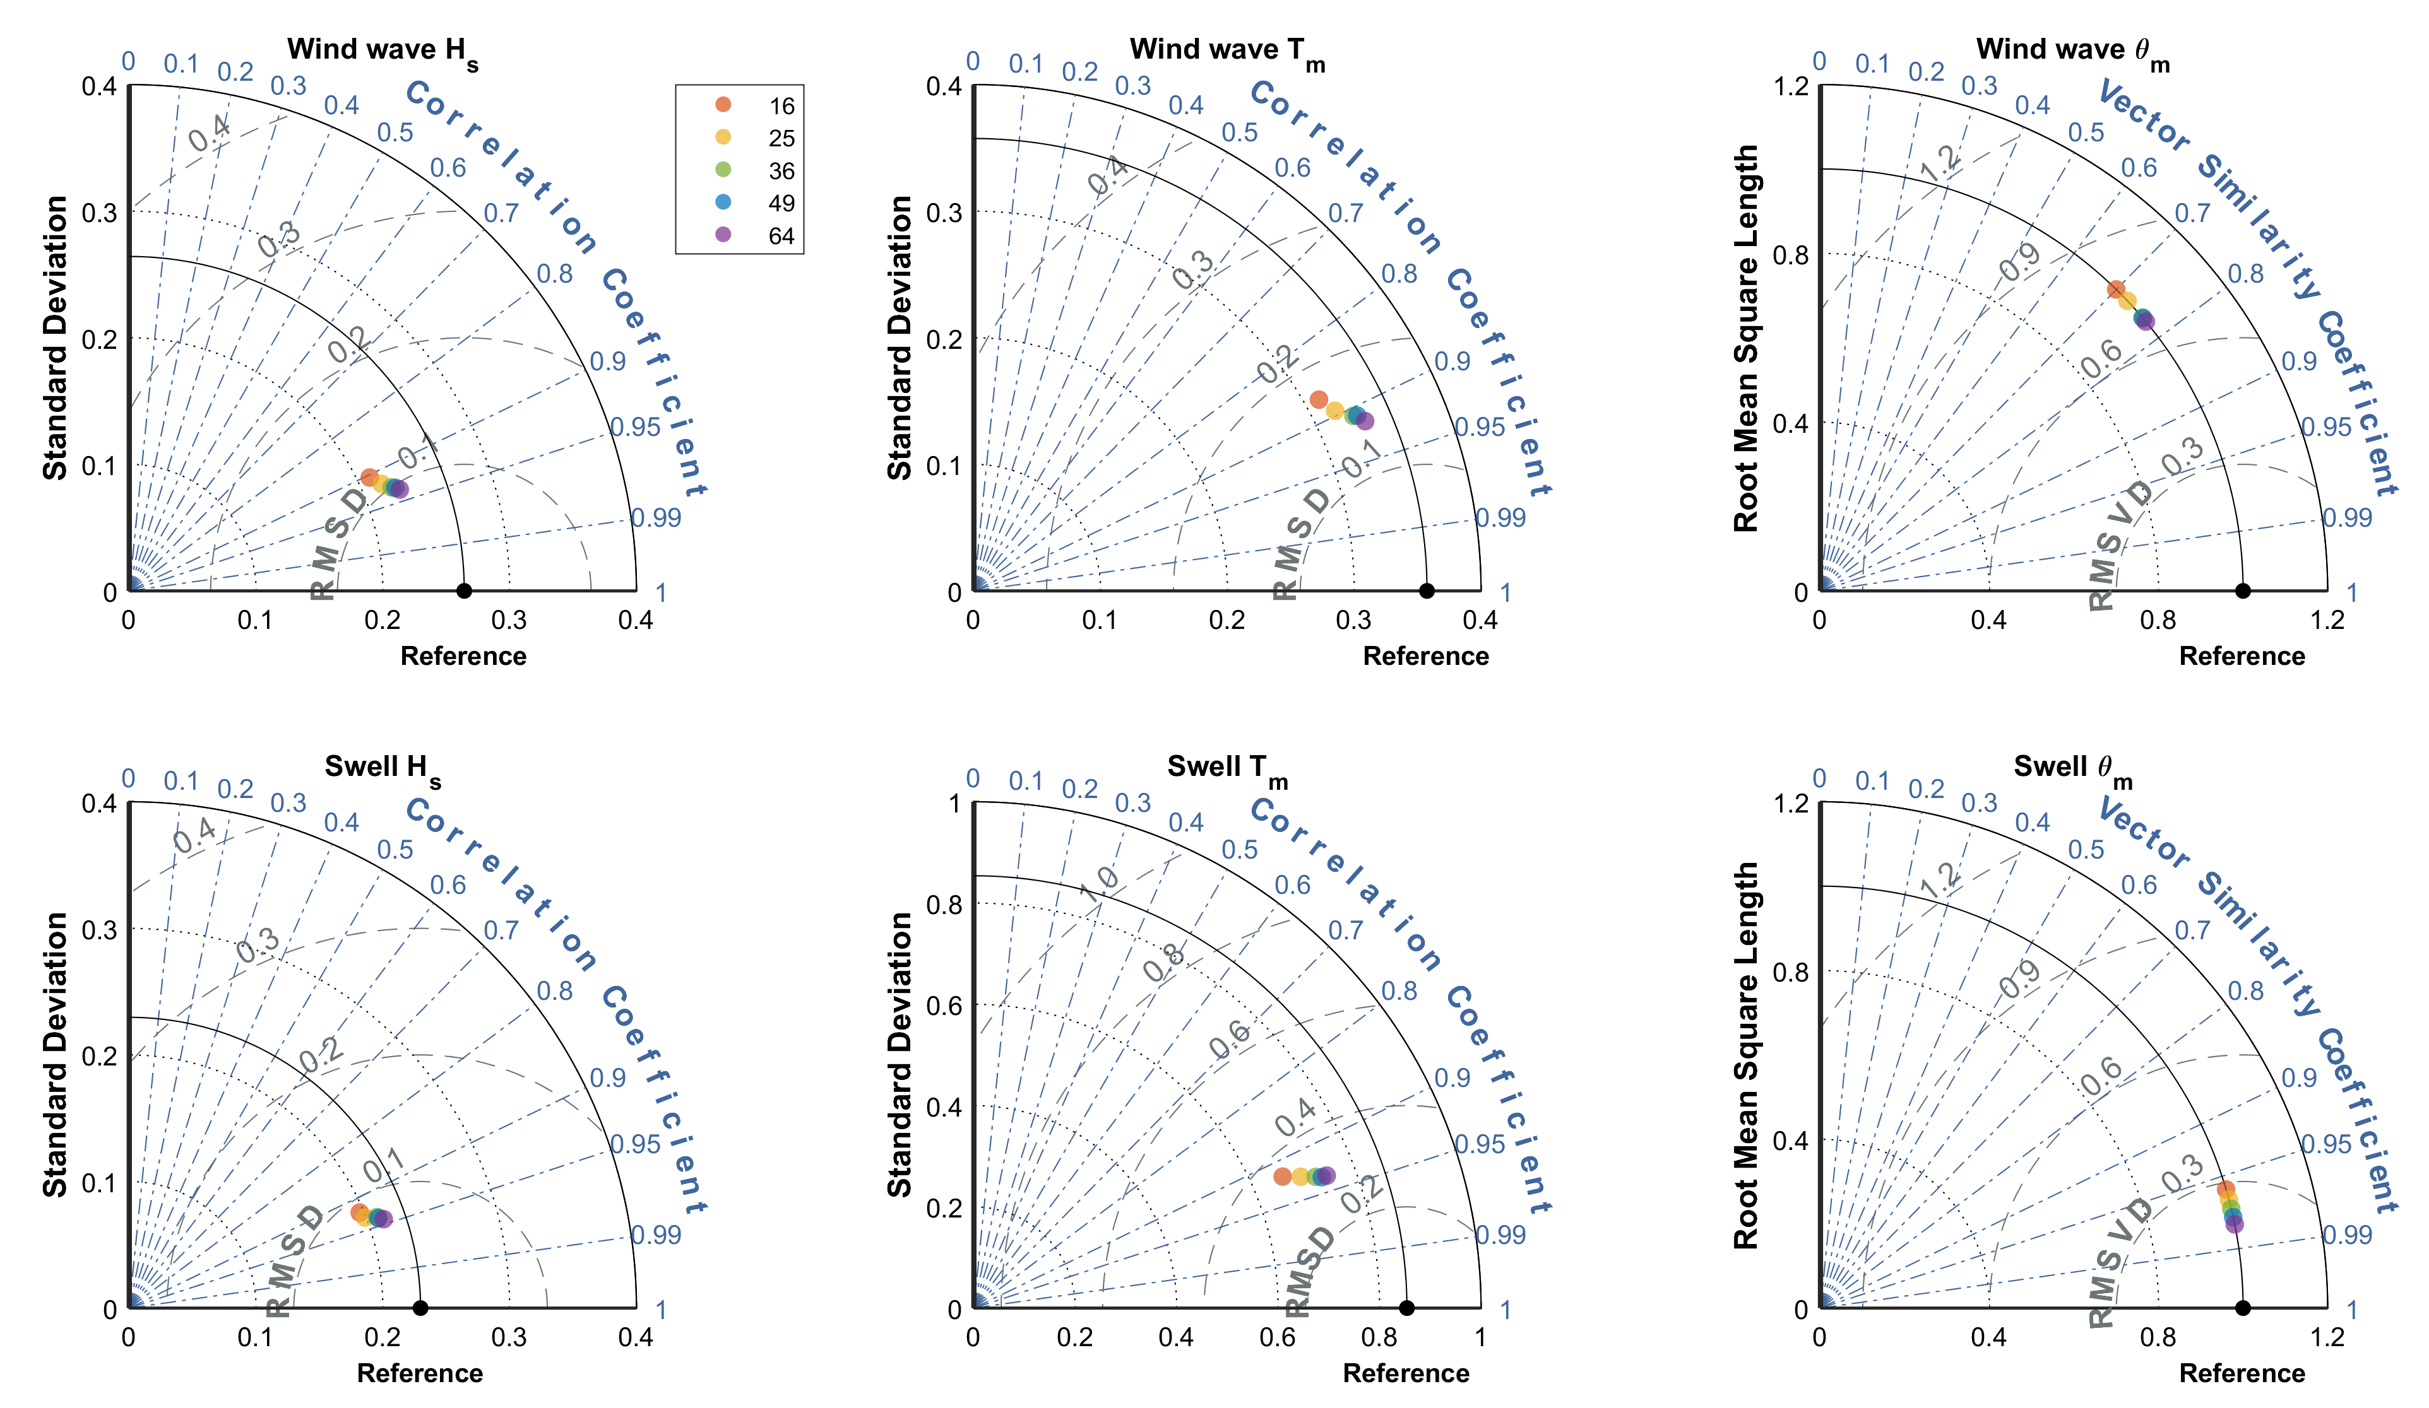
Fig. S10 Diagrams for comparing model performance in estimating wind wave and swell variables with different numbers of WTs
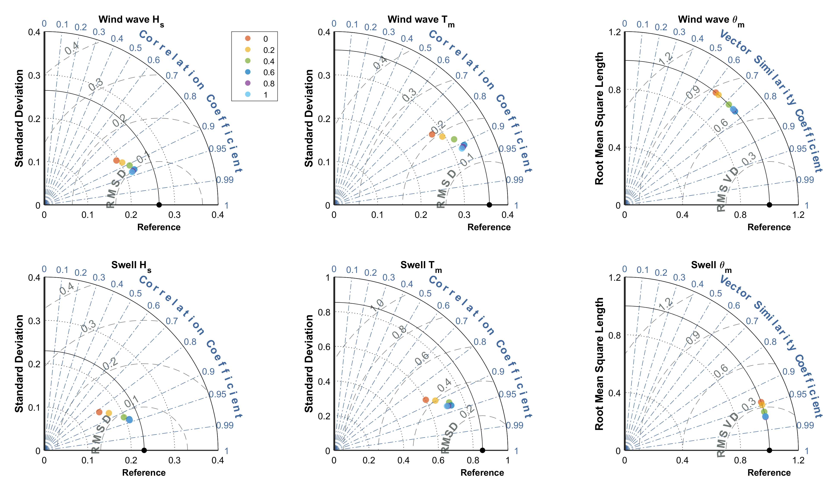
Fig. S11 Diagrams for comparing model performance in estimating wind wave and swell variables with different α values

