Supplmentary Information for
Distinct phase-locked local and remote forcing deepens the summer thermocline in the southern Bay of Bengal
Tuyi Chenª, Dongxiao Wang^{a,*}, Ke Huang^{b,*}, Qihua Peng^{c}
ª School of Marine Sciences, Sun Yat-sen University, and Southern Marine Science and Engineering Guangdong Laboratory (Zhuhai), Zhuhai, 519082, China.
^{b} State Key Laboratory of Tropical Oceanography, South China Sea Institute of Oceanology, Chinese Academy of Sciences, Guangzhou, 510301, China.
^{c} Scripps Institution of Oceanography, University of California San Diego, La Jolla, CA, 92093-0206, USA.

*Corresponding authors:
Dongxiao Wang, dxwang@mail.sysu.edu.cn;
Ke Huang, kehuang@scsio.ac.cn.

Fig. S1. Comparison of equatorial zonal wind stress using different datasets. Zonal wind stress along the equator from (a) ERA5 and (b) CCMP2.

Fig. S2. The spatial structure of monthly climatological surface dynamic pressure ($980 gcm^{-1}s^{-2}$) averaged from July to September. (a) Main run experiment; (b)-(e) 1st-4th baroclinic modes, (f) main run minus the sum of the first four modes.

Fig. S3. The Hovmöller diagram of monthly climatological surface dynamic pressure ($980 gcm^{-1}s^{-2}$). (a) Main run experiment, (b) no boundary reflection (only local forcing), (c) only boundary reflection (only remote forcing).

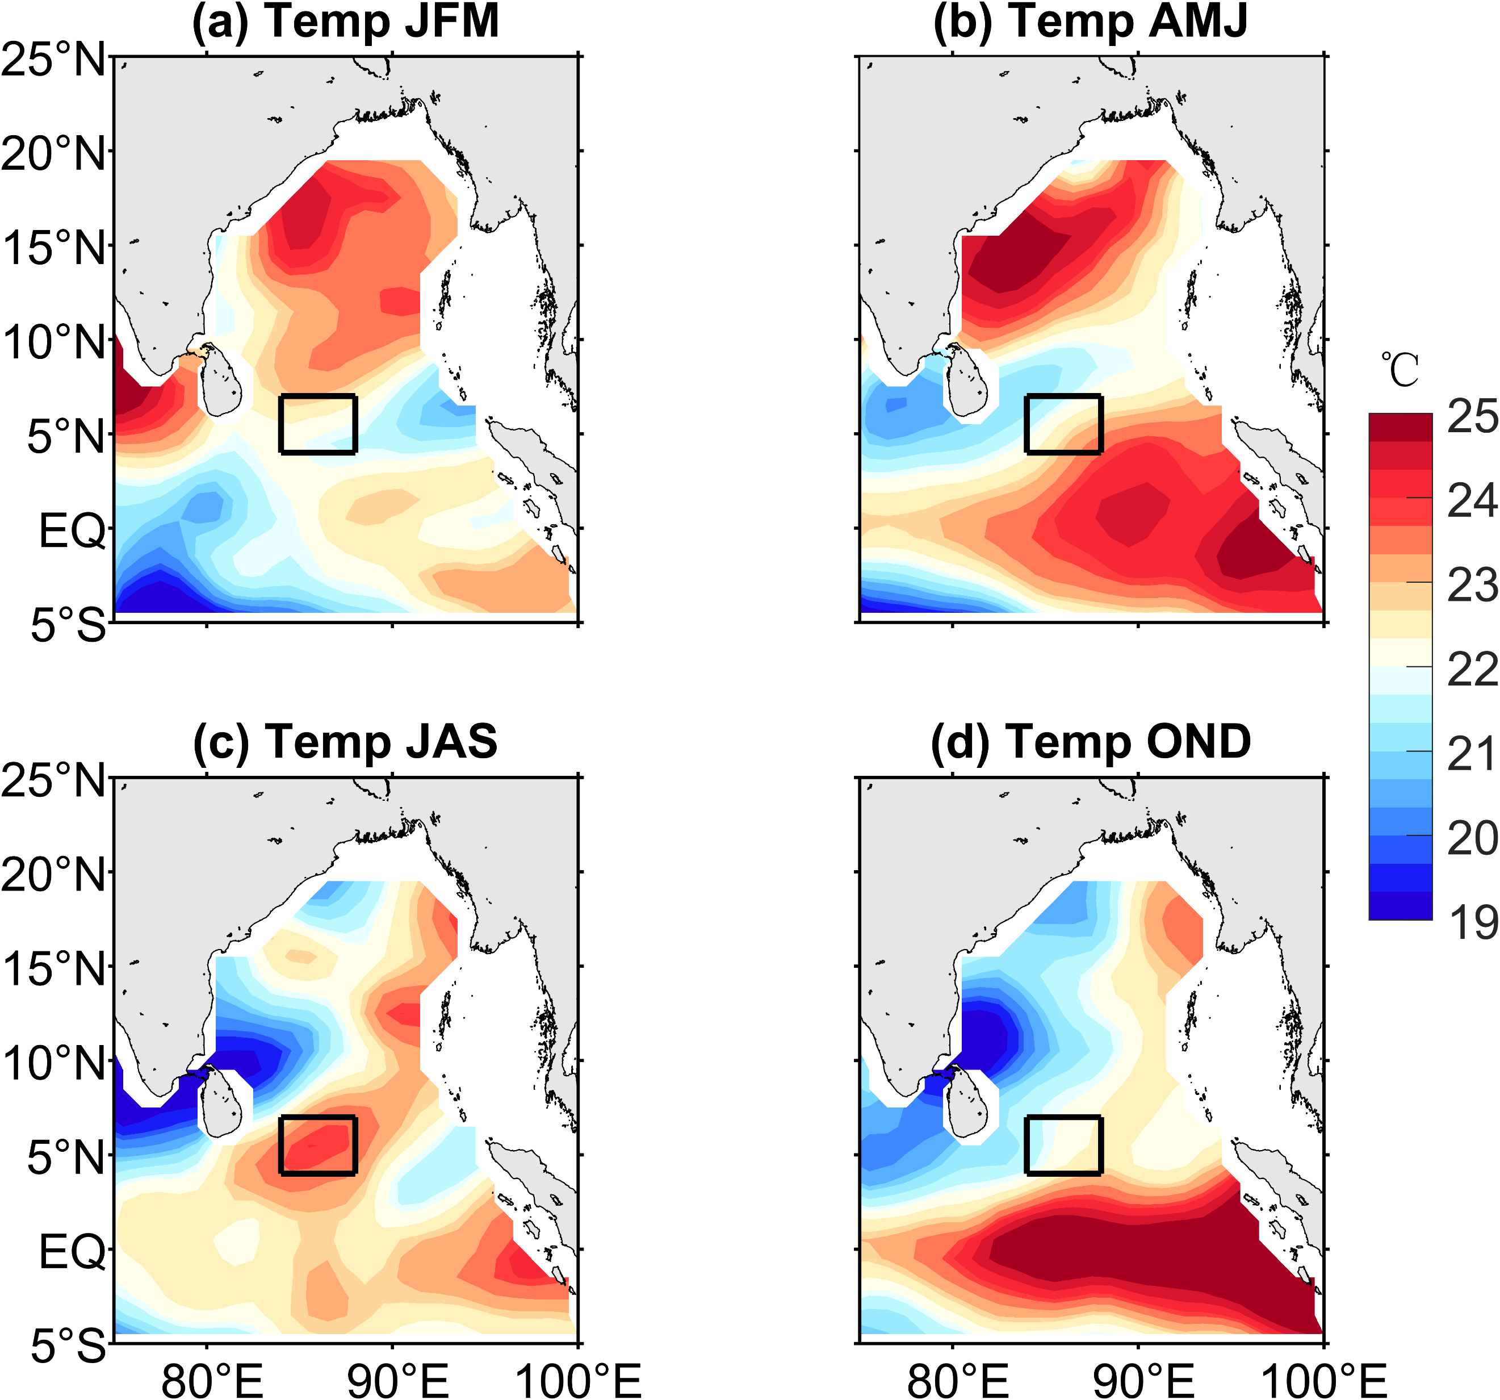
Fig. S4. Seasonal cycles of the climatological temperature at the depth of 100-m. (a) from January to March; (b) from April to June; (c) from July to September; (d) from October to December. The black box (4-7ºN, 84-88ºE) indicates the region of maximum temperature.

The Linear Ocean Model (LOM) and Experiments
A wind-forced, linear, continuously stratified LOM was used to assess the relative importance of the equatorial baroclinic modes in contributing to the sea surface height and the focused deepened thermocline structure in this study. The model is fully described in McCreary (1981) and has been widely applied to explain the dynamics of the Rossby waves and equatorial current system in the Indian Ocean (Chen et al., 2015; Huang et al., 2018, 2020). Consequently, the LOM can be used to investigate the equatorial waves dynamics in the Indian Ocean.
The linear equations of motion including the wind forcing term are:
$$\begin{aligned}u_{t}-f_{0}v+\frac{1}{\overline{ρ}}\frac{∂P}{∂x}=τ^{x}z\left(z\right)+{\left(νu_{z}\right)}_{z}+ν_{2}∇^{2}u\#\left(S1\right)\end{aligned}$$
$$\begin{aligned}{v_{t}+f}_{0}u+\frac{1}{\overline{ρ}}\frac{∂P}{∂y}=τ^{y}z\left(z\right)+{\left(νv_{z}\right)}_{z}+ν_{2}∇^{2}v\#\left(S2\right)\end{aligned}$$
$$\begin{aligned}\frac{∂P}{∂z}=-ρg\#\left(S3\right)\end{aligned}$$
$$\begin{aligned}\frac{∂u}{∂x}+\frac{∂v}{∂y}+\frac{∂w}{∂z}=0\#\left(S4\right)\end{aligned}$$
$$\begin{aligned}\frac{∂ρ}{∂t}+w\frac{∂\overline{ρ}}{∂z}=0\#\left(S5\right)\end{aligned}$$
where u, v, and w are the zonal, meridional and vertical velocity anomalies, P and $ρ$ are the pressure and density anomalies, respectively. $g$ is the acceleration due to gravity, $f =βy$ is the Coriolis parameter. The parameters $ν$ is the coefficient of vertical eddy viscosity and $ν_{2}$ is the coefficient of Laplacian mixing. $τ^{x}$ and $τ^{y}$ are the zonal and meridional wind stress that force the system, and the stress enters the ocean as body force with the vertical structure $z(z)$.
Considering the vertical mode decomposition, the Eqs. (S3) and (S5) reduced to:
$$\begin{aligned}\frac{1}{\overline{ρ}}\frac{∂^{2}P}{∂t∂z}=-N^{2}w\#\left(S6\right)\end{aligned}$$
$$\begin{aligned}N^{2}=-\frac{g}{\overline{ρ}}\frac{∂\overline{ρ}}{∂z}\#\left(S7\right)\end{aligned}$$
Where N is the Brunt-Väisälä frequency, which is calculated from the vertical profile of potential density from the ORAS4 data. Under the shallow water approximation, the horizontal velocity and pressure are expressed as:
$$\begin{aligned}\left(u,v,P\right)=\sum_{n=0}^{∞}{\left(u_{n}\left(x,y,t\right),v_{n}\left(x,y,t\right),p_{n}\left(x,y,t\right)\right)}ψ_{n}(z)\#\left(S8\right)\end{aligned}$$
Using the continuity equation, we have:
$$\begin{aligned}\frac{∂w}{∂z}=-\frac{∂u}{∂x}-\frac{∂v}{∂y} \\ =-\sum{\left(\frac{∂u_{n}\left(x,y,t\right)}{∂x}+\frac{∂v_{n}\left(x,y,t\right)}{∂y}\right)}ψ_{n}\left(z\right) \\ =\sum_{n=0}^{∞}{\left(w_{n}\left(x,y,t\right)\right)}ψ_{n}\left(z\right)\#\left(S9\right)\end{aligned}$$
Assume that $w_{n}\left(x,y,t\right)=-\frac{∂u_{n}\left(x,y,t\right)}{∂x}-\frac{∂v_{n}\left(x,y,t\right)}{∂y}$. Integrated Eq. (S9), we have
$$\begin{aligned}w=\sum_{n=0}^{∞}{\left(w_{n}\left(x,y,t\right)\right)}S_{n}\left(z\right), [\frac{∂S_{n}\left(z\right)}{∂z}=ψ_{n}(z)]\#\left(S10\right)\end{aligned}$$
where $S_{n}\left(z\right)$ is the vertical structure functions of vertical velocity. Substitution of Eqs. (S8) and (S10) into Eq. (S6) gives
$$\begin{aligned}\sum_{n=0}^{∞}{\left(\frac{1}{\overline{ρ}}\frac{∂^{2}p_{n}\left(x,y,t\right)ψ_{n}(z)}{∂t∂z}\right)}=-N^{2}\sum_{n=0}^{∞}{\left(w_{n}\left(x,y,t\right)\right)S_{n}\left(z\right)}\#\left(S11\right)\end{aligned}$$
$$\begin{aligned}\frac{dψ_{n}(z)/dz}{N^{2}S_{n}\left(z\right)}=\frac{\overline{ρ}w_{n}}{∂p_{n}/∂t}=-\frac{1}{c_{n}^{2}}\#\left(S12\right)\end{aligned}$$
As the first term in Eq. (S12) is a function of z alone and the second term is a function of (x, y, t) alone, both terms must be equal to a constant for consistency. Here we take the “separation constant” to be $-1/c_{n}^{2}$ as in Eq. (S12), and the eigenvalue $c_{n}$ is also known as the characteristic speed for the mode n. Then the vertical structure simplified from Eq. (S11) is given as
$$\begin{aligned}\frac{1}{N^{2}}\frac{dψ_{n}(z)}{dz}=-\frac{1}{c_{n}^{2}}S_{n}\left(z\right) \#\left(S13\right)\end{aligned}$$
Taking the z-derivative, we have
$$\begin{aligned}\frac{d}{dz}\left(\frac{1}{N^{2}}\frac{dψ_{n}\left(z\right)}{dz}\right)+\frac{1}{c_{n}^{2}}ψ_{n}\left(z\right)=0\#\left(S14\right)\end{aligned}$$
The $ψ_{n}(z)$ forms a set of orthogonal functions and are normalized by $ψ_{n}\left(0\right)=1$ for all n. We can solve this eigenvalue problem numerically from the vertical density profile of independent ocean reanalysis datasets.
The LOM is configured for an idealized Indian Ocean basin and first spun up for 20 years. Then the model is integrated forward in time using monthly CCMP winds from 1979 to 2018. This solution is referred to as the LOM main run (“MR”). To isolate the effects of eastern boundary-reflected Rossby waves, the second experiment is performed with a damper in the eastern equatorial ocean, which is named as “Damp”. This damper is nonzero only in the eastern equatorial ocean and can efficiently absorb the energy of incoming equatorial Kelvin waves. Therefore, no Rossby waves are reflected back into the ocean interior from the eastern boundary in the experiments. Since the model is linearized, the “MR” minus “Damp” can represent the effects of reflected Rossby wave only (named the “Reflect” experiment).
According to Fig. S3, the “MR” experiment can be well described by the first four barocline mode, with the first two barocline mode being the most dominated. M2 exhibit the closest agreement with the observed deepened thermocline, suggesting that the second barocline mode is governing this phenomenon. The results of “Reflect” experiment shows the remote forcing exists significant semi-annual cycle (Fig. S4), which is consistent with the result of “Remote” experiment conduct by 1.5-layer reduced gravity model. It also demonstrated that the nonlinear term in the governing equations of 1.5-layer model do not affect our analysis.

