Supplementary Materials

To increase the confidence in predicting tissue strain in living subjects, we compared the KTH FE model displacement and strain predictions to experimental displacements and strains measured in a human volunteer using tagged MRI during mild frontal impact (Feng et al. 2010). In the experiments by Feng and coworkers (Feng et al. 2010), a mild angular deceleration of the head of a volunteer was generated using a device which rotated about a pivot allowing constrained motion in the anterior-posterior direction. In the device, a frame holding the head dropped approximately 2 cm and hit a rubber stop. To reproduce the experimental set-up with the FE head model, the skull was assumed to be a rigid-body to which the experimental skull rigid-body motion was applied. Estimated skull-brain relative displacement from the FE simulations in the sagittal plane was directly compared to experiments (Figure S1a).

Experimental maximum principal strain was calculated from the measured displacement field using Delunay triangulation of the grid points corresponding to the intersection of the tagged MRI lines followed by a least square identification of the gradient of deformation F for each triangle (Feng et al. 2010). To summarize, intersection points in reference (pre-impact) and deformed (post-impact) configurations were used to generate a mesh of triangular elements (Figures S1b top). We obtained the deformation gradient tensor, F, by fitting the equation:

$$dx_{i}=FdX_{i} i=1,2,3$$

where $dX_{i}$ is a vector from one triangle vertex to another in the reference configuration, and $dx_{i}$ is that same segment in the deformed configuration. We calculated the Lagrangian strain tensor, E, from F as following:

$$E=\frac{1}{2}(F^{T}F-I)$$

The Green-Lagrange maximum principal strain was calculated as the biggest eigenvalue of E. In Figure S1b we colored the face for each triangle in the mesh with the maximum principal Green-Lagrange strain at 39.2, 44.8, 50.4, 56.0 and 61.6 ms (Figure S1b).

As it can be seen from Figure S1a, the KTH model tended to underestimate the magnitude of displacement seen in the experiment. While measured displacement reached almost 3mm, the maximum predicted displacement was around 2 mm. Relative skull-brain displacement peak errors were on average 1 mm or less. The FE model correctly localized the motion: the biggest displacement was found in the parietal lobe of the brain, peaked around 40-50 ms and successively decreased (Figure S1a). A similar pattern can be seen for the predictions of maximum principal strain (Figure S1b): the KTH model tended to underestimate the magnitude of strain, with average peak errors of 37%. However, the simulated FE model strain was largest in the frontal/parietal lobe and the skull base, which was in agreement with the in vivo experiment.
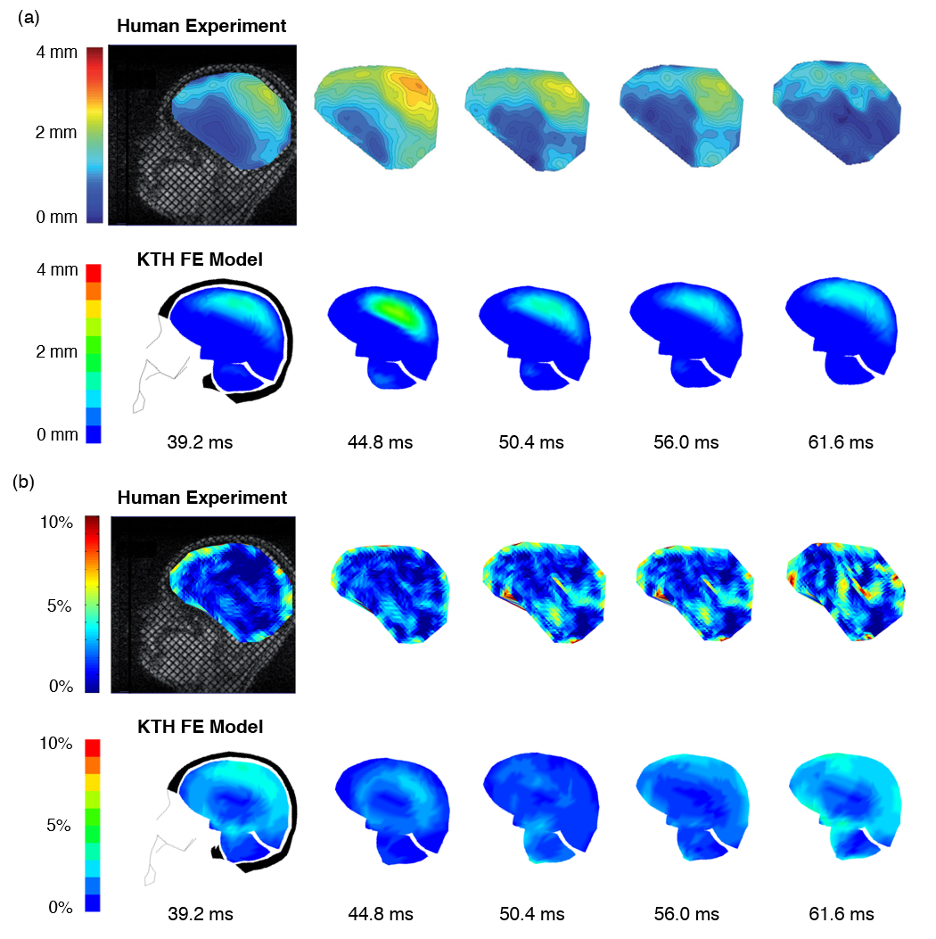
Figure S1: Model prediction of skull-brain relative displacement and brain strain compared to a human volunteer experiment. In the experiment, kinematics of a mild frontal impact were generated using a pivot device while displacement and strain were measured using tagged MRI. The KTH FE model tended to underestimate the magnitudes of displacement and strain but correctly localized them, spatially and temporally.

