Supplementary materials
Supplement 1
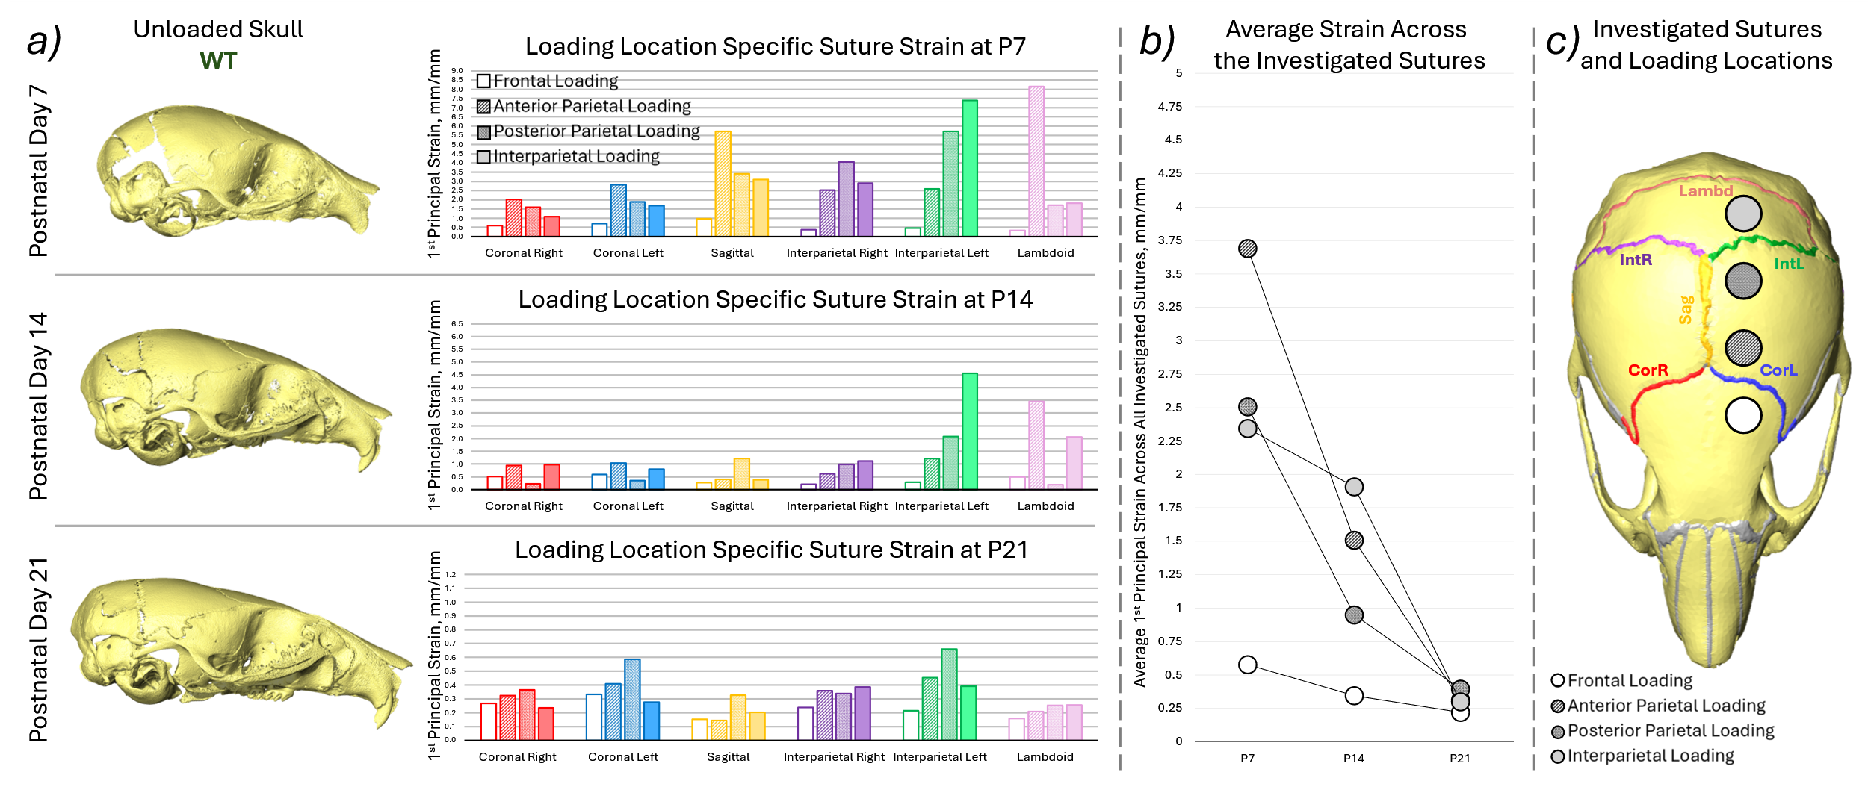
Fig. S1. a) Representative unloaded skull shapes at the three investigated ages (P7, P14 and P21) for WT animals, average 1st principal strain suture strain results for each investigated suture for the 4 different loading conditions (empty box – frontal bone, hashed box – anterior part of the parietal bone, dotted box – posterior part of the parietal bone and solid filled box – interparietal bone), b) average 1st principal strain across all of the investigated sutures compared with age for the 4 different loading conditions, c) highlighted investigated sutures and the approximate loading locations.

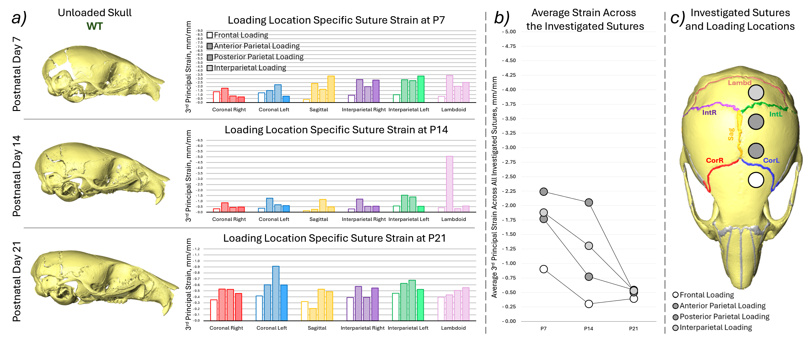
Fig. S2. a) Representative unloaded skull shapes at the three investigated ages (P7, P14 and P21) for WT animals, average 3rd principal strain suture strain results for each investigated suture for the 4 different loading conditions (empty box – frontal bone, hashed box – anterior part of the parietal bone, dotted box – posterior part of the parietal bone and solid filled box – interparietal bone), b) average 3rd principal strain across all of the investigated sutures compared with age for the 4 different loading conditions, c) highlighted investigated sutures and the approximate loading locations.

