Supplementary Materials
Stretch
Stress [kPa]
Fig. S1 Regression curve fit results for viscoelastic neo-Hookean (blue), Mooney-Rivlin (yellow), Arruda-Boyce (green), Gent (orange), and Ogden (purple) models for Ca1 = day 0, Ca2 = day 1, Ca3 = day 1-0.2 M CaCl₂, Ca4 = day 1-2 M CaCl₂, Ca5 = day 10, Ca6 = day 10-0.2 M CaCl₂, and Ca7 = day 10-2 M CaCl₂ clot types at 0.1/s stretch rate plotted against experimental data (dotted curves)

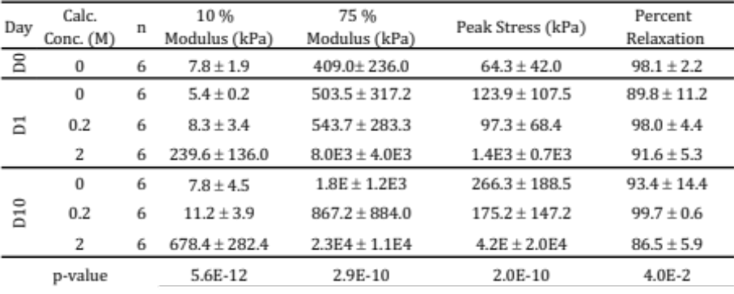
Table S1 Calcified Clot Analog uniaxial compressive data. Sample size (n), low and high strain tangent moduli, compressive peak stress at 80% strain, and percent relaxation are listed with mean values ± standard deviation. Data were collected for day 0, day 1, day 1-0.2 M CaCl₂, day 1-2 M CaCl₂, day 10, day 10-0.2 M CaCl₂, day 10-2 M CaCl₂. One way ANOVA p-value results are listed for all groups
Fig. S2 a. Regression curve fit results for representative viscoelastic Gent model for day 0 aged clot types at 0.05 (blue), 0.1 (orange), 0.15/s (green) stretch rate fits (solid lines) plotted against experimental data (dotted curves). b. Corresponding iso-contours for the elastic contribution to the stress of the tensile fits. c-d. Re-fitted tensile fits and corresponding iso-contours with manual constraint on the determinant of the Hessian of the elastic energy imposed.

Table S2 Calcified Clot Analog uniaxial tensile data. Sample size (n), low and high strain tangent moduli, compressive peak stress at 80% strain, and percent relaxation are listed with mean values ± standard deviation. Data were collected for day 0, day 1, day 1-0.2 M CaCl₂, day 1-2 M CaCl₂, day 10, day 10-0.2 M CaCl₂, day 10-2 M CaCl₂. One way ANOVA p-value results are listed for all groups

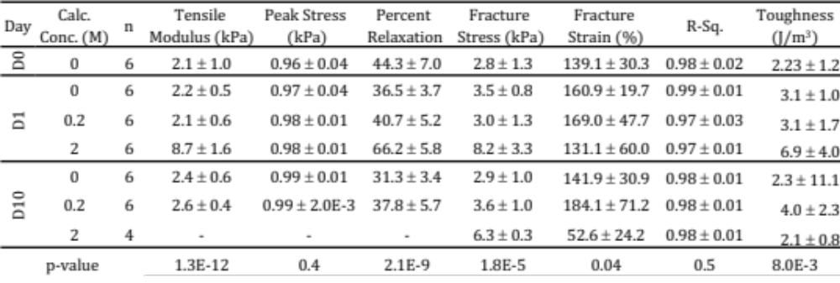
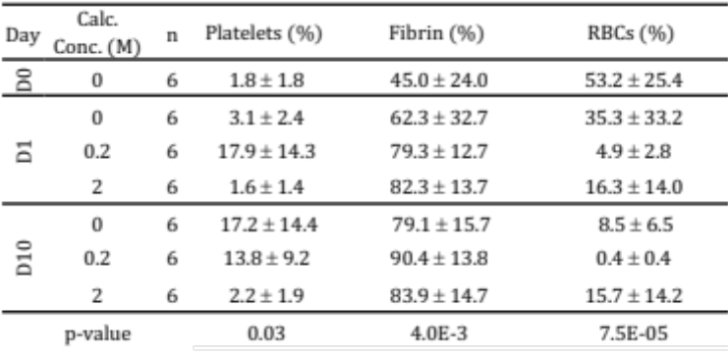
Table S3 Calcified Clot Analog Carstairs analysis data. Sample size (n), percentage platelets, fibrin, and red blood cells (RBCs) are listed with mean values ± standard deviation. Data were collected for day 0, day 1, day 1-0.2 M CaCl₂, day 1-2 M CaCl₂, day 10, day 10-0.2 M CaCl₂, day 10-2 M CaCl₂. One way ANOVA p-value results are listed for all groups

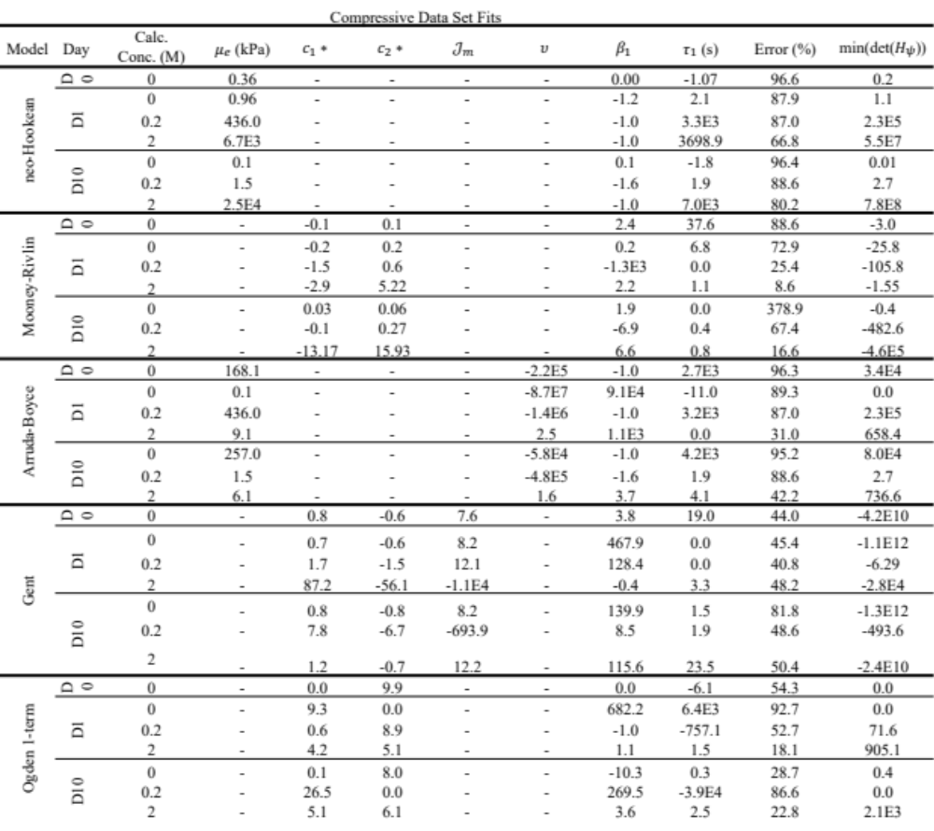
Table S4 Calcified Clot Analog curve fitting parameters for neo-Hookean, Mooney-Rivlin, Arruda-Boyce, Gent, and Ogden type models on the compressive portion of the data. Data were fitted for day 0, day 1, day 1-0.2 M CaCl₂, day 1-2 M CaCl₂, day 10, day 10-0.2 M CaCl₂, day 10-2 M CaCl₂. Relative error is measured in percent, and det($H_{ψ}$) is the calculated minimum of det($H_{ψ}$), the determinant of the Hessian of the strain energy density

Table S5 Calcified Clot Analog curve fitting parameters for neo-Hookean, Mooney-Rivlin, Arruda-Boyce, Gent, and Ogden type models on the tensile portion of the data. Data were fitted for day 0, day 1, day 1-0.2 M CaCl₂, day 1-2 M CaCl₂, day 10, day 10-0.2 M CaCl₂, day 10-2 M CaCl₂. Relative error is measured in percent, and det($H_{ψ}$) is the calculated minimum of det($H_{ψ}$), the determinant of the Hessian of the strain energy density

