Table 1：Frequency of mutations in AA and MDS groups.
Gene | AA | MDS | P value
ASXL1 | 2.9% | 18.4% | <0.001
DNMT3A | 1.8% | 5.2% | 0.043
TET2 | 1.8% | 6.9% | 0.005
U2AF1 | 0.7% | 24.7% | <0.001
RUNX1 | 0.7% | 5.7% | 0.002
ETV6 | 0.7% | 4.0% | 0.031
SETBP1 | 0.4% | 5.2% | 0.001
SRSF2 | 0.4% | 4.6% | 0.003
CBL | 0.4% | 4.0% | 0.006
NRAS | 0.4% | 4.0% | 0.006
CEBPA | 0.4% | 2.3% | 0.074
NPM1 | 0.4% | 2.3% | 0.074
KIT | 0.4% | 0.0% | -
TP53 | 0.0% | 13.2% | -
SF3B1 | 0.0% | 4.6% | -
IDH1 | 0.0% | 2.9% | -
PHF6 | 0.0% | 2.9% | -
JAK2 | 0.0% | 1.7% | -
GATA2 | 0.0% | 0.6% | -
IDH2 | 0.0% | 1.1% | -
FLT3-TKD | 0.0% | 0.6% | -
ZRSR2 | 0.0% | 0.6% | -

Table 2：Details of all the somatic mutations in AA patients.
ID | somatic mutations | Protein | VAF (%)
55 | ASXL1  SETBP1  RUNX1 | p. H630fs  p.E858K  p. Q185X | 7.38  40.34  46.44
214 | ASXL1 | p.R725fs | 46.06
19 | ASXL1 | p.Q780X | 12.4
136 | ASXL1 | p.Y700X  p.P1042fs | 11  10.5
14 | ASXL1 | p.G642fs | 6.5
79 | ASXL1 | p.G642fs | 13.46
231 | ASXL1 | p.D1004fs | 1.96
148 | ASXL1 | p.D1293fs | 1.1
252 | CBL  RUNX1 | p.C404Y  p.R201X | 15.59  14.08
53 | CEBPA  TET2 | p.P261fs  p.E1958fs | 32.42  30.8
188 | DNMT3A | p.L637Q | 5.85
196 | DNMT3A | p.Y735C | 1.55
139 | DNMT3A | p.R882S | 3.58
270 | DNMT3A | p.R882C | 2.36
87 | DNMT3A | p.R882H | 20.85
133 | ETV6  SRSF2 | p.R369Q  p.P95R | 2.37  1.06
105 | KIT | p.D816Y | 2.14
8 | NPM1 | p.L287fs | 2.32
193 | NRAS | p.G12D | 1.89
137 | TET2  ETV6 | p.R1465X  p.R105G | 7.49  2.31
279 | TET2 | p.G1564fs | 1.84
158 | TET2 | p.Q593X | 30.01
24 | TET2 | p.R1261S | 4.36
168 | U2AF1 | p. S34F | 1.59
78 | U2AF1 | p. S34F | 24.33

Fig.1
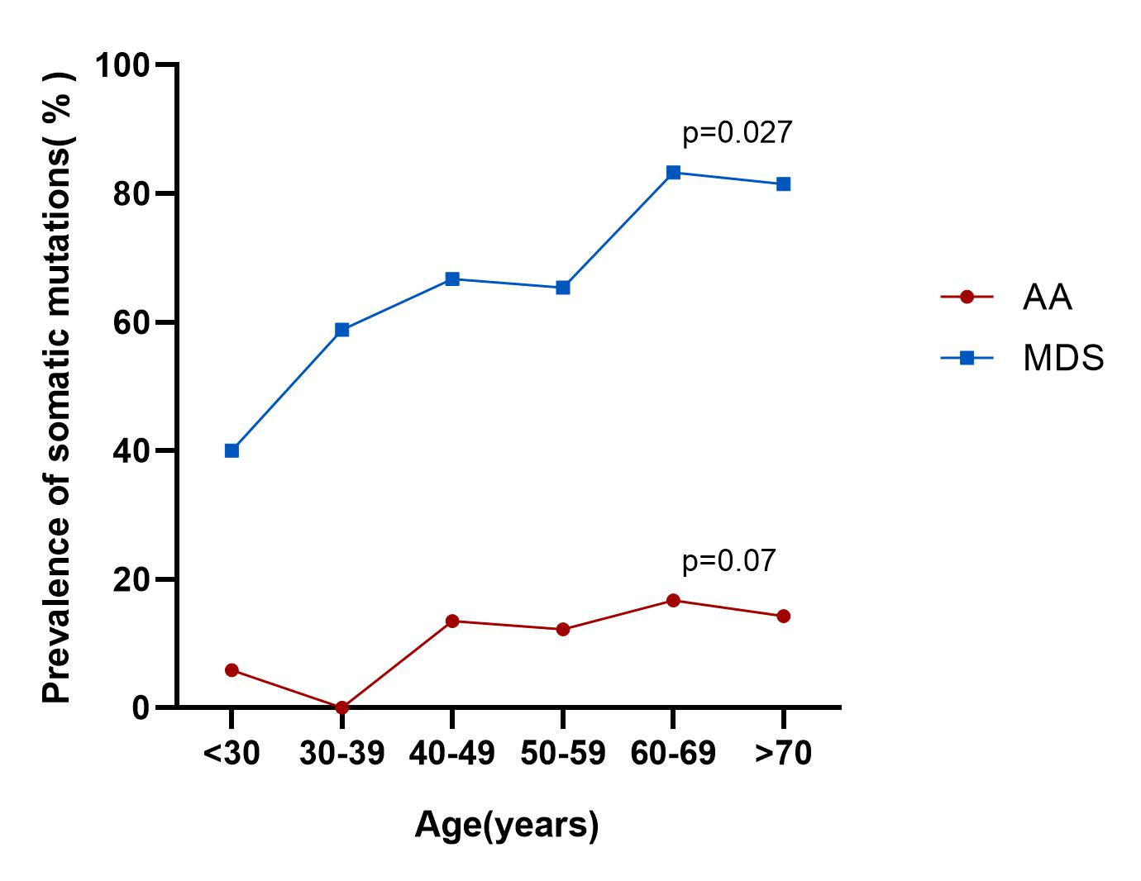
Fig.1 The line plots represent the frequency of mutations in various age groups. The red line represents the AA patients(p=0.07), whereas the blue line represents the MDS patients, the proportion of mutation increased with age(p=0.027).

AA, aplastic anemia; MDS, myelodysplastic syndromes.
AA, aplastic anemia; VAF, variant allele frequency.

