Table S1: Basic clinical characteristics of patients in the TCGA cohort, E-MTAB-1980 and CPTAC cohorts.
 | TCGA (531) | E-MTAB-1980 (101) | CPTAC (98)
Age(years)
≥65 | 198(37.3%) | 44(43.6%) | 41(41.8%)
＜65 | 333(62.7%) | 57(56.4%) | 57(58.2%)
Sex
Male | 345(65.0%) | 77(23.8%) | 75(76.5%)
Female | 186(35.0%) | 24(23.8% | 23(23.5%)
Grade
G1 | 13(2.4%) | 13(12.9%) | 6(6.1%)
G2 | 229(43.1%) | 59(58.4%) | 47(48.0%)
G3 | 205(38.6%) | 22(21.8%) | 36(36.7%)
G4 | 76(14.3%) | 5(5.0%) | 9(9.2%)
Unknown | 8(1.5%) | 2(2.0%) | 0
Stage
I | 266(50.1%) | 67(66.3%) | 46(46.9%)
II | 57(10.7%) | 11(10.9%) | 11(11.2%)
III | 124(23.4%) | 14(13.9%) | 31(31.6%)
IV | 84(15.8%) | 13(12.9%) | 10(10.2%)
T stage
T1 | 271(51.0%) | 68(67.3%) | 48(49.0%)
T2 | 69(13.0%) | 11(10.9%) | 12(12.2%)
T3 | 180(33.9%) | 21(20.85) | 37(37.8%)
T4 | 11(2.1%) | 1(1.0%) | 1(1.0%)
N stage
N2 | / | 4(4%) | /
N1 | 16(3.0%) | 3(3.0%) | /
N0 | 240(45.2%) | 94(93.1%) | /
Unknown | 275(51.8%) | / | /
M stage |  |  | /
M1 | 79(14.9%) | 12(11.9%) | /
M0 | 422(79.5%) | 89(88.1%) | /
Unknown | 30(5.6%) | / | /
Survival
Dead | 175(33.0%) | 23(22.8%) | 12(12.2%)
Living | 356(67.0%) | 78(77.25) | 86(87.8%)

Table S2: Primers of relative genes (PYGB, PHKG1, PHKB, PHKA1, PGM1, GYG2, EPM2A, AGL, ACTB)
 | F（5‘-3’） | R（5‘-3’）
PYGB | AGGTGCGGAAGAGCTTCAAC | TCGCGCTCGTAGTAGTGCT
PHKG1 | TGGGATGATTACTCGGACACC | CTGGTAGTAGATCCGCACTGA
PHKB | ACTCTCTGGGATAAGTTGGACC | ACCGCATGTTTTAGTGGGAAA
PHKA1 | GAAAGATGCTTGGGTCCGAGA | GTCTGCATTCTTCCGATAGGC
PGM1 | CCAAACCGACTGAAGATCCGT | CATGTTTCGATCCCCATCTCC
GYG2 | TCCAGTGCAAAGGTCGTCC | TTGTTCTGGTAGACCGTCCAC
EPM2A | GACACGTTCTGGTACAAGTTCC | ACAATACACACCATCCACCAAG
AGL | CGATTAGGCCCAACTTTACAGG | CCCAATCCAGAGAACGGAATTT
ACTB | GTTGTCGACGACGAGCG | GCACAGAGCCTCGCCTT

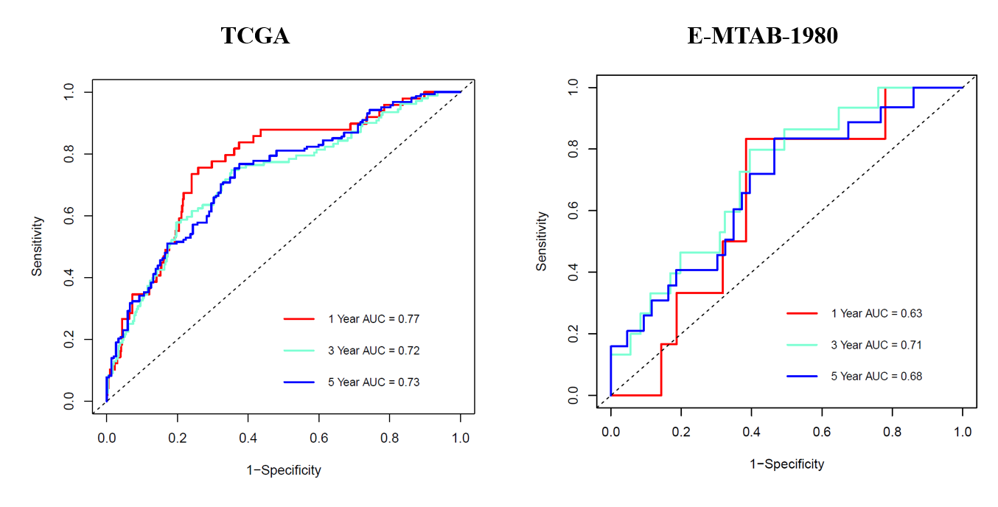
Figure S1. ROC curve analysis of prognostic model accuracy.
Figure S2. Relationship between risk score and disease progression. (A) The relationship between risk score and T stage. (B) The relationship between risk score and lymph node metastasis. (C) The relationship between risk score and distant metastasis. (D) The relationship between risk score and Grade. (E) The relationship between risk score and Stage.

