Supplementary Information
Contents
Supplementary Figure 1
Supplementary Table 1 and Table 2

Supplementary Fig. 1. Survival and duration of response estimates of R/R T-ALL patients. A. Kaplan-Meier curves for relapse-free survival; B. Kaplan-Meier curves for duration of response; C. Kaplan-Meier curves for overall survival. R/R T-ALL, relapse/refractory T-cell acute lymphoblastic leukemia
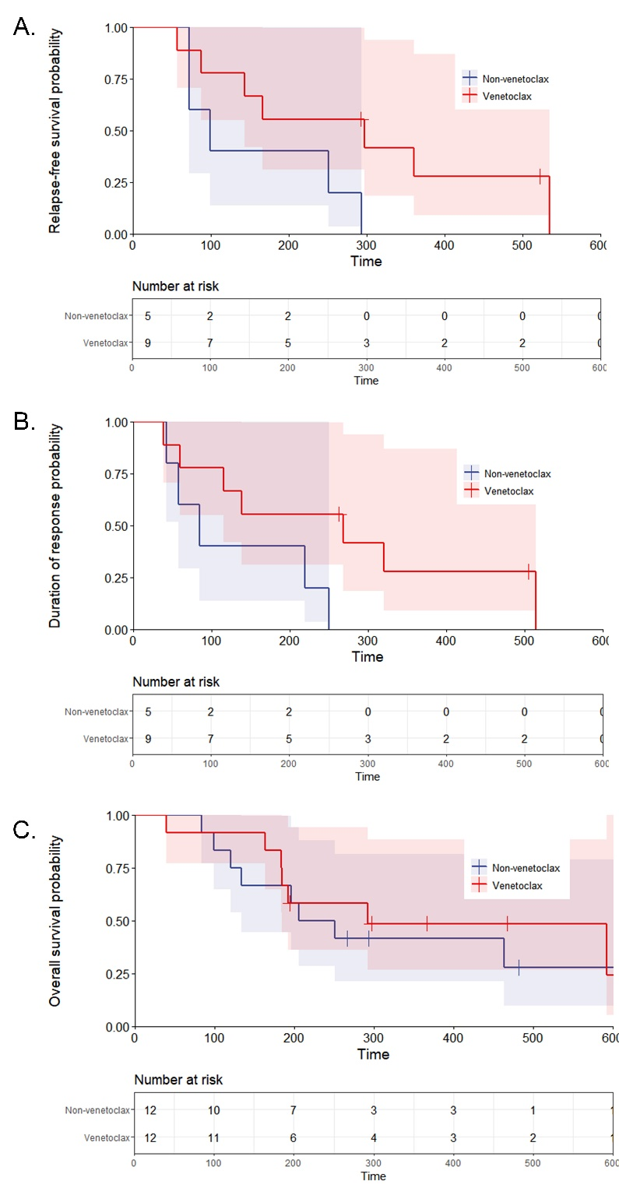

Supplementary Table 1. Therapeutic responses for R/R T-ALL patients treated without venetoclax.
 | Total, n=12 | VDCLP, n=5 | Hyper-CVAD/MA, n=4 | CAM, n=3
CR | 5(41.7%) | 2(40.0%) | 1(25.0%) | 2(66.7%)
CR/CRi | 5(41.7%) | 2(40.0%) | 1(25.0%) | 2(66.7%)
Abbreviations: R/R T-ALL, relapsed/refractory T-cell acute lymphoblastic leukemia; VDCLP: vindesine, daunorubicin/idarubicin, prednisone, cyclophosphamide and pegylated asparaginase; Hyper-CVAD/MA: cyclophosphamide, vincristine, doxorubicin and dexamethasone alternating with high-dose methotrexate and cytarabine; CAM: cyclophosphamide, cytarabine and mercaptopurine; CR, complete remission; CRi, complete remission with incomplete blood count recovery.

Supplementary Table 2. Therapeutic responses for R/R T-ALL patients treated with venetoclax.
 | Total, n=12 | HAG/CAG+HMAs, n=3 | HAG/CAG, n=6 | HMAs+Daratumumab, n=1 | HMAs, n=2
CR | 7(58.3%) | 2(66.7%) | 4(66.7%) | 0(0) | 1(50.0%)
CR/CRi | 9(75.0%) | 2(66.7%) | 5(83.3%) | 0(0) | 2(100%)
Abbreviations: R/R T-ALL, relapsed/refractory T-cell acute lymphoblastic leukemia; HAG, homoharringtonine, cytarabine and granulocyte colony-stimulating factor; CAG, cytarabine, aclarubicin and granulocyte colony-stimulating factor; HMAs, hypomethylating agents; CR, complete remission; CRi, complete remission with incomplete blood count recovery.

