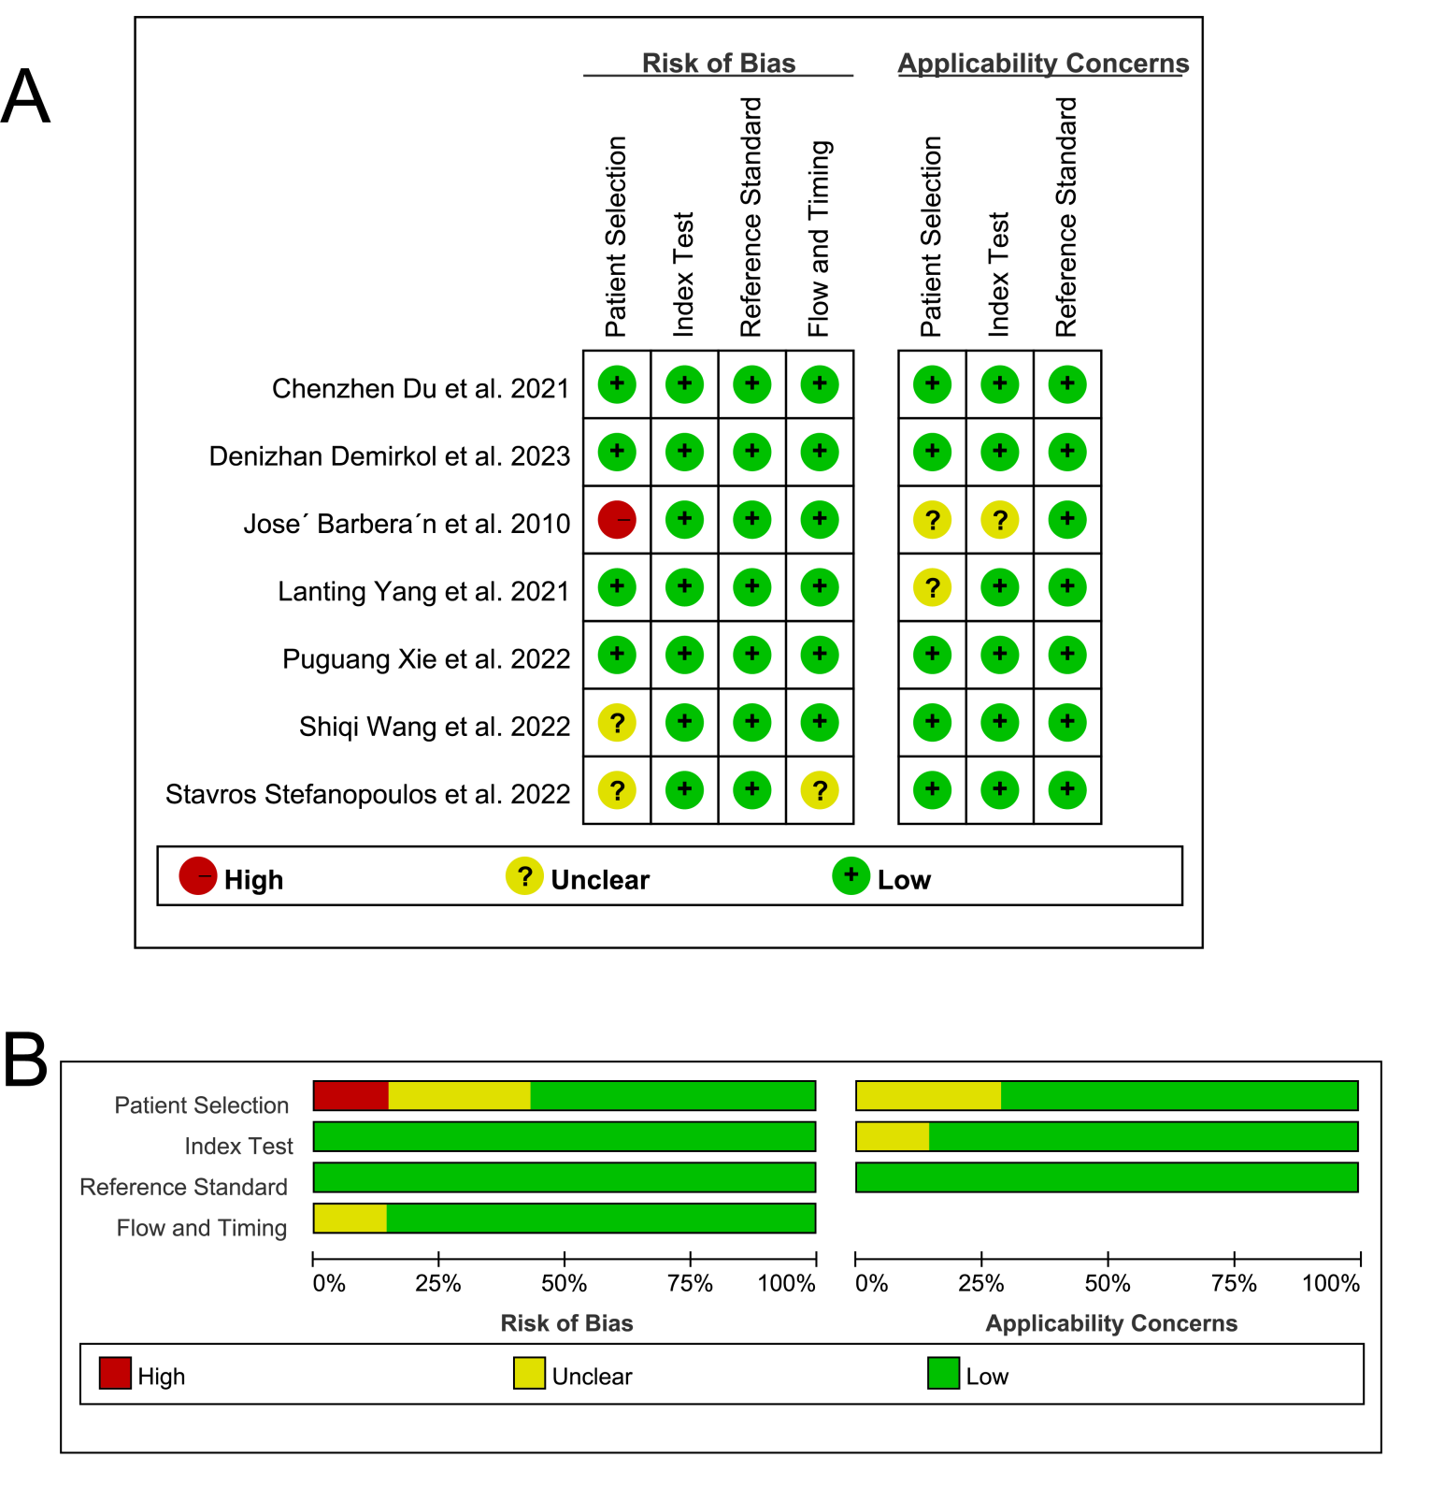
Supplementary Figure 1. Quality Assessment Using QUADAS-2. (A) QUADAS-2 risk of bias plot. (B) QUADAS-2 risk of bias summary plot

