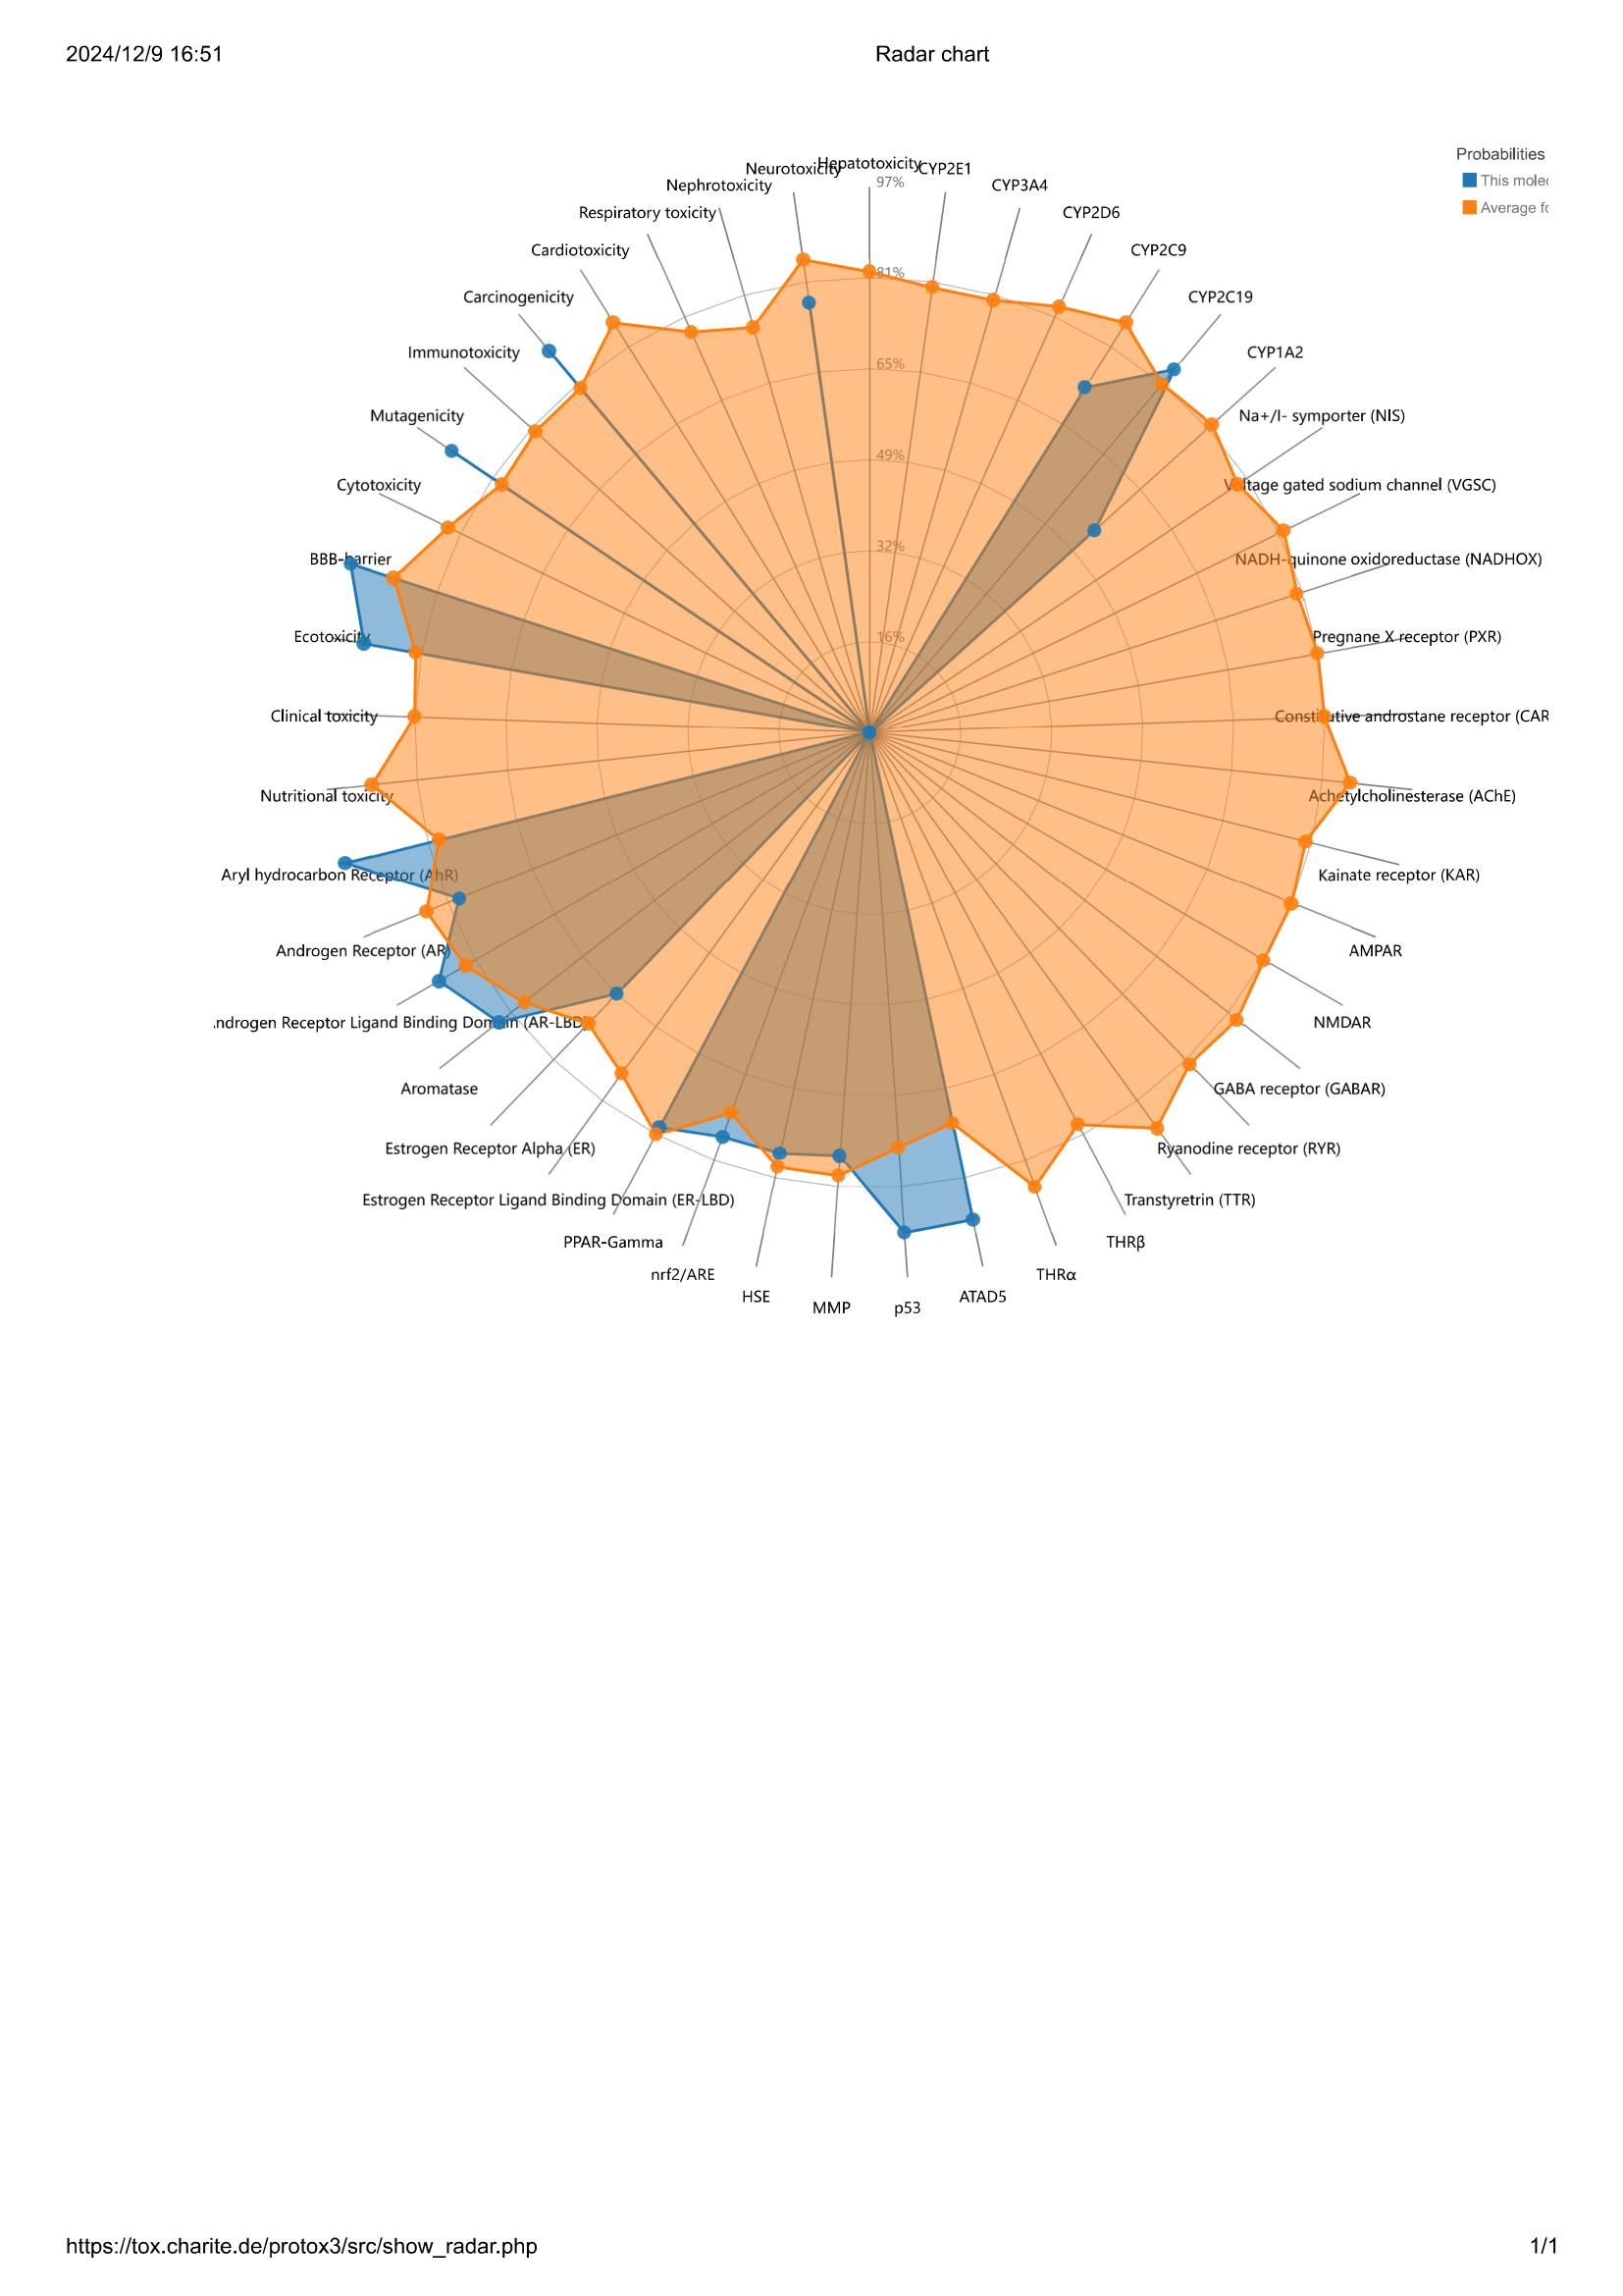
Figure S1: Radar chart of the toxicity of B[a]P

Figure S2: Building PPI Networks using the STRING Database

Compounds | Toxicity Class | LD50 | Classification | Database | Probability
B[a]P | 4 | 316 mg/kg | Respiratory toxicity | ADMETlab3.0 ProTox-II | 0.977
Table S1: Predicted probabilities of respiratory toxicity for B[a]P.

