Supplementary

Contents
Search strategy 2
Reconstruction of Studies’ Data 4
PPV and NPV Across Test Prevalence 8
Head to Head Comparisons (MRI vs US) 9
Further Publication Bias Analysis 11

Search strategy

Table S1. Search strategy for each database

Database | String | Results | Date
PubMed | ("Breast Neoplasms" OR "breast cancer" OR "early breast cancer" OR ( (Newly diagnosed) AND ("Breast Cancer"))) AND ("Lymph Nodes" OR "lymph node status" OR "axillary lymph nodes" OR "nodal metastasis") AND ("Ultrasonography" OR ultrasound OR sonography) AND ("Magnetic Resonance Imaging" OR MRI) AND (preoperative OR pre-operation OR "preoperative staging") | 214 | 12/31/2025
Scopus | TITLE-ABS-KEY(  "breast cancer" OR "early breast cancer" OR "early-stage breast cancer" OR  ("newly diagnos*" W/3 ("breast cancer" OR (breast W/1 cancer*))) OR  (breast W/1 (cancer* OR neoplasm* OR carcinoma* OR tumor* OR tumour* OR malignan*)) OR  "mammary carcinoma" OR "mammary neoplasm*"  )  AND TITLE-ABS-KEY(  "lymph node*" OR "lymph node status" OR "nodal status" OR  "axillary lymph node*" OR (axilla* W/2 node*) OR  "sentinel lymph node*" OR ALN OR SLN OR  (nodal W/1 metastas*) OR "nodal metastas*" OR "lymphatic metastas*"  )  AND TITLE-ABS-KEY(  ultrasound OR ultrasonograph* OR sonograph* OR ultrasonography OR  "axillary ultrasound" OR "breast ultrasound"  )  AND TITLE-ABS-KEY(  "magnetic resonance imag*" OR MRI OR "MR imag*" OR "MR scan*" OR  "contrast-enhanced MRI" OR "DCE-MRI"  )  AND TITLE-ABS-KEY(  preoperativ* OR "pre-operative" OR "pre operative" OR presurg* OR "pre-surg*" OR  "pre surgical" OR "pre-surgical" OR "before surgery" OR  "preoperative staging" OR "preoperative assessment"  ) | 341 | 12/31/2025
Web of Science | TS=(  ("breast cancer" OR "early breast cancer" OR "early-stage breast cancer" OR  ("newly diagnos*" NEAR/3 "breast cancer") OR  (breast NEAR/1 (cancer* OR neoplasm* OR carcinoma* OR tumor* OR tumour* OR malignan*)) OR  "mammary carcinoma" OR "mammary neoplasm*")  AND  ("lymph node*" OR "lymph node status" OR "nodal status" OR  "axillary lymph node*" OR (axilla* NEAR/2 node*) OR  "sentinel lymph node*" OR ALN OR SLN OR  (nodal NEAR/1 metastas*) OR "nodal metastas*" OR "lymphatic metastas*")  AND  (ultrasound OR ultrasonograph* OR sonograph* OR ultrasonography OR "axillary ultrasound" OR "breast ultrasound")  AND  ("magnetic resonance imag*" OR MRI OR "MR imag*" OR "MR scan*" OR "contrast-enhanced MRI" OR "DCE-MRI")  AND  (preoperativ* OR pre-operativ* OR presurg* OR pre-surg* OR "pre surgical" OR "pre-surgical" OR "before surgery" OR  "preoperative staging" OR "preoperative assessment")  ) | 207 | 12/31/2025
EMBASE | ('breast cancer':ti,ab,kw OR 'early breast cancer':ti,ab,kw OR 'early-stage breast cancer':ti,ab,kw OR (('newly diagnos*' NEAR/3 'breast cancer'):ti,ab,kw) OR (('breast' NEAR/1 (cancer* OR neoplasm* OR carcinoma* OR tumor* OR tumour* OR malignan*)):ti,ab,kw) OR 'mammary carcinoma':ti,ab,kw OR 'mammary neoplasm*':ti,ab,kw) AND ('lymph node*':ti,ab,kw OR 'lymph node status':ti,ab,kw OR 'nodal status':ti,ab,kw OR 'axillary lymph node*':ti,ab,kw OR ((axilla* NEAR/2 node*):ti,ab,kw) OR 'sentinel lymph node*':ti,ab,kw OR aln:ti,ab,kw OR sln:ti,ab,kw OR ((nodal NEAR/1 metastas*):ti,ab,kw) OR 'nodal metastas*':ti,ab,kw OR 'lymphatic metastas*':ti,ab,kw) AND (ultrasound:ti,ab,kw OR ultrasonograph*:ti,ab,kw OR sonograph*:ti,ab,kw OR ultrasonography:ti,ab,kw OR 'axillary ultrasound':ti,ab,kw OR 'breast ultrasound':ti,ab,kw) AND ('magnetic resonance imag*':ti,ab,kw OR mri:ti,ab,kw OR 'mr imag*':ti,ab,kw OR 'mr scan*':ti,ab,kw OR 'contrast-enhanced mri':ti,ab,kw OR 'dce-mri':ti,ab,kw) AND (preoperativ*:ti,ab,kw OR 'pre operativ*':ti,ab,kw OR presurg*:ti,ab,kw OR 'pre surg*':ti,ab,kw OR 'pre surgical':ti,ab,kw OR 'pre-surgical':ti,ab,kw OR 'before surgery':ti,ab,kw OR 'preoperative staging':ti,ab,kw OR 'preoperative assessment':ti,ab,kw) | 299 | 12/31/2025

Reconstruction of Studies’ Data
Table S2. Reconstructed 2×2 counts by study and modality
study | country | design | samplesize | modality | prevalence | diseased | nondiseased | TP | FP | TN | FN
Abe H (2013) | USA | Retrospective | 50 | MRI | 33.5% | 17 | 33 | 10 | 7 | 26 | 7
Ahn HS (2019) | South Korea | Retrospective | 74 | MRI | 22.9% | 17 | 57 | 9 | 6 | 51 | 8
Aktaş A (2022) | Turkey | Retrospective | 336 | MRI | 92.8% | 312 | 24 | 269 | 6 | 18 | 43
Arslan G (2016) | Turkey | Prospective | 35 | MRI | 42.9% | 15 | 20 | 11 | 1 | 19 | 4
Assing MA (2017) | USA | Retrospective | 271 | MRI | 14.3% | 39 | 232 | 34 | 5 | 227 | 5
Atallah D (2020) | Lebanon | Retrospective | 169 | MRI | 47.0% | 79 | 90 | 56 | 11 | 79 | 23
Barco I (2016) | Spain | Prospective | 1,505 | MRI | 39.1% | 588 | 917 | 175 | 31 | 886 | 413
Chayakulkheeree J (2019) | Thailand | Retrospective | 131 | MRI | 51.2% | 67 | 64 | 66 | 27 | 37 | 1
Di Micco R (2025) | Italy | Prospective | 246 | MRI | 23.4% | 58 | 188 | 24 | 15 | 173 | 34
Ergul N (DCE-MRI) (2015) | Turkey | Prospective | 24 | MRI | 64.5% | 15 | 9 | 7 | 2 | 7 | 8
Ergul N (DWI-MRI) (2015) | Turkey | Prospective | 24 | MRI | 61.7% | 15 | 9 | 6 | 0 | 9 | 9
Fernández A G (2011) | Spain | Prospective | 507 | MRI | 33.6% | 170 | 337 | 61 | 13 | 324 | 109
Hieken TJ (2013) | USA | Retrospective | 988 | MRI | 35.4% | 350 | 638 | 190 | 139 | 499 | 160
Jung NY (2015) | South Korea | Retrospective | 105 | MRI | 32.4% | 34 | 71 | 17 | 13 | 58 | 17
Kim SH (Reader 1) (2017) | South Korea | Retrospective | 147 | MRI | 26.3% | 39 | 108 | 23 | 7 | 101 | 16
Kim SH (Reader 2) (2017) | South Korea | Retrospective | 147 | MRI | 26.3% | 39 | 108 | 20 | 7 | 101 | 19
Motomura K (2015) | Japan | Prospective | 70 | MRI | 25.0% | 18 | 52 | 18 | 2 | 50 | 0
Panda SK (2019) | India | Prospective | 40 | MRI | 20.0% | 8 | 32 | 6 | 2 | 30 | 2
Riedel F (2021) | Germany | Retrospective | 611 | MRI
Rukanskiene D (2020) | Lithuania | Prospective | 227 | MRI
Schumacher K (2021) | USA | Retrospective | 349 | MRI | 53.3% | 186 | 163 | 13 | 3 | 160 | 173
Stadnik TW (2006) | Belgium | Retrospective | 10 | MRI | 50.0% | 5 | 5 | 5 | 1 | 4 | 0
Upadhyaya VS (2019) | Singapore | Retrospective | 605 | MRI
Valente SA (2012) | USA | Retrospective | 244 | MRI | 25.4% | 62 | 182 | 23 | 6 | 176 | 39
Wang J (2021) | China | Prospective | 85 | MRI
Wang LJ (2025) | Taiwan | Prospective | 247 | MRI | 15.3% | 38 | 209 | 18 | 21 | 188 | 20
Xu Y (2018) | China | Prospective | 92 | MRI
Yu Y (2021) | China | Retrospective | 803 | MRI | 38.1% | 306 | 497 | 184 | 94 | 403 | 122
Zhang H (2019) | China | Retrospective | 170 | MRI | 37.4% | 64 | 106 | 53 | 21 | 85 | 11
de Felice C (2014) | Italy | Retrospective | 26 | MRI | 18.6% | 5 | 21 | 2 | 0 | 21 | 3
van Nijnatten TJA (2016) | Netherlands | Retrospective | 377 | MRI | 4.2% | 16 | 361 | 6 | 6 | 355 | 10
Abe H (2013) | USA | Retrospective | 50 | US | 32.7% | 16 | 34 | 9 | 6 | 28 | 7
Ahn HS (2019) | South Korea | Retrospective | 74 | US
Aktaş A (2022) | Turkey | Retrospective | 336 | US | 81.4% | 274 | 62 | 227 | 24 | 38 | 47
Arslan G (2016) | Turkey | Prospective | 35 | US
Assing MA (2017) | USA | Retrospective | 271 | US | 20.6% | 56 | 215 | 46 | 11 | 204 | 10
Atallah D (2020) | Lebanon | Retrospective | 169 | US
Barco I (2016) | Spain | Prospective | 1,505 | US | 38.8% | 585 | 920 | 278 | 59 | 861 | 307
Chayakulkheeree J (2019) | Thailand | Retrospective | 131 | US
Di Micco R (2025) | Italy | Prospective | 246 | US
Ergul N (DCE-MRI) (2015) | Turkey | Prospective | 24 | US
Ergul N (DWI-MRI) (2015) | Turkey | Prospective | 24 | US
Fernández A G (2011) | Spain | Prospective | 507 | US
Hieken TJ (2013) | USA | Retrospective | 988 | US | 31.1% | 308 | 680 | 154 | 133 | 547 | 154
Jung NY (2015) | South Korea | Retrospective | 105 | US
Kim SH (Reader 1) (2017) | South Korea | Retrospective | 147 | US
Kim SH (Reader 2) (2017) | South Korea | Retrospective | 147 | US
Motomura K (2015) | Japan | Prospective | 70 | US
Panda SK (2019) | India | Prospective | 40 | US | 20.0% | 8 | 32 | 5 | 1 | 31 | 3
Riedel F (2021) | Germany | Retrospective | 611 | US | 34.5% | 211 | 400 | 112 | 26 | 374 | 99
Rukanskiene D (2020) | Lithuania | Prospective | 227 | US | 15.0% | 34 | 193 | 18 | 20 | 173 | 16
Schumacher K (2021) | USA | Retrospective | 349 | US | 36.8% | 129 | 220 | 34 | 31 | 189 | 95
Stadnik TW (2006) | Belgium | Retrospective | 10 | US
Upadhyaya VS (2019) | Singapore | Retrospective | 605 | US | 33.7% | 204 | 401 | 154 | 28 | 373 | 50
Valente SA (2012) | USA | Retrospective | 244 | US | 25.2% | 61 | 183 | 27 | 7 | 176 | 34
Wang J (2021) | China | Prospective | 85 | US | 54.1% | 46 | 39 | 33 | 6 | 33 | 13
Wang LJ (2025) | Taiwan | Prospective | 247 | US | 24.2% | 60 | 187 | 33 | 30 | 157 | 27
Xu Y (2018) | China | Prospective | 92 | US | 52.6% | 48 | 44 | 44 | 12 | 32 | 4
Yu Y (2021) | China | Retrospective | 803 | US | 39.0% | 313 | 490 | 153 | 49 | 441 | 160
Zhang H (2019) | China | Retrospective | 170 | US | 37.4% | 64 | 106 | 47 | 24 | 82 | 17
de Felice C (2014) | Italy | Retrospective | 26 | US
van Nijnatten TJA (2016) | Netherlands | Retrospective | 377 | US | 4.2% | 16 | 361 | 2 | 0 | 361 | 14
For each study and modality (MRI/US), TP, FP, TN, FN were reconstructed using reported Sensitivity/Specificity and one of Accuracy/PPV/NPV with sample size. Reconstruction is performed ONLY when the corresponding flag is present (has_mri/has_us = 1). 'status' = ok/warn/fail/skip; 'skip' indicates modality absent per flags; 'zero_cell' flags at least one zero count (only when status=ok).

PPV and NPV Across Test Prevalence

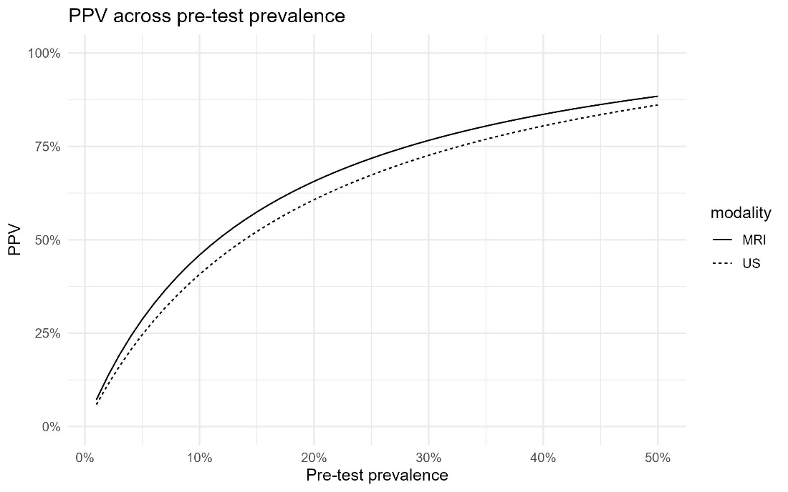

Figure S1. PPV across pre-test prevalence. PPV derived from pooled sensitivity/specificity. Separate curves for MRI and ultrasound.

v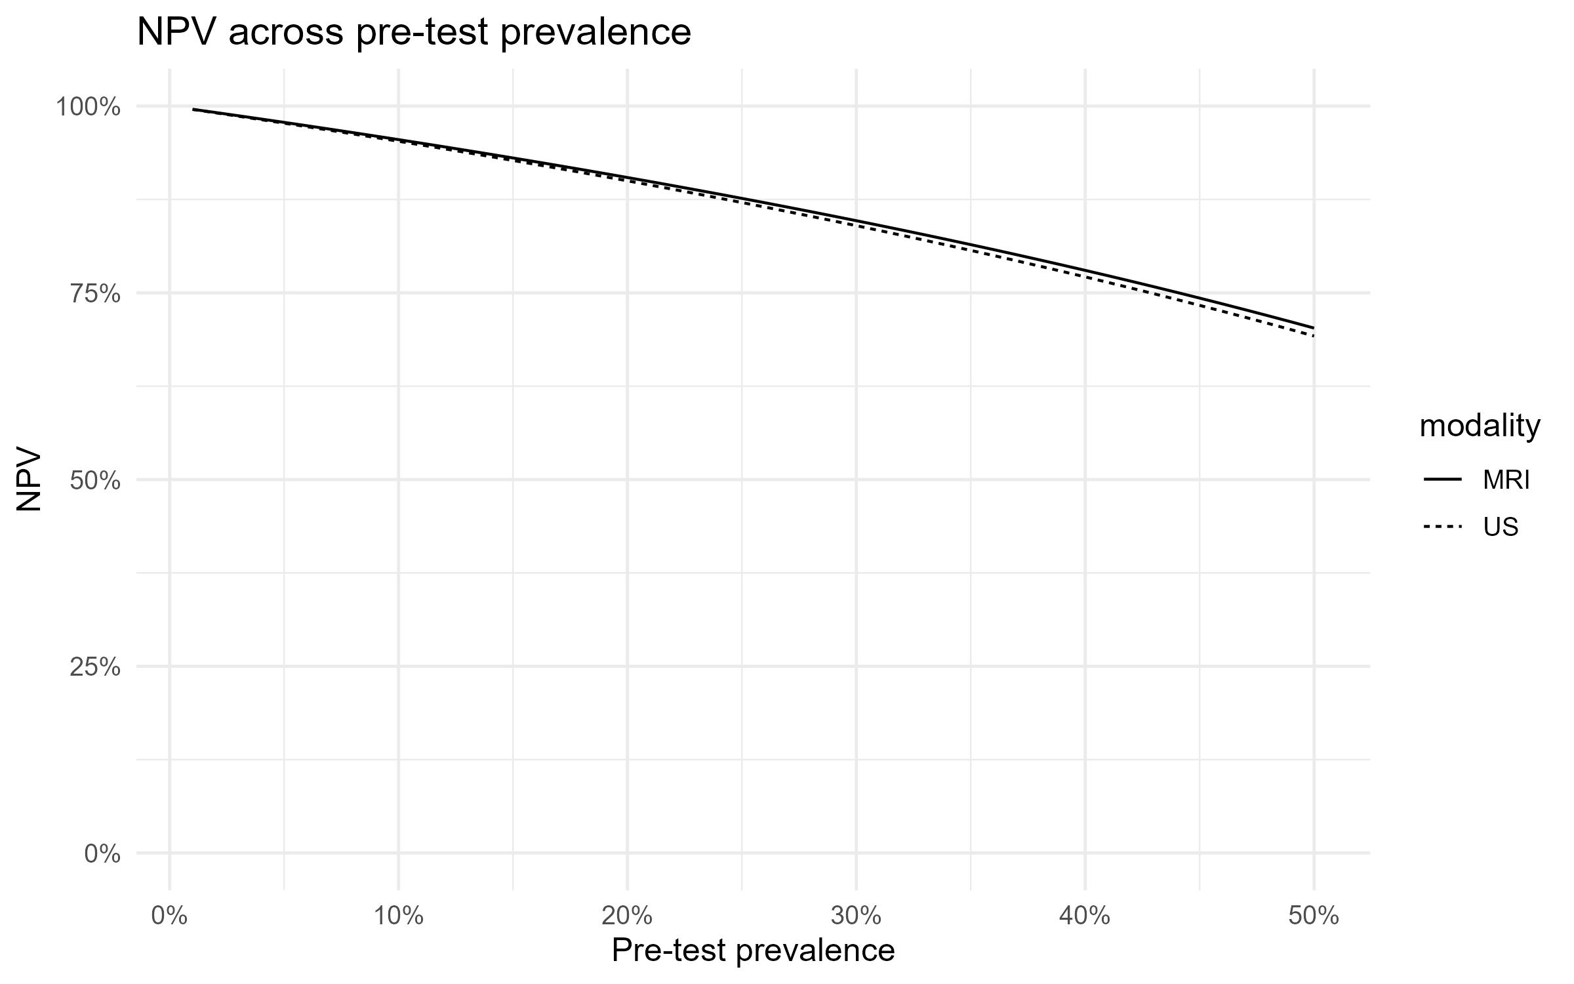
Figure S2. NPV across pre-test prevalence. NPV derived from pooled sensitivity/specificity. Separate curves for MRI and ultrasound.

Head to Head Comparisons (MRI vs US)

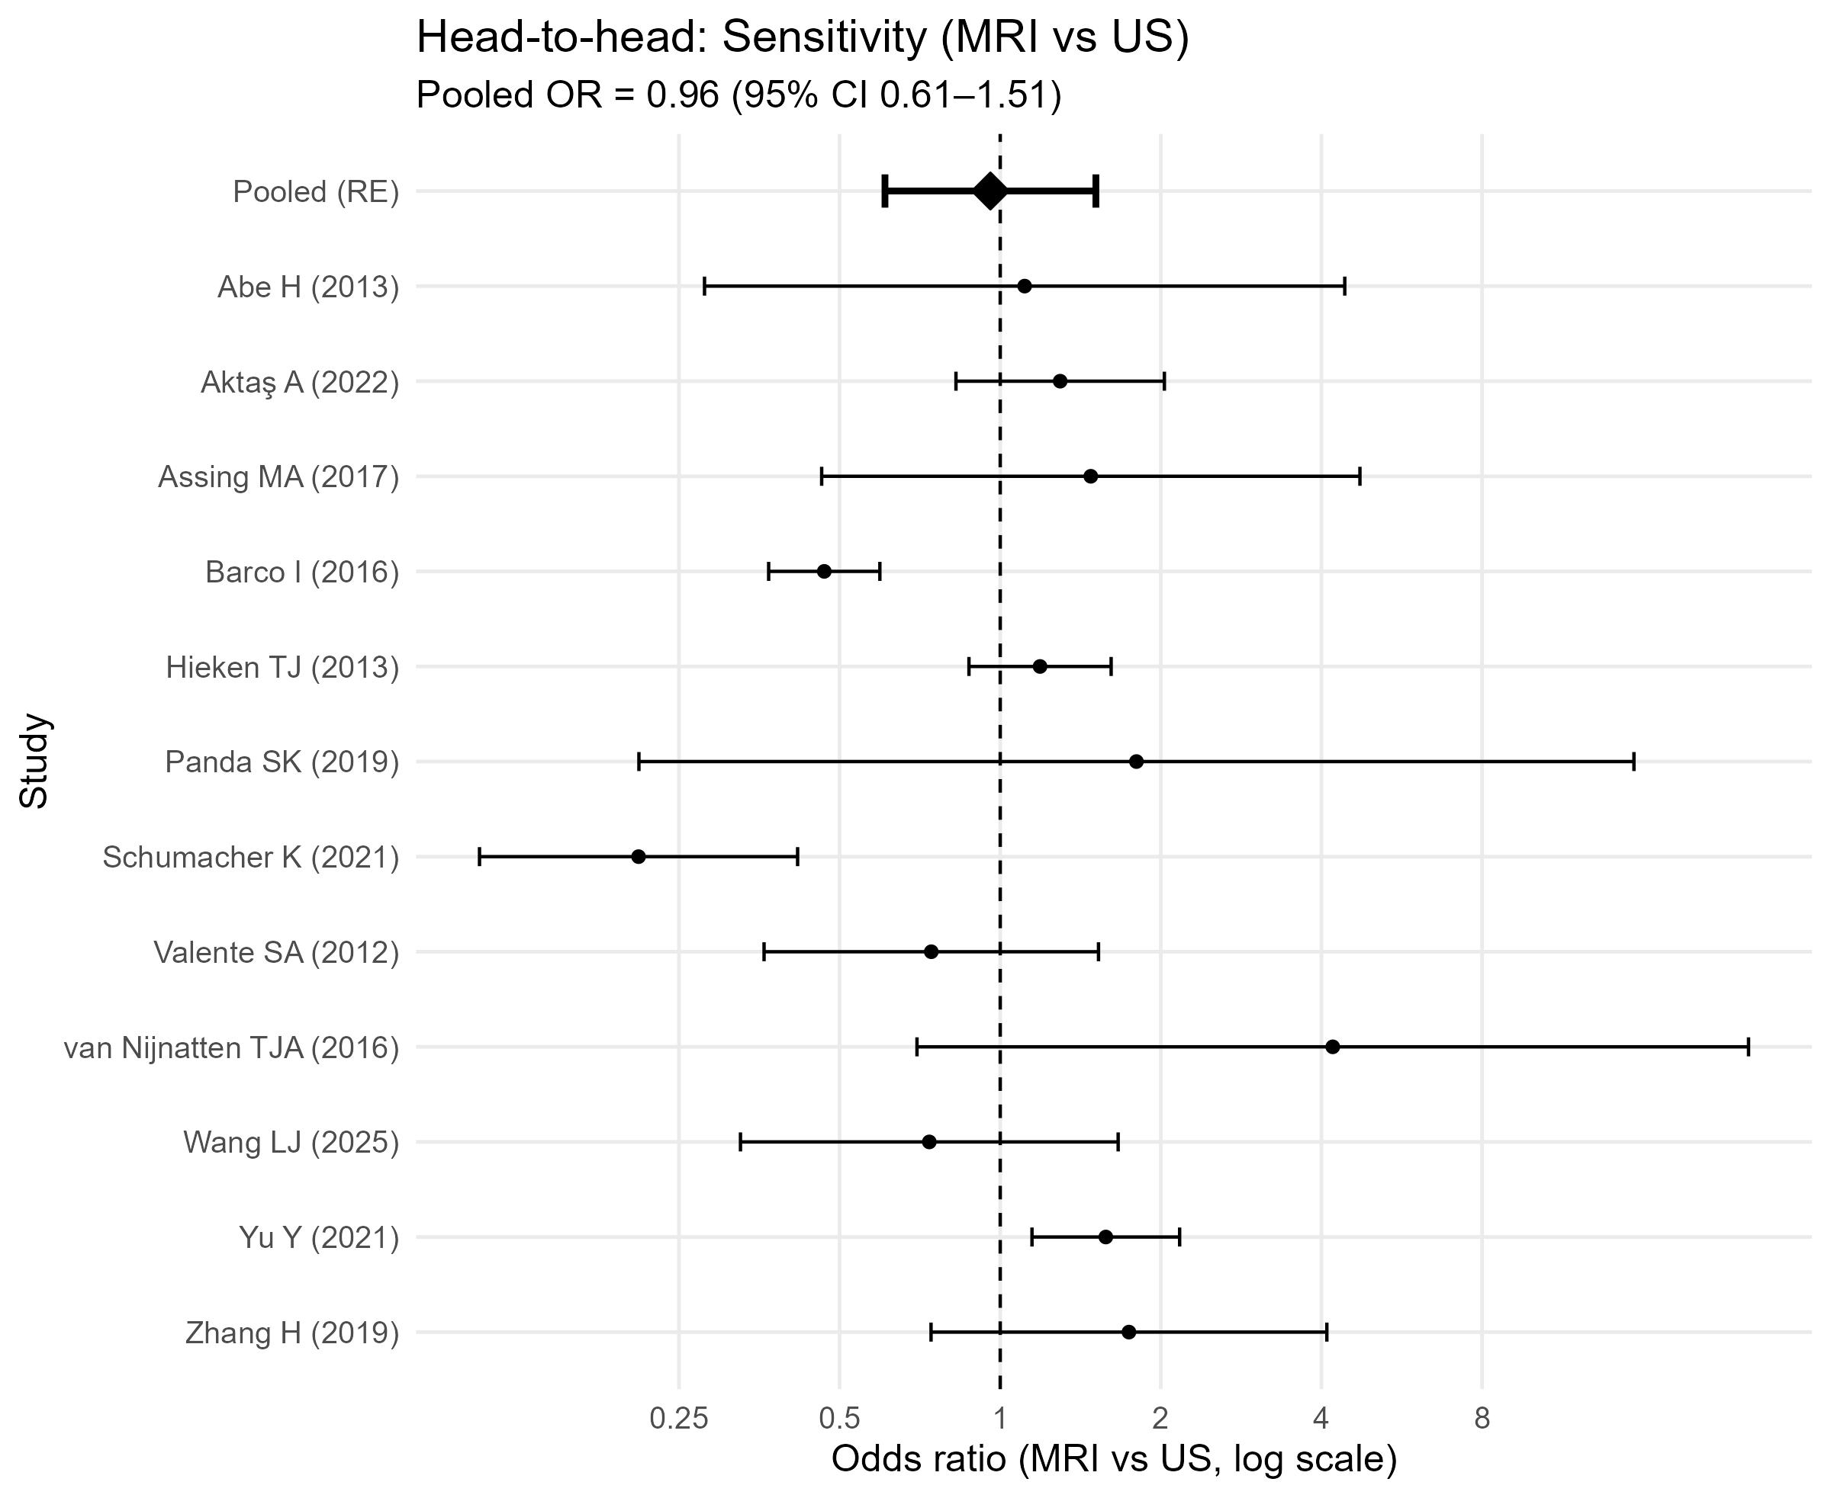
Figure S3. Head-to-head: Sensitivity (MRI vs US). Forest plot of within-study odds ratios (MRI vs ultrasound). The diamond is the random-effects pooled OR. Vertical dashed line marks OR=1 (no difference).

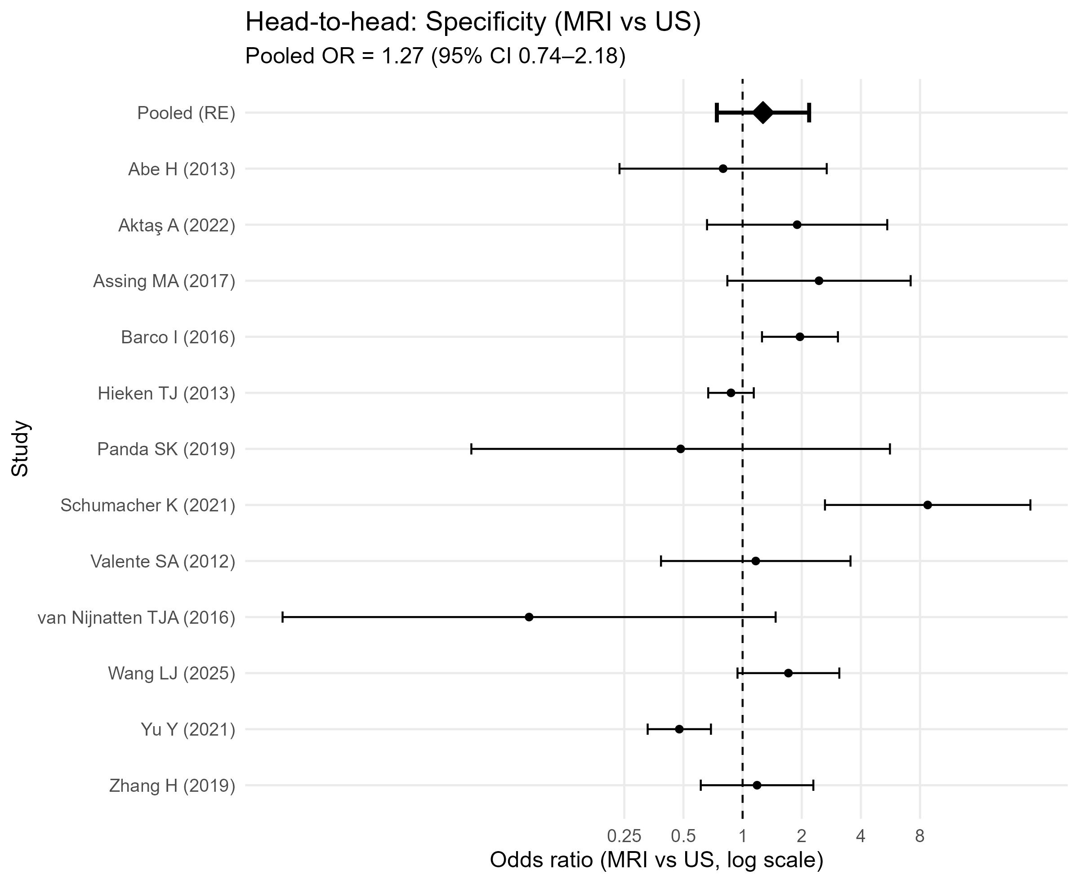
Figure S4. Head-to-head: Specificity (MRI vs US). Forest plot of within-study odds ratios (MRI vs ultrasound). The diamond is the random-effects pooled OR. Vertical dashed line marks OR=1 (no difference).

Further Publication Bias Analysis

Table S3. Deeks influence diagnostics (MRI)
study | lnDOR | X | ESS | any_zero | cooks
Hieken TJ (2013) | 1.4500 | 0.1439 | 48.2826 | FALSE | 1.3612
Barco I (2016) | 2.4941 | 0.2038 | 24.0834 | FALSE | 0.2788
Assing MA (2017) | 5.7324 | 0.6586 | 2.3051 | FALSE | 0.1607
Ergul N (DCE-MRI) (2015) | 1.1192 | 0.9543 | 1.0980 | FALSE | 0.0685
Schumacher K (2021) | 1.3882 | 0.6498 | 2.3681 | FALSE | 0.0435
Jung NY (2015) | 1.4955 | 0.4602 | 4.7212 | FALSE | 0.0335
Abe H (2013) | 1.6689 | 0.6513 | 2.3575 | FALSE | 0.0286
Ergul N (DWI-MRI) (2015) | 2.5649 | 1.5377 | 0.4229 | TRUE | 0.0276
Motomura K (2015) | 6.6166 | 1.5728 | 0.4042 | TRUE | 0.0213
Fernández A G (2011) | 2.6353 | 0.3249 | 9.4717 | FALSE | 0.0187
Zhang H (2019) | 2.9705 | 0.4113 | 5.9115 | FALSE | 0.0161
Stadnik TW (2006) | 3.4965 | 1.7523 | 0.3257 | TRUE | 0.0132
de Felice C (2014) | 3.4247 | 1.6529 | 0.3660 | TRUE | 0.0122
Atallah D (2020) | 2.8614 | 0.4061 | 6.0642 | FALSE | 0.0116
van Nijnatten TJA (2016) | 3.5695 | 0.6604 | 2.2928 | FALSE | 0.0093
Chayakulkheeree J (2019) | 4.5047 | 1.0389 | 0.9266 | FALSE | 0.0080
Ahn HS (2019) | 2.2578 | 0.6499 | 2.3675 | FALSE | 0.0073
Kim SH (Reader 1) (2017) | 3.0321 | 0.5087 | 3.8649 | FALSE | 0.0061
Aktaş A (2022) | 2.9321 | 0.4992 | 4.0129 | FALSE | 0.0043
Wang LJ (2025) | 2.0866 | 0.3981 | 6.3094 | FALSE | 0.0034
Valente SA (2012) | 2.8507 | 0.4914 | 4.1413 | FALSE | 0.0030
Di Micco R (2025) | 2.0969 | 0.3788 | 6.9674 | FALSE | 0.0026
Kim SH (Reader 2) (2017) | 2.7205 | 0.5054 | 3.9156 | FALSE | 0.0007
Yu Y (2021) | 1.8666 | 0.1636 | 37.3815 | FALSE | 0.0001
Panda SK (2019) | 3.8067 | 1.0954 | 0.8333 | FALSE | 0.0000
Arslan G (2016) | 3.9560 | 1.1805 | 0.7176 | FALSE | 0.0000
Influence diagnostics from weighted Deeks regression. Cook’s distance highlights studies with disproportionate impact on the slope estimate.

Table S4. Deeks influence diagnostics (Ultrasound)
study | lnDOR | X | ESS | any_zero | cooks
Hieken TJ (2013) | 1.4141 | 0.1494 | 44.7749 | FALSE | 0.7674
Barco I (2016) | 2.5813 | 0.1580 | 40.0560 | FALSE | 0.3441
Upadhyaya VS (2019) | 3.7143 | 0.2547 | 15.4110 | FALSE | 0.1751
Schumacher K (2021) | 0.7802 | 0.2784 | 12.9054 | FALSE | 0.1375
Assing MA (2017) | 4.4463 | 0.4664 | 4.5966 | FALSE | 0.0784
Abe H (2013) | 1.7918 | 0.6755 | 2.1913 | FALSE | 0.0322
Riedel F (2021) | 2.7895 | 0.2453 | 16.6210 | FALSE | 0.0295
Wang LJ (2025) | 1.8557 | 0.3272 | 9.3421 | FALSE | 0.0116
Aktaş A (2022) | 2.0343 | 0.3060 | 10.6764 | FALSE | 0.0048
Xu Y (2018) | 3.3787 | 0.6223 | 2.5819 | FALSE | 0.0029
Rukanskiene D (2020) | 2.2753 | 0.4169 | 5.7526 | FALSE | 0.0027
Valente SA (2012) | 2.9941 | 0.4637 | 4.6514 | FALSE | 0.0025
Zhang H (2019) | 2.2456 | 0.3660 | 7.4648 | FALSE | 0.0018
Wang J (2021) | 2.6363 | 0.5515 | 3.2874 | FALSE | 0.0011
Panda SK (2019) | 3.9448 | 1.2512 | 0.6387 | FALSE | 0.0010
Yu Y (2021) | 2.1525 | 0.1883 | 28.1994 | FALSE | 0.0004
van Nijnatten TJA (2016) | 4.8256 | 1.5722 | 0.4046 | TRUE | 0.0001
Influence diagnostics from weighted Deeks regression for ultrasound.

