Supplementary Textbox 1. MEDLINE (PubMed) search strategy for FLT3 inhibitors in patients with AML.
Query
#5 AND #11 AND #12
(((((randomized controlled trial[Publication Type]) OR (controlled clinical trial[Publication Type])) OR (randomized[Title/Abstract])) OR (randomly[Title/Abstract])) OR (trial[Title/Abstract])) OR (groups[Title/Abstract])
#6 OR #7 OR #8 OR #9 OR #10
((gilteritinib[Title/Abstract]) OR (ASP2215[Title/Abstract])) OR (ASP-2215[Title/Abstract])
((quizartinib[Title/Abstract]) OR (AC-220[Title/Abstract])) OR (AC220[Title/Abstract])
((midostaurin[Title/Abstract]) OR (PKC-412[Title/Abstract])) OR (PKC412[Title/Abstract])
((FLT3[Title/Abstract]) OR (FLT-3[Title/Abstract])) OR (midostaurin[Title/Abstract])
fms like tyrosine kinase 3[MeSH Terms]
#1 OR #4
#2 AND #3
("myelo*"[Text Word] OR "nonlympho*"[Text Word] OR "granulocytic*"[Text Word] OR "monocyt*"[Text Word] OR "megakaryoblast*"[Text Word] OR "promyelocyt*"[Text Word] OR "erythroblast*"[Text Word]) AND ("leuk*em*"[Text Word] OR "leuc*"[All Fields])
acut*[Text Word]
acute myeloid leukemia[MeSH Terms]
Supplementary Textbox 2. MEDLINE (PubMed) search strategy for FLT3 inhibitors in patients with AML.
('acute myeloid leukemia'/exp OR ('acut*':ti,ab,kw,de,dn,df,mn,tn AND ('myelo*':ti,ab,kw,de,dn,df,mn,tn OR 'nonlympho*':ti,ab,kw,de,dn,df,mn,tn OR 'granulocytic*':ti,ab,kw,de,dn,df,mn,tn OR 'monocyt*':ti,ab,kw,de,dn,df,mn,tn OR 'megakaryoblast*':ti,ab,kw,de,dn,df,mn,tn OR 'promyelocyt*':ti,ab,kw,de,dn,df,mn,tn OR 'erythroblast*':ti,ab,kw,de,dn,df,mn,tn) AND ('leuk*em*':ti,ab,kw,de,dn,df,mn,tn OR 'leuc*'))) AND ('cd135 antigen'/exp OR 'flt3':ti,ab,kw OR 'flt-3':ti,ab,kw OR 'midostaurin':ti,ab,kw OR 'pkc-412':ti,ab,kw OR 'pkc412':ti,ab,kw OR 'quizartinib':ti,ab,kw OR 'ac-220':ti,ab,kw OR 'ac220':ti,ab,kw OR 'gilteritinib':ti,ab,kw OR 'asp2215':ti,ab,kw OR 'asp-2215':ti,ab,kw) AND ('randomized controlled trial':it OR 'controlled clinical trial':it OR 'randomized':ti,ab,kw OR 'randomly':ti,ab,kw OR 'trial':ti,ab,kw OR 'groups':ti,ab,kw)
Supplementary Textbox 3. Cochrane search strategy for FLT3 inhibitors in patients with AML.
(acut* AND (myelo* OR nonlympho* OR granulocytic* OR monocyt* OR megakaryoblast* OR promyelocyt* OR erythroblast*) AND (leukem* OR leuc*)) AND (FLT3 OR "FLT-3" OR midostaurin OR PKC-412 OR PKC412 OR quizartinib OR AC-220 OR AC220 OR gilteritinib OR ASP2215 OR ASP-2215) AND (randomized OR trial OR "randomly allocated" OR "controlled clinical trial" OR "clinical trial")
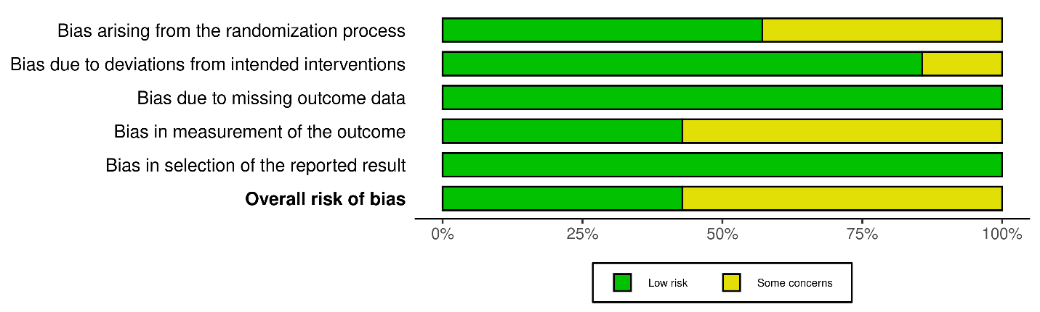
Supplementary Figure 1. Risk of bias graph of included trials.
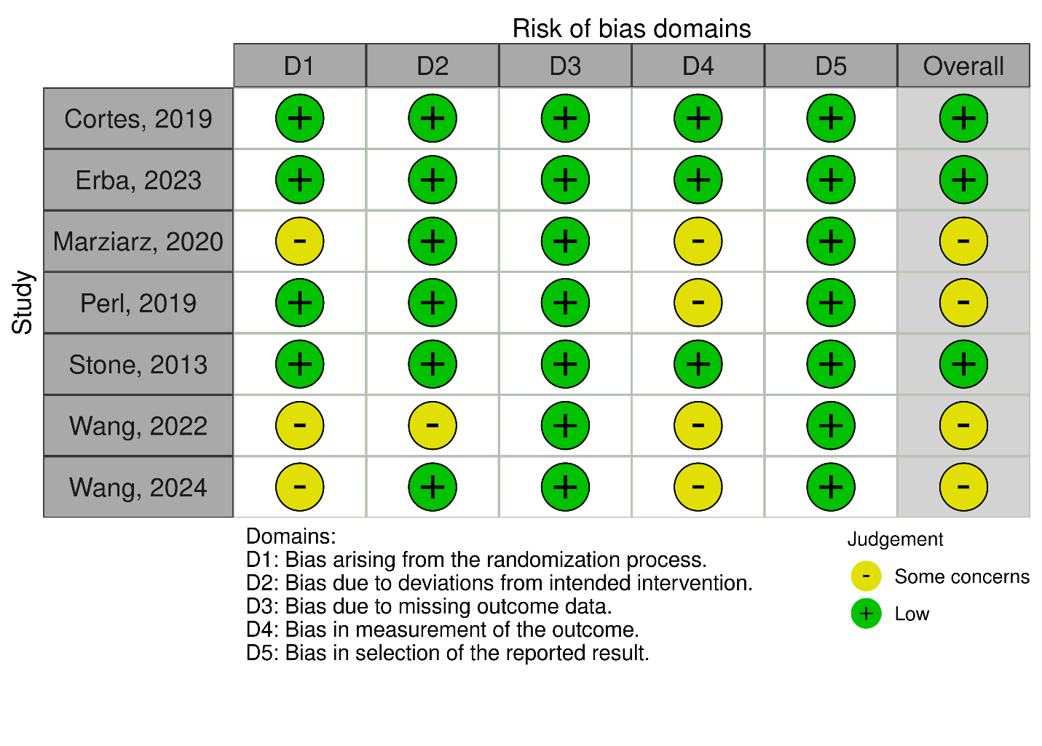
Supplementary Figure 2. Risk of bias summary of included trials.

Supplementary Table 1. Data sources and methods of calculation for the safety outcome. Filled circle indicates that the study explicitly reported data for the specific safety outcome in the corresponding column; the “x” indicates that the study did not report data for the specific safety outcome; “Cal” indicates that the safety outcome was not explicitly reported but could be calculated from the data provided in the study; “NA” is not applicable.
Author, year | Grade 1-2 | Grade 3 | Grade 4 | Grade 5 | All grades | ≥3 grade | p-value
Cortes, 2019 | ● | ● | ● | ● | Cal | Cal | x
Erba, 2023 | x | x | x | x | ● | ● | x
Maziarz, 2020 | x | x | x | x | ● | ● | x
Perl, 2019 | x | x | x | x | ● | ● | x
Stone, 2017 | x | x | x | x | x | ● | ●
Wang, 2022 | x | x | x | x | ● | ● | x
Wang, 2024 | x | x | x | x | ● | ● | x

Supplementary Table 2. Percentage of grade 3 and above adverse events, classified by System Organ Class and stratified by each study included in the review. Note: Data from Stone et al. include only grade 3 and 4 adverse events, excluding grade 5.
Adverse events  (≥3 grade) | Cortes, 2019 |  | Erba, 2023 |  | Maziarz, 2020 |  | Perl, 2019 |  | Stone, 2017* |  | Wang, 2022 |  | Wang, 2024
Adverse events  (≥3 grade) | Quizartinib (N=245) | Control (N=122) | Quizartinib (N=268) | Control (N=271) | Midostaurin (N=30) | Control (N=30) | Gilteritinib (N=246) | Control (N=109) | Midostaurin (N=355) | Control (N=354) | Gilteritinib (N=73) | Control (N=47) | Gilteritinib (N=113) | Control (N=104)
Blood and lymphatic system disorders
Anemia | 29.9% | 28.7% | 5.7% | 5.2% | 6.7% | 10.0% | 40.7% | 30.3% | 92.7% | 87.9% | 24.7% | 27.7% | 71.7% | 59.6%
Bone marrow event |  |  |  |  |  |  |  |  | 0.3% | 1.4%
Febrile neutropenia | 30.7% | 21.3% | 43.4% | 41.0% |  |  | 45.9% | 36.7% | 81.7% | 82.5% | 35.6% | 19.1% | 25.7% | 28.8%
Leukocytosis | 2.9% | 3.2%
Leukopenia | 17.4% | 16.0% |  |  |  |  | 13.0% | 17.4% | 26.2% | 29.7% |  |  | 68.1% | 68.3%
Neutropenia | 31.5% | 24.5% | 26.8% | 11.9% | 6.7% | 13.3% | 30.5% | 24.8% | 95.2% | 95.8% | 41.1% | 29.8% | 64.6% | 50.0%
Pancytopenia | 4.6% | 0.0%
Thrombocytopenia | 35.3% | 34.0% | 7.9% | 9.7% |  |  | 44.7% | 41.3% | 97.5% | 96.6% | 45.2% | 38.3% | 78.8% | 76.0%
Gastrointestinal disorders
Abdominal pain | 2.1% | 1.1% | 2.3% | 1.9% |  |  | 2.0% | 0.0%
Constipation | 0.0% | 0.0% | 0.4% | 0.0% |  |  | 0.8% | 0.0% |  |  | 0.0% | 0.0%
Diarrhea | 1.7% | 3.2% | 3.8% | 3.7% | 3.3% | 10.0% | 3.7% | 2.8% | 15.8% | 15.3% | 6.8% | 0.0% | 3.5% | 2.9%
Dyspepsia |  |  | 0.4% | 0.7%
Nausea | 2.5% | 1.1% | 1.5% | 1.9% | 10.0% | 3.3% | 2.0% | 0.0% | 5.6% | 9.6% | 1.4% | 2.1% | 0.0% | 0.0%
Stomatitis | 2.1% | 4.3% | 4.5% | 3.0% |  |  | 2.4% | 3.7%
Vomiting | 3.3% | 1.1% | 0.0% | 1.5% | 3.3% | 6.7% | 0.4% | 0.0% |  |  | 2.7% | 0.0% | 0.9% | 1.0%
General disorders
Asthenia |  |  |  |  |  |  | 2.4% | 1.8% |  |  | 6.8% | 0.0%
Fatigue | 7.9% | 1.1% | 0.4% | 0.0% | 0.0% | 3.3% | 2.4% | 1.8% | 9.0% | 10.5%
Mucositis/stomatitis |  |  |  |  |  |  |  |  | 6.2% | 7.9%
Oedema peripheral | 1.2% | 0.0% | 0.4% | 1.1% | 0.0% | 0.0% | 0.4% | 0.0% |  |  | 0.0% | 0.0%
Pain |  |  |  |  |  |  |  |  | 13.2% | 12.4%
Pain in extremity |  |  |  |  |  |  | 0.8% | 0.9%
Pyrexia | 2.5% | 4.3% | 4.5% | 4.9% | 3.3% | 0.0% | 3.3% | 3.7% |  |  | 9.6% | 0.0% | 6.2% | 2.9%
Hepatobiliary disorders
Hyperbilirubinemia |  |  |  |  |  |  |  |  | 7.0% | 7.9%
Immune system disorders
Graft-versus-host disease | 4.6% | 0.0%
Infections and infestations
Cellulitis | 3.3% | 0.0%
Clostridioides difficile  infection | 2.1% | 0.0%
Device-related infection | 3.3% | 5.3%
Infection |  |  |  |  |  |  |  |  | 52.4% | 50.3%
Sepsis or septic shock | 19.1% | 19.1% | 4.2% | 9.0% |  |  |  |  |  |  | 5.5% | 10.6%
Upper respiratory tract infection | 2.1% | 0.0% |  |  |  | 0.0%
Urinary tract infection | 4.1% | 0.0%
Investigations
ALT increased | 3.7% | 2.1% | 4.5% | 4.9% | 13.3% | 10.0% | 13.8% | 4.6% | 12.7% | 9.3% |  |  | 6.2% | 3.8%
AST increased |  |  | 2.6% | 1.1% | 13.3% | 6.7% | 14.6% | 1.8% |  |  | 5.5% | 0.0% | 5.3% | 4.8%
Blood alkaline  phosphatase increased |  |  |  |  |  |  | 2.8% | 0.0%
Blood creatine  phosphokinase increased |  |  |  |  |  |  | 6.5% | 0.0%
Blood lactate dehydrogenase increased |  |  |  |  |  |  |  |  |  |  |  |  | 4.4% | 2.9%
Electrocardiogram  QT prolonged | 4.1% | 0.0% | 3.0% | 1.1%
Lymphopenia |  |  |  |  |  |  |  |  | 38.4% | 44.0% |  |  | 16.8% | 21.2%
Weight decreased | 0.4% | 0.0%
Weight increased |  |  |  |  |  |  |  |  |  |  |  |  | 4.4% | 0.0%
Metabolism and nutrition disorders
Decreased appetite | 2.5% | 0.0% | 4.9% | 1.9% |  |  | 2.0% | 4.6% |  |  | 4.1% | 2.1%
Hyperglycaemia | 2.1% | 3.2% |  |  |  |  | 7.3% | 8.3% |  |  |  |  | 2.7% | 1.0%
Hypoalbuminemia |  |  |  |  |  |  | 1.2% | 1.8%
Hypocalcemia | 0.4% | 2.1% | 0.8% | 3.0% |  |  | 4.9% | 0.9% | 6.8% | 5.9% |  |  | 2.7% | 3.8%
Hypokalemia | 11.6% | 8.5% | 18.9% | 16.4% |  |  | 13.0% | 11.0% | 13.8% | 16.9% | 8.2% | 8.5% | 13.3% | 14.4%
Hypomagnesemia | 0.0% | 0.0% | 0.4% | 0.4% |  |  | 0.8% | 0.0%
Hyponatremia | 3.3% | 0.0% |  |  |  |  | 6.5% | 2.8% | 8.7% | 6.5% | 12.3% | 2.1% | 7.1% | 4.8%
Hypophosphatemia | 4.6% | 5.3% | 6.8% | 6.0% |  |  | 8.1% | 3.7% | 5.4% | 8.2%
Muscoloskeletal disorders
Arthralgia |  |  | 0.4% | 0.7% | 3.3% | 0.0% | 1.6% | 0.9%
Back pain |  |  | 0.0% | 0.7% |  |  | 0.8% | 0.9%
Myalgia | 4.1% | 4.3% |  |  |  |  | 0.4% | 0.0%
Neoplasms
Acute myeloid leukemia |  |  |  |  |  |  | 13.4% | 3.7%
Nervous system disorders
Dizziness | 0.0% | 0.0% |  |  | 0.0% | 0.0% | 0.4% | 0.0%
Dysgeusia |  |  |  |  |  |  | 0.0% | 0.0%
Headache | 0.4% | 0.0% | 0.0% | 0.7% | 0.0% | 0.0% | 1.2% | 0.0%
Syncope | 3.7% | 0.0%
Tremor |  |  |  |  | 0.0% | 0.0%
Psychiatric disorders
Insomnia |  |  | 0.0% | 0.0% | 0.0% | 0.0% | 0.0% | 0.0%
Renal and urinary disorders
Renal failure, acute | 2.1% | 0.0%
Respiratory disorders
Cough | 0.4% | 0.0% | 0.4% | 0.0% | 0.0% | 0.0% | 0.4% | 0.0%
Dyspnoea | 5.0% | 5.3% |  |  | 3.3% | 0.0% | 4.1% | 2.8%
Epistaxis |  |  | 1.1% | 0.4% |  |  | 0.8% | 0.9%
Oropharyngeal pain | 0.0% | 0.0% | 0.0% | 0.4%
Pneumonia | 12.0% | 8.5% | 11.3% | 11.2% |  |  | 11.8% | 4.6% | 7.9% | 8.2% | 20.5% | 17.0% | 22.1% | 17.3%
Skin disorders
Petechiae | 0.8% | 0.0%
Pruritus |  |  | 0.8% | 0.0% | 0.0% | 10.0%
Rash | 2.5% | 0.0% | 3.0% | 1.1% | 0.0% | 0.0% | 0.4% | 0.9% | 14.1% | 7.6%
Vascular disorders
Hypertension |  |  | 4.9% | 6.7% |  | 13.3% | 8.1% | 3.7%
Hypotension | 3.7% | 2.1% |  |  |  |  | 7.7% | 2.8%

Supplementary Table 3. Percentage of any grade adverse events, classified by System Organ Class and stratified by each study included in the review. Note: Stone et al. did not report adverse events of any grade.
Adverse events  (≥3 grade) | Cortes, 2019 |  | Erba, 2023 |  | Maziarz, 2020 |  | Perl, 2019 |  | Stone, 2017* |  | Wang, 2022 |  | Wang, 2024
Adverse events  (≥3 grade) | Quizartinib (N=245) | Control (N=122) | Quizartinib (N=268) | Control (N=271) | Midostaurin (N=30) | Control (N=30) | Gilteritinib (N=246) | Control (N=109) | Midostaurin (N=355) | Control (N=354) | Gilteritinib (N=73) | Control (N=47) | Gilteritinib (N=113) | Control (N=104)
Blood and lymphatic system disorders
Anemia | 36.5% | 31.9% | 10.9% | 7.1% | 20.0% | 23.3% | 62.6% | 34.9% | NA | NA | 31.5% | 34.0% | 77.9% | 64.4%
Febrile neutropenia | 33.6% | 27.7% | 44.2% | 42.2% |  |  | 63.0% | 36.7% | NA | NA | 35.6% | 21.3% | 25.7% | 28.8%
Leukocytosis | 6.2% | 3.2% |  |  |  |  |  |  | NA | NA
Leukopenia | 19.5% | 17.0% |  |  |  |  | 21.5% | 17.4% | NA | NA |  |  | 70.8% | 68.3%
Neutropenia | 33.6% | 25.5% | 30.6% | 14.6% | 10.0% | 23.3% | 41.9% | 25.7% | NA | NA | 43.8% | 36.2% | 66.4% | 52.9%
Pancytopenia | 5.4% | 0.0% |  |  |  |  |  |  | NA | NA
Thrombocytopenia | 39.0% | 34.0% | 11.3% | 11.2% |  |  | 67.1% | 42.2% | NA | NA | 49.3% | 42.6% | 85.8% | 76.0%
Eye disorders
Drye eye |  |  |  |  | 20.0% | 16.7% |  |  | NA | NA
Gastrointestinal disorders
Abdominal pain | 22.4% | 17.0% | 28.3% | 23.5% |  |  | 21.5% | 14.7% | NA | NA
Constipation | 19.5% | 23.4% | 21.1% | 25.7% |  |  | 37.4% | 14.7% | NA | NA | 34.2% | 21.3%
Diarrhea | 29.0% | 36.2% | 37.0% | 35.1% | 23.3% | 40.0% | 45.9% | 29.4% | NA | NA | 38.4% | 17.0% | 28.3% | 24.0%
Dyspepsia |  |  | 11.3% | 8.6% |  |  |  |  | NA | NA
Nausea | 48.1% | 41.5% | 34.0% | 31.3% | 26.7% | 66.7% | 46.7% | 33.0% | NA | NA | 32.9% | 21.3% | 16.8% | 24.0%
Stomatitis | 16.6% | 19.1% | 21.5% | 20.9% |  |  | 20.3% | 14.7% | NA | NA
Vomiting | 33.2% | 21.3% | 24.5% | 19.8% | 23.3% | 73.3% | 27.6% | 13.8% | NA | NA | 24.7% | 17.0% | 19.5% | 23.1%
General disorders
Asthenia |  |  |  |  |  |  | 19.5% | 9.2% | NA | NA | 23.3% | 14.9%
Fatigue | 39.4% | 28.7% | 10.9% | 8.6% | 30.0% | 26.7% | 34.1% | 12.8% | NA | NA
Mucositis or stomatitis |  |  |  |  |  |  |  |  | NA | NA
Oedema peripheral | 21.2% | 23.4% | 11.3% | 13.8% | 30.0% | 26.7% | 29.3% | 11.9% | NA | NA | 21.9% | 10.6%
Pain |  |  |  |  |  |  |  |  | NA | NA
Pain in extremity |  |  |  |  |  |  | 17.9% | 7.3% | NA | NA
Pyrexia | 38.2% | 44.7% | 42.3% | 40.7% | 16.7% | 13.3% | 55.7% | 29.4% | NA | NA | 47.9% | 34.0% | 44.2% | 36.5%
Immune system disorders
Graft-versus-host disease | 12.0% | 0.0% |  |  |  |  |  |  | NA | NA
Infections and infestations
Cellulitis | 6.6% | 0.0% |  |  |  |  |  |  | NA | NA
Clostridioides difficile  infection | 4.6% | 0.0% |  |  |  |  |  |  | NA | NA
Device-related infection | 4.6% | 7.4% |  |  |  |  |  |  | NA | NA
Infection |  |  |  |  |  |  |  |  | NA | NA
Sepsis or septic shock | 21.6% | 26.6% | 5.7% | 10.4% |  |  |  |  | NA | NA | 5.5% | 10.6%
Upper respiratory tract infection | 8.7% | 0.0% |  |  |  | 30.0% |  |  | NA | NA
Urinary tract infection | 9.1% | 0.0% |  |  |  |  |  |  | NA | NA
Investigations
ALT increased | 13.3% | 4.3% | 15.8% | 10.1% | 23.3% | 20.0% | 45.9% | 9.2% | NA | NA |  |  | 31.0% | 19.2%
AST increased |  |  | 10.6% | 7.1% | 26.7% | 16.7% | 45.5% | 11.9% | NA | NA | 24.7% | 6.4% | 35.4% | 16.3%
Blood alkaline  phosphatase increased |  |  |  |  |  |  | 23.6% | 1.8% | NA | NA
Blood creatine  phosphokinase increased |  |  |  |  |  |  | 26.8% | 3.7% | NA | NA
Blood lactate dehydrogenase increased |  |  |  |  |  |  |  |  | NA | NA |  |  | 44.2% | 20.2%
Electrocardiogram  QT prolonged | 26.6% | 0.0% | 13.6% | 4.1% |  |  |  |  | NA | NA
Lymphopenia |  |  |  |  |  |  |  |  | NA | NA |  |  | 19.5% | 23.1%
Weight decreased | 11.2% | 0.0% |  |  |  |  |  |  | NA | NA
Weight increased |  |  |  |  |  |  |  |  | NA | NA |  |  | 20.4% | 1.0%
Metabolism and nutrition disorders
Decreased appetite | 20.3% | 0.0% | 17.4% | 13.4% |  |  | 26.0% | 18.3% | NA | NA | 20.5% | 14.9%
Hyperglycaemia | 6.2% | 7.4% |  |  |  |  | 20.3% | 12.8% | NA | NA |  |  | 24.8% | 14.4%
Hypoalbuminemia |  |  |  |  |  |  | 15.9% | 6.4% | NA | NA
Hypocalcemia | 12.0% | 10.6% | 9.8% | 10.8% |  |  | 21.5% | 5.5% | NA | NA |  |  | 26.5% | 21.2%
Hypokalemia | 32.4% | 27.7% | 35.1% | 35.8% |  |  | 42.7% | 31.2% | NA | NA | 21.9% | 21.3% | 40.7% | 38.5%
Hypomagnesemia | 15.4% | 0.0% | 11.3% | 11.2% |  |  | 20.7% | 11.0% | NA | NA
Hyponatremia | 9.1% | 0.0% |  |  |  |  | 15.9% | 5.5% | NA | NA | 19.2% | 6.4% | 23.0% | 20.2%
Hypophosphatemia | 10.0% | 10.6% | 10.2% | 9.0% |  |  | 18.7% | 4.6% | NA | NA
Muscoloskeletal disorders
Arthralgia |  |  | 10.9% | 13.1% | 20.0% | 10.0% | 13.8% | 5.5% | NA | NA
Back pain |  |  | 7.2% | 10.4% |  |  | 17.1% | 11.9% | NA | NA
Myalgia | 37.8% | 28.7% |  |  |  |  | 15.9% | 3.7% | NA | NA
Neoplasms
Acute myeloid leukemia |  |  |  |  |  |  | 15.0% | 3.7% | NA | NA
Nervous system disorders
Dizziness | 14.9% | 10.6% |  |  | 20.0% | 10.0% | 20.3% | 1.8% | NA | NA
Dysgeusia |  |  |  |  |  |  | 12.2% | 4.6% | NA | NA
Headache | 21.6% | 17.0% | 27.5% | 19.8% | 23.3% | 26.7% | 32.5% | 14.7% | NA | NA
Syncope | 4.6% | 0.0% |  |  |  |  |  |  | NA | NA
Tremor |  |  |  |  | 13.3% | 23.3% |  |  | NA | NA
Psychiatric disorders
Insomnia |  |  | 14.0% | 11.2% | 20.0% | 13.3% | 18.7% | 5.5% | NA | NA
Renal and urinary disorders
Renal failure, acute | 5.8% | 0.0% |  |  |  |  |  |  | NA | NA
Respiratory disorders
Cough | 23.2% | 13.8% | 18.9% | 16.4% | 20.0% | 26.7% | 33.7% | 10.1% | NA | NA
Dyspnoea | 20.3% | 8.5% |  |  | 23.3% | 10.0% | 26.4% | 6.4% | NA | NA
Epistaxis |  |  | 15.1% | 10.8% |  |  | 20.3% | 7.3% | NA | NA
Oropharyngeal pain | 10.4% | 0.0% | 10.2% | 6.7% |  |  |  |  | NA | NA
Pneumonia | 15.8% | 10.6% | 14.7% | 15.3% |  |  | 20.7% | 7.3% | NA | NA | 26.0% | 17.0% | 29.2% | 26.0%
Skin disorders
Petechiae | 11.2% | 0.0% |  |  |  |  |  |  | NA | NA
Pruritus |  |  | 13.2% | 14.9% | 20.0% | 23.3% |  |  | NA | NA
Rash | 22.8% | 18.1% | 26.0% | 24.6% | 20.0% | 20.0% | 18.7% | 9.2% | NA | NA
Vascular disorders
Hypertension |  |  | 10.9% | 12.3% |  | 30.0% | 17.9% | 9.2% | NA | NA
Hypotension | 13.3% | 10.6% |  |  |  |  | 20.7% | 7.3% | NA | NA

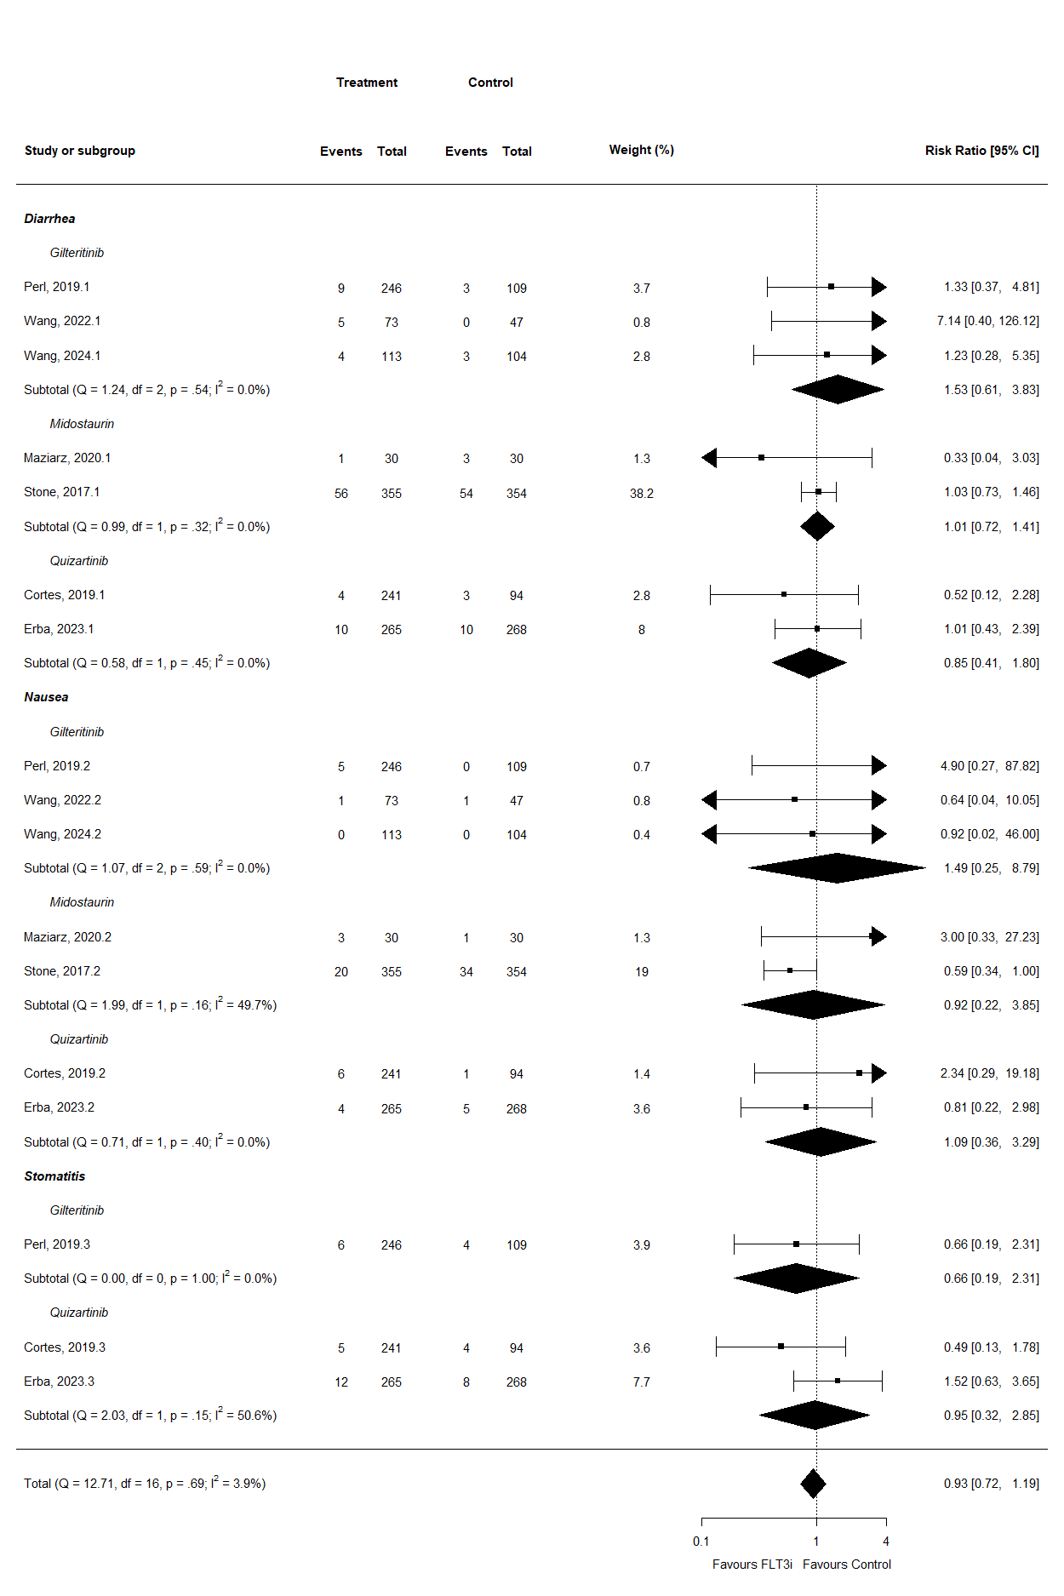Supplementary Figure 3. Forest plot for adverse events related to gastrointestinal disorders.
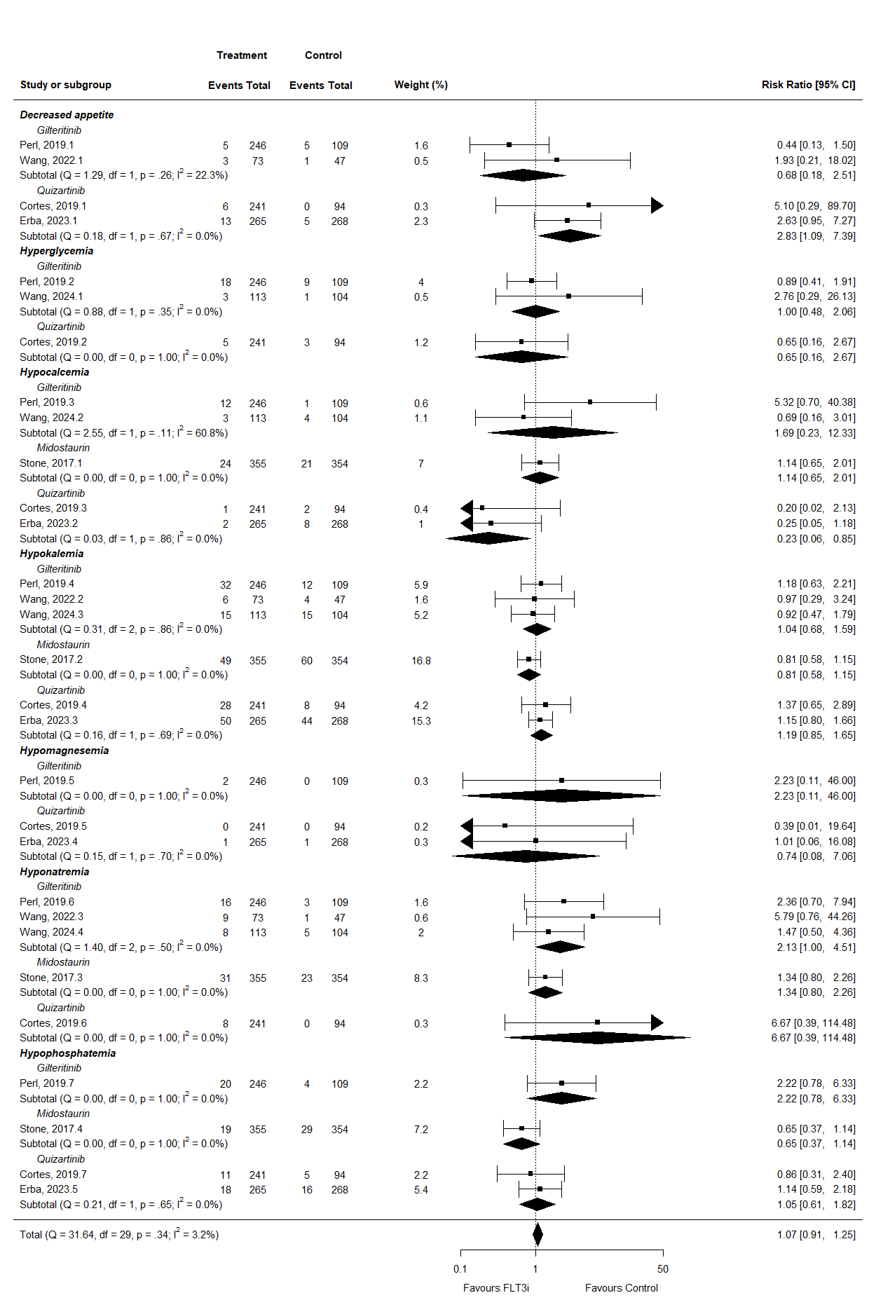
Supplementary Figure 4. Forest plot for adverse events related to metabolism disorders.
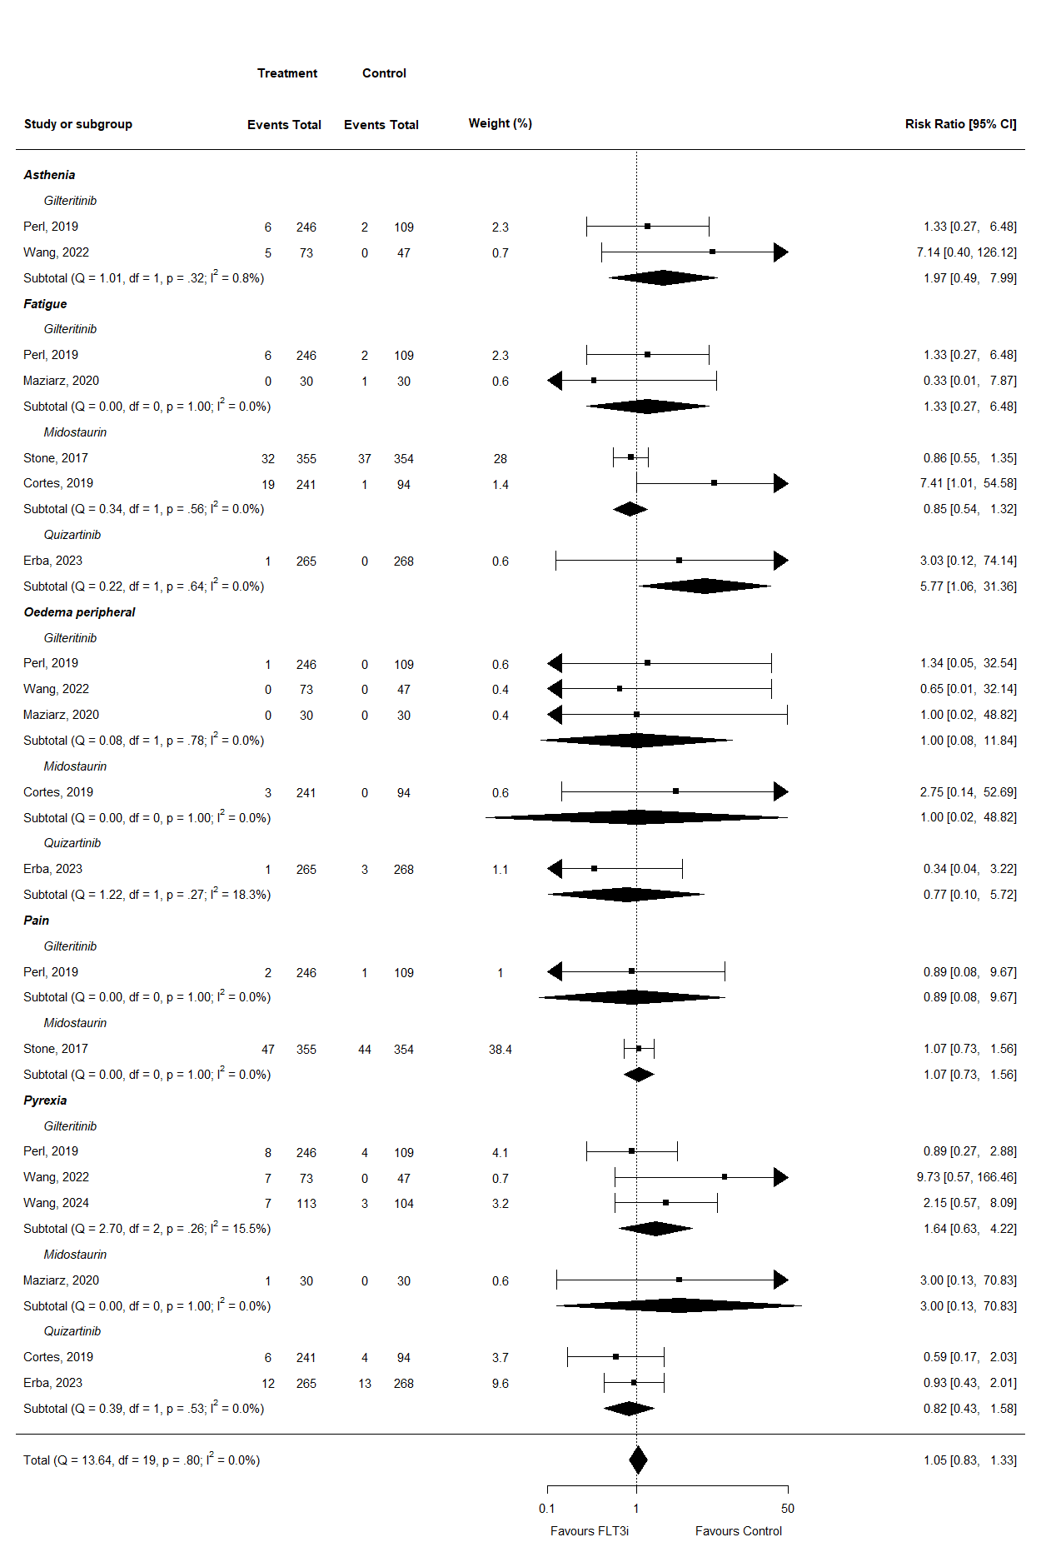Supplementary Figure 5. Forest plot for adverse events related to general disorders.
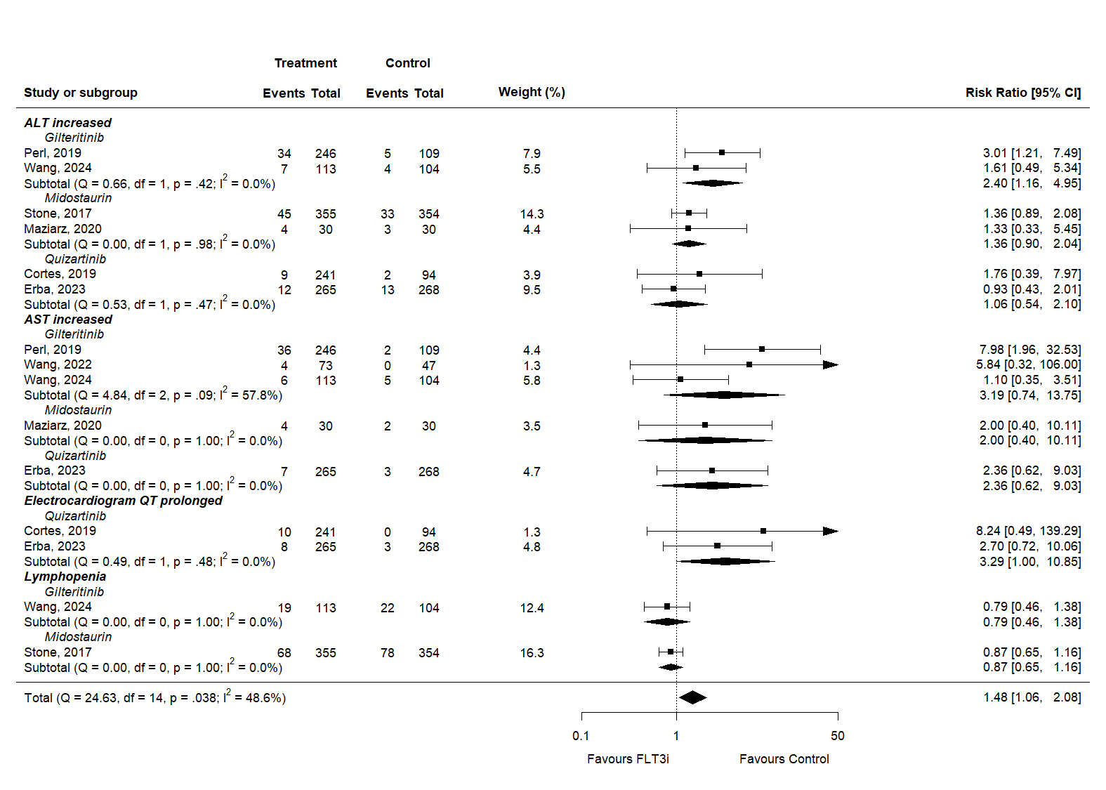
Supplementary Figure 6. Forest plot for adverse events related to investigation.
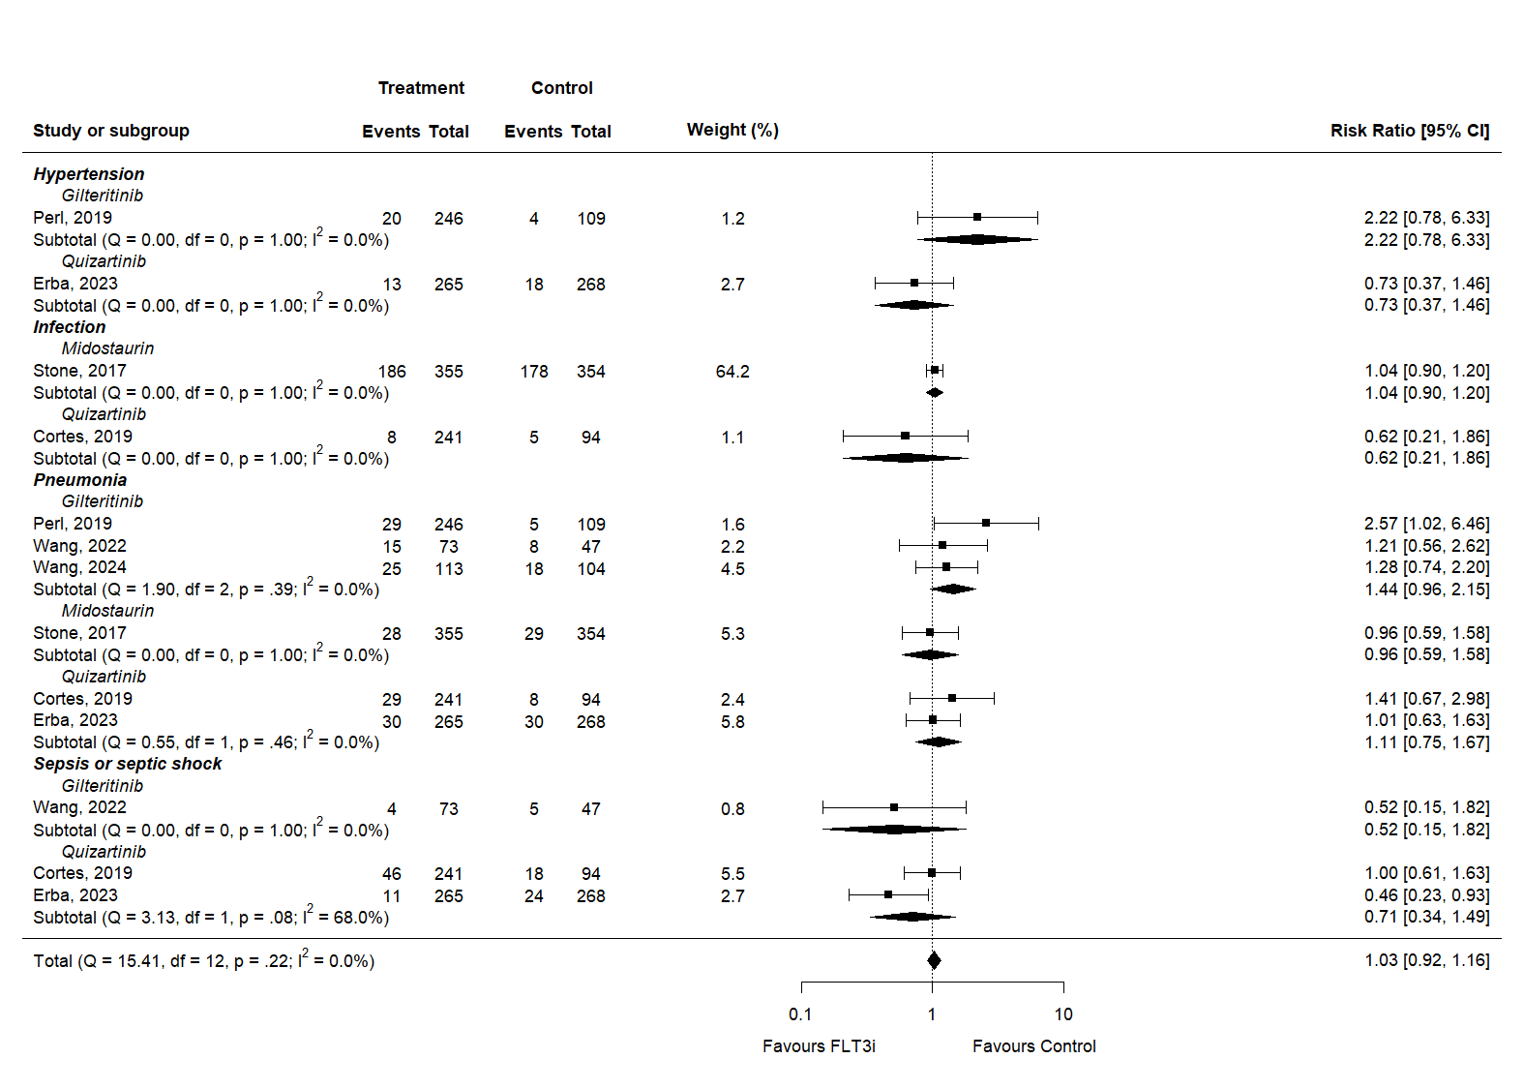
Supplementary Figure 7. Forest plot for other adverse events.

