Supplementary Material

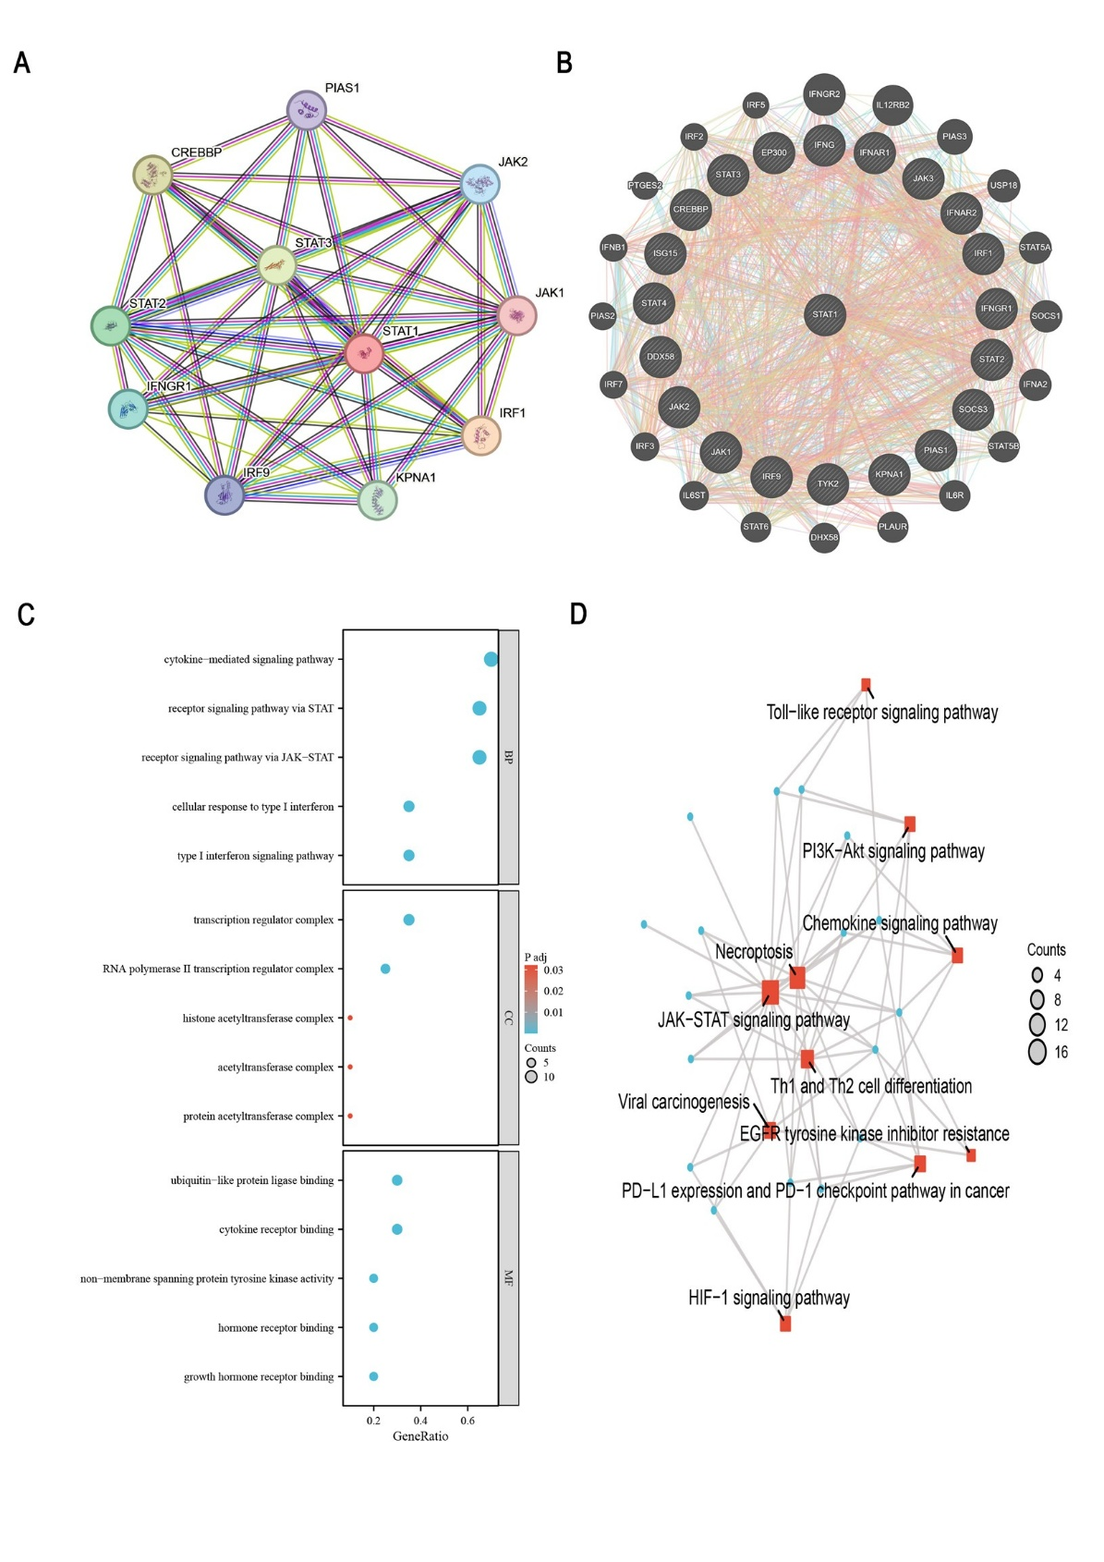

Figure S1: A. STAT1 protein-protein interaction (PPI) network diagram; B. Extended protein-protein interaction network of STAT1 protein; C. GO enrichment analysis bubble chart of STAT1-related interacting proteins; D. KEGG analysis network diagram of STAT1-related interacting proteins.

