Supplementary material

Methodology

Applying the QVAR model begins with data preparation, which entails collecting data, assessing its stationarity, and arranging it into a matrix format conducive to VAR analysis. Afterward, the optimal lag for the model is identified through several criteria, such as AIC, BIC, and FPE. Different quantiles are selected to illustrate various market conditions; for instance, the 5th, 50th, and 95th quantiles signify bearish, normal, and bullish trends, respectively. The next step involves estimating a quantile VAR model. Therefore, QVAR(p) is obtained as follows for computing connectivity metrics:

$$y_{t}=μ\left(τ\right)+Σ_{j=1}^{p}Φ_{j}\left(τ\right)y_{t-j}+u_{t}\left(τ\right).$$

Here, y_{t} and y_{t-j} are vectors of size k×1 that represent the values of endogenous variables at time t and t-j, respectively. In this study, the time series consists of 12 green sectors, making both vectors of size 12×1. The vector y_{t} explains the joint behavior of all sectors. The vectors representing the quantiles of the conditional distribution for the variables in y_{t} are indicated by τ, with values that span the range [0, 1] and have an order of k×1. This study employs quantile levels (τ) of 0.50, 0.05, and 0.95 to analyze standard and extreme market conditions. Moreover, the optimal lag length of the QVAR model is denoted by p. Furthermore, Φ_{j} (τ) refers to the k×k dimensional matrix that contains lagged coefficient of quantiles in τ. The term μ(τ) represents a k× 1 vector of intercepts at quantile τ, whereas $u_{t}\left(τ\right)$ is a vector of residuals at quantile τ and have the same size, accompanied by a variance–covariance matrix of dimensions k × k, represented as Σ(τ). Furthermore, Wold's theorem is used to convert QVAR(p) into QVMA(ꝏ) form:

$$Y_{t}=μ\left(τ\right)+Σ_{j=1}^{p}Φ_{j}\left(τ\right)y_{t-j}+u_{t}\left(τ\right)=μ\left(τ\right)+Σ_{i=1}^{∞} ψ_{i}\left(τ\right)u_{t-i}$$
After that, to understand the effect of a shock in the τ^{th} quantile of variable j on variable i, the H-step forward Generalized Forecast Error Variance Decomposition (GFEVD) of Koop et al. (1996) and Pesaran and Shin (1998) is calculated using the equations below:

$$ψ_{ij}^{g}(H)=\frac{{∑(τ)}_{ii}^{-1} ∑_{h=0}^{H-1} {(e_{i}^{'}ψ_{h}(τ)Σ(e_{j})}^{2}}{∑_{h=0}^{H-1} (e_{i}^{'}ψ_{h}(τ)Σ(τ)ψ_{h}{\left(τ\right)}^{'}ⅇ_{i})}$$
$${\tilde{ψ}}_{ij}^{g}\left(H\right)= \frac{ψ_{ij}^{g}(H)}{∑_{j=1}^{k}∅_{ij}^{g}(H)}$$
In this case, e_{i} refers to a zero vector with unity on the i^{th} position. The following equations result from this normalizing process:
$$∑_{j=1}^{k} {\tilde{ψ}}_{ij}^{g}\left(H\right)=1$$
$$∑_{i,j=1}^{k}{\tilde{ψ}}_{ij}^{g}\left(H\right)=k$$
Afterward, the calculation of total directional connectedness (TO) to others quantifies the extent to which an impact of a shock to the variable i spillovers to all other variables j. A variable exhibits a high "TO" value is crucial in influencing the network’s other variables. Any instability in this sector suggests a greater risk of contagion spreading to other variables. Furthermore, with the help of the "TO" value, policymakers and investors can recognize variables that serve as the key determinants of information flow or systemic risk. This value can be obtained using the following equation:
$$C_{i→j}^{g}\left(H\right)=∑_{j=1,i≠j}^{k} {\tilde{ψ}}_{ji}^{g}\left(H\right)$$
Following, the total directional connectedness (FROM) others, which describes how much shock spillovers are received by variable i from all other variables j. When a variable exhibits a high "FROM" value, it implies that it is particularly sensitive to disturbances in other variables and is greatly impacted by external factors. This value can be obtained using the following equation:
$$C_{i←j}^{g}\left(H\right)=∑_{j=1,i≠j}^{k} {\tilde{ψ}}_{ij,}^{g}\left(H\right)$$
Moreover, the NET total directional connectivity represents the difference between total directional connectedness TO others and FROM others. It calculates the net influence of variable i on the system network. The net positive (negative) contribution value refers to the role of a variable as a shock transmitter (receiver), as explained by Antonakakis et al. (2019). A consistently high positive NET connectedness value in certain variables indicates their role as major contributors to systemic risk. Here, systemic risk is defined as the possibility that a failure or crisis occurring in one or more areas of the financial system may extend and result in extensive disruption across the whole system. By concentrating on these variables, policymakers can effectively lessen the dissemination of negative shocks. The net contribution of each variable can be estimated using the undermentioned equation:

$$C_{i}^{g}\left(H\right)=C_{i→j}^{g}\left(H\right) {- C}_{i←j}^{g}\left(H\right)$$
Finally, the adjusted total connectedness index (TCI), ranging from 0 to 1, is derived according to Chatziantoniou and Gabauer (2021). The TCI serves as a measure of market risk, often utilized to illustrate the overall interconnectedness within the system. Higher values indicate a close relationship between variables. This metric can be computed using the following equation:
$$TCI\left(H\right)=\frac{∑_{i,j=1, i≠j}^{k} {\tilde{ψ}}_{ij}^{g}\left(H\right)}{K-1}$$
Additionally, robustness tests are performed, including the validation of quantile thresholds and the examination of various rolling window sizes, to enhance the reliability of the analyses.

Tables and Figures

Table S1. Details of NASDAQ OMX Green Economic Sector Indices
Index | Description
Advanced Materials | This green sector index monitors the performance of companies that manufacture materials supporting renewable technologies or promoting reduced reliance on petroleum-based products.
Bio/Clean Fuels | This index monitors companies that produce fuel from plant-based materials for transportation, serving as a substitute for petroleum-based fuels.
Energy Efficiency | This index comprises companies focused on energy efficiency, divided into four subsectors: Energy Storage, Energy Management, Green IT, and Smart Grid.
Green Building | This index monitors companies that focus on constructing buildings with innovative designs aimed at improving water and energy efficiency.
Green Transportation | This index features companies dedicated to improving energy efficiency and minimizing pollution from trains, vehicles, and other modes of transportation.
Healthy Living | This index involves businesses that manufacture personal care items, food, and other associated products using natural, safe, and certified ingredients, all sourced through sustainable farming methods.
Lighting | This index focuses on firms that produce cutting-edge lighting solutions aimed at enhancing energy efficiency, including LED and compact fluorescent technologies.
Natural Resources | This index comprises businesses involved in forestry, agriculture, and the production of natural products while employing sustainable practices, such as Forest Stewardship Council certified forestry and certified organic farming.
Pollution Mitigation | This index includes companies that offer products and services aimed at reducing pollution from conventional plants, factories, and industries.
Recycling | This index consists of companies that help minimize waste and extend the lifespan of components from precious metal products, as well as reuse, recover, and recycle materials for future use.
Renewable Energy Generation | This index monitors companies involved in generating energy from renewable sources like fuel cells, waves, wind, solar, and geothermal.
Water | This index includes companies focused on purifying and conserving water for industries, businesses, and households.

Table S2. Descriptive Statistics of Green Sectoral Equities.
 | Mean | SD | kurtosis | skewness | ADF | Jarque–Bera | Stability test
Advanced Materials | 0.011 | 1.47 | 5.8 | −0.46 | −14.85*** | 4827.4*** | 0.1281
Bio/Clean Fuels | −0.002 | 1.84 | 10.9 | −0.82 | −14.28*** | 16956.0*** | 0.1281
Energy Efficiency | 0.030 | 1.28 | 7.9 | −0.37 | −14.64*** | 8804.5*** | 0.1276
Green Transportation | 0.051 | 1.69 | 7.8 | −0.38 | −14.18*** | 8612.5*** | 0.0759
Green Building | 0.011 | 1.32 | 21.7 | −1.41 | −13.74*** | 66403.0*** | 0.0759
Lighting | 0.010 | 1.57 | 4.0 | −0.22 | −15.53*** | 2232.6*** | 0.0603
Healthy Living | 0.020 | 1.22 | 9.5 | −0.38 | −14.72*** | 12564.0*** | 0.0597
Pollution Mitigation | 0.024 | 1.17 | 7.6 | −0.51 | −14.87*** | 8174.4*** | 0.0597
Natural Resources | 0.035 | 1.67 | 45.8 | −2.48 | −15.41*** | 294528.0*** | 0.0451
Renewable Energy Generation | 0.020 | 1.17 | 13.2 | −0.84 | −14.00*** | 24457.0*** | 0.0451
Recycling | 0.038 | 1.21 | 8.1 | −0.63 | −14.78*** | 9291.7*** | 0.0279
Water | 0.027 | 1.04 | 9.7 | −0.52 | −14.77*** | 13205.0*** | 0.0279
Notes: *** denotes a 1% level of significance.

Table S3. Descriptive statistics of quantile level and connectedness measures

Quantile level and connectedness measures | Mean | S.D. | Min. | Max.
Total Connectedness Index (cTCI/CTI)
Median quantile | 84.48/77.44 | 7.37 | 62.15 | 96.19
Lower quantile | 97.51/89.39 | 1.37 | 92.84 | 102.03
Upper quantile | 96.97/88.89 | 1.33 | 92.73 | 101.27
Directional connectedness TO others
Median quantile | 77.44 | 17.16 | 9.34 | 119.92
Lower quantile | 89.39 | 4.19 | 0.01 | 437.92
Upper quantile | 88.89 | 4.22 | 0.041 | 526.76
Directional connectedness FROM others
Median quantile | 77.44 | 4.49 | 18.23 | 89.59
Lower quantile | 89.39 | 0.50 | 55.24 | 100.00
Upper quantile | 88.89 | 0.57 | 52.10 | 100.00
Net connectedness
Median quantile | −0.00083 | 12.89 | −39.37 | 39.41
Lower quantile | 0.00083 | 3.81 | −99.99 | 377.73
Upper quantile | 0.00083 | 3.70 | −99.96 | 474.66

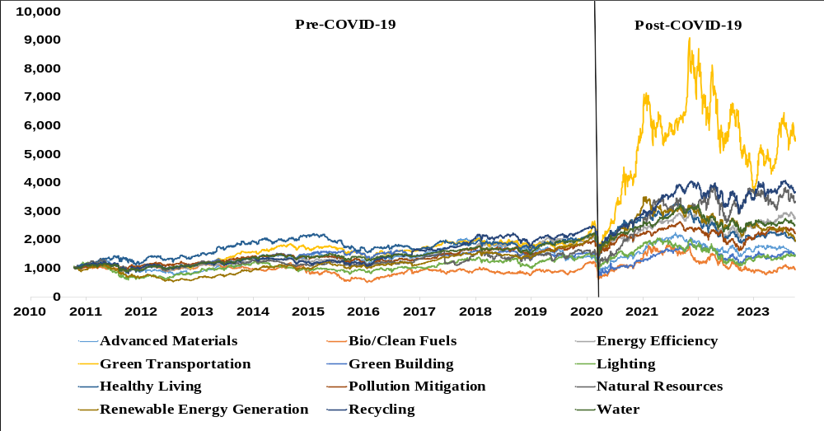
Figure S1. Daily closing values of Green Sectoral Equities.

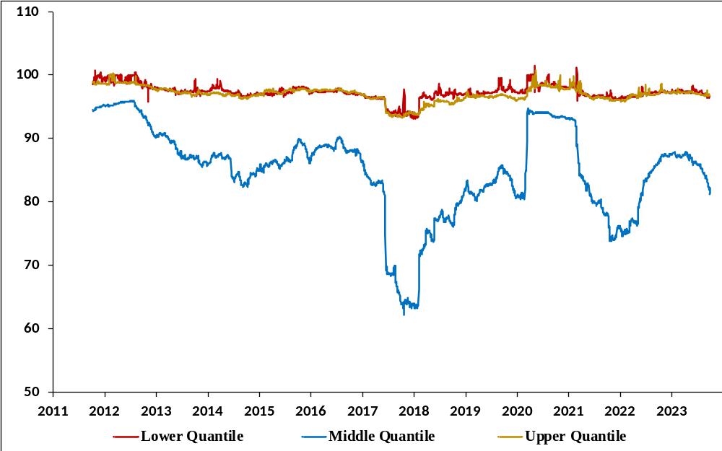

Figure S1. Dynamic Total Connectedness Index in the quantile VAR (q = 0.05, q = 0.50, q = 0.95). Notes: This dynamic TCI is obtained using the optimal lag 1 (AIC), 20 step-ahead forecast horizon and rolling window size of 250 days.

References

Antonakakis N, Gabauer D, Gupta R (2019) International monetary policy spillovers: Evidence from a time-varying parameter vector autoregression. Int Rev Financ Anal 65:101382 https://doi.org/10.1016/j.irfa.2019.101382

Chatziantoniou I, Gabauer D (2021) EMU risk-synchronisation and financial fragility through the prism of dynamic connectedness. Q Rev Econ Finance 79:1–14 https://doi.org/10.1016/j.qref.2020.12.003

Koop G, Pesaran MH, Potter SM (1996) Impulse response analysis in nonlinear multivariate models. J Econom 74(1):119–147 https://doi.org/10.1016/0304-4076(95)01753-4

Pesaran HH, Shin Y (1998) Generalized impulse response analysis in linear multivariate models. Econ Lett 58(1):17–29 https://doi.org/10.1016/S0165-1765(97)00214-0

