Appendix

Table A1: Descriptive Statistics
 | Mean | Std. Dev.
Housing Insecurity
Secure | 0.916
Insecure | 0.084
Subjective Well-Being
1 (largely unhappy) | 0.014
2 | 0.011
3 | 0.020
4 | 0.035
5 | 0.096
6 | 0.162
7 | 0.240
8 | 0.270
9 | 0.093
10 (largely happy) | 0.061
Family types
Single | 0.264
Couples without children | 0.267
Couples with children | 0.351
Single Parent | 0.077
Other | 0.041
Household Head (HH) Characteristics
Age | 60.105 | 15.335
Education
Low | 0.616
Medium | 0.260
High | 0.124
Occupational status
Employed | 0.313
Self employed | 0.098
Not working | 0.589
Highest education of HH parents
Low | 0.740
Medium | 0.102
High | 0.0412
Don’t know | 0.1163
Net wealth | 254601 | 564421.3
Immigration status
No | 0.915
Europe/North America | 0.050
Other countries | 0.035
N | 36,094
Source: own elaboration on SHIW data.

Table A2: OLS coefficient estimates of housing insecurity on subjective well-being by family types.
 | Model 1 | Model 2 | Model 3 | Model 4
HI=1, Insecure | -0.782*** | -0.319*** | -0.306*** | -0.0960
 | (0.0390) | (0.0677) | (0.0668) | (0.136)
Family types (base = couple without children):
Single |  |  | -0.708*** | -0.713***
 |  |  | (0.0887) | (0.0903)
Couple with children |  |  | -0.124** | -0.107*
 |  |  | (0.0581) | (0.0584)
Single parent |  |  | -0.781*** | -0.718***
 |  |  | (0.114) | (0.116)
Other |  |  | -0.805*** | -0.771***
 |  |  | (0.141) | (0.143)
Family types*HI (base = couple without children):
Single*HI |  |  |  | -0.0457
 |  |  |  | (0.172)
Couple with children*HI |  |  |  | -0.328*
 |  |  |  | (0.170)
Single parent*HI |  |  |  | -0.629***
 |  |  |  | (0.241)
Other*HI |  |  |  | -0.384
 |  |  |  | (0.334)
Household and HH characteristics:
Age |  | -0.0329** | -0.0551*** | -0.0539***
 |  | (0.0136) | (0.0141) | (0.0141)
Age² |  | 0.000208* | 0.000353*** | 0.000342***
 |  | (0.000113) | (0.000114) | (0.000114)
Education (base = Low)
Medium |  | -0.0662 | -0.0707 | -0.0682
 |  | (0.0756) | (0.0749) | (0.0748)
High |  | 0.0418 | 0.0339 | 0.0344
 |  | (0.132) | (0.129) | (0.129)
Occupational status:
Self Employed |  | -0.0700 | -0.0830 | -0.0791
 |  | (0.0880) | (0.0870) | (0.0866)
Not Working |  | -0.118** | -0.127** | -0.122**
 |  | (0.0550) | (0.0545) | (0.0545)
Father/Mother of HH tertiary education |  | -0.0772 | -0.0318 | -0.0345
 |  | (0.107) | (0.108) | (0.107)
Immigration status (base = No)
Europe/North America |  | 0.0143 | -0.216 | -0.213
 |  | (0.233) | (0.243) | (0.241)
Other countries |  | -0.0941 | -0.319 | -0.314
 |  | (0.299) | (0.309) | (0.305)
Net wealth |  | 1.35e-07** | 1.18e-07** | 1.19e-07**
 |  | (5.60e-08) | (4.87e-08) | (4.93e-08)
Observations | 36,094 | 36,094 | 36,094 | 36,094
Household fixed effects |  | Yes | Yes | Yes
Notes: These are regressions based on our estimation sample. Standard errors in parentheses are clustered at the household level. All the models have regional and time effects. The dependent variable is an ordinal categorical variable assessing the level of subjective well-being on a scale from 1 to 10. $^{*}p<0.1, ^{**}p<0.05$, $^{***}p<0.01$

Table A3: OLS and Ordinal logistic coefficients estimates and of housing insecurity on subjective well-being by family types
 | Model 5 | Model 6 | Model 7 | Model 8
HI = 1, Insecure | -0.306*** | -0.399*** | -0.0960 | -0.144
 | (0.0668) | (0.0864) | (0.136) | (0.197)
Family type (base: couples without children):
Single | -0.708*** | -0.868*** | -0.713*** | -0.876***
 | (0.0887) | (0.110) | (0.0903) | (0.113)
Couples with children | -0.124** | -0.183** | -0.107* | -0.156*
 | (0.0581) | (0.0848) | (0.0584) | (0.0861)
Single parents | -0.781*** | -0.950*** | -0.718*** | -0.878***
 | (0.114) | (0.143) | (0.116) | (0.148)
HI*Family type
HI*Single |  |  | -0.0457 | -0.0489
 |  |  | (0.172) | (0.233)
HI*Couples with children |  |  | -0.328* | -0.391*
 |  |  | (0.170) | (0.234)
HI*Single parents |  |  | -0.629*** | -0.699**
 |  |  | (0.241) | (0.309)
Observations | 36,094 | 36,094 | 36,094 | 36,094
Time and regional effects | Yes | Yes | Yes | Yes
Household Controls | Yes | Yes | Yes | Yes
Household fixed effects | Yes | Yes | Yes | Yes

Notes: These are regressions based on our estimation sample. Standard errors in parentheses are clustered at the household level. The dependent variable is an ordinal categorical variable assessing the level of subjective well-being in a scale from 1 to 10. All the models have regional and time effects. Household controls are head of the household (HH) age, HH’s educational level, HH’s occupational status, HH’s father education and net wealth. $^{*}p<0.1, ^{**}p<0.05$, $^{***}p<0.01$ Source: Waves 1998-2020 of the Survey on Household Income and Wealth (SHIW).

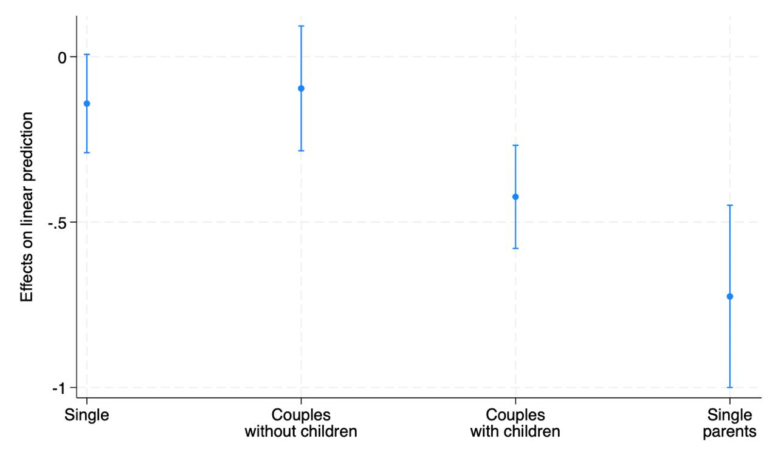
Figure A1: Average Marginal Effects of Housing Insecurity by Family Type. Household controls are head of the household (HH) age, HH’s educational level, HH’s occupational status, HH’s father education and net wealth. Regional, time and household fixed unobserved effects are also included. Source: Waves 2004-2020 of the Survey on Household Income and Wealth (SHIW).

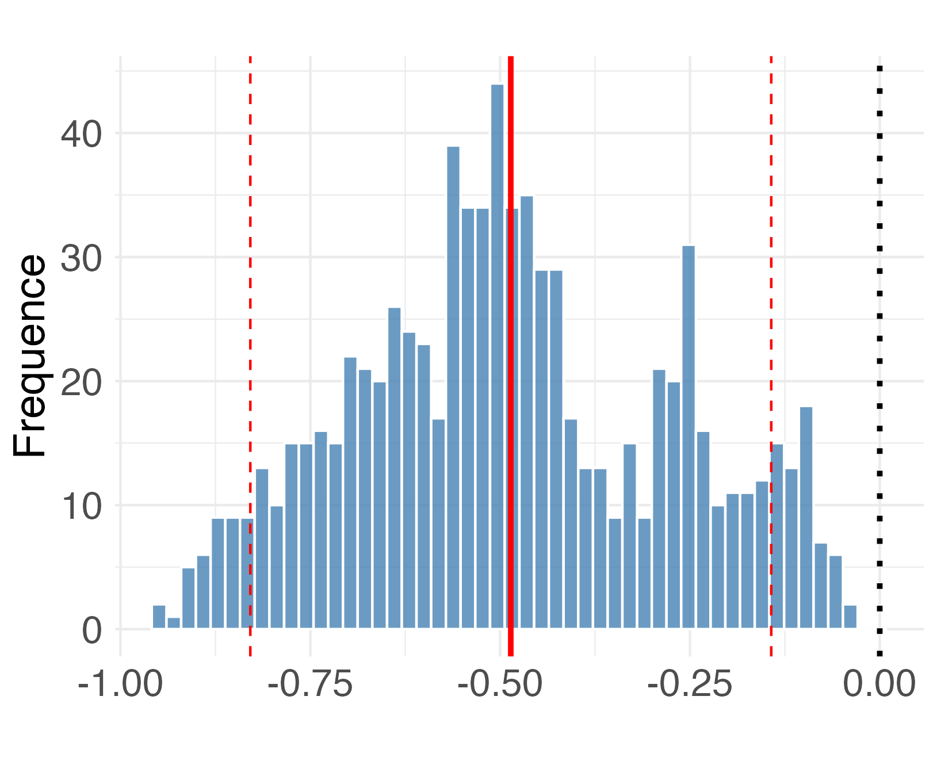
Figure A2: Distribution of HI estimated coefficient values when varying all parameter values. The Y-axis represents the frequency, and the X-axis represents the estimated coefficient values. The solid red line represents the coefficient estimates mean, and the dotted red lines represent the 95% confidence interval for the mean estimation.
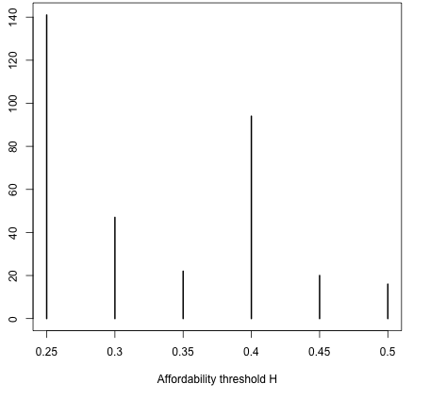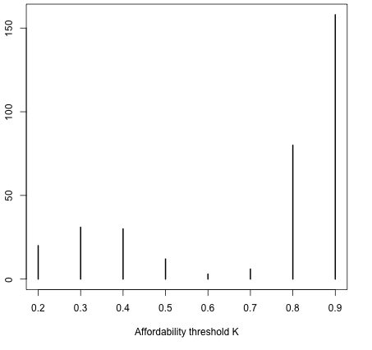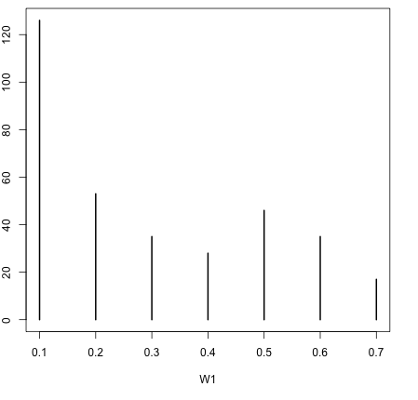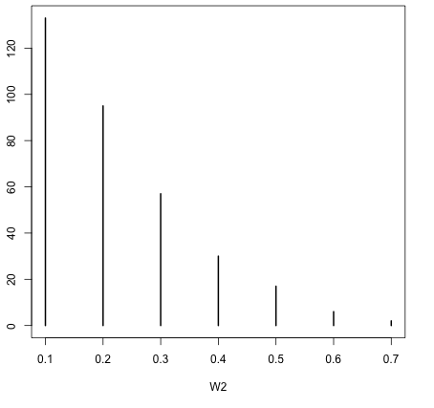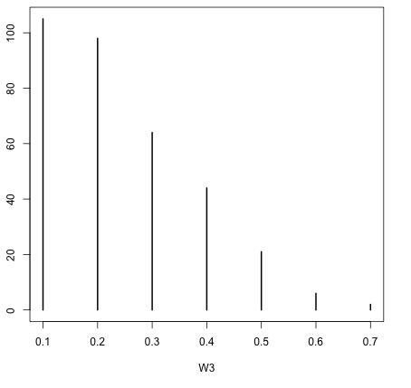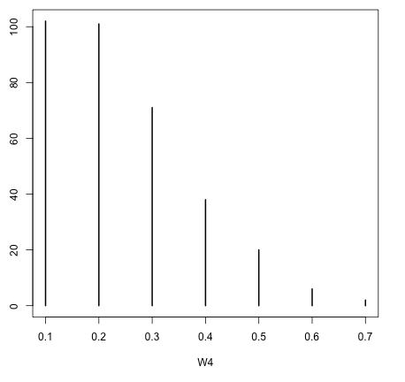
Figure A3: Frequency distribution of non-significant HI coefficient estimates according to the HI index parameters. The Y-axis represents the frequency of non-significant estimates; the X-axis represents the set of parameter values.

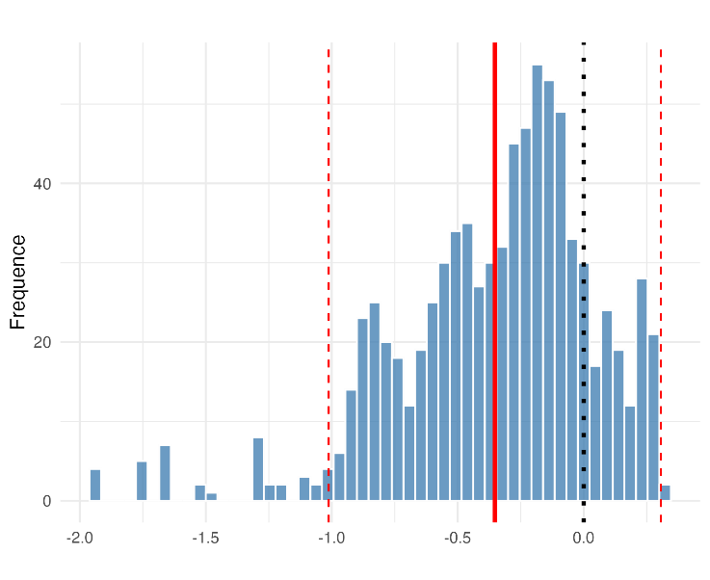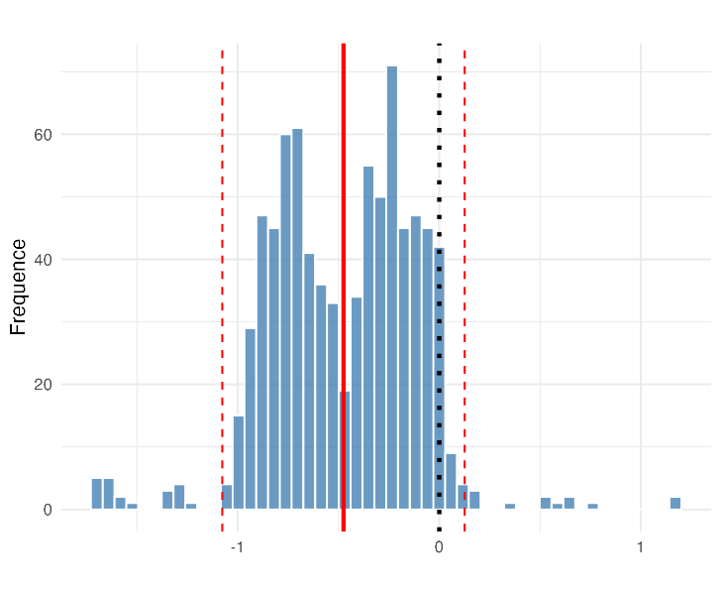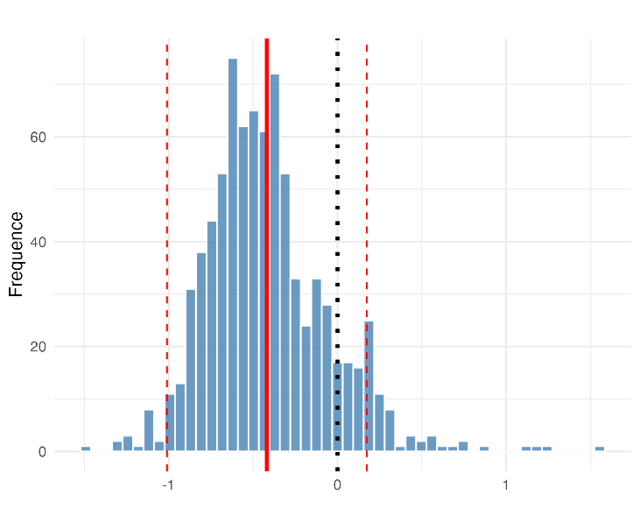
Figure A4: Distribution of HI*Family Types estimated coefficient values when varying all parameter values. The top right graph represents HI*Singles, the top left represents HI*Couples with children and the bottom one represents HI*Single parents. The solid red lines are the coefficient estimates mean, and the dotted red lines are the 95% confidence interval for the mean estimation.

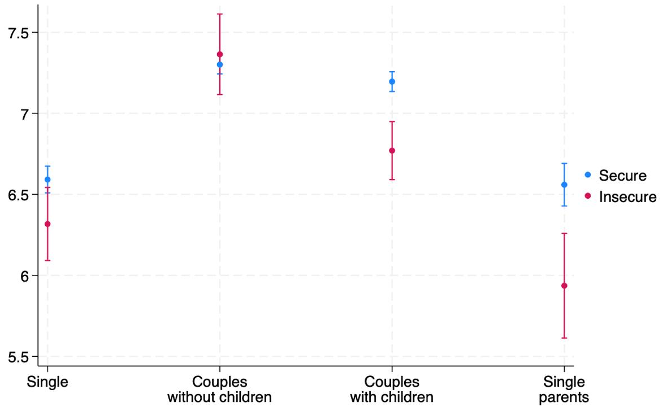
Figure A5: Predicted well-being by housing insecurity and family type with weights as in Romaguera de la Cruz (2020). Household controls are head of the household (HH) age, HH’s educational level, HH’s occupational status, HH’s father education and net wealth. Regional, time and household fixed unobserved effects are also included. Source: Waves 2004-2020 of the Survey on Household Income and Wealth (SHIW).

