Wishing well: a data-driven investigation of Italian adolescents’ wishes and trust in the future
Isabella Gagliardi^{1,}*, Marcello Passarelli^{2,}*, Alessandro Albizzati³, Ivana Lazzarini⁴, Giuseppe Ponzini⁵, Giusi Sellitto³, Antonella Bodini^{1,@}
¹Institute for Applied Mathematics and Information Technologies E. Magenes, National Research Council, Milano, Italy
²Institute for Educational Technologies, National Research Council, Genova, Italy
³ASST Santi Paolo e Carlo, Milano, Italy
⁴ItaliaAdozioni APS, Cernusco sul Naviglio (Milano), Italy
⁵Deceased author (on 9 July 2022). Former affiliation: Institute for Research on Population and Social Policies, National Research Council, Brindisi, Italy

* These authors share first authorship
@ Corresponding author

Supplementary material
S1. List of questions
The original questionnaire (in Italian) in full is publicly available on the website Blinded link and can be required to the Authors. The survey employed in this study explored several different aspects of adolescents’ lives using single-item Likert-type indicators for each question. The items are grouped here based on how they were considered in the analysis, and not according to the structure of the original questionnaire.
- Indicators of distress:
  - Whether they had ever consulted a psychologist (Yes, before the pandemic; Yes, after the pandemic started; No, I don't think I need it; No, but I would like it/would have liked it; No, it's not for me. Dichotomized to Yes/No);
  - Self-reported distress in the following areas: feeling judged, having economic difficulties, sexual orientation, gender identity, lack of parental support, feeling ignored by teachers / parents / friends, being single, having no friends, lacking social media followers, body image, feelings of failure, other (from 1=not at all to 5=very much and “I don’t know” option);
- Coping strategies:
  - Coping strategies in times of distress: playing videogames, travelling, studying, streaming, engaging in sports, seeking solitude, using social media, shopping, listening to music, dancing, and turning to friends / family / a partner (from 1=not at all to 5=very much and “I don’t know” option).
- Leisure habits:
  - Frequency of the following activities: engaging in sports, being online alone, being online with friends, listening to music, reading, idling, pursuing hobbies, sleeping, going to the movies, dancing, and spending time with friends (from 1=never to 5=very often and “I don’t know” option);
  - Usual bedtime on schooldays (categorized as before 22:00, between 22:00 and 23:00, between 23:00 and midnight, after midnight).
- Perceptions of adolescent distress:
  - One item measuring perceived distress among their peers (“It is not a real problem / I have never heard of it / There is a bit-some-a great deal of malaise”);
  - Beliefs about potential causes of distress, including social media, school, religion, politicians, traditional media, family, crime, and youth associations (from 1=not at all to 5=very much and “I don’t know” option).
- Future projection:
  - The type of desire they expressed (coded according to the clustering procedure outlined in Section 2.4 for the Research Question 1 (RQ1): 8 clusters with assigned probability ranging from 0 to 1 and a further “No answer” cluster, with assigned probability equal to 1);
  - Identification of role models, either parents, a famous person, or "I don’t know."
- Interpersonal relationships:
  - Self-reported quality of relationships with family members, classmates, and peers (on a 6-points scale from 1= Almost no relationships to 6=Excellent);
  - Whether they have a confident (dichotomous); Frequency of time spent with parental figures (from 1=never to 5=very often);
- School:
  - Self-reported school achievement (from 1=very negative to 5=very positive);
  - Importance attributed to school achievement (from 1=not at all to 5=very much);
  - School motivation (from 1=very low to 5=very high);
  - Quality of relationship with teachers (from 1=very negative to 5=very positive);
  - Agreement about competence of teachers (from 1=not at all to 5=completely);
  - Extent to which they see teachers as role models (from 1=not at all to 5=completely);
  - Level of academic struggle (from 1=none to 5 very high);
  - Level of exam anxiety (from 1=none to 5 very high);
  - Parental intervention in school matters (dichotomous).
- Socio-biographical characteristics and socio-economic indicators:
  - Ownership of a personal room (dichotomous)
  - Number of employed parental figures (ranging from 0 to 2);
  - Living in the metropolitan area (dichotomous: City of Milan vs surroundings).
  - Sex (female, male, other, I prefer not to answer; dichotomized responses with random assignment to male/female of the few different responses.);
  - Age (≤15, 16-17, ≥18 years);
  - Family unit size (0, 1, 2-4, > 4, excluding the respondent).
- Interaction with digital technologies:
  - Personal assessment of internet usage quality (Certainly adequate / partly inadequate / partly inadequate / uncertain);
  - Personal and familiar smartphone use during family meals (from 1=never to 5=always);
  - Having Internet usage rules (dichotomous);
  - Age at which they received their first smartphone (≤9, 10-11, 12-13, ≥14 years);
  - Change in free-time Internet usage post-pandemic (from 1 = strongly decreased to 5 = strongly increased).

S2. Descriptive analysis
Supplementary Table 1 - Mean, standard deviation, and median for variables with Likert-type answer included in the study. The adopted scale is also indicated, for easy of reading.
Category | Variable | Mean | SD | Median
Dependent variable  (1=None, 5=very much) | Level of Trust in the Future | 2.85 | 0.93 | 3
Coping  (1=not at all; 5=very much and “I don’t know” option) | Friends | 3.85 | 1.02 | 4
 | Partner | 3.74 | 1.26 | 4
 | Solitude | 3.07 | 1.13 | 3
 | Sport | 3.38 | 1.27 | 3
 | Studying | 2.45 | 1.19 | 2
 | Social Media | 2.22 | 0.90 | 2
 | Videogames | 2.17 | 1.13 | 2
 | Shopping | 2.40 | 1.23 | 2
 | Streaming | 2.98 | 1.10 | 3
 | Travelling | 3.75 | 1.18 | 4
 | Family | 3.00 | 1.28 | 3
 | Music | 3.93 | 1.14 | 4
 | Dancing | 2.49 | 1.37 | 2
Distress  (1=not at all; 5=very much and “I don’t know” option) | Gender Identity | 1.32 | 0.81 | 1
 | Ignored by Teachers | 2.42 | 1.21 | 2
 | Body Image | 3.16 | 1.31 | 3
 | Feelings of Failure | 3.87 | 1.11 | 4
 | Economic Difficulties | 2.61 | 1.25 | 2
 | Feeling Judged by Adults | 2.94 | 1.28 | 3
 | No Friends | 3.29 | 1.39 | 3
 | Ignored by Friends | 3.37 | 1.21 | 3
 | No Social Media Followers | 1.33 | 0.64 | 1
 | Feeling Ignored by Parents | 3.19 | 1.27 | 3
 | Feeling Judged by Parents | 2.95 | 1.35 | 3
 | Lack of Parental Support | 3.02 | 1.41 | 3
 | Other | 1.80 | 1.15 | 1
 | Sexual Orientation | 1.50 | 0.96 | 1
 | Being Single | 2.47 | 1.33 | 2
 | Feeling Ignored by Friends | 2.84 | 1.40 | 3
Future Projection  (probability of belonging to each cluster) | Cluster 0 | 0.14 | 0.27 | 0
 | Cluster 1 | 0.16 | 0.30 | 0
 | Cluster 2 | 0.10 | 0.23 | 0
 | Cluster 3 | 0.08 | 0.20 | 0
 | Cluster 4 | 0.07 | 0.18 | 0
 | Cluster 5 | 0.06 | 0.21 | 0
 | Cluster 6 | 0.05 | 0.19 | 0
 | Cluster 7 | 0.06 | 0.20 | 0
 | No response | 1 | 0 | 1
Leisure habits  (1=never;  5=very often and “I don’t know” option) | Online Alone | 2.84 | 0.98 | 3
 | Online with Friends | 2.40 | 0.94 | 2
 | With Friends | 3.06 | 0.97 | 3
 | Reading | 2.37 | 1.18 | 2
 | Listening to Music | 3.55 | 1.18 | 4
 | Sleeping | 2.31 | 1.12 | 2
 | Idling | 2.25 | 1.04 | 2
 | Playing Sports | 2.59 | 1.15 | 3
 | Hobbies | 2.49 | 1.10 | 2
 | At the Movies | 1.68 | 0.81 | 2
 | Dancing | 1.74 | 0.99 | 1
Perceived Peer Distress  (1 = It is not a real problem; 5 = There is a great deal of distress) |  | 3.20 | 0.86 | 3
Opinions on general youth distress  (1=not at all; 5=very much and “I don’t know” option) | Cause of distress: Traditional Media | 2.61 | 0.95 | 3
 | Cause of distress: Social Media | 3.72 | 0.98 | 4
 | Cause of distress: Family | 3.14 | 1.06 | 3
 | Cause of distress: School | 3.71 | 1.01 | 4
 | Cause of distress: Politicians | 2.33 | 1.15 | 2
 | Cause of distress: Religion | 2.06 | 1.03 | 2
 | Cause of distress: Associations | 1.46 | 0.63 | 1
 | Cause of distress: Crime | 2.94 | 1.12 | 3
Relationships  (1= Almost no relationships; 6=Excellent) | With Peers | 4.54 | 1.13 | 5
Relationships  (1= Almost no relationships; 6=Excellent) | With Classmates | 4.37 | 1.34 | 5
Relationships  (1= Almost no relationships; 6=Excellent) | With Family | 4.65 | 1.12 | 5
Relationships  (1=never;  5=very often) | Time spent with parental figures | 2.61 | 0.91 | 2
School  (different 5-point Likert scales: the higher the value the better the involvement/relationship/perceived competence/role. Opposite for test anxiety) | School Motivation | 3.15 | 1.05 | 3
 | School Achievement | 3.91 | 0.85 | 4
 | Importance of School Achievement | 4.09 | 0.90 | 4
 | Quality of Teacher Relationship | 3.85 | 0.74 | 4
 | Exam Anxiety | 3.57 | 1.15 | 4
 | Academic Struggle | 2.88 | 1.11 | 3
 | Perceived Teacher Competence | 3.32 | 0.92 | 3
 | Teachers as Role Models | 2.65 | 0.99 | 3
Usage of Technologies | Change in free-time Internet Usage  (1=much decreased; 5= much increased) | 3.60 | 0.94 | 4
Usage of Technologies | Smartphone Use During Meals  (1=never, 5=always) | 1.42 | 0.66 | 1

S3. Supplementary RQ1 analysis
The parameters in the BERTopic model that led to the clustering results are:
- Language: Italian;
- number of neighbors (UMAP)= 15;
- min_samples (HDBSCAN)=10;
- min_cluster_size (HDBSCAN)=10;
- Embedding Model: paraphrase-multilingual-MiniLM-L12-v2 model. It is a transformer-based model with 12 transformer layers, created by Microsoft, used to generate embeddings (384 dimensions), especially for paraphrase identification and semantic similarity across multiple languages.
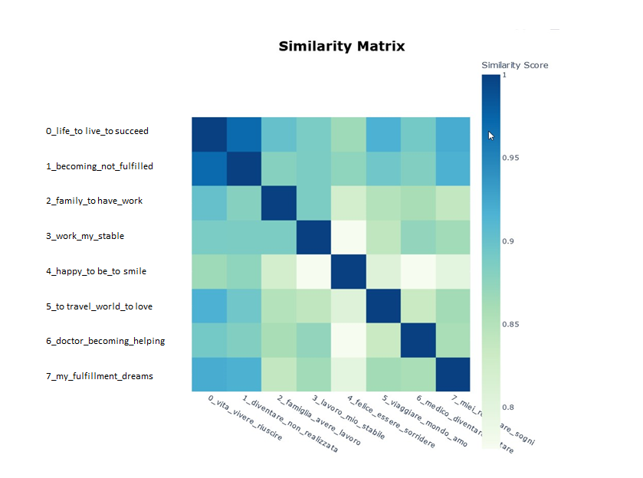
Supplementary Figure 1 - Similarity matrix between topics created using text vectorization of the key terms for each topic. Labels are shown in both Italian and English for reader convenience.

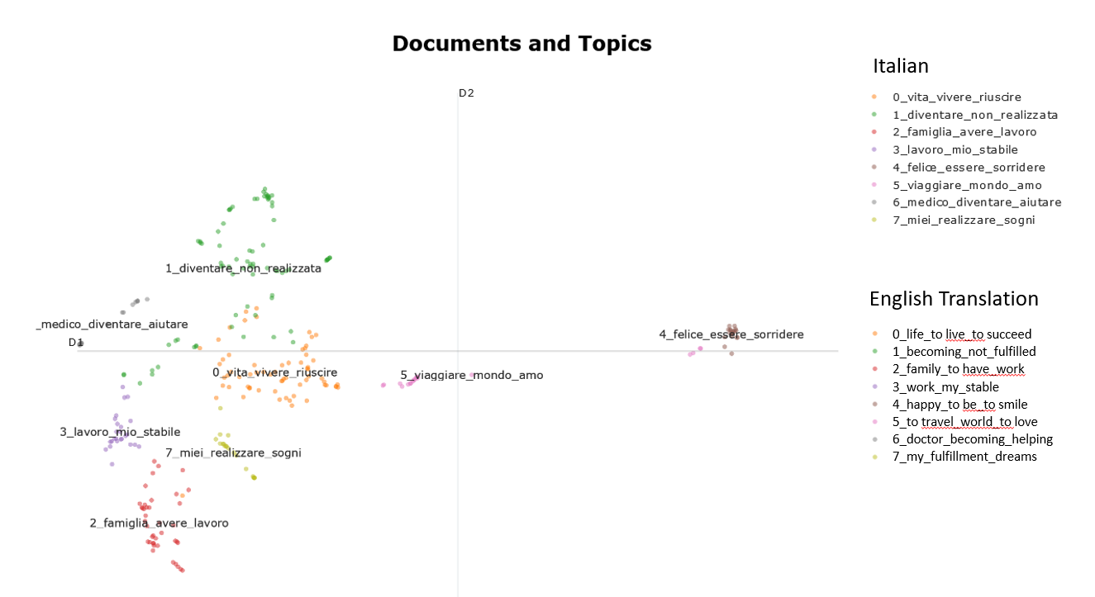
Supplementary Figure 2 –Topic modelling on the question "your greatest desire" with open-ended response. Clusters and topics are presented in both Italian and English translation for reader convenience. The analysis was conducted on Italian texts.

S4. Supplementary Sentiment analysis
To complement the cluster analysis, we carried out a simple sentiment analysis to explore the feelings of students.
Sentiment analysis was conducted on both the original Italian texts and their automatic translation into English using Google Translate (Han 2020). Several experiments were conducted, evaluating pretrained models for sentiment analysis in both Italian and English. For Italian, resources such as FEEL-IT (Bianchi et al. 2021) and UmBERTo (Parisi et al. 2020), as well as the Bidirectional LSTM-based SentIta (Bosco et al. 2015) were tested, covering polarity- and aspect-based annotations.
For the English translations, experiments involved VADER (Valence Aware Dictionary and sEntiment Reasoner) sentiment analysis algorithm (Hutto and Gilbert 2014), and Transformer-based models (Wolf et al. 2020) available through Hugging Face, including pretrained BERT models (Devlin et al. 2019) for sentiment analysis, with VADER achieving the best performance among the tested approaches.
The results indicated that models trained for English tended to be more reliable than those trained for Italian. This difference could be attributed to several factors, such as the size of the training corpus, semantic representation, and the availability of linguistic resources.

The best results obtained with the VADER are presented here. The VADER algorithm uses a specialized dictionary of English words with assigned sentiment scores to understand the sentiment expressed in text data. VADER has been chosen because it is trained on informal texts, such as tweets from X or other social media, and considering idiomatic expressions used by our students.
The application of the sentiment algorithm VADER on text data revealed that positive sentiments dominate in almost all clusters, while negative sentiments are significantly under-present (Supplementary Table 2). Cluster 4, which includes representative words such as "happy," "smile," and "children," is the only cluster in which all sentences reflect a positive feeling. Only in clusters 0-3 and 6 is there a certain percentage of sentences with a negative sentiment. The greater prevalence of a negative feeling in cluster 6 could be due to responses that either capture a personal health-related discomfort or express the awareness of a segment of society that needs help. While for topic modeling original texts in Italian were used, sentiment analysis was conducted on machine-translated responses, which may have distorted nuances and emotional valence.

Supplementary Table 2 - Frequency distribution of sentiment in clusters: sentiment analysis using Vader algorithm.
CLUSTER | POSITIVE (%) | NEUTRAL (%) | NEGATIVE (%)
0 – life students aspire to live | 70.3 | 17.2 | 12.5
1 – becoming-fulfilled-success | 39.7 | 57.7 | 2.6
2 – family life | 64.1 | 30.8 | 5.1
3 – stability and satisfaction | 70.8 | 20.8 | 8.3
4 – happiness | 100.0 | 0.0 | 0.0
5 – travel/live abroad | 44.4 | 55.6 | 0.0
6 – help others | 43.8 | 37.5 | 18.8
7 – pursuing personal dreams | 61.1 | 38.9 | 0.0

S5. Supplementary RQ2 analysis
Supplementary Figure 3 - Scatterplot of levels of trust in the future expressed by students and levels of trust in the future predicted by the LASSO model (training dataset, standardized data).

Supplementary Figure 4 - Scatterplot of levels of trust in the future expressed by students and levels of trust in the future predicted by the LASSO model (test dataset, standardized data).
S6. Supplementary sensitivity analysis
We assessed the robustness of the pooled results to the choices made in the imputation stage. Missing information in the analytic sample was limited: 515 of 29,928 predictor cells (1.72%; N = 344, 87 predictors) required imputation. The outcome variable was complete by design, as cases with a missing outcome were excluded prior to imputation. Seven of the ten predictors that reached significance in the primary analysis had no imputed cells at all; the exceptions were Perceived Distress: Politicians (28 imputed cells, 8.1%), Perceived Distress: Social Media (8 cells, 2.3%), and Distress: Economic Difficulties (1 cell, 0.3%).
We first re-ran the complete analytical pipeline (LASSO on each imputed dataset, ≥50% selection-stability threshold, and pooled OLS via Rubin’s rules) under seven variations of the imputation stage: (i) a complete-case specification, fitting the pooled model on the subsample with no missing values on the consistently selected variables (n = 257); (ii–iii) two alternative imputation models in place of predictive mean matching — Bayesian linear regression (“norm”) and classification and regression trees (“cart”); (iv–vi) three alternative random seeds for the PMM procedure; and (vii) an increased number of imputations (m = 50). Supplementary Table 3 reports the pooled p-values for the ten primary significant predictors under each specification.
Results were materially unchanged across all specifications. No coefficient changed sign in any analysis; the pooled R² remained between 0.42 and 0.43 in every multiple-imputation variant; and the consistently selected set varied only between 36 and 38 variables. Nine of the ten significant predictors remained significant in essentially every imputation-based variant. The exception was Perceived Distress: Politicians (baseline p = 0.041), which crossed the conventional threshold under the norm (p = 0.079) and cart (p = 0.096) imputation models and under one alternative seed (p = 0.064), while retaining a stable negative coefficient of similar magnitude throughout. In the complete-case specification, three predictors fell short of significance (Time with Friends, p = 0.054; Exam Anxiety, p = 0.079; Living Outside Milan, p = 0.388) with essentially unchanged point estimates for the first two, a pattern consistent with the loss of statistical power entailed by discarding a substantial portion of the sample rather than with imputation-driven bias; the larger attenuation for Living Outside Milan suggests its association partly depends on cases removed by list wise deletion, and it should accordingly be interpreted with caution.
Second, because the missing-at-random assumption cannot be verified empirically, we performed delta-adjustment (tipping-point) analyses to probe sensitivity to violations of MAR. Imputed values — and only imputed values — were shifted by δ ∈ {−1, −0.5, +0.5, +1} standard deviations of the corresponding variable, and the pooled model was refitted with the selected set held fixed. We applied these shifts (a) separately to each significant predictor with imputed cells (Supplementary Table 4), and (b) globally, displacing all 515 imputed cells across all predictors simultaneously by ±0.5 SD as a worst-case stress test. Under the global shift, all ten predictors remained significant in both directions. In the per-variable analyses, Distress: Economic Difficulties was unaffected (p = 0.013–0.015), Perceived Distress: Social Media fell marginally short of significance only under the most extreme negative shift (δ = −1 SD, p = 0.055), and Perceived Distress: Politicians crossed the threshold under positive shifts (δ = +0.5 SD, p = 0.055; δ = +1 SD, p = 0.077), again with a stable negative estimate.
Taken together, these analyses indicate that the substantive conclusions of the paper do not depend on the imputation model, the number of imputations, the random seed, or plausible departures from MAR. The borderline behavior of Perceived Distress: Politicians is consistent with its position at the margin of the significance threshold in the primary analysis (p =0.041) and reinforces the hypothesis-generating reading of the weaker candidate predictors, whose signs and magnitudes remain stable throughout.

Supplementary Table 3 - Pooled coefficients and p-values for the ten significant predictors across imputation specifications.
Predictor | β (MI) | p (MI) | p (CC) | p (norm) | p (cart) | p (s=1) | p (s=42) | p (s=2026) | p (m=50)
Perceived Peer Distress | −0.225 | <.001 | <.001 | .001 | <.001 | <.001 | <.001 | <.001 | <.001
Time with Friends | +0.158 | .001 | .054 | <.001 | <.001 | .001 | .001 | .002 | .001
Distress: No Social Media Followers | +0.179 | .009 | .001 | .005 | .009 | .010 | .010 | .008 | .009
Distress: Economic Difficulties | −0.091 | .014 | .024 | .017 | .017 | .014 | .013 | .015 | .013
Exam Anxiety | −0.107 | .015 | .079 | .014 | .017 | .015 | .013 | .019 | .015
School Motivation | +0.110 | .018 | .046 | .014 | .019 | .018 | .017 | .018 | .019
Number of Employed Parents | −0.248 | .025 | .019 | .028 | .030 | .027 | .023 | .024 | .025
Perc. Distress: Social Media | +0.097 | .038 | .010 | .018 | .042 | .042 | .040 | .034 | .033
Perc. Distress: Politicians | −0.083 | .041 | .048 | .079 | .096 | .047 | .034 | .064 | .048
Living Outside Milan | −0.194 | .048 | .388 | .031 | .026 | .045 | .046 | .038 | .044
MI = primary analysis (PMM, m = 20, seed 108). CC = complete-case (n = 257; all other columns N = 344). norm/cart = alternative imputation models (m = 20, seed 108). s = alternative seeds (PMM, m = 20). m = 50: PMM, seed 108. Shaded cells: p ≥ .05. No coefficient changed sign in any specification.

Supplementary Table 4 - Delta-adjustment (tipping-point) analyses for the significant predictors with imputed cells.
Predictor | Imputed cells (n, %) | p (δ = −1 SD) | p (−0.5 SD) | p (+0.5 SD) | p (+1 SD)
Distress: Economic Difficulties | 1 (0.3%) | .013 | .013 | .014 | .015
Perc. Distress: Social Media | 8 (2.3%) | .055 | .045 | .032 | .028
Perc. Distress: Politicians | 28 (8.1%) | .031 | .034 | .055 | .077
Imputed cells only were shifted by δ × SD of the variable; the pooled OLS model was refitted on the fixed consistently-selected set (m = 20). Shaded cells: p ≥ .05. The remaining seven significant predictors have no imputed cells. Global shift of all 515 imputed cells by ±0.5 SD: all ten predictors remain significant.

Supplementary references
Bianchi F, Nozza D, Hovy D (2021, April). FEEL-IT: Emotion and sentiment classification for the Italian language. In Proceedings of the eleventh workshop on computational approaches to subjectivity, sentiment and social media analysis (pp. 76-83).
Bosco C, Tonelli S, Zanzotto FM (2015). Sentita and doxa: Italian databases and tools for sentiment analysis purposes. In Proceedings of the second Italian conference on computational linguistics CLiC-it (Vol. 3, p. 4).
Devlin J, Chang MW, Lee K, Toutanova K (2019). Bert: Pre-training of deep bidirectional transformers for language understanding. In Proceedings of the 2019 conference of the North American chapter of the association for computational linguistics: human language technologies, volume 1 (long and short papers) (pp. 4171-4186).
Han S (2020). Googletrans: Free and unlimited Google translate API for Python (Ver. 3.0. 0).
Hutto C, Gilbert E (2014). VADER: A parsimonious rule-based model for sentiment analysis of social media text. In Proceedings of the international AAAI conference on web and social media, vol. 8, No. 1, pp. 216-225.
Parisi L, Francia S, Magnani P (2020) UmBERTo: an Italian language model trained with whole word masking. GitHub https://github.com/musixmatchresearch/umberto
Wolf T, Debut L, Sanh V, Chaumond J, Delangue C, Moi A, ... Rush AM (2020). Transformers: State-of-the-art natural language processing. In Proceedings of the 2020 conference on empirical methods in natural language processing: system demonstrations (pp. 38-45).

Hugging face https://huggingface.co/ last visited 03/12/2026

