SUPPLEMENTAL MATERIALS

Deep Learning Body Region Classification of MRI and CT examinations

Inclusion and Exclusion Criteria 2
MRI Sequences 2
Flowchart of Exclusion Criteria (CT Development Datasets) 4
Flowchart of Exclusion Criteria (MRI Development Datasets) 5
Flowchart of Exclusion Criteria (CT Test Dataset) 6
Flowchart of Exclusion Criteria (MRI Test Dataset) 7
Distribution of Development Datasets 8
Patient and Image Distribution by Body Region (CT) 8
Patient and Image Distribution by Body Region (MRI) 9
Study Distribution by Demographics, and Manufacturer (CT) 10
Series Distribution by Scanner Parameters and Clinical Protocol (CT) 11
Study Distribution by Demographics and Manufacturer (MRI) 12
Series Distribution by Scanner Parameters and Clinical Protocol (MRI) 13
Results Validation Dataset 14
Evaluation Metrics 14
Sensitivity and Specificity by Body Region (CT) 15
Sensitivity and Specificity by Body Region (MRI) 16
Sensitivity and Specificity by Demographics, Manufacturer, and Scanner parameters (CT) 17
Sensitivity and Specificity by Demographics, Manufacturer, and Scanner parameters (MRI) 18
Examples of ML Misclassifications 19
Misclassifications in Anatomical Transition Areas 19
Other Image Misclassifications 20
Training Parameters 21
Performance and Hardware Information 22

Inclusion and Exclusion Criteria

MRI Sequences

Many types of MRI sequences were included in the study such as image weighting, spin echo, gradient echo, inversion recovery, MRA, In and Out of Phase, and diffusion imaging (Table 1).

Were excluded from consideration in the study, imaging sequences used to determine flow velocities such as VIPR (High Speed 3D Phase-Contrast method for flow) and FASTPC (Fast Phase Contrast Imaging) as well as the dynamic MRA sequence called TRICKS (Time Resolved Imaging of Contrast KineticS) and MRE (MR Elastography) used for liver disease. Regarding CT, only series related to the evaluation of flow velocities were excluded. For both modalities, a first filtering pass was applied using a search on selective keywords in the series description (Table 2). A second quality control review was conducted to ensure no irrelevant series were kept in the training dataset.

MRI Sequence Type | Sequence Names
Image weighting | T1, T2, T1/T2*, PD, SWI, SWAN, BRAVO, MERGE
Spin echo | SE, Fast SE, Single Shot FSE, HASTE, VISTA, PROPELLER
Gradient echo | GRE, FFE, FE, SPGR, FGRE, LAVA, VIBRANT, VIBE, BLISS, FISP, SSFP, FIESTA, TRU FISP
Inversion recovery | IR, STIR, FLAIR
MRA | TOF, CONTRAST ENHANCED, DELAY ENHANCED
In and Out of Phase | IN/OUT, IN of Phase, Out of Phase
Diffusion | DIFFUSION, DWI

Table 1: Examples of MRI sequences included in the development datasets.

 | EXCLUDED SEQUENCES WITH FOLLOWING KEYWORDS
MRI series | FLOW, VELOCITY, ADC, APPARENT DIFFUSION, IDEAL, EP2D_DIFF, FASTPC, PC, CBV, CBF, MTT, TTP, CAD, DWI_SSH, VIPR
CT series | Velocity

Table 2: Series filtering using selective keywords in the series description.

Flowchart of Exclusion Criteria (CT Development Datasets)

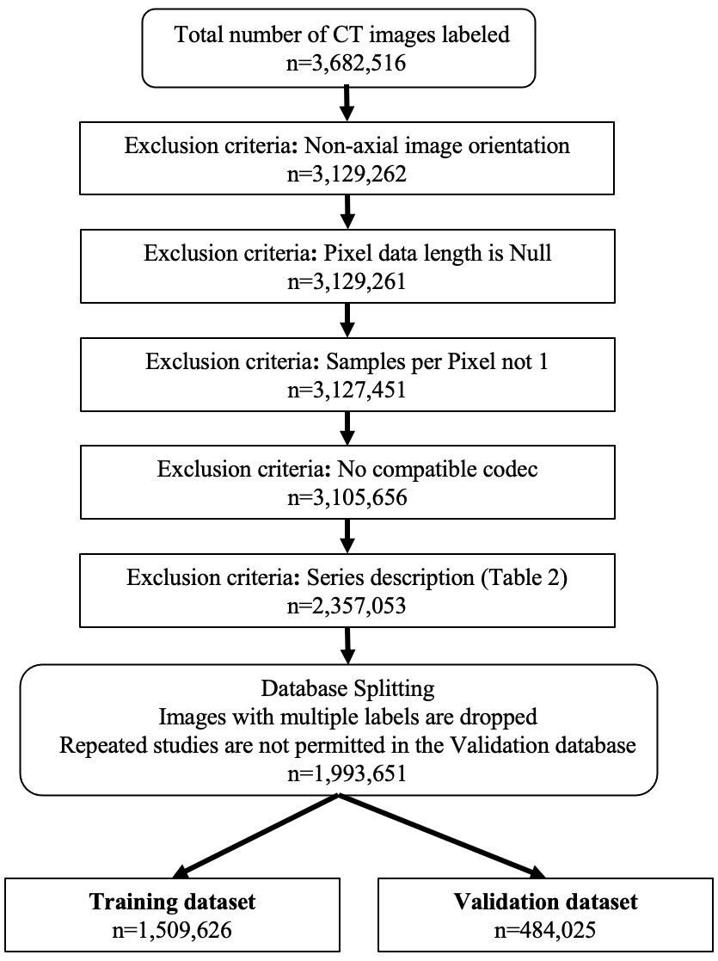
Figure 1: Flowchart of exclusion criteria for CT annotated images (development datasets).

Flowchart of Exclusion Criteria (MRI Development Datasets)

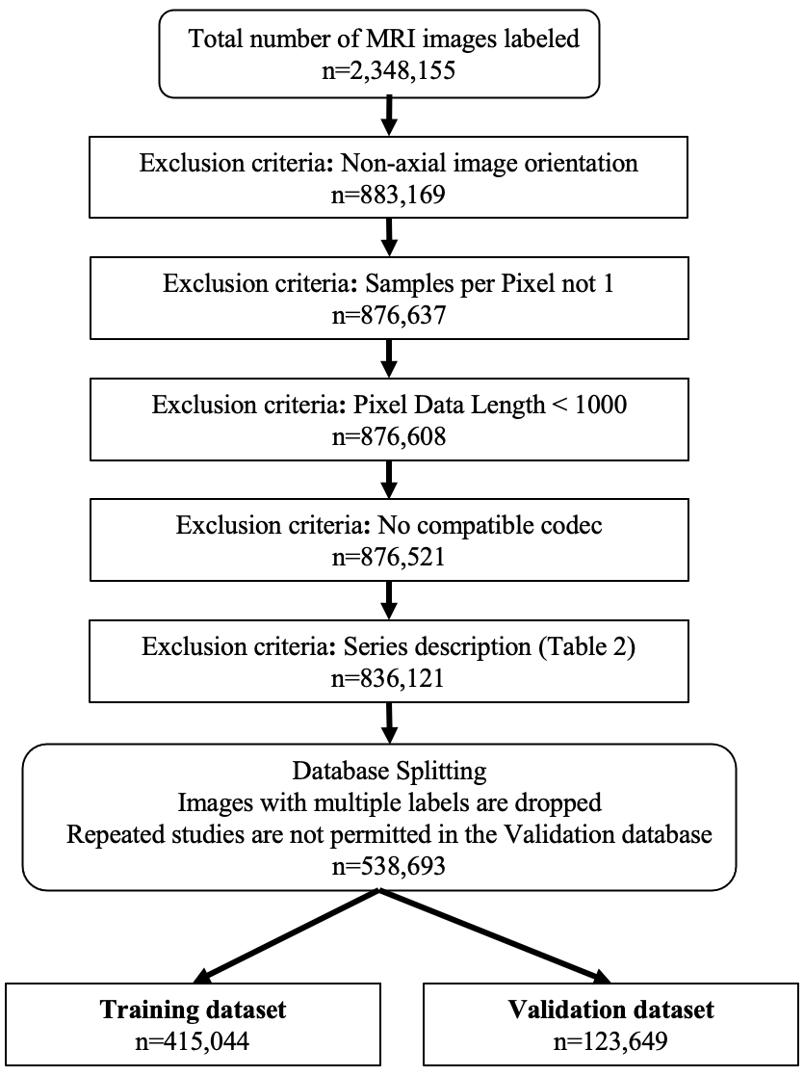
Figure 2: Flowchart of exclusion criteria for MRI annotated images (development datasets).

Flowchart of Exclusion Criteria (CT Test Dataset)

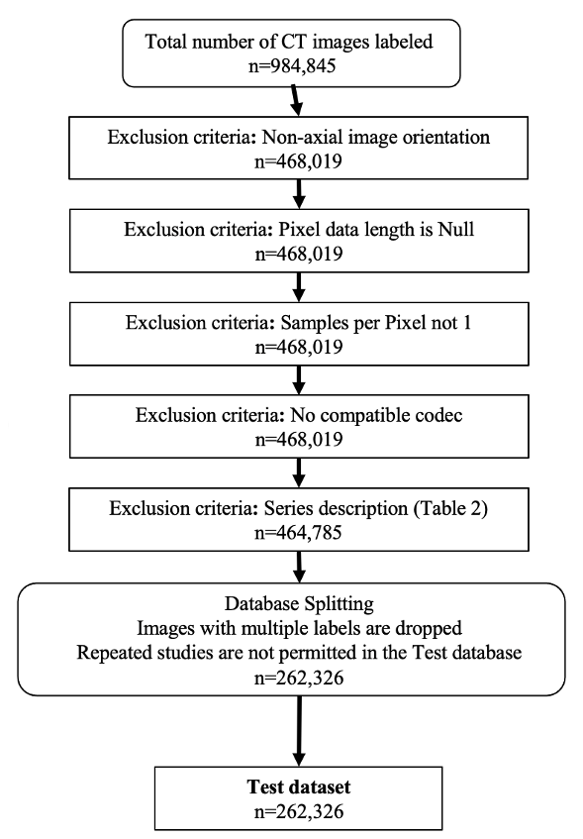

Figure 3: Flowchart of exclusion criteria for CT annotated images (Test dataset).

Flowchart of Exclusion Criteria (MRI Test Dataset)

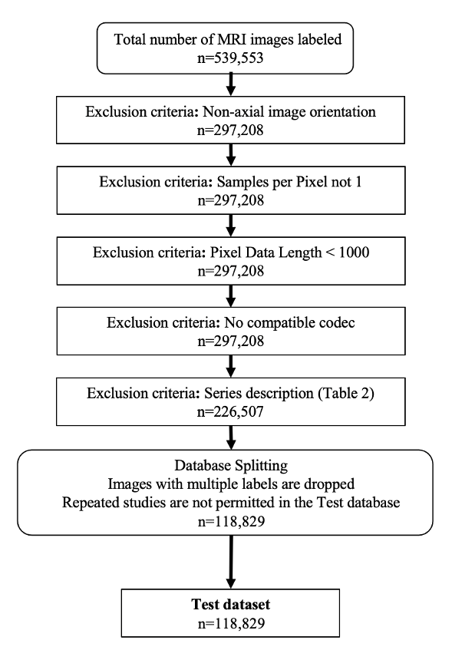

Figure 4: Flowchart of exclusion criteria for MRI test annotated images (Test dataset).

Distribution of Development Datasets

Patient and Image Distribution by Body Region (CT)

Body Region | Patients |  | Images
Body Region | Training | Validation | Training | Validation
Head | 262 | 86 | 78,487 | 20,732
Neck | 315 | 107 | 54,691 | 17,483
Cervical spine | 209 | 68 | 52,470 | 17,467
Chest | 510 | 165 | 105,262 | 34,745
Thoracic spine | 285 | 95 | 74,552 | 24,566
Abdmchst | 356 | 117 | 48,660 | 17,854
Abdomen | 354 | 113 | 58,808 | 19,154
Lumbar spine | 147 | 49 | 65,147 | 21,098
Pelvis | 319 | 96 | 62,556 | 19,018
Thigh | 228 | 69 | 88,390 | 25,663
Knee | 227 | 70 | 131,590 | 43,054
Calf | 262 | 82 | 150,307 | 46,935
Foot | 245 | 81 | 149,354 | 47,647
Shoulder | 290 | 102 | 70,008 | 24,832
Arm | 361 | 126 | 72,357 | 23,209
Elbow | 237 | 82 | 77,044 | 25,847
Forearm | 254 | 90 | 49,548 | 17,515
Hand | 250 | 79 | 120,395 | 37,206

Table 4: Distribution of CT patients as a function of body region information extracted from the ground-truth. Note that a study can contain several body regions, as a result it may contribute to several anatomical regions.

Patient and Image Distribution by Body Region (MRI)

Body Region | Patients |  | Images
Body Region | Training | Validation | Training | Validation
Head | 208 | 66 | 60,027 | 17,474
Neck | 249 | 84 | 15,838 | 4,923
Cervical spine | 135 | 43 | 5,976 | 1,989
Chest | 330 | 108 | 17,995 | 4,895
Thoracic spine | 185 | 63 | 98,27 |  | 3,226
Abdmchst | 265 | 89 | 18,672 |  | 5,649
Abdomen | 253 | 78 | 40,835 |  | 11,680
Lumbar spine | 134 | 45 | 7,660 |  | 2,094
Pelvis | 288 | 96 | 31,777 |  | 8,783
Thigh | 201 | 55 | 11,795 |  | 3,272
Knee | 219 | 74 | 7,898 |  | 2,425
Calf | 138 | 44 | 11,160 |  | 3,701
Foot | 224 | 75 | 10,433 |  | 3,082
Shoulder | 176 | 62 | 6,380 |  | 1,945
Arm | 180 | 61 | 7,844 |  | 2,432
Elbow | 325 | 100 | 16,926 |  | 4,911
Forearm | 225 | 72 | 11,342 |  | 3,778
Hand | 223 | 69 | 14,263 |  | 4,234
Breast | 137 | 46 | 108,396 |  | 33,156

Table 5: Distribution of MRI patients as a function of body region information extracted from the ground-truth. Note that a study can contain several body regions, as a result it may contribute to several anatomical regions.

Study Distribution by Demographics, and Manufacturer (CT)

Attributes | Categories | Training |  | Validation
Attributes | Categories | n | % | n | %
Sex | Female | 867 | 48.1 | 294 | 48.8
Sex | Male | 935 | 51.9 | 308 | 51.2
Age | 18 - 44 years | 436 | 24.2 | 133 | 22.1
Age | 45 – 64 years | 640 | 35.5 | 236 | 39.3
Age | >= 65 years | 654 | 36.3 | 212 | 35.3
Manufacturer | Canon | - | - | - | -
Manufacturer | GE | 1,671 | 92.5 | 555 | 92.3
Manufacturer | Hitachi | - | - | - | -
Manufacturer | Philips | 4 | 0.2 | 2 | 0.3
Manufacturer | Siemens | 96 | 5.3 | 37 | 6.2
Manufacturer | Toshiba | 35 | 1.9 | 7 | 1.2
Manufacturer | Others | - | - | - | -

Table 6: Distribution of CT studies with respect to demographics, and manufacturer.

Series Distribution by Scanner Parameters and Clinical Protocol (CT)

Attributes | Categories | Training |  | Validation
Attributes | Categories | n | % | n | %
Contrast | With contrast | 1,300 | 32.6 | 404 | 31.1
Contrast | Without contrast | 2689 | 67.4 | 894 | 68.9
Slice thickness | <= 2 mm | 2,722 | 67.2 | 899 | 68.1
Slice thickness | >2 mm and < 5 mm | 343 | 8.5 | 98 | 7.4
Slice thickness | >= 5 mm | 985 | 24.3 | 324 | 24.5
Kernel | Bone | 1,072 | 26.9 | 342 | 26.3
Kernel | Soft tissue | 2,917 | 73.1 | 956 | 73.7

Table 7: Distribution of CT series with respect to clinical protocol. Series with a bone CT kernel were identified using a search of the keyword “bone” in the series description. It includes series with and without Metal Artifact Reduction (MAR). All other axial series in the same study were considered soft tissue acquisitions. The studies with contrast include a spectrum of contrast phases, such as portal venous phase, arterial phase, and delayed phase imaging.

Study Distribution by Demographics and Manufacturer (MRI)

Attributes | Categories | Training |  |  | Validation
Attributes | Categories | n | % | n |  | %
Sex | Female | 1,040 | 54.5 | 326 |  | 52.2
Sex | Male | 870 | 45.5 | 298 |  | 47.8
Age | 18 – 44 years | 592 | 31.6 | 194 |  | 31.5
Age | 45 – 64 years | 668 | 35.6 | 214 |  | 34.3
Age | >= 65 years | 375 | 20 | 130 |  | 21.1
Manufacturer | GE | 1,634 | 85.5 | 542 |  | 86.7
Manufacturer | Hitachi | - | - | 2 |  | 0.3
Manufacturer | Philips | 40 | 2.1 | 12 |  | 1.9
Manufacturer | Siemens | 235 | 12.3 | 69 |  | 11
Manufacturer | Toshiba | 1 | 0.1 | - |  | -

Table 8: Distribution of MRI studies with respect to demographics, and manufacturer.

Series Distribution by Scanner Parameters and Clinical Protocol (MRI)

Attributes | Categories | Training |  | Validation
Attributes | Categories | n | % | n | %
Contrast | With contrast | 1585 | 22.4 | 520 | 24.1
Contrast | Without contrast | 5466 | 77.6 | 1641 | 75.9
Slice thickness | <= 2 mm | 934 | 13.2 | 287 | 13.3
Slice thickness | >2 mm and < 5 mm | 3,402 | 48.2 | 1,102 | 51.0
Slice thickness | >= 5 mm | 2,715 | 38.5 | 772 | 35.7
Sequences | Image weighting | 5,378 | 73.2 | 1,656 | 73.9
Sequences | Spin echo | 329 | 4.5 | 127 | 5.7
Sequences | Gradient echo | 821 | 11.2 | 234 | 10.4
Sequences | Inversion recovery | 221 | 3.0 | 57 | 2.5
Sequences | MRA | 182 | 2.5 | 40 | 1.8
Sequences | In and Out of Phase | 108 | 1.5 | 38 | 1.7
Sequences | Diffusion | 307 | 4.2 | 88 | 3.9

Table 9: Distribution of MRI series with respect to clinical protocol. MRI sequences are selected based on the search of keywords in series description listed in Table 1.

Results Validation Dataset

Evaluation Metrics
Sensitivity and specificity were used as the primary evaluation metrics as required by the FDA for the 510K submission. These metrics measure the true positive rate, sensitivity, and the true negative rate. This allows the end user to have direct knowledge of how likely a positive or negative prediction is to be correct. It is also the standard required by the FDA 510K submission process for such models. The F1 score is a balanced accuracy score attempting to summarize the precision and sensitivity into one number. The reported aggregate metrics evenly weight all classes.

Overall accuracy was not reported as it is strongly influenced by the number of images from each class. Since some body regions are more frequently imaged than others, using the accuracy would yield results relevant for the main classes but fail to show how the less frequent classes perform. An average weighted by the number of images of the class level sensitivity is the same as the overall accuracy. The class balance of the test set may not represent all uses cases, as such class level metrics are preferred for comparison and evaluation.

$$Sensitivity=\frac{TruePositives}{TruePositive+FalseNegitives}$$

$$Specificity=\frac{TrueNegatives}{TrueNegatives+FalseNegitives}$$

$$F_{1}Score=\frac{2*TruePostives}{2*TruePostives+FalsePostives+FalseNegatives}$$

Sensitivity and Specificity by Body Region (CT)

Body Region | Sensitivity (95% CI) | Specificity (95% CI)
Overall | 91.7 (91.5 – 91.9) | 99.3 (99.3 – 99.4)
Head | 98.7 (98.3 – 99.1) | 99.9 (99.8 – 99.9)
Neck | 89.4 (88.1 – 90.7) | 99.8 (99.7 – 99.8)
Cervical spine | 91.6 (90.1 – 93.1) | 99.8 (99.7 – 99.8)
Chest | 92.6 (92.0 – 93.1) | 98.9 (98.8 – 98.9)
Thoracic spine | 95.6 (94.7 – 96.6) | 99.6 (99.5 – 99.6)
Abdomen | 93.3 (92.8 – 93.9) | 98.8 (98.7 – 98.9)
Lumbar spine | 96.4 (95.5 – 97.2) | 99.8 (99.8 – 99.9)
Pelvis | 90.5 (89.4 – 91.5) | 99.5 (99.5 – 99.6)
Thigh | 88.2 (86.9 – 89.4) | 99.3 (99.2 – 99.4)
Knee | 82.1 (80.7 – 83.4) | 99.5 (99.4 – 99.5)
Calf | 91.2 (90.2 – 92.2) | 99.3 (99.2 – 99.3)
Foot | 94.2 (93.4 – 95.1) | 99.6 (99.6 – 99.7)
Shoulder | 91.4 (90.3 – 92.3) | 99.5 (99.4 – 99.5)
Arm | 90.4 (89.2 – 91.5) | 99.1 (99.0 – 99.2)
Elbow | 85.6 (84.1 – 87.2) | 99.6 (99.5 – 99.6)
Forearm | 87.2 (85.6 – 88.8) | 99.4 (99.3 – 99.5)
Hand | 92.4 (91.5 – 93.4) | 99.8 (99.8 – 99.8)

Table 10: Validation dataset - CT weighted image-level sensitivity and specificity (%) as a function of body region.

Sensitivity and Specificity by Body Region (MRI)

Body Region | Sensitivity (95% CI) | Specificity (95% CI)
Overall | 93.9 (93.7 – 94.3) | 99.3 (99.3 – 99.3)
Head | 98.9 (98.4 – 99.4) | 99.6 (99.5 – 99.7)
Neck | 85.4 (82.7 – 88.0) | 99.8 (99.8 – 99.9)
Cervical spine | 84.8 (81.9 – 87.7) | 99.9 (99.9 – 99.9)
Chest | 89.6 (88.7 – 90.6) | 98.5 (98.3 – 98.6)
Thoracic spine | 97.9 (97.0 – 98.8) | 99.7 (99.6 – 99.8)
Abdomen | 92.7 (92.2 – 93.6) | 98.0 (97.9 – 98.2)
Lumbar spine | 89.8 (87.3 – 92.0) | 99.8 (99.8 – 99.9)
Pelvis | 92.1 (91.0 – 93.2) | 99.7 (99.6 – 99.7)
Thigh | 91.7 (90.0 – 93.4) | 99.9 (99.9 – 99.9)
Knee | 94.4 (92.6 – 96.0) | 99.7 (99.7 – 99.8)
Calf | 90.8 (89.1 – 92.7) | 99.8 (99.7 – 99.8)
Foot | 94.9 (93.2 – 96.6) | 99.8 (99.8 – 99.9)
Shoulder | 97.1 (95.6 – 98.5) | 99.9 (99.9 – 99.9)
Arm | 90.2 (87.9 – 92.3) | 99.8 (99.7 – 99.8)
Elbow | 92.3 (90.5 – 94.0) | 99.7 (99.6 – 99.8)
Forearm | 91.8 (89.8 – 93.8) | 99.8 (99.8 – 99.9)
Hand | 97.5 (96.3 – 98.5) | 99.8 (99.8 – 99.9)
Breast | 99.9 (99.8 – 99.9) | 99.9 (99.9 – 99.9)

Table 11: Validation dataset - MRI weighted image-level sensitivity and specificity (%) as a function of body region.

Sensitivity and Specificity by Demographics, Manufacturer, and Scanner parameters (CT)

Attributes | Categories | Sensitivity (95% CI) | Specificity (95% CI)
Sex | Female | 91.8 (91.4 – 92.1) | 99.4 (99.3 – 99.4)
Sex | Male | 91.7 (91.4 – 92.0) | 99.3 (99.3 – 99.3)
Age | 18 – 44 years | 90.8 (90.3 – 91.3) | 99.3 (99.3 – 99.4)
Age | 45 – 64 years | 92.2 (91.9 – 92.5) | 99.3 (99.2 – 99.3)
Age | >= 65 years | 91.6 (91.1 – 91.9) | 99.4 (99.3 – 99.4)
Manufacturer | GE | 91.9 (91.7 – 92.2) | 99.3 (99.3 – 99.4)
Manufacturer | Philips | - | -
Manufacturer | Siemens | 89.4 (88.1 – 90.7) | 98.8 (98.6 – 98.9)
Manufacturer | Toshiba | 78.9 (75.3 – 82.4) | 97.9 (97.1 – 98.7)
Contrast | With contrast | 92.9 (92.6 – 93.3) | 99.0 (98.9 – 99.1)
Contrast | Without contrast | 90.9 (90.7 – 91.3) | 99.4 (99.3 – 99.4)
Kernel | Bone | 91.3 (90.8 – 91.7) | 99.4 (99.4 – 99.4)
Kernel | Soft tissue | 91.9 (91.6 – 92.1) | 99.1 (99.1 – 99.2)
Slice thickness | <= 2 mm | 91.3 (90.9 – 91.5) | 99.4 (99.4 – 99.4)
Slice thickness | > 2 mm and < 5 mm | 91.7 (91.0 – 92.4) | 99.2 (99.1 – 99.3)
Slice thickness | >= 5 mm | 93.4 (92.9 – 93.8) | 96.9 (96.6 – 97.2

Table 12: Validation dataset - CT weighted image-level sensitivity and specificity (%) as a function of demographics, manufacturer and acquisition protocol.

Sensitivity and Specificity by Demographics, Manufacturer, and Scanner parameters (MRI)

Attributes | Categories | Sensitivity (95% CI) | Specificity (95% CI)
Sex | Female | 94.9 (94.5 – 95.2) | 99.4 (99.4 – 99.5)
Sex | Male | 92.3 (92.4 – 93.3) | 99.0 (98.9 – 99.1)
Age | 18 – 44 years | 94.9 (94.4 – 95.4) | 99.5 (99.5 – 99.6)
Age | 45 – 64 years | 93.9 (93.5 – 94.4) | 99.3 (99.3 – 99.4)
Age | >= 65 years | 93.0 (92.5 – 93.5) | 98.9 (98.8 – 99.0)
Manufacturer | GE | 93.9 (93.6 – 94.2) | 99.4 (99.4 – 99.4)
Manufacturer | Hitachi | - | -
Manufacturer | Philips | - | -
Manufacturer | Siemens | 94.1 (93.4 – 94.7) | 98.3 (98.0 – 98.5)
Manufacturer | Toshiba | - | -
Contrast | With contrast | 94.8 (94.4 – 95.3) | 99.2 (99.1 – 99.3)
Contrast | Without contrast | 93.5 (93.2 – 93.9) | 99.3 (99.3 – 99.4)
Slice thickness | <= 2 mm | 98.4 (97.9 – 98.8) | 98.9 (98.4 – 99.3)
Slice thickness | > 2 mm and < 5 mm | 94.3 (93.6 – 94.5) | 99.5 (99.4 – 99.5)
Slice thickness | >= 5 mm | 92.5 (92.1 – 92.9) | 98.8 (98.6 – 98.8)
Sequences | Image weighting | 93.5 (93.1 – 93.9) | 99.5 (99.4 – 99.5)
Sequences | Spin echo | 91.5 (89.8 – 93.2) | 99.1 (98.9 – 99.3)
Sequences | Gradient echo | 95.1 (94.5 – 95.6) | 98.6 (98.5 – 98.8)
Sequences | Inversion recovery | 89.6 (86.9 – 92.3) | 99.3 (99.1 – 99.5)
Sequences | MRA | 95.9 (93.7 – 97.8) | 97.6 (95.7 – 99.1)
Sequences | In and Out of Phase | 91.1 (89.8 – 92.4) | 88.9 (87.1 – 90.9)
Sequences | Diffusion | 95.3 (94.3 – 96.3) | 99.0 (98.7 – 99.3)
Table 13: Validation dataset - MRI weighted image-level sensitivity and specificity (%) as a function of demographics, manufacturer, and acquisition protocol.

Examples of ML Misclassifications

Misclassifications in Anatomical Transition Areas

Definitions: GT = Ground Truth, MP = Model Prediction.

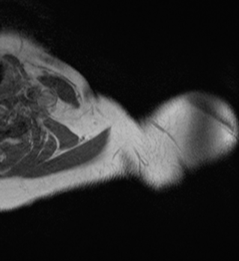  a: GT = neck, MP = neck | 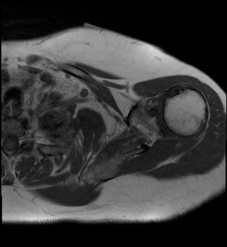  b: GT = neck, MP = shoulder | 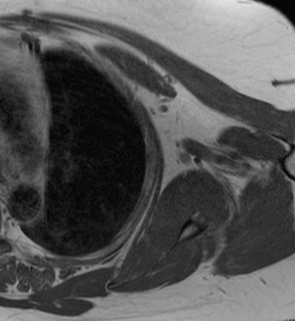  c: GT = chest, MP = chest

Figure 5: MRI Chest study. Images correctly inferred as neck (a) and chest (c). The image in-between is classified as shoulder instead of neck (b). The shoulder is clearly present in the image. This illustrates one limitation of the multi-class framework where only one label is assigned to an image.

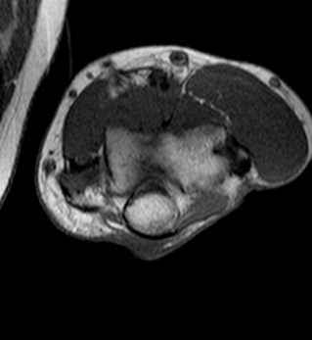  a: GT = elbow, MP = elbow | 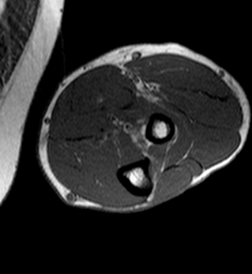  b: GT = forearm, MP = elbow | 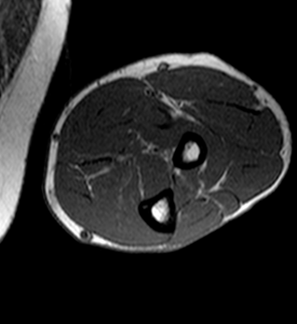  c: GT = forearm, MP = forearm

Figure 6: MRI Upper extremity study. Images correctly inferred as elbow (a) and forearm (c). The image in-between is misclassified as elbow (b), illustrating the challenge of defining the ground truth in transition areas.

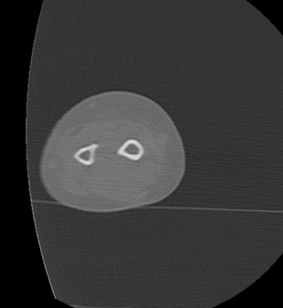  a: GT = forearm, MP = forearm | 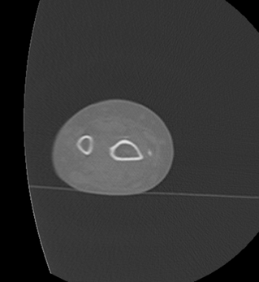  b: GT=forearm, MP = hand | 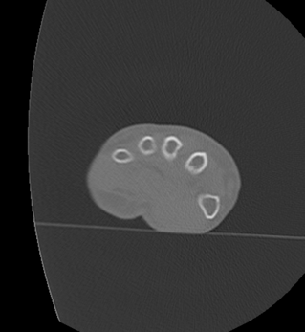  c: GT = hand, MP = hand

Figure 7: CT Upper extremity study. Images correctly inferred as forearm (a) and hand (c). The image in-between is misclassified as hand (b), illustrating the challenge of defining the ground truth in transition areas.

Other Image Misclassifications

Definitions: GT = Ground Truth, MP = Model Prediction.

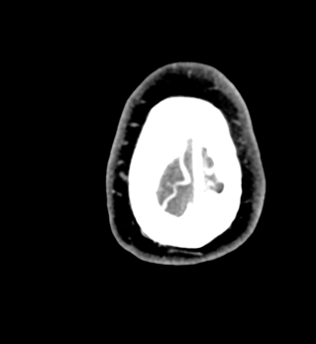  a: GT = head, MP = elbow | 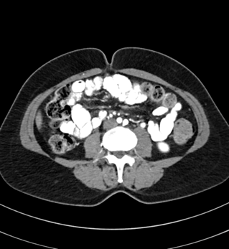  b: GT = pelvis, MP = hand | 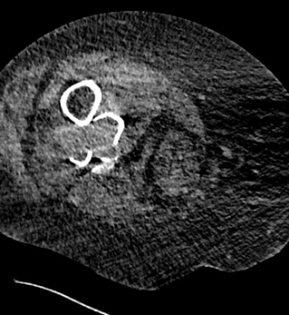  c: GT = knee, MP = shoulder

Figure 8: Examples of erroneous classifications (CT) prior to post-processing. Head image misclassified as elbow (a). This image of the top of the skull is not very specific and may mimick the overall configuration of bone and soft tissue seen in elbow images. Pelvis image misclassified as hand (b). It is possible that fecal tagging in the colon may have created some confusing imaging pattern. Knee image clasified as shoulder (c). Notice the combination of a bone fracture and poor image quality (large amount of noise). It is important to note that each of those examples are single occurences in their respective series. The post-processing step adequatly corrected these misclassifications using the anatomical predictions from neighbouring slices.

Training Parameters

Parameters | CT Model | MRI model
Best Training epoch | 87 | 89
Learning rate | 1e-05 | 1e-05
Optimization algorithm | Nadam | Nadam
Batch size | 128 | 96
Step size | 2948 | 865
Table 3: Training hyperparameters.

Performance and Hardware Information
We used Google Cloud Platform to store data, manage our database of experiments, execute the experimentations, and run the inference engine. Docker containers were built with the necessary TensorFlow library and its dependencies. Training for each model took up to 24 hours on a dedicated cloud instance using Nvidia V100 GPU hardware. Inference through TensorFlow Serving on a dedicated cloud instance with Nvidia T4 can process more than 35,000 images per hour, which amount to roughly 4,000 series or 600 studies per hour. Everything was run on Linux through Python and node.js.

