FIGURES
Figure 1: Example of a late arterial phase CT scan (left) with manual segmentations of the pancreatic ductal adenocarcinoma tumor and automatic segmentations of surrounding abdominal organs.

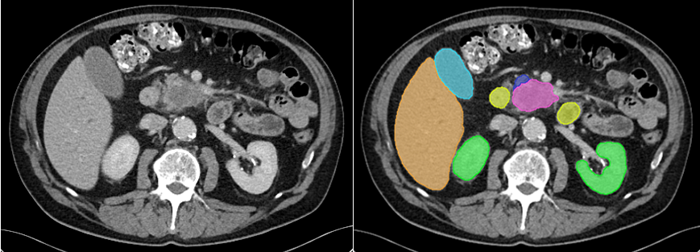

Legend: Pink: Pancreatic Ductal Adenocarcinoma Tumor, Orange = Liver, Green = Kidneys, Yellow = Duodenum, Light Blue = Gallbladder, Dark Blue = Pancreas.

Table 1: Five-fold cross-validation results for each of the four correction matrices.
Performance Metric | Precision Priority | Inclusive Correction | Pattern Discerner | Underestimation  Focuser
Dice Similarity Coefficient | 0.67 | 0.69 | 0.69 |  | 0.70

