Supplementary Materials
Table S1 CT scan parameters
 | GE  (Lightspeed VCT) |  | Philips  (Brilliance iCT) |  | United Imaging  (uCT760) |  | Canon  (Acquilion ONE) |  | Philips  (IQon Spectral CT)
 | Cervical spine | Lumbar spine | Cervical spine | Lumbar spine | Cervical spine | Lumbar spine | Cervical spine | Lumbar spine | Cervical spine | Lumbar spine
Tube voltage (kV) | 120 | 120 | 120 | 120 | 140 | 120 | 120 | 120 | 120 | 120
Tube current (mA) | Smart mA | Smart mA | 250-350 | 250-350 | Smart mA | Smart mA | 200 | 300 | 250 | 250
Standard layer Thickness (mm) | 3.75 | 5.0 | 3.0 | 3.0 | 3.0 | 3.0 | 5.0 | 5.0 | 3.0 | 3.0
Thin layer thickness (mm) | 0.63 | 0.63 | 0.9 | 0.9 | 1.0 | 1.5 | 1.0 | 1.0 | 1.0 | 1.0
Slice spacing (mm) | 1.0 |  | 1.0 |  | 1.0 |  | 1.0 |  | 1.0
Field of view (cm) | 15‒25 |  | 15‒25 |  | 15‒25 |  | 15‒25 |  | 15‒25
Matrix | 512×512 |  | 512×512 |  | 512×512 |  | 512×512 |  | 512×512
Reconstruction layer thickness  (mm) | 3.0 |  | 3.0 |  | 3.0 |  | 3.0 |  | 3.0

Bad Cases

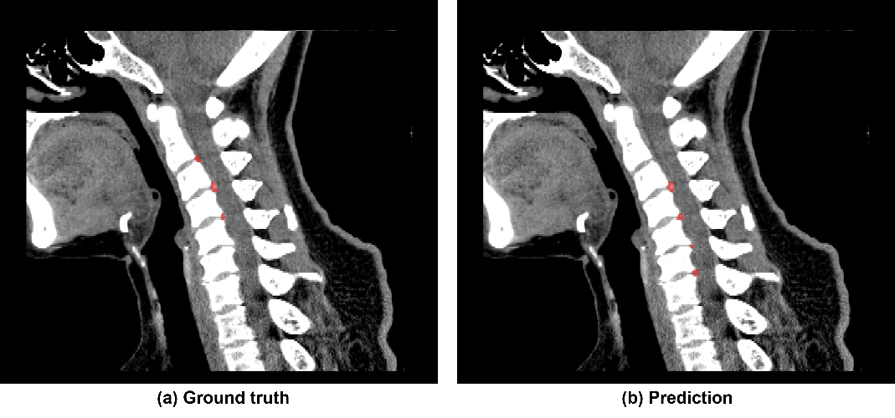
Fig.S1 The case with the lowest Dice (0.466) on the internal test set. It may differ from the reference standard due to bone hyperplasia, poor visualization of the posterior longitudinal ligament and herniated discs, or subtle lesions.

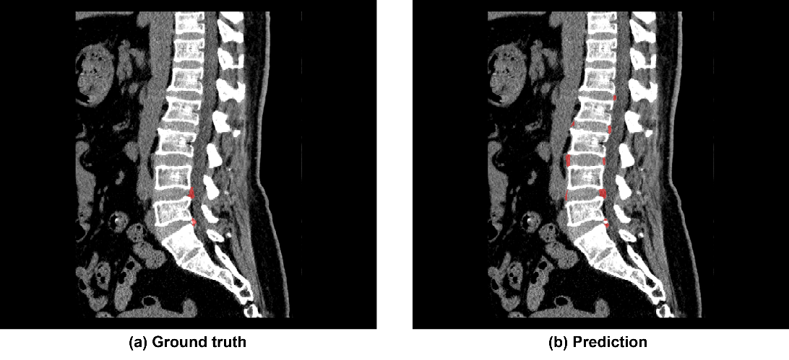
Fig.S2 The case with the lowest Dice (0.146) on the external test set. Errors in identifying disc herniation and bulging mainly arised from modeling bias, manual annotation subjectivity, and subvisual lesions, leading to mismatches.

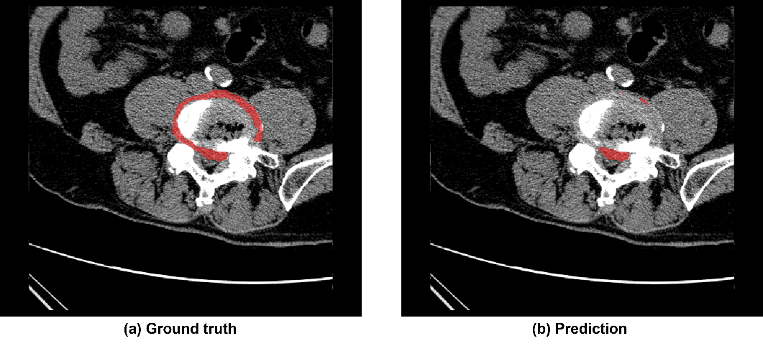
Fig.S3 Incomplete segmentation of intervertebral disc lesions, resulting in the incorrect classification of bulge as herniation. Incomplete bulge recognition may stem from tissue density differences in the ROI or interference from adjacent bone hyperplasia and calcification.

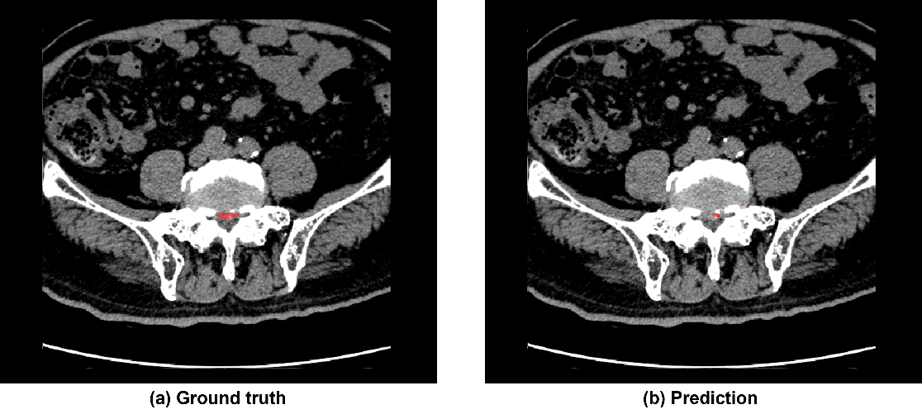
Fig.S4 The right subarticular region of the reference standard was not discerned. Model errors may stem from intervertebral disc calcification affecting tissue contrast and segmentation.

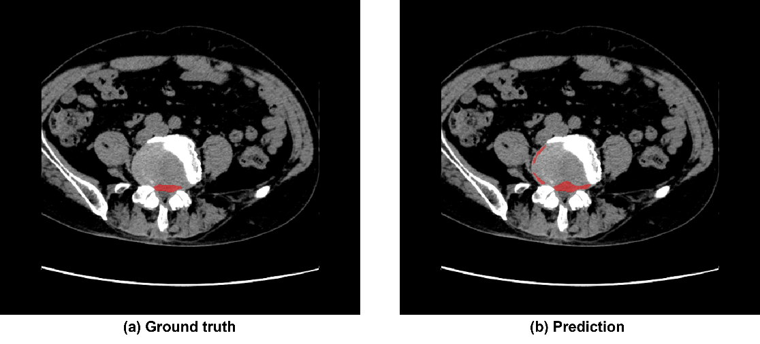
Fig.S5 The prediction data inaccurately identified the left foraminal region. When the model's predicted range exceeds the ground truth, it may be misclassified as a bulging lesion. This mismatch may result from spatial misalignment due to poor scan positioning or abnormal spinal curvature.

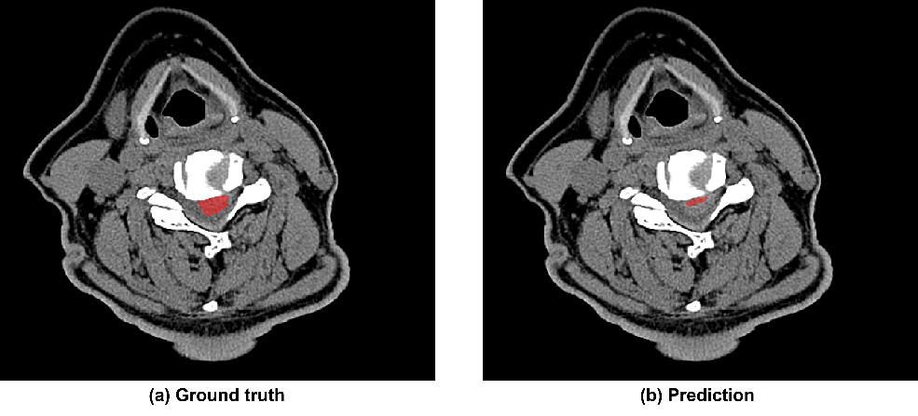
Fig.S6 Grading of intervertebral disc herniation. The prediction result was classified as Grade 1, below Grade 2 of the reference standard. Small cervical disc size and poor resolution in distinguishing the posterior ligament and herniated material lead to incomplete segmentation and grading errors.

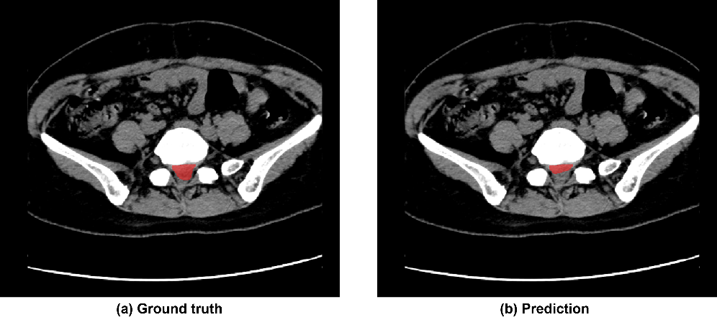
Fig.S7 Grading of intervertebral disc herniation. The prediction result was classified as Grade 2, below Grade 3 of the reference standard. Low CT soft tissue contrast, posterior vertebral complexity, and disc herniation-induced compression and overlap impaired model segmentation accuracy.

Table S2 Qualitative Analysis: A Summary of Suboptimal Cases

Error Type | Result Impact | Possible Causes | Optimization Directions
False Positive/Over-segmentation | - herniation and bulge confusion  - increased false positives  - segmentation errors  - grade overestimation | - Annotation-model mismatch: Subjective manual annotation, poor minor lesion recognition; model reconstruction bias, limited boundary detection.  - Complex lesion challenges: Blurred segmentation boundaries in calcification, osteophytes, severe degeneration cases.  - Image resolution limitations: Disc herniation-induced dural sac/posterior longitudinal ligament displacement and overlap, reducing image resolution. | - Data Aspects:  - Improve annotation quality: reduce missing/incorrect labels  - Data augmentation: oversample rare cases (e.g., bulging)  - Algorithm Aspects:  - Dilated convolution: expand receptive field, capture context, improve small blurred region detection  - Multi-scale fusion: propagate small target features across all levels  - Attention mechanism: Focus model on potential small target regions, suppress background  - Refined loss: Tversky Loss with α/β tuning for false positive/negative balance  - Boundary optimization: Boundary Loss constraints to enhance edge precision, prevent over/under-segmentation
False Negative/Under-segmentation | - herniation and bulge confusion  - reduced true positives  - missed regions  - grade underestimation

Checklist for Artificial Intelligence in Medical Imaging (CLAIM): 2024 Update
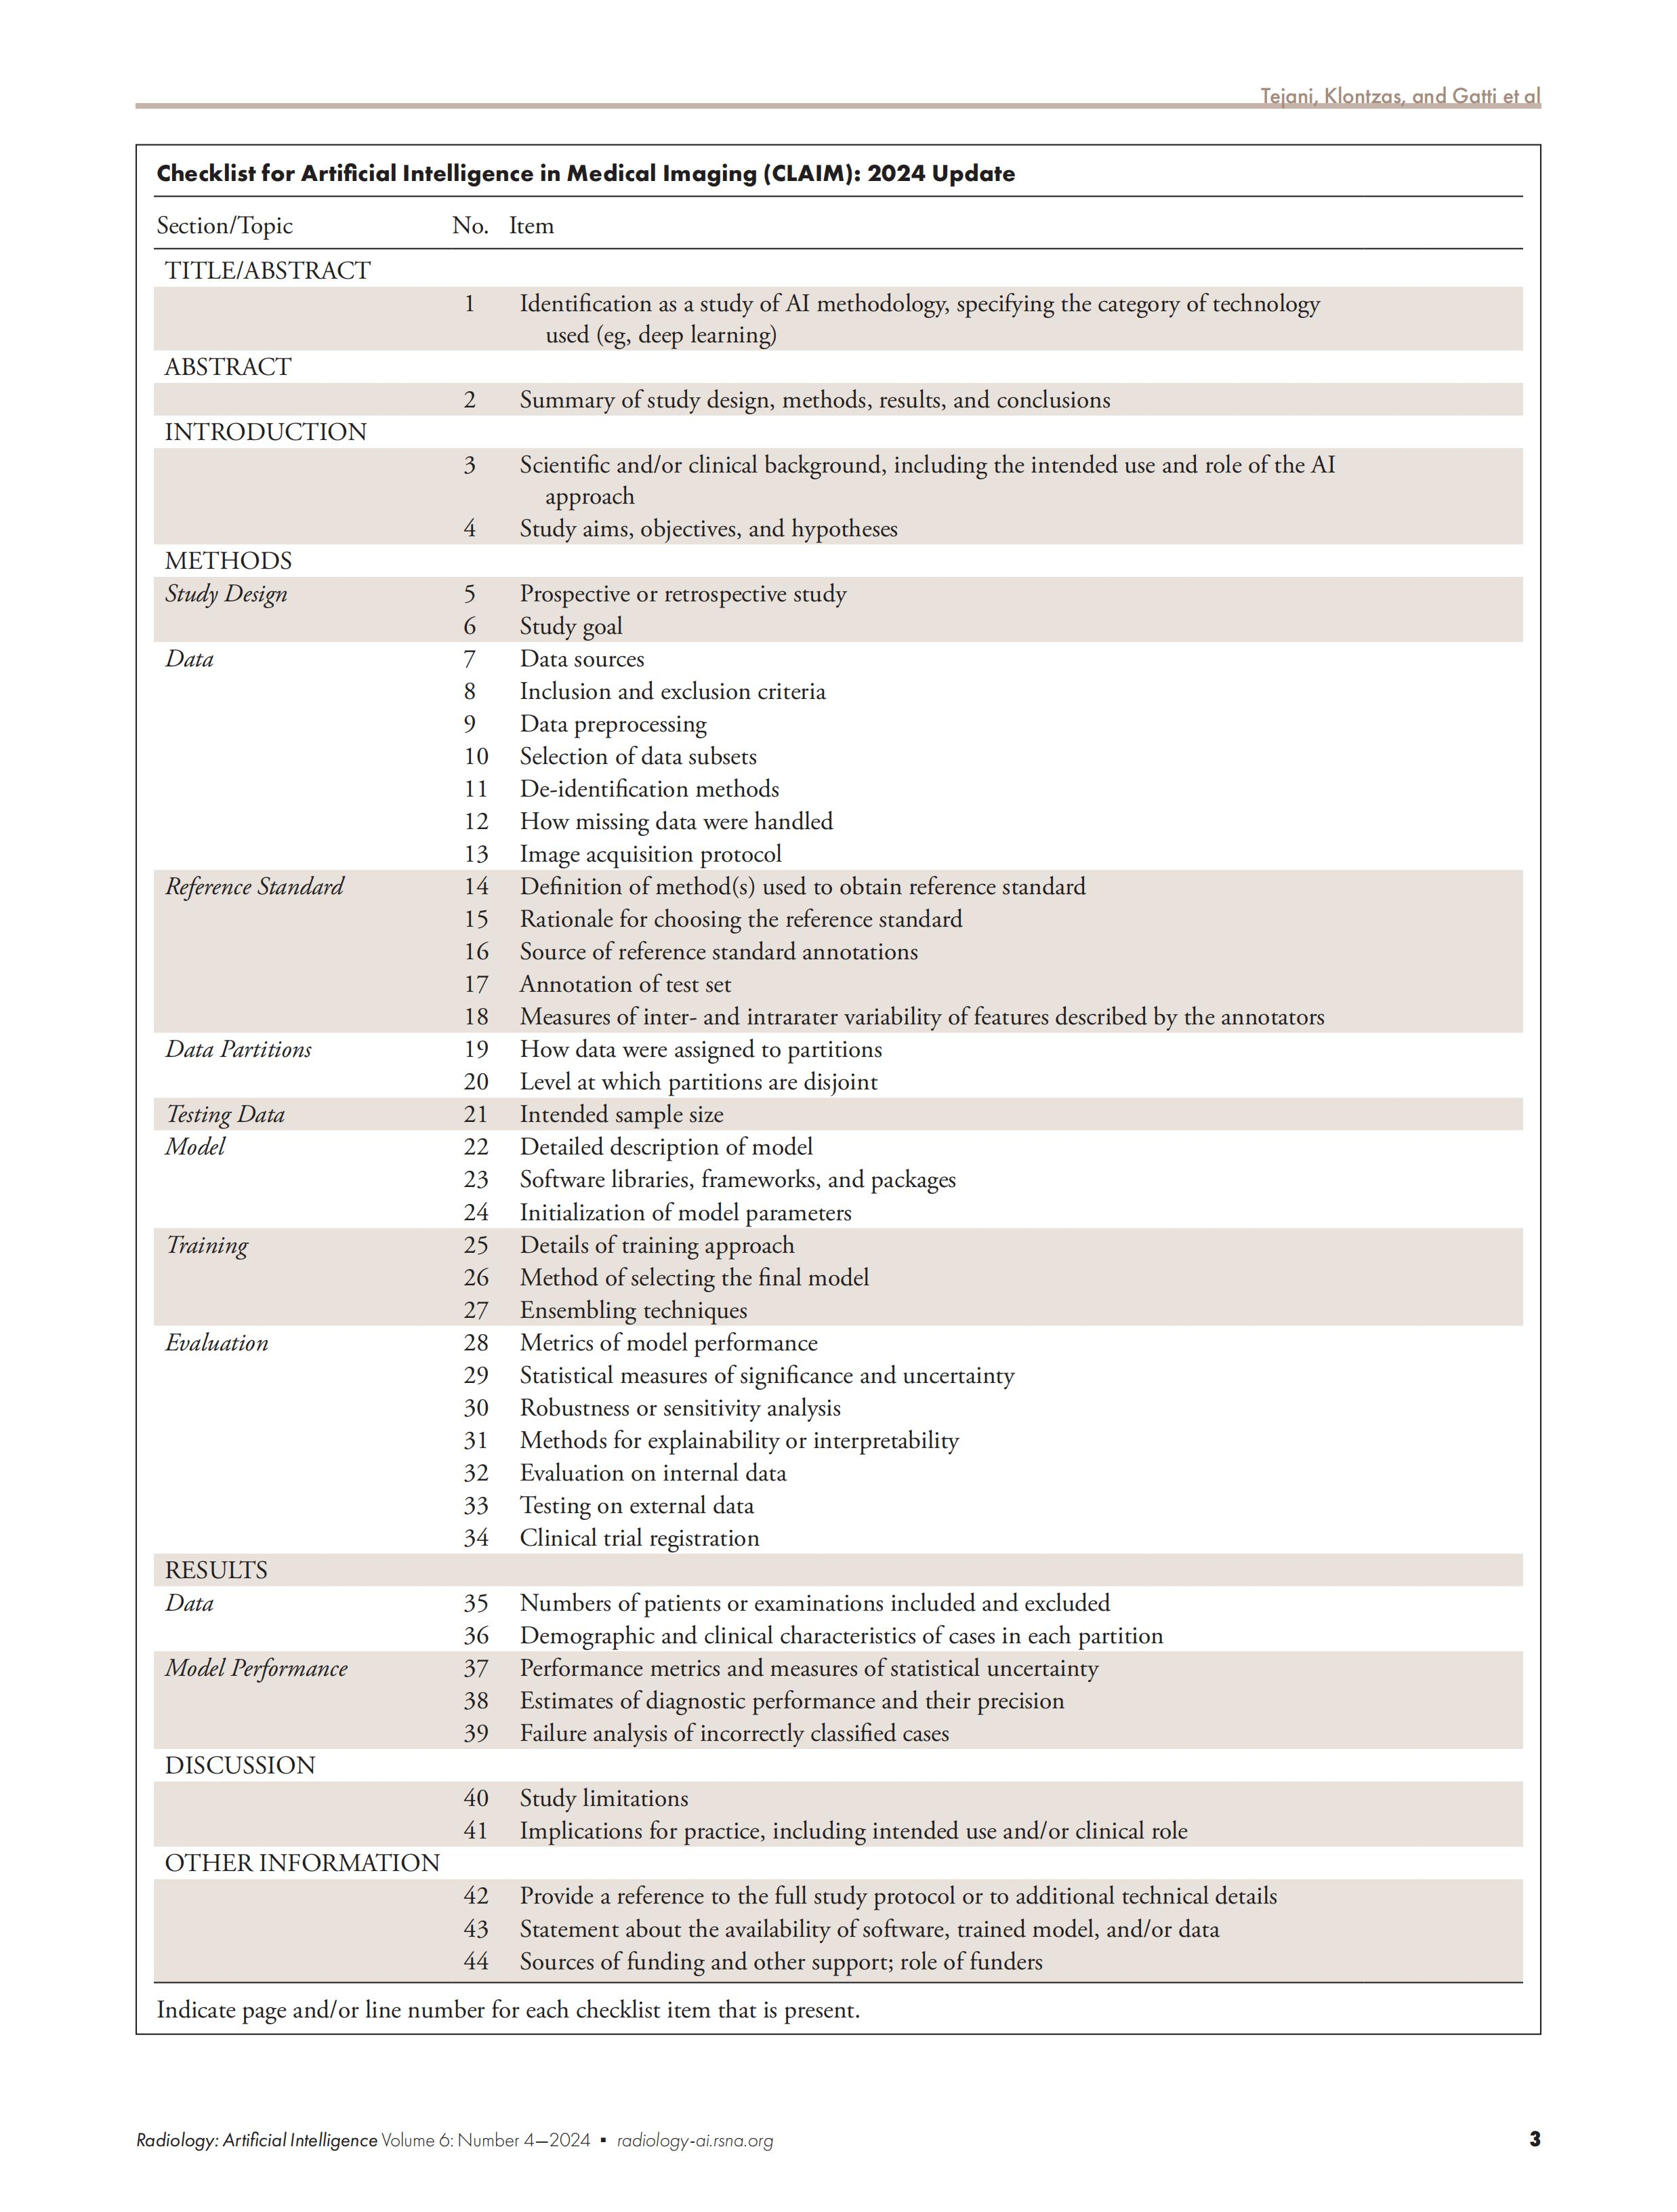
Reference: Tejani AS, Klontzas ME, Gatti AA, et al. Checklist for Artificial Intelligence in Medical Imaging (CLAIM): 2024 Update. Radiol Artif Intell. 2024;6(4):e240300. doi:10.1148/ryai.240300

