Supplementary Materials
- GLAM Geometric Classes
9) Anisotropy: While the RDF captures isotropic correlations, many biological structures exhibit directional organization. For example, muscle fibers, white matter tracts, and aligned stromal bands form distinctly anisotropic patterns. To capture this directional dependency, we compute an Anisotropy Index.
Each reference voxel of gray level α defines a cloud of surrounding β-voxels within a cutoff radius. The shape of this cloud is described by its gyration tensor³², equivalent to the covariance matrix of neighbor positions. Two complementary indices are derived:
Positional Anisotropy: The Relative Shape Anisotropy,
 | $$A\left(α,β\right)=1-3\frac{{λ_{1}λ_{2}{+λ}_{1}λ_{3}+λ_{2}λ}_{3}}{{\left(λ_{1}+λ_{2}+λ_{2}\right)}^{2}}$$ | (8)
​uses the eigenvalues λ_{i} of the gyration tensor to quantify geometric elongation²⁵. A=0 represents spherical isotropy, whereas A→1 reflects line-like elongation. Averaged across all voxels, A(α,β) provides a matrix representation of spatial anisotropy between gray-level components, revealing oriented structures or directional coherence within tissues.
Orientational Anisotropy: To capture alignment of voxel orientations, intensity gradient vectors define local directions. From these, a nematic ordering tensor is constructed, and its largest eigenvalue yields the order parameter²⁵:
 | $$S=\frac{1}{2}〈3\cos^{2}{θ}-1〉$$ | (9)
This metric, analogous to the Onsager order parameter of liquid crystals, quantifies the degree of alignment of local directions within the texture^{25,36}. S=0 represents random orientation, and S=1 indicates perfect alignment, as seen in fibrous or laminar tissues. Together, positional and orientational anisotropy metrics extend GLAM beyond scalar texture analysis, enabling quantitative evaluation of directional tissue organization.
10) Fractal Dimension: To quantify geometric complexity and multiscale self-similarity, the GLAM framework calculates the fractal dimension via a 3D box-counting algorithm^{29,37}. The number of boxes, N(L), required to cover ROI scales with box size, L, according to the power law^{29,37} N(L)∝ L^{−Df}. The fractal dimension is then derived from the slope of the log-log plot of N(L) versus L (Figure 3). Two complementary measures are defined:
Volume Fractal Dimension (D_{V}): calculated for all voxels belonging to a single gray level, indicating its space-filling capacity. Values near 3 correspond to dense, 3-dimensional structures; lower values indicate porous, flat (2-dimensional) or filamentous (1-dimensional) organization.
Interface Fractal Dimension (D_{I}): calculated between two different gray levels (α≠β), measuring interface roughness. D_{I}≈2 denotes smooth boundaries, while higher values correspond to irregular or invasive interfaces, as often observed in aggressive tumors.
The resulting D_{f}(α,β) matrix contains both diagonal (volume) and off-diagonal (interface) terms, capturing the hierarchical complexity of tissue architecture.
11) Multifractal Spectrum: Complex biological tissues often exhibit multifractal behavior, where the scaling properties are not constant but vary across the region. GLAM employs a generalized dimension approach (D_{q}) to capture this spectrum. By analyzing the partition function of voxel distribution moments q, we derive the multifractal spectrum width (∆α) and the generalized dimensions. The spectrum width ∆α = α _{max} - α _{min} quantifies the diversity of scaling behaviors; a wide spectrum indicates high multifractality (a mix of sparse and dense regions), often associated with the heterogeneous chaos of aggressive malignancies.
12) Lacunarity: While fractal dimension quantifies how much space a structure fills, it does not distinguish between textures with different gap distributions. To address this, GLAM computes Lacunarity (Λ), a counterpart to fractal dimension that measures "gappiness" or the heterogeneity of the texture's empty spaces. Calculated using a gliding-box algorithm, Lacunarity is defined by the ratio of the variance (σ²) to the square of the mean (μ²) of mass within the boxes:
$$Λ\left(L\right)=\frac{σ^{2}\left(L\right)}{μ^{2}\left(L\right)}+1$$
where L is the box size. High Lacunarity indicates a texture with large, irregular gaps or voids (heterogeneous), whereas low Lacunarity suggests a uniform, translationally invariant distribution (homogeneous). The resulting Λ(α, β) matrix characterizes the spatial heterogeneity of each gray-level component and their interfaces.
13) Topological Invariants: To quantify the connectivity and fundamental shape of the tumor microenvironment, GLAM utilizes algebraic topology. Specifically, we compute the Betti numbers (B_{k}), which count the number of fragmented "islands" of a specific gray level (B₀), the number of loops or tunnels (e.g., vascular networks or necrotic tracks) penetrating the structure (B₁), and the number of enclosed internal cavities or hollows (B₂). These invariants are related by the Euler-Poincaré formula to the Euler Characteristic (χ), a classic measure of topological complexity:
$$χ=B_{0}-B_{1}+B_{2}$$
Unlike statistical texture metrics, these topological features are invariant under continuous deformation, providing a robust descriptor of the tissue's structural integrity and porosity.
14) Discrete Morphology: While texture describes the arrangement of voxels, the geometric shape of the gray-level clusters themselves carries independent diagnostic information. GLAM extracts explicit 3D morphological descriptors for each gray-level isosurface, including Sphericity and Solidity. Furthermore, for off-diagonal elements, the framework measures the total surface area of the boundary between two distinct gray levels, representing the extent of physical contact or infiltration between different tissue types. By computing the Centroid Distance, defined as the Euclidean distance between their centers of mass, and the Interface Area, which quantifies the total surface of direct contact between the two phases.

2. GLAM Matrices Robustness
To ensure the GLAM framework is robust to extreme outliers while preserving physical information, we applied range-compressing transformations, such as logarithmic or symmetric log (symlog) scaling^{38,39}. Matrices requiring transformation were identified using the ratio of the Interquartile Range to the total Range (IQR/Range) using a threshold of <0.2 to select distributions with extreme outliers. The GLAM software computes and exports a complete set of features for both the original and transformed matrices, allowing for direct comparative analysis.

Supplementary Figure S1: Savitzky-Golay Filter Parameter Selection
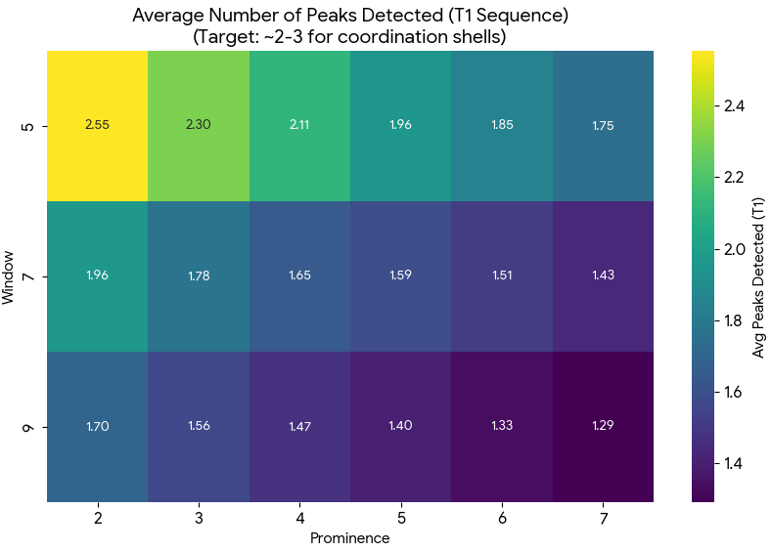 | 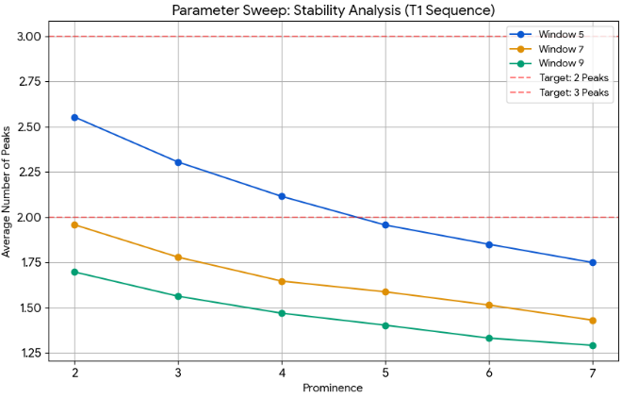
The GLAM feature extraction parameters were optimized through iterative sweeping across T1, T1ce, T2, and FLAIR MRI sequences to maximize the detection of true physical coordination shells while rejecting image-induced noise. A Savitzky-Golay filter with a window length of 7 and a polynomial order of 3 was selected; this combination provided the necessary mathematical stiffness to smooth out local intensity fluctuations without over-fitting the noise or overly dampening the signal. The peak prominence threshold was the most critical variable and was empirically tuned to a universal value of 4.0. Lower prominences (e.g., 0.1) were found to be overly sensitive, falsely identifying random noise spikes as structural peaks in the T1c and T2 maps, which artificially skewed the downstream GLAM matrices. Conversely, higher prominences (e.g., 5.0) failed to detect the more subtle architectural features inherent to the smoother T1 sequences. A prominence of 4.0 emerged as the optimal compromise, consistently and robustly isolating the expected physical coordination shells across all three imaging modalities.
Supplementary Figure S2: Schematic overview of the Leave-One-Center-Out (LOCO) cross-validation and predictive modeling workflow.
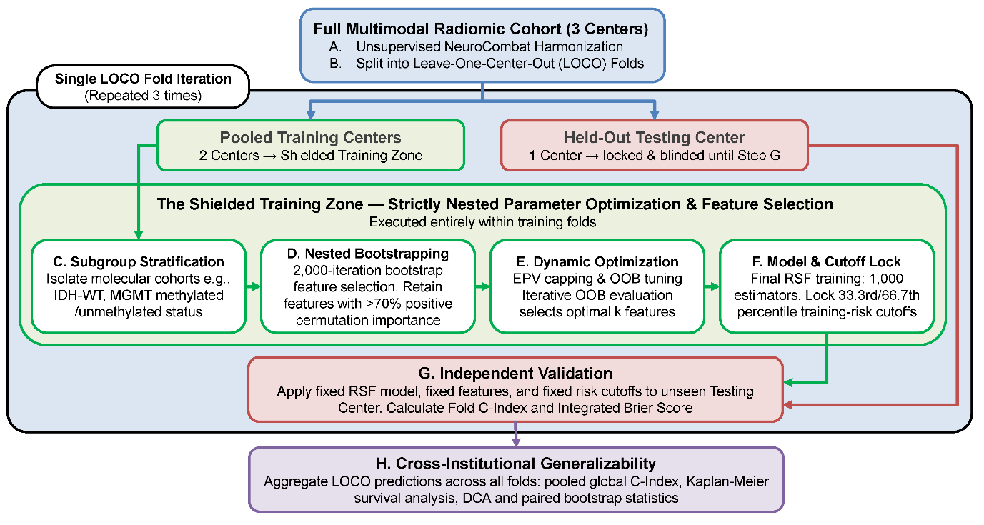
The pipeline begins with unsupervised multi-center harmonization (NeuroCombat) before splitting the global cohort into iterative LOCO folds. To strictly prevent data leakage, all model development steps, including molecular subgroup stratification, nested bootstrap feature selection, dynamic out-of-bag (OOB) optimization, and Random Survival Forest (RSF) training, are executed exclusively within a "Shielded Training Zone" using the pooled training centers. The finalized model and its empirically derived risk cutoffs are then locked and applied to the completely blinded, held-out testing center for independent validation. Finally, patient predictions across all three iterative folds are aggregated to evaluate true cross-institutional generalizability.
Supplementary Figure S3: Convergence of GLAM Radiomic Features
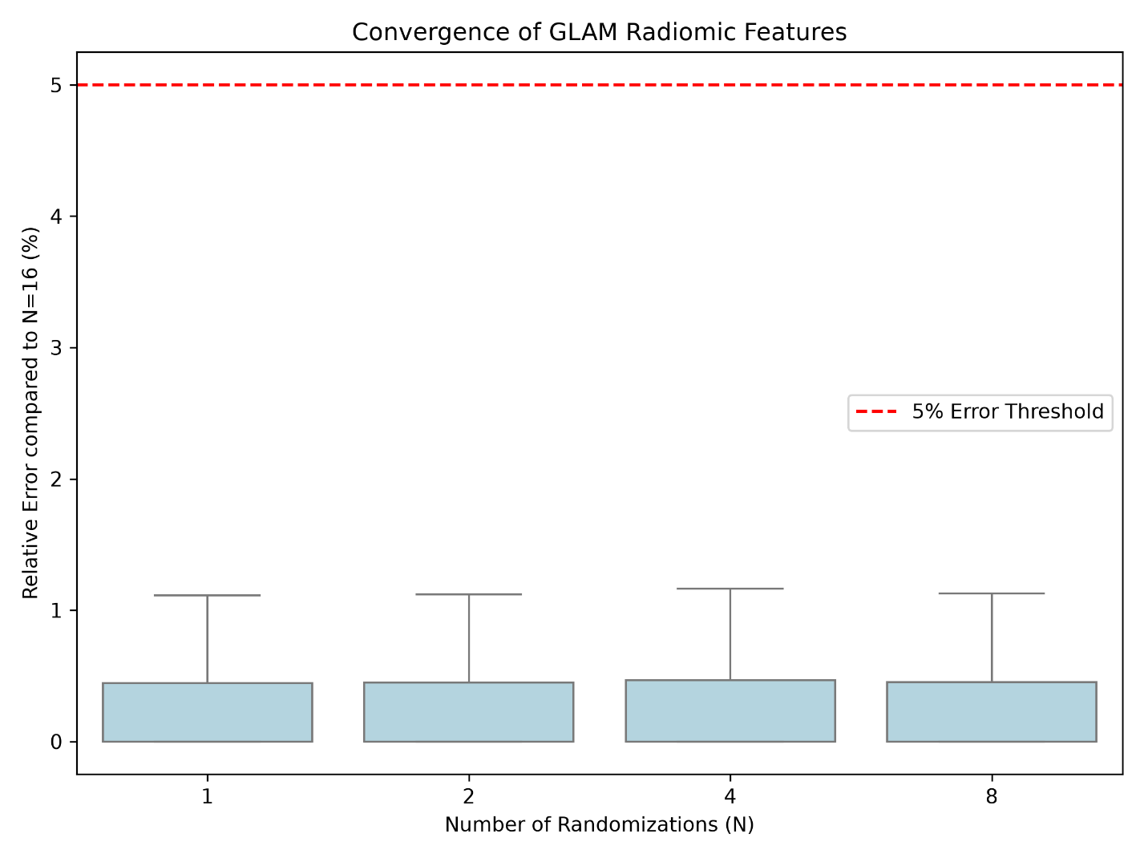

Boxplots demonstrating the relative percentage error of radiomic features extracted using varying numbers of randomizations, N = (1, 2, 4, 8), compared to the N=16 baseline. The red dashed line indicates a 5% error threshold. Across all evaluated randomization parameters, the interquartile range and maximum relative variance remain well below 1.5%, confirming robust feature stability and justifying the computational choice of N=4.

Supplementary Figure S4: Radial Distribution Function Convergence.
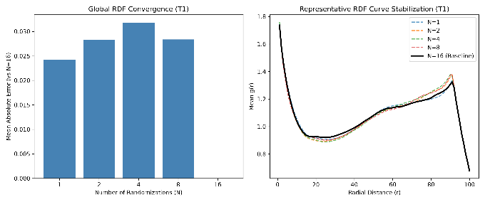 | 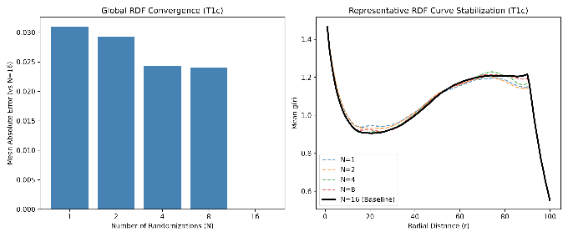
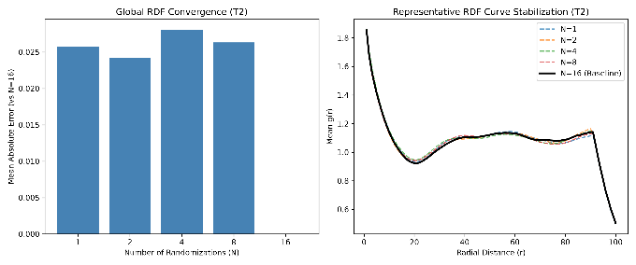 | 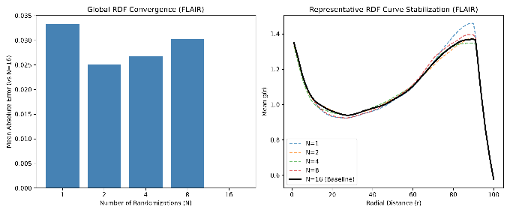

Evaluation of RDF structural stability across standard MRI modalities (FLAIR, T1, T1c, T2). (Left) Bar charts quantifying the Mean Absolute Error (MAE) of the global RDF matrix for N = (1, 2, 4, 8) relative to the N=16 (ground truth). (Right) Representative mean g(r) curves plotted against radial distance r.
Supplementary Figure S5: 1-Year Calibration curves
Conventional Radiomics GLAM Conventional and GLAM
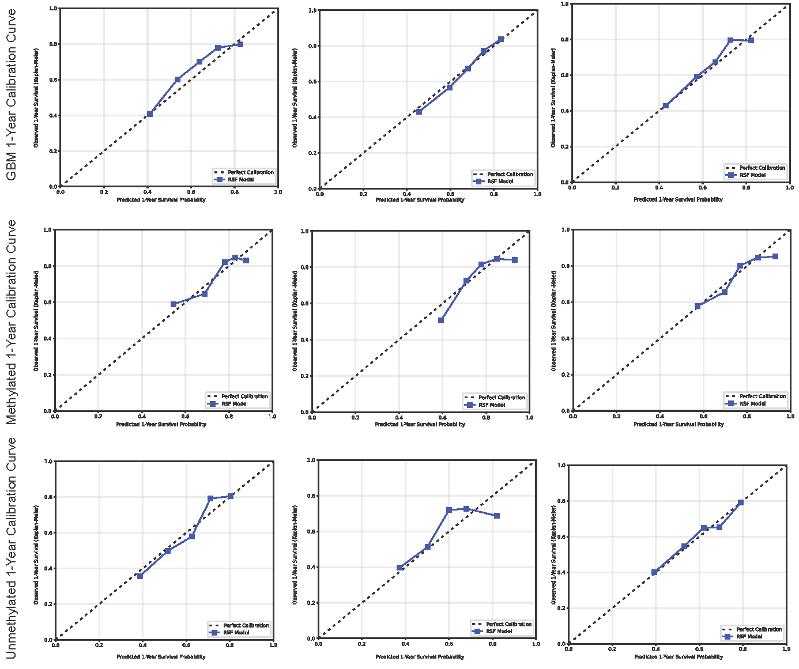
Supplementary Figure S6: Decision Curve Analysis (1-Year)
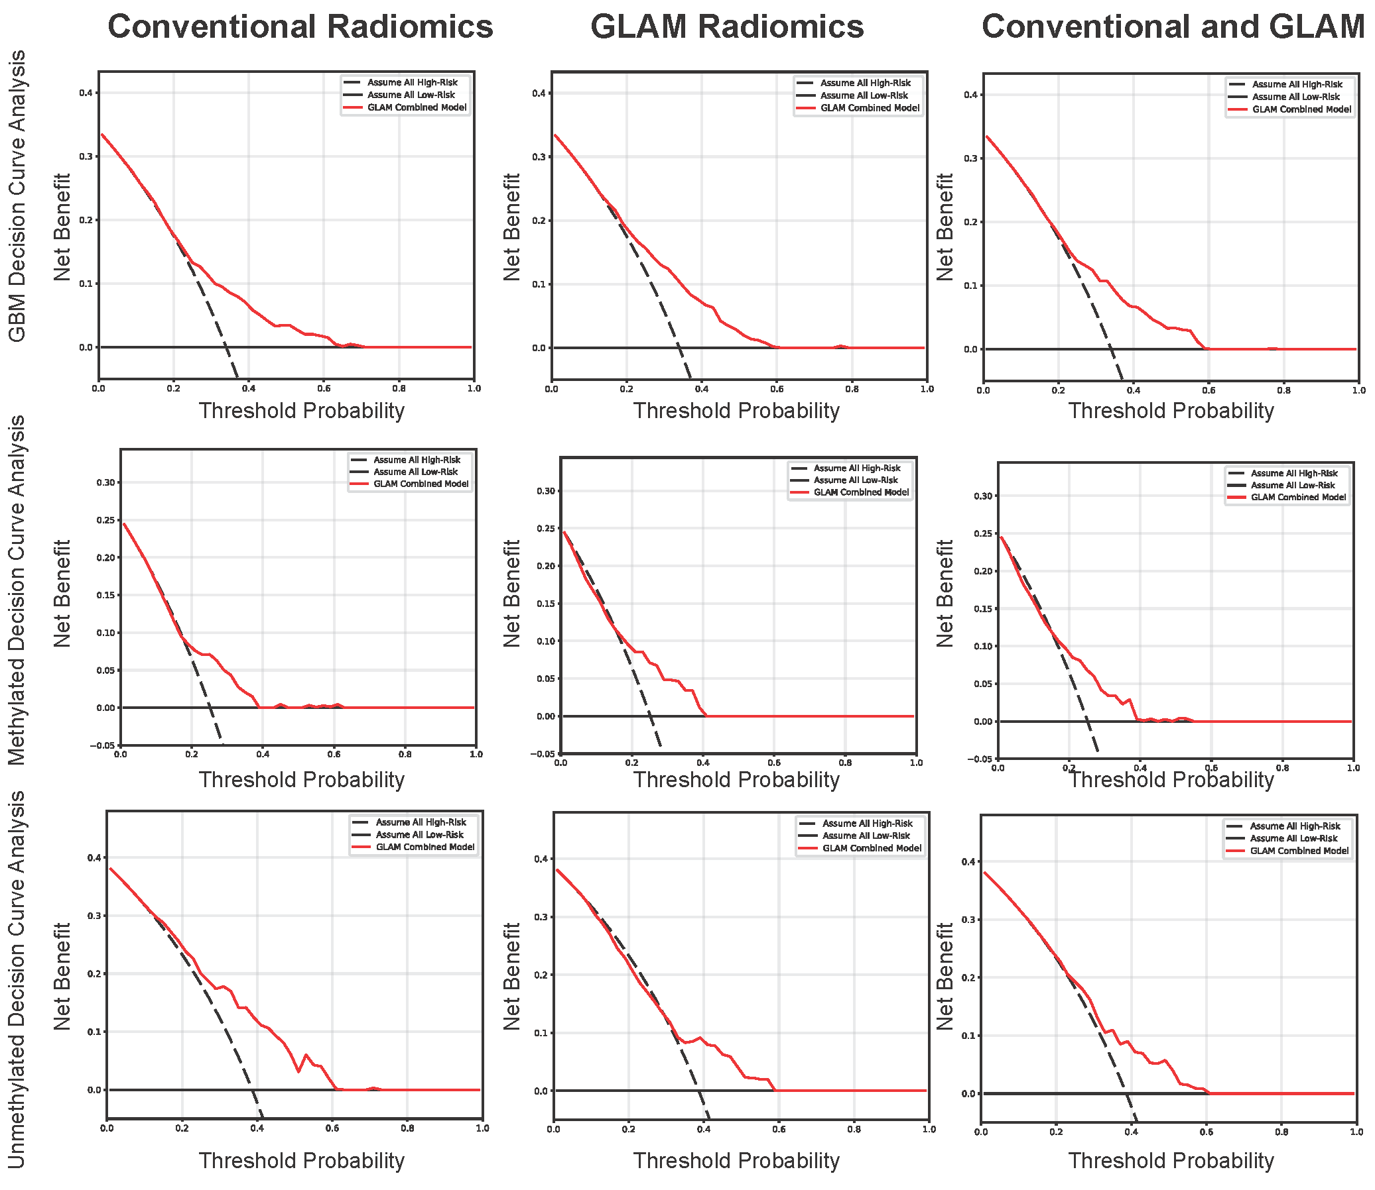
Table S1. Prognostic Radiomic Signatures Masked in Combined Cohort Analysis.
Category | MRI  Sequence | Original Radiomics | GLAM Features | Combined
IDH-WT | T1 | - | 7 (100%) | 7
MGMT Methylated | T1c | - | 10 (100%) | 10
(Hidden in Combined) | T2 | 2 (9%) | 20 (91%) | 22
 | FLAIR | - | 13 (100%) | 13
 | Total | 2 (4%) | 50 (96%) | 52
IDH-WT | T1 | 1 (20%) | 4 (80%) | 5
MGMT Unmethylated | T1c | 3 (18%) | 14 (82%) | 17
(Hidden in Combined) | T2 | 1 (25%) | 3 (75%) | 4
 | FLAIR | 1 (20%) | 4 (80%) | 5
 | Total | 6 (19%) | 25 (81%) | 31

This table details the quantity and distribution of radiomic features that demonstrated significant prognostic value (P < 0.005, Log-rank test) exclusively within isolated molecular subgroups (MGMT-methylated or MGMT-unmethylated IDH-wildtype glioblastoma). These specific textural and topological signals were completely masked—failing to reach the P < 0.005 threshold—when evaluated across the broader, combined IDH-wildtype population. The data is stratified by MRI sequence and feature type, highlighting the disproportionate ability of the GLAM framework to capture these highly specific, "hidden" survival biomarkers compared to standard radiomics.

Supplementary Table S2: Combined Model Domain Invariance and Algorithmic Feature Preference
Note: This table details the exact hold-out performance of the hybrid model across the three independent institutional folds. Domain Spread highlights the maximum variance in testing accuracy. The algorithm overwhelmingly selected multiscale GLAM features over conventional radiomics to achieve this cross-institutional stability.
Cohort | Held-Out Center | Train  C-Index | Test  C-Index | Domain Spread | Total Features | Ratio  (GLAM : Orig)
IDH-Wildtype | NU | 0.759 | 0.597 | 0.068 | 7 | 6 : 1
 | UCSF | 0.752 | 0.665 |  | 8 | 7 : 1
 | UPENN | 0.783 | 0.621 |  | 10 | 7 : 3
MGMT Methylated | NU | 0.752 | 0.632 | 0.009 | 2 | 2 : 0
 | UCSF | 0.758 | 0.641 |  | 1 | 1 : 0
 | UPENN | 0.787 | 0.641 |  | 6 | 4 : 2
MGMT Unmethylated | NU | 0.752 | 0.625 | 0.067 | 2 | 1 : 1
 | UCSF | 0.747 | 0.685 |  | 6 | 4 : 2
 | UPENN | 0.787 | 0.618 |  | 6 | 4 : 2

Supplementary Table S3: Complete Feature Signatures per LOCO Fold (Combined Model)
Cohort | Hold-Out Center | Selected Features List
IDH-Wildtype | NU | T2_GLAM.LogRDF_PeakHeight.FirstOrder.InterquartileRange, T1c_GLAM.LogRDF_PeakHeight.SecondOrder.MaximumProbability, T2_GLAM.PotentialEnergy_Symlog.FirstOrder.InterquartileRange, FLAIR_GLAM.EnergyDensity.Advanced.Eigen.Eigenvalue2, T1c_original_firstorder_Kurtosis, FLAIR_GLAM.LogRDF_Skewness.Advanced.Eigen.Eigenvalue1, FLAIR_GLAM.PotentialEnergy_Symlog.FirstOrder.InterquartileRange
 | UCSF | T1c_GLAM.LogRDF_PeakHeight.SecondOrder.JointEnergy, T2_GLAM.LogRDF_PeakHeight.FirstOrder.InterquartileRange, T1c_GLAM.LogRDF_PeakHeight.SecondOrder.MaximumProbability, T2_GLAM.PotentialEnergy_Symlog.FirstOrder.InterquartileRange, T2_GLAM.LogRDF_PeakHeight.SecondOrder.SumAverage, T1c_original_firstorder_Kurtosis, FLAIR_GLAM.LogRDF_Skewness.Advanced.Eigen.Eigenvalue1, FLAIR_GLAM.PotentialEnergy_Symlog.FirstOrder.MeanAbsoluteDeviation
 | UPENN | T1c_GLAM.LogRDF_PeakHeight.SecondOrder.MaximumProbability, T1c_original_ngtdm_Strength, T2_GLAM.PotentialEnergy_Symlog.FirstOrder.InterquartileRange, T2_GLAM.LogRDF_PeakHeight.FirstOrder.InterquartileRange, FLAIR_GLAM.EnergyDensity.Advanced.Eigen.Eigenvalue2, FLAIR_GLAM.LogRDF_Skewness.Advanced.Eigen.Eigenvalue1, T1c_original_glrlm_RunVariance, T1c_original_glrlm_LongRunHighGrayLevelEmphasis, T2_GLAM.PotentialEnergy_Symlog.SecondOrder.Autocorrelation, T2_GLAM.LogRDF_PeakHeight.SecondOrder.SumAverage
MGMT Methylated | NU | T1c_GLAM.LogRDF_PeakHeight.SecondOrder.MaximumProbability, T2_GLAM.LogRDF_PeakHeight.FirstOrder.InterquartileRange
 | UCSF | T1c_GLAM.LogRDF_PeakHeight.SecondOrder.MaximumProbability
 | UPENN | T1c_GLAM.LogRDF_PeakHeight.SecondOrder.MaximumProbability, T2_GLAM.LogRDF_PeakHeight.FirstOrder.InterquartileRange, T1c_original_ngtdm_Strength, T2_GLAM.PotentialEnergy_Symlog.FirstOrder.InterquartileRange, T2_original_firstorder_Variance, FLAIR_GLAM.EnergyDensity.Advanced.Eigen.Eigenvalue2
MGMT Unmethylated | NU | FLAIR_GLAM.PotentialEnergy_Symlog.FirstOrder.InterquartileRange, T1c_original_ngtdm_Strength
 | UCSF | T1c_original_ngtdm_Strength, T1c_original_glszm_LargeAreaLowGrayLevelEmphasis, T2_GLAM.LogRDF_Kurtosis.SecondOrder.DifferenceEntropy, T1c_GLAM.B2_Symlog.Advanced.Diag.DominanceRatio, FLAIR_GLAM.LogRDF_Kurtosis.Advanced.Diag.Mean, FLAIR_GLAM.LogRDF_Skewness.Advanced.Eigen.Eigenvalue1
 | UPENN | T1c_GLAM.Lacunarity_Ln.Advanced.Cluster.SizeVariance, FLAIR_GLAM.LogRDF_Kurtosis.Advanced.Diag.Mean, T1c_original_glszm_LargeAreaLowGrayLevelEmphasis, FLAIR_GLAM.EnergyDensity.SecondOrder.InverseVariance, T2_GLAM.LogRDF_PeakHeight.SecondOrder.SumAverage, T1c_original_ngtdm_Strength

Supplementary Table S4: Pairwise Bootstrap Hypothesis Testing of Cross-Institutional Pooled LOCO Predictions
Molecular Cohort | Model Comparison | ΔC-Index  95% Confidence Interval | Two-Sided Paired  P-Value
IDH-WT / GBM  (N = 1056) | Combined vs. Conventional | +0.0152  [+0.0049,+0.0244] | P<0.001
IDH-WT / GBM  (N = 1056) | Combined vs. GLAM | +0.0089  [+0.0034,+0.0149] | P=0.004
IDH-WT / GBM  (N = 1056) | GLAM vs. Conventional | +0.0063  [−0.0045,+0.0163] | P=0.254
IDH-WT  MGMT Methylated  (N = 457) | Combined vs. Conventional | +0.0032  [−0.0242,+0.0305] | P=0.862
IDH-WT  MGMT Methylated  (N = 457) | Combined vs. GLAM | −0.0077  [−0.0151,−0.0002] | P=0.046
IDH-WT  MGMT Methylated  (N = 457) | GLAM vs. Conventional | +0.0109  [−0.0176,+0.0409] | P=0.044
IDH-WT  MGMT Unmethylated  (N = 334) | Combined vs. Conventional | −0.0142  [−0.0300,+0.0022] | P=0.11
IDH-WT  MGMT Unmethylated  (N = 334) | Combined vs. GLAM | +0.0375  [+0.0188,+0.0565] | P<0.001
IDH-WT  MGMT Unmethylated  (N = 334) | GLAM vs. Conventional | −0.0517  [−0.0732,−0.0282] | P<0.001

Pairwise comparative efficacy of predictive frameworks across molecular cohorts. To evaluate absolute cross-institutional ranking accuracy, overall model performance was assessed using a paired bootstrap hypothesis test (1,000 resamples) on the differences in Concordance Indices (ΔC-Index) between the competing models across the pooled multi-center hold-out cohorts. Positive Δ values indicate prognostic superiority of the first model in the comparison pair.

