Article Title: Downstream-Aware Automated QC of Images and AI-Generated Segmentations

Journal Name: Journal of Imaging Informatics in Medicine

Authors: BLIND

Author Affiliations: BLIND

Corresponding Author: BLIND

SUPPLEMENTAL MATERIALS
Supplemental Methods
Reader classification criteria
The primary classification criteria for readers were kidney coverage and scan quality. Common special cases occurred throughout the dataset, however, and included single/double nephrectomies, artifacts, transplanted kidneys, atrophic kidneys, and cyst exclusion. Guidelines for these special cases were outlined to readers as follows:
Double nephrectomies: if the scan is good quality and no segmentation is present, classify the case as Accept. If scan quality is good but the model segments improperly, classify the case as Rework. A case should be classified as Reject if the scan is not of diagnostic quality.
Artifacts: severe artifacts affecting segmentation should be classified as Reject. Mild artifacts (such as minimal patient motion) may be classified as Rework if kidney boundaries are traceable for the entirety of the scan.
Transplanted kidneys: may be present with zero, one, or two native kidneys. Classification should focus solely on the scan quality and accuracy of native kidney segmentation.
Atrophic kidneys: if they are missed on the segmentation, classify these cases as Rework.
Cyst exclusion: if a cyst (standard or complex) is excluded for >2 slices, classify the case as Rework. If it is missed on 1-2 slices with a small enough area, the case can be classified as Accept.
Initial scan-level exploratory split and patient overlap
The manuscript reports model performance using a patient-disjoint split. The exploratory analyses in this Supplemental Material, including the decoupled binary tasks and additional architecture comparisons, were performed using an initial scan-level split. This scan-level split was used during early model development to maximize the number of available training scans and preserve scan-level QC-label variability across repeated studies. However, because multiple scans from the same patient could appear across training, validation, and test subsets, these exploratory results are likely optimistic relative to patient-disjoint evaluation and should not be interpreted as primary generalization estimates. Although these supplemental experiments do not directly correspond to the primary patient-disjoint analyses in the main text, we include them to document early model-development decisions and to illustrate how patient overlap can affect evaluation even when the prediction target is scan-level.
The original scan-level dataset contained 16,492 scan/segmentation pairs. The training subset contained 15,292 pairs labeled as Accept, Reject, or Rework. Validation and test subsets each contained 600 scan/segmentation pairs, balanced with 200 Accept, 200 Reject, and 200 Rework cases. Validation and test subsets were also filtered to exclude cases where the kidney segmentation mask touched the scan edge, to reduce reliance on boundary-contact heuristics. Supplemental Table 1 summarizes the breakdown of scans per split and classification label for this initial cohort. Supplemental Table 2 summarizes the number of unique patients in each mutually exclusive overlap category across splits. Supplemental Table 3 summarizes classification label variability among overlapping patients, demonstrating that repeated scans from the same patients did not always receive identical Accept/Reject/Rework classification.

Supplemental Table 1 Original scan-level exploratory dataset split used for supplemental binary-task and architecture analyses.
Split | Scans | Accept | Reject | Rework | Boundary-filtered?
Train | 15,292 | 7,140 | 6,784 | 1,368 | No
Validation | 600 | 200 | 200 | 200 | Yes
Test | 600 | 200 | 200 | 200 | Yes
Total | 16,492 | 7,540 | 7,184 | 1,768

Supplemental Table 2 Summary of patient overlap across initial scan-level exploratory dataset split. Counts are presented as number of patients in each mutually exclusive overlap category.
Overlap Category | Number of Patients
Train only | 1,939
Validation only | 45
Test only | 39
Train/Validation | 269
Train/Test | 269
Validation/Test | 2
Train/Validation/Test | 154
Total unique patients | 2717

Supplemental Table 3 Classification label variability across repeated scans from overlapping patients in the original scan-level exploratory split. Values indicate the number of patients with each Accept/Reject/Rework label combination across repeated scans.
Overlap Group | Accept | Reject | Rework | Accept + Reject | Accept + Rework | Reject + Rework | Accept + Reject + Rework
Train + Validation | 47 | 29 | 15 | 84 | 26 | 32 | 36
Train + Test | 50 | 20 | 21 | 86 | 30 | 18 | 44
Validation + Test | 0 | 0 | 2 | 0 | 0 | 0 | 0
Train + Validation + Test | 8 | 9 | 9 | 53 | 12 | 11 | 52

Binary task data curation
Decoupled binary classification tasks were evaluated using the original scan-level exploratory split described above. For these experiments, the same pool of 600 validation scans was used, with a balanced number of true vs false cases pertaining to each task. The first task (Accept/Rework vs Reject) utilized 200 true scans (100 Accept, 100 Rework) and 200 false (Reject) cases. The second task (Accept vs Rework) utilized 200 Accept and 200 Rework cases, with the 100 Accept and 100 Rework from the first task overlapping the second task’s validation set. A holdout test set of 600 cases was saved for further evaluation of the best model. Both validation and testing datasets included only cases with segmentations where kidney labels did not touch any edge of the masked scan.
Pipeline structure
Decoupled binary classification tasks were also tested using MultiImageNet with both single and multi-input variations, with an emphasis on multi-input runs due to their superior performance. Like the multiclass problem, both binary tasks (Accept/Rework vs Reject, and the subsequent Accept vs Rework) utilized the scan, its corresponding segmentation, and the masked scan as inputs to the model.
Binary model performance
Performance for the decoupled binary tasks was comparable to the multiclass classification models, but we selected multiclass classification because it provided a simpler single-step output. Supplemental Table 4 reports classification metrics for both of the binary classification tasks using each of the R1 and R2 labels as reference standards. ResNet18 was the highest performing model for both binary tasks. In the original scan-level exploratory validation set, the first stage (Accept/Rework vs Reject) achieved macro F1-scores of 0.82-0.95 across readers, with accuracies ranging from 89-95%, indicating reliable separation of clearly unusable scans. The second stage (Accept vs Rework) was more challenging, with macro F1-scores of 0.72-0.77 and accuracies ranging from 72-73% across readers. This reflects the subjectivity of classification between these classes and mirrors the primary patient-disjoint analysis, where the Accept/Rework boundary remained the dominant source of model confusion.

Supplemental Table 4 ResNet18 decoupled binary model macro-averaged performance metrics on the initial scan-level exploratory validation datasets. R1 and R2 denote reader-defined reference standards; R1 is the pooled primary reference-label set.
 | Task ª | Accuracy ^{b} | Precision ^{b} | Recall ^{b} | F1-score ^{b} | Specificity – True ^{b} | Specificity – False ^{b}
R1 | Accept/Rework (T) vs Reject (F) | 0.89 | 0.82 | 0.82 | 0.82 | 0.79 | 0.99
R1 | Accept (T) vs Rework (F) | 0.73 | 0.80 | 0.65 | 0.72 | 0.48 | 0.98
R2 | Accept/Rework (T) vs Reject (F) | 0.95 | 0.97 | 0.94 | 0.95 | 0.91 | 0.97
R2 | Accept (T) vs Rework (F) | 0.72 | 0.97 | 0.65 | 0.77 | 0.46 | 0.97
ª (T) denotes the positive class, while (F) denotes the negative class.
^{b} Macro-averaged values represent the unweighted mean of the per-class metrics across Accept, Reject, and Rework

To better compare the decoupled binary task performance with multiclass results, we ran the Accept/Rework vs Reject problem on the full validation dataset from the scan-level split. All predicted Accept and Rework cases were then run through the second model to distinguish Accept and Rework labels. The predictions were then compiled and plotted as a single pseudo-multiclass confusion matrix. These predictions can be seen in Supplemental Fig 1.
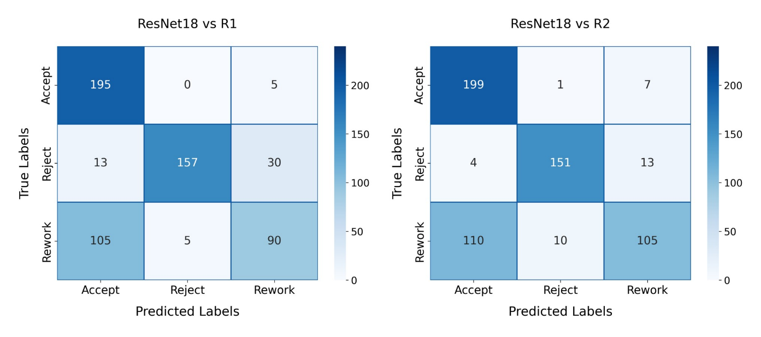
Supplemental Fig 1 Confusion matrices demonstrating exploratory ResNet18 performance on the combined binary tasks mimicking multiclass classification using the initial scan-level validation set.

The metrics for the combined binary tasks calculated from the R1 and R2 reference standard labels are visible in Supplemental Table 5. ResNet18 achieved macro F1-scores of 0.73 and 0.76 (R1 and R2, respectively), with accuracies ranging from 74-75% across readers.

Supplemental Table 5 ResNet18 pseudo-multiclass performance from combined binary tasks on the original scan-level exploratory validation set.
 | Accuracy | Precision | Recall | F1-score | Specificity – Accept | Specificity – Reject | Specificity – Rework
R1 | 0.74 | 0.77 | 0.74 | 0.73 | 0.71 | 0.99 | 0.90
R2 | 0.75 | 0.79 | 0.77 | 0.76 | 0.72 | 0.98 | 0.93

Exploratory multiclass architecture comparisons using initial scan-level split
Additional model architectures were evaluated for multiclass classification using MultiImageNet during early model development. These exploratory experiments used the original scan-level split described above and therefore may overestimate generalization compared with the patient-disjoint evaluation reported in the main manuscript. The results are included to document the architecture-selection process that motivated subsequent focus on ResNet18, ResNet34, and DenseNet121. Top runs with additional model architectures tested for multiclass classification using MultiImageNet can be seen in Supplemental Table 6. Metrics were calculated across multiple readers’ classification labels.

Supplemental Table 6 Multiclass model macro-averaged performance metrics on original scan-level validation set.
Reader | Model | Accuracy | Precision | Recall | F1-score
R1 | VGG16 | 0.75 | 0.78 | 0.75 | 0.74
R1 | ViT | 0.69 | 0.76 | 0.69 | 0.68
R1 | EfficientNet-b0 | 0.75 | 0.78 | 0.75 | 0.75
R1 | Swin UNET-R | 0.61 | 0.67 | 0.61 | 0.59
R1 | MR-CLIP | 0.57 | 0.46 | 0.57 | 0.48
R1 | MedicalNet ResNet18 [1] | 0.74 | 0.77 | 0.74 | 0.74
R2 | VGG16 | 0.79 | 0.83 | 0.80 | 0.80
R2 | ViT | 0.72 | 0.80 | 0.74 | 0.72
R2 | EfficientNet-b0 | 0.79 | 0.77 | 0.74 | 0.71
R2 | Swin UNET-R | 0.62 | 0.70 | 0.65 | 0.62
R2 | MR-CLIP | 0.56 | 0.45 | 0.60 | 0.49
R2 | MedicalNet ResNet18 [1] | 0.78 | 0.81 | 0.79 | 0.78

Per-class specificity values from evaluation against individual readers are visible in Supplemental Table 7. These values were calculated one-vs-rest according to Equation 1, where positives were target class c and negatives were all other classes. Across readers, Reject specificity was consistently high (0.97-0.99), while Accept and Rework specificities showed greater variability across readers.

Supplemental Table 7: Exploratory multiclass per-class specificity values per reader (one-vs-rest) on the original scan-level validation set.
 | Model | Specificity – Accept | Specificity – Reject | Specificity – Rework
R1 | VGG16 | 0.75 | 0.99 | 0.90
R1 | ViT | 0.61 | 0.99 | 0.95
R1 | EfficientNet-b0 | 0.75 | 0.99 | 0.88
R1 | Swin UNET-R | 0.51 | 0.99 | 0.92
R1 | MR-CLIP | 0.37 | 0.98 | 1.0
R1 | MedicalNet ResNet18 [1] | 0.74 | 0.99 | 0.89
R2 | VGG16 | 0.76 | 0.98 | 0.94
R2 | ViT | 0.62 | 0.97 | 0.98
R2 | EfficientNet-b0 | 0.76 | 0.99 | 0.92
R2 | Swin UNET-R | 0.51 | 0.98 | 0.93
R2 | MR-CLIP | 0.36 | 0.97 | 1.0
R2 | MedicalNet ResNet18 [1] | 0.75 | 0.98 | 0.93

References
1. Chen S, Ma K, Zheng Y. Med3D: Transfer Learning for 3D Medical Image Analysis. arXiv preprint arXiv:1904.00625, DOI: 10.48550/arXiv.1904.00625, July 17, 2019.

