Supplementary Material

A Scoping Review of Interpretable AI Model Approaches in Echocardiography: Frameworks, Model Types, Explanation Strategies, and Evaluation Practices

Journal: Journal of Imaging Informatics in Medicine
Authors:
Removed for blinded review

Contents

Online Resource 1-6
Online Resource Table 1
References

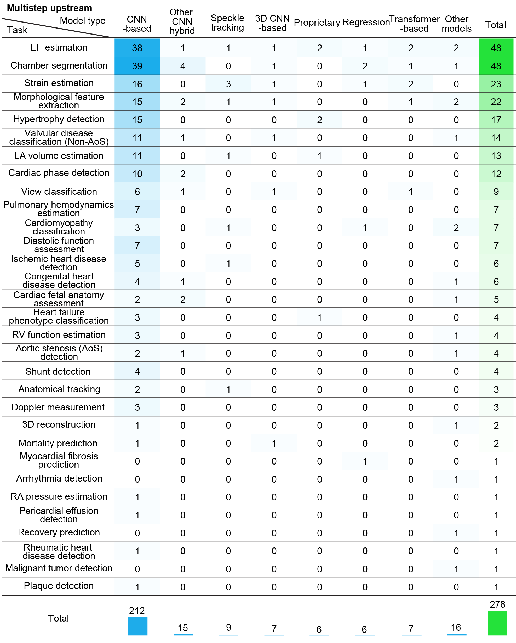
Online Resource 1 Heatmap of upstream model-task pairings in multistep frameworks, showing the distribution of clinical target tasks across upstream model groups. EF, LA, LV, AoS, and RV denote ejection fraction, left atrium, left ventricle, aortic stenosis, and right ventricle, respectively. Counts represent multistep target-task instances linked to the upstream model category of the primary pipeline, not unique studies. One study could contribute multiple target-task instances when multiple clinical tasks were reported. These target-task instances are concentrated on a limited set of tasks, including EF estimation, segmentation, strain estimation, morphological feature extraction, hypertrophy assessment, and valvular disease classification. These patterns indicate that tasks are primarily focused on anatomical and functional indices, reflecting the role of clinical intermediate representations derived within the multistep framework
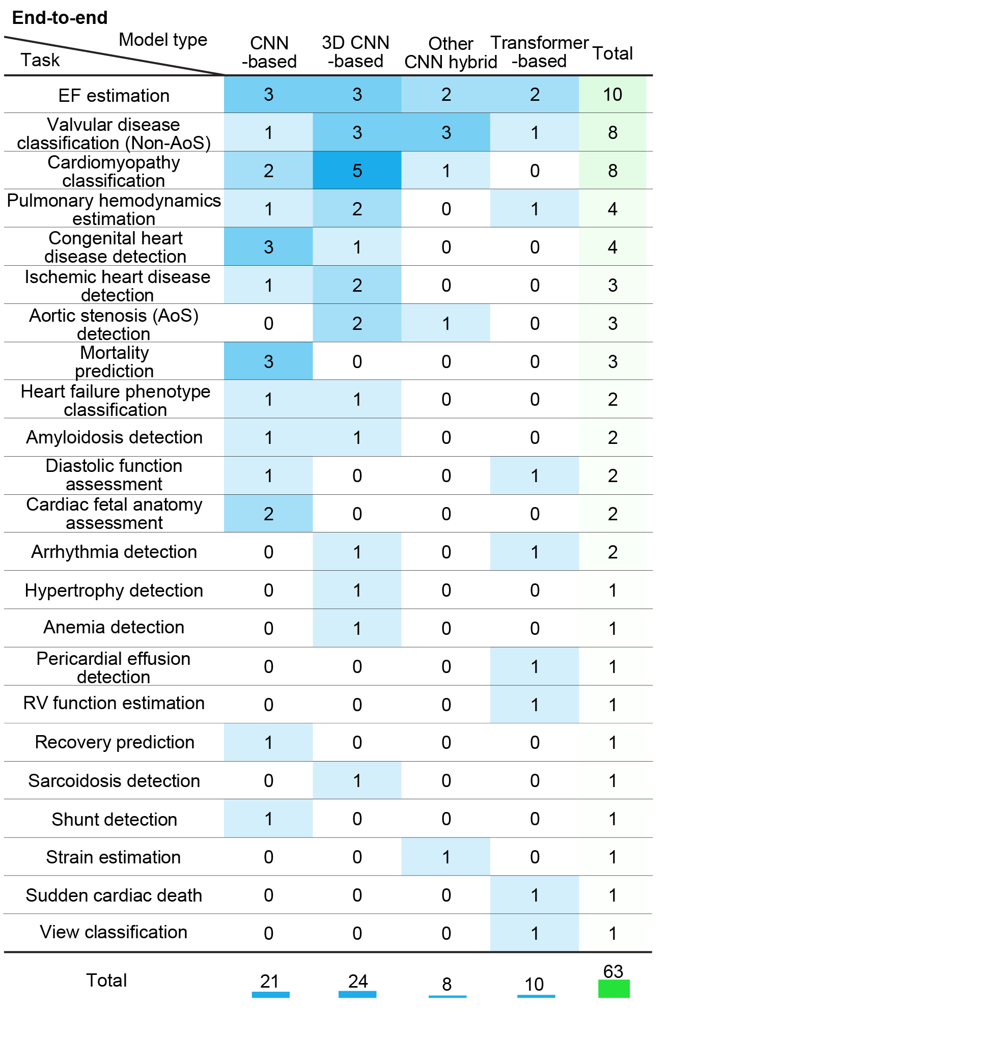
Online Resource 2 Heatmap of model-task pairings in end-to-end frameworks, showing the distribution of clinical target tasks across model groups. EF, AoS, and RV denote ejection fraction, aortic stenosis, and right ventricle, respectively. Counts represent end-to-end target-task instances, not unique studies. One study could contribute multiple target-task instances when multiple clinical tasks were reported. Approximately half of the end-to-end target-task instances are concentrated on EF estimation, valvular disease classification, cardiomyopathy classification, and pulmonary hemodynamics. In contrast to multistep frameworks, fewer tasks focus on anatomical parameters because clinical intermediate representations are not explicitly derived. Instead, there is a stronger emphasis on disease classification tasks, reflecting task selection aligned with the characteristics of the end-to-end framework

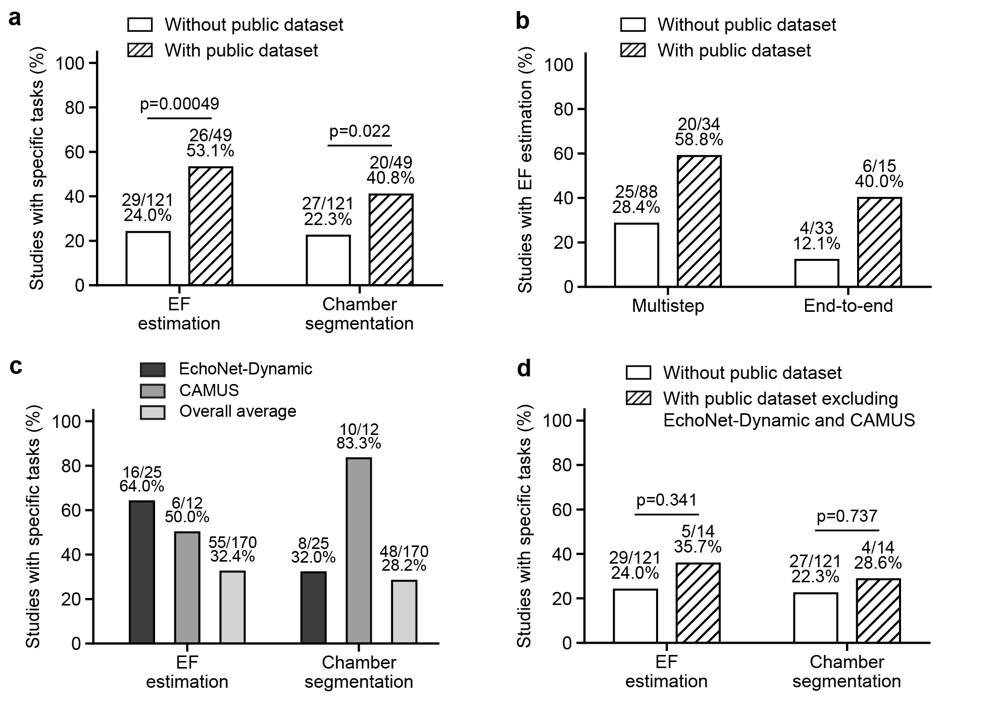
Online Resource 3 Public dataset use and concentration of EF estimation and chamber segmentation tasks. Association between public dataset use and task concentration for EF estimation and chamber segmentation. EF denotes ejection fraction. White bars indicate studies without public dataset use, and hatched bars indicate studies with public dataset use, except in (c), where grayscale bars indicate EchoNet-Dynamic, CAMUS, and the overall average. P values were calculated using Fisher’s exact test. Statistical significance was defined as p < 0.05.
(a) Across all studies, EF estimation and chamber segmentation were more frequent among studies using public datasets than among studies without public dataset use, and the differences were statistically significant for both tasks by Fisher’s exact test.
(b) Public dataset use was associated with a higher proportion of EF-estimation studies among both multistep and end-to-end studies.
(c) Task-specific public benchmark patterns showed enrichment of EF estimation in EchoNet-Dynamic studies and enrichment of chamber segmentation in CAMUS studies compared with the overall study average.
(d) After excluding studies using EchoNet-Dynamic or CAMUS, the association between public dataset use and EF estimation or chamber segmentation was attenuated and was not statistically significant by Fisher’s exact test

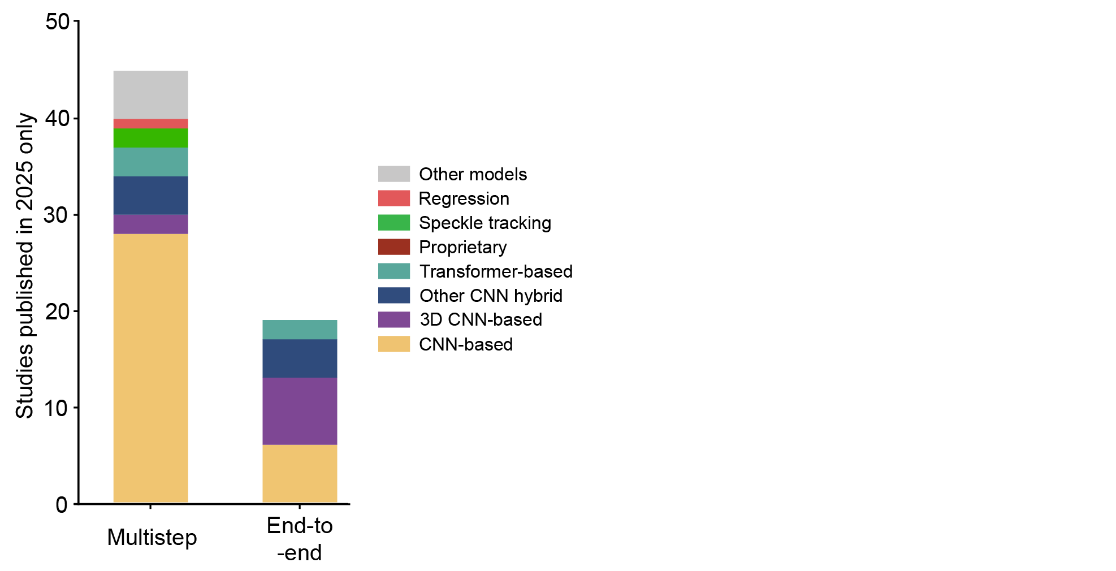
Online Resource 4 Bar chart showing the distribution of model groups in studies published in 2025, separated into multistep and end-to-end frameworks. Counts represent unique studies published in 2025, with one representative image-processing model assigned per study. Although a more pronounced increase in advanced architectures, such as 3D CNN-based, other CNN hybrid, and transformer-based models, is observed in the end-to-end framework, the overall distribution of this 2025 subset remains largely consistent with the temporal trends in Fig. 4, suggesting that these patterns are representative of recent developments
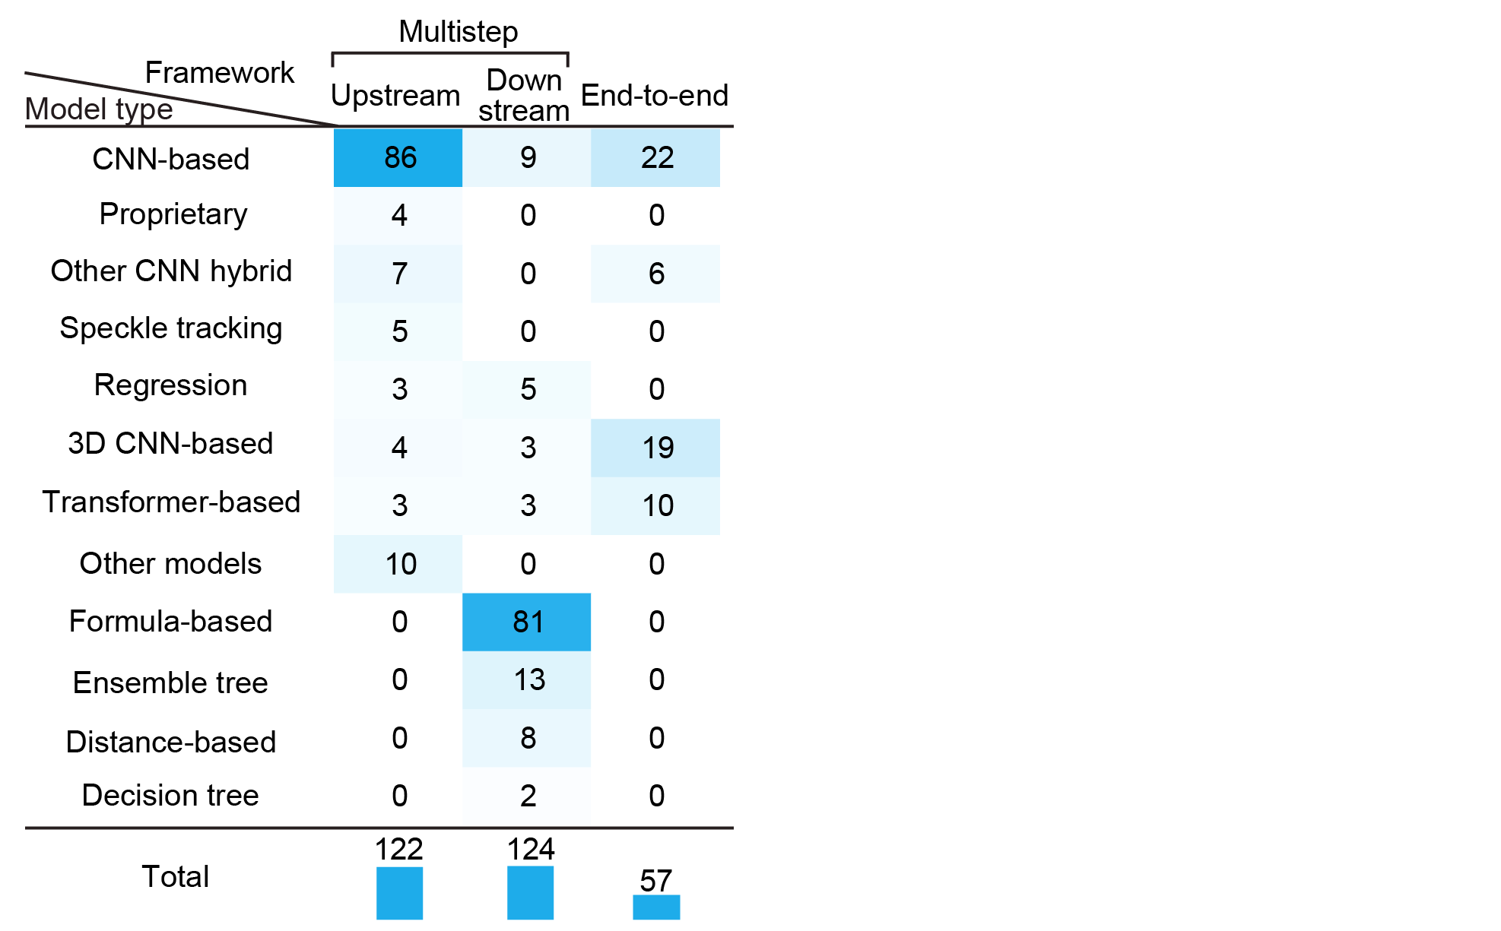
Online Resource 5 Summary of model-approach instance distribution heatmaps across multistep upstream, multistep downstream, and end-to-end analyses. Counts represent model-approach instances, not unique studies. CNN-based model-approach instances are the most commonly used in both multistep upstream and end-to-end analyses. In multistep downstream analyses, formula-based approaches are frequently employed, reflecting the design principle of preserving interpretability. In end-to-end analyses, the range of model types is more limited, yet advanced architectures, such as 3D CNN-based and transformer-based models, are relatively frequently used, suggesting that no clear standard has yet been established
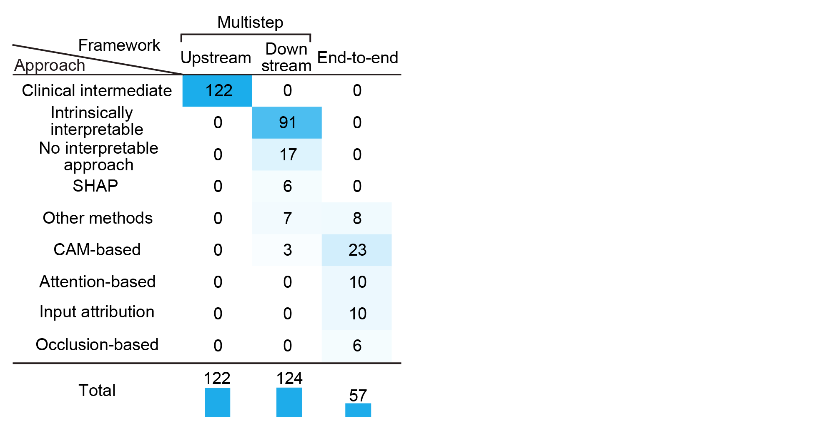
Online Resource 6 Summary of interpretable AI model approach distribution heatmaps across multistep upstream, multistep downstream, and end-to-end analyses. Counts represent model-approach instances, not unique studies. In multistep analyses, upstream components are represented by a single interpretable AI model approach, clinical intermediate, while downstream models predominantly rely on intrinsically interpretable approaches, consistent with the design principle of interpretability. In end-to-end analyses, a diverse range of post-hoc methods, including CAM-based, attention-based, input attribution, and occlusion-based approaches, is employed, suggesting that the flexibility of model design is accompanied by increased diversity in XAI strategies
Online Resource Table 1 Dataset accessibility, model-development status, and validation-related reporting among included echocardiography AI studies after final eligibility assessment. Each row represents one unique study, and all variables in this table are reported at the study level. Columns report author, year, title, direct human assessment status, dataset access type (private, public, or both), public dataset name(s), model development status, and whether internal splitting, patient-level splitting, and external validation were reported. Direct human assessment indicates whether a study included direct human evaluation of an AI-generated explanation or clinically interpretable output, representing the direct-assessment subtype of human-assessment-grounded evaluation defined in Table 1B. Public dataset names are provided only for Public or Both studies; the public dataset name field is marked N/A for Private studies. When no model development was performed, split-related fields were coded as N/A because there was no training process. External validation was assessed independently of model development. The year shown in the table and temporal analyses follows the source-database publication-date or publication-year field at the time of extraction; for online-first articles later assigned to a subsequent issue year, the final issue citation is retained in the reference list

Author | Year | Title | Direct human assessment | Private or Public | Dataset name | Model development | Internal split reported | Patient-level split reported | External validation
Stowell CC, et al. [1] | 2024 | 2-Dimensional Echocardiographic Global Longitudinal Strain With Artificial Intelligence Using Open Data From a UK-Wide Collaborative | No | Public | Unity Imaging Collaborative Open-Access Datasets for AI in Cardiology | Yes | Yes | Not reported | Yes
Laumer F, et al. [2] | 2025 | 2D echocardiography video to 3D heart shape reconstruction for clinical application | No | Both | Paper-specific public dataset | Yes | Yes | Not reported | Not reported
Gomez C, et al. [3] | 2025 | A cascade approach for the early detection and localization of myocardial infarction in 2D-echocardiography | No | Public | CAMUS; HMC-QU | Yes | Yes | Yes | Not reported
Rogstadkjernet M, et al. [4] | 2024 | A deep learning based method for left ventricular strain measurements: repeatability and accuracy compared to experienced echocardiographers | No | Both | CAMUS | Yes | Yes | Not reported | Not reported
Al-Alusi MA, et al. [5] | 2025 | A Deep Learning Model to Identify Mitral Valve Prolapse From the Echocardiogram | No | Private | N/A | Yes | Yes | Yes | Yes
Tromp J, et al. [6] | 2022 | A formal validation of a deep learning-based automated workflow for the interpretation of the echocardiogram | No | Private | N/A | No | N/A | N/A | Yes
Bouatmane A, et al. [7] | 2025 | A Hybrid Diffusion-VAE for High-Fidelity Tissue Doppler Imaging Augmentation in Cardiotoxicity Detection | No | Public | BC_cardiotox: A cardiotoxicity dataset for breast cancer patients | Yes | Yes | Yes | Not reported
Yang X, et al. [8] | 2024 | A Joint Mask-Augmented Adaptive Scale Alignment and Periodicity-Aware Method for Cardiac Function Assessment in Healthcare Consumer Electronics | No | Public | EchoNet-Dynamic | Yes | Yes | Not reported | Not reported
Ulloa Cerna AE, et al. [9] | 2025 | A Large-scale Multimodal Study for Predicting Mortality Risk Using Minimal and Low Parameter Models and Separable Risk Assessment | No | Private | N/A | Yes | Yes | Yes | Not reported
Zheng B, et al. [10] | 2025 | A machine learning model using echocardiographic myocardial strain to detect myocardial ischemia | No | Private | N/A | Yes | Yes | Yes | Not reported
Gül S, et al. [11] | 2025 | A Multimodular AI Algorithm for Automated Assessment of Left Ventricular Function in Ischemic Heart Disease: Ejection Fraction, Wall Motion, and Regional Myocardial Segmentation | No | Both | EchoNet-Dynamic | Yes | Yes | Not reported | Not reported
Tian Y, et al. [12] | 2021 | A Periodic Frame Learning Approach for Accurate Landmark Localization in M-Mode Echocardiography | No | Private | N/A | Yes | Yes | Not reported | Not reported
Reddy C, et al. [13] | 2025 | AI Learning for Pediatric Right Ventricular Assessment: Development and Validation Across Multiple Centers | No | Private | N/A | Yes | Yes | Not reported | Yes
Li Y, et al. [14] | 2024 | An Artificial Intelligence-Driven Approach for Automatic Evaluation of Right-to-Left Shunt Grades in Saline-Contrasted Transthoracic Echocardiography | No | Private | N/A | Yes | Yes | Yes | Yes
Wang W, et al. [15] | 2024 | An Automated Heart Shunt Recognition Pipeline Using Deep Neural Networks | No | Private | N/A | Yes | Yes | Not reported | Not reported
Sadeghpour A, et al. [16] | 2025 | An Automated Machine Learning–Based Quantitative Multiparametric Approach for Mitral Regurgitation Severity Grading | No | Private | N/A | Yes | Yes | Yes | Yes
Li X, et al. [17] | 2025 | An automatic and real-time echocardiography quality scoring system based on deep learning to improve reproducible assessment of left ventricular ejection fraction | No | Private | N/A | Yes | Yes | Not reported | Yes
Thorley A, et al. [18] | 2025 | Anatomically Constrained Transformers for Cardiac Amyloidosis Classification | No | Private | N/A | Yes | Yes | Yes | Not reported
Meredith T, et al. [19] | 2025 | Aortic valve leaflet motion for diagnosis and classification of aortic stenosis using single view echocardiography | No | Private | N/A | Yes | Yes | Not reported | Not reported
Sahashi Y, et al. [20] | 2025 | Artificial Intelligence Automation of Echocardiographic Measurements | Yes | Private | N/A | Yes | Yes | Yes | Yes
Kim R, et al. [21] | 2025 | Artificial intelligence based automatic classification, annotation, and measurement of the fetal heart using HeartAssist | Yes | Private | N/A | Yes | Yes | Not reported | Not reported
Zhang D, et al. [22] | 2025 | Artificial intelligence diagnosis and heatmap agent for mitral valve prolapse using 3D cine echocardiography | No | Private | N/A | Yes | Yes | Yes | Yes
Salehi M, et al. [23] | 2025 | Artificial intelligence-based echocardiography assessment to detect pulmonary hypertension | No | Private | N/A | No | N/A | N/A | Yes
Celestin B, et al. [24] | 2025 | Artificial Intelligence-Based Echocardiography in Pulmonary Arterial Hypertension | No | Private | N/A | No | N/A | N/A | Yes
Kuwahara A, et al. [25] | 2024 | Artificial intelligence-derived left ventricular strain in echocardiography in patients treated with chemotherapy | No | Private | N/A | No | N/A | N/A | Yes
Moon I, et al. [26] | 2025 | Artificial Intelligence-Enhanced Analysis of Echocardiography-Based Radiomic Features for Myocardial Hypertrophy Detection and Etiology Differentiation | No | Private | N/A | Yes | Yes | Yes | Yes
Jeong D, et al. [27] | 2024 | Artificial intelligence-enhanced automation for M-mode echocardiographic analysis: ensuring fully automated, reliable, and reproducible measurements | No | Private | N/A | Yes | Yes | Not reported | Yes
Park J, et al. [28] | 2025 | Artificial intelligence-enhanced comprehensive assessment of the aortic valve stenosis continuum in echocardiography | No | Private | N/A | Yes | Yes | Yes | Yes
Qin S, et al. [29] | 2025 | Artificial intelligence-enhanced three-dimensional echocardiography reveals left atrial-ventricular coupling index as a novel prognostic marker in coronary artery disease | No | Private | N/A | Yes | Not reported | Not reported | Not reported
Oikonomou EK, et al. [30] | 2025 | Artificial intelligence-guided detection of under-recognised cardiomyopathies on point-of-care cardiac ultrasonography: a multicentre study | No | Private | N/A | Yes | Yes | Yes | Yes
Oo MM, et al. [31] | 2024 | Artificial intelligence‐assisted automated heart failure detection and classification from electronic health records | No | Private | N/A | No | N/A | N/A | Yes
Chen X, et al. [32] | 2023 | Artificial Intelligence–Assisted Left Ventricular Diastolic Function Assessment and Grading: Multiview Versus Single View | No | Private | N/A | Yes | Yes | Not reported | Yes
Laumer F, et al. [33] | 2022 | Assessment of Artificial Intelligence in Echocardiography Diagnostics in Differentiating Takotsubo Syndrome From Myocardial Infarction | No | Private | N/A | Yes | Yes | Yes | Yes
Yim J, et al. [34] | 2024 | Assessment of left ventricular wall thickness and dimension: accuracy of a deep learning model with prediction uncertainty | No | Private | N/A | Yes | Yes | Yes | Not reported
Wang J, et al. [35] | 2022 | Assessment of Transcatheter or Surgical Closure of Atrial Septal Defect using Interpretable Deep Keypoint Stadiometry | No | Private | N/A | Yes | Yes | Yes | Yes
Liu Y, et al. [36] | 2024 | Atrial Septal Defect Detection in Children Based on Ultrasound Video Using Multiple Instances Learning | No | Private | N/A | Yes | Yes | Yes | Not reported
Pellikka PA, et al. [37] | 2022 | Automated analysis of limited echocardiograms: Feasibility and relationship to outcomes in COVID-19 | No | Private | N/A | No | N/A | N/A | Yes
Binder C, et al. [38] | 2025 | Automated Aortic Regurgitation Detection and Quantification: A Deep Learning Approach Using Multi-View Echocardiography | No | Private | N/A | Yes | Yes | Yes | Yes
Lu N, et al. [39] | 2024 | Automated Atrial Fibrillation Diagnosis by Echocardiography without ECG: Accuracy and Applications of a New Deep Learning Approach | No | Private | N/A | Yes | Yes | Yes | Not reported
Michel H, et al. [40] | 2025 | Automated detection of neonatal pulmonary hypertension in echocardiograms with a deep learning model | No | Private | N/A | Yes | Yes | Yes | Not reported
Akerman AP, et al. [41] | 2023 | Automated Echocardiographic Detection of Heart Failure With Preserved Ejection Fraction Using Artificial Intelligence | No | Private | N/A | Yes | Yes | Yes | Yes
Upton R, et al. [42] | 2022 | Automated Echocardiographic Detection of Severe Coronary Artery Disease Using Artificial Intelligence | No | Private | N/A | Yes | Yes | Not reported | Yes
Wang J, et al. [43] | 2021 | Automated interpretation of congenital heart disease from multi-view echocardiograms | No | Private | N/A | Yes | Yes | Yes | Not reported
Tromp J, et al. [44] | 2022 | Automated interpretation of systolic and diastolic function on the echocardiogram: a multicohort study | No | Both | EchoNet-Dynamic | Yes | Yes | Yes | Yes
Farhad M, et al. [45] | 2024 | Automated LVH Grading: Integration of Deep Learning and Explainable AI for Accurate Diagnosis | No | Private | N/A | Yes | Yes | Not reported | Not reported
Jevsikov J, et al. [46] | 2024 | Automated mitral inflow Doppler peak velocity measurement using deep learning | No | Both | IntSaV Doppler dataset | Yes | Yes | Not reported | Yes
Loncaric F, et al. [47] | 2021 | Automated Pattern Recognition in Whole-Cardiac Cycle Echocardiographic Data: Capturing Functional Phenotypes with Machine Learning | No | Private | N/A | Yes | Not reported | Not reported | Not reported
Volpato V, et al. [48] | 2019 | Automated, machine learning‐based, 3D echocardiographic quantification of left ventricular mass | No | Private | N/A | No | N/A | N/A | Yes
Nurmaini S, et al. [49] | 2023 | Automatic echocardiographic anomalies interpretation using a stacked residual-dense network model | No | Public | Echo-Infant | Yes | Yes | Yes | Not reported
Olaisen S, et al. [50] | 2024 | Automatic measurements of left ventricular volumes and ejection fraction by artificial intelligence: clinical validation in real time and large databases | Yes | Both | CAMUS | Yes | Yes | Yes | Yes
Vafaeezadeh M, et al. [51] | 2022 | Automatic morphological classification of mitral valve diseases in echocardiographic images based on explainable deep learning methods | No | Private | N/A | Yes | Yes | Yes | Not reported
Bang HJ, et al. [52] | 2025 | Automatic quantitative analysis of atherosclerotic aortic plaques in patients with embolic cerebral infarction using deep learning | No | Private | N/A | Yes | Yes | Yes | Yes
Huang J, et al. [53] | 2023 | Automatic Segmentation and Assessment of Valvular Regurgitations with Color Doppler Echocardiography Images: A VABC-UNet-Based Framework | No | Private | N/A | Yes | Yes | Not reported | Not reported
Liu G, et al. [54] | 2024 | Automatic Segmentation and Evaluation of Mitral Regurgitation Using Doppler Echocardiographic Images | No | Private | N/A | Yes | Yes | Not reported | Not reported
Tan W, et al. [55] | 2023 | Bayesian Inference and Dynamic Neural Feedback Promote the Clinical Application of Intelligent Congenital Heart Disease Diagnosis | No | Private | N/A | Yes | Yes | Yes | Yes
He B, et al. [56] | 2023 | Blinded, randomized trial of sonographer versus AI cardiac function assessment | Yes | Both | EchoNet-Dynamic | No | N/A | N/A | Yes
Zhao Y, et al. [57] | 2025 | Block Matching Based Speckle Tracking Echocardiography: Clinical Applications and Research Outlook in a Deep Learning Context | Yes | Private | N/A | No | N/A | N/A | Yes
Shen C, et al. [58] | 2025 | CardiacField: computational echocardiography for automated heart function estimation using two-dimensional echocardiography probes | No | Public | CardiacField GitHub repository | Yes | Not reported | Not reported | Not reported
Vafaeezadeh M, et al. [59] | 2023 | CarpNet: Transformer for mitral valve disease classification in echocardiographic videos | No | Private | N/A | Yes | Yes | Yes | Not reported
Sun D, et al. [60] | 2024 | Chamber Attention Network (CAN): Towards interpretable diagnosis of pulmonary artery hypertension using echocardiography | No | Private | N/A | Yes | Yes | Not reported | Yes
Sanchez-Martinez S, et al. [61] | 2017 | Characterization of myocardial motion patterns by unsupervised multiple kernel learning | No | Private | N/A | Yes | Not reported | Not reported | Not reported
Huang H, et al. [62] | 2025 | Classification of mitral regurgitation in echocardiography based on deep learning methods | No | Private | N/A | Yes | Yes | Not reported | Not reported
Carneiro G, et al. [63] | 2013 | Combining Multiple Dynamic Models and Deep Learning Architectures for Tracking the Left Ventricle Endocardium in Ultrasound Data | No | Private | N/A | Yes | Yes | Yes | Not reported
Sheikh M, et al. [64] | 2024 | Comparing HeartModelAI and cardiac magnetic resonance imaging for left ventricular volume and function evaluation in patients with dilated cardiomyopathy | No | Private | N/A | No | N/A | N/A | Yes
Vukadinovic M, et al. [65] | 2025 | Comprehensive echocardiogram evaluation with view primed vision language AI | No | Both | MIMIC-IV-ECHO | Yes | Yes | Yes | Yes
Yu J, et al. [66] | 2024 | Continuous monitoring of left ventricular function in postoperative intensive care patients using artificial intelligence and transesophageal echocardiography | No | Private | N/A | No | N/A | N/A | Yes
Jafari MH, et al. [67] | 2021 | Deep Bayesian Image Segmentation for a More Robust Ejection Fraction Estimation | No | Private | N/A | Yes | Yes | Yes | Not reported
Katsushika S, et al. [68] | 2022 | Deep Learning Algorithm to Detect Cardiac Sarcoidosis From Echocardiographic Movies | No | Both | EchoNet-Dynamic | Yes | Yes | Yes | Not reported
Kusunose K, et al. [69] | 2023 | Deep learning approach for analyzing chest x-rays to predict cardiac events in heart failure | No | Private | N/A | No | N/A | N/A | Yes
Nova R, et al. [70] | 2025 | Deep Learning Approach for Predicting Cardiac Septal Defects Using Echocardiography | No | Private | N/A | Yes | Yes | Not reported | Not reported
Mor-Avi V, et al. [71] | 2023 | Deep learning assisted measurement of echocardiographic left heart parameters: improvement in interobserver variability and workflow efficiency | Yes | Private | N/A | Yes | Yes | Not reported | Yes
Ragnarsdottir H, et al. [72] | 2024 | Deep Learning Based Prediction of Pulmonary Hypertension in Newborns Using Echocardiograms | No | Private | N/A | Yes | Yes | Yes | Not reported
Hughes JW, et al. [73] | 2021 | Deep learning evaluation of biomarkers from echocardiogram videos | No | Private | N/A | Yes | Yes | Yes | Yes
Zha SZ, et al. [74] | 2023 | Deep learning for automated left ventricular outflow tract diameter measurements in 2D echocardiography | No | Private | N/A | Yes | Yes | Yes | Not reported
Davi S, et al. [75] | 2025 | Deep Learning for Early Detection of Cardiovascular Diseases From Medical Imaging | No | Public | EchoNet-Dynamic | Yes | Yes | Not reported | Not reported
Salte IM, et al. [76] | 2023 | Deep Learning for Improved Precision and Reproducibility of Left Ventricular Strain in Echocardiography: A Test-Retest Study | No | Private | N/A | No | N/A | N/A | Yes
Zaman F, et al. [77] | 2024 | Deep learning from atrioventricular plane displacement in patients with Takotsubo syndrome: lighting up the black-box | No | Private | N/A | No | N/A | N/A | Not reported
Ghorbani A, et al. [78] | 2020 | Deep learning interpretation of echocardiograms | No | Private | N/A | Yes | Yes | Yes | Not reported
Tveten IE, et al. [79] | 2025 | Deep Learning Segmentation and Quantification of the Left Ventricle from the Parasternal Short-Axis View in Echocardiography | No | Private | N/A | Yes | Yes | Yes | Not reported
Yang F, et al. [80] | 2025 | Deep learning-assisted aortic stenosis detection and grading based on multiview versus single-view echocardiography | No | Private | N/A | Yes | Yes | Not reported | Yes
Liu X, et al. [81] | 2021 | Deep learning-based automated left ventricular ejection fraction assessment using 2-D echocardiography | No | Both | EchoNet-Dynamic; CAMUS | Yes | Yes | Yes | Yes
Kwan AC, et al. [82] | 2024 | Deep Learning-Derived Myocardial Strain | No | Both | EchoNet-Dynamic | Yes | Yes | Yes | Yes
Karužas A, et al. [83] | 2025 | Deep Learning‐Driven Automated Assessment of Left Ventricular Diastolic Function in Echocardiography | No | Private | N/A | No | N/A | N/A | Yes
Ulloa Cerna AE, et al. [84] | 2021 | Deep-learning-assisted analysis of echocardiographic videos improves predictions of all-cause mortality | No | Private | N/A | Yes | Yes | Yes | Yes
Borja MG, et al. [85] | 2024 | Deriving phenotype-representative left ventricular flow patterns by reduced-order modeling and classification | No | Private | N/A | Yes | Yes | Yes | Not reported
Hernandez-Cruz N, et al. [86] | 2024 | Detection of fetal congenital heart defects on three-vessel view ultrasound videos | No | Private | N/A | Yes | Yes | Not reported | Not reported
Cheng CY, et al. [87] | 2023 | Development and validation of a deep learning pipeline to measure pericardial effusion in echocardiography | No | Private | N/A | Yes | Yes | Yes | Yes
Bao Y, et al. [88] | 2025 | Development and validation of a novel echocardiography-based nomogram for the streamlined classification of cardiac tumors in cancer patients | No | Private | N/A | Yes | Yes | Not reported | Not reported
Valsaraj A, et al. [89] | 2023 | Development and validation of echocardiography-based machine-learning models to predict mortality | No | Private | N/A | Yes | Yes | Yes | Yes
Wrzosek M, et al. [90] | 2025 | Diagnosing Severe Low-Gradient vs Moderate Aortic Stenosis with Artificial Intelligence Based on Echocardiography Images | No | Public | EchoNet-Dynamic | Yes | Yes | Not reported | Not reported
Jian Z, et al. [91] | 2020 | Diagnosis of left ventricular hypertrophy using convolutional neural network | No | Private | N/A | Yes | Not reported | Not reported | Not reported
Sengan S, et al. [92] | 2022 | Echocardiographic Image Segmentation for Diagnosing Fetal Cardiac Rhabdomyoma During Pregnancy Using Deep Learning | No | Private | N/A | Yes | Yes | Not reported | Not reported
Liang G, et al. [93] | 2025 | Echocardiographic Texture Analysis Using Machine Learning for Predicting Myocardial Fibrosis in Hypertrophic Cardiomyopathy | No | Private | N/A | Yes | Yes | Yes | Not reported
Lin X, et al. [94] | 2022 | Echocardiography-based AI detection of regional wall motion abnormalities and quantification of cardiac function in myocardial infarction | No | Private | N/A | Yes | Yes | Not reported | Yes
Lin X, et al. [95] | 2023 | Echocardiography-based AI for detection and quantification of atrial septal defect | No | Private | N/A | Yes | Not reported | Not reported | Yes
Chao C, et al. [96] | 2024 | Echocardiography-Based Deep Learning Model to Differentiate Constrictive Pericarditis and Restrictive Cardiomyopathy | No | Private | N/A | Yes | Yes | Yes | Yes
Mokhtari M, et al. [97] | 2023 | EchoGNN: Explainable Ejection Fraction Estimation with Graph Neural Networks | No | Public | EchoNet-Dynamic | Yes | Yes | Yes | Not reported
Thomas S, et al. [98] | 2024 | EchoNarrator: Generating Natural Text Explanations for Ejection Fraction Predictions | No | Public | EchoNet-Dynamic | Yes | Yes | Yes | Not reported
Kumar KA, et al. [99] | 2025 | Echovision AI-Predictive Deep Learning for Cardiovascular Diagnostics | No | Public | EchoNet-Dynamic | Yes | Not reported | Not reported | Not reported
Roshanitabrizi P, et al. [100] | 2025 | End-to-End Spatiotemporal Analysis of Color Doppler Echocardiograms: Application for Rheumatic Heart Disease Detection | No | Private | N/A | Yes | Yes | Not reported | Yes
Deepika S, et al. [101] | 2025 | Enhanced Heart Disease Classification Using Dual Attention Mechanisms and 3D-Echo Fusion Algorithm in Echocardiogram Videos | No | Private | N/A | Yes | Yes | Not reported | Not reported
Huang D, et al. [102] | 2024 | Enhancing Prediction of Myocardial Recovery After Coronary Revascularization: Integrating Radiomics from Myocardial Contrast Echocardiography with Machine Learning | No | Private | N/A | Yes | Yes | Yes | Not reported
Taskén AA, et al. [103] | 2025 | Estimation of Segmental Longitudinal Strain in Transesophageal Echocardiography by Deep Learning | No | Private | N/A | Yes | Yes | Not reported | Not reported
Yu J, et al. [104] | 2024 | Explainable and Controllable Motion Curve Guided Cardiac Ultrasound Video Generation | No | Both | EchoNet-Dynamic | Yes | Yes | Not reported | Not reported
Lee S, et al. [105] | 2025 | Explainable Integrative Bipartite Graph Convolutional Neural Network for Predicting Ejection Fraction in Echocardiography | No | Public | EchoNet-Pediatric | Yes | Yes | Not reported | Not reported
Moal O, et al. [106] | 2022 | Explicit and automatic ejection fraction assessment on 2D cardiac ultrasound with a deep learning-based approach | No | Both | CAMUS | Yes | Yes | Yes | Yes
Majchrowska S, et al. [107] | 2025 | Exploring interpretable echo analysis using self-supervised parcels | No | Public | EchoNet-Dynamic; CAMUS | Yes | Yes | Not reported | Not reported
Peng G, et al. [108] | 2025 | Formal validation of a deep learning-based automated interpretation system for cardiac structure and function in adult echocardiography | No | Private | N/A | Yes | Yes | Yes | Yes
Krishna H, et al. [109] | 2023 | Fully Automated Artificial Intelligence Assessment of Aortic Stenosis by Echocardiography | No | Public | EchoNet-Dynamic | No | N/A | N/A | Yes
Zhang J, et al. [110] | 2018 | Fully Automated Echocardiogram Interpretation in Clinical Practice | No | Private | N/A | Yes | Yes | Not reported | Yes
Sveric KM, et al. [111] | 2025 | Fully Automatic AI-Based Quantification of LV Mass in Echocardiography: A Multimodality Validation | No | Private | N/A | No | N/A | N/A | Yes
Painchaud N, et al. [112] | 2025 | Fusing Echocardiography Images and Medical Records for Continuous Patient Stratification | No | Private | N/A | Yes | Yes | Yes | Not reported
Mokhtari M, et al. [113] | 2023 | GEMTrans: A General, Echocardiography-Based, Multi-level Transformer Framework for Cardiovascular Diagnosis | No | Private | N/A | Yes | Yes | Not reported | Not reported
Sarker MMK, et al. [114] | 2025 | HarmonicEchoNet: Leveraging harmonic convolutions for automated standard plane detection in fetal heart ultrasound videos | Yes | Private | N/A | Yes | Yes | Not reported | Not reported
Almadani A [115] | 2025 | HCM-Echo-VAR-Ensemble: Deep Ensemble Fusion to Detect Hypertrophic Cardiomyopathy in Echocardiograms | No | Both | EchoNet-Dynamic | Yes | Yes | Not reported | Not reported
Sveric KM, et al. [116] | 2024 | Improved assessment of left ventricular ejection fraction using artificial intelligence in echocardiography: A comparative analysis with cardiac magnetic resonance imaging | No | Private | N/A | No | N/A | N/A | Yes
Patra A, et al. [117] | 2020 | Incremental Learning of Fetal Heart Anatomies Using Interpretable Saliency Maps | No | Private | N/A | Yes | Yes | Not reported | Not reported
Lafitte S, et al. [118] | 2025 | Integrating artificial intelligence into an echocardiography department: Feasibility and comparative study of automated versus human measurements in a high-volume clinical setting | No | Private | N/A | No | N/A | N/A | Yes
Duffy G, et al. [119] | 2022 | Interpretable deep learning prediction of 3d assessment of cardiac function | No | Public | EchoNet-Dynamic | Yes | Yes | Yes | Not reported
Belfilali H, et al. [120] | 2022 | Left ventricle analysis in echocardiographic images using transfer learning | No | Public | CAMUS | Yes | Yes | Yes | Not reported
Huang K, et al. [121] | 2024 | Left Ventricular Segmentation, Warping, and Myocardial Registration for Automated Strain Measurement | No | Private | N/A | Yes | Yes | Yes | Yes
Duffy G, et al. [122] | 2024 | Leveraging 3D Echocardiograms to Evaluate AI Model Performance in Predicting Cardiac Function on Out-of-Distribution Data | No | Private | N/A | Yes | Yes | Not reported | Not reported
Sriram S, et al. [123] | 2025 | Leveraging Advanced Preprocessing and CNN for Mortality and Rehospitalization Prediction in Heart Failure Patients | No | Public | EchoNet-Dynamic; MIMIC-III | Yes | Yes | Not reported | Yes
Muldoon M, et al. [124] | 2023 | Lightweight and Interpretable Left Ventricular Ejection Fraction Estimation Using Mobile U-Net | No | Public | EchoNet-Dynamic | Yes | Yes | Not reported | Not reported
Leclerc S, et al. [125] | 2020 | LU-Net: A Multistage Attention Network to Improve the Robustness of Segmentation of Left Ventricular Structures in 2-D Echocardiography | No | Public | CAMUS | Yes | Yes | Not reported | Not reported
Narang A, et al. [126] | 2019 | Machine learning based automated dynamic quantification of left heart chamber volumes | No | Private | N/A | No | N/A | N/A | Yes
Damen FW, et al. [127] | 2021 | Machine Learning Driven Contouring of High-Frequency Four-Dimensional Cardiac Ultrasound Data | No | Private | N/A | Yes | Yes | Not reported | Not reported
Genovese D, et al. [128] | 2019 | Machine Learning–Based Three-Dimensional Echocardiographic Quantification of Right Ventricular Size and Function: Validation Against Cardiac Magnetic Resonance | Yes | Private | N/A | No | N/A | N/A | Yes
Narula S, et al. [129] | 2016 | Machine-Learning Algorithms to Automate Morphological and Functional Assessments in 2D Echocardiography | No | Private | N/A | Yes | Yes | Yes | Not reported
Shaikh F, et al. [130] | 2022 | Measuring the accuracy of cardiac output using POCUS: the introduction of artificial intelligence into routine care | No | Private | N/A | No | N/A | N/A | Yes
Lagopoulos A, et al. [131] | 2022 | Measuring the Left Ventricular Ejection Fraction using Geometric Features | No | Public | EchoNet-Dynamic | Yes | Yes | Not reported | Not reported
Wifstad SV, et al. [132] | 2024 | Mitral Valve Segmentation and Tracking from Transthoracic Echocardiography Using Deep Learning | No | Private | N/A | Yes | Yes | Yes | Not reported
Evain E, et al. [133] | 2022 | Motion Estimation by Deep Learning in 2D Echocardiography: Synthetic Dataset and Validation | No | Both | CAMUS | Yes | Yes | Not reported | Yes
Wu V, et al. [134] | 2025 | MultiASNet: Multimodal Label Noise Robust Framework for the Classification of Aortic Stenosis in Echocardiography | No | Public | TMED-2 | Yes | Yes | Yes | Yes
Lai C, et al. [135] | 2025 | Multimodal AI to forecast arrhythmic death in hypertrophic cardiomyopathy | No | Private | N/A | Yes | Yes | Yes | Yes
Soto JT, et al. [136] | 2022 | Multimodal deep learning enhances diagnostic precision in left ventricular hypertrophy | No | Private | N/A | Yes | Yes | Yes | Yes
Goto S, et al. [137] | 2022 | Multinational Federated Learning Approach to Train ECG and Echocardiogram Models for Hypertrophic Cardiomyopathy Detection | No | Private | N/A | Yes | Yes | Yes | Yes
Deng Y, et al. [138] | 2022 | Myocardial strain analysis of echocardiography based on deep learning | No | Private | N/A | Yes | Not reported | Not reported | Yes
Tromp J, et al. [139] | 2024 | Nurse-led home-based detection of cardiac dysfunction by ultrasound: results of the CUMIN pilot study | No | Private | N/A | No | N/A | N/A | Yes
Dong J, et al. [140] | 2025 | Personalized echocardiographic segmentation via bidirectional encoder representations from transformers Y-shaped network with patient attributes | No | Public | CAMUS | Yes | Yes | Yes | Not reported
Gu AN, et al. [141] | 2025 | ProtoASNet: Comprehensive evaluation and enhanced performance with uncertainty estimation for aortic stenosis classification in echocardiography | No | Public | TMED-2 | Yes | Yes | Yes | Not reported
Kim YH, et al. [142] | 2025 | Quantification of left ventricular mass in multiple views of echocardiograms using model-agnostic meta learning in a few-shot setting | No | Public | CAMUS; TMED-2; EchoNet-LVH | Yes | Yes | Yes | Not reported
Varriano G, et al. [143] | 2025 | Radiomic analysis to predict arrhythmias in athletes by echocardiography: Artificial intelligence vs. formal methods | No | Private | N/A | Yes | Yes | Not reported | Not reported
Ahmadi M, et al. [144] | 2025 | Radiomics early assessment of post chemotherapy cardiotoxicity in cancer patients using 2D echocardiography imaging an interpretable machine learning study | No | Private | N/A | Yes | Yes | Not reported | Not reported
Tseng CH, et al. [145] | 2024 | Real-Time Automatic M-Mode Echocardiography Measurement With Panel Attention | No | Public | MEIS: M-mode Echocardiograms for Instance Segmentation | Yes | Yes | Not reported | Not reported
Zamzmi G, et al. [146] | 2022 | Real-time echocardiography image analysis and quantification of cardiac indices | No | Both | EchoNet-Dynamic | Yes | Yes | Not reported | Yes
Hirata Y, et al. [147] | 2024 | Reducing echocardiographic examination time through routine use of fully automated software: a comparative study of measurement and report creation time | Yes | Private | N/A | No | N/A | N/A | Not reported
Cheng L, et al. [148] | 2022 | Revealing Unforeseen Diagnostic Image Features With Deep Learning by Detecting Cardiovascular Diseases From Apical 4‐Chamber Ultrasounds | No | Private | N/A | Yes | Yes | Not reported | Not reported
Taksøe-Vester CA, et al. [149] | 2024 | Role of artificial-intelligence-assisted automated cardiac biometrics in prenatal screening for coarctation of aorta | Yes | Private | N/A | Yes | Yes | Yes | Not reported
Holste G, et al. [150] | 2023 | Severe aortic stenosis detection by deep learning applied to echocardiography | No | Private | N/A | Yes | Yes | Yes | Yes
Zhou SK, et al. [151] | 2010 | Shape regression machine and efficient segmentation of left ventricle endocardium from 2D B-mode echocardiogram | No | Private | N/A | Yes | Yes | Not reported | Not reported
Sveric KM, et al. [152] | 2023 | Single-Site Experience with an Automated Artificial Intelligence Application for Left Ventricular Ejection Fraction Measurement in Echocardiography | No | Private | N/A | No | N/A | N/A | Yes
Malins JG, et al. [153] | 2025 | Snapshot artificial intelligence—determination of ejection fraction from a single frame still image: a multi-institutional, retrospective model development and validation study | No | Both | EchoNet-Dynamic | Yes | Yes | Yes | Yes
Zaman F, et al. [154] | 2021 | Spatio-temporal hybrid neural networks reduce erroneous human “judgement calls” in the diagnosis of Takotsubo syndrome | No | Private | N/A | Yes | Yes | Not reported | Yes
Hsu C, et al. [155] | 2025 | Spatiotemporal feature disentanglement for quality surveillance of left ventricular echocardiographic video using ST-R(2 + 1)D-ConvNeXt | No | Both | EchoNet-Dynamic | Yes | Yes | Yes | Not reported
Er YA, et al. [156] | 2025 | Spatiotemporal XAI: Explaining video regression models in echocardiography videos for ejection fraction prediction | No | Public | EchoNet-Dynamic | Yes | Yes | Yes | Not reported
Qiao S, et al. [157] | 2024 | SPReCHD: Four-Chamber Semantic Parsing Network for Recognizing Fetal Congenital Heart Disease in Medical Metaverse | No | Private | N/A | Yes | Yes | Not reported | Not reported
Azad MA, et al. [158] | 2025 | Taming Modern Point Tracking for Speckle Tracking Echocardiography via Impartial Motion | No | Private | N/A | Yes | Not reported | Not reported | Yes
Woelfert A, et al. [159] | 2025 | The impact of heart rate on echocardiographic measures of left ventricular function: novel insights facilitated by deep learning | No | Private | N/A | No | N/A | N/A | Not reported
Naser N, et al. [160] | 2022 | The Reliability of Automated Three-Dimensional Echocardiography-HeartModelA.I. Versus 2D Echocardiography Simpson Methods in Evaluation of Left Ventricle Volumes and Ejection Fraction in Patients With Left Ventricular Dysfunction | No | Private | N/A | No | N/A | N/A | Yes
Sveric KM, et al. [161] | 2024 | The role of artificial intelligence in standardizing global longitudinal strain measurements in echocardiography | No | Private | N/A | No | N/A | N/A | Not reported
Corona S, et al. [162] | 2025 | Towards standardizing mitral transcatheter edge-to-edge repair with deep-learning algorithm: a comprehensive multi-model strategy | No | Both | MVSEG2023 | Yes | Yes | Not reported | Yes
Ahmadi N, et al. [163] | 2024 | Transformer-Based Spatio-Temporal Analysis for Classification of Aortic Stenosis Severity From Echocardiography Cine Series | No | Both | TMED-2 | Yes | Yes | Not reported | Yes
Jamthikar AD, et al. [164] | 2025 | Ultrasonic Texture Analysis for Predicting Acute Myocardial Infarction | No | Both | MIMIC-IV-ECHO; HMC-QU | Yes | Yes | Yes | Yes
Jin C, et al. [165] | 2016 | Using Anatomic Intelligence to Localize Mitral Valve Prolapse on Three-Dimensional Echocardiography | Yes | Private | N/A | No | N/A | N/A | Yes
Brown K, et al. [166] | 2024 | Using Artificial Intelligence for Rheumatic Heart Disease Detection by Echocardiography: Focus on Mitral Regurgitation | No | Private | N/A | Yes | Yes | Yes | Not reported
Wouters L, et al. [167] | 2025 | Utilizing CNNs on shear wave M-mode data to differentiate cardiac patients from healthy volunteers | No | Private | N/A | Yes | Yes | Yes | Not reported
Luong CL, et al. [168] | 2024 | Validation of machine learning models for estimation of left ventricular ejection fraction on point-of-care ultrasound: insights on features that impact performance | No | Private | N/A | No | N/A | N/A | Not reported
Huang K, et al. [169] | 2025 | Video Transformer for Segmentation of Echocardiography Images in Myocardial Strain Measurement | No | Both | CAMUS | Yes | Yes | Not reported | Not reported
Christensen M, et al. [170] | 2024 | Vision–language foundation model for echocardiogram interpretation | No | Public | EchoNet-Dynamic | Yes | Yes | Yes | Yes

References
1. Stowell CC, Howard JP, Ng T, Cole GD, Bhattacharyya S, Sehmi J, Alzetani M, Demetrescu CD, Hartley A, Singh A, Ghosh A, Vimalesvaran K, Mangion K, Rajani R, Rana BS, Zolgharni M, Francis DP, Shun-Shin MJ (2024) 2-Dimensional Echocardiographic Global Longitudinal Strain With Artificial Intelligence Using Open Data From a UK-Wide Collaborative. JACC Cardiovasc Imaging 17:865–876. https://doi.org/10.1016/j.jcmg.2024.04.017
2. Laumer F, Rubi L, Matter MA, Buoso S, Fringeli G, Mach F, Ruschitzka F, Buhmann JM, Matter CM (2025) 2D echocardiography video to 3D heart shape reconstruction for clinical application. Med Image Anal 101:103434. https://doi.org/10.1016/j.media.2024.103434
3. Gomez C, Letizia A, Tufano V, Molinari F, Salvi M (2025) A cascade approach for the early detection and localization of myocardial infarction in 2D-echocardiography. Med Eng Phys 143:104400. https://doi.org/10.1016/j.medengphy.2025.104400
4. Rogstadkjernet M, Zha S, Klæboe L, Larsen C, Aalen J, Scheirlynck E, Singstad B, Droogmans S, Cosyns B, Smiseth O, Haugaa K, Edvardsen T, Samset E, Brekke P (2024) A deep learning based method for left ventricular strain measurements: repeatability and accuracy compared to experienced echocardiographers. BMC Med Imaging. https://doi.org/10.1186/s12880-024-01470-7
5. Al-Alusi M, Lau E, Small A, Reeder C, Shnitzer T, Andrews C, Kany S, Rämö J, Haimovich J, Khurshid S, Sanborn D, Picard M, Ho J, Maddah M, Ellinor PT (2026) A Deep Learning Model to Identify Mitral Valve Prolapse From the Echocardiogram. JACC Cardiovasc Imaging. https://doi.org/10.1016/j.jcmg.2025.08.011
6. Tromp J, Bauer D, Claggett BL, Frost M, Iversen MB, Prasad N, Petrie MC, Larson MG, Ezekowitz JA, Solomon SD (2022) A formal validation of a deep learning-based automated workflow for the interpretation of the echocardiogram. Nat Commun 13:6776. https://doi.org/10.1038/s41467-022-34245-1
7. Bouatmane A, Bousselham A, Daaif A, Youssfi M, Bouattane O (2025) A Hybrid Diffusion-VAE for High-Fidelity Tissue Doppler Imaging Augmentation in Cardiotoxicity Detection. IEEE Access 13:204337–204354. https://doi.org/10.1109/access.2025.3634757
8. Yang X, Wang Q, Wang Z, Xu H, Chen L, Gao H (2024) A Joint Mask-Augmented Adaptive Scale Alignment and Periodicity-Aware Method for Cardiac Function Assessment in Healthcare Consumer Electronics. IEEE Trans Consum Electron. https://doi.org/10.1109/tce.2024.3387444
9. Cerna A, vanMaanen D, Jing L, Stough J, Patel A, Haggerty C, Fornwalt B, Pattichis M (2025) A Large-scale Multimodal Study for Predicting Mortality Risk Using Minimal and Low Parameter Models and Separable Risk Assessment. IEEE J Biomed Health Inform. https://doi.org/10.1109/jbhi.2025.3529320
10. Zheng B, Liu Y, Zhang J, Ma TT, Zhou Y, Chen Y, Yang Y, Ma W, Fan F, Jia J, Zhang Y, Li J, Zhong W (2025) A machine learning model using echocardiographic myocardial strain to detect myocardial ischemia. Intern Emerg Med 20:1425–1436. https://doi.org/10.1007/s11739-025-03968-6
11. Gül S, Taşdemir R, Açıkgöz B, Duman H, Hodzic H, Köker S, Erdemir N, Kıvrak M (2026) A Multimodular AI Algorithm for Automated Assessment of Left Ventricular Function in Ischemic Heart Disease: Ejection Fraction, Wall Motion, and Regional Myocardial Segmentation. Balk Med J. https://doi.org/10.4274/balkanmedj.galenos.2025.2025-8-160
12. Tian Y, Xu S, Guo L, Cong F (2021) A Periodic Frame Learning Approach for Accurate Landmark Localization in M-Mode Echocardiography. 2021 IEEE Int Conf Acoust Speech Signal Process (ICASSP). https://doi.org/10.1109/icassp39728.2021.9414375
13. Reddy C, Yan Y, Qiu M, Tang Y, Jin B, Han Z, Li Y, Zhou S, Tang Q, Xiao H, Yang S, Wen Q, Wu L-P, Fu L-J, Jing Z-Y, Yang Y-J, Zhang Y-Q, Ozawa N, Ichikawa T, Ling E, Wong RJ, Marić I, Aghaeepour N, Gaudilliere B, Angst MS, Sylvester KG, Cohen HJ, Darmstadt GL, Stevenson DK, Chubb H, Ceresnak S, Tandon A, McElhinney DB, Zhang H, Ling XB (2025) AI Learning for Pediatric Right Ventricular Assessment: Development and Validation Across Multiple Centers. medRxiv 2025.03.14.25323989. https://doi.org/10.1101/2025.03.14.25323989
14. Li Y, Chen H, Yang X, Peng A, Wang S, Wang H, Jiang Z, Zhang J, Peng Y, Li L, Zhuo L, Li M, Sha L, Peng B, Liu X, Chen L (2024) An Artificial Intelligence-Driven Approach for Automatic Evaluation of Right-to-Left Shunt Grades in Saline-Contrasted Transthoracic Echocardiography. Ultrasound Med Biol 50:1134–1142. https://doi.org/10.1016/j.ultrasmedbio.2024.03.019
15. Wang W, Zhang H, Li Y, Wang Y, Zhang Q, Ding G, Yin L, Tang J, Peng B (2024) An Automated Heart Shunt Recognition Pipeline Using Deep Neural Networks. J Imaging Inform Med. https://doi.org/10.1007/s10278-024-01047-4
16. Sadeghpour A, Jiang Z, Hummel YM, Frost M, Lam CSP, Shah SJ, Lund LH, Stone GW, Swaminathan M, Weissman NJ, Asch FM (2025) An Automated Machine Learning–Based Quantitative Multiparametric Approach for Mitral Regurgitation Severity Grading. JACC Cardiovasc Imaging 18:1–12. https://doi.org/10.1016/j.jcmg.2024.06.011
17. Li X, Liao L, Wu K, Meng A, Jiang Y, Zhu Y, Cui C, Xu X, Shi B, Fei H (2025) An automatic and real-time echocardiography quality scoring system based on deep learning to improve reproducible assessment of left ventricular ejection fraction. Quant Imaging Med Surg. https://doi.org/10.21037/qims-24-512
18. Thorley A, Chartsias A, Strom J, Lang R, Slivnick J, O’Driscoll J, Sharma R, Kotecha D, Duan J, Gomez A (2026) Anatomically Constrained Transformers for Cardiac Amyloidosis Classification. Simplifying Medical Ultrasound: 6th International Workshop, ASMUS 2025 248–257. https://doi.org/10.1007/978-3-032-06329-8_24
19. Meredith T, Mohammed F, Pomeroy A, Barbieri S, Meijering E, Jorm L, Roy D, Hayward C, Kovacic JC, Muller DWM, Feneley MP, Namasivayam M (2025) Aortic valve leaflet motion for diagnosis and classification of aortic stenosis using single view echocardiography. J Cardiovasc Imaging 33:8. https://doi.org/10.1186/s44348-025-00051-8
20. Sahashi Y, Ieki H, Yuan V, Christensen M, Vukadinovic M, Binder-Rodriguez C, Rhee J, Zou JY, He B, Cheng P, Ouyang D (2025) Artificial Intelligence Automation of Echocardiographic Measurements. J Am Coll Cardiol 86:964–978. https://doi.org/10.1016/j.jacc.2025.07.053
21. Kim R, Lee M-Y, Lee YJ, Won H-S, Park J, Lee J, Choi K (2025) Artificial intelligence based automatic classification, annotation, and measurement of the fetal heart using HeartAssist. Sci Rep 15:13055. https://doi.org/10.1038/s41598-025-97934-z
22. Zhang D, Yu M, Lin X, Guo Y, Liu X, Liu Q, Zhong X, Sheng Y, Luo S, Huang Y, Chen L, Xu J, Lin X, Liu Y (2025) Artificial intelligence diagnosis and heatmap agent for mitral valve prolapse using 3D cine echocardiography. iScience. https://doi.org/10.1016/j.isci.2025.113033
23. Salehi M, Alabed S, Sharkey M, Maiter A, Dwivedi K, Yardibi T, Selej M, Hameed A, Charalampopoulos A, Kiely DG, Swift AJ (2025) Artificial intelligence-based echocardiography assessment to detect pulmonary hypertension. ERJ Open Res 11:00592–02024. https://doi.org/10.1183/23120541.00592-2024
24. Celestin B, Bagherzadeh SP, Santana E, Frost M, Iversen M, Hermansson FN, Sweatt A, Zamanian RT, Hummel YM, Rendon GG, Yen J, Sandros M, Salerno M, Haddad F (2025) Artificial Intelligence-Based Echocardiography in Pulmonary Arterial Hypertension. Chest. https://doi.org/10.1016/j.chest.2025.06.052
25. Kuwahara A, Iwasaki Y, Kobayashi M, Takagi R, Yamada S, Kubo T, Satomi K, Tanaka N (2024) Artificial intelligence-derived left ventricular strain in echocardiography in patients treated with chemotherapy. Int J Cardiovasc Imaging 40:1903–1910. https://doi.org/10.1007/s10554-024-03178-9
26. Moon I, Lee J, Lee S-A, Jeong D, Jeon J, Jang Y, Jeong S, Kim J, Choi H-M, Hwang I-C, Hong Y, Cho G-Y, Yoon YE, Chang H-J (2025) Artificial Intelligence-Enhanced Analysis of Echocardiography-Based Radiomic Features for Myocardial Hypertrophy Detection and Etiology Differentiation. Circ Cardiovasc Imaging 18:e017436. https://doi.org/10.1161/circimaging.124.017436
27. Jeong D, Jung S, Yoon YE, Jeon J, Jang Y, Ha S, Hong Y, Cho J, Lee S-A, Choi H-M, Chang H-J (2024) Artificial intelligence-enhanced automation for M-mode echocardiographic analysis: ensuring fully automated, reliable, and reproducible measurements. Int J Cardiovasc Imaging 40:1245–1256. https://doi.org/10.1007/s10554-024-03095-x
28. Park J, Kim J, Jeon J, Yoon YE, Jang Y, Jeong H, Hong Y, Lee S-A, Choi H-M, Hwang I-C, Cho G-Y, Chang H-J (2025) Artificial intelligence-enhanced comprehensive assessment of the aortic valve stenosis continuum in echocardiography. eBioMedicine 112:105560. https://doi.org/10.1016/j.ebiom.2025.105560
29. Qin S, Li D, Feng Q, Zhang Y, Zhou D, Liu S (2025) Artificial intelligence-enhanced three-dimensional echocardiography reveals left atrial-ventricular coupling index as a novel prognostic marker in coronary artery disease. BMC Cardiovasc Disord 25:859. https://doi.org/10.1186/s12872-025-05341-z
30. Oikonomou EK, Vaid A, Holste G, Coppi A, McNamara RL, Baloescu C, Krumholz HM, Wang Z, Apakama DJ, Nadkarni GN, Khera R (2025) Artificial intelligence-guided detection of under-recognised cardiomyopathies on point-of-care cardiac ultrasonography: a multicentre study. Lancet Digit Health 7:e113–e123. https://doi.org/10.1016/s2589-7500(24)00249-8
31. Oo MM, Gao C, Cole C, Hummel Y, Guignard‐Duff M, Jefferson E, Hare J, Voors AA, Boer RA de, Lam CSP, Mordi IR, Tromp J, Lang CC (2024) Artificial intelligence‐assisted automated heart failure detection and classification from electronic health records. ESC Heart Fail 11:2769–2777. https://doi.org/10.1002/ehf2.14828
32. Chen X, Yang F, Zhang P, Lin X, Wang W, Pu H, Chen X, Chen Y, Yu L, Deng Y, Liu B, Bai Y, Burkhoff D, He K (2023) Artificial Intelligence–Assisted Left Ventricular Diastolic Function Assessment and Grading: Multiview Versus Single View. J Am Soc Echocardiogr 36:1064–1078. https://doi.org/10.1016/j.echo.2023.07.001
33. Laumer F, Vece DD, Cammann VL, Würdinger M, Petkova V, Schönberger M, Schönberger A, Mercier JC, Niederseer D, Seifert B, Schwyzer M, Burkholz R, Corinzia L, Becker AS, Scherff F, Brouwers S, Pazhenkottil AP, Dougoud S, Messerli M, Tanner FC, Fischer T, Delgado V, Schulze PC, Hauck C, Maier LS, Nguyen H, Surikow SY, Horowitz J, Liu K, Citro R, Bax J, Ruschitzka F, Ghadri J-R, Buhmann JM, Templin C (2022) Assessment of Artificial Intelligence in Echocardiography Diagnostics in Differentiating Takotsubo Syndrome From Myocardial Infarction. JAMA Cardiol 7:494–503. https://doi.org/10.1001/jamacardio.2022.0183
34. Yim J, Mahdavi M, Vaseli H, Luong C, Tsang MYC, Yeung DF, Gin K, Barnes ME, Nair P, Jue J, Abolmaesumi P, Tsang TSM (2024) Assessment of left ventricular wall thickness and dimension: accuracy of a deep learning model with prediction uncertainty. Int J Cardiovasc Imaging 40:2157–2165. https://doi.org/10.1007/s10554-024-03207-7
35. Wang J, Xie W, Cheng M, Wu Q, Wang F, Li P, Fan B, Zhang X, Wang B, Liu X (2022) Assessment of Transcatheter or Surgical Closure of Atrial Septal Defect using Interpretable Deep Keypoint Stadiometry. Research 2022:1–10. https://doi.org/10.34133/2022/9790653
36. Liu Y, Huang Q, Han X, Liang T, Zhang Z, Lu X, Dong B, Yuan J, Wang Y, Hu M, Wang J, Stefanidis A, Su J, Chen J, Li Q, Zhang Y (2024) Atrial Septal Defect Detection in Children Based on Ultrasound Video Using Multiple Instances Learning. J Imaging Inform Med 37:965–975. https://doi.org/10.1007/s10278-024-00987-1
37. Pellikka P, Strom J, Pajares-Hurtado G, Keane M, Khazan B, Qamruddin S, Tutor A, Gul F, Peterson E, Thamman R, Watson S, Mandale D, Scott C, Naqvi T, Woodward G, Hawkes W (2022) Automated analysis of limited echocardiograms: Feasibility and relationship to outcomes in COVID-19. Front Cardiovasc Med. https://doi.org/10.3389/fcvm.2022.937068
38. Binder C, Sahashi Y, Ieki H, Vukadinovic M, Yuan V, Rawlani M, Cheng P, Ouyang D, Siegel RJ (2025) Automated Aortic Regurgitation Detection and Quantification: A Deep Learning Approach Using Multi-View Echocardiography. medRxiv. https://doi.org/10.1101/2025.03.18.25323918
39. Lu N, Vaseli H, Mahdavi M, Dezaki FT, Luong C, Yeung D, Gin K, Tsang M, Nair P, Jue J, Barnes M, Behnami D, Abolmaesumi P, Tsang TSM (2024) Automated Atrial Fibrillation Diagnosis by Echocardiography without ECG: Accuracy and Applications of a New Deep Learning Approach. Diseases 12:35. https://doi.org/10.3390/diseases12020035
40. Michel H, Ozkan E, Chin-Cheong K, Badura A, Lehnerer V, Gerling S, Vogt J, Wellmann S (2025) Automated detection of neonatal pulmonary hypertension in echocardiograms with a deep learning model. Pediatr Res. https://doi.org/10.1038/s41390-025-04404-3
41. Akerman AP, Porumb M, Scott CG, Beqiri A, Chartsias A, Ryu AJ, Hawkes W, Huntley GD, Arystan AZ, Kane GC, Pislaru SV, Lopez-Jimenez F, Gomez A, Sarwar R, O’Driscoll J, Leeson P, Upton R, Woodward G, Pellikka PA (2023) Automated Echocardiographic Detection of Heart Failure With Preserved Ejection Fraction Using Artificial Intelligence. JACC: Adv 2:100452. https://doi.org/10.1016/j.jacadv.2023.100452
42. Upton R, Mumith A, Beqiri A, Parker A, Hawkes W, Gao S, Porumb M, Sarwar R, Marques P, Markham D, Kenworthy J, O’Driscoll JM, Hassanali N, Groves K, Dockerill C, Woodward W, Alsharqi M, McCourt A, Wilkes EH, Heitner SB, Yadava M, Stojanovski D, Lamata P, Woodward G, Leeson P (2022) Automated Echocardiographic Detection of Severe Coronary Artery Disease Using Artificial Intelligence. JACC Cardiovasc Imaging 15:715–727. https://doi.org/10.1016/j.jcmg.2021.10.013
43. Wang J, Liu X, Wang F, Zheng L, Gao F, Zhang H, Zhang X, Xie W, Wang B (2021) Automated interpretation of congenital heart disease from multi-view echocardiograms. Med Image Anal 69:101942. https://doi.org/10.1016/j.media.2020.101942
44. Tromp J, Seekings PJ, Hung C-L, Iversen MB, Frost MJ, Ouwerkerk W, Jiang Z, Eisenhaber F, Goh RSM, Zhao H, Huang W, Ling L-H, Sim D, Cozzone P, Richards AM, Lee HK, Solomon SD, Lam CSP, Ezekowitz JA (2022) Automated interpretation of systolic and diastolic function on the echocardiogram: a multicohort study. Lancet Digit Health 4:e46–e54. https://doi.org/10.1016/s2589-7500(21)00235-1
45. Farhad M, Masud M (2024) Automated LVH Grading: Integration of Deep Learning and Explainable AI for Accurate Diagnosis. Proc 2024 8th Int Conf Med Health Inform 212–218. https://doi.org/10.1145/3673971.3674000
46. Jevsikov J, Ng T, Lane E, Alajrami E, Naidoo P, Fernandes P, Sehmi J, Alzetani M, Demetrescu C, Azarmehr N, Serej N, Stowell C, Shun-Shin M, Francis D, Zolgharni M (2024) Automated mitral inflow Doppler peak velocity measurement using deep learning. Comput Biol Med. https://doi.org/10.1016/j.compbiomed.2024.108192
47. Loncaric F, Castellote P-MM, Sanchez-Martinez S, Fabijanovic D, Nunno L, Mimbrero M, Sanchis L, Doltra A, Montserrat S, Cikes M, Crispi F, Piella G, Sitges M, Bijnens B (2021) Automated Pattern Recognition in Whole-Cardiac Cycle Echocardiographic Data: Capturing Functional Phenotypes with Machine Learning. J Am Soc Echocardiogr 34:1170–1183. https://doi.org/10.1016/j.echo.2021.06.014
48. Volpato V, Mor‐Avi V, Narang A, Prater D, Gonçalves A, Tamborini G, Fusini L, Pepi M, Patel AR, Lang RM (2019) Automated, machine learning‐based, 3D echocardiographic quantification of left ventricular mass. Echocardiography 36:312–319. https://doi.org/10.1111/echo.14234
49. Nurmaini S, Sapitri A, Tutuko B, Rachmatullah M, Rini D, Darmawahyuni A, Firdaus F, Mandala S, Nova R, Bernolian N (2023) Automatic echocardiographic anomalies interpretation using a stacked residual-dense network model. BMC Bioinformatics. https://doi.org/10.1186/s12859-023-05493-9
50. Olaisen S, Smistad E, Espeland T, Hu J, Pasdeloup D, Østvik A, Aakhus S, Rösner A, Malm S, Stylidis M, Holte E, Grenne B, Løvstakken L, Dalen H (2023) Automatic measurements of left ventricular volumes and ejection fraction by artificial intelligence: clinical validation in real time and large databases. Eur Heart J Cardiovasc Imaging 25:383–395. https://doi.org/10.1093/ehjci/jead280
51. Vafaeezadeh M, Behnam H, Hosseinsabet A, Gifani P (2022) Automatic morphological classification of mitral valve diseases in echocardiographic images based on explainable deep learning methods. Int J Comput Assist Radiol Surg 17:413–425. https://doi.org/10.1007/s11548-021-02542-7
52. Bang HJ, Park J-H, Chae SG, Bae SJ, Jung J-H, Cho YH, Park JW, Kim D-W, Cho JS (2025) Automatic quantitative analysis of atherosclerotic aortic plaques in patients with embolic cerebral infarction using deep learning. Korean J Intern Med 40:767–779. https://doi.org/10.3904/kjim.2024.360
53. Huang J, Huang A, Xu R, Wu M, Wang P, Wang Q (2023) Automatic Segmentation and Assessment of Valvular Regurgitations with Color Doppler Echocardiography Images: A VABC-UNet-Based Framework. Bioengineering (Basel). https://doi.org/10.3390/bioengineering10111319
54. Liu G, Wang Y, Cheng H, Shi Z, Qi Z, Yao J, Luo S, Chen G (2024) Automatic Segmentation and Evaluation of Mitral Regurgitation Using Doppler Echocardiographic Images. Bioengineering (Basel). https://doi.org/10.3390/bioengineering11111131
55. Tan W, Cao Y, Ma X, Ru G, Li J, Zhang J, Gao Y, Yang J, Huang G, Yan B, Li J (2023) Bayesian Inference and Dynamic Neural Feedback Promote the Clinical Application of Intelligent Congenital Heart Disease Diagnosis. Engineering 23:90–102. https://doi.org/10.1016/j.eng.2022.10.015
56. He B, Kwan AC, Cho JH, Yuan N, Pollick C, Shiota T, Ebinger J, Bello NA, Wei J, Josan K, Duffy G, Jujjavarapu M, Siegel R, Cheng S, Zou JY, Ouyang D (2023) Blinded, randomized trial of sonographer versus AI cardiac function assessment. Nature 616:520–524. https://doi.org/10.1038/s41586-023-05947-3
57. Zhao Y, Pang G, Sun Z, Liu Y, Lv L, Li T, Jiang T, Li Z, Xu J, Xing J, Babyn P, Yao G, Sun F (2025) Block Matching Based Speckle Tracking Echocardiography: Clinical Applications and Research Outlook in a Deep Learning Context. J Imaging Inform Med 1–16. https://doi.org/10.1007/s10278-025-01750-w
58. Shen C, Zhu H, Zhou Y, Liu Y, Yi S, Dong L, Zhao W, Brady D, Cao X, Ma Z, Lin Y (2024) CardiacField: computational echocardiography for automated heart function estimation using two-dimensional echocardiography probes. Eur Heart J Digit Health. https://doi.org/10.1093/ehjdh/ztae072
59. Vafaeezadeh M, Behnam H, Hosseinsabet A, Gifani P (2023) CarpNet: Transformer for mitral valve disease classification in echocardiographic videos. Int J Imaging Syst Technol. https://doi.org/10.1002/ima.22885
60. Sun D, Hu Y, Li Y, Yu X, Chen X, Shen P, Tang X, Wang Y, Lai C, Kang B, Bai Z, Ni Z, Wang N, Wang R, Guan L, Zhou W, Gao Y (2024) Chamber Attention Network (CAN): Towards interpretable diagnosis of pulmonary artery hypertension using echocardiography. J Adv Res 63:103–115. https://doi.org/10.1016/j.jare.2023.10.013
61. Sanchez-Martinez S, Duchateau N, Erdei T, Fraser AG, Bijnens BH, Piella G (2017) Characterization of myocardial motion patterns by unsupervised multiple kernel learning. Med Image Anal 35:70–82. https://doi.org/10.1016/j.media.2016.06.007
62. Huang H, Ge Z, Wang H, Wu J, Hu C, Li N, Wu X, Pan C (2025) Classification of mitral regurgitation in echocardiography based on deep learning methods. Quant Imaging Med Surg. https://doi.org/10.21037/qims-2025-120
63. Carneiro G, Nascimento JC (2013) Combining Multiple Dynamic Models and Deep Learning Architectures for Tracking the Left Ventricle Endocardium in Ultrasound Data. IEEE Trans Pattern Anal Mach Intell 35:2592–2607. https://doi.org/10.1109/tpami.2013.96
64. Sheikh M, Fallah SA, Moradi M, Jalali A, Vakili-Basir A, Sahebjam M, Ashraf H, Zoroufian A (2024) Comparing HeartModelAI and cardiac magnetic resonance imaging for left ventricular volume and function evaluation in patients with dilated cardiomyopathy. BMC Cardiovasc Disord 24:670. https://doi.org/10.1186/s12872-024-04355-3
65. Vukadinovic M, Chiu I-M, Tang X, Yuan N, Chen T-Y, Cheng P, Li D, Cheng S, He B, Ouyang D (2025) Comprehensive echocardiogram evaluation with view primed vision language AI. Nature 1–8. https://doi.org/10.1038/s41586-025-09850-x
66. Yu J, Taskén A, Berg E, Tannvik T, Slagsvold K, Kirkeby-Garstad I, Grenne B, Kiss G, Aakhus S (2024) Continuous monitoring of left ventricular function in postoperative intensive care patients using artificial intelligence and transesophageal echocardiography. Intensive Care Med Exp. https://doi.org/10.1186/s40635-024-00640-9
67. Jafari M, Woudenberg NV, Luong C, Abolmaesumi P, Tsang T (2021) Deep Bayesian Image Segmentation for a More Robust Ejection Fraction Estimation. 2021 IEEE Int Symp Biomed Imaging (ISBI). https://doi.org/10.1109/isbi48211.2021.9433781
68. Katsushika S, Kodera S, Nakamoto M, Ninomiya K, Kakuda N, Shinohara H, Matsuoka R, Ieki H, Uehara M, Higashikuni Y, Nakanishi K, Nakao T, Takeda N, Fujiu K, Daimon M, Ando J, Akazawa H, Morita H, Komuro I (2021) Deep Learning Algorithm to Detect Cardiac Sarcoidosis From Echocardiographic Movies. Circ J 86:87–95. https://doi.org/10.1253/circj.cj-21-0265
69. Kusunose K, Hirata Y, Yamaguchi N, Kosaka Y, Tsuji T, Kotoku J, Sata M (2023) Deep learning approach for analyzing chest x-rays to predict cardiac events in heart failure. Front Cardiovasc Med 10:1081628. https://doi.org/10.3389/fcvm.2023.1081628
70. Nova R, Sapitri A, Rahayuningsih S, Putra S (2025) Deep Learning Approach for Predicting Cardiac Septal Defects Using Echocardiography. 2025 International Conference on Artificial Intelligence and Technological Solutions (ICAITech). https://doi.org/10.1109/icaitech66481.2025.11387258
71. Mor-Avi V, Blitz A, Schreckenberg M, Addetia K, Kebed K, Scalia G, Badano LP, Kirkpatrick JN, Gutierrez-Fajardo P, Rodrigues ACT, Sadeghpour A, Tucay ES, Prado AD, Tsang W, Ogunyankin KO, Rossmanith A, Schummers G, Laczik D, Asch FM, Lang RM (2023) Deep learning assisted measurement of echocardiographic left heart parameters: improvement in interobserver variability and workflow efficiency. Int J Cardiovasc Imaging 39:2507–2516. https://doi.org/10.1007/s10554-023-02960-5
72. Ragnarsdottir H, Ozkan E, Michel H, Chin-Cheong K, Manduchi L, Wellmann S, Vogt JE (2024) Deep Learning Based Prediction of Pulmonary Hypertension in Newborns Using Echocardiograms. Int J Comput Vis 132:2567–2584. https://doi.org/10.1007/s11263-024-01996-x
73. Hughes JW, Yuan N, He B, Ouyang J, Ebinger J, Botting P, Lee J, Theurer J, Tooley JE, Nieman K, Lungren MP, Liang DH, Schnittger I, Chen JH, Ashley EA, Cheng S, Ouyang D, Zou JY (2021) Deep learning evaluation of biomarkers from echocardiogram videos. EBioMedicine 73:103613. https://doi.org/10.1016/j.ebiom.2021.103613
74. Zha S, Rogstadkjernet M, Klæboe L, Skulstad H, Singstad B, Gilbert A, Edvardsen T, Samset E, Brekke PH (2023) Deep learning for automated left ventricular outflow tract diameter measurements in 2D echocardiography. Cardiovasc Ultrasound. https://doi.org/10.1186/s12947-023-00317-5
75. Davi S, Kumar M, Hanif Z, Kumar A, Kumari M, Ridham F, Shaikh A, Azad I, Kumar M, Suwasi F, Venjhraj F, Verma A (2025) Deep Learning for Early Detection of Cardiovascular Diseases From Medical Imaging. Health Sci Rep. https://doi.org/10.1002/hsr2.71334
76. Salte I, Østvik A, Olaisen S, Karlsen S, Dahlslett T, Smistad E, Eriksen-Volnes T, Brunvand H, Haugaa K, Edvardsen T, Dalen H, Lovstakken L, Grenne B (2023) Deep Learning for Improved Precision and Reproducibility of Left Ventricular Strain in Echocardiography: A Test-Retest Study. J Am Soc Echocardiogr. https://doi.org/10.1016/j.echo.2023.02.017
77. Zaman F, Isom N, Chang A, Wang Y, Abdelhamid A, Khan A, Makan M, Abdelghany M, Wu X, Liu K (2024) Deep learning from atrioventricular plane displacement in patients with Takotsubo syndrome: lighting up the black-box. Eur Heart J Digit Health. https://doi.org/10.1093/ehjdh/ztad077
78. Ghorbani A, Ouyang D, Abid A, He B, Chen JH, Harrington RA, Liang DH, Ashley EA, Zou JY (2020) Deep learning interpretation of echocardiograms. npj Digit Med 3:10. https://doi.org/10.1038/s41746-019-0216-8
79. Tveten I, Nyberg J, Grue J, Helland R, Melichova D, Nguyen T, Brunvand H, Edvardsen T, Haugaa K, Dalen H, Løvstakken L, Grenne B, Østvik A (2026) Deep Learning Segmentation and Quantification of the Left Ventricle from the Parasternal Short-Axis View in Echocardiography. Ultrasound Med Biol. https://doi.org/10.1016/j.ultrasmedbio.2025.10.005
80. Yang F, Zhang Y, Gao Y, Wang B, Lin X, Chen X, Wang Q, Zhang M, Li X, Liu B, Zhang P, He K, Zhang L (2025) Deep learning-assisted aortic stenosis detection and grading based on multiview versus single-view echocardiography. Quant Imaging Med Surg. https://doi.org/10.21037/qims-2025-415
81. Liu X, Fan Y, Li S, Chen M, Li M, Hau W, Zhang H, Xu L, Lee A (2021) Deep learning-based automated left ventricular ejection fraction assessment using 2-D echocardiography. Am J Physiol Heart Circ Physiol. https://doi.org/10.1152/ajpheart.00416.2020
82. Kwan AC, Chang EW, Jain I, Theurer J, Tang X, Francisco N, Haddad F, Liang D, Fábián A, Ferencz A, Yuan N, Merkely B, Siegel R, Cheng S, Kovács A, Tokodi M, Ouyang D (2024) Deep Learning-Derived Myocardial Strain. JACC Cardiovasc Imaging 17:715–725. https://doi.org/10.1016/j.jcmg.2024.01.011
83. Karužas A, Miščikas L, Kiziela A, Šablauskas K, Kažukauskienė I, Verikas D, Naskauskas K, Šakalytė G, Jaruševičius G, Plisienė J, Lesauskaitė V (2025) Deep Learning‐Driven Automated Assessment of Left Ventricular Diastolic Function in Echocardiography. Echocardiography 42:e70290. https://doi.org/10.1111/echo.70290
84. Cerna AEU, Jing L, Good CW, vanMaanen DP, Raghunath S, Suever JD, Nevius CD, Wehner GJ, Hartzel DN, Leader JB, Alsaid A, Patel AA, Kirchner HL, Pfeifer JM, Carry BJ, Pattichis MS, Haggerty CM, Fornwalt BK (2021) Deep-learning-assisted analysis of echocardiographic videos improves predictions of all-cause mortality. Nat Biomed Eng 5:546–554. https://doi.org/10.1038/s41551-020-00667-9
85. Borja MG, Martinez-Legazpi P, Nguyen C, Flores O, Kahn AM, Bermejo J, Álamo JC del (2023) Deriving Explainable Metrics of Left Ventricular Flow by Reduced-Order Modeling and Classification. medRxiv 2023.10.03.23296524. https://doi.org/10.1101/2023.10.03.23296524
86. Hernandez-Cruz N, Patey O, Salovic B, Mishra D, Sarker M, Papageorghiou A, Noble J (2024) Detection of fetal congenital heart defects on three-vessel view ultrasound videos. WFUMB Ultrasound Open. https://doi.org/10.1016/j.wfumbo.2024.100075
87. Cheng C, Wu C, Chen H, Hung C, Chen T, Lin C, Chiu I (2023) Development and validation of a deep learning pipeline to measure pericardial effusion in echocardiography. Front Cardiovasc Med. https://doi.org/10.3389/fcvm.2023.1195235
88. Bao Y, Lu C, Yang Q, Lu S, Zhang T, Tian J, Wu D, Kang Q, Zhang P, Liu Y (2025) Development and validation of a novel echocardiography-based nomogram for the streamlined classification of cardiac tumors in cancer patients. Quant Imaging Med Surg. https://doi.org/10.21037/qims-24-1096
89. Valsaraj A, Kalmady SV, Sharma V, Frost M, Sun W, Sepehrvand N, Ong M, Equibec C, Dyck JRB, Anderson T, Becher H, Weeks S, Tromp J, Hung C-L, Ezekowitz JA, Kaul P (2023) Development and validation of echocardiography-based machine-learning models to predict mortality. eBioMedicine 90:104479. https://doi.org/10.1016/j.ebiom.2023.104479
90. Wrzosek M, Buchwald M, Czernik P, Kupinski S, Zatorska K, Jasińska A, Zakrzewski D, Pukacki J, Mazurek C, Pękal R, Hryniewiecki T (2025) Diagnosing Severe Low-Gradient vs Moderate Aortic Stenosis with Artificial Intelligence Based on Echocardiography Images. J Imaging Inform Med 1–7. https://doi.org/10.1007/s10278-025-01497-4
91. Jian Z, Wang X, Zhang J, Wang X, Deng Y (2020) Diagnosis of left ventricular hypertrophy using convolutional neural network. BMC Med Inform Decis Mak. https://doi.org/10.1186/s12911-020-01255-2
92. Sengan S, Mehbodniya A, Bhatia S, Saranya S, Alharbi M, Basheer S, Subramaniyaswamy (2022) Echocardiographic Image Segmentation for Diagnosing Fetal Cardiac Rhabdomyoma During Pregnancy Using Deep Learning. IEEE Access. https://doi.org/10.1109/access.2022.3215973
93. Liang G, Peng Z, Hu J, Liang L, Xie D, Chen X, Zhi R, Guan X, Deng Y (2025) Echocardiographic Texture Analysis Using Machine Learning for Predicting Myocardial Fibrosis in Hypertrophic Cardiomyopathy. Ultrasound Med Biol 51:1991–2000. https://doi.org/10.1016/j.ultrasmedbio.2025.07.010
94. Lin X, Yang F, Chen Y, Chen X, Wang W, Chen X, Wang Q, Zhang L, Guo H, Liu B, Yu L, Pu H, Zhang P, Wu Z, Li X, Burkhoff D, He K (2022) Echocardiography-based AI detection of regional wall motion abnormalities and quantification of cardiac function in myocardial infarction. Front Cardiovasc Med 9:903660. https://doi.org/10.3389/fcvm.2022.903660
95. Lin X, Yang F, Chen Y, Chen X, Wang W, Li W, Wang Q, Zhang L, Li X, Deng Y, Pu H, Chen X, Wang X, Luo D, Zhang P, Burkhoff D, He K (2023) Echocardiography-based AI for detection and quantification of atrial septal defect. Front Cardiovasc Med 10:985657. https://doi.org/10.3389/fcvm.2023.985657
96. Chao C-J, Jeong J, Arsanjani R, Kim K, Tsai Y-L, Yu W-C, Farina JM, Mahmoud AK, Ayoub C, Grogan M, Kane GC, Banerjee I, Oh JK (2024) Echocardiography-Based Deep Learning Model to Differentiate Constrictive Pericarditis and Restrictive Cardiomyopathy. JACC Cardiovasc Imaging 17:349–360. https://doi.org/10.1016/j.jcmg.2023.09.011
97. Mokhtari M, Tsang T, Abolmaesumi P, Liao R (2022) EchoGNN: Explainable Ejection Fraction Estimation with Graph Neural Networks. Lect Notes Comput Sci 360–369. https://doi.org/10.1007/978-3-031-16440-8_35
98. Thomas S, Cao Q, Novikova A, Kulikova D, Ben-Yosef G (2024) EchoNarrator: Generating natural text explanations for ejection fraction predictions. Lect Notes Comput Sci 634–644. https://doi.org/10.1007/978-3-031-72083-3_59
99. Kumar KA, Appala C, K MN, Balaiahgari PR, Balurgi S (2025) Echovision AI-Predictive Deep Learning for Cardiovascular Diagnostics. 2025 Int Conf Data Sci Bus Syst (ICDSBS) 1–9. https://doi.org/10.1109/icdsbs63635.2025.11031503
100. Roshanitabrizi P, Nath V, Brown K, Broudy T, Jiang Z, Parida A, Rwebembera J, Okello E, Beaton A, Roth H, Sable C, Linguraru MG (2026) End-to-End Spatiotemporal Analysis of Color Doppler Echocardiograms: Application for Rheumatic Heart Disease Detection. IEEE Trans Med Imaging. https://doi.org/10.1109/tmi.2025.3615574
101. Deepika S, Jaisankar N (2025) Enhanced Heart Disease Classification Using Dual Attention Mechanisms and 3D-Echo Fusion Algorithm in Echocardiogram Videos. IEEE Access 13:1609–1620. https://doi.org/10.1109/access.2024.3522996
102. Huang D, Yang X, Ruan H, Zhuo Y, Yuan K, Ruan B, Li F (2024) Enhancing Prediction of Myocardial Recovery After Coronary Revascularization: Integrating Radiomics from Myocardial Contrast Echocardiography with Machine Learning. Int J Gen Med 17:2539–2555. https://doi.org/10.2147/ijgm.s465023
103. Tasken A, Judge T, Berg E, Yu J, Grenne B, Lindseth F, Aakhus S, Jodoin P, Duchateau N, Bernard O, Kiss G (2026) Estimation of Segmental Longitudinal Strain in Transesophageal Echocardiography by Deep Learning. IEEE J Biomed Health Inform. https://doi.org/10.1109/jbhi.2025.3605793
104. Yu J, Chen R, Zhou Y, Chen Y, Duan Y, Huang Y, Zhou H, Tan T, Yang X, Ni D (2024) Explainable and Controllable Motion Curve Guided Cardiac Ultrasound Video Generation. Lect Notes Comput Sci 232–241. https://doi.org/10.1007/978-3-031-73290-4_23
105. Lee S, Kim J, Kang K, Kang M (2025) Explainable Integrative Bipartite Graph Convolutional Neural Network for Predicting Ejection Fraction in Echocardiography. Lect Notes Comput Sci 331–341. https://doi.org/10.1007/978-3-032-05162-2_32
106. Moal O, Roger E, Lamouroux A, Younes C, Bonnet G, Moal B, Lafitte S (2022) Explicit and automatic ejection fraction assessment on 2D cardiac ultrasound with a deep learning-based approach. Comput Biol Med. https://doi.org/10.1016/j.compbiomed.2022.105637
107. Majchrowska S, Hildeman A, Mokhtari R, Diethe T, Teare P (2025) Exploring interpretable echo analysis using self-supervised parcels. Comput Biol Med 192:110322. https://doi.org/10.1016/j.compbiomed.2025.110322
108. Peng G, Ling R, Liu X, Liu Q, Zhong X, Sheng Y, Zheng Y, Luo S, Yang Y, Lin X, Tang K, Zheng J, Chen L, Ni D, Xu J, Liu Y, Xue W (2025) Formal validation of a deep learning-based automated interpretation system for cardiac structure and function in adult echocardiography. Quant Imaging Med Surg. https://doi.org/10.21037/qims-24-1852
109. Krishna H, Desai K, Slostad B, Bhayani S, Arnold JH, Ouwerkerk W, Hummel Y, Lam CSP, Ezekowitz J, Frost M, Jiang Z, Equilbec C, Twing A, Pellikka PA, Frazin L, Kansal M (2023) Fully Automated Artificial Intelligence Assessment of Aortic Stenosis by Echocardiography. J Am Soc Echocardiogr 36:769–777. https://doi.org/10.1016/j.echo.2023.03.008
110. Zhang J, Gajjala S, Agrawal P, Tison GH, Hallock LA, Beussink-Nelson L, Lassen MH, Fan E, Aras MA, Jordan C, Fleischmann KE, Melisko M, Qasim A, Shah SJ, Bajcsy R, Deo RC (2018) Fully Automated Echocardiogram Interpretation in Clinical Practice. Circulation 138:1623–1635. https://doi.org/10.1161/circulationaha.118.034338
111. Sveric KM, Platzek I, Jellinghaus S, Botan R, Cansız B, Schietzold FN, Haussig S, Kaliske M, Hoffmann R-T, Linke A (2025) Fully Automatic AI-Based Quantification of LV Mass in Echocardiography: A Multimodality Validation. JACC Cardiovasc Imaging 19:311–322. https://doi.org/10.1016/j.jcmg.2025.09.014
112. Painchaud N, Stym-Popper J, Courand P, Thome N, Jodoin P, Duchateau N, Bernard O (2025) Fusing Echocardiography Images and Medical Records for Continuous Patient Stratification. IEEE Trans Ultrason Ferroelectr Freq Control. https://doi.org/10.1109/tuffc.2025.3600902
113. Mokhtari M, Ahmadi N, Tsang TSM, Abolmaesumi P, Liao R (2023) GEMTrans: A General, Echocardiography-based, Multi-Level Transformer Framework for Cardiovascular Diagnosis. arXiv. https://doi.org/10.48550/arxiv.2308.13217
114. Sarker MMK, Mishra D, Alsharid M, Hernandez-Cruz N, Ahuja R, Patey O, Papageorghiou AT, Noble JA (2025) HarmonicEchoNet: Leveraging harmonic convolutions for automated standard plane detection in fetal heart ultrasound videos. Med Image Anal 106:103758. https://doi.org/10.1016/j.media.2025.103758
115. Almadani A, Sarwar A, Agu E, Ahluwalia M, Kpodonu J (2025) HCM-Echo-VAR-Ensemble: Deep Ensemble Fusion to Detect Hypertrophic Cardiomyopathy in Echocardiograms. IEEE Open Journal of Engineering in Medicine and Biology. https://doi.org/10.1109/ojemb.2024.3486541
116. Sveric K, Ulbrich S, Dindane Z, Winkler A, Botan R, Mierke J, Trausch A, Heidrich F, Linke A (2024) Improved assessment of left ventricular ejection fraction using artificial intelligence in echocardiography: A comparative analysis with cardiac magnetic resonance imaging. Int J Cardiol. https://doi.org/10.1016/j.ijcard.2023.131383
117. Patra A, Noble JA (2020) Incremental learning of fetal heart anatomies using interpretable saliency maps. Commun Comput Inf Sci 129–141. https://doi.org/10.1007/978-3-030-39343-4_11
118. Lafitte S, Lafitte L, Jonveaux M, Pascual Z, Ternacle J, Dijos M, Bonnet G, Reant P, Bernard A (2025) Integrating artificial intelligence into an echocardiography department: Feasibility and comparative study of automated versus human measurements in a high-volume clinical setting. Arch Cardiovasc Dis 118:477–488. https://doi.org/10.1016/j.acvd.2025.04.051
119. Duffy G, Jain I, He B, Ouyang D (2021) Interpretable deep learning prediction of 3d assessment of cardiac function. Pac Symp Biocomput 27:231–241. https://doi.org/10.1142/9789811250477_0022
120. Belfilali H, Bousefsaf F, Messadi M (2022) Left ventricle analysis in echocardiographic images using transfer learning. Phys Eng Sci Med. https://doi.org/10.1007/s13246-022-01179-3
121. Huang K-C, Lin DS-H, Jeng G-S, Lin T-T, Lin L-Y, Lee C-K, Lin L-C (2024) Left Ventricular Segmentation, Warping, and Myocardial Registration for Automated Strain Measurement. J Imaging Inform Med 37:2274–2286. https://doi.org/10.1007/s10278-024-01119-5
122. Duffy G, Christensen K, Ouyang D (2024) Leveraging 3D Echocardiograms to Evaluate AI Model Performance in Predicting Cardiac Function on Out-of-Distribution Data. Pac Symp Biocomput 29:39–52. https://doi.org/10.1142/9789811286421_0004
123. Sriram S, Kumar VV, Jayakrishnan G, Vijayaraj N (2025) Leveraging Advanced Preprocessing and CNN for Mortality and Rehospitalization Prediction in Heart Failure Patients. 2025 Int Conf Netw Cryptol (NETCRYPT) 821–827. https://doi.org/10.1109/netcrypt65877.2025.11102711
124. Muldoon M, Khan N (2023) Lightweight and Interpretable Left Ventricular Ejection Fraction Estimation Using Mobile U-Net. 2023 IEEE Int Symp Biomed Imaging (ISBI). https://doi.org/10.1109/isbi53787.2023.10230603
125. Leclerc S, Smistad E, Ostvik A, Cervenansky F, Espinosa F, Espeland T, Berg E, Belhamissi M, Israilov S, Grenier T, Lartizien C, Jodoin P, Lovstakken L, Bernard O (2020) LU-Net: A Multistage Attention Network to Improve the Robustness of Segmentation of Left Ventricular Structures in 2-D Echocardiography. IEEE Trans Ultrason Ferroelectr Freq Control. https://doi.org/10.1109/tuffc.2020.3003403
126. Narang A, Mor-Avi V, Prado A, Volpato V, Prater D, Tamborini G, Fusini L, Pepi M, Goyal N, Addetia K, Gonçalves A, Patel AR, Lang RM (2019) Machine learning based automated dynamic quantification of left heart chamber volumes. Eur Heart J Cardiovasc Imaging 20:541–549. https://doi.org/10.1093/ehjci/jey137
127. Damen FW, Newton DT, Lin G, Goergen CJ (2021) Machine Learning Driven Contouring of High-Frequency Four-Dimensional Cardiac Ultrasound Data. Appl Sci 11:1690. https://doi.org/10.3390/app11041690
128. Genovese D, Rashedi N, Weinert L, Narang A, Addetia K, Patel AR, Prater D, Gonçalves A, Mor-Avi V, Lang RM (2019) Machine Learning–Based Three-Dimensional Echocardiographic Quantification of Right Ventricular Size and Function: Validation Against Cardiac Magnetic Resonance. J Am Soc Echocardiogr 32:969–977. https://doi.org/10.1016/j.echo.2019.04.001
129. Narula S, Shameer K, Omar AMS, Dudley JT, Sengupta PP (2016) Machine-Learning Algorithms to Automate Morphological and Functional Assessments in 2D Echocardiography. J Am Coll Cardiol 68:2287–2295. https://doi.org/10.1016/j.jacc.2016.08.062
130. Shaikh F, Kenny J-E, Awan O, Markovic D, Friedman O, He T, Singh S, Yan P, Qadir N, Barjaktarevic I (2022) Measuring the accuracy of cardiac output using POCUS: the introduction of artificial intelligence into routine care. Ultrasound J 14:47. https://doi.org/10.1186/s13089-022-00301-6
131. Lagopoulos A, Hristu-Varsakelis D (2022) Measuring the Left Ventricular Ejection Fraction using Geometric Features. 2022 IEEE 35th Int Symp Comput-Based Med Syst (CBMS). https://doi.org/10.1109/cbms55023.2022.00008
132. Wifstad S, Kildahl H, Grenne B, Holte E, Hauge S, Saebo S, Mekonnen D, Nega B, Haaverstad R, Estensen M, Dalen H, Lovstakken L (2024) Mitral Valve Segmentation and Tracking from Transthoracic Echocardiography Using Deep Learning. Ultrasound Med Biol. https://doi.org/10.1016/j.ultrasmedbio.2023.12.023
133. Evain E, Sun Y, Faraz K, Garcia D, Saloux E, Gerber B, Craene MD, Bernard O (2022) Motion Estimation by Deep Learning in 2D Echocardiography: Synthetic Dataset and Validation. IEEE Trans Med Imaging. https://doi.org/10.1109/tmi.2022.3151606
134. Wu V, Fung A, Khodabakhshian B, Abdelsamad B, Vaseli H, Ahmadi N, Goco JAD, Tsang MY, Luong C, Abolmaesumi P, Tsang TSM (2025) MultiASNet: Multimodal Label Noise Robust Framework for the Classification of Aortic Stenosis in Echocardiography. IEEE Trans Med Imaging. https://doi.org/10.1109/tmi.2025.3609319
135. Lai C, Yin M, Kholmovski EG, Popescu DM, Lu D-Y, Scherer E, Binka E, Zimmerman SL, Chrispin J, Hays AG, Phelan DM, Abraham MR, Trayanova NA (2025) Multimodal AI to forecast arrhythmic death in hypertrophic cardiomyopathy. Nat Cardiovasc Res 4:891–903. https://doi.org/10.1038/s44161-025-00679-1
136. Soto JT, Hughes JW, Sanchez PA, Perez M, Ouyang D, Ashley EA (2022) Multimodal deep learning enhances diagnostic precision in left ventricular hypertrophy. Eur Heart J Digit Health 3:380–389. https://doi.org/10.1093/ehjdh/ztac033
137. Goto S, Solanki D, John JE, Yagi R, Homilius M, Ichihara G, Katsumata Y, Gaggin HK, Itabashi Y, MacRae CA, Deo RC (2022) Multinational Federated Learning Approach to Train ECG and Echocardiogram Models for Hypertrophic Cardiomyopathy Detection. Circulation 146:755–769. https://doi.org/10.1161/circulationaha.121.058696
138. Deng Y, Cai P, Zhang L, Cao X, Chen Y, Jiang S, Zhuang Z, Wang B (2022) Myocardial strain analysis of echocardiography based on deep learning. Front Cardiovasc Med. https://doi.org/10.3389/fcvm.2022.1067760
139. Tromp J, Sarra C, Nidhal B, Mejdi BM, Zouari F, Hummel Y, Mzoughi K, Kraiem S, Fehri W, Gamra H, Lam CSP, Mebazaa A, Addad F (2023) Nurse-led home-based detection of cardiac dysfunction by ultrasound: results of the CUMIN pilot study. Eur Heart J Digit Health 5:163–169. https://doi.org/10.1093/ehjdh/ztad079
140. Dong J, Huang C, Li C, Liu C, Zhang Q, Lu Z, Du Y, Cao C, Sun J (2025) Personalized echocardiographic segmentation via bidirectional encoder representations from transformers Y-shaped network with patient attributes. Med Phys. https://doi.org/10.1002/mp.70235
141. Gu AN, Vaseli H, Tsang MY, Wu V, Amiri SNA, Kondori N, Fung A, Tsang TSM, Abolmaesumi P (2025) ProtoASNet: Comprehensive evaluation and enhanced performance with uncertainty estimation for aortic stenosis classification in echocardiography. Med Image Anal 103:103600. https://doi.org/10.1016/j.media.2025.103600
142. Kim Y, Kim D, Youm J, Won J, Kim S, Park W, Kim Y, Lee D (2025) Quantification of left ventricular mass in multiple views of echocardiograms using model-agnostic meta learning in a few-shot setting. PeerJ Comput Sci. https://doi.org/10.7717/peerj-cs.3161
143. Varriano G, Lagonigro E, Prisco G, Spina M, Komici K, Guerra G, Santone A (2025) Radiomic analysis to predict arrhythmias in athletes by echocardiography: Artificial intelligence vs. formal methods. Meta-Radiol 3:100174. https://doi.org/10.1016/j.metrad.2025.100174
144. Ahmadi M, Barzegar-Golmoghani E, Jolfayi AG, Mohebi M, Alizadehasl A, Mohseni M, Bitarafan-Rajabi A (2025) Radiomics early assessment of post chemotherapy cardiotoxicity in cancer patients using 2D echocardiography imaging an interpretable machine learning study. Sci Rep 15:30888. https://doi.org/10.1038/s41598-025-02687-4
145. Tseng C, Chien S, Wang P, Lee S, Pu B, Zeng X (2024) Real-Time Automatic M-Mode Echocardiography Measurement With Panel Attention. IEEE J Biomed Health Inform. https://doi.org/10.1109/jbhi.2024.3413628
146. Zamzmi G, Rajaraman S, Hsu L, Sachdev V, Antani S (2022) Real-time echocardiography image analysis and quantification of cardiac indices. Med Image Anal. https://doi.org/10.1016/j.media.2022.102438
147. Hirata Y, Nomura Y, Saijo Y, Sata M, Kusunose K (2024) Reducing echocardiographic examination time through routine use of fully automated software: a comparative study of measurement and report creation time. J Echocardiogr 22:162–170. https://doi.org/10.1007/s12574-023-00636-6
148. Cheng L, Bosch PBJ, Hofman RFH, Brakenhoff TB, Bruggemans EF, Geest RJ van der, Holman ER (2021) Revealing Unforeseen Diagnostic Image Features With Deep Learning by Detecting Cardiovascular Diseases From Apical 4‐Chamber Ultrasounds. J Am Heart Assoc 11:e024168. https://doi.org/10.1161/jaha.121.024168
149. Taksoe-Vester C, Mikolaj K, Petersen O, Vejlstrup N, Christensen A, Feragen A, Nielsen M, Svendsen M, Tolsgaard M (2024) Role of artificial-intelligence-assisted automated cardiac biometrics in prenatal screening for coarctation of aorta. Ultrasound Obstet Gynecol. https://doi.org/10.1002/uog.27608
150. Holste G, Oikonomou EK, Mortazavi BJ, Coppi A, Faridi KF, Miller EJ, Forrest JK, McNamara RL, Ohno-Machado L, Yuan N, Gupta A, Ouyang D, Krumholz HM, Wang Z, Khera R (2023) Severe aortic stenosis detection by deep learning applied to echocardiography. Eur Heart J 44:4592–4604. https://doi.org/10.1093/eurheartj/ehad456
151. Zhou SK (2010) Shape regression machine and efficient segmentation of left ventricle endocardium from 2D B-mode echocardiogram. Med Image Anal 14:563–581. https://doi.org/10.1016/j.media.2010.04.002
152. Sveric K, Botan R, Dindane Z, Winkler A, Nowack T, Heitmann C, Schleussner L, Linke A (2023) Single-Site Experience with an Automated Artificial Intelligence Application for Left Ventricular Ejection Fraction Measurement in Echocardiography. Diagnostics (Basel). https://doi.org/10.3390/diagnostics13071298
153. Malins JG, Anisuzzaman DM, Jackson JI, Lee E, Naser JA, Rostami B, Bird JG, Spiegelstein D, Amar T, Oh JK, Pellikka PA, Thaden JJ, Lopez-Jimenez F, Pislaru SV, Friedman PA, Kane GC, Attia ZI (2025) Snapshot artificial intelligence—determination of ejection fraction from a single frame still image: a multi-institutional, retrospective model development and validation study. Lancet Digit Health 7:e255–e263. https://doi.org/10.1016/j.landig.2025.02.003
154. Zaman F, Ponnapureddy R, Wang Y, Chang A, Cadaret L, Abdelhamid A, Roy S, Makan M, Zhou R, Jayanna M, Gnall E, Dai X, Singh A, Zheng J, Boppana V, Wang F, Singh P, Wu X, Liu K (2021) Spatio-temporal hybrid neural networks reduce erroneous human “judgement calls” in the diagnosis of Takotsubo syndrome. eClinicalMedicine. https://doi.org/10.1016/j.eclinm.2021.101115
155. Hsu C-C, Wang Y-W, Lin L-C, Chang R-F (2025) Spatiotemporal feature disentanglement for quality surveillance of left ventricular echocardiographic video using ST-R(2 + 1)D-ConvNeXt. Biomed Signal Process Control 105:107671. https://doi.org/10.1016/j.bspc.2025.107671
156. Er Y, Guler A, Demir M, Uysal H, Guler G, Oksuz I (2025) Spatiotemporal XAI: Explaining video regression models in echocardiography videos for ejection fraction prediction. Image Vis Comput. https://doi.org/10.1016/j.imavis.2025.105691
157. Qiao S, Pang S, Sun Y, Luo G, Yin W, Zhao Y, Pan S, Lv Z (2024) SPReCHD: Four-Chamber Semantic Parsing Network for Recognizing Fetal Congenital Heart Disease in Medical Metaverse. IEEE J Biomed Health Inform. https://doi.org/10.1109/jbhi.2022.3218577
158. Azad MA, Nyberg J, Dalen H, Grenne B, Lovstakken L, Østvik A (2025) Taming Modern Point Tracking for Speckle Tracking Echocardiography via Impartial Motion. 2025 IEEE/CVF International Conference on Computer Vision Workshops (ICCVW). https://doi.org/10.1109/iccvw69036.2025.00120
159. Woelfert A, Mjølstad OC, Dale AC, Salvesen Ø, Lovstakken L, Dalen H, Østvik A, Grenne B (2025) The impact of heart rate on echocardiographic measures of left ventricular function: novel insights facilitated by deep learning. Eur Heart J Imaging Methods Pract 4:qyaf163. https://doi.org/10.1093/ehjimp/qyaf163
160. Naser N, Stankovic I, Neskovic A (2022) The Reliability of Automated Three-Dimensional Echocardiography-HeartModelA.I. Versus 2D Echocardiography Simpson Methods in Evaluation of Left Ventricle Volumes and Ejection Fraction in Patients With Left Ventricular Dysfunction. Med Arch 76:259. https://doi.org/10.5455/medarh.2022.76.259-266
161. Sveric K, Botan R, Winkler A, Dindane Z, Alothman G, Cansiz B, Fassl J, Kaliske M, Linke A (2024) The role of artificial intelligence in standardizing global longitudinal strain measurements in echocardiography. Eur Heart J Imaging Methods Pract. https://doi.org/10.1093/ehjimp/qyae130
162. Corona S, Godefroy T, Tastet O, Corbin D, Modine T, Bardeleben S von, Lesage F, Ali WB (2025) Towards standardizing mitral transcatheter edge-to-edge repair with deep-learning algorithm: a comprehensive multi-model strategy. Front Netw Physiol 5:1701758. https://doi.org/10.3389/fnetp.2025.1701758
163. Ahmadi N, Tsang MY, Gu AN, Tsang T, Abolmaesumi P (2024) Transformer-Based Spatio-Temporal Analysis for Classification of Aortic Stenosis Severity From Echocardiography Cine Series. IEEE Trans Med Imaging. https://doi.org/10.1109/tmi.2023.3305384
164. Jamthikar AD, Hathaway QA, Maganti K, Hamirani Y, Bokhari S, Yanamala N, Sengupta PP (2025) Ultrasonic Texture Analysis for Predicting Acute Myocardial Infarction. JACC Cardiovasc Imaging 18:1185–1199. https://doi.org/10.1016/j.jcmg.2025.06.018
165. Jin C-N, Salgo IS, Schneider RJ, Kam KK-H, Chi W-K, So C-Y, Tang Z, Wan S, Wong R, Underwood M, Lee AP-W (2016) Using Anatomic Intelligence to Localize Mitral Valve Prolapse on Three-Dimensional Echocardiography. J Am Soc Echocardiogr 29:938–945. https://doi.org/10.1016/j.echo.2016.07.002
166. Brown K, Roshanitabrizi P, Rwebembera J, Okello E, Beaton A, Linguraru M, Sable C (2024) Using Artificial Intelligence for Rheumatic Heart Disease Detection by Echocardiography: Focus on Mitral Regurgitation. J Am Heart Assoc. https://doi.org/10.1161/jaha.123.031257
167. Wouters L, Bamps K, Caenen A, Youssef A, Voigt J, D’Hooge J (2025) Utilizing CNNs on shear wave M-mode data to differentiate cardiac patients from healthy volunteers. 2025 IEEE International Ultrasonics Symposium (IUS). https://doi.org/10.1109/ius62464.2025.11201805
168. Luong CL, Jafari MH, Behnami D, Shah YR, Straatman L, Woudenberg NV, Christoff L, Gwadry N, Hawkins NM, Sayre EC, Yeung D, Tsang M, Gin K, Jue J, Nair P, Abolmaesumi P, Tsang T (2024) Validation of machine learning models for estimation of left ventricular ejection fraction on point-of-care ultrasound: insights on features that impact performance. Echo Res Pract 11:9. https://doi.org/10.1186/s44156-024-00043-2
169. Huang K-C, Lin C-E, Lin DS-H, Lin T, Wu C-K, Jeng G-S, Lin L-Y, Lin L-C (2025) Video Transformer for Segmentation of Echocardiography Images in Myocardial Strain Measurement. J Imaging Inform Med 1–19. https://doi.org/10.1007/s10278-025-01682-5
170. Christensen M, Vukadinovic M, Yuan N, Ouyang D (2024) Vision–language foundation model for echocardiogram interpretation. Nat Med 30:1481–1488. https://doi.org/10.1038/s41591-024-02959-y

