Supplementary Materials

Supplementary Table S1. Per-cohort missingness patterns for clinical covariates and outcome fields.
Clinical variable | All cohorts  (n = 1491) | DUKE  (n = 280) | I-SPY1  (n = 167) | I-SPY2  (n = 980) | NACT  (n = 64)
Age | 0 (0.0%) | 0 (0.0%) | 0 (0.0%) | 0 (0.0%) | 0 (0.0%)
Weight, kg | 248 (16.6%) | 57 (20.4%) | 9 (5.4%) | 182 (18.6%) | 0 (0.0%)
Bilateral breast cancer | 0 (0.0%) | 0 (0.0%) | 0 (0.0%) | 0 (0.0%) | 0 (0.0%)
Multifocal cancer | 157 (10.5%) | 0 (0.0%) | 157 (94.0%) | 0 (0.0%) | 0 (0.0%)
Endocrine therapy | 1211 (81.2%) | 0 (0.0%) | 167 (100.0%) | 980 (100.0%) | 64 (100.0%)
Anti-HER2 therapy | 1211 (81.2%) | 0 (0.0%) | 167 (100.0%) | 980 (100.0%) | 64 (100.0%)
Mastectomy post-NAC | 1147 (76.9%) | 0 (0.0%) | 167 (100.0%) | 980 (100.0%) | 0 (0.0%)
Tumor subtype | 22 (1.5%) | 0 (0.0%) | 5 (3.0%) | 0 (0.0%) | 17 (26.6%)
HR status | 511 (34.3%) | 280 (100.0%) | 167 (100.0%) | 0 (0.0%) | 64 (100.0%)
ER status | 996 (66.8%) | 0 (0.0%) | 2 (1.2%) | 980 (100.0%) | 14 (21.9%)
PR status | 996 (66.8%) | 0 (0.0%) | 2 (1.2%) | 980 (100.0%) | 14 (21.9%)
HER2 status | 22 (1.5%) | 0 (0.0%) | 5 (3.0%) | 0 (0.0%) | 17 (26.6%)

Supplementary Table S2. Cohort and exploratory subgroup discrimination for the full multimodal model on the held-out test set
Category | Subgroup | Test-set n | pCR count | AUC | 95% CI
Cohort | DUKE | 56 | 13 | 0.795 | 0.72-0.85
Cohort | I-SPY1 | 34 | 10 | 0.837 | 0.75-0.89
Cohort | I-SPY2 | 196 | 63 | 0.831 | 0.74-0.88
Cohort | NACT | 13 | 2 | 0.846 | 0.76-0.90
Tumor subtype | Luminal | 115 | 11 | 0.77 | 0.70-0.83
Tumor subtype | HER2-positive | 75 | 35 | 0.85 | 0.78-0.94
Tumor subtype | Triple-negative | 104 | 42 | 0.87 | 0.80-0.91
Receptor status | ER-positive | 56 | 8 | 0.85 | 0.78-0.90
Receptor status | ER-negative | 45 | 17 | 0.63 | 0.55-0.71
Receptor status | PR-positive | 50 | 5 | 0.85 | 0.78-0.90
Receptor status | PR-negative | 51 | 20 | 0.65 | 0.57-0.72
Receptor status | HR-positive | 102 | 17 | 0.71 | 0.63-0.78
Receptor status | HR-negative | 94 | 46 | 0.69 | 0.61-0.76
Receptor status | HER2-negative | 219 | 53 | 0.79 | 0.71-0.85
Receptor status | HER2-positive | 75 | 35 | 0.85 | 0.78-0.94

Supplementary Table S3: Pairwise AUC Comparisons Against Full Multimodal Contrastive Model. * p value means not significant.
Comparison method | Full multimodal AUC | Comparator AUC | AUC difference (95% CI) | Two-sided DeLong p
No Contrastive (late fusion) | 0.830 | 0.780 | 0.050 (–0.04-0.13) | 0.243*
No MIL (Average Pooling) | 0.830 | 0.760 | 0.070 (–0.01-0.15) | 0.073*
Transformer + MIL | 0.830 | 0.600 | 0.230 (0.14-0.32) | <0.001
ResNet-50 | 0.830 | 0.590 | 0.240 (0.15-0.33) | <0.001
DenseNet-121 | 0.830 | 0.580 | 0.250 (0.15-0.35) | <0.001
MLP | 0.830 | 0.710 | 0.120 (0.03-0.21) | 0.009
Logistic Regression | 0.830 | 0.700 | 0.130 (0.04-0.21) | 0.002

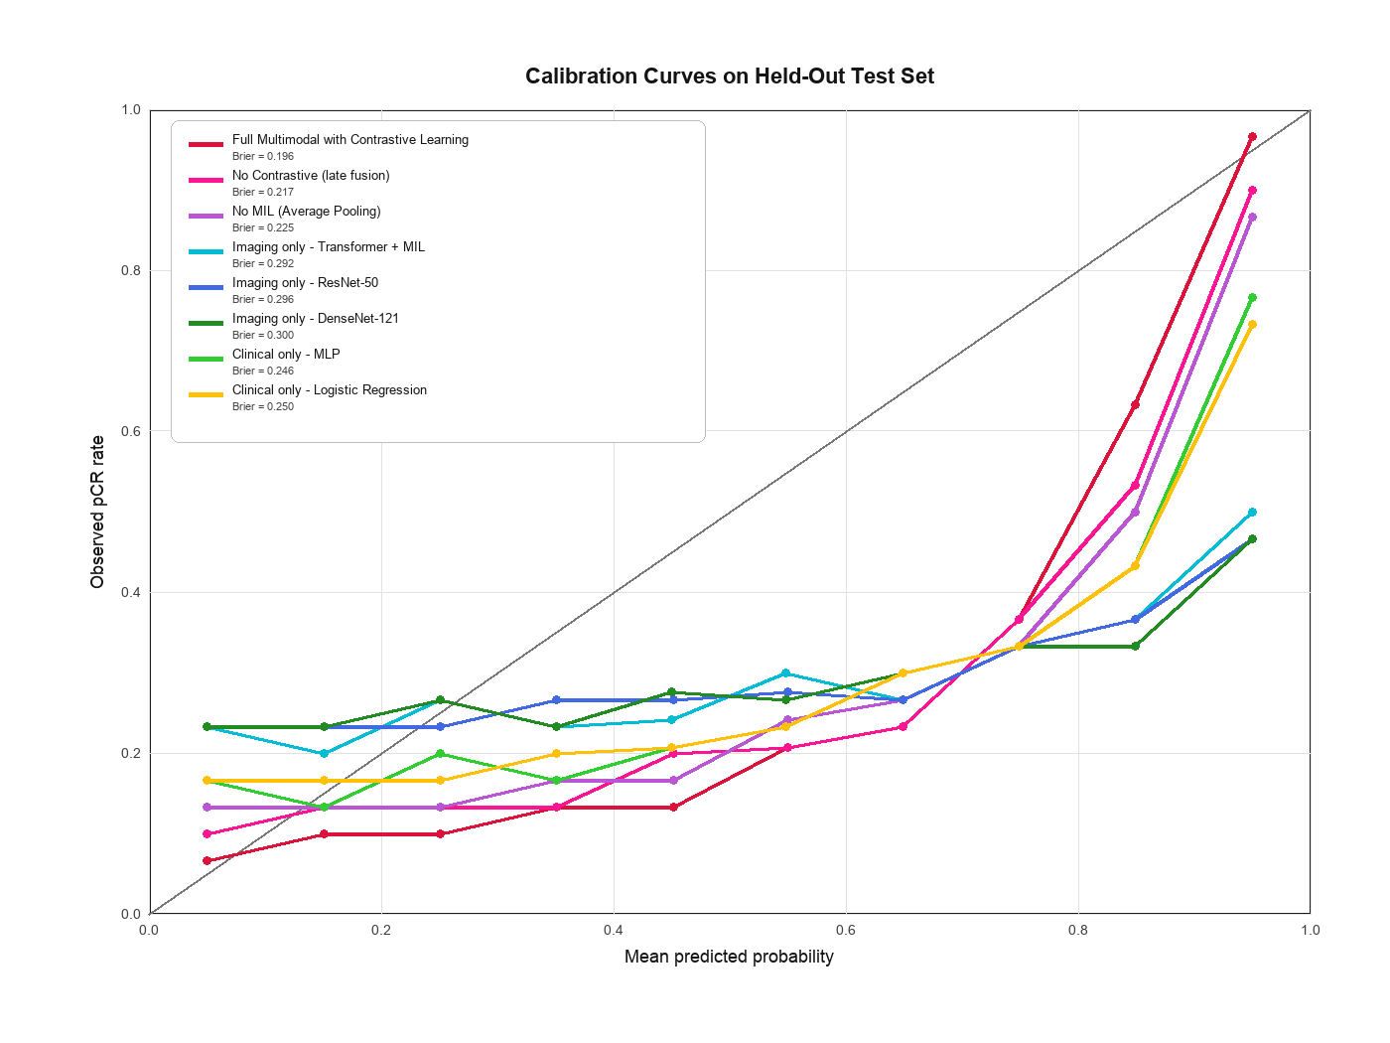
Supplementary Figure S1. Calibration curve for the full multimodal model on the held-out test set.

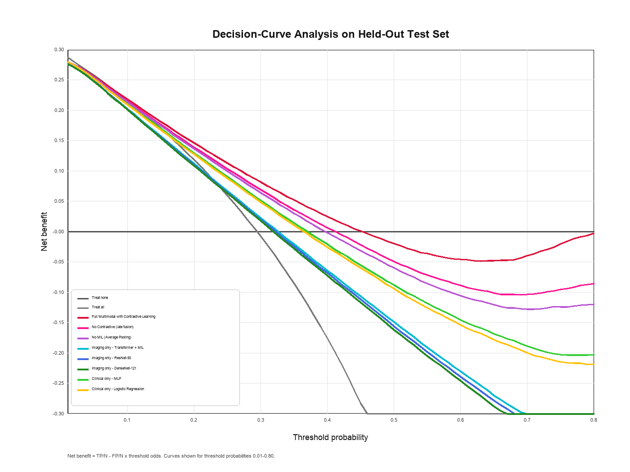
Supplementary Figure S2. Decision curves compare the net benefit of each model with treat-all and treat-none strategies.

