Supplementary Material

S1 Extended Network Architecture
The predictive model evaluated in this study is a customized 2D Convolutional Neural Network derived from the ResNet topology, designated as ResNet-51q (instantiated via the timm library’s byobnet framework), pre-trained on ImageNet. While maintaining a fundamental residual bottleneck structure, the architecture incorporates several advanced topological modifications designed to optimize the trade-off between computational efficiency and representational capacity (Figure S1).
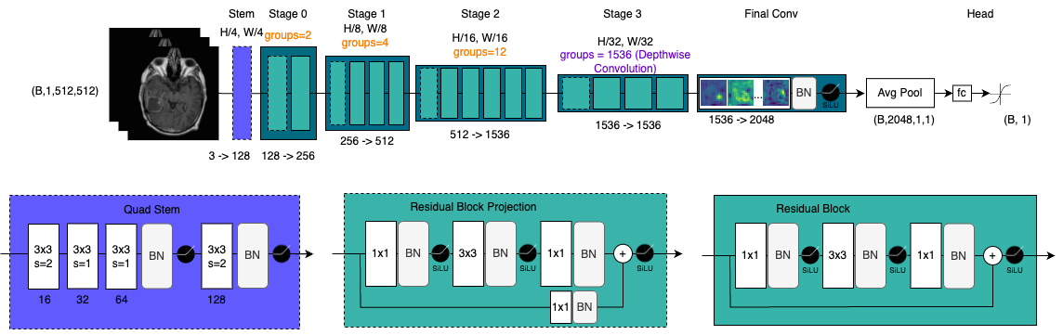
Figure S1: The ResNet-51Q Architecture. The conventional initial max-pooling is replaced by a progressive, convolutional "quad" stem. The network utilizes SiLU activations for smoother gradient propagation and relies extensively on grouped and depthwise convolutions to maximize parameter efficiency across its intermediate stages. To accommodate the single-channel grayscale MRI input, the pre-trained ImageNet weights of the initial convolutional layer were averaged across the original RGB channels.

S2 Explainability Methods and Benchmarking

S2.1 Saliency maps methods:
Gradient-weighted Class Activation Mapping (Grad-CAM):
Grad-CAM was implemented to generate coarse, class-discriminative localisation maps. Conforming strictly to standard literature, the method computes the gradients of the target logit with respect to the feature maps of the final convolutional stage (intermediate convolutions for the layer-wise analysis). These gradients are globally average-pooled to derive the neuron importance weights. The final spatial heatmap is obtained by applying a ReLU activation to the linearly weighted combination of the forward activation maps, strictly isolating features that exert a positive influence on the predicted clinical outcome.
Layer-wise Relevance Propagation (LRP):
Unlike gradient-based heuristics, LRP traces the exact prediction score back to the input pixel space by enforcing a strict layer-wise conservation property. It distributes each neuron's importance through proportional values to the preceding layers without requiring gradient calculations, which is highly effective for generating detailed spatial attributions in medical imaging. To adapt this method to the deep and highly optimized topology of the ResNet-51Q without suffering from numerical instability or attribution noise, a composite rule strategy (EpsilonPlusFlat) was implemented using the Zennit library. Relevance was backpropagated using 3 rules: (1) the Flat rule was applied to the initial soft-stem convolutions to distribute relevance uniformly, (2) the Z-Plus rule was enforced across all intermediate grouped and depthwise convolutions to restrict the flow of relevance strictly to positive weight contributions, and (3) the Epsilon rule was utilized to safely distribute relevance while absorbing computational noise.
Local Interpretable Model-agnostic Explanations (LIME):
LIME is a perturbation-based approach that approximates the complex predictive model's behavior locally by systematically masking superpixels and fitting an interpretable surrogate linear model. Rather than visualizing standard discrete patches of important superpixels, we aggregated the surrogate weights into a continuous spatial saliency map to enable a direct, pixel-level comparison with LRP and Grad-CAM outputs. Because LIME relies on random perturbations, its explanations can suffer from instability. To rigorously counteract this and ensure robust intra-patient consistency, a multi-scale consensus strategy was implemented. For a single MRI slice, 25 distinct Simple Linear Iterative Clustering (SLIC) superpixel segmentations were generated (ranging from 30 to 270 segments, compactness = 0.3). The final attribution map represents the average of explanations across these 25 granularities, repeated over 3 independent iterations (totaling approximately 5 million forward passes for the test cohort). To maintain computational feasibility at this massive scale, perturbations were strictly restricted to the anatomical foreground mask. While this optimization efficiently isolated the biological features of interest, it constitutes a methodological limitation, as the framework inherently assumes the masked non-anatomical background does not independently drive the prognostic prediction.

S2.2 Region of Interest (ROI) Segmentation
Anatomical regions of interest (ROIs) were segmented exclusively to serve as independent anatomical ground truths for the post-hoc XAI evaluation. A radiation oncologist manually delineated the Gross Tumour Volume (GTV), while a 3D U-Net automatically segmented the brain and skull. Intra-tumoral ROIs (necrotic core, T1 enhancement area) were segmented via automated clustering approximatively with the GTV masks. These masks enabled the quantitative measurement of the model’s focus (MIoU, Mass relevance) and guided the targeted input ablation studies.

S2.3 Supplementary saliency maps
To evaluate the consistency of the model’s decision-making across the cohort, additional representative axial slices were visualized. These cases provide extended evidence of the dichotomous strategy identified in the main manuscript: a systematic focus on the contrast-enhancing tumoral rim for short-term predictions (Figure S2) and a recurring reliance on the hyper-intense surgical site or cranial vault for long-term predictions (Figure S3).

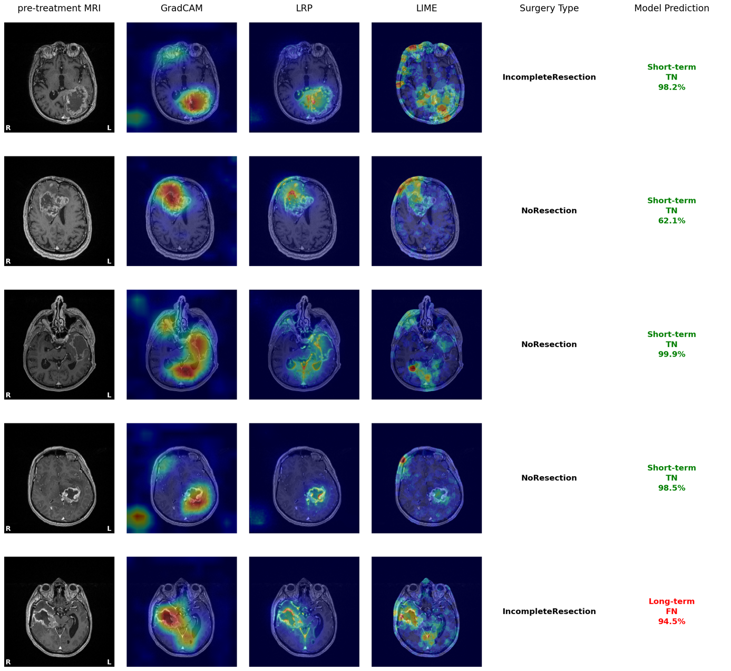
Figure S2: Saliency maps demonstrating tumour-focused predictions for short-term survivors. Representative axial T1-Gd MRI slices of patients correctly classified as short-term survivors. From left to right: original input MRI, Grad-CAM, Layer-wise Relevance Propagation (LRP), and LIME saliency maps. For this poor prognosis cohort, all three explainability methods consistently highlight the Gross Tumour Volume (GTV) as the primary visual driver of the network's decision. High-resolution LRP specifically pinpoints the contrast-enhancing rim. Negative values are clipped to zero to display only the regions positively contributing to the prediction.

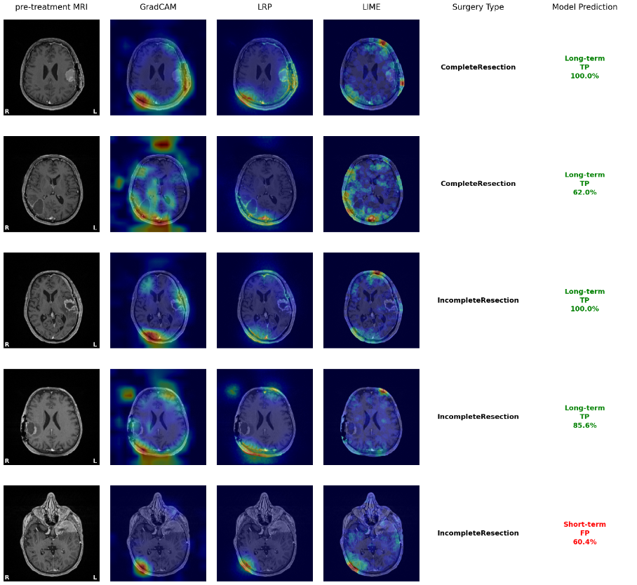
Figure S3: Saliency maps demonstrating skull-focused predictions for long-term survivors. Representative axial T1-Gd MRI slices of patients correctly classified as long-term survivors. From left to right: original input MRI, Grad-CAM, Layer-wise Relevance Propagation (LRP), and LIME saliency maps. For this good prognosis cohort, all three explainability methods consistently highlight the cranial vault, with a particular emphasis on the surgical site, as the primary visual driver of the network's decision. Negative values are clipped to zero to display only the regions positively contributing to the prediction.

S2.4 XAI Quantitative Analysis
Analyses were conducted independently for both survival classes (short-term and long-term survivors) across the 6 primary processing stages of the architecture. To evaluate population-level trends, individual scores for both metrics were averaged across all 𝑁= 333 images.
Given the non-normal distribution of the resulting data, a unified two-step non-parametric statistical evaluation was performed for both the mIoU and the Relevance Mass.
First, an omnibus Friedman test was applied within each processing stage:
𝑯𝟎 (Omnibus): Within a specific network stage, the evaluated spatial metric (mIoU or Relevance Mass) is equally distributed across all evaluated anatomical regions (GTV, Brain, Skull).
𝑯𝟏 (Omnibus): The evaluated spatial metric is significantly concentrated on at least one specific anatomical region compared to the others within the given stage.
Second, for stages where the Friedman test indicated a significant global difference (𝑝 < 0.05), paired Wilcoxon signed-rank tests were conducted a priori to compare the target region specifically against the non-tumoral anchors (Brain and Skull):
𝑯𝟎 (Post-hoc): There is no significant difference in the evaluated metric between the GTV and the evaluated non-tumoral region (Brain or Skull).
𝑯𝟏 (Post-hoc): The evaluated metric significantly differs between the GTV and the evaluated non-tumoral region.
A Bonferroni correction was systematically applied to these multiple comparisons. The comprehensive layer-wise evolution and statistical significance for both metrics are illustrated in Supplementary Figures S4-7 and supplementary analyses are provided in Supplementary
Sections S3 and S4.

b) 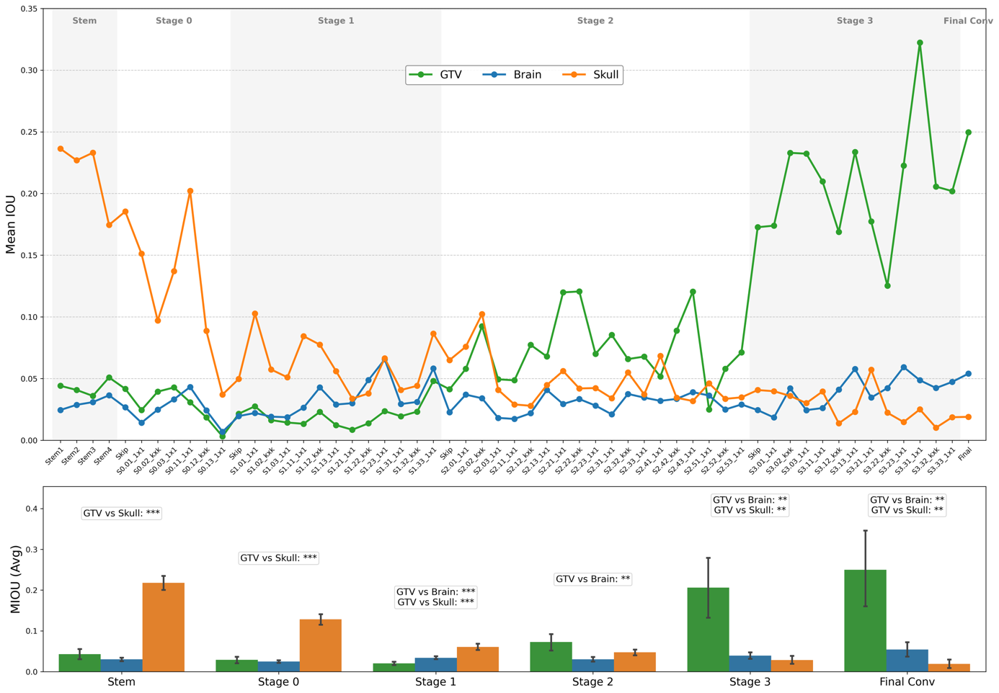
a)
Supplementary Figure S4: Quantitative evolution of the model’s anatomical focus (mIoU) in short-term survivors. (A) Layer-wise evolution of the Mean Intersection over Union (mIoU). The metric quantifies the spatial overlap between the model’s focus (binary masks derived from Grad-CAM heatmaps thresholded at the 95th percentile) and three anatomical Regions of Interest (ROIs): Gross Tumour Volume (GTV), Skull, and whole Brain. The analysis is restricted to the ‘Short-Term’ class. The curves illustrate a spatial shift: the model initially focuses on the skull (early layers) before progressively reorienting towards the tumour (intermediate to final layers). (B) Aggregated mean mIoU per processing stage. Bar charts display the average overlap for each ROI across the model’s four stages. Statistical significance for the comparison between GTV and Skull attribution is indicated as follows: ∗𝑝< 0.05, ∗∗𝑝< 0.01, and ∗∗∗𝑝< 0.001 (Wilcoxon signed-rank test).

b) 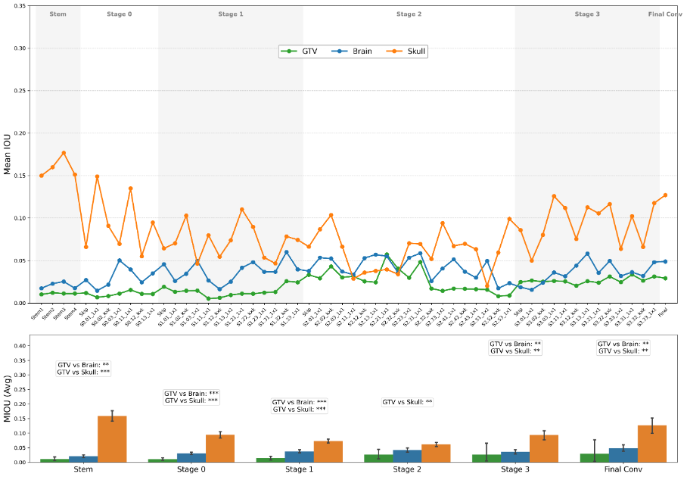
a)
Supplementary Figure S5: Quantitative evolution of the model’s anatomical focus (mIoU) in Long-Term survivors.(A) Layer-wise evolution of the Mean Intersection over Union (mIoU). The mIoU metric quantifies the spatial overlap between the model’s focus (binary masks derived from Grad-CAM heatmaps at the 95th percentile) and three anatomical Regions of Interest (ROIs): Gross Tumour Volume (GTV), Skull, and Brain (GTV not included). The analysis is restricted to the long-term survival class here. Overall, spatial attribution exhibits a characteristic trajectory: mIoU values decrease from the initial Stem Block through the early intermediate layers, before progressively increasing across Stage 3 and the Final Convolution, heavily driven by the skull anchor. Notably, a transient, minor peak in GTV focus is observed during Stage 2, although its absolute overlap remains systematically low. (B) Aggregated mean mIoU per processing stage. Bar charts display the average overlap for each ROI across the model’s primary stages. Statistical significance for the a priori comparisons (GTV vs. Skull and GTV vs. Brain) is indicated as follows: *p<0.05, **p<0.01, and ***p<0.001 (paired Wilcoxon signed-rank test with Bonferroni correction).

a)  b) | 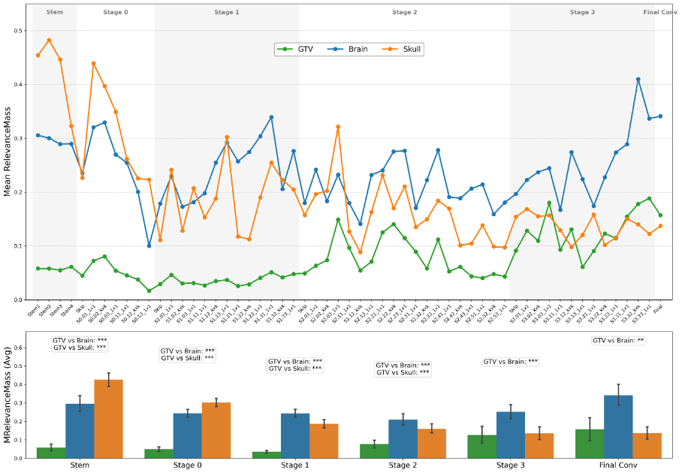
Supplementary Figure S6: Threshold-independent evolution of the model’s spatial focus in Short-terms survivors. (A) Layer-wise evolution of the Relevance Mass. Unlike binary mIoU, this continuous metric quantifies the absolute proportion of attribution density directed towards three anatomical ROIs: Gross Tumour Volume (GTV), Skull, and Brain (GTV not included). For Short-Term survivors, the network exhibits a decisive strategic shift: the initial baseline reliance on the skull progressively decays, while the Relevance Mass assigned to the GTV sharply increases at Stage 2 and plateaus at a high amplitude through the final layers. (B) Aggregated mean Relevance Mass per processing stage. Bar charts display the average attribution density. Statistical significance for a priori comparisons (GTV vs. Skull and GTV vs. Brain) is indicated as: *p<0.05, **p<0.01, and ***p<0.001 (paired Wilcoxon signed-rank test with Bonferroni correction).

a)  b) | 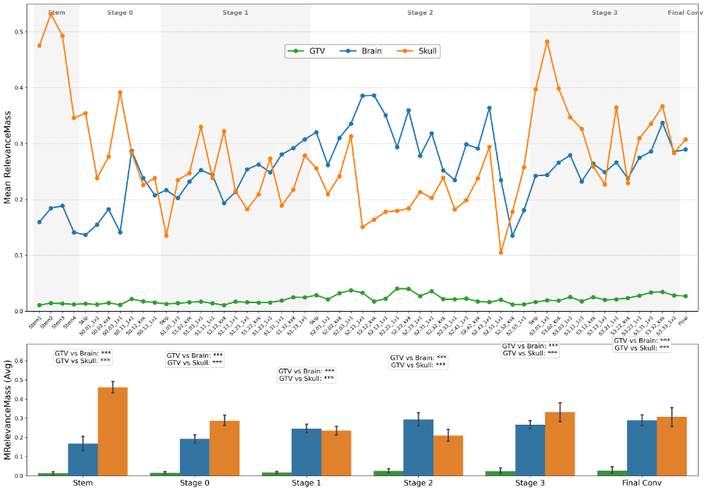
Supplementary Figure S7: Threshold-independent evolution of the model’s spatial focus in Long-Term survivors.(A) Layer-wise evolution and (B) stage-wise aggregation of the Relevance Mass. The structural and statistical methodology is identical to Supplementary Figure S6. For long-term survivors, the absolute energy directed towards the GTV remains systematically low compared to the skull and healthy brain throughout the network’s depth. However, a distinct transient peak is observed during Stage 2 for both the GTV and, most notably the brain. Following this intermediate exploration, the model’s final focus firmly re-anchors on the skull to output the good prediction.

S2.5 Analysis of the quality of saliency maps explanations
To rigorously benchmark the behavior of Grad-CAM, LRP, and LIME beyond visual inspection, an evaluation was conducted utilizing five standardized metrics. Given the inherent differences in probability baselines for short-term (Class 0) and long-term (Class 1) predictions, both insertion and deletion paradigms were strictly required to prevent mathematical floor or ceiling effects during evaluation.
Explanation Faithfulness (Insertion and Deletion AUC): These metrics quantify whether the XAI heatmap genuinely reflects the model's internal feature representations. The Deletion AUC measures the area under the probability curve as the most salient pixels of the saliency maps are progressively masked (set to a baseline value of zero). A sharp drop (low AUC) indicates high faithfulness. Conversely, the Insertion AUC measures the rise in probability as salient pixels are progressively revealed from saliency maps. A rapid recovery (high AUC) indicates that the highlighted pixels contain the core predictive signal. Notably, because the attribution maps are highly correlated with hyper-intensities (as established in Section S5.1), these saliency-based ablations fundamentally mirror the trajectory of the intensity-based ablation.
Overall, LRP demonstrated the most consistent faithfulness across both prognostic classes.
Spatial Anatomical Relevance (Pointing Game): This metric evaluates whether the highest-attributed pixel (the maximum peak of the saliency map) falls within the clinically relevant Gross Tumour Volume (GTV). Interestingly, LIME systematically pointed to the skull, further corroborating the network's dangerous reliance on a non-biological intensity heuristic rather than the tumor morphology.
Structural Concentration (Gini Sparsity Index): To quantify the focus of the explanations, the Gini index was employed rather than standard Shannon Entropy. The Gini index provides a scale-invariant measure of inequality in the attribution distribution, effectively mitigating confounding correlations with the absolute volume of the tumor or the cranial cavity. LRP and LIME produced highly sparse, concentrated explanations, whereas Grad-CAM exhibited significant spatial diffusion due to the low resolution of the final convolutional feature maps.
Perturbation Stability (Robustness): This metric assesses the stability of the explanation when the input image is subjected to subtle, visually imperceptible additive Gaussian noise. While LRP provides superior resolution and faithfulness, LIME demonstrated the highest resilience to local noise perturbations, inherent to its surrogate sampling methodology.

S3 Analysis of decision dynamics
To statistically validate the temporal network dynamics observed in the spatial trajectories (illustrated in Supplementary Figures S4–S7), three specific hypotheses regarding the onset, evolution, and final divergence of the model's feature extraction trajectory were formulated. For these analyses, patient-level aggregated Relevance Mass scores were utilised to evaluate the average network behaviour across the test dataset.

Hypothesis 1: The Stage 2 "Turning Point" (Intra-Class Longitudinal Shift)
To verify the visual observation that the model actively redirects its focus towards the tumour at an intermediate depth, a one-sided paired Wilcoxon signed-rank test was performed to compare the GTV Relevance Mass between Stage 1 and Stage 2.
• 𝐻#: The Relevance Mass attributed to the tumour (GTV) at Stage 2 is less than or equal to the attribution at Stage 1.
• 𝐻$: The Relevance Mass attributed to the tumour at Stage 2 is strictly and significantly greater than at Stage 1.
• Outcome: The null hypothesis was strongly rejected (𝑝= 5.16 × 10%&), providing statistical evidence of a significant escalation in tumour focus at this specific processing depth.
Hypothesis 2: Initial Convergence at the Stem Block (Inter-Class Baseline
Similarity)
To confirm that the network initiates its feature extraction relying on identical low-level heuristics regardless of the underlying patient outcome, a two-sided Mann-Whitney U test (for independent samples) was conducted on the initial Skull focus.
• 𝐻#: The Relevance Mass attributed to the Skull at the Stem block is identical (drawn from the same distribution) between short-term survivors and long-term survivors.
• 𝐻$: The Relevance Mass attributed to the Skull at the Stem block differs significantly between the two survival classes.
• Outcome: The null hypothesis could not be rejected (𝑝 = 0.5260), confirming that the initial anatomical focus is statistically indistinguishable between the two prognostic groups.
Hypothesis 3: Final Strategic Divergence (Inter-Class Dichotomy)
To establish that the final prediction relies on a dichotomous anchoring strategy, two separate one-sided Mann-Whitney U tests were conducted at the Final Stage to compare the independent survival cohorts.

Test 3A: Poor Prognosis Anchoring (GTV)
• 𝐻#: At the Final Stage, the GTV Relevance Mass for short-term survivors is less than or equal to that of long-term survivors.
• 𝐻$: At the Final Stage, the GTV Relevance Mass for short-term survivors is strictly greater than for long-term survivors.
• Outcome: The null hypothesis was rejected (𝑝 = 0.0098), confirming that the network specifically targets the tumour to encode a poor prognosis.
Test 3B: Good Prognosis Anchoring (Skull)
• 𝐻#: At the Final Stage, the Skull Relevance Mass for long-term survivors is less than or equal to that of short-term survivors.
• 𝐻$: At the Final Stage, the Skull Relevance Mass for long-term survivors is strictly greater than for short-term survivors.
• Outcome: The null hypothesis was rejected (𝑝 = 0.0001), confirming that the network specifically targets the surgical skull heuristic to encode a good prognosis.

S4 Global Saliency Patterns and Error Analysis (Linear Mixed-Effects
Models)
To rigorously assess systemic differences in spatial attribution across the network's depth while strictly accounting for intra-patient correlation (repeated measures across sequential layers), Linear Mixed-Effects Models (LMEM) were employed. Standard parametric evaluation (such as ANOVA or Student’s t-tests) was precluded, as the intra-patient layer-wise data severely violates the fundamental assumption of statistical independence.
In all defined models, the patient identifier (`patient_id`) was specified as a random effect (random intercept) to capture baseline individual variability, whilst the clinical category or predictive outcome was modelled as a fixed effect. All tests were two-sided.

Systemic Strategic Differences (Fixed Effect: Survival Class)
To determine whether the network's focus on the tumour is a global algorithmic phenomenon or merely a final-layer artefact, the true survival class was evaluated as a fixed effect against multiple GTV attribution metrics across all layers.
Systemic mIoU & Mean Activation: The null hypotheses stating that the survival class has no systematic effect on the overall GTV spatial overlap (mIoU) and mean activation intensity were strongly rejected (𝑝 < 0.001 and 𝑝 = 0.000154 , respectively). The network systematically allocates significantly less focus and lower activation magnitude to the tumour mass when processing long-term survivor profiles.
Concentration Topology (Gini Index): Conversely, the null hypothesis regarding the Gini index could not be rejected (𝑝 = 0.20). This demonstrates that while the absolute intensity and spatial overlap differ between classes, the internal topological concentration of the focus remains statistically indistinguishable.
Final Convolution Verification: A targeted evaluation at the final convolutional layer confirmed this dichotomy, with short-term survivors exhibiting a significantly higher GTV mIoU compared to long-term survivors (0.25 vs 0.03, 𝑝 < 0.0001).
Systematic Error Mechanisms (Fixed Effect: Prediction Outcome)
To investigate whether model misclassifications stem from random feature failures or the rigid misapplication of learned heuristics, prediction outcomes (True Positives [TP], False Positives [FP], True Negatives [TN], False Negatives [FN]) were modelled as fixed effects. The objective was to prove the absence of statistical difference in spatial focus when the model commits an error.
False Negatives vs. True Negatives (GTV Focus): The null hypothesis comparing GTV mIoU between FN and TN outcomes could not be rejected (𝑝 = 0.0551). The model does not significantly alter its tumour focus when committing a False Negative error.

False Positives vs. True Positives (Distraction Heuristics): Similarly, the null hypotheses comparing the focus on the Skull (𝑝 = 0.338) and the healthy Brain (𝑝 = 0.928) between FP and TP predictions could not be rejected.
Conclusion: These non-significant findings provide a critical insight: the model's errors are not erratic. When the algorithm fails, it rigidly applies the exact same anatomical decision rules—anchoring on the GTV for negative predictions, or being distracted by the skull for positive predictions—that it utilises for correct predictions. The errors are therefore systematic and entirely explainable by the presence of confounding visual heuristics in the input images.

S5 Causal Auditing of Feature Dependence

S5.1 Correlation Analysis (MRI Intensity vs Saliency maps)
Qualitative and quantitative analyses of the spatial attributions (Grad-CAM, LRP, and LIME) revealed a distinct dichotomous focus: the model systematically targets the tumoral contrast-enhancing rim for short-term predictions and the cranial vault for long-term predictions (as established in Figure 1 and Section S4). Crucially, in standard T1-weighted Gadolinium-enhanced MRI, both of these specific anatomical structures are inherently characterized by hyper-intense pixels. This consistent spatial overlap led to the hypothesis that the network's predictive capacity is not based on the extraction of complex biological morphological features, but is instead heavily reliant on a low-level "intensity heuristic".
To quantitatively validate this observation, a pixel-wise statistical evaluation was conducted to measure the association between raw image brightness and XAI importance. The Spearman's rank correlation coefficient was computed between the raw MRI pixel intensities and the corresponding attribution scores generated by each explainability method. Prior to correlation, both the raw MRI slices and the respective saliency maps were independently Min-Max normalized to a standard [0, 1] range. This normalization step is methodologically imperative to ensure strict mathematical comparability across heterogeneous patient acquisitions and distinct XAI algorithmic scales. The results of this analysis are illustrated in Supplementary Figure S8.

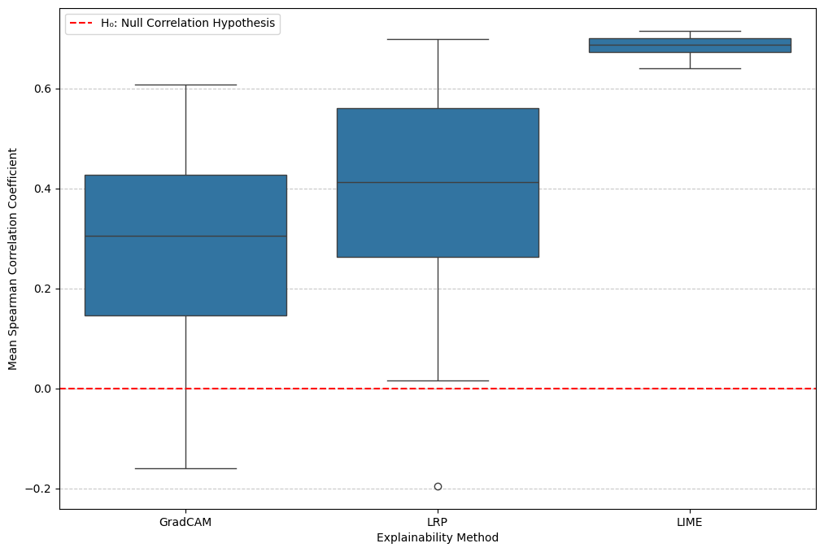
Figure S8: Quantitative correlation between raw MRI pixel intensity and XAI spatial attribution. Spearman's rank correlation assesses the relationship between the normalized raw T1-Gd MRI pixel intensities and the corresponding relevance scores assigned by Grad-CAM, LRP, and LIME across the independent test set. This analysis quantifies the model's reliance on hyper-intense radiological features. Among the evaluated paradigms, LIME—a perturbation-based surrogate model—demonstrates the strongest and most significant correlation with pixel brightness (Spearman's ρ = 0.69 ± 0.03). This high correlation quantitatively corroborates that the underlying predictive strategy is overwhelmingly anchored on a high-intensity heuristic, specifically targeting the bright contrast-enhancing tumour rim and the skull (hyper-intense surgical site).

S5.2 Targeted Input Ablation Study
While the Spearman correlation established a robust statistical association and LIME provided local, instance-level explanations of feature importance, these approaches do not definitively prove global causal dependence. To formally validate the hypothesis that the network relies on a global intensity heuristic rather than specific anatomical representations, a macroscopic input ablation study was conducted across the independent test set (illustrated in Main Text Figure 2).

First, targeted anatomical regions were systematically masked to evaluate the resulting drop in predictive performance. As detailed in Supplementary Table S1, masking either the Skull or the Gross Tumour Volume (GTV) in isolation resulted in only marginal performance degradation. However, the simultaneous ablation of both regions precipitated a substantial collapse in predictive capacity (AUC decreased from 0.888 to 0.688). This structural redundancy strongly implies that the model does not strictly depend on a single biological morphology. Instead, it opportunistically exploits the hyper-intense pixels present in either the cranial vault or the contrast-enhancing tumour rim, perfectly corroborating the Spearman correlation findings.
To conclusively isolate and confirm this reliance on intensity, a continuous threshold-based ablation was subsequently performed, ignoring anatomical boundaries to strictly mask the top percentages of the brightest foreground pixels. As demonstrated in Main Text Figure 2, ablating merely the top 1% of hyper-intense pixels is sufficient to disrupt the network's prediction. Table S1 summarizes the comprehensive metrics across these discrete ablation conditions, highlighting the critical vulnerability of the model when the top 5% brightest pixels are removed (AUC 0.642). Finally, Supplementary Figure S9 provides the complete continuous sensitivity analysis, mapping the AUC trajectory across all possible intensity ablation thresholds. This global evaluation definitively proves that the model's prognostic signal is not distributed across the tumour volume, but is overwhelmingly encoded within a arrow fraction of the brightest image pixels.
Ablation condition | AUC | Optimal  threshold | Accuracy | Sensitivity | Specificity | Precision | F1 score
Full image | 0.888 | 0.51 | 0.83 | 0.78 | 0.89 | 0.88 | 0.83
No skull | 0.886 | 0.30 | 0.83 | 0.89 | 0.75 | 0.79 | 0.84
No GTV | 0.826 | 0.85 | 0.80 | 0.64 | 0.97 | 0.96 | 0.76
No necrosis | 0.825 | 0.82 | 0.81 | 0.67 | 0.96 | 0.94 | 0.78
No enhancement | 0.822 | 0.85 | 0.80 | 0.64 | 0.96 | 0.95 | 0.76
No GTV and no skull | 0.688 | 0.56 | 0.68 | 0.53 | 0.84 | 0.78 | 0.63
No 5% brightest pixels | 0.642 | 0.17 | 0.60 | 0.60 | 0.61 | 0.62 | 0.61
Table S1: Impact of anatomical and intensity-based ablation on predictive performance. Performance metrics are reported for the baseline model ('Full Image') and five ablation conditions. Optimal thresholds were recalibrated for each condition using the Youden Index. While masking individual anatomical regions (Skull or GTV) resulted in limited performance drops (AUC 0.886 and 0.826, respectively), the simultaneous removal of both regions reduced the AUC to 0.688. The most significant performance collapse occurred when masking the top 5% brightest pixels (AUC 0.642). As detailed in Table S1, the model maintains high predictive performance when the skull is masked in isolation (AUC 0.886), yet suffers a significant collapse when both the skull and tumour are ablated simultaneously (AUC 0.688). While this structural redundancy strongly validates the model's reliance on a distributed intensity heuristic, the absolute magnitude of these performance drops should nonetheless be interpreted with methodological caution. Systematically setting pixels to zero within large anatomical regions or the top 5% of brightest pixels inherently creates artificial, out-of-distribution (OOD) images. Because the network was never exposed to such abrupt, non-biological artifacts during training, the severe performance collapse observed (e.g., dropping to AUC 0.642) likely reflects a combination of removing the critical prognostic signal and the model's diminished capacity to process OOD inputs.

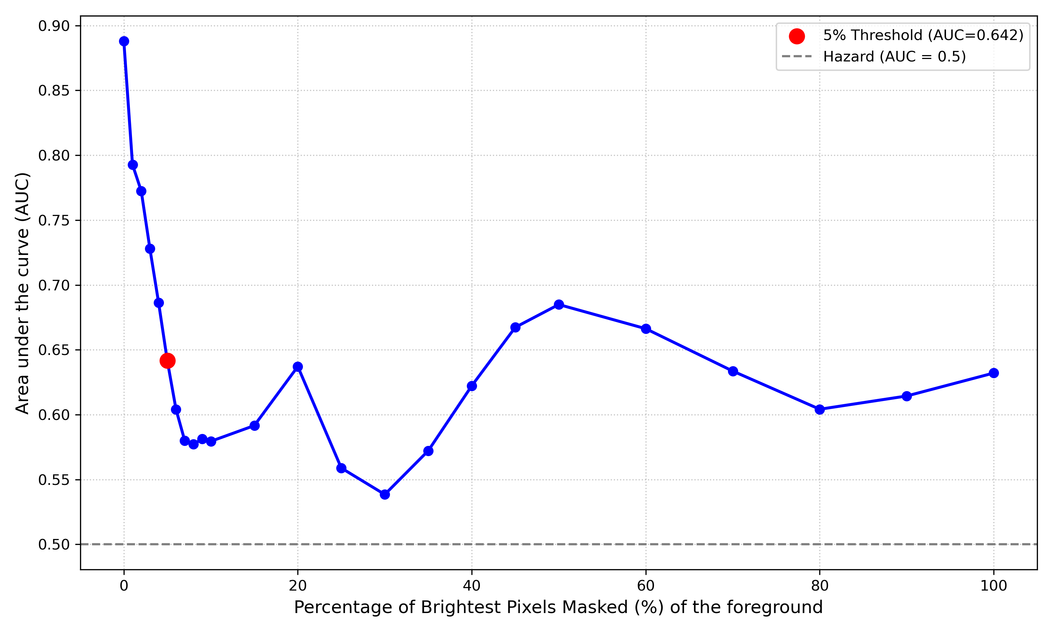
Supplementary Figure S9: Continuous sensitivity analysis of predictive performance via progressive intensity-based ablation. The line plot illustrates the global degradation of the model's Area Under the Curve (AUC) across the independent test set as a function of the ablation threshold. The x-axis represents the percentage 𝑘 of the brightest foreground pixels systematically masked (set to 0.0), where 𝑘 ranges from 0% (baseline MRI) to 100% (complete anatomical removal). The curve demonstrates a severe, non-linear collapse in performance: ablating merely the top 1% to 5% of hyper-intense pixels precipitates a catastrophic drop in AUC. Beyond this initial collapse, the performance gradually plateaus, culminating at a residual AUC of 0.63 when 𝑘= 100.

S6 Multi-Reader Multi-Case (MRMC) Clinical Evaluation Protocol
To rigorously assess the clinical utility of the AI tool and the impact of the XAI visualisations, a Multi-Reader Multi-Case (MRMC) study was conducted. The evaluation involved 4 clinical experts reviewing 37 test patients across 3 sequential phases (Expert alone, Expert+AI, Expert+AI+XAI), yielding a total of N=444 observations. Because each patient was evaluated multiple times (by different readers and across different phases), the data is inherently correlated.

S6.1 Descriptive Performance Metrics (Clustered Bootstrapping)
To generate robust point estimates and 95% Confidence Intervals (CIs) for primary prognostic metrics (AUC, Accuracy, Precision, Recall, F1-score, and Brier Score) without violating independence assumptions, a clustered bootstrapping procedure was employed. A total of 1,000 bootstrap iterations were performed. At each iteration, resampling was executed at the cluster level (by sampling `patient_id` with replacement) rather than at the observation level, ensuring that the intra-patient correlation structure was preserved within each bootstrap sample.

S6.2 Inferential Hypothesis Testing (Generalised Estimating Equations)
To formally test hypotheses regarding shifts in expert accuracy, confidence, and human-AI interaction, Generalised Estimating Equations (GEE) were utilised. GEE models are specifically designed to handle clustered, non-independent data by estimating population-average effects.
In all models, the `patient_id` was specified as the clustering variable with an exchangeable working correlation structure.
Binary Outcomes (Prognostic Accuracy): Evaluated using a Binomial family distribution with a logit link function. The outcome variable was `is_correct` (1 if the expert's prediction matched the ground truth, 0 otherwise).
Continuous Outcomes (Prognostic Confidence): Evaluated using a Gaussian family distribution with an identity link function. The outcome variable was the expert's reported continuous confidence score (`score_expert` ∈[0,1]).
Three specific levels of inferential testing were conducted:
- Baseline Comparisons (Tests 1 & 2): Evaluating the absolute marginal benefit of AI assistance (Phase 2) and XAI assistance (Phase 3) against the unassisted human baseline (Phase 1).

- Incremental XAI Benefit (Tests 3 & 4): A direct comparison between Phase 3 and Phase 2 to isolate the specific contribution of visual explanations over numerical AI predictions.
- Interaction Analysis (Tests 5 & 6): Evaluating the interaction term `Phase *
AI_Score` to determine whether the introduction of XAI fundamentally alters the cognitive strategy of the expert (i.e., how strongly clinicians anchor their decision and confidence on the AI's numerical prediction).

S6.3 Baseline Comparisons (Absolute Benefit of AI and XAI)
To determine if the integration of artificial intelligence safely improves clinical performance, Phase 2 (Expert+AI) and Phase 3 (Expert+AI+XAI) were compared against the unassisted human baseline (Phase 1).
Test 1: Prognostic Accuracy (Binary)
• 𝐻#: The probability of a correct prediction in Phase 2 or Phase 3 is equal to that of Phase 1.
• 𝐻$: The probability of a correct prediction significantly increases with AI/XAI assistance.
• Outcome:𝐻# was rejected. Compared to Phase 1, the odds of a correct prediction increased significantly when experts were provided with the AI prediction (Phase 2: OR = 1.336, 95% CI [1.049 - 1.703], p = 0.0190) and further increased with the addition of visual explanations (Phase 3: OR = 1.598, 95% CI [1.171 - 2.181], p = 0.0031).
Test 2: Prognostic Confidence (Continuous)
• 𝐻#: The mean expert confidence in Phase 2 or Phase 3 is equal to that of Phase 1.
• 𝐻$: The mean expert confidence significantly changes with AI/XAI assistance.
• Outcome:𝐻# could not be rejected. The integration of AI (p = 0.7545) and subsequent
XAI (p = 0.5606) did not yield any statistically significant inflation in absolute expert confidence compared to the baseline.
Incremental XAI Benefit (Direct Phase 3 vs. Phase 2 Comparison)

To isolate the specific marginal value of visual heatmaps over simple numerical predictions, Phase 3 was directly compared against Phase 2.
Test 3 and 4: Average Accuracy and Confidence Shifts
• 𝐻#: There is no significant difference in mean accuracy (Test 3) or mean confidence (Test 4) between Phase 3 and Phase 2.
• 𝐻$: The transition from Phase 2 to Phase 3 significantly alters mean accuracy or confidence.
• Outcome:𝐻# could not be rejected for either metric. The direct addition of XAI did not produce a statistically significant independent increase in overall mean accuracy (OR = 1.196, p = 0.0808) nor in mean absolute confidence (Coef = -0.005, p = 0.6348).
Interaction Analysis (Cognitive Strategy and AI Anchoring)
Given the absence of an average marginal benefit (Test 3), interaction terms (Phase * y_score_model) were introduced. The objective was to determine if XAI subtly alters how the expert utilises the AI's numerical prediction to reach a decision, rather than simply boosting average performance.
Test 5: Interaction Effect on Accuracy (Decision Strategy)
• 𝐻#: The relationship between the AI's predicted score and the expert's likelihood of being correct remains identical between Phase 2 and Phase 3.
• 𝐻$: The provision of XAI (Phase 3) significantly alters the relationship between the AI's score and the expert's accuracy.
• Outcome:𝐻# was rejected. A statistically significant interaction was observed (OR = 0.535, 95% CI [0.343 - 0.836], p = 0.0061). This demonstrates that visual explanations fundamentally modify the experts' decision-making strategy, allowing them to achieve correct predictions differently depending on the underlying AI score, rather than acting as a universal performance amplifier.
Test 6: Interaction Effect on Confidence (Psychological Anchoring)
• 𝐻#: The degree to which expert confidence is anchored to the AI's numerical score is identical between Phase 2 and Phase 3.

• 𝐻$: XAI (Phase 3) significantly reduces or alters this psychological anchoring effect compared to Phase 2.
• Outcome:𝐻# could not be rejected. The main effect of the AI score strongly drives expert confidence (Coef = 0.351, p < 0.0001), and the interaction term (Phase 3: y_score_model) was not significant (p = 0.6466). This confirms that while XAI alters the actionable decision strategy (Test 5), it does not dismantle the underlying psychological bias of anchoring confidence to the machine's prediction.

S6.4 Clinical Evaluation Metrics
To comprehensively evaluate the clinical reliability and practical value of the prognostic strategies, two specific evaluation frameworks were mathematically assessed alongside standard discrimination measures (AUC).
While the AUC evaluates the ranking (discrimination) of predictions, it does not assess their absolute accuracy. The Brier Score quantifies the overall accuracy of probabilistic predictions, capturing both discrimination and calibration. A lower Brier score indicates superior calibration. To visually assess this, calibration curves (reliability diagrams) were generated by plotting the mean predicted probability within discretised bins against the actual observed fraction of positive outcomes.
To assess whether the AI or XAI-assisted strategies yield a tangible clinical advantage over default strategies (e.g., treating all patients or treating none), Decision Curve Analysis (DCA) was employed. DCA calculates the Net Benefit (NB) across a continuous range of threshold probabilities (𝑝'). The comparative DCA results are illustrated in the main manuscript (Figure 6).
Calibration curves and Brier scores were evaluated to assess the agreement between predicted probabilities and observed outcomes across all prognostic strategies (Supplementary Figure S10 and Main Text Table 1). The standalone AI model achieved the highest prognostic reliability (lowest Brier score), although it exhibited localized overconfidence when predicting long-term survival at higher probability thresholds. Unassisted clinical experts (Phase 1) yielded the poorest reliability, characterized by systematic underconfidence when evaluating non-responders. The integration of numerical AI predictions (Phase 2) improved overall reliability compared to the human baseline but introduced inappropriate overconfidence in prognostically uncertain mid-range cases. Crucially, the subsequent addition of visual explanations (Phase 3) successfully mitigated this induced overreliance. By shifting experts back toward a conservative state of statistical underconfidence, the XAI intervention optimized human-machine synergy. This resulted in the best Brier score among all human-in-the-loop strategies, effectively bridging the gap toward the standalone algorithm's mathematical performance.
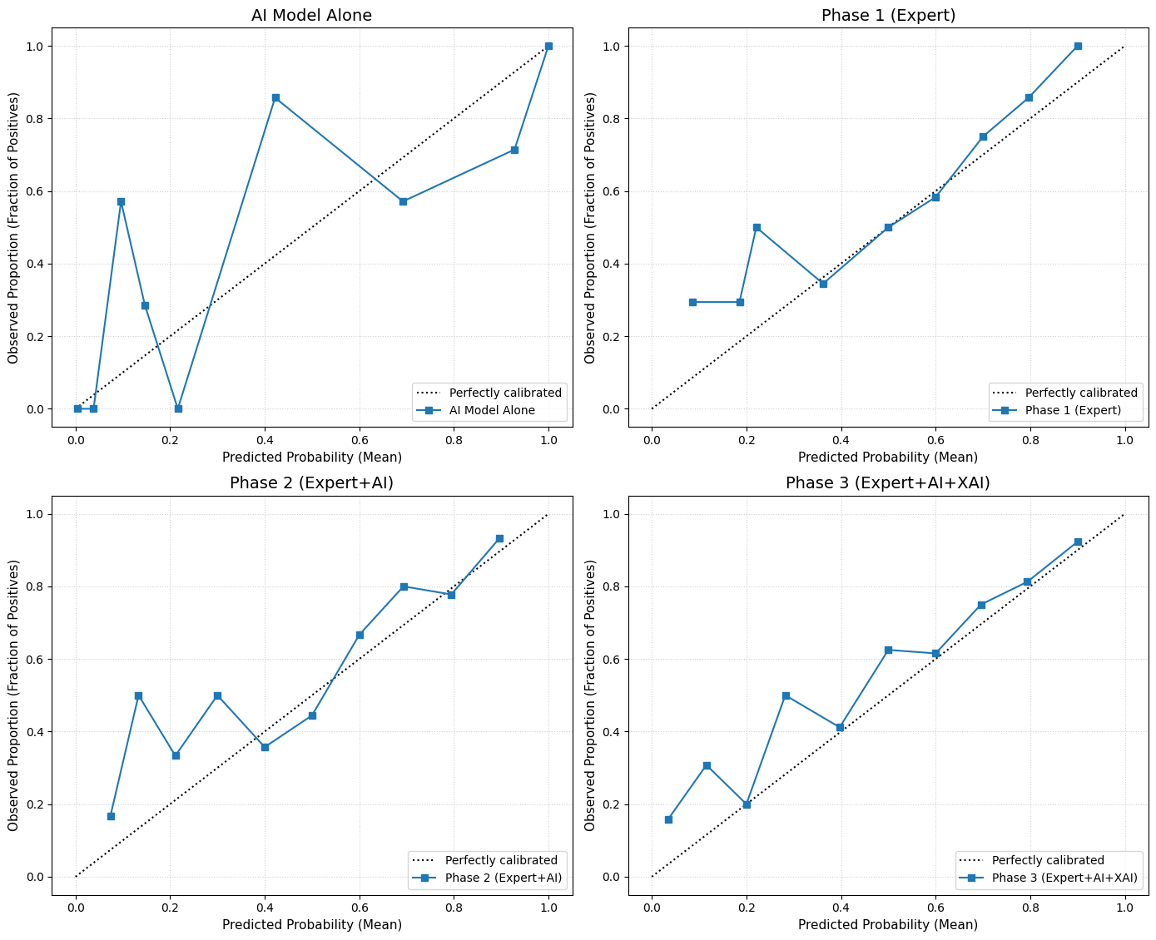
Supplementary Figure S10: Impact of AI assistance and visual explanations on expert calibration. Calibration curves map the assigned predictive probabilities (x-axis) against the observed fraction of true positive outcomes (y-axis). The dashed diagonal line represents perfect statistical calibration. Unassisted experts (Phase 1) demonstrate a relatively well-calibrated baseline but generally tend to under-predict the actual outcome frequency. The introduction of numerical AI predictions (Phase 2) introduces localized variability, including instances of over-confidence in mid-range probabilities. Conversely, the addition of XAI visualisations (Phase 3) shifts the curve consistently above the diagonal, indicating systemic statistical under-confidence.

