Supplemental Material

Buffalo Concussion Treadmill Test symptom severity scale
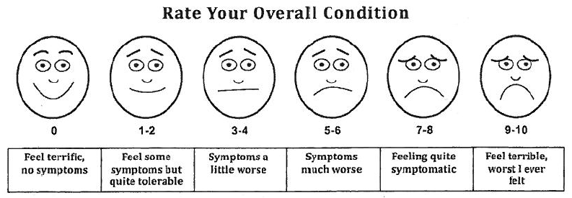

Leddy JJ, Willer B. Use of graded exercise testing in concussion and return-to-activity management. Curr Sports Med Rep. 2013;12(6):370-376.

Functional Ability Score:

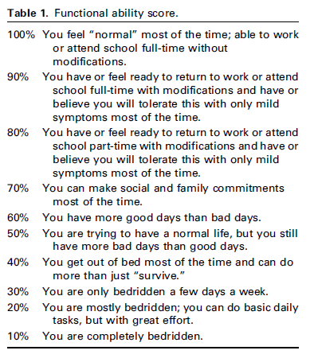
Schofield JR, Chemali KR. Intravenous Immunoglobulin Therapy in Refractory Autoimmune Dysautonomias: A Retrospective Analysis of 38 Patients. Am J Ther. 2019;26(5):570-582.

Results Continued

The following section describes the the effect of the exercise treatment on outcomes over the 12-week intervention (within ET group effect).

Aerobic Fitness & Exercise Tolerance
Within the ET group, there was a significant improvement in stroke volume with maintenance of cardiac output at anaerobic threshold (p<0.0001) and peak O2 pulse both absolute (p<0.0001) and predicted (p<0.0001) between visits (Table 1). Within the ET group, individuals demonstrated a significant reduction in heart rate, total peripheral resistance, RPE and dyspnea rating at both the matched and AT workload, with VO₂ reduced only at the 25W workload (Table 1).

Table 1 Change in cardiac response and exercise tolerance within the ET group
 | Baseline | 3 Months Post | Mean Difference (95% CI) | P-value
Matched 25W
VO₂ (mL/min/kg) | 9.8±2.1 | 9.4±1.5 | -0.45(-0.85, -0.05) | 0.028
Heart rate (bpm) | 113±22 | 107±16 | -6.0 (-11, -1) | 0.0132
Cardiac output (L/min) | 6.6±1.7 | 5.9±1.1 | -0.006 (-0.38, 0.37) | 0.9747
Stroke volume (mL) | 59.3±11.6 | 57.3±11.6 | 2.2 (-0.98, 5.4) | 0.1688
Total Peripheral Resistance Woods units) | 15.4 ± 3.3 | 14.5 ± 2.9 | -5.1 (-7.8, 1.5) | 0.0007
RPE | 11.0±2.5 | 9.7±2.5 | -1.3 (-1.7, 0.9) | <.0001
Dyspnea | 2.6±1.8 | 1.7±1.4 | -0.9 (-1.2, -0.5) | <.0001
Anaerobic Threshold
VO₂ (mL/min/kg) | 13.8±2.8 | 13.8±3.2 | 0.04 (-0.46, 0.53) | 0.8878
Heart rate (bpm) | 134±24 | 125±18 | -9 (-13 , -5) | <.0001
Cardiac output (L/min) | 8.2±1.6 | 8.2±1.8 | -0.03 (-0.40, -0.34) | 0.8734
Stroke volume (mL) | 59.6±14.3 | 64.3±14.8 | 3.5 (0.6, 6.5) | <.0001
Total Peripheral Resistance (Woods units) | 12.6 ± 2.4 | 11.7 ± 3.1 | -8.3 (-11.1, 5.5) | <.0001
RPE | 14.5±1.8 | 12.1±2.7 | -2.4 (-3.2, -1.6) | <.0001
Dyspnea | 4.3±1.7 | 2.8±1.5 | 3.5 (0.6, 6.5) | <.0001
Peak
VO₂ Peak (mL/min/kg) | 18.8±5.0 | 22.3±5.0 | 3.4 (2.7, 4.2) | <.0001
VO₂ Peak (% predicted) | 62±15 | 73±17 | 11.8 (9.3,14.3) | <.0001
Peak HR (bpm) | 164±25 | 168±20 | 5 (1,8) | 0.0293
Peak O₂ pulse | 8.4±2.2 | 9.7±2.2 | 1.3 (.9, 1.7) | <.0001
Peak O₂ pulse (% predicted) | 71±14 | 81±14 | 10 (7, 13) | <.0001
Mean arterial pressure (mmHg) | 105.2±16.2 | 102.6±12.2 | -1.5 (-4.2, 1.2) | 0.2670
RPE: rating of perceived exertion. Values mean ± SD. P<0.05 based on paired t-test
Symptom improvement (COMPASS 31, SF-36 and FAS)
Within the ET group, individuals reported a significant improvement in all domains of the COMPASS 31 (Supplemental Table 2). Within the ET group, all 8 domains of health in the SF-36 showed significant improvement except role-emotional (the degree to which emotional health is affecting work or other activities) (Supplemental Table 3).
Table 2: Change in COMPASS subscale scores within the ET group
 | Baseline | 3 Months Post | Mean Difference (95% CI) | P-value
Orthostatic intolerance | 6.2±2 | 4.4±2 | -1.8 (-2.4, -1.2) | <0.0001
Vasomotor | 3.6±0.8 | 3.3±0.7 | -0.27 (-0.51, -0.03) | 0.0293
GI | 10.7±5.2 | 8.2±4.9 | -2.5 (-3.8, -1.2) | 0.0003
Secretomotor | 3.0±1.9 | 2.1±1.6 | -0.92 (-1.28, -0.57) | <0.0001
Bladder | 1.4±1.6 | 1.1±1.5 | -0.35 (-0.59, -0.1) | 0.008
Pupilomotor | 7.1±3.6 | 5.7±3.0 | -1.4 (-2.2, -0.5) | 0.0022
Total autonomic symptom score | 47.7± | 37.2±12.0 | -11.0 (-14.1, -7.9) | <0.0001
Values mean ± SD. P<0.05 based on paired t-test

Table 3: Change in SF-36 domain scores within the ET group
 | Baseline | 3 Months Post | Mean Difference (95% CI) | P-value
Physical functioning | 48.1±17.0 | 62.1±16.2 | 14.0 (9.9, 18.1) | <.0001
Role-Physical | 4.8±14.2 | 32.7±39.2 | 27.9 (18.1, 37.7) | <.0001
Bodily pain | 45.3±26.0 | 64.1±27.6 | 18.8 (13.6, 24.0) | <.0001
General health | 31.0±14.0 | 36.6±19.9 | 5.6 (1.8, 9.3) | 0.0045
Vitality | 21.7±13.0 | 31.0±22.5 | 9.2 (4.1, 14.4) | 0.0007
Social functioning | 67.3±27.6 | 83.7±22.0 | 16.3 (9.0, 23.7) | <.0001
Role-Emotional | 52.6±45.4 | 64.1±42.1 | 11.5 (-1.7, 24.8) | 0.0861
Mental health | 60.9±21.2 | 70.5±19.9 | 9.5 (6.7, 12.3) | <.0001
Physical component summary | 29.0±7.2 | 36.0±10.6 | 7.0 (5.1, 8.8) | <.0001
Mental component summary | 44.1±12.4 | 47.9±11.6 | 3.8 (1.4, 6.3) | 0.0023
Values mean ± SD. P<0.05 based on paired t-test

Orthostatic Tolerance 10-minute Stand Test
Within the ET group, the change in heart rate with standing was 4 bpm less falling from 31±14 to 27±10 bpm on the follow-up visit [-3.6 (-7.3, -0.0) p=0.0478, baseline vs. 3-months post]. Additionally, there were three individuals in the ET group who on their baseline visit were unable to stand for the entire 10 minutes, but all participants stood for 10 minutes on the 3-month follow-up visit.

