Supplement to:
Identifying the sensitivity of GPS to non-tidal loadings at various time resolutions: examining vertical displacements from continental Eurasia
Anna Klos¹, Henryk Dobslaw², Robert Dill², Janusz Bogusz¹
1 Military University of Technology, Faculty of Civil Engineering and Geodesy, Warsaw, Poland
2 GFZ German Research Centre for Geosciences, Potsdam, Germany
Contact e-mail: anna.klos@wat.edu.pl

Content:
Figures provided below supplement the main paper of percentage of missing observations found in the GPS vertical displacements we utilized (Fig. S1), individual decomposition levels estimated for ARTU GPS station for NTOL- and NTAL-predicted displacements (Fig. S2), correlation coefficients estimated between GPS vertical displacements and displacements predicted by total environmental loading NTAL+NTOL+HYDL+SLEL (Fig. S3), by HYDL+SLEL (Fig. S4), by NTOL (Fig. S5) and by NTAL (Fig. S6). Figs S3 and S5 are especially important, since no part of these has been included in the main body of the paper. For Figs S4 and S6 only seasonal frequency bands (D7 and D8) were missing in the main body of the paper. Finally, we also provide histograms of RMS reduction once individual and total loading-predicted displacements are removed from the GPS displacements (Figs. S7-S10).
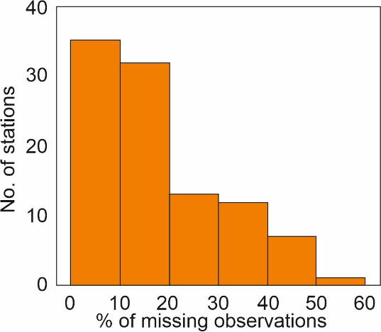
Fig. S1 Percentage of missing observations in a set of 100 Eurasian GPS displacement time series.

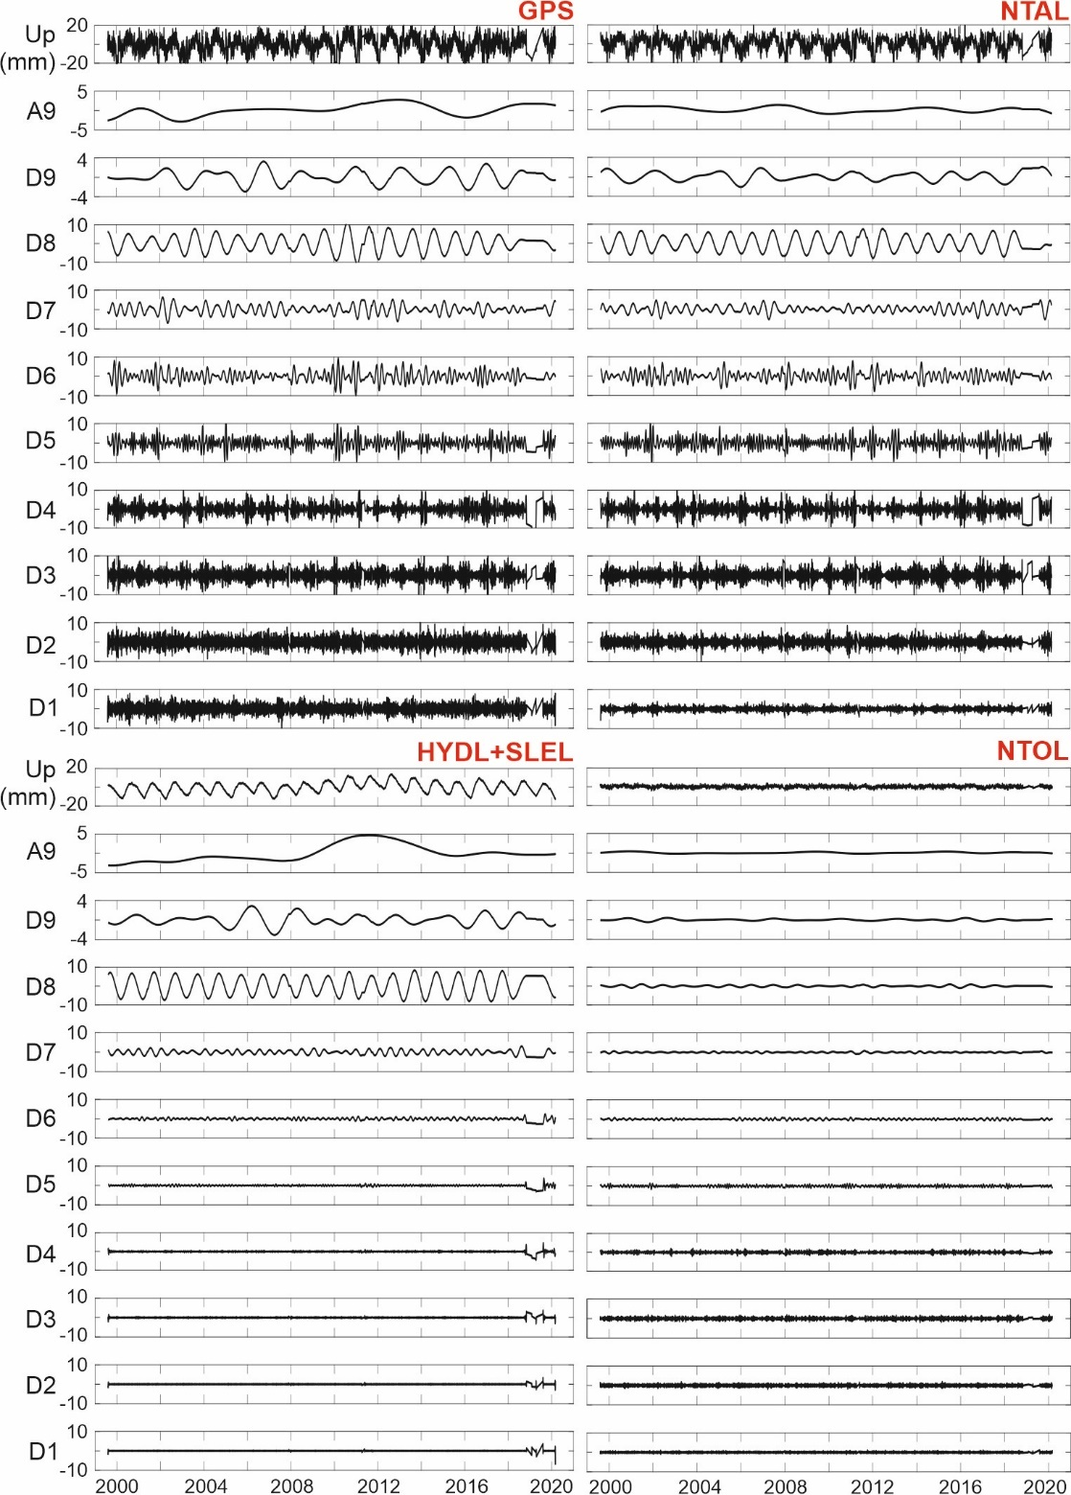
Fig. S2 Various decomposition levels for ARTU GPS station (Russia). Wavelet decomposition is performed using Meyer’s mother wavelet, by using 9 levels of decomposition. The following displacement time series were decomposed: original GPS displacement time series (GPS), displacements predicted by the non-tidal atmospheric loading model (NTAL), displacements predicted by a sum of hydrological and barystatic sea-level variations (HYDL+SLEL) and displacements predicted by non-tidal oceanic loading (NTOL). The figure is an extension of the one included in the manuscript, where contributions of NTAL and NTOL were presented together as NTAL+NTOL.

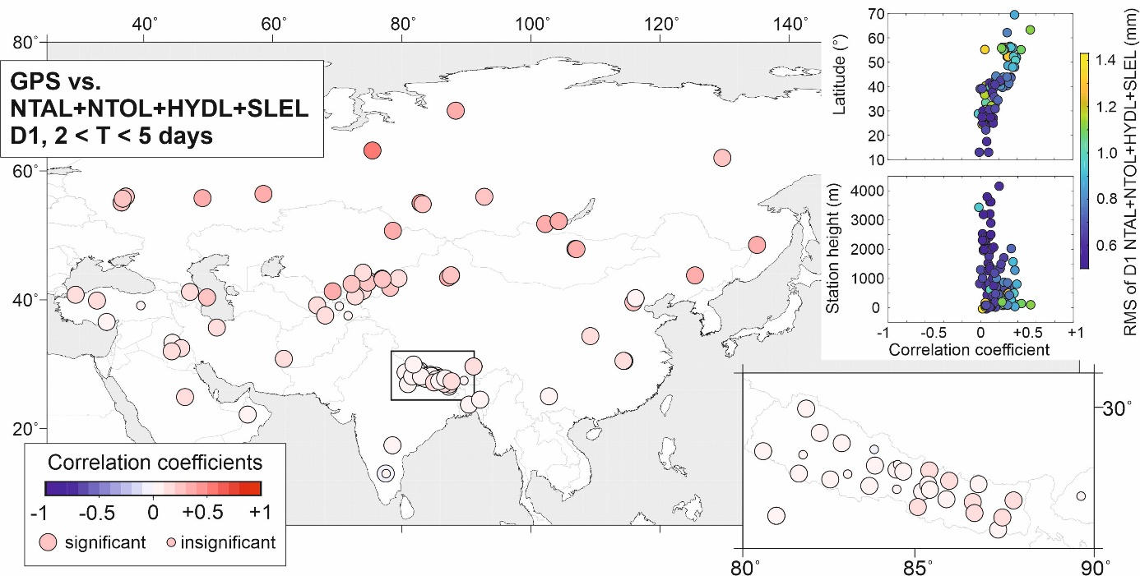
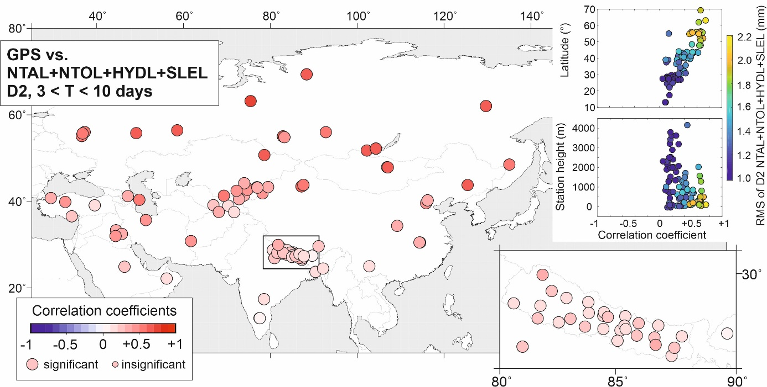
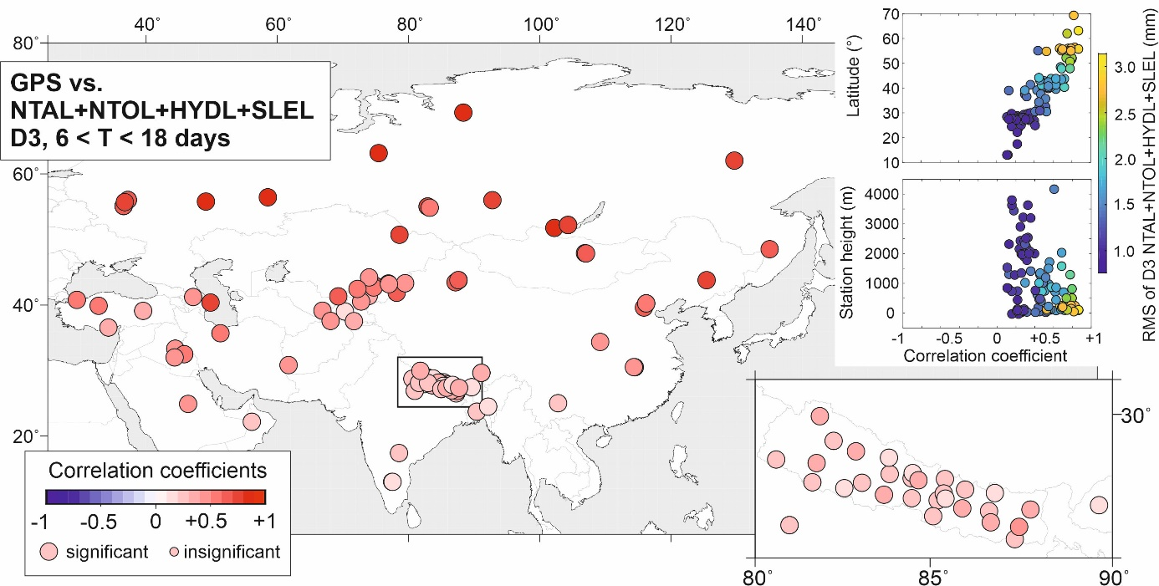
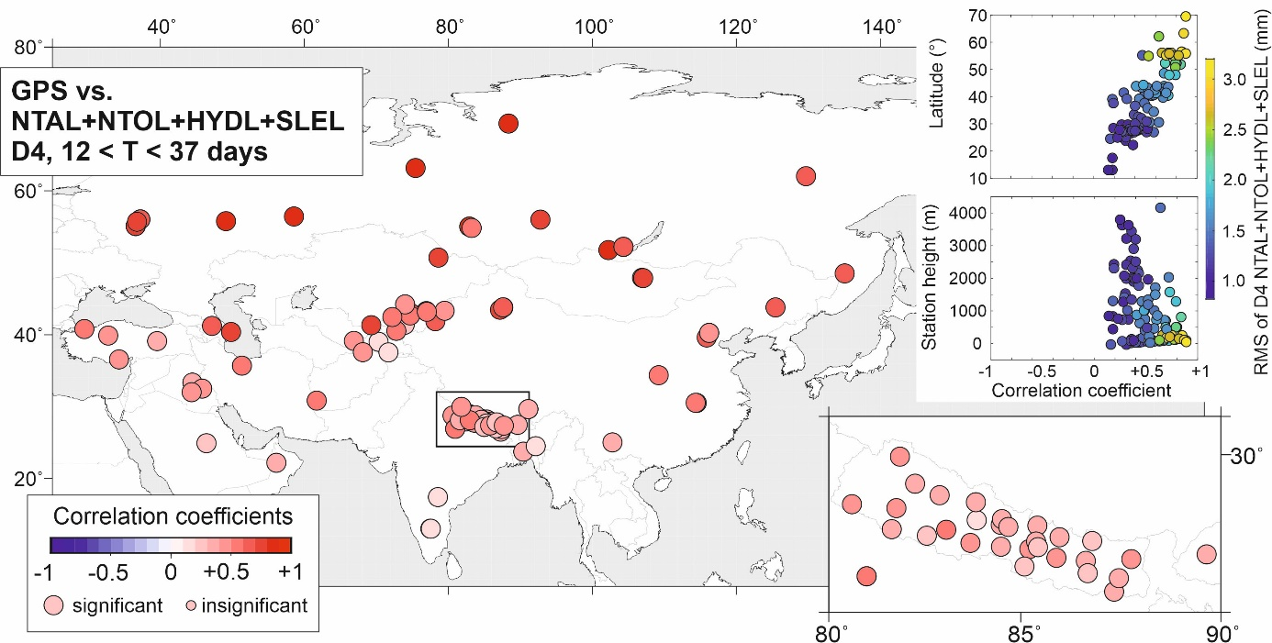
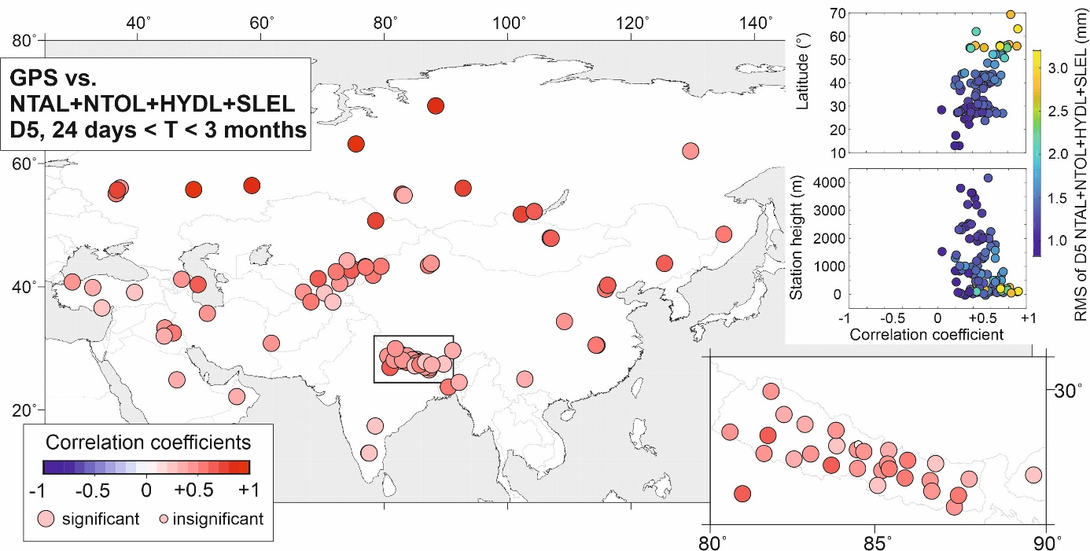
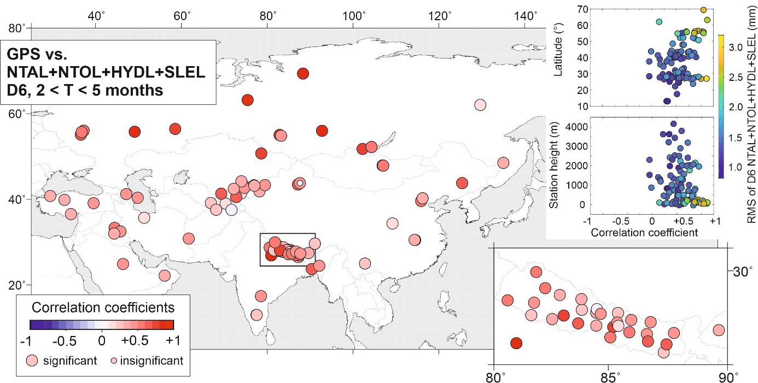
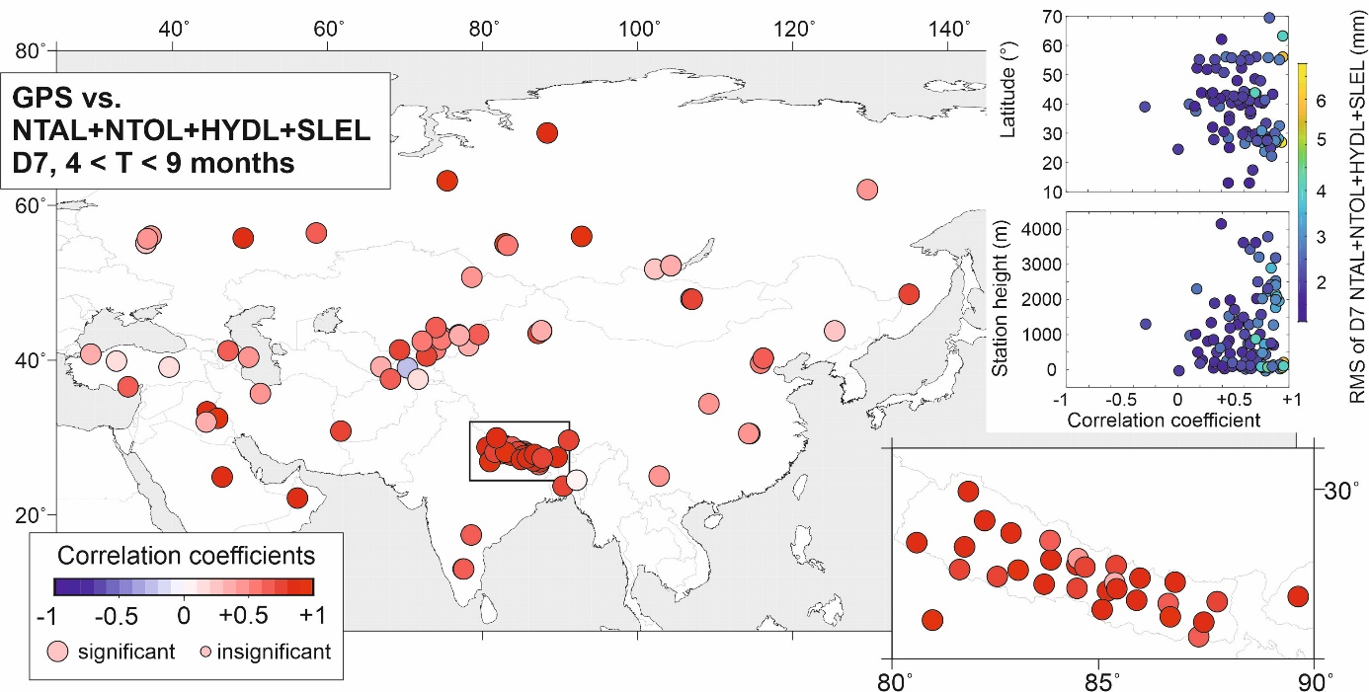
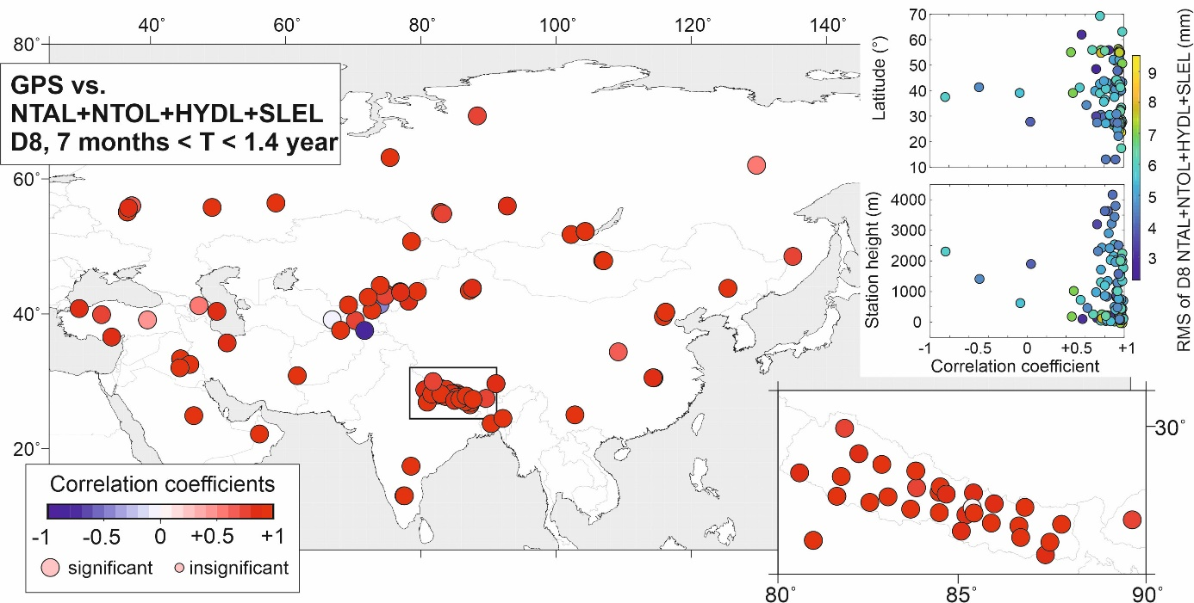
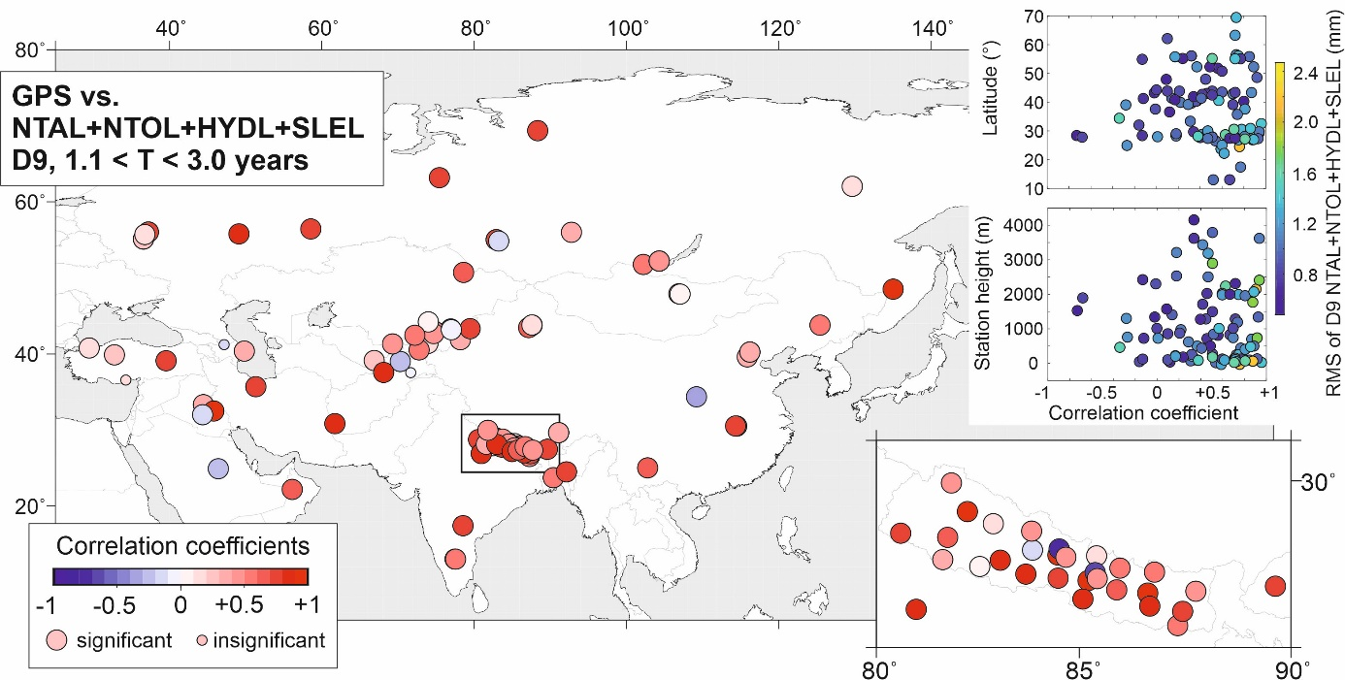
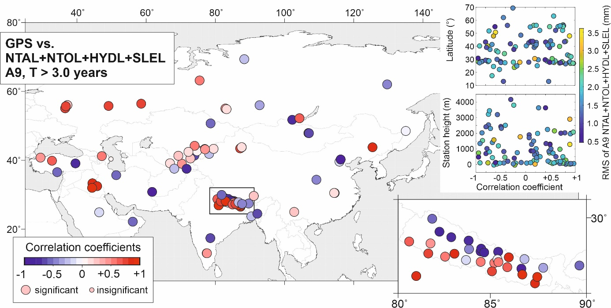
Fig. S3 Correlation coefficients between GPS displacements and displacements predicted by a sum of environmental loading models in various frequency bands, from D1 to A9. Displacements predicted by loading models are provided for a sum of non-tidal atmospheric (NTAL), non-tidal-oceanic (NTOL) and hydrologic (HYDL) models. The latter is supported by barystatic sea-level changes (SLEL) to close the global mass budget. The area marked with a black rectangle is enlarged in the right plot. Relationships between correlation coefficients and the station’s latitude and height are also presented at the right, where the dots are color-coded according to the RMS of the model-predicted vertical displacements estimated for certain frequency bands.

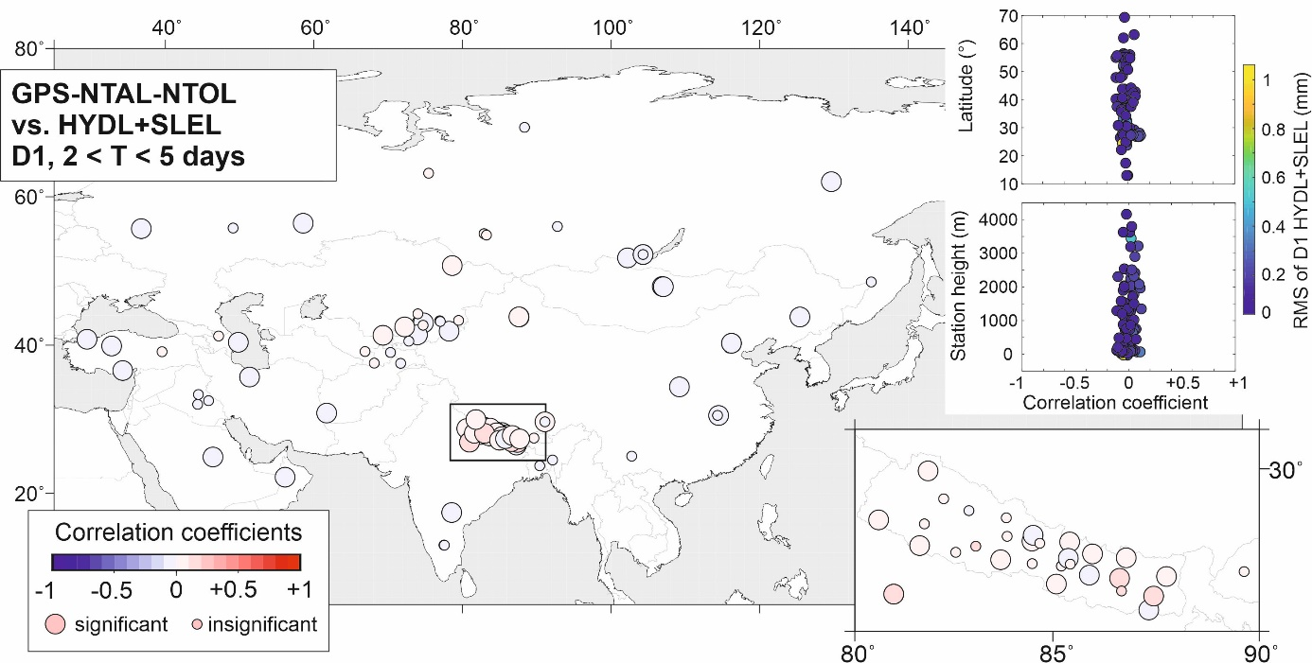
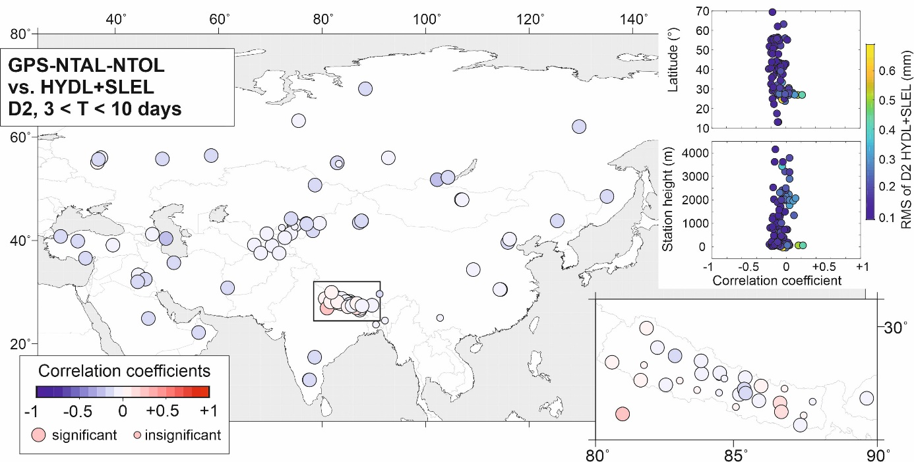
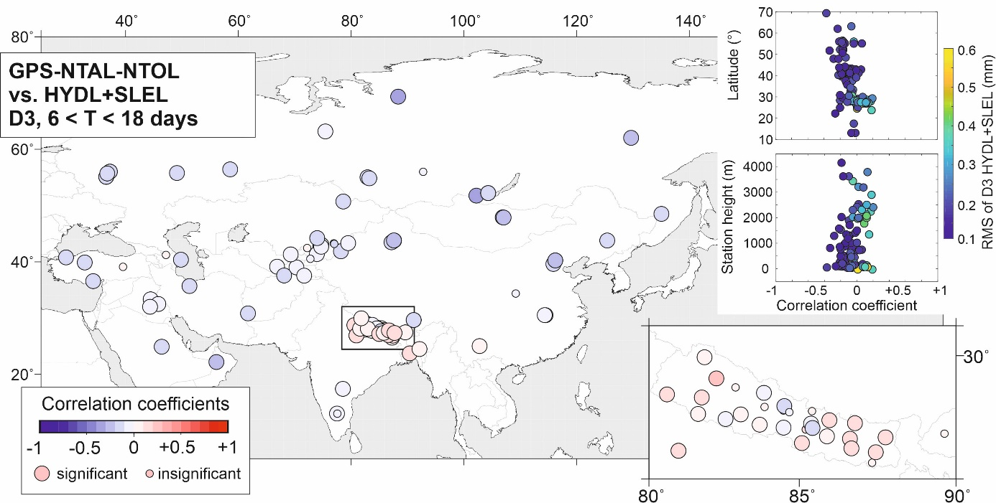
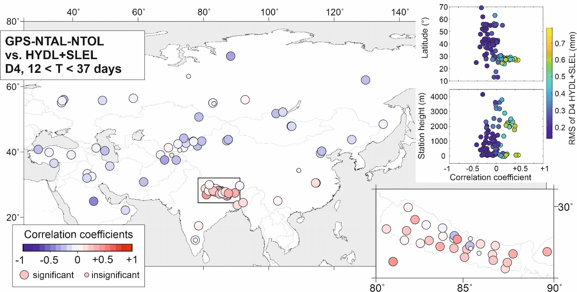
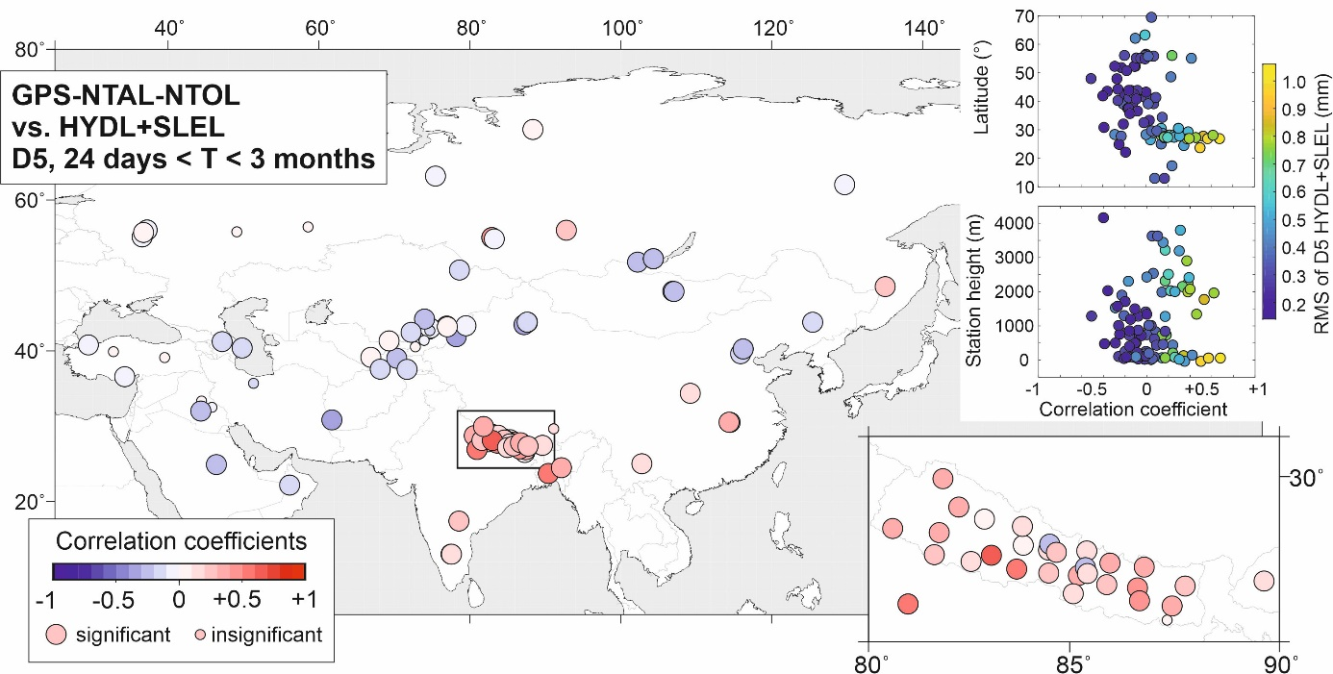
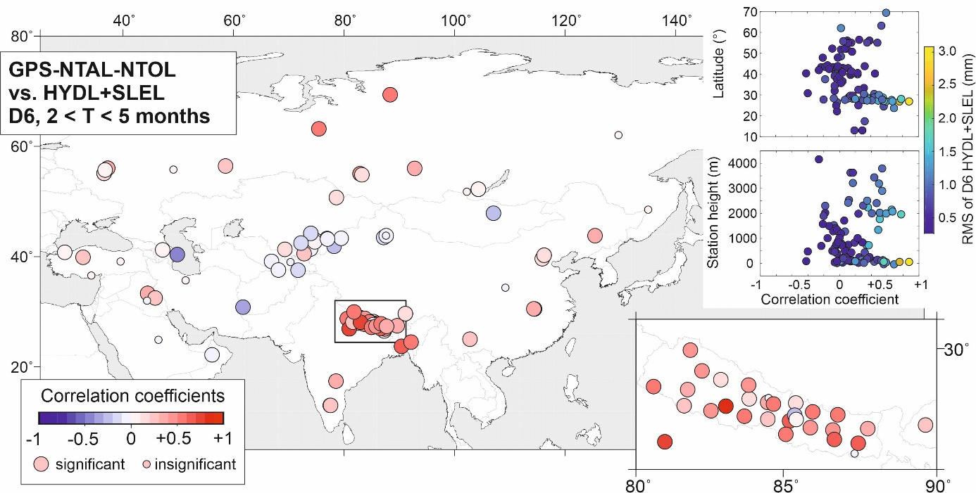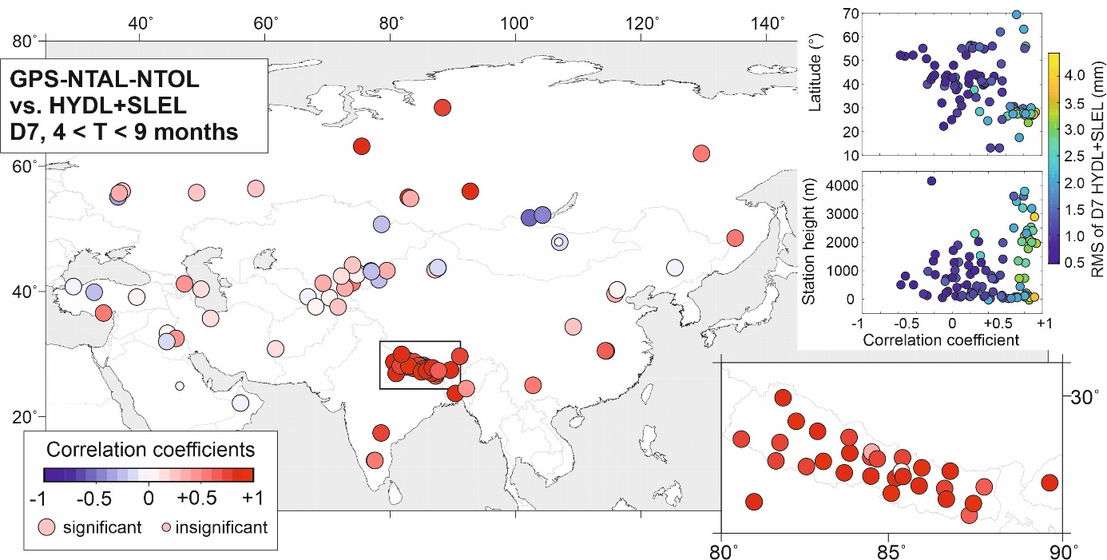
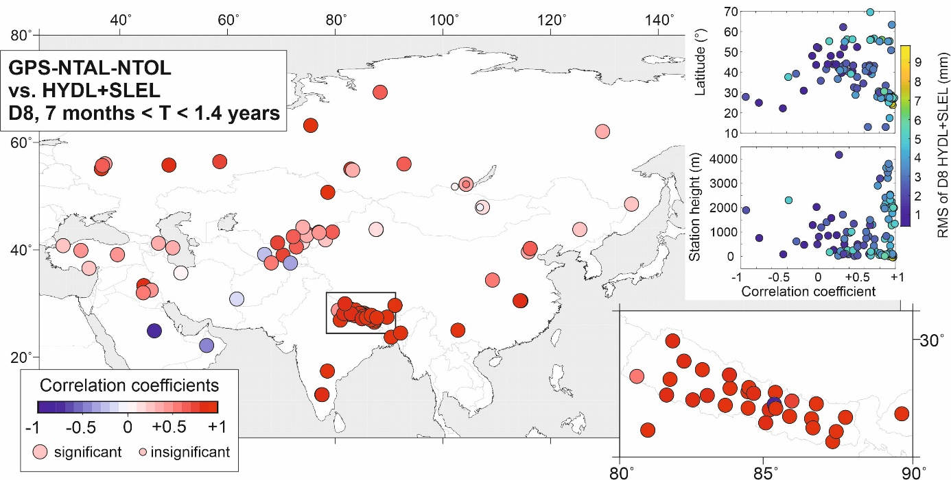
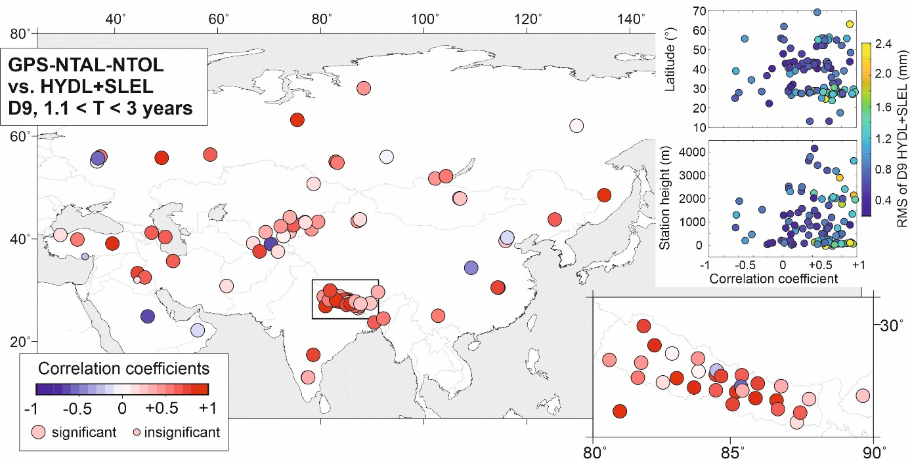
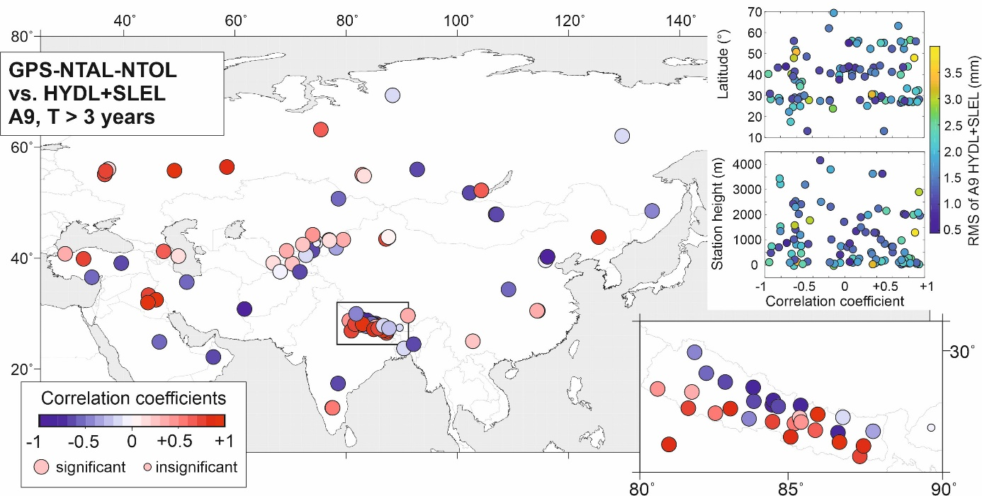
Fig. S4 Correlation coefficients between GPS displacements reduced by displacements predicted by NTAL and NTOL and displacements predicted by a sum of HYDL+SLEL in various frequency bands, from D1 to A9. The area marked with a black rectangle is enlarged in the right plot. Relationships between correlation coefficients and the station’s latitude and height are also presented at the right, where the dots are color-coded according to the RMS of the model-predicted vertical displacements estimated for certain frequency bands.

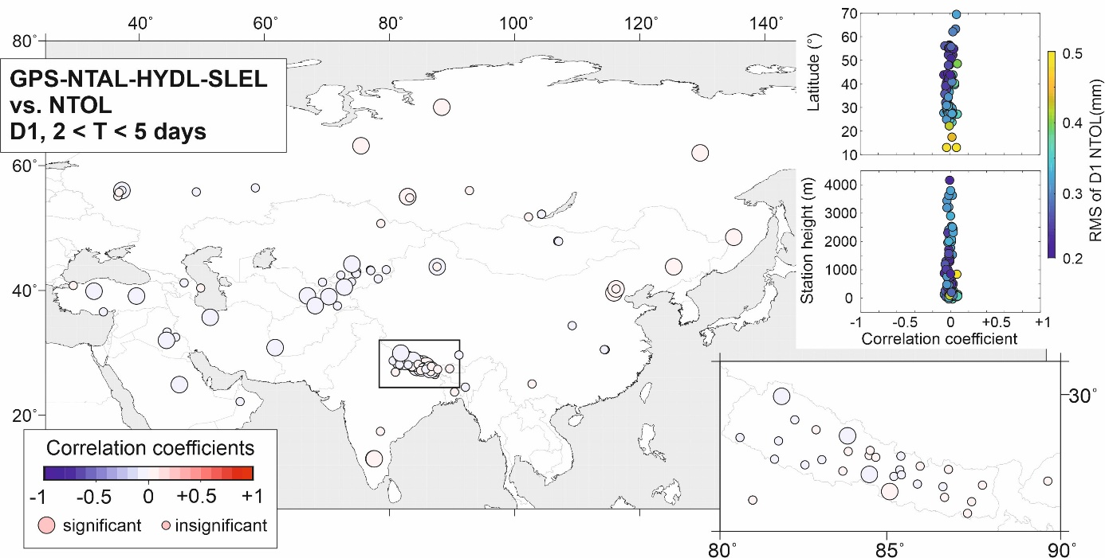
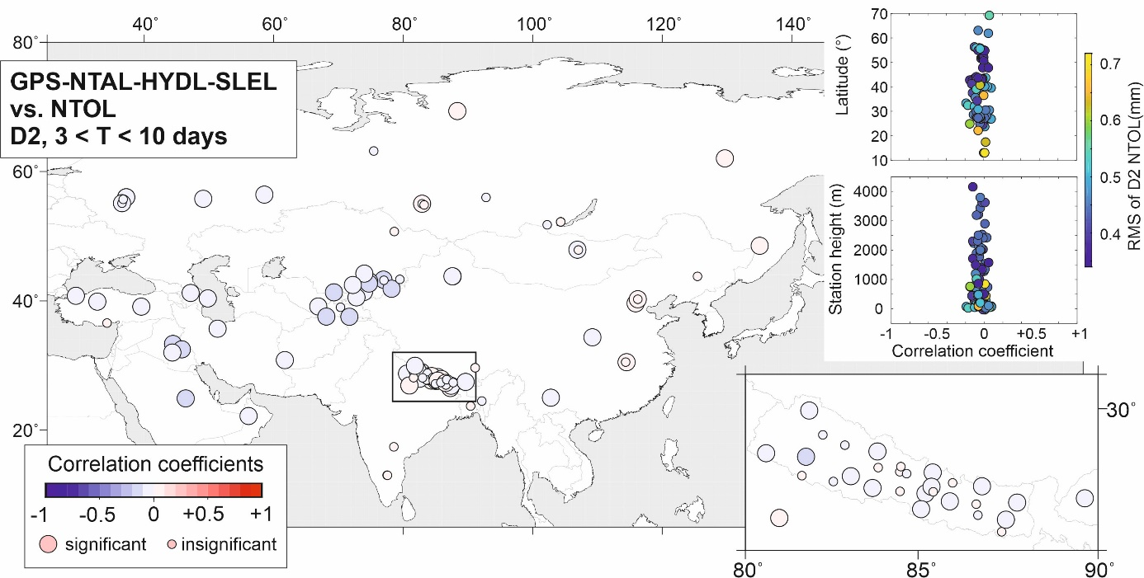
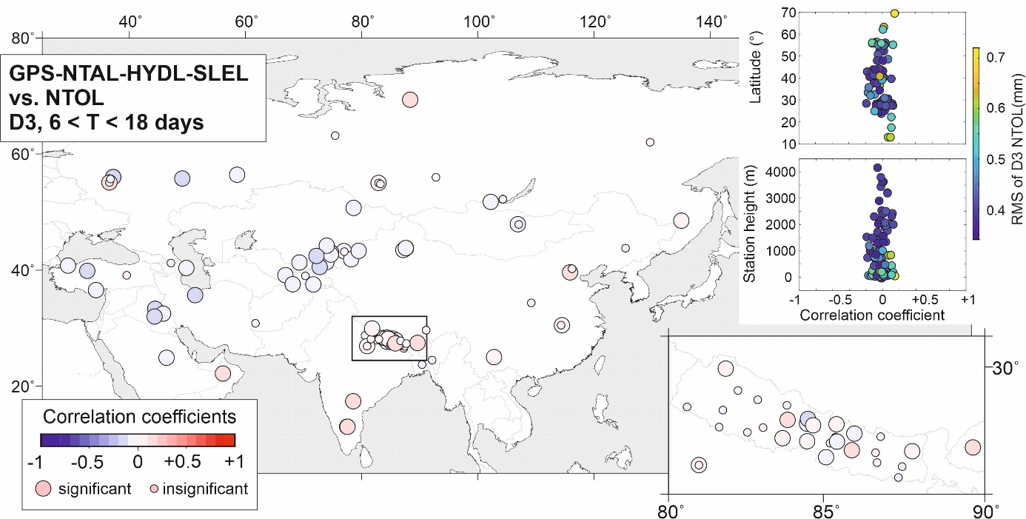
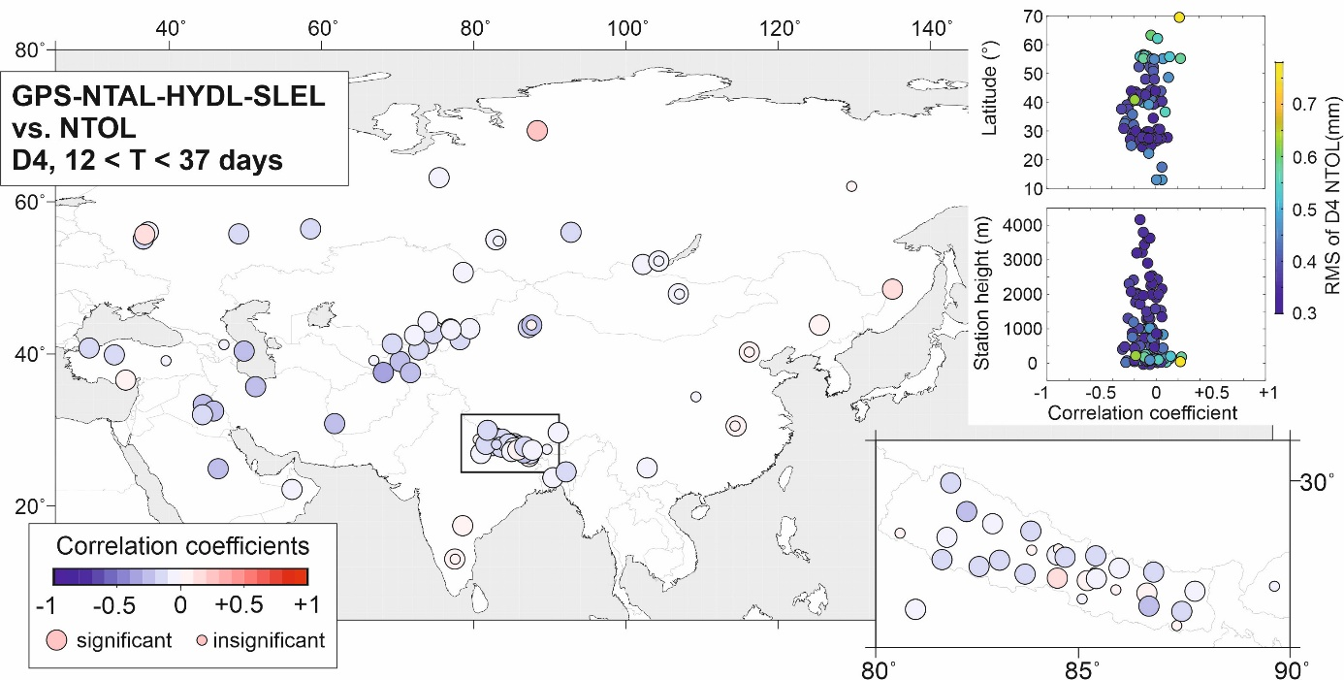
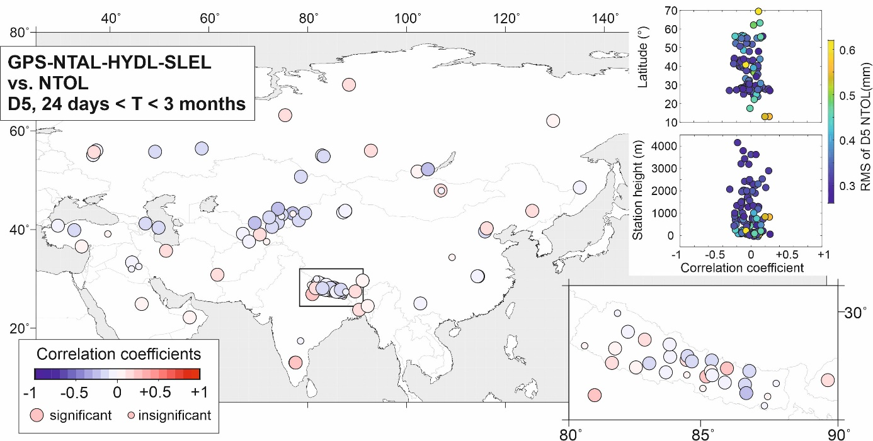
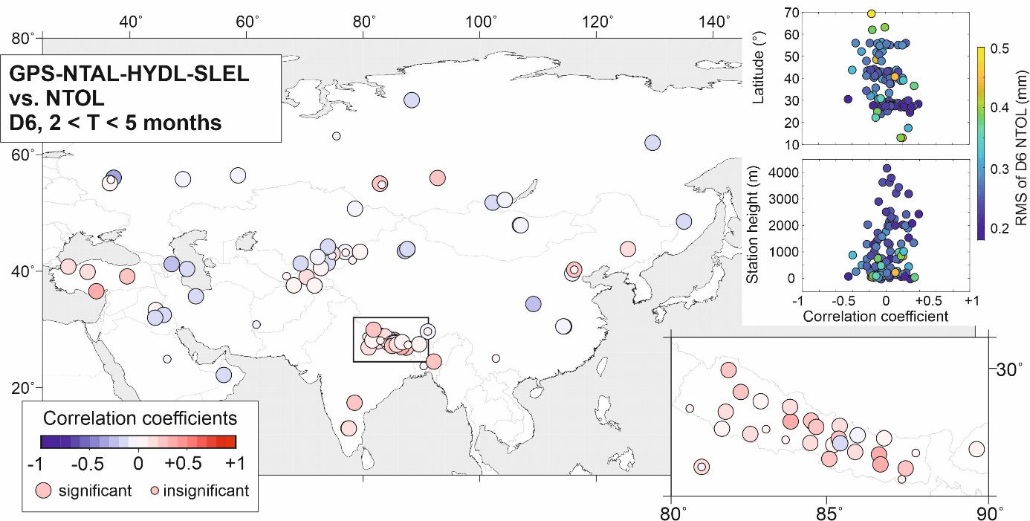
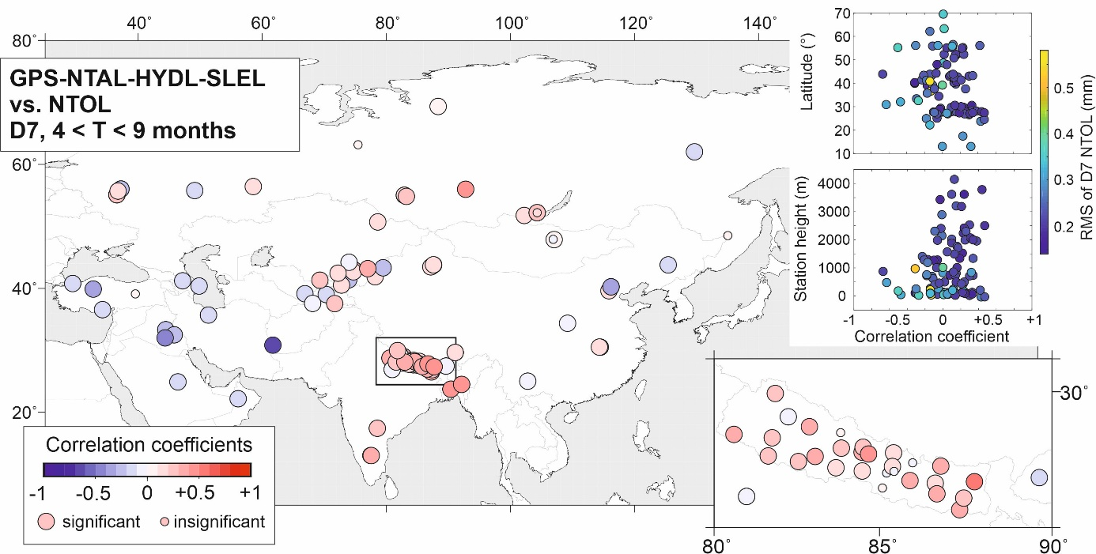
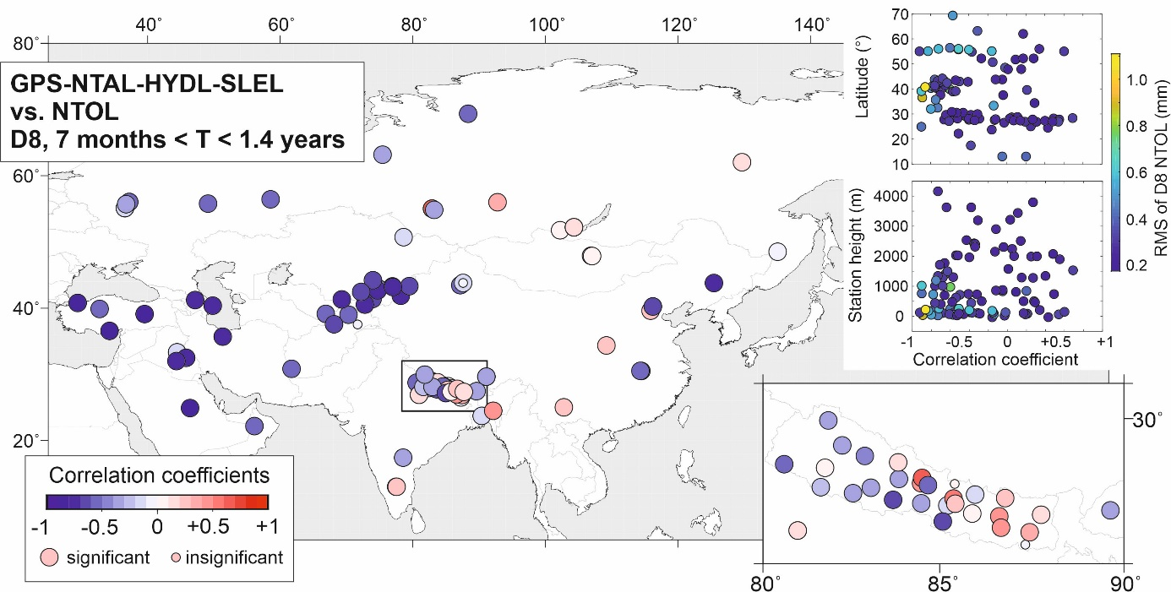
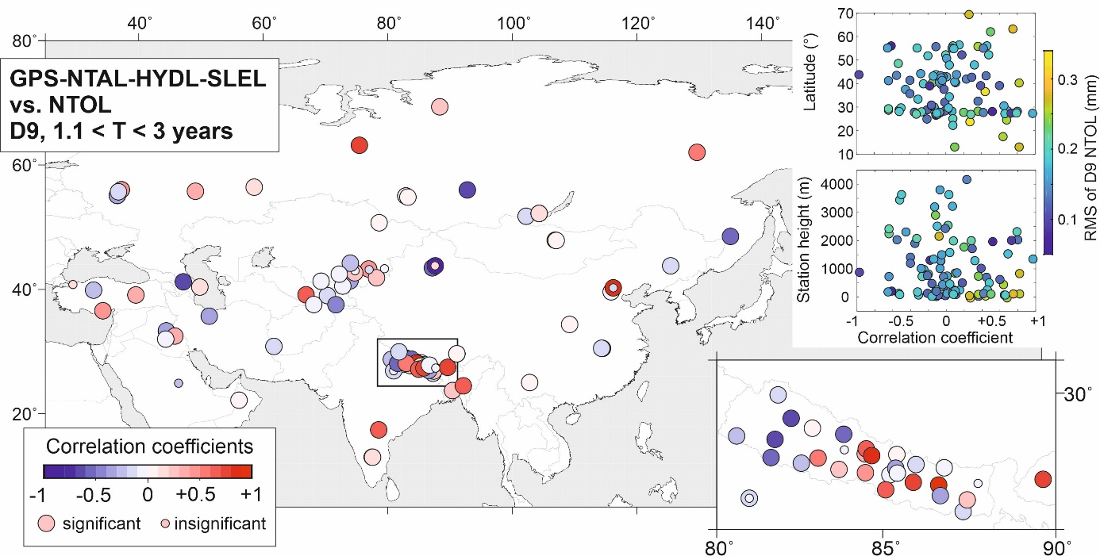
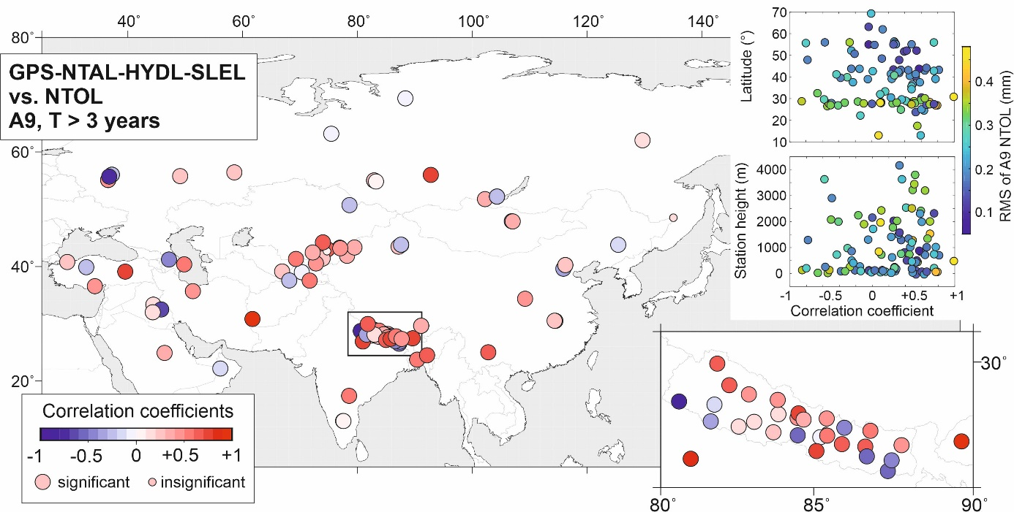
Fig. S5 Correlation coefficients between GPS displacements reduced by displacements predicted by NTAL, HYDL and SLEL and displacements predicted by NTOL in various frequency bands, from D1 to A9. The area marked with a black rectangle is enlarged in the right plot. Relationships between correlation coefficients and the station’s latitude and height are also presented at right, where the dots are color-coded according to the RMS of the model-predicted vertical displacements estimated for certain frequency bands.

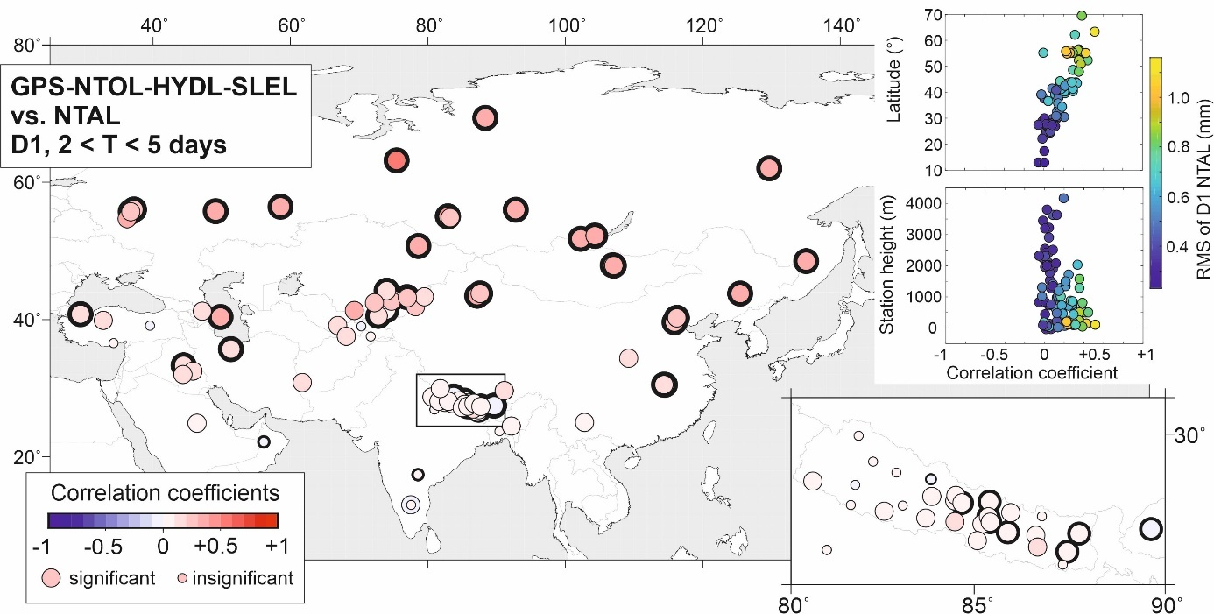
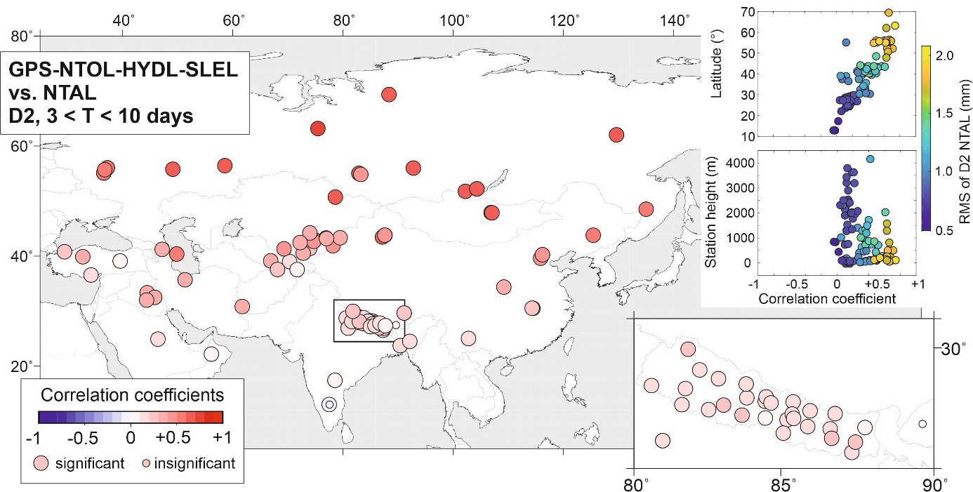
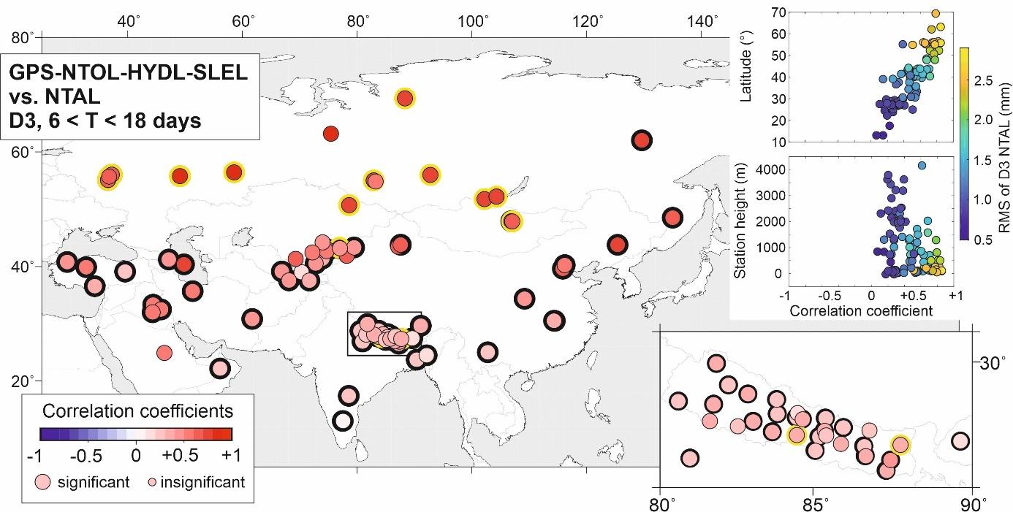
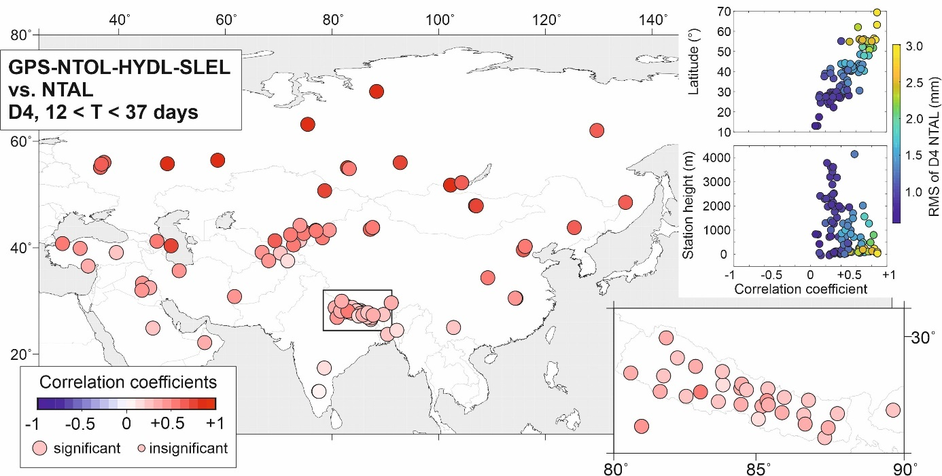
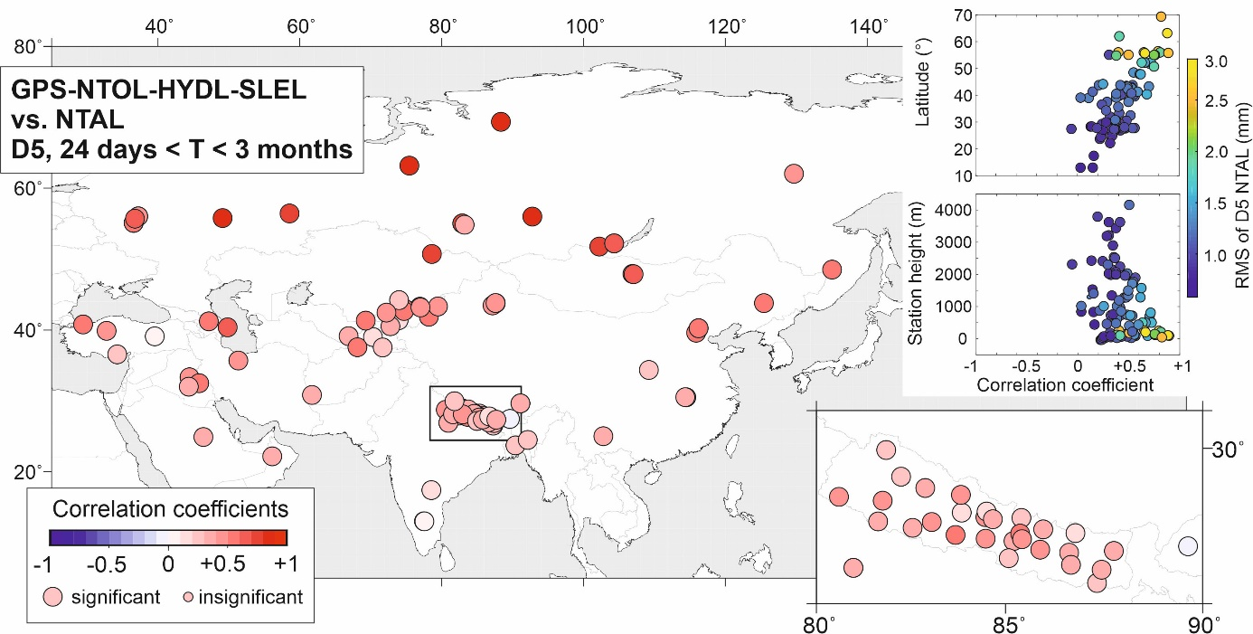
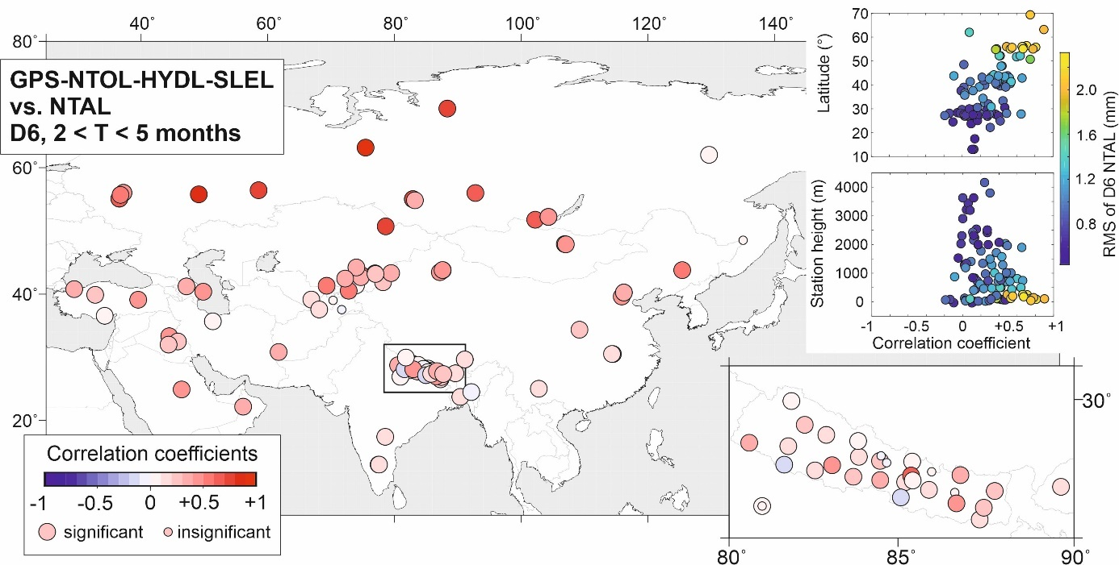
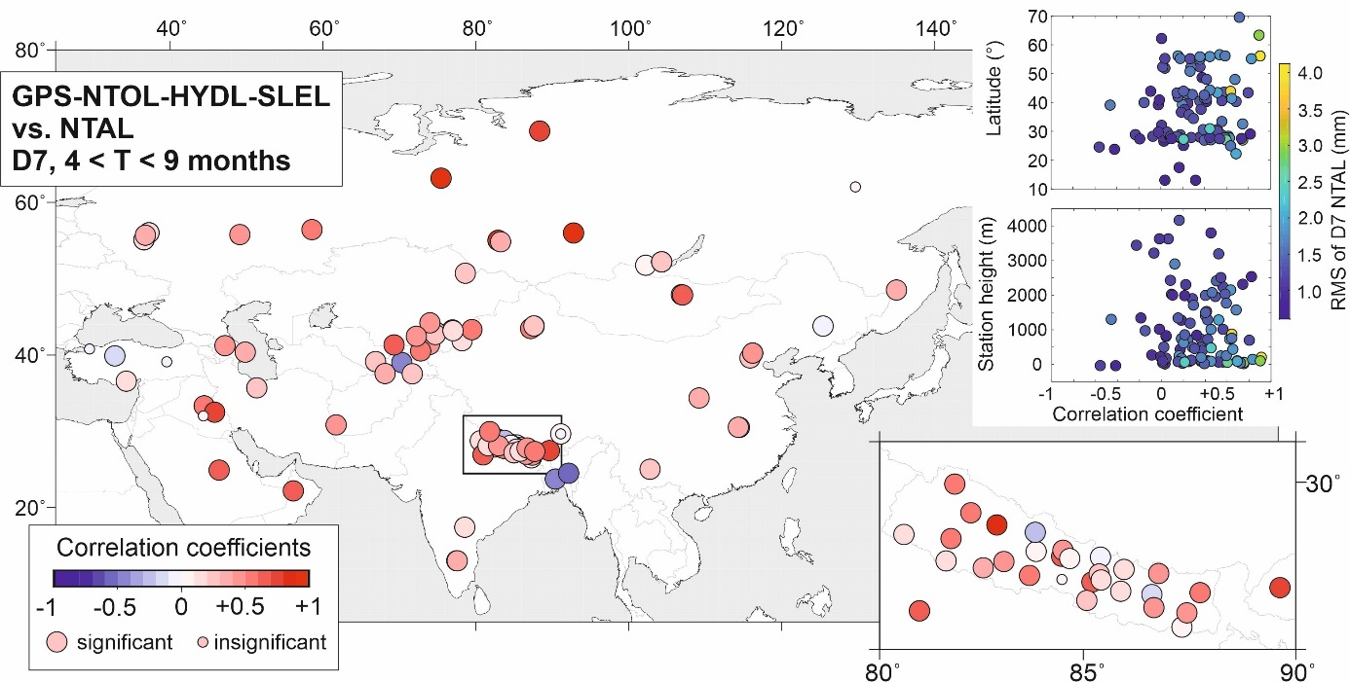
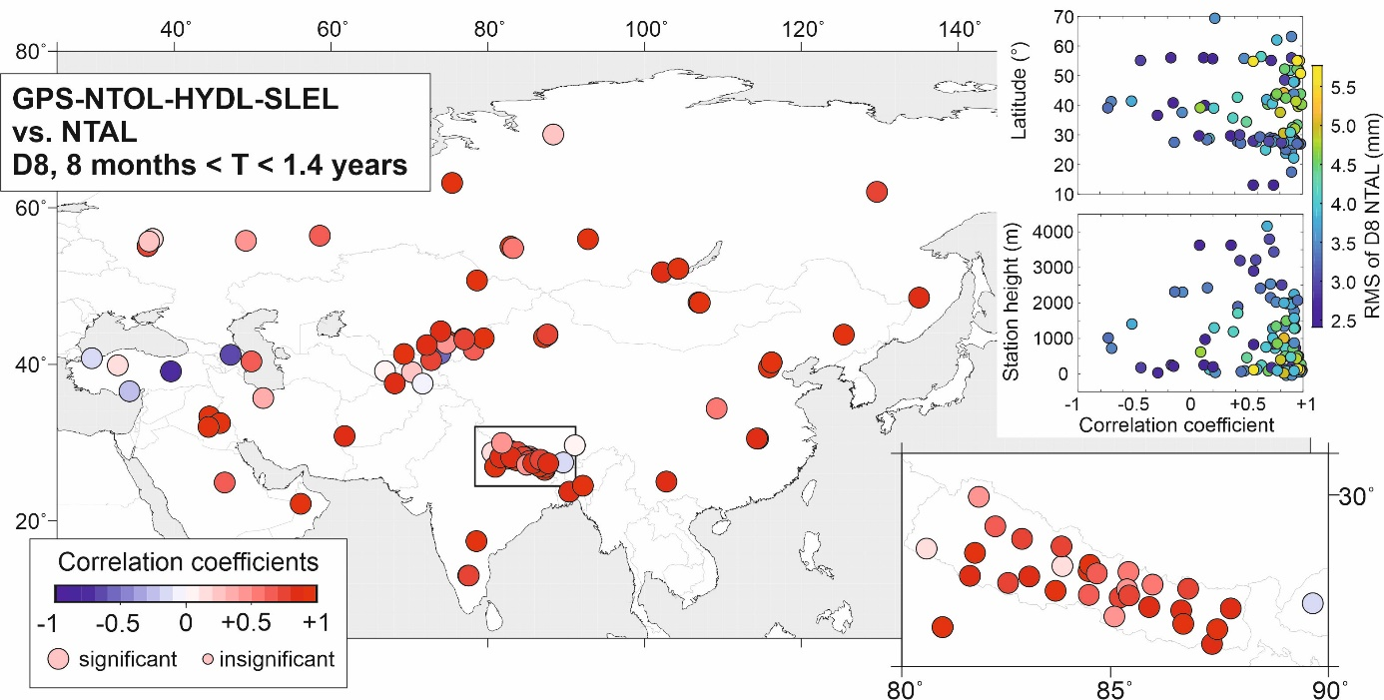
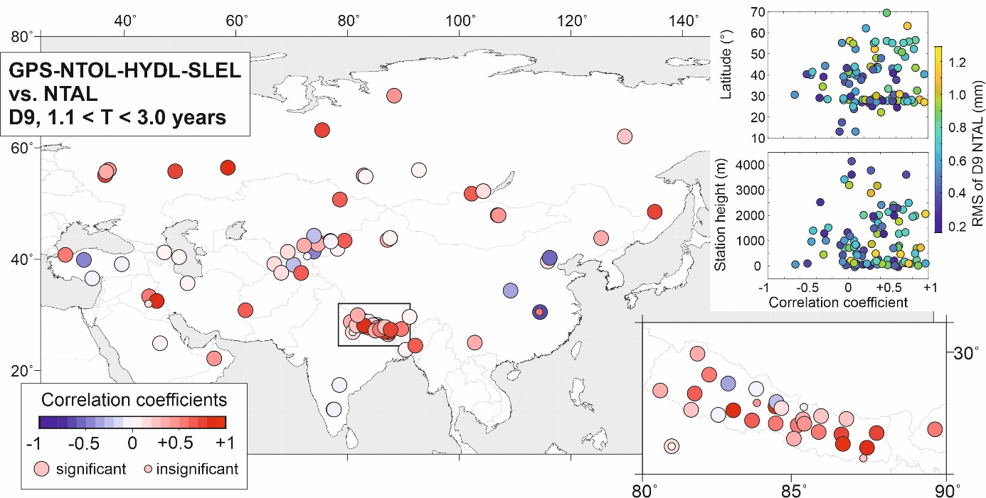
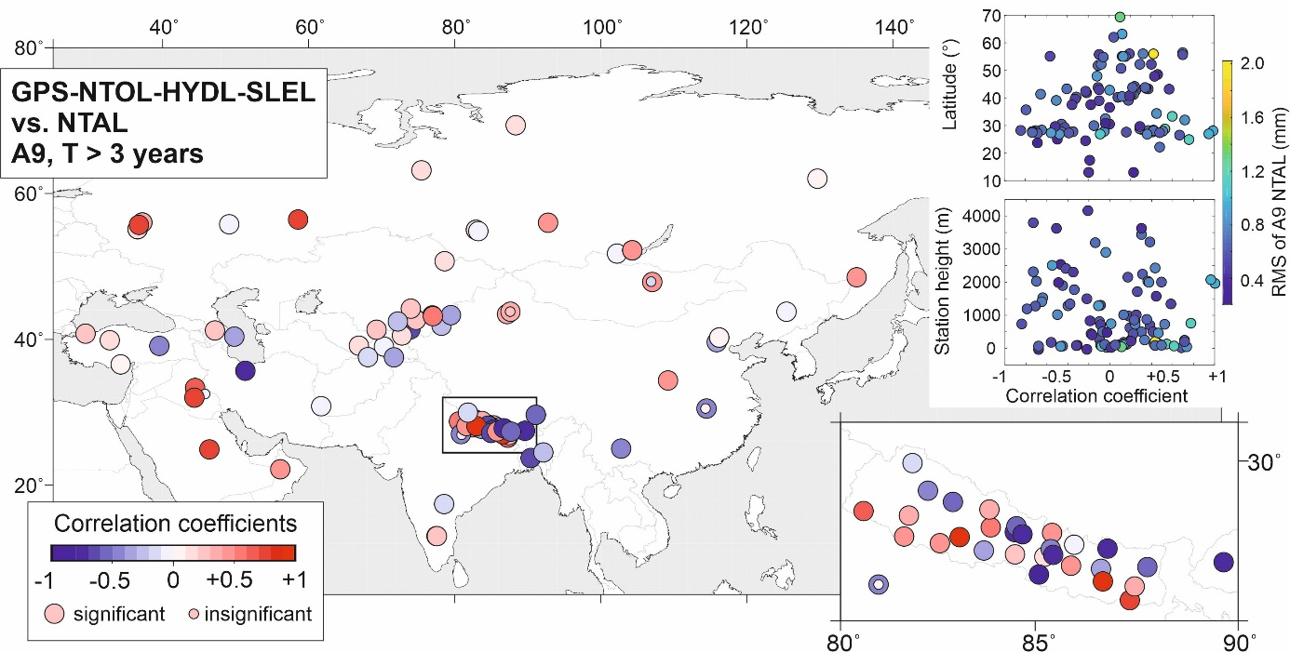
Fig. S6 Correlation coefficients between GPS displacements reduced by displacements predicted by NTOL, HYDL and SLEL and displacements predicted by NTAL in various frequency bands, from D1 to A9. The area marked with a black rectangle is enlarged in the right plot. Relationships between correlation coefficients and the station’s latitude and height are also presented at right, where the dots are color-coded according to the RMS of the model-predicted vertical displacements estimated for certain frequency bands.

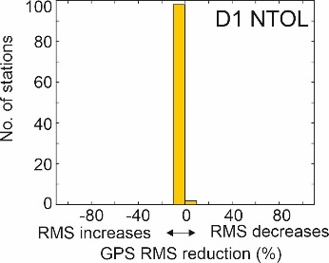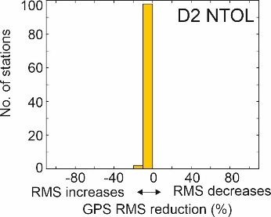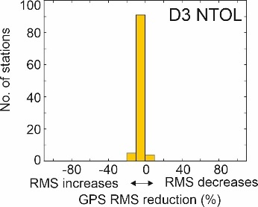
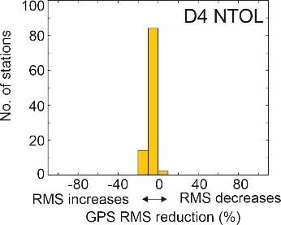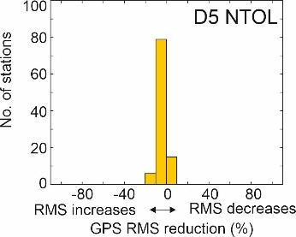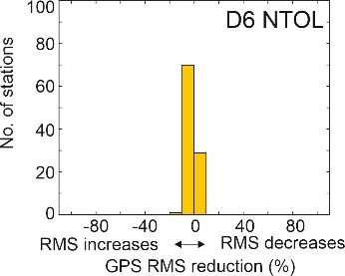
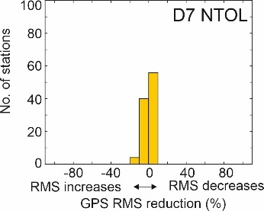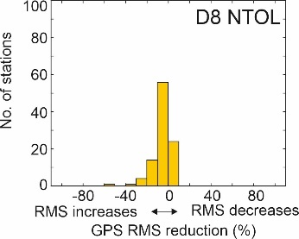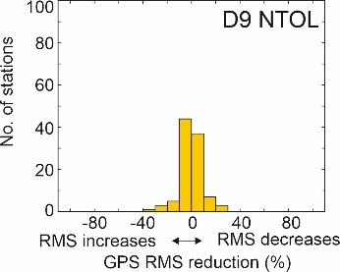
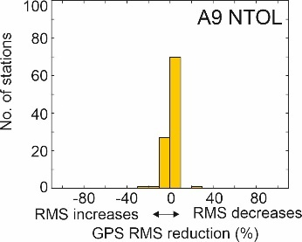
Fig. S7 Reduction of RMS of GPS vertical displacements reduced by NTAL+HYDL+SLEL, once NTOL loading model has been also removed. The reduction is presented for various frequency bands, from D1 to A9.

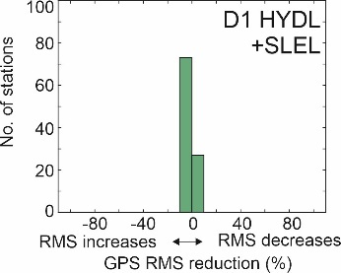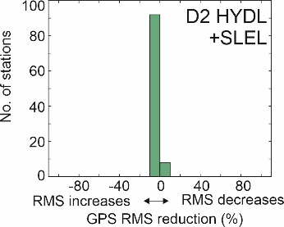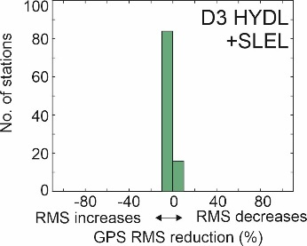
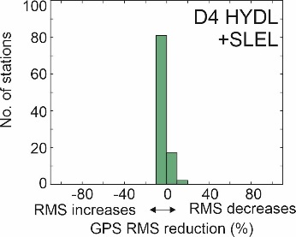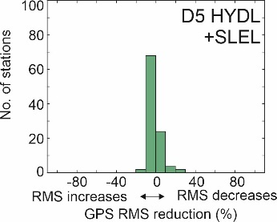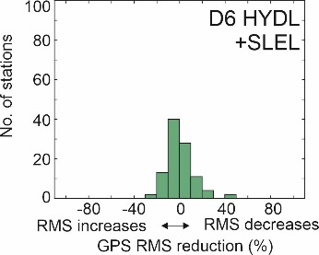
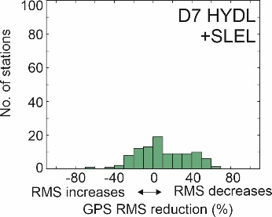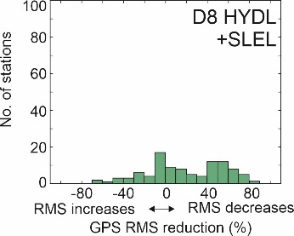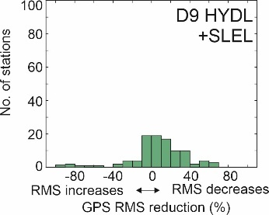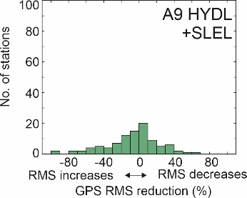
Fig. S8 Reduction of RMS of GPS vertical displacements reduced by NTAL+NTOL, once HYDL+SLEL loading models have been also removed. The reduction is presented for various frequency bands, from D1 to A9.

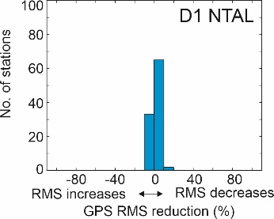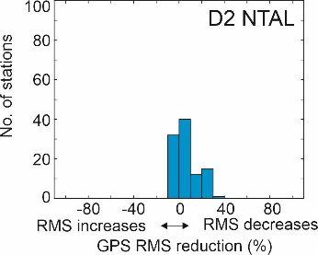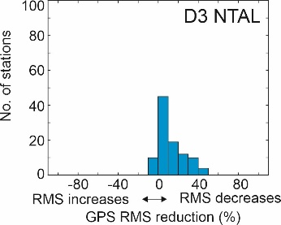
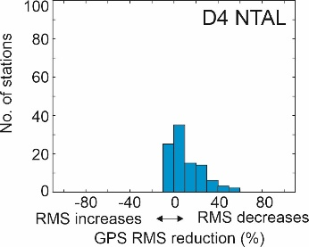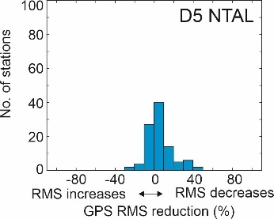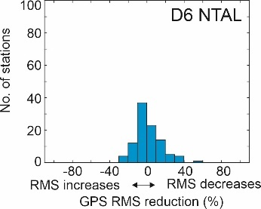
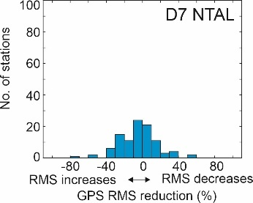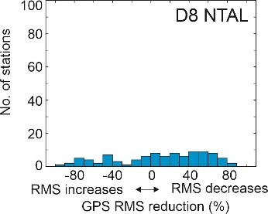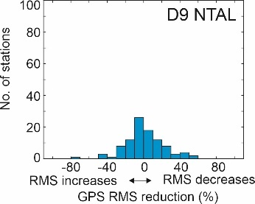
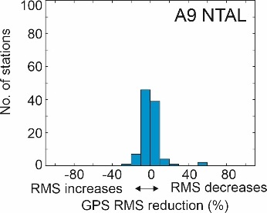
Fig. S9 Reduction of RMS of GPS vertical displacements reduced by NTOL+HYDL+SLEL, once NTAL loading model has been also removed. The reduction is presented for various frequency bands, from D1 to A9.

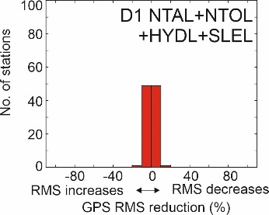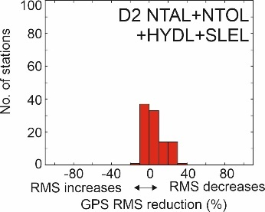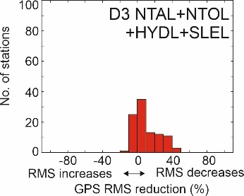
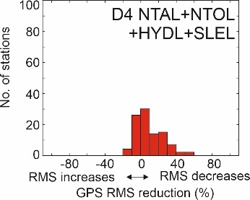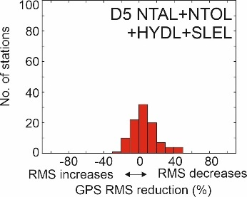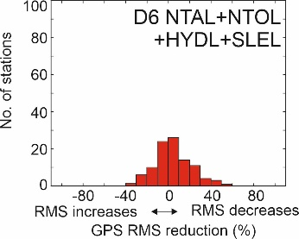
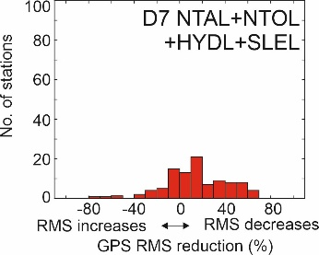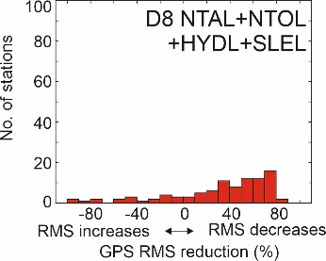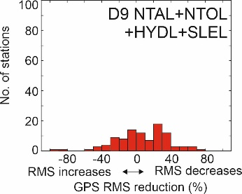
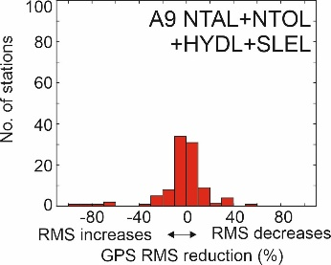
Fig. S10 Reduction of RMS of GPS vertical displacements, once NTAL+NTOL+HYDL+SLEL loading models have been also removed. The reduction is presented for various frequency bands, from D1 to A9.

