Supplement
Volcanic clouds detection applying machine learning techniques to GNSS Radio Occultations
Author information
Mohammed Hammouti (1), Christian N. Gencarelli * (1), Simone Sterlacchini (1), Riccardo Biondi (2)

(1) Institute of Environmental Geology and Geoengineering (IGAG), Italian National Research Council (CNR), Milan, Italy.
(2) CIMA Research Foundation, Savona, Italy.
*Corresponding author

Supplementary Information:

The tables in this supplementary file show other model results for the Base datasets using SVM poly3 and RBF kernels.
The figure shows the location of analyzed Radio Occultations in 11 panels.
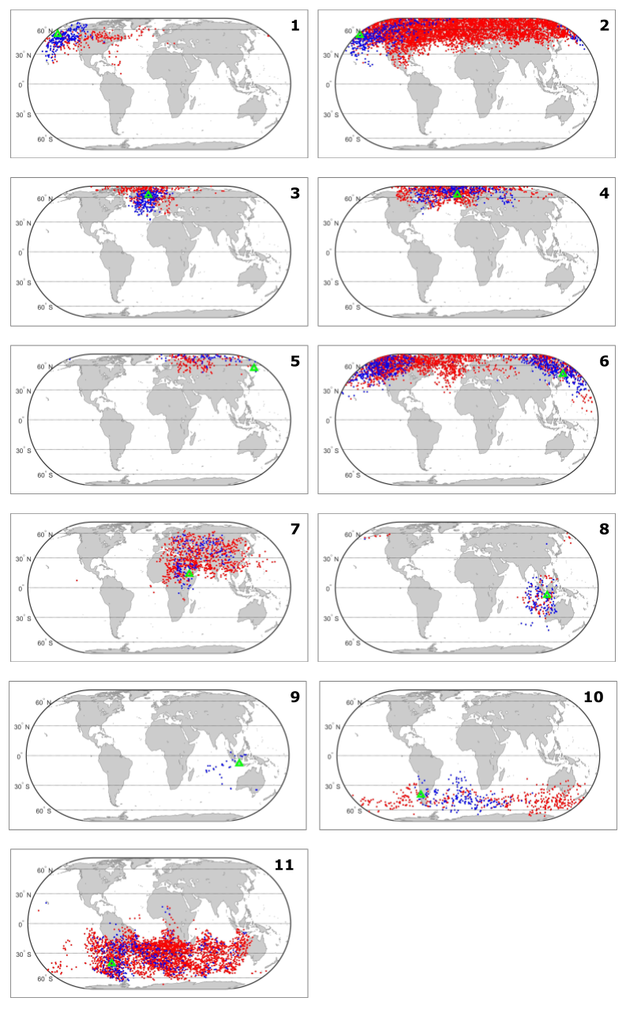
Figure S1. Location of analyzed ROs and volcanoes: 1 Okmok, 2 Kasatochi, 3 Eyjafjallajökull, 4 Grímsvötn, 5 Tolbachik, 6 Sarychev, 7 Nabro, 8 Merapi, 9 Kelut, 10 PCC, and 11 Calbuco. Red dots represent the Base_dataset, blue dots the FVC_dataset, green triangles the volcanoes.
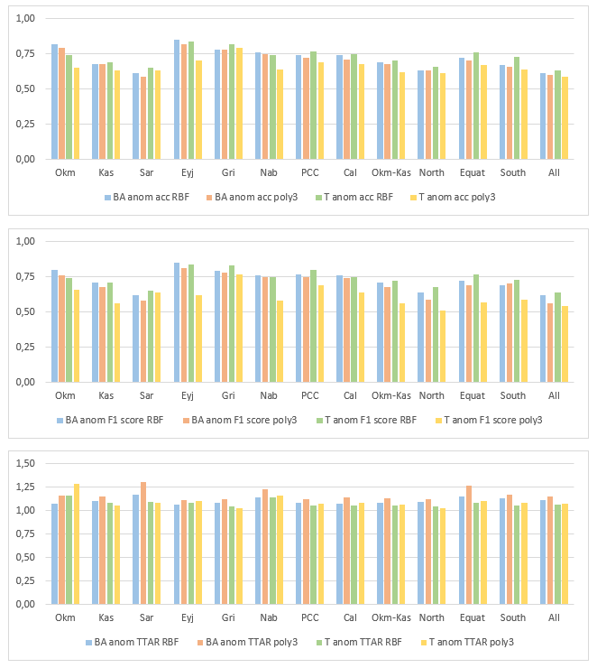
Figure S2. Model results (without Cross Validation) for Base datasets using SVM RBF and poly3 kernels. Upper panel: accuracy. Central panel: F1 score. Lower panel: TTAR.

Table S1. Model results (without Cross Validation) for Base datasets using SVM poly3 kernel.
Experiment name | BA acc | BA F1 score | BA TTAR | T acc | T F1 score | T TTAR
Okm | 0.77 | 0.74 | 1.23 | 0.70 | 0.67 | 1.21
Kas | 0.70 | 0.71 | 1.10 | 0.66 | 0.64 | 1.02
Sar | 0.60 | 0.63 | 1.23 | 0.60 | 0.60 | 1.09
Eyj | 0.80 | 0.81 | 1.16 | 0.83 | 0.83 | 1.06
Gri | 0.75 | 0.75 | 1.16 | 0.79 | 0.79 | 1.08
Nab | 0.67 | 0.69 | 1.36 | 0.61 | 0.62 | 1.15
PCC | 0.63 | 0.64 | 1.28 | 0.75 | 0.77 | 1.06
Cal | 0.72 | 0.73 | 1.11 | 0.73 | 0.76 | 1.03
Okm-Kas | 0.63 | 0.64 | 1.11 | 0.61 | 0.60 | 1.05

Table S2. Model results (without Cross Validation) for Base datasets using SVM RBF kernel.
Experiment name | BA acc | BA F1 score | BA TTAR | T acc | T F1 score | T TTAR
Okm | 0.79 | 0.78 | 1.06 | 0.74 | 0.73 | 1.07
Kas | 0.69 | 0.72 | 1.02 | 0.66 | 0.67 | 1.02
Sar | 0.60 | 0.65 | 1.10 | 0.60 | 0.63 | 1.04
Eyj | 0.80 | 0.81 | 1.03 | 0.82 | 0.83 | 1.03
Gri | 0.75 | 0.77 | 1.02 | 0.77 | 0.79 | 1.02
Nab | 0.69 | 0.70 | 1.12 | 0.62 | 0.63 | 1.08
PCC | 0.63 | 0.67 | 1.08 | 0.71 | 0.72 | 1.02
Cal | 0.72 | 0.73 | 1.03 | 0.72 | 0.74 | 1.01
Okm-Kas | 0.62 | 0.66 | 1.04 | 0.60 | 0.60 | 1.02

Table S3. Model results (without Cross Validation) for Base datasets using SVM poly3 kernel.
Experiment name | BA anom acc | BA anom F1 score | BA anom TTAR | T anom acc | T anom F1 score | T anom TTAR
Okm | 0.79 | 0.76 | 1.16 | 0.65 | 0.66 | 1.29
Kas | 0.68 | 0.68 | 1.15 | 0.63 | 0.56 | 1.05
Sar | 0.59 | 0.58 | 1.30 | 0.63 | 0.64 | 1.08
Eyj | 0.82 | 0.81 | 1.11 | 0.70 | 0.62 | 1.10
Gri | 0.78 | 0.78 | 1.12 | 0.79 | 0.77 | 1.03
Nab | 0.75 | 0.75 | 1.23 | 0.64 | 0.58 | 1.16
PCC | 0.72 | 0.75 | 1.12 | 0.69 | 0.69 | 1.07
Cal | 0.71 | 0.74 | 1.14 | 0.68 | 0.64 | 1.08
Okm-Kas | 0.68 | 0.68 | 1.13 | 0.62 | 0.56 | 1.06
North | 0.63 | 0.59 | 1.12 | 0.61 | 0.51 | 1.03
Equat | 0.70 | 0.69 | 1.27 | 0.67 | 0.57 | 1.10
South | 0.66 | 0.70 | 1.17 | 0.64 | 0.59 | 1.08
All | 0.60 | 0.56 | 1.15 | 0.59 | 0.54 | 1.07
Test1 | 0.46 | 0.36 | 1.57 | 0.53 | 0.47 | 1.24
Test2 | 0.56 | 0.54 | 1.40 | 0.53 | 0.46 | 1.25
Test3 | 0.55 | 0.52 | 1.33 | 0.42 | 0.29 | 1.57
Test4 | 0.53 | 0.48 | 1.37 | 0.61 | 0.64 | 1.08

