  - Geocenter motion based on GNSS – a comparison between low-degree surface load coefficients and network shift parameters
  - Adrian Nowak¹ (0000-0003-2103-4245), Radosław Zajdel^{2,1} (0000-0002-1634-388X), Krzysztof Sośnica¹ (0000-0001-6181-1307)
¹ Wrocław University of Environmental and Life Sciences, Institute of Geodesy and Geoinformatics, Grunwaldzka Str. 53, 50-357 Wrocław, Poland
² Research Institute of Geodesy, Topography and Cartography, Geodetic Observatory Pecný, Ústecká 98, 250 66 Zdiby, Czechia
e-mail: adrian.nowak@upwr.edu.pl

Contents of this file:
- Introduction
- Text S1, Figure S1
- Table S1
- Text S2, Figure S2
- References

Introduction
Supplementary information provides additional results of the analyses that support the conclusions and justify the choices made in the main text of the article. The nomenclature and references in the supporting information are consistent with those in the main article.
Text S1 and Figure S1 contain explanations related to the drifts of the GNSS-based geocenter solutions discussed in the article. In Table S1, the annual and semi-annual amplitudes and phases of the estimated geocenter variations for the individual GNSS-based and SLR solutions are explored. Text S2 and Figure S2 provide a complementary analysis of the seasonal component for all components of geocenter motion and all test cases, along with the reference SLR solution for clarity. The analysis shows the percentage of the total variance in the seasonal component that can be explained by the sum of annual and semi-annual signals.

Text S1: Drift of the geocenter
The current parametrization of the station positions indirectly accounts for linear motions caused by geophysical phenomena acting on secular time scales. These include the mixture of plate tectonics, glacial isostatic adjustment, and the present-day surface mass trend. The latter two phenomena are the primary drivers of the geocenter motion on secular time scales. As a consequence of this parametrization, the International Terrestrial Reference Frame (ITRF) origin reflects the Center of Mass (CM) on secular time scales, neglecting short-term deviations from the long-term mean. The definition of the ITRF origin as a linear function of time, as well as the limited stability of its origin (Riddell et al., 2017), has the effect of reducing the value of the secular geocenter motion derived from Satellite Laser Ranging (SLR) data. Consequently, the long-term trend becomes unobservable and, in theory, is ideally absorbed by estimated station velocities. The CM approach, employing elastic deformation time series from GNSS-repro3 data, also lacks the capacity to recover long-term trends in geocenter motion. The GNSS-based geocenter solutions to repro3 represent CM coordinates with respect to the IGSR3 datum, which naturally inherits its origin from ITRF2014. Therefore, the linear trends shown in Figure S1 represent the long-term drift between the CM sensed by the CODE-repro3 solutions from the two approaches and the ITRF2014 origin. This drift linearly follows the CM sensed by the SLR input to ITRF2014 (Altamimi et al., 2016). Additionally, Figure S1 shows the trend estimated from SLR data from the dynamic approach for comparison.
In general, from 2002 to 2020, the long-term CM for the Z component, as determined by GNSS data, aligns with the long-term CM identified by SLR within the 1-sigma uncertainty range obtained by Riddell et al. (2017) for the ITRF2014 origin. This range is ±0.33 mm/year employing a power law and white noise model. From the same study, the uncertainties for the X- and Y-components are ±0.13 and ±0.17 mm/year, respectively. For the X-component, all values obtained from GNSS do not fall outside this range. However, for the Y-component, three GNSS inversion solutions (CM-1, CM-7, and CM-8), which exceed the value of ±0.17 mm/year, while the Network Shift (NSH) solution is identified as having the largest value with a clear negative trend exceeding −0.5 mm/year.
The Z-component reflects the exchange of mass between the northern and southern hemispheres (Blewitt et al., 2001). In this case, with a negative trend, more mass is transported from north to south. Theoretically, no trend is expected in the SLR estimates over the period defining the ITRF, as station velocities are expected to absorb it. However, a slight positive trend in the SLR solution, with an approximate rate of 0.2 mm/year, has been observed. Due to the fact that ITRF2014 uses SLR input data up to 2015, trend values prior to 2015 and during the period 2015-2020 are calculated. The results obtained oscillate around 0 in the first period (for all components) and begin to drift after the start of 2015 with values of 0.35, 0.29, and 0.72 mm/year for X, Y, and Z components, respectively. This trend is most likely the result of ITRF2014 extrapolation errors rather than an actual geophysical signal. A similar observation can be made when examining GNSS-based estimates, though this is only evident for the Z component. In contrast to the SLR, an opposing trend is noted from about −0.1 to −0.8 mm/year in extreme cases (i.e., CM-8 and NSH solutions). The variable trends observed in GNSS approaches are likely attributable to the network effect and the associated complications arising from the approximation of CF by different CNs.

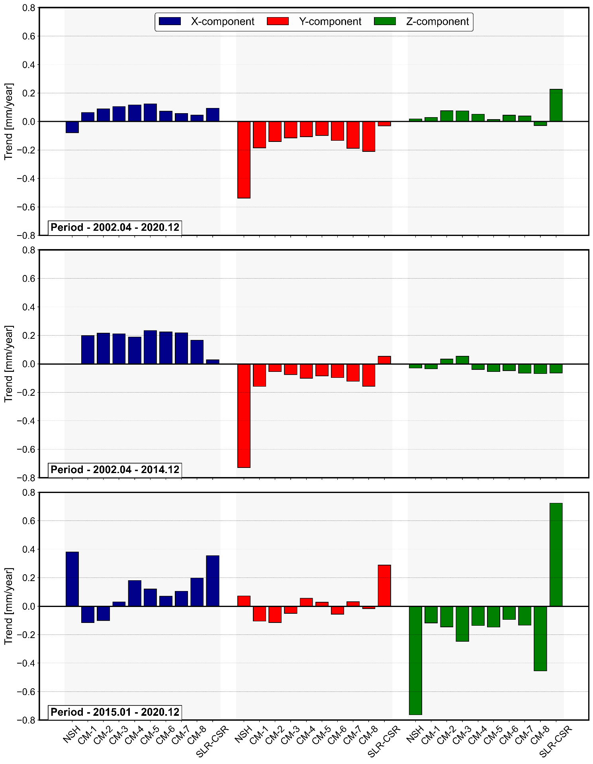
Figure S1. Linear trends (in mm/year) adjusted to the original geocenter time series from the GNSS-NSH, GNSS-CM approach, and SLR for different periods.

Table S1. Annual and semi-annual amplitudes (A) and phases (φ) of the estimated geocenter variations for different solutions. Uncertainties represent one-sigma formal errors from the least-square fits.
Solution | X | Y | Z
Solution | A [mm] / φ [°] | A [mm] / φ [°] | A [mm] / φ [°]
 | Annual
GNSS-NSH | 1.6 ± 0.1 / 26 ± 3 | 3.7 ± 0.1 / 303 ± 1 | 2.0 ± 0.3 / 47 ± 7
CM-1 | 1.0 ± 0.0 / 29 ± 2 | 2.1 ± 0.0 / 314 ± 1 | 4.4 ± 0.1 / 28 ± 1
CM-2 | 0.8 ± 0.0 / 46 ± 2 | 1.8 ± 0.0 / 313 ± 1 | 3.4 ± 0.1 / 28 ± 1
CM-3 | 1.1 ± 0.0 / 68 ± 2 | 1.6 ± 0.0 / 312 ± 1 | 3.9 ± 0.1 / 33 ± 1
CM-4 | 0.7 ± 0.0 / 52 ± 2 | 1.7 ± 0.0 / 320 ± 1 | 3.2 ± 0.1 / 27 ± 1
CM-5 | 0.6 ± 0.0 / 41 ± 3 | 1.8 ± 0.0 / 316 ± 1 | 3.2 ± 0.1 / 25 ± 1
CM-6 | 0.5 ± 0.0 / 57 ± 4 | 1.6 ± 0.0 / 314 ± 1 | 2.9 ± 0.1 / 24 ± 1
CM-7 | 0.3 ± 0.0 / 10 ± 7 | 1.9 ± 0.0 / 315 ± 1 | 2.7 ± 0.1 / 27 ± 1
CM-8 | 0.5 ± 0.0 / 24 ± 4 | 2.0 ± 0.0 / 322 ± 3 | 2.6 ± 0.1 / 26 ± 2
SLR-CSR | 1.3 ± 0.1 / 68 ± 3 | 3.2 ± 0.1 / 306 ± 1 | 1.5 ± 0.1 / 41 ± 4
 | Semi-annual
GNSS-NSH | 0.6 ± 0.1 / 248 ± 7 | 0.6 ± 0.1 / 137 ± 5 | 0.1 ± 0.3 / 137 ± 9
CM-1 | 0.2 ± 0.0 / 243 ± 11 | 0.3 ± 0.0 / 146 ± 6 | 0.7 ± 0.1 / 218 ± 4
CM-2 | 0.2 ± 0.0 / 250 ± 11 | 0.3 ± 0.0 / 135 ± 6 | 0.5 ± 0.1 / 199 ± 6
CM-3 | 0.3 ± 0.0 / 245 ± 6 | 0.3 ± 0.0 / 149 ± 5 | 0.4 ± 0.1 / 205 ± 8
CM-4 | 0.2 ± 0.0 / 249 ± 6 | 0.2 ± 0.0 / 140 ± 8 | 0.5 ± 0.1 / 213 ± 7
CM-5 | 0.4 ± 0.0 / 232 ± 5 | 0.2 ± 0.0 / 135 ± 7 | 0.4 ± 0.1 / 201 ± 9
CM-6 | 0.4 ± 0.0 / 242 ± 5 | 0.2 ± 0.0 / 114 ± 8 | 0.4 ± 0.1 / 215 ± 9
CM-7 | 0.4 ± 0.0 / 255 ± 6 | 0.3 ± 0.0 / 135 ± 7 | 0.4 ± 0.1 / 194 ± 10
CM-8 | 0.3 ± 0.0 / 244 ± 6 | 0.3 ± 0.0 / 128 ± 7 | 0.3 ± 0.1 / 209 ± 14
SLR-CSR | 0.6 ± 0.1 / 245 ± 6 | 0.1 ± 0.1 / 148 ± 21 | 1.3 ± 0.1 / 177 ± 4

Text S2: Seasonal variations
The seasonal signals of the X component of geocenter motion appear to be more irregular than those of the other components for solutions obtained from the CM approach. The difference exceeds 40% between the lowest value obtained for the CM-7 solution (44.3%) and the highest for the CM-3 solution (87.2%). This considerable disparity among the solutions elucidates the high variability of the annual signal amplitude observed in Figure 7 in the article, suggesting that the amplitude may be underestimated for higher degrees of truncation. The superposition of the annual and semi-annual sinusoidal curves can explain approximately 70% of the seasonal component in the NSH solution.
In the case of the Y component, it is clear that the seasonal signals in the various series can be predominantly explained (more than 90% in each case) by the superposition of the regular annual and semi-annual oscillations. This further confirms the stability of the seasonal behavior over the considered period (2002-2020). The variability between the extreme solutions is minimal, amounting to approximately 2%.
The seasonal signal in the Z component shows the most significant discrepancy between solutions derived from different approaches and techniques. The percentage of the total variance of the seasonal component explained by the sum of the annual and semi-annual signals tends to decrease as the degree of truncation increases in solutions obtained from the CM approach. Nevertheless, these values consistently exceed those observed in other solutions, ranging from 86% to 97%. In the case of the NSH-GNSS solution for the Z component, only 22.8% of the total variance is absorbed by the annual and semi-annual oscillations, which explains the decidedly lower amplitude of the annual signal (see Figure 7 in the article).
In general, similar results were obtained to the values derived from the independent SLR-CSR solution for the X and Y components. For the GNSS-CM approach, the CM-3 and CM-4 solutions in every case have more than 80% of the variance of the seasonal attributed to the sum of annual and semi-annual signals with constant amplitudes and phases. The percentage contributions for X, Y, and Z are 87.2/80.1, 95.2/95.4, and 95.1/93.9%, respectively, for CM-3 and CM-4. In contrast, the corresponding values for SLR are 68.7, 94.5, and 64.1%, while for GNSS-NSH, only the Y component yielded more than 80 percent (95.2%).
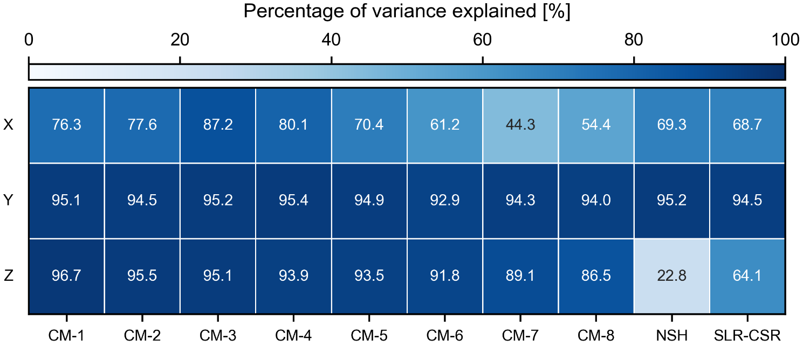
Figure S2. The percentage of the total variance in the seasonal component explained by the sum of annual and semi-annual signals for all components of the geocenter motion and all solutions.

References
Altamimi, Z., Rebischung, P., Métivier, L., & Collilieux, X. (2016). ITRF2014: A new release of the International Terrestrial Reference Frame modeling nonlinear station motions. Journal of Geophysical Research: Solid Earth, 121(8), 6109–6131. https://doi.org/https://doi.org/10.1002/2016JB013098
Blewitt, G., Lavallée, D., Clarke, P., & Nurutdinov, K. (2001). A new global mode of Earth deformation: seasonal cycle detected. Science (New York, N.Y.), 294(5550), 2342–2345. https://doi.org/10.1126/science.1065328
Riddell, A. R., King, M. A., Watson, C. S., Sun, Y., Riva, R. E. M., & Rietbroek, R. (2017). Uncertainty in geocenter estimates in the context of ITRF2014. Journal of Geophysical Research: Solid Earth, 122(5), 4020–4032. https://doi.org/https://doi.org/10.1002/2016JB013698

