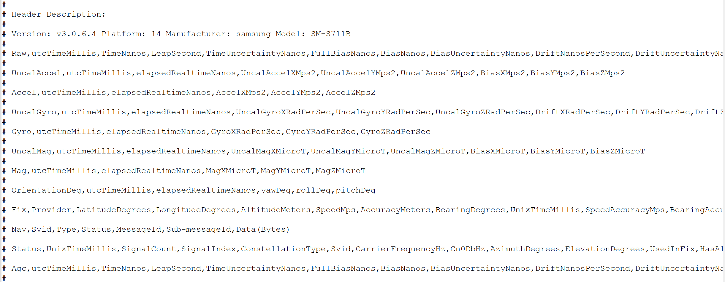
Fig. S1 The screenshot of GnssLogger raw data header

Table S1 An example of #Raw line GNSS information from GnssLogger raw data sample
Raw | Data
'utcTimeMillis' | 1743756889999.00
'TimeNanos' | 18579332336.00
'LeapSecond' | 18.00
'TimeUncertaintyNanos' | 0.00
'FullBiasNanos' | -1427792089420670000.00
'BiasNanos' | 0.00
'BiasUncertaintyNanos' | 10.31
'DriftNanosPerSecond' | 2566.21
'DriftUncertaintyNanosPerSecond' | 0.00
'HardwareClockDiscontinuityCount' | 0.00
'Svid' | 25.00
'TimeOffsetNanos' | 0.00
'State' | 16431.00
'ReceivedSvTimeNanos' | 464107931345219.00
'ReceivedSvTimeUncertaintyNanos' | 10.00
'Cn0DbHz' | 47.30
'PseudorangeRateMetersPerSecond' | 1152.70
'PseudorangeRateUncertaintyMetersPerSecond' | 0.06
'AccumulatedDeltaRangeState' | 25.00
'AccumulatedDeltaRangeMeters' | 4186.75
'AccumulatedDeltaRangeUncertaintyMeters' | 0.04
'CarrierFrequencyHz' | 1575420030.00
'CarrierCycles'
'CarrierPhase'
'CarrierPhaseUncertainty'
'MultipathIndicator' | 0.00
'SnrInDb'
'ConstellationType' | 1.00
'AgcDb' | 6.50
'BasebandCn0DbHz' | 42.30
'FullInterSignalBiasNanos' | 0.00
'FullInterSignalBiasUncertaintyNanos' | 0.00
'SatelliteInterSignalBiasNanos' | 0.00
'SatelliteInterSignalBiasUncertaintyNanos' | 0.00
'CodeType' | C
'ChipsetElapsedRealtimeNanos' | 3322306912177.00
'IsFullTracking'

