Supporting Information
Visible light photocatalytic degradation of microplastic residuals with zinc oxide nanorods
Tajkia Syeed Tofa,¹ Karthik Laxman Kunjali,² Swaraj Paul,³ and Joydeep Dutta ^{2*}

¹Department of Sustainable development, Environmental Science and Engineering, School of Architecture and the Built Environment, KTH Royal Institute of Technology, Stockholm, Sweden
²Functional Materials, Department of Applied Physics, School of Engineering Sciences, KTH Royal Institute of Technology, Stockholm, Sweden
³PP Polymer AB, Krossgatan 15 , SE-162 50 Vällingby, Stockholm, Sweden

*Corresponding author:
Prof. Joydeep Dutta
Functional Materials, Dept. of Applied Physics
KTH Royal Institute of Technology
Isafjordsgatan 22, SE 164 40, Kista
Email: joydeep@kth.se
Ph: +46-8-790 81 42, Mb: +46-73-765 21 86

Experimental set-up
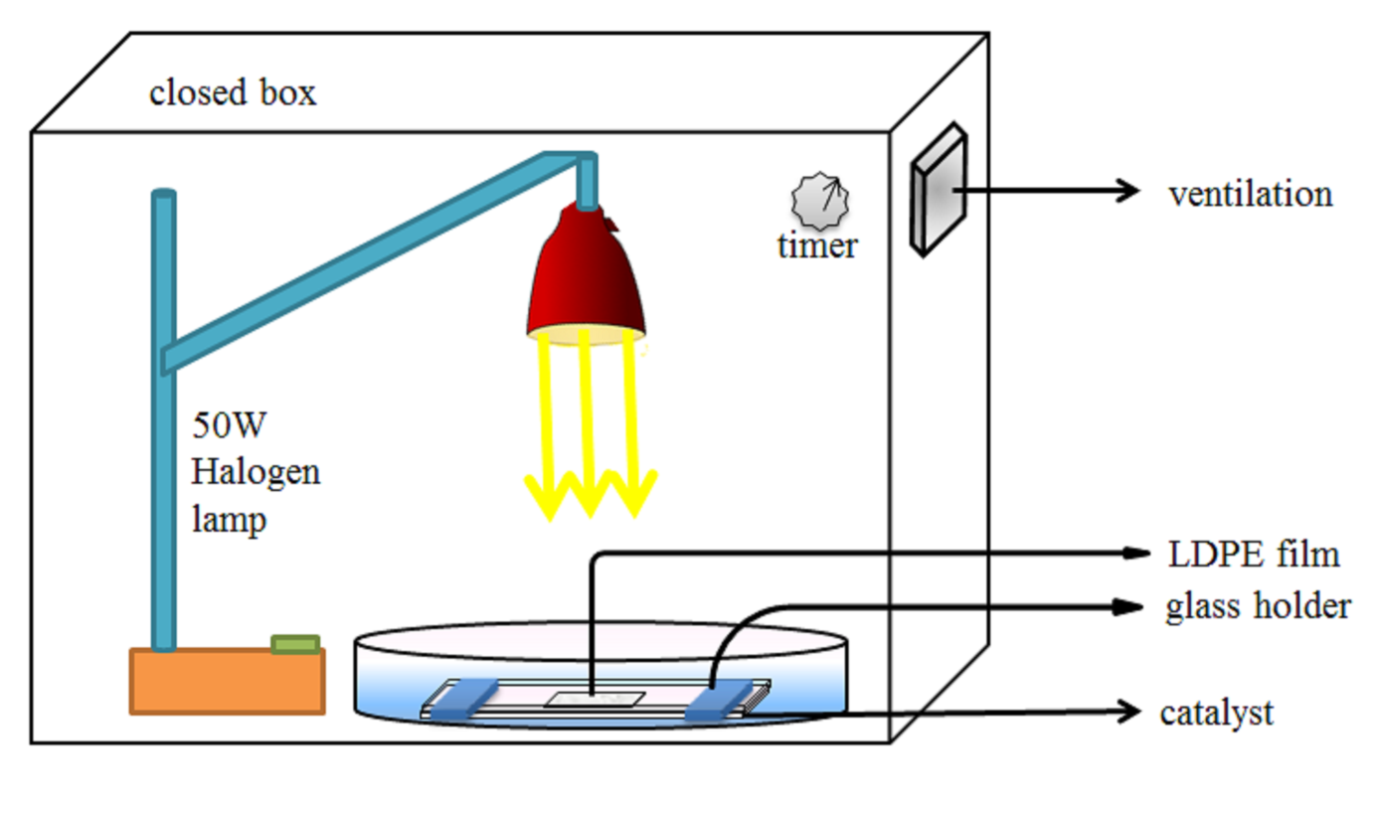
Fig. S1: Experimental setup for conducting photocatalysis process.

SEM Images
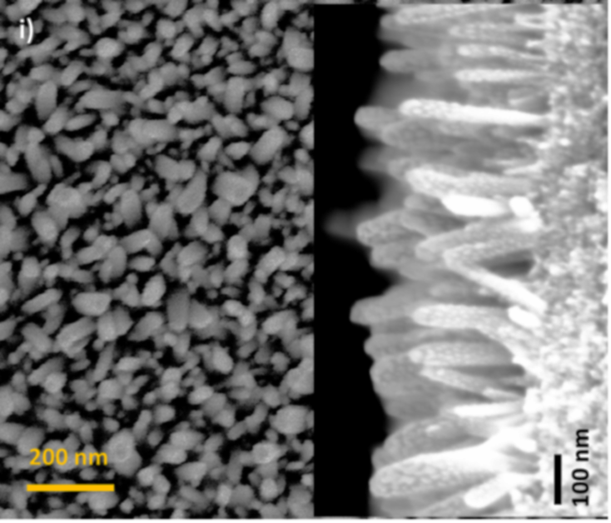 | 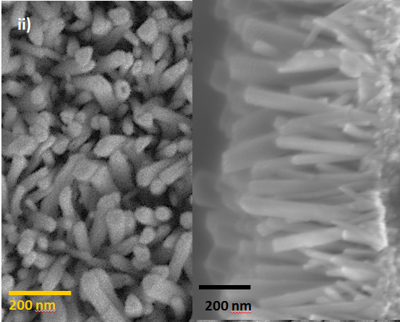
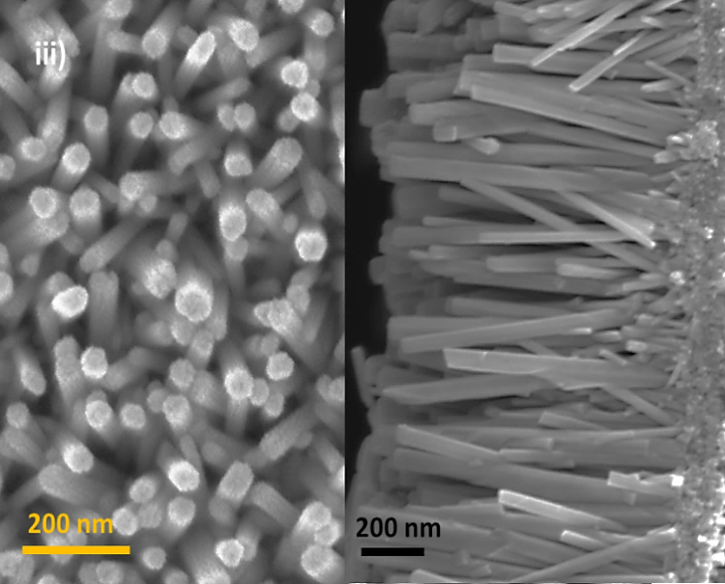 | 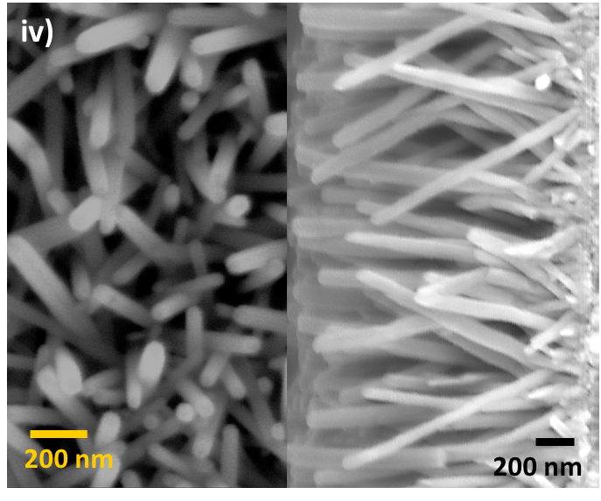
Fig. S2: SEM images of the top view demonstrate diameter and density of the hydrothermally prepared different concentration of ZnO nanorods on glass substrate. Also, side view shows the length of nanorods. a) 3 mM_5hrs, b) 5 mM_5hrs c) 10 mM_5hr, and d) 20 mM_5hr.

Table S1: Properties of ZnO catalysts of different concentrations
Growth concentration | 3mM_5hrs | 5mM_5hrs | 10mM_5hrs | 20mM_5hrs
avg. diameter, d (nm) | 34.5 | 40 | 55 | 65
avg. side length, l (nm) | 263 | 511 | 960 | 1750
avg. area of each nano rod (nm²) | 28766.68 | 63398.46 | 162329.59 | 346738.44
avg. density of the nanorods on substrate (/nm²) | 0.000225 | 0.00035 | 0.0003 | 0.00015
Total effective surface area on a substrate of sizes (1 cm X 1 cm) (cm²) | 6.5 | 22 | 49 | 55

