Supplementary Material

Text S1 Comments on application
We proposed an effective experimental setup in this study, which was a fiber ball derived aeration adsorption system. The adsorbent, fiber and all, often has a very small specific surface area, with BET values of 0.08 m² /g, 0.86 m²/g⁻¹.81 m²/g (Dai et al., 2002). Our BET result was 0.18 m²/g with an average pore diameter of 11.94 nm. Overall, these values are much lower than those of many traditional adsorbents, such as activated carbon and adsorbent (Purkait et al., 2007; Zhang et al., 2007). On the other hand, they have a very smooth surface and will not be destroyed after adsorption for several hours. Figure S7 shows the results of SEM before adsorption and after adsorption for 24 and 72 h, respectively. Although there are some wrinkles on the surface after adsorption, which could be due to water flow lashing or cavitation, the overall shape remains unchanged. These findings demonstrated that the use of fiber balls was possible in the engineering system. The current study focuses on the removal of suspended solids and oil from water in market applications. It demonstrated that the role of solid filtration and chemical group functionalization in oil separation is successful. Given the lower specific surface value of the material and the lack of further treatment, it should be difficult to remove other pollutants. However, it has been shown to be effective for nitrogen and phosphorus removal.

It was also to be effective for colloidal particle interception in such a system. As can be seen in the photos (Figure S8a-b), the raw water was a deep black color before treatment and became less black and more transparent after treatment. Comparatively, it was much more effective under alkaline condition such as pH 7.67 and 9.67 (Figure S8c), with 500 g fiber ball in the system. It also demonstrates that increased numbers of fiber balls had a higher degree of pollutant interception, resulting in a better treatment effect. When the fiber ball mass in the system was increased to 1000 g, for example, turbidity could be reduced by up to 85%. (Figure S8d). These findings demonstrated that the aeration adsorption system can be used to not only figure out filtration setup but also to effectively pollute the setup.

Table S1: Fitting parameters of reaction kinetics for NH₃-N and Total P removal.

Class | pH |  | Pseudo-first-order kinetics |  |  |  | Pseudo-second-order kinetics
Class | pH |  | Q_{e}(mg/g) | k₁ (min⁻¹) | R² |  | Q_{e}(mg/g) | k₂(g/(mg·min) | R²
NH₃-N | 5.67 |  | 0.82 | 0.11 | 0.63 |  | 0.94 | 0.16 | 0.69
NH₃-N | 7.67 |  | 2.14 | 0.04 | 0.97 |  | 3.47 | 0.01 | 0.97
NH₃-N | 9.67 |  | 1.64 | 0.16 | 0.84 |  | 2.32 | 0.05 | 0.84
Total P | 5.67 |  | 0.23 | 0.14 | 0.92 |  | 0.30 | 0.43 | 0.93
Total P | 7.67 |  | 0.12 | 0.17 | 0.88 |  | 0.14 | 1.36 | 0.92
Total P | 9.67 |  | 0.13 | 0.17 | 0.72 |  | 0.16 | 1.19 | 0.74

Table S2: Fitting parameters of reaction kinetics for PO₄³⁻ removal
Class | pH |  | Pseudo-first-order kinetics |  |  |  | Pseudo-second-order kinetics
Class | pH |  | Q_{e}(mg/g) | k₁ (min⁻¹) | R² |  | Q_{e}(mg/g) | k₂(g/(mg·min) | R²
PO₄³⁻ | 5.67 |  | 0.23 | 0.14 | 0.92 |  | 0.30 | 0.4 | 0.93
PO₄³⁻ | 7.67 |  | 0.12 | 0.17 | 0.88 |  | 0.14 | 1.36 | 0.92
PO₄³⁻ | 9.67 |  | 0.13 | 0.17 | 0.72 |  | 0.16 | 1.19 | 0.74

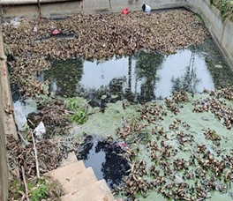
Figure S1: Detail view of the sampling site for collection of black, odorous water treated in this study.

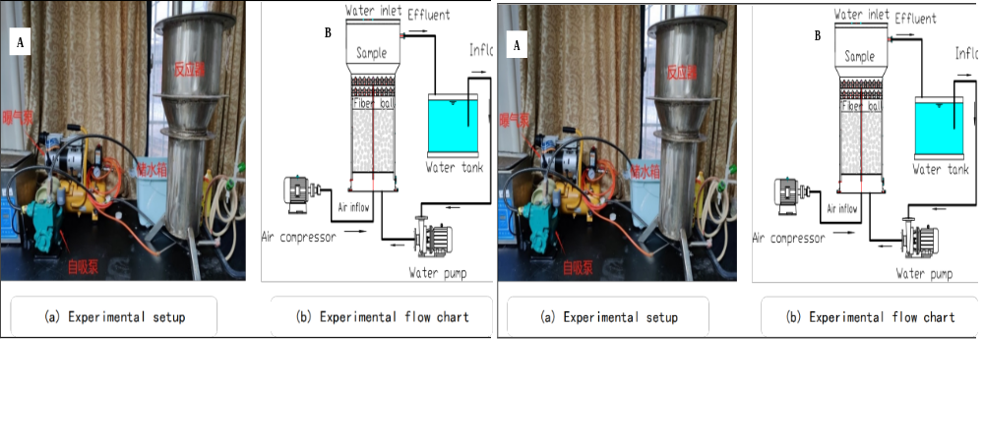

Figure S2: (A) Experimental apparatus and (B) experimental flow chart, which describes the experimental process in detail.

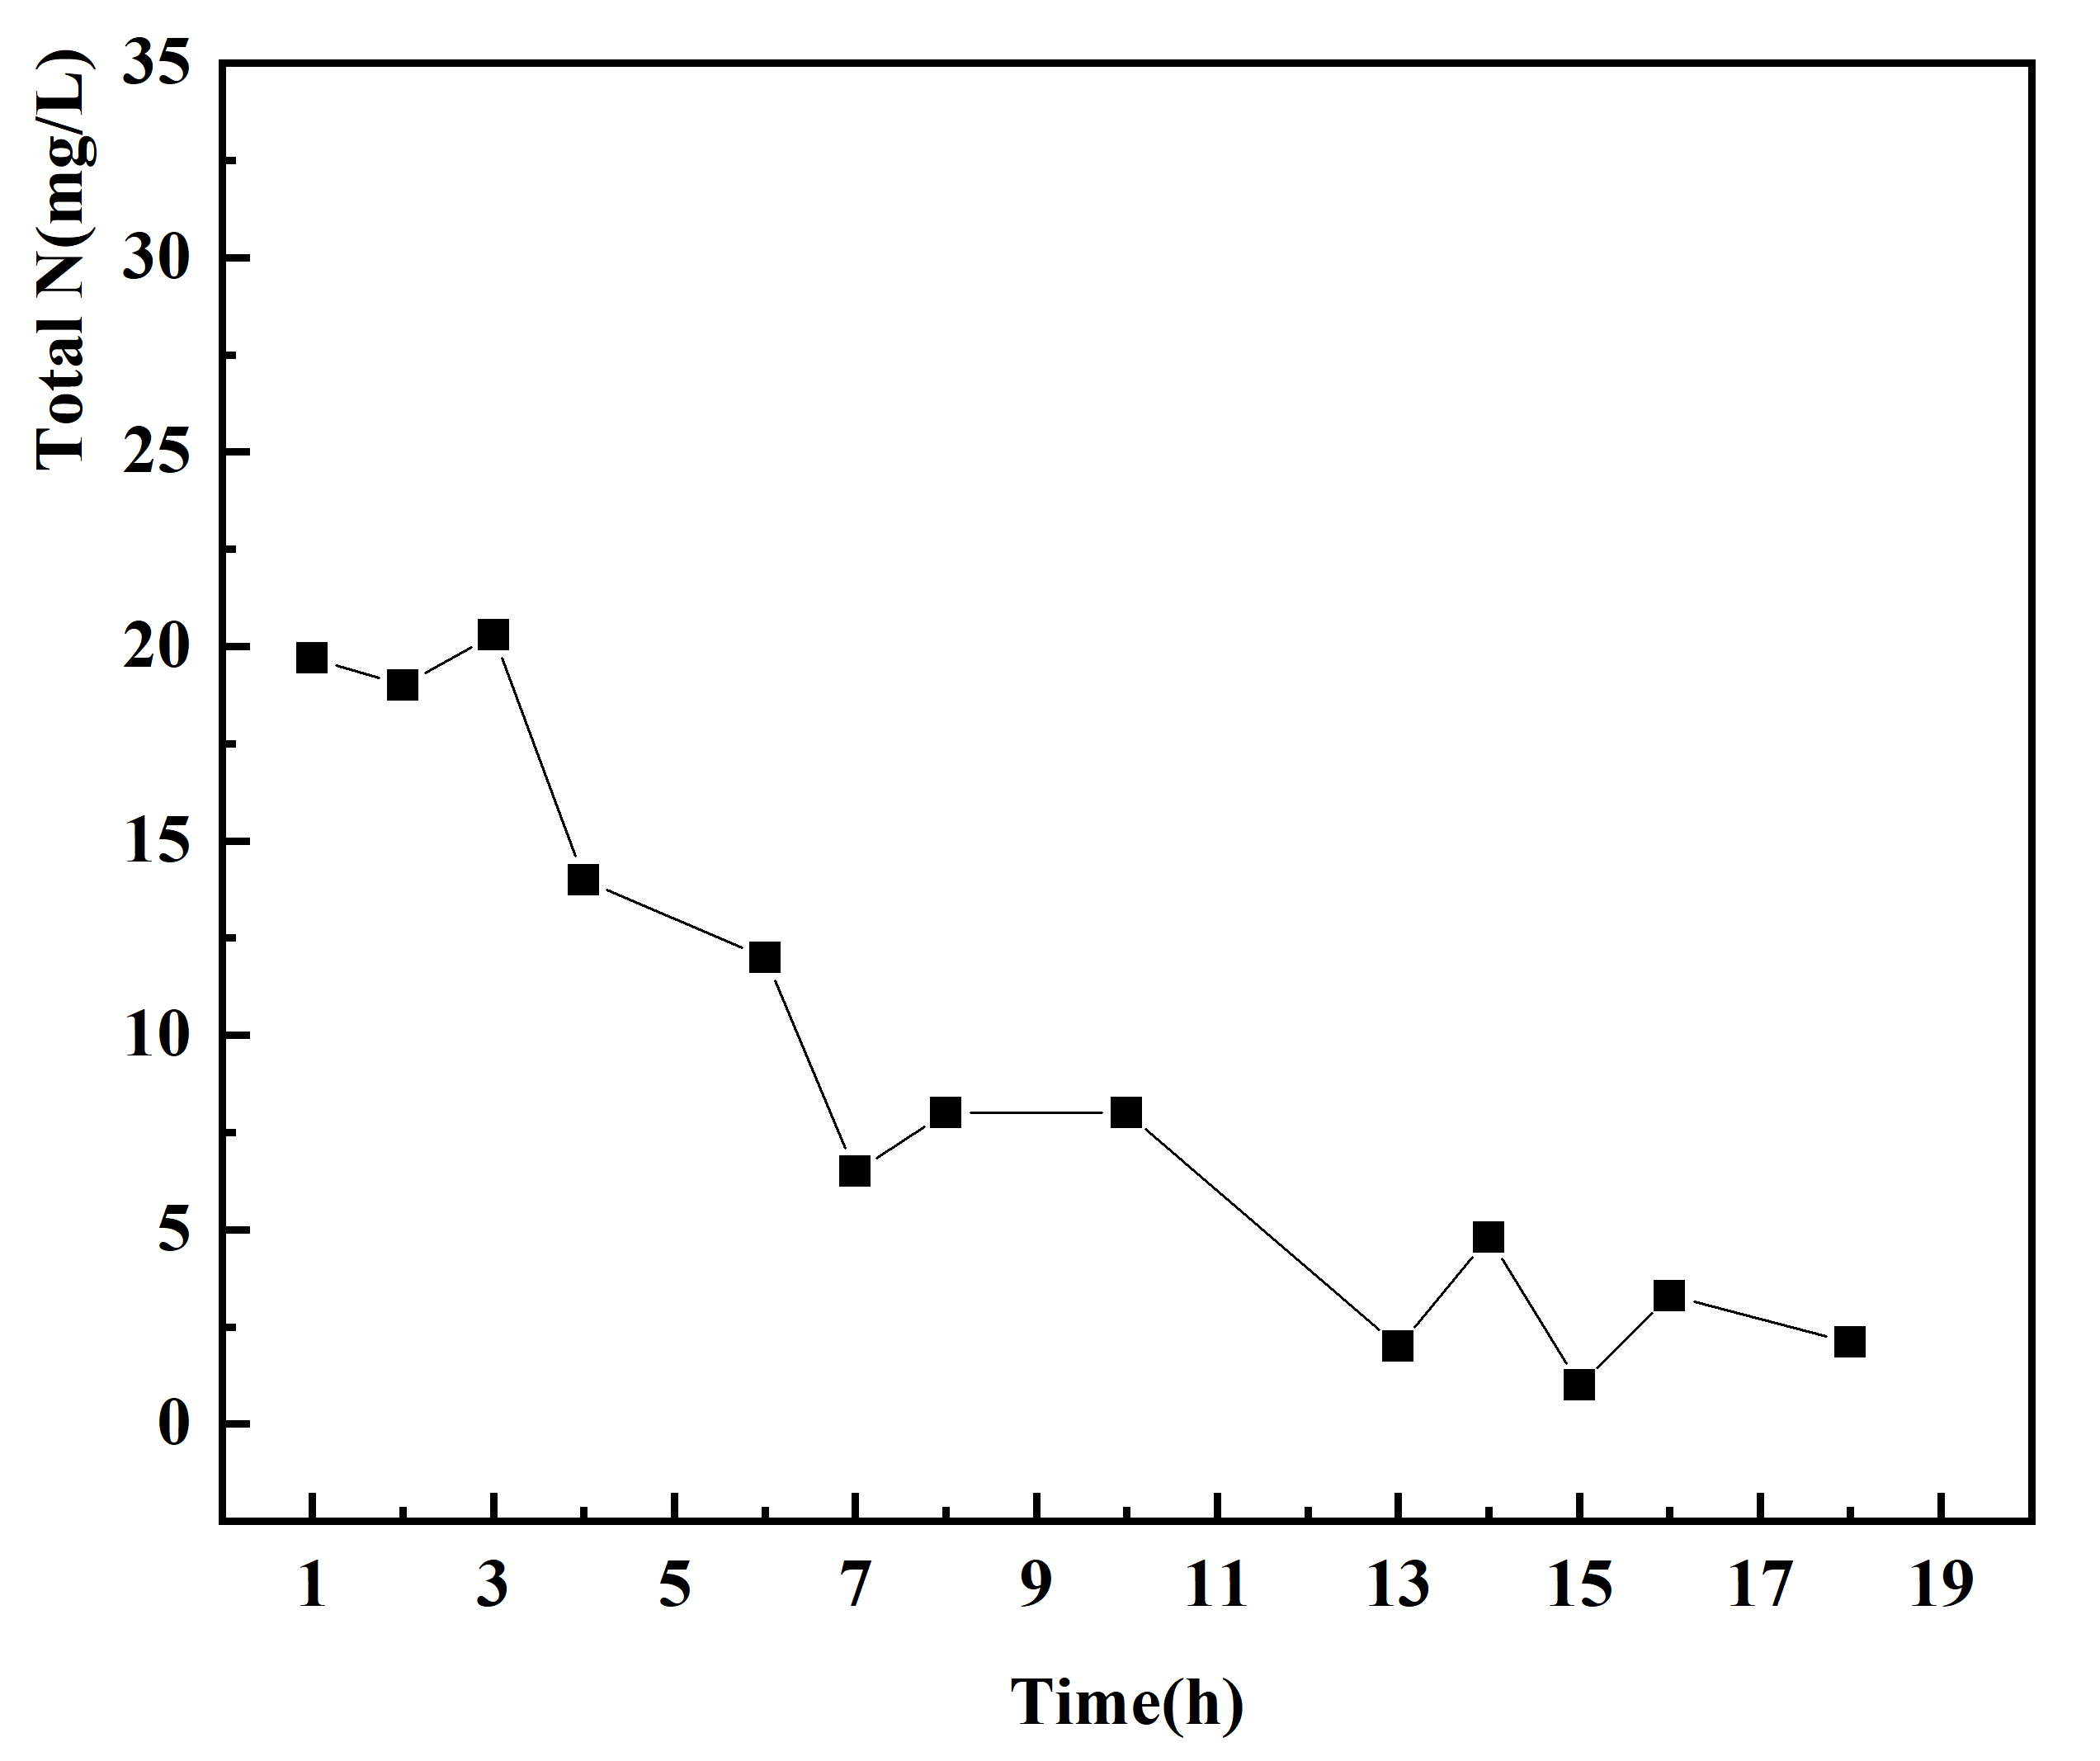
Figure S3: Effect of the system on removal total N at pH 9.67

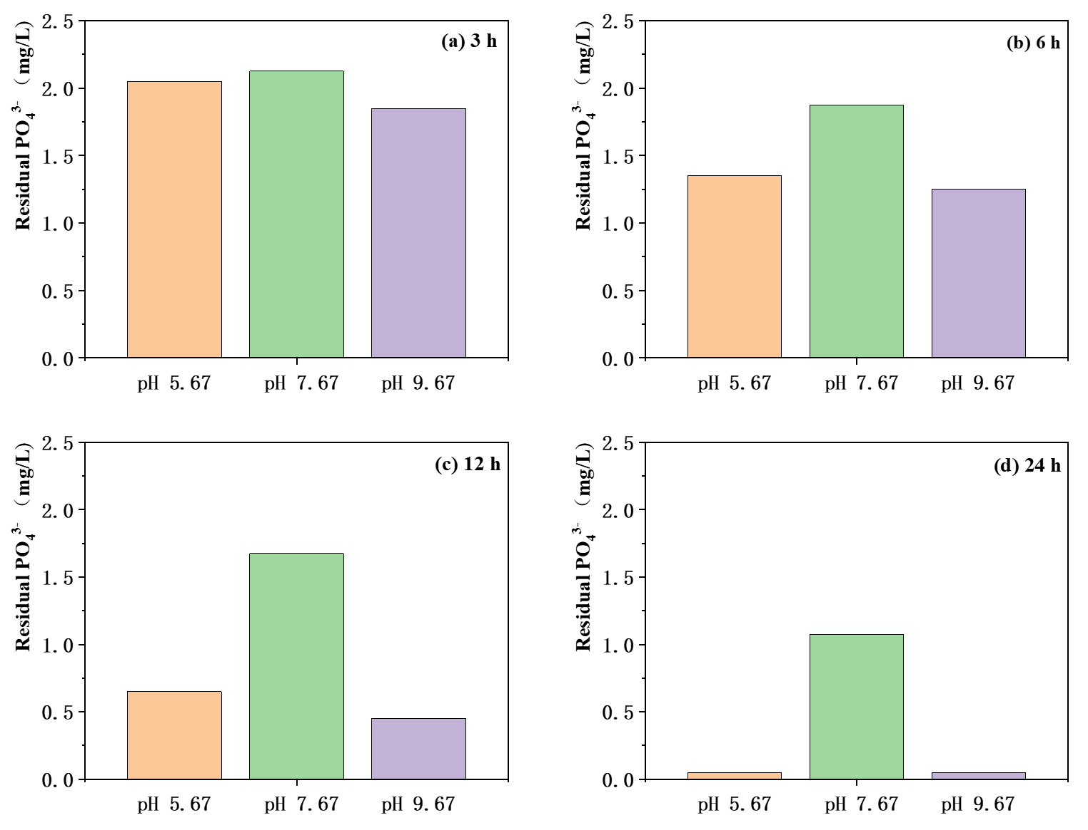

Figure S4: Residual PO₄³⁻ in black-odorous water samples after treatment with varying pH for reaction time of: (a) 3 h, (b) 6 h, (c) 12 h, and (d) 24 h.

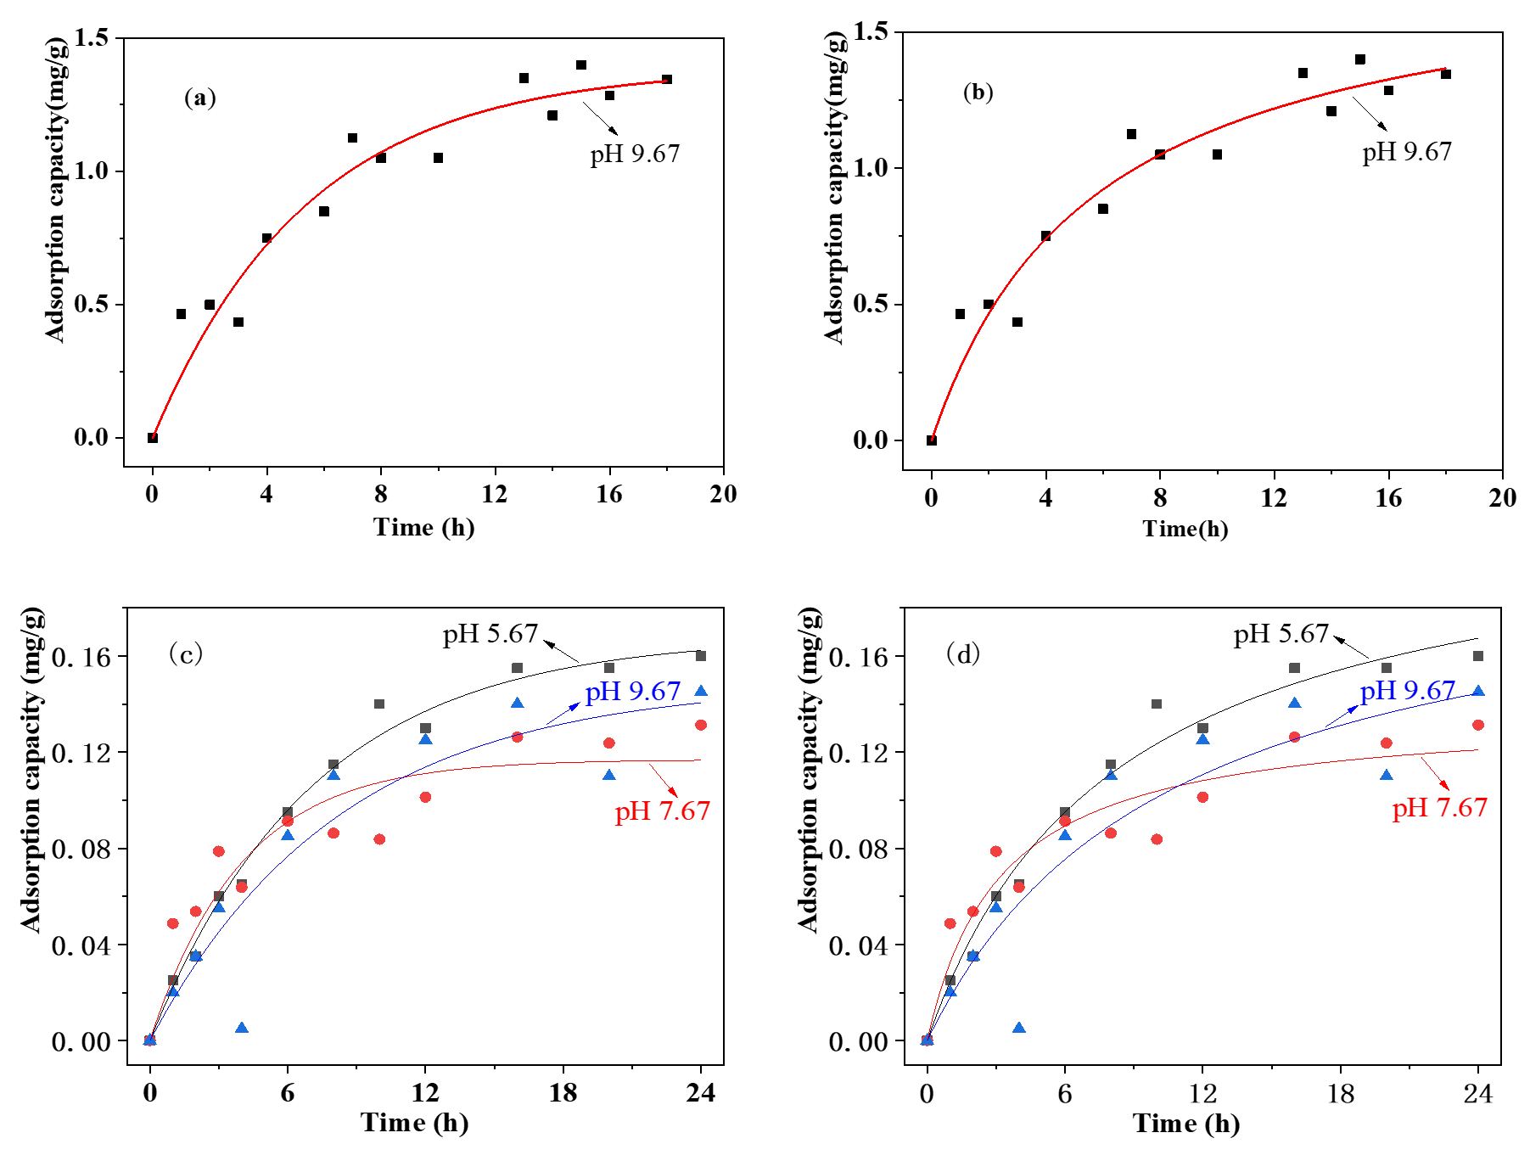
Figure S5: Reaction kinetics for removal of total N and PO₄³⁻: (a) pseudo-first-order kinetics for total N, (b) pseudo-second-order kinetics for total N, (c) pseudo-first-order kinetics for PO₄³⁻ and (d) pseudo-second-order kinetics for PO₄³⁻. The solid lines are best fit curves.
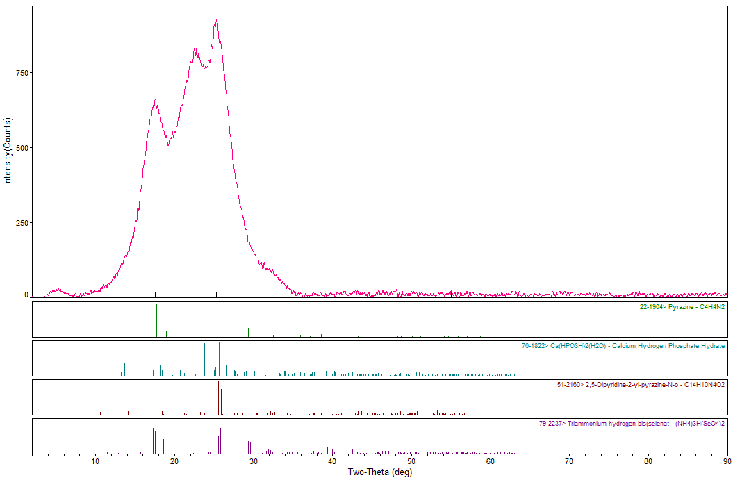
Figure S6: The XRD pattern of fiber balls after treatment of black, odorous water

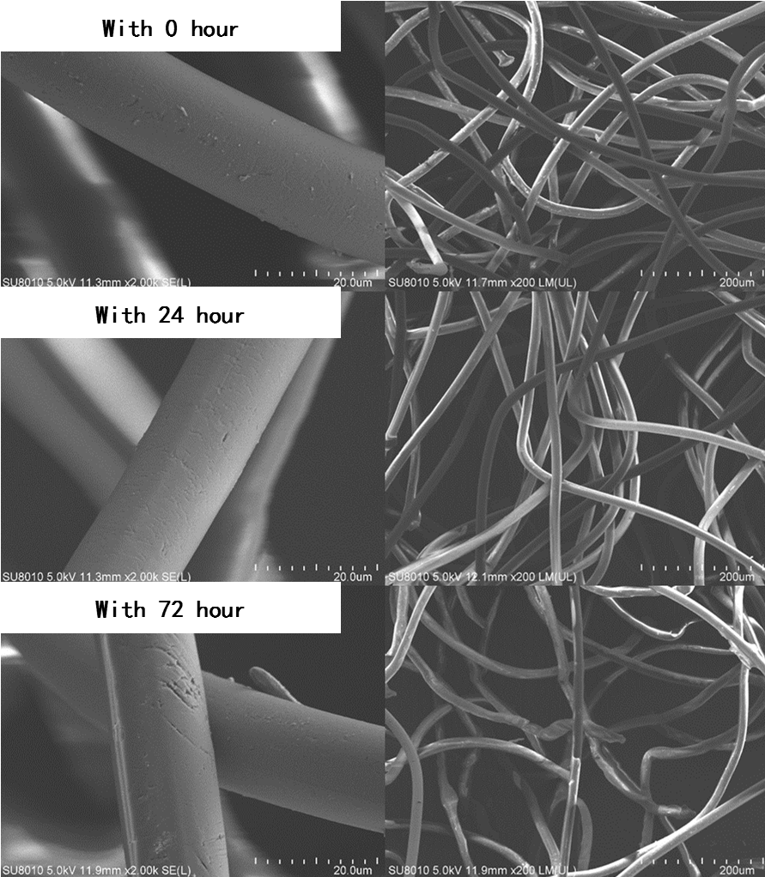

Figure S7: A detailed view by SEM of fiber balls before and after reaction in the treatment system.

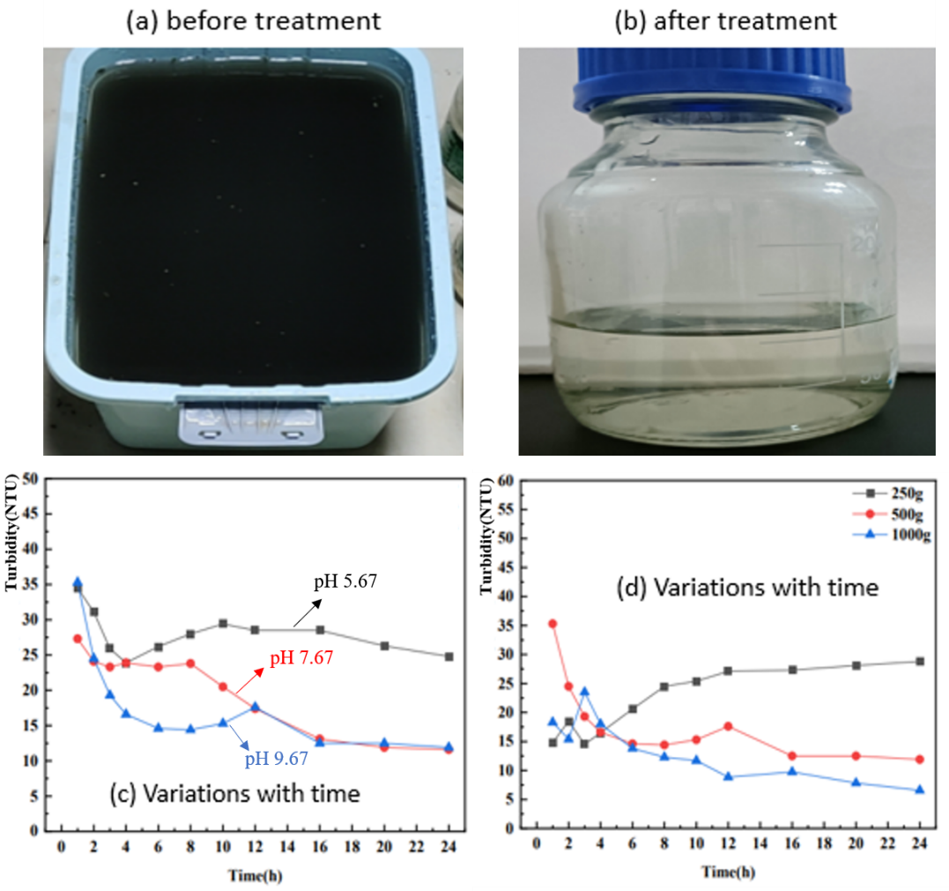
Figure S8: Removal of turbidity of black, odorous water sample: (a) raw water (b) treatment effluent (c) the effect of pH
and (d) dosing level on turbidity.

References

Purkait, M.K., Maiti, A., Dasgupta, S., De, S., 2007. Removal of congo red using activated carbon and its regeneration. J Hazard Mater 145, 287-295. https://doi.org/10.1016/j.jhazmat.2006.11.021

Z. Zhang, Y. Shan, J. Wang, H. Ling, S. Zang, G. Wei, Z. Zhao, Zhang, H., 2007. Investigation on the rapid degradation of congo red catalyzed by activated carbon powder under microwave irradiation. J Hazard Mater 147, 325-333. https://doi.org/10.1016/j.jhazmat.2006.12.083

