Supplementary Material for
Algae and bacteria consortia for wastewater decontamination and transformation into biodiesel, bioethanol, biohydrogen, biofertilizers and animal feed: A review

Study design
This review aims to consider all the fundamental papers concerning algae and bacteria valorisation and use for wastewater bioremediation, with the aim to summarize and analyse the current state and find existing or emerging opportunities for the sustainable treatment of wastewater streams. For a suitable and systematic literature analysis, the data were retrieved from SCOPUS, using the following keywords (algae)OR(alga) AND (bacteria)OR(bacterium) AND wastewater AND (purification)OR(remediation)OR(removal), for the title, abstract, or keywords of relevant publications. This literature search was carried out on November 1, 2022, and the number of resulting publications was 1177.
For cluster bibliometric analysis, the free software VOSviewer (https://www.vosviewer.com/) was used. Keywords selected by the authors of the publication and occurred more than 15 times in the database were enrolled in the final analysis. On this basis, VOSviewer performed data analysis, processing, and map generation based on the keywords co-occurrence network. Fig. S1 shows the resulting map.
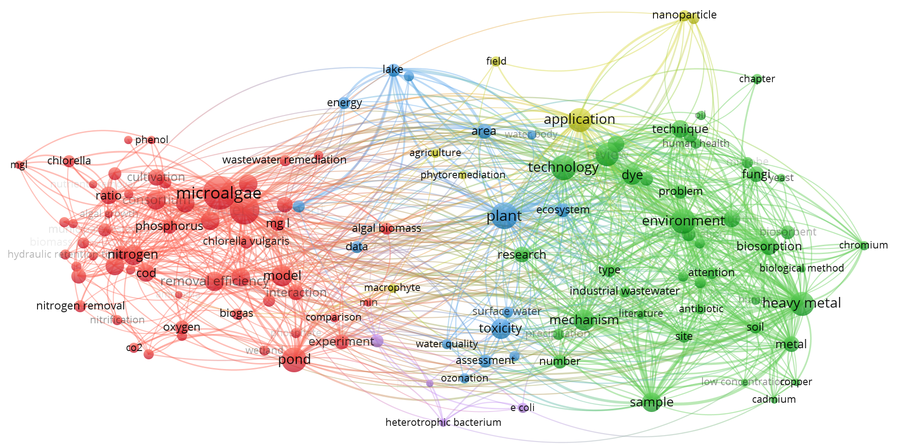
Fig. S1. The bibliographic analysis map of VOSviewer was obtained by using the Scopus database, representing the co-occurrence network of the selected papers' keywords. Five clusters of interconnected keywords are highlighted, in different colors. The data was updated on November 1, 2022.

In Fig. S1, cluster 1 (represented by red bubbles) containing 56 items (for example, nutrients, nutrient removal, phosphorous, and algal growth) is mainly devoted to microalgae and wastewater treatments. Cluster 2 (represented by green balls) is identified by 43 items and is more aligned to biological treatments (some keywords are, for example, biological method, bioremediation, microbe, and so on). Cluster 3 (represented by blue bubbles) contains only 15 items, which are essentially devoted to water and its quality (for example, water bodies, water quality, surface water, lakes, eutrophication, and so on). Yellow balls identify a small cluster (cluster 4) containing only 7 items related to application and nanoparticle use. Finally, the last cluster (cluster 5) is represented by purple bubbles, with only 4 items related to a specific bacterium (such as E. coli and cyanobacterium).
Based on the bibliographic cluster analysis, this review paper was conceived in different sections. The first section is devoted to discussing wastewater composition (mainly considering cluster 3 results). Sections 4 and 5 are respectively devoted to the use of algae and bacteria in wastewater treatment, based on clusters 1 and 2 items. Section 7 describes the harvesting techniques of algae (based on cluster 1). The last review part concerns the valorisation of the algal and microbial biomass (based on cluster 4). Finally, conclusions are reported.

