Supplementary Information

Airborne hydrophilic microplastics in cloud water at high altitudes and their role in cloud formation

Yize Wang^{1*}, Hiroshi Okochi^{1*}, Yuto Tani¹, Hiroshi Hayami¹, Yukiya Minami², Naoya Katsumi², Masaki Takeuchi³, Atsuyuki Sorimachi⁴, Yusuke Fujii⁵, Mizuo Kajino⁶, Kouji Adachi⁶, Yasuhiro Ishihara⁷, Yoko Iwamoto⁷, and Yasuhiro Niida⁸.

¹ Graduate School of Creative Science and Engineering, Waseda University
² Faculty of Bioresources and Environmental Science, Ishikawa Prefectural University
³ Graduate School of Biomedical Sciences, Tokushima University
⁴ Faculty of Science and Engineering, Toyo University
⁵ Graduate School of Humanities and Sustainable System Sciences, Osaka Prefecture University
⁶ Meteorological Research Institute
⁷ Graduate School for Integrated Sciences for Life, Hiroshima University
⁸ PerkinElmer Japan Co. Ltd., Kanagawa, Japan

------------------------------------------------------------------------------------
* Corresponding author:
Yize Wang: wangyizeqqcs@fuji.waseda.jp
Hiroshi Okochi: hokochi@waseda.jp

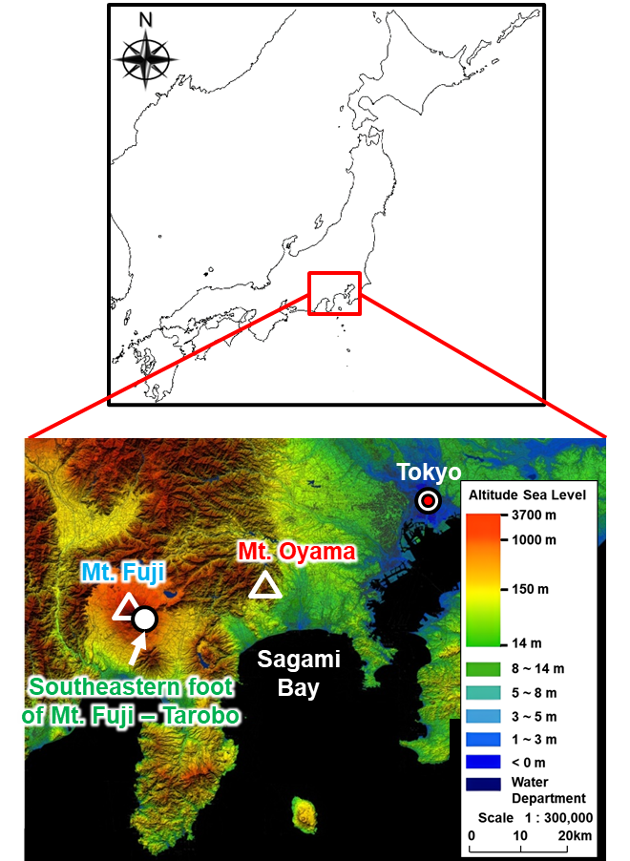
Fig. S1. Map of the sampling site (the map is from the website of the Geospatial information authority of Japan, available at https://www.gsi.go.jp/kankyochiri/degitalelevationmap_kanto.html).

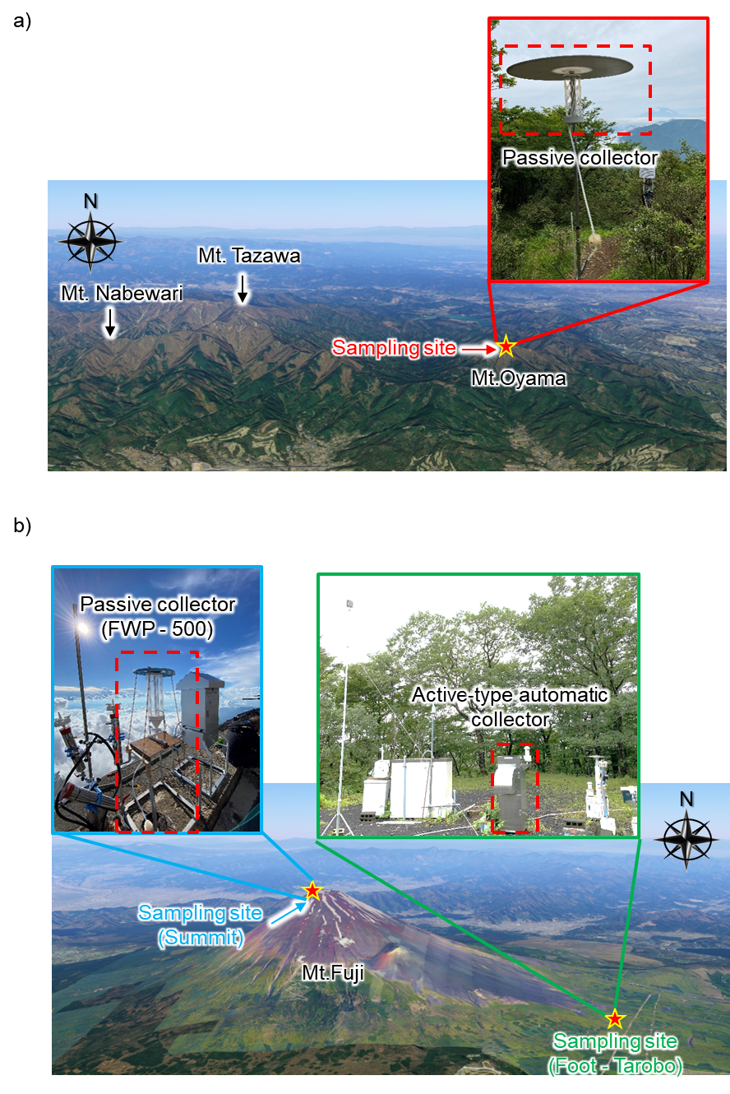

Fig. S2. Sampling scenery and topography around the sampling point at the summit of Mt. Oyama (a), the summit of Mt. Fuji, and foot of Mt. Fuji-Tarobo (b).

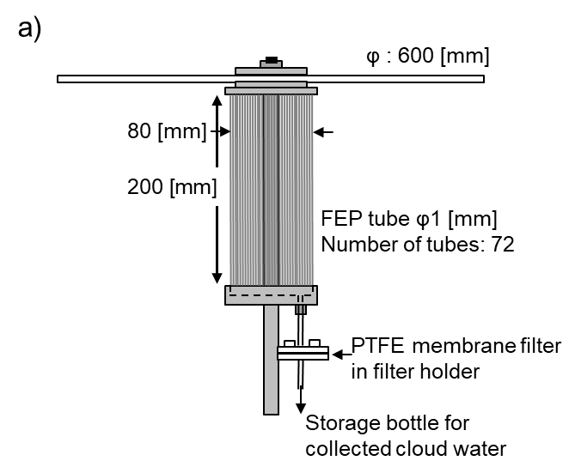
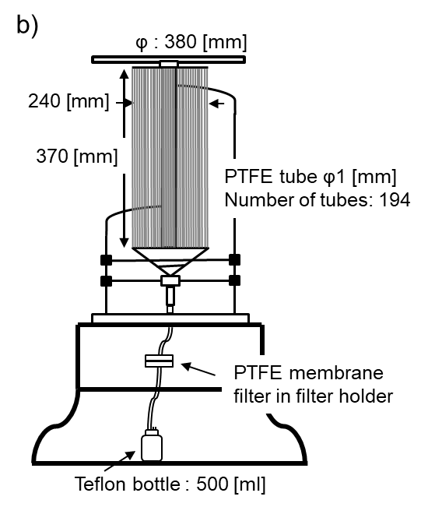

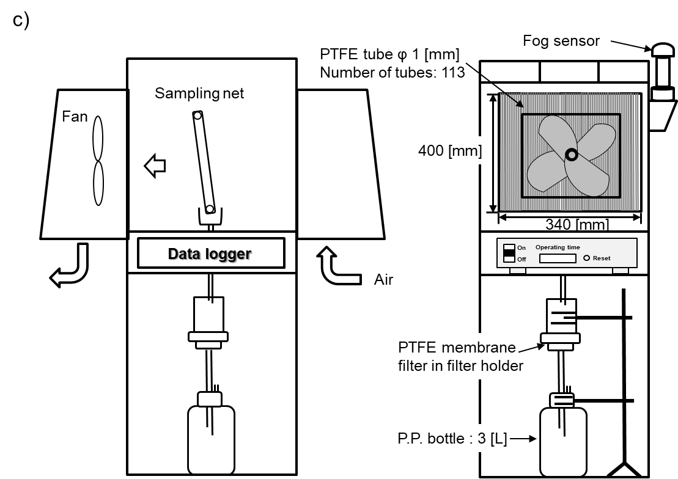

Fig. S3. (a) Passive-type cloud water collector at the summit of Mt. Oyama, (b) passive collector (FWP-500) at the summit of Mt. Fuji, (c) active-type automatic cloud water collector at the foot of Mt. Fuji-Tarobo.

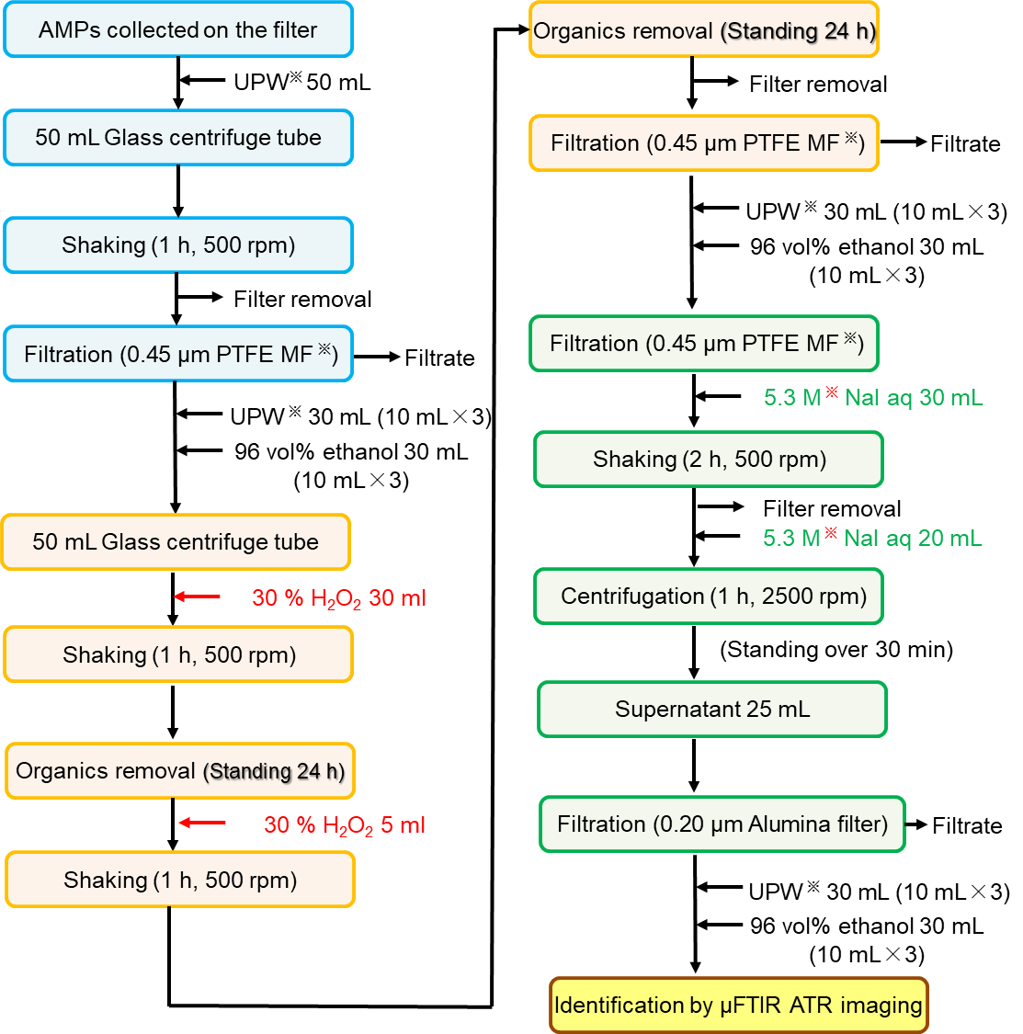

※UPW: Ultrapure water
※PTFE MF: PTFE hydrophilic membrane filter
※NaI solution should be filtered through a hydrophilic PTFE filter with a pore size of 0.45 μm before use, as this grade of NaI contains large amounts of polyethylene terephthalate (PET) fragments as impurities depending lot release

Fig. S4. Pretreatment of cloud water microplastics.

Pretreatment for analyzing airborne microplastics in cloud water
Centrifuge tubes containing the samples were filled with 50 mL of UPW and shaken at 500 rpm for 1 h (ASCM-1 AS ONE) to remove water-soluble interference. Afterwards, the 1.0-μm pore size PTFE-MF was removed from the tube and the filtrate was filtered through a 0.45-μm pore size PTFE-MF (JHWP02500; Omnipore, Co.). Following filtration, the PTFE-MF was transferred to a another 50-mL centrifuge tube, 30 mL of hydrogen peroxide solution (30.0 %; FUJIFILM Wako Corporation) was added, shaken at 500 rpm for 1 h, and left on a clean bench (CT-600UVAD AS ONE) for 24 h to remove organic matter (microbes, organic particles, and organic matter adsorbed on the AMPs surface). Hydrogen peroxide in water (5 mL) was added again, shaken at 500 rpm for 1 h, and incubated on a clean bench for 24 h. Afterward, the 0.45-μm pore size PTFE-MF was removed from the tube, and the filtrate was filtered through another 0.45-μm pore size PTFE-MF. After filtration, the filter was transferred to another 50mL centrifuge tube and 30 mL of 5.3 M sodium iodide solution (99.0 %; 1st Grade, FUJIFILM Wako, Co.) was added, then shaken at 500 rpm for 2 h. After removing the filter from the centrifuge tube, 20 mL of 5.3 M NaI solution was added again. Density separation was performed using centrifuge (H-36; KOKUSAN, Co., Ltd.) at 2500 rpm for 1 h and left to stand for 0.5 h before the final step of filtration. The upper 25 mL of the solution was taken in 2.5 mL portions using a glass digifit and then filtered through a 0.2 μm aluminum filter (Anodisc25; Whatman, Co., Ltd.). The aluminum filter was then placed in a glass Petri dish and dried in a desiccator to remove water.

Analytical method for ionic components in cloud water
The transported cloud water was immediately filtered through a 0.45-μm pore size membrane filter (A045A025A; Advantec, Co.), measured for pH (HM-41X; DKK-TOA Corp.) and electrical conductivity (CM-25R; DKK-TOA Corp.), and stored in a refrigerator until major ions were analyzed. The concentrations of major inorganic ions (NH₄⁺, Na⁺, K⁺, Mg²⁺, Ca²⁺, Cl⁻, NO₃⁻, and SO₄²⁻) were determined using an ion chromatograph (Dionex Corp., DX-1000 with a column of Dionex Corp., IonPac CS12A) for cations and an ion chromatograph (Dionex Corp., DX-320 with a column of Dionex Corp., IonPac AS4A-SC) for anions.

Micro-Fourier transform infrared spectroscopy spectroscopy analysis
AMPs in the cloud water were identified by attenuated total reflection imaging using Micro-Fourier transform infrared spectroscopy (FTIR) (Spectrum3/Spotlight 400; PerkinElmer, Waltham, MA; hereafter μFTIR ATR imaging). The μFTIR parameters were as follows: wavenumber resolution: 8 cm⁻¹, number of scans: 1, wavenumber range: 4000–695 cm⁻¹, pixel size: 1.56 μm, imaging measurement area: 750 × 750 μm. A large Ge crystal with a refractive index of 4.0 was used for ATR imaging to detect not only polymers but also black rubber. In each region (750 μm × 750 μm), substances with absorbance in the C-H stretching vibration band (3000–2700 cm⁻¹) and the C=O stretching vibration band (1740–1710 cm⁻¹) were considered AMPs candidates. The spatial resolution of ATR imaging was approximately 1.8 μm at the wavenumber of the C-H stretching vibration band and 3.1 μm at the wavenumber of the C=O stretching vibration band. Almost all organics absorb in the C-H stretching vibration band, although the absorbance varies depending on the polymer type and degradation state. AMPs with C=O bonds, such as polyethylene terephthalate (PET), polymethyl methacrylate (PMMA), polyamide 6 (PA), polycarbonate (PC), and polyurethane (PUR), can be detected using the absorbance of the C=O stretching vibration band.
Measuring the entire filtration spot area (4 mm in diameter) on a filter using ATR imaging requires a considerable amount of time. It is also technically difficult to measure an entire area without overlapping the measurement area. In this study, five fields of view were systematically measured: the center of the spot, and four fields of view between the center and edge of the spot. This corresponded to 22.4 % of the filtered spot area. The lower limit of detection was calculated from the standard deviation of the absorbance data screened from the blank imaging data and was determined by a factor of five standard deviations (Tokunaga et al. 2023). The Feret diameter of each AMP that was fully within the image was measured using ImageJ and the particle size was considered. Each spectrum was extracted from particles showing higher absorbance than the lower limit of detection and identiﬁed by the matching score (70 % or more) based on a library search of Spectrum IR (PerkinElmer), followed by visual confirmation of polymer-derived absorption peaks and further confirmation by a PerkinElmer Japan expert.

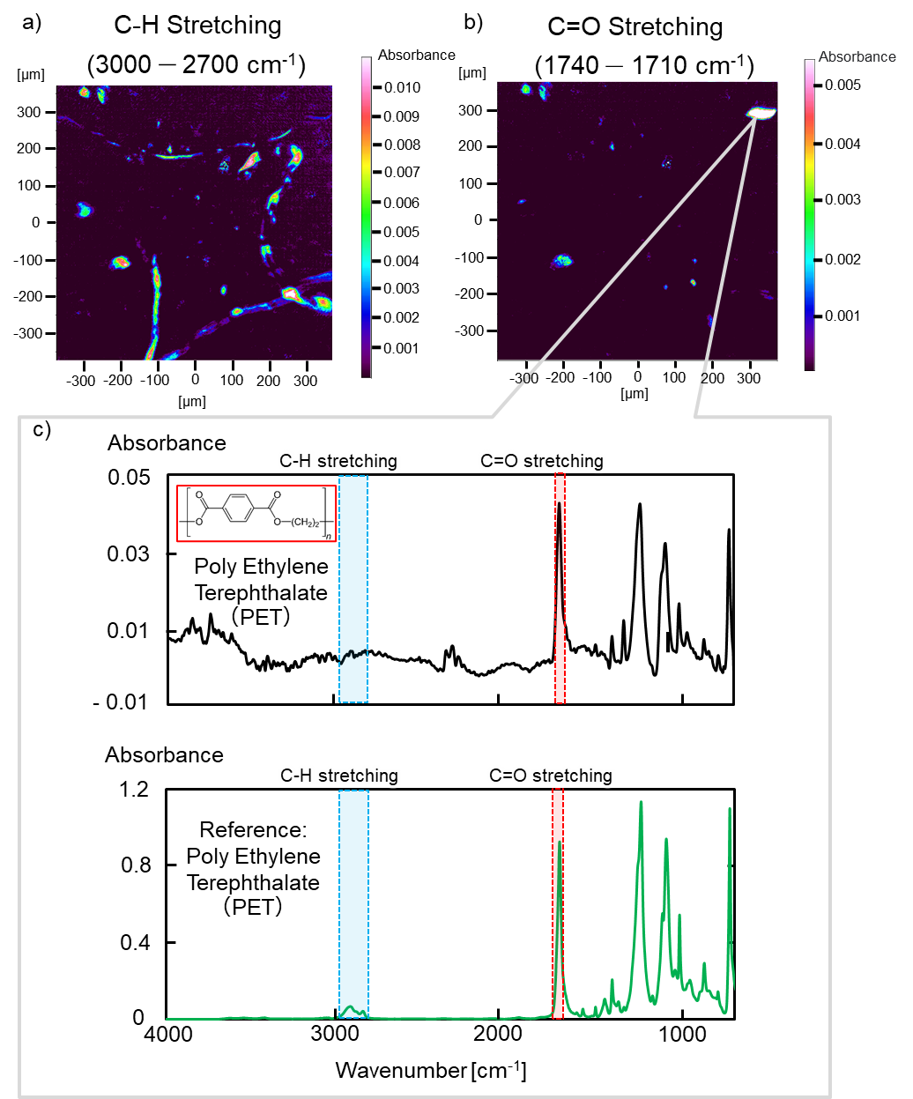
Fig. S5. (a) The image of infrared radiation (IR) peak band of C-H stretching band 3000–2700 cm⁻¹, (b) C=O stretching band 1740–1710 cm⁻¹, and (c) the Fourier transform infrared spectroscopy (FTIR) spectral of polyethylene terephthalate (PET) in the cloud water as well as reference spectra of PET.

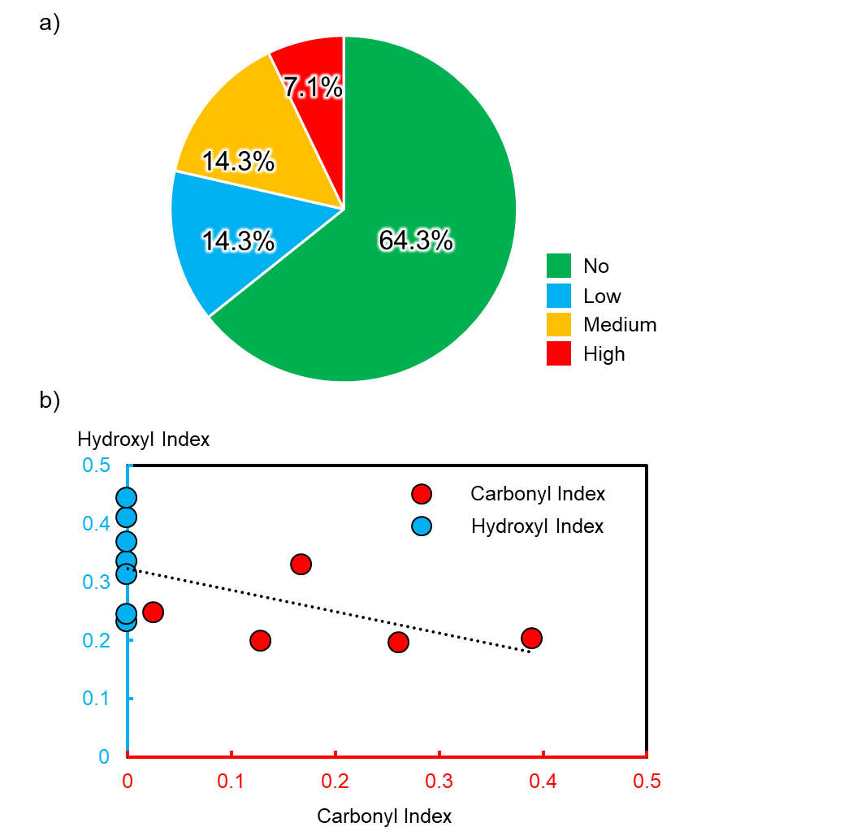
Fig. S6. Degradation level of polypropylene in cloud water (sample n = 14) (a) Percentage of degradation level by carbonyl index. 0 to 0.15, 0.15 to 0. 30, and 0.30 and above are determined as low, medium, and high levels, respectively (Cooper and Corcoran 2010). (b) Relationship between carbonyl index and hydroxyl index. Even polypropylene that is determined to be free of degradation by the carbonyl index is often determined to be degraded by the hydroxyl index. The hydroxyl index decreases as the carbonyl index increases. In summary, polypropylene in cloud water was hydrophilic due to the presence of carbonyl and/or hydroxyl groups due to degradation.

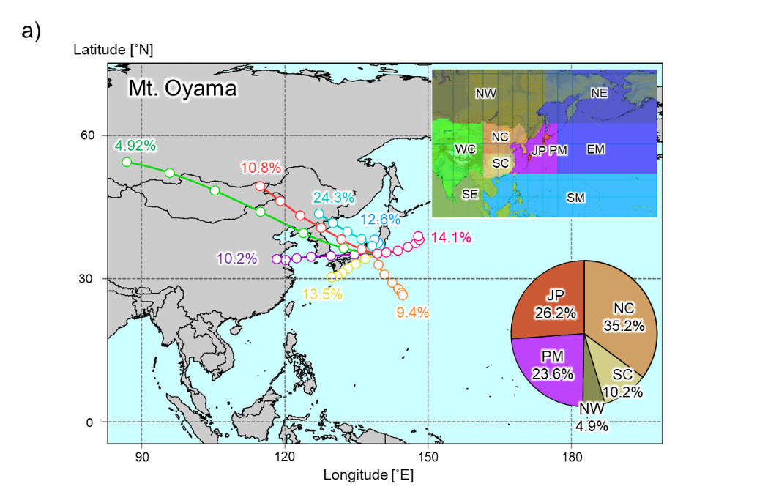

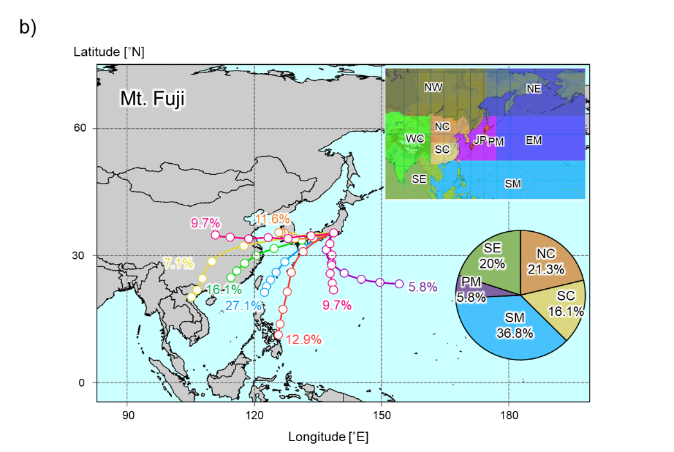

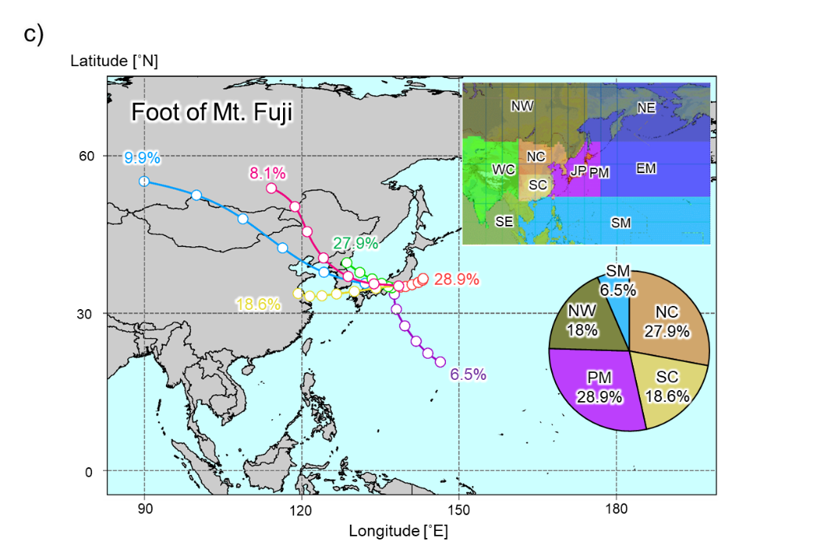

Fig. S7. (a) The percentage of air mass direction with cloud water containing airborne microplastics (AMPs) during the observation period at the summit of Mt. Oyama, (b) at the summit of Mt. Fuji, and (c) at the foot of Mt. Fuji. The geographical origin of the air masses is referred to the information provided by the Japan Meteorological Agency (https://www.data.jma.go.jp/ghg/kanshi/trajectory/info_trajectory.html).
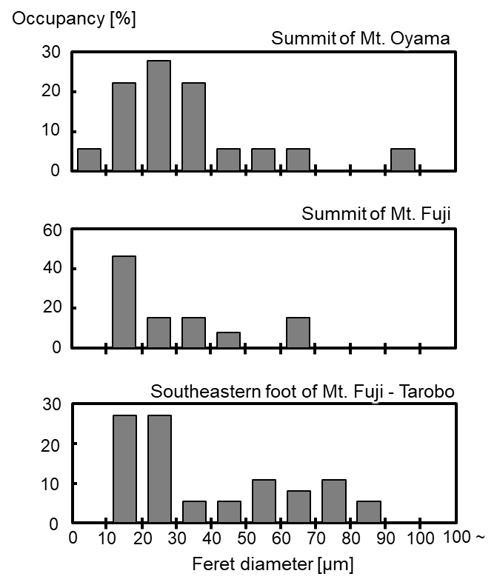
Fig. S8. Feret diameter distribution and Feret diameter shape occupancy of airborne microplastics (AMPs) in cloud water at the summit of Mt. Oyama, at the summit of Mt. Fuji, and at the southeastern of Mt. Fuji.

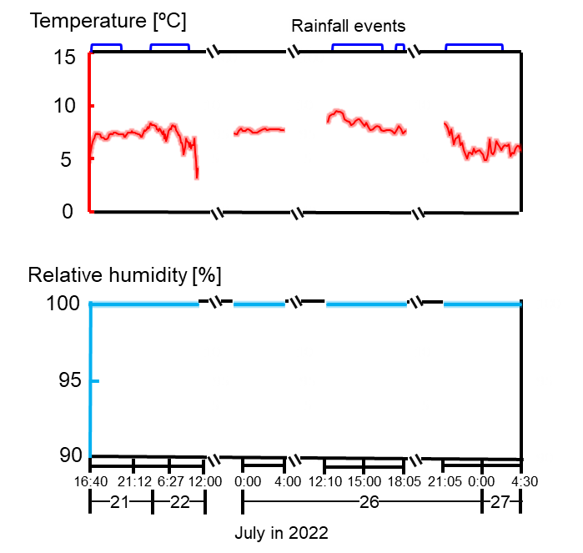
Fig. S9. The weather at the summit of Mt. Fuji changes over time during the sampling period (July 21–22, 2022; July 26–27, 2022), with the red line indicating the temperature, the blue line indicating the relative humidity, and the presence or absence of precipitation. (Relative humidity was almost 100 % and rainfall was observed by using a tipping bucket rain gauge. However, the low amount of rainfall suggests that it was not "rainfall” from the upper atmosphere but rather a collection of wind-driven cloud droplets and small raindrops blown off from the bottom by very strong winds.)

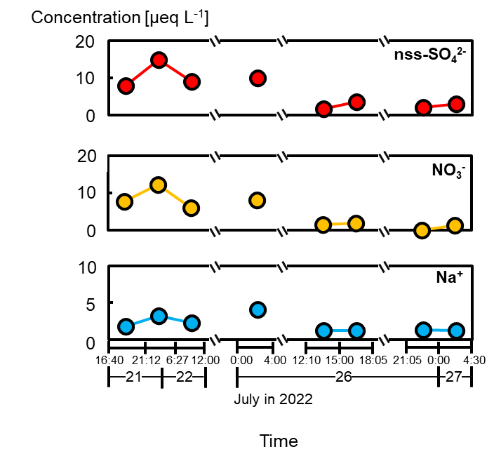
Fig. S10. The concentration of cloud water at the summit of Mt. Fuji changes over time during the sampling period (July 21–22, 2022; July 26–27, 2022), with the red dotted line indicating the no-sea-salt sulfate (nss-SO₄²⁻), the orange dotted line indicating the NO₃⁻, and the dotted blue line indicating the Na⁺.

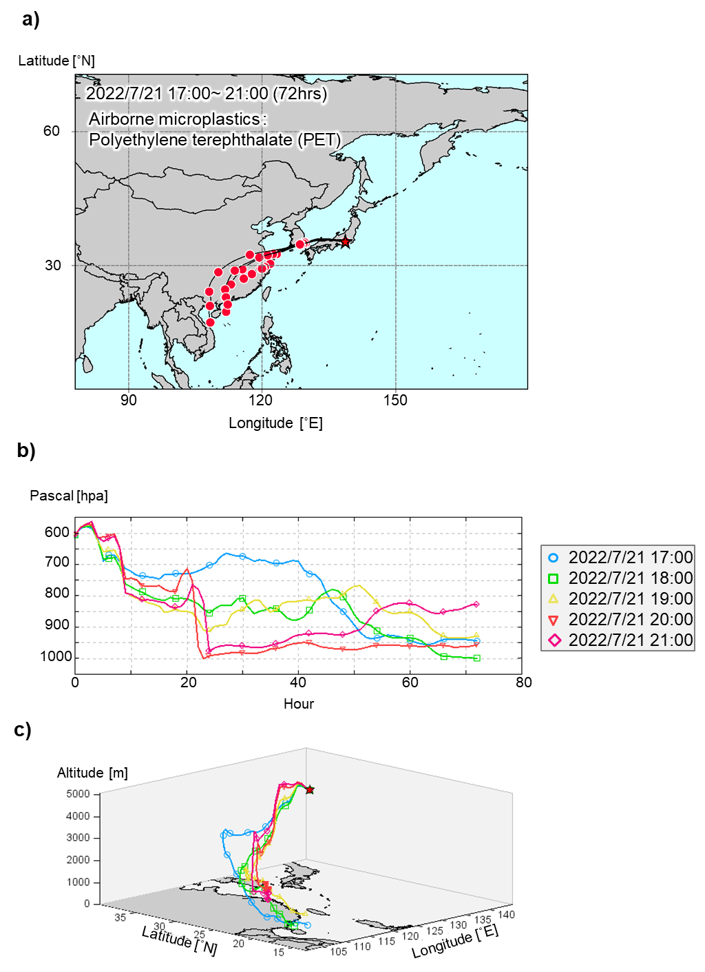
Fig. S11. (a) Backward trajectory analysis of the air mass for each hour during the observation period from 17:00 to 21:00 on July 21, 2022, (b) the atmospheric pressure, and (c) a 3D map of the altitude and latitude and longitude of the air masses. Backward trajectories were calculated for the air mass arriving at the summit of Mt. Fuji (3776 m a.s.l.) for 72 h.

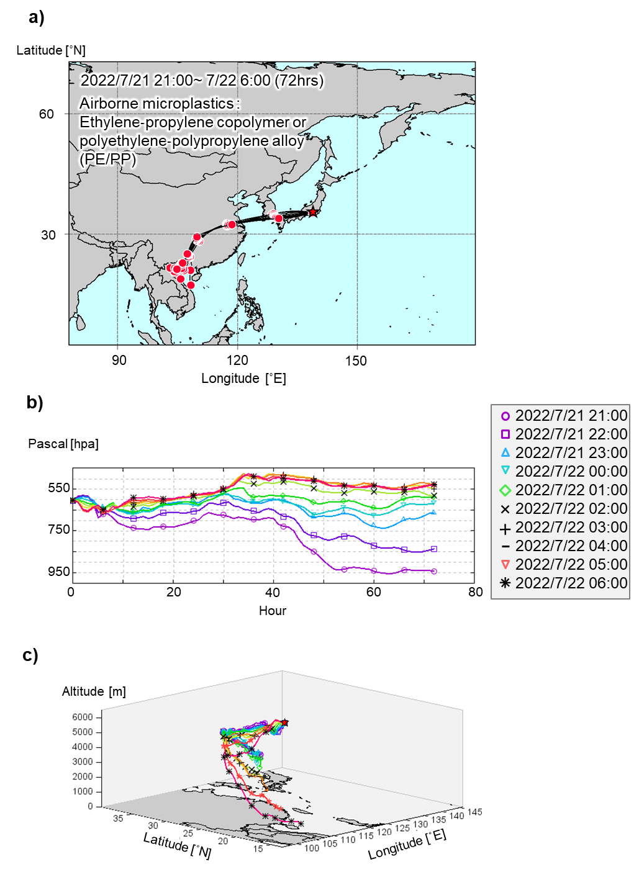
Fig. S12. (a) Backward trajectory analysis of the air mass for each hour during the observation period from 21:00 on July 21 to 6:00 on July 22, 2022, (b) the atmospheric pressure, and (c) a 3D map of the altitude and latitude and longitude of the air masses. Backward trajectories were calculated for the air mass arriving at the summit of Mt. Fuji (3776 m a.s.l.) for 72 h.

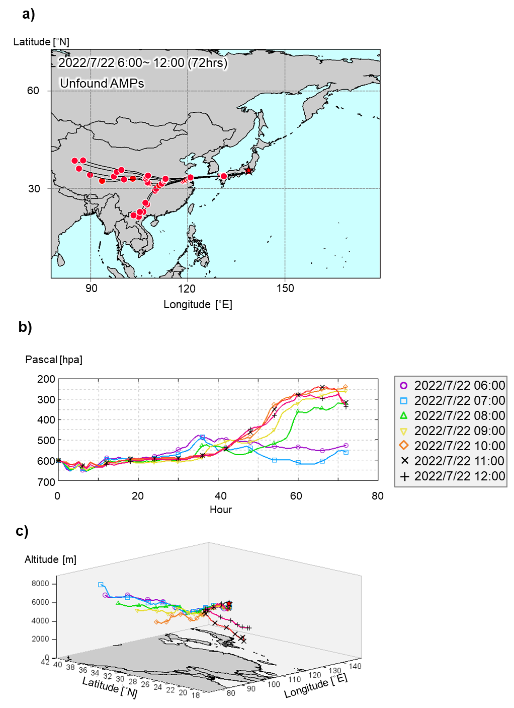
Fig. S13. (a) Backward trajectory analysis of the air mass for each hour during the observation period from 6:00 to 12:00 on July 22, 2022, (b) the atmospheric pressure, and (c) a 3D map of the altitude and latitude and longitude of the air masses. Backward trajectories were calculated for the air mass arriving at the summit of Mt. Fuji (3776 m a.s.l.) for 72 h.

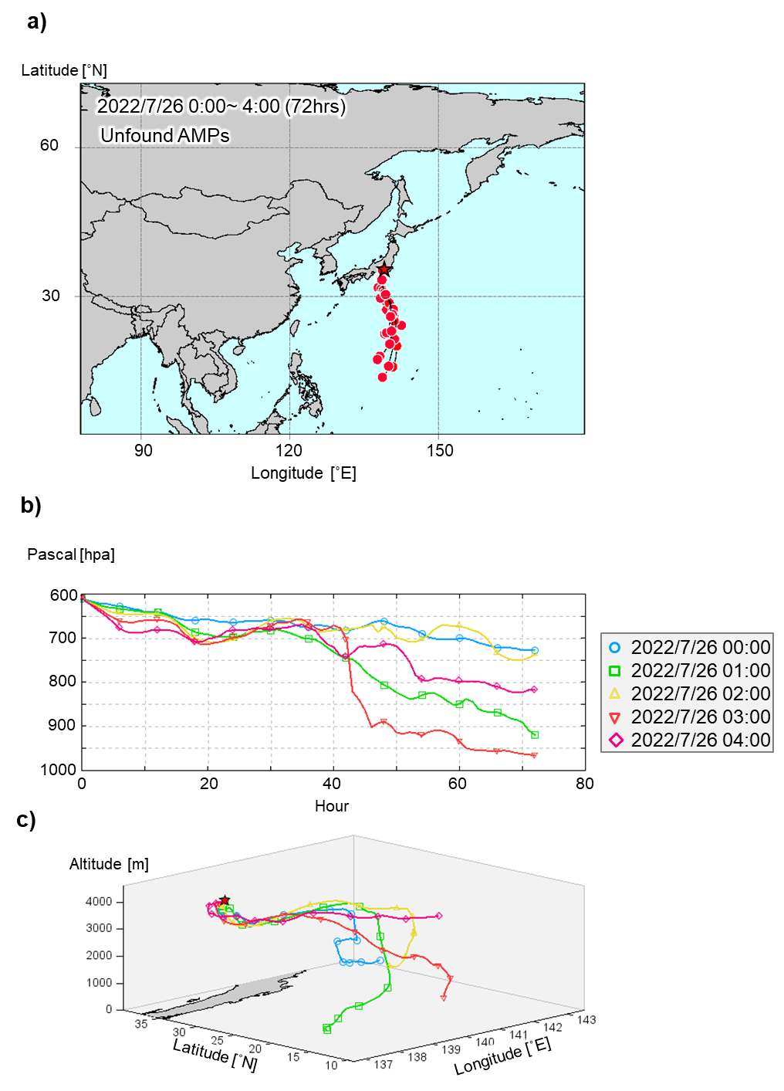
Fig. S14. (a) Backward trajectory analysis of the air mass for each hour during the observation period from 0:00 to 4:00 on July 26, 2022, (b) the atmospheric pressure, and (c) a 3D map of the altitude and latitude and longitude of the air masses. Backward trajectories were calculated for the air mass arriving at the summit of Mt. Fuji (3776 m a.s.l.) for 72 h.

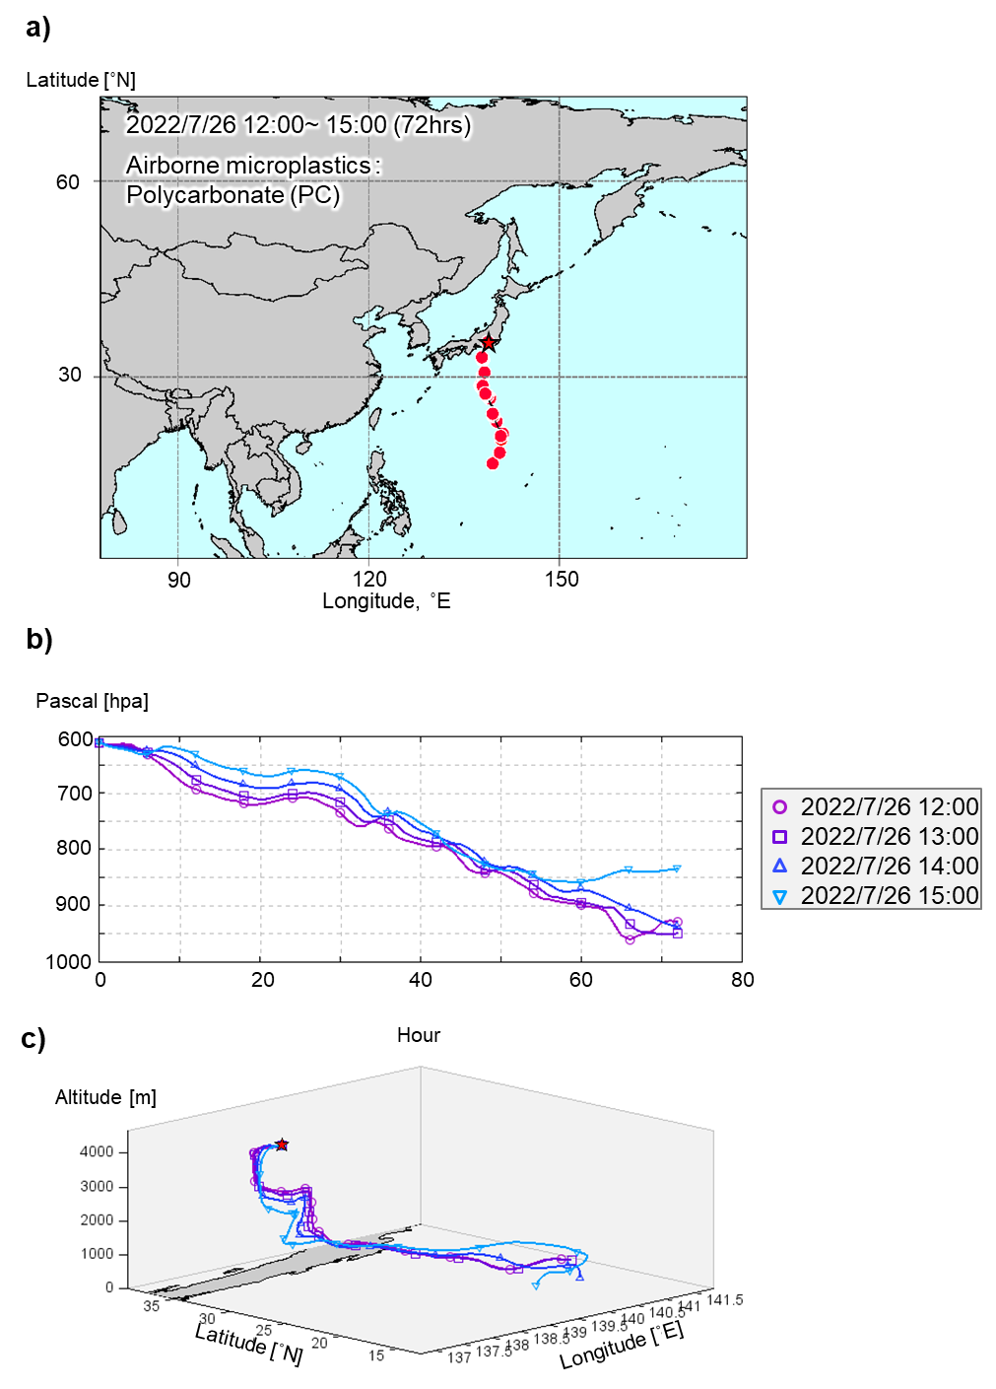
Fig. S15. (a) Backward trajectory analysis of the air mass for each hour during the observation period from 12:00 to 15:00 on July 26, 2022, (b) the atmospheric pressure, and (c) a 3D map of the altitude and latitude and longitude of the air masses. Backward trajectories were calculated for the air mass arriving at the summit of Mt. Fuji (3776 m a.s.l.) for 72 h.

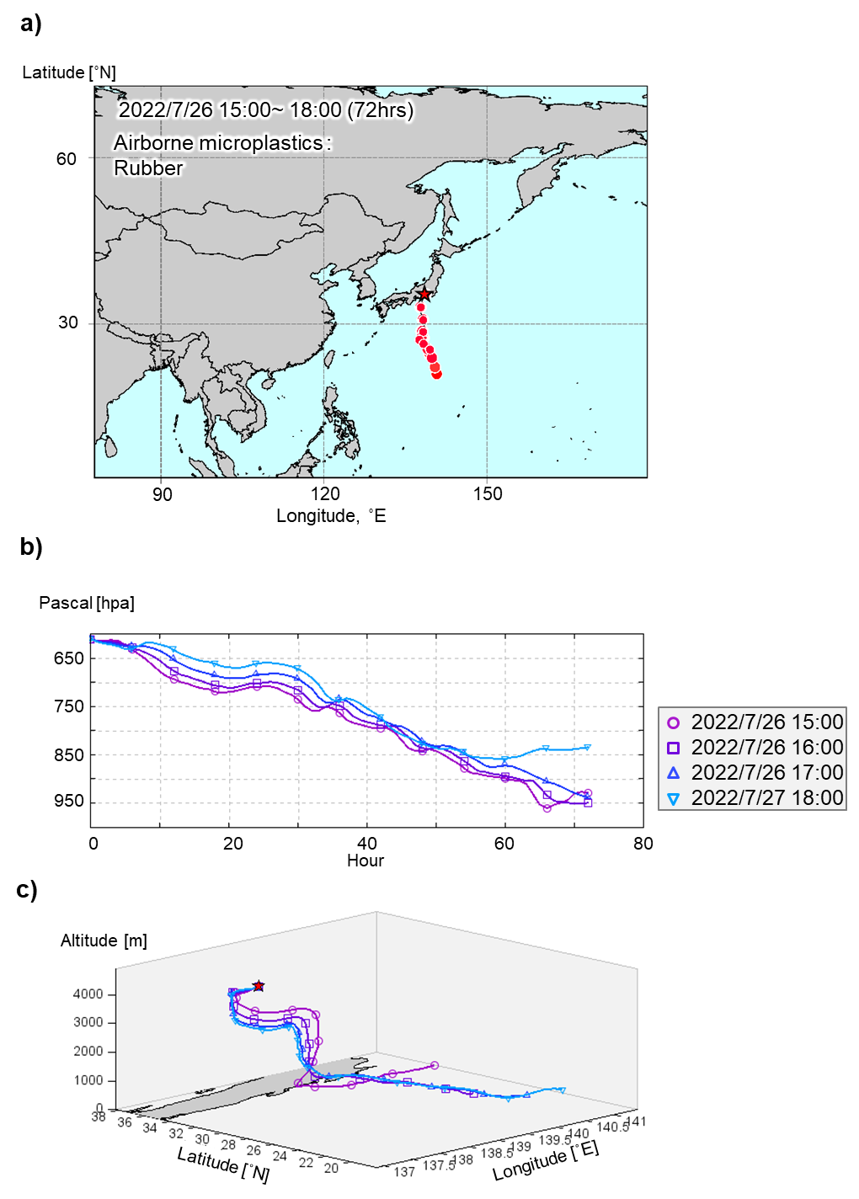
Fig. S16. (a) Backward trajectory analysis of the air mass for each hour during the observation period from 15:00 to 18:00 on July 26, 2022, (b) the atmospheric pressure, and (c) a 3D map of the altitude and latitude and longitude of the air masses (c). Backward trajectories were calculated for the air mass arriving at the altitude of 3776 m at Mt. Fuji for 72 h.

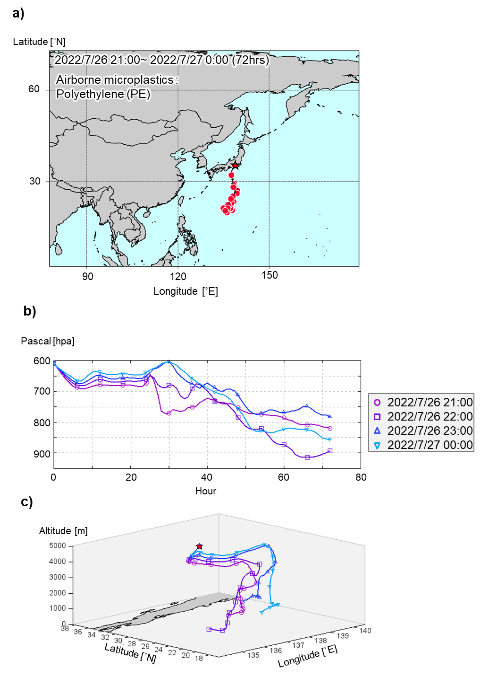
Fig. S17. (a) Backward trajectory analysis of the air mass trajectory for each hour during the observation period from 21:00 on July 26 to 0:00 on July 27, 2022, (b) the atmospheric pressure, and (c) a 3D map of the altitude and latitude and longitude of the air masses. Backward trajectories were calculated for the air mass arriving at the summit of Mt. Fuji (3776 m a.s.l.) for 72 h.

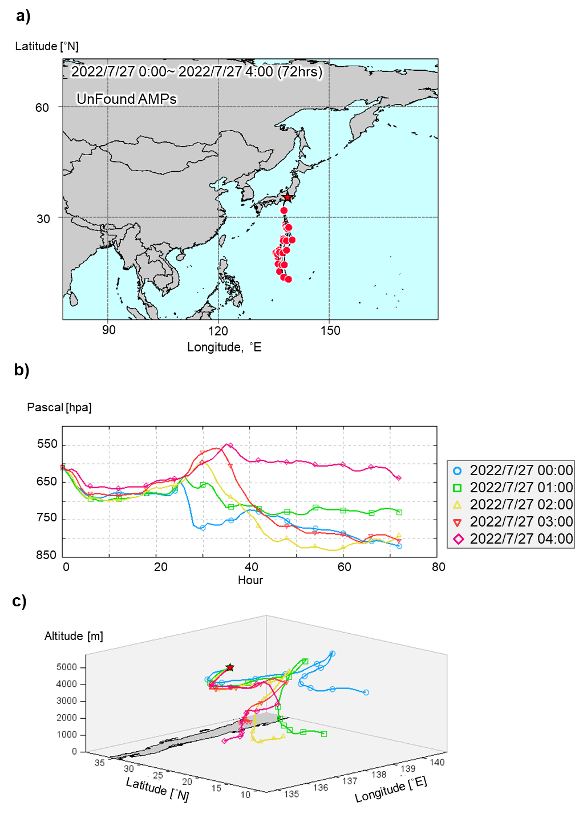
Fig. S18. (a) Backward trajectory analysis of the air mass trajectory for each hour during the observation period from 0:00 to 4:00 on July 27, 2022, (b) the atmospheric pressure, and (c) a 3D map of the altitude and latitude and longitude of the air masses. Backward trajectories were calculated for the air mass arriving at the summit of Mt. Fuji (3776 m a.s.l.) for 72 h.

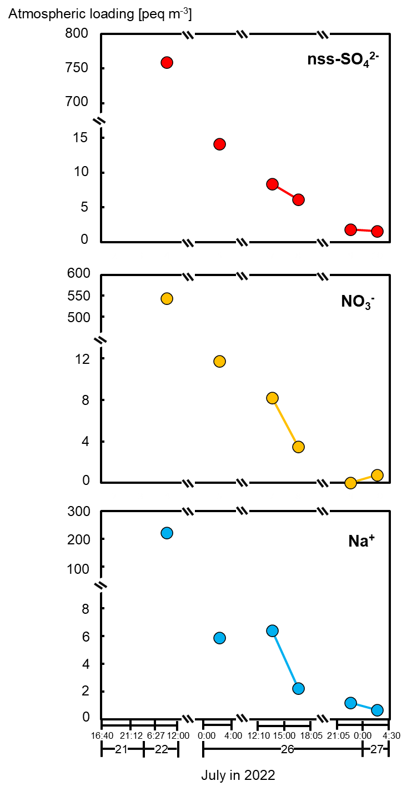
Fig. S19. Changes of estimated atmospheric loading of non-sea-salt sulfate (nss-SO₄²⁻), NO₃⁻, and Na⁺ over time at the summit of Mt. Fuji during the period from July 21 to 22 and from July 26 to 27 in 2022. Atmospheric load is calculated by multiplying liquid water content (LWC) by cloud water concentration. The fog monitor (FM-100; Droplet Measurement Technol- ogies) was used to observe the LWC.

Table S1. Information on Mt. Oyama
ID No. | Sampling day | Yes or No detection MPs | Number of detected MPs (pieces) | Types of MPs
1 | Jan. 9 ~ Feb. 13, 2022 | Yes | 14 | PP, PET, PUR
2 | Feb. 13 ~ Mar. 2, 2022 | No | - | -
3 | Mar. 2 ~ Apr. 10, 2022 | Yes | 1 | PP
4 | Apr. 10 ~ May. 15, 2022 | No | - | -
5 | May. 15~ Jun. 17, 2022 | No | - | -
6 | Jun. 17~ Jul. 13, 2022 | No | - | -
7 | Jul. 13~ Aug. 9, 2022 | No | - | -
8 | Aug. 9~ Sep. 28, 2022 | Yes | 3 | PET
9 | Sep. 28~ Oct. 20, 2022 | Yes | 1 | PE/PP

Full names of microplastics (MPs) that are abbreviated in the table: polypropylene (PP), polyethylene terephthalate (PET), ethylene propylene copolymer or polyethylene-polypropylene alloy (PE/PP), and polyurethane (PUR).

Table S2. Information on Mt. Fuji
ID No. | Sampling day | Yes or No detection MPs | Number of detected MPs (pieces) | Types of MPs
1 | Aug. 12 13:10 ~ Aug. 17 10:30, 2021 | Yes | 2 | EP, PA
2 | Aug. 17 10:30 ~ Aug. 17 11:20, 2021 | No | - | -
3 | Aug. 17 11:20 ~ Aug. 20 8:30, 2021 | No | - | -
4 | Aug. 20 8:30 ~ Aug. 20 17:00, 2021 | Yes | 2 | PP, PET
5 | Aug. 20 17:00 ~ Aug. 21 8:45, 2021 | No | - | -
6 | Aug. 21 8:45 ~ Aug. 21 16:30, 2021 | No | - | -
7 | Aug. 21 16:30 ~ Aug. 22 8:55, 2021 | No | - | -
8 | Aug. 22 8:55 ~ Aug. 23 8:30, 2021 | No | - | -
9 | Aug. 23 8:30 ~ Aug. 24 8:30, 2021 | No | - | -
10 | Aug. 24 8:30 ~ Aug. 25 8:30, 2021 | No | - | -
11 | Aug. 25 8:30 ~ Aug. 25 10:56, 2021 | No | - | -
12 | Jul. 21 16:40 ~ Jul. 21 21:21, 2022 | Yes | 1 | PET
13 | Jul. 21 21:21 ~ Jul. 22 6:27, 2022 | Yes | 1 | PE/PP
14 | Jul. 22 6:27 ~ Jul. 22 12:00, 2022 | No | - | -
15 | Jul. 26 0:00 ~ Jul. 26 4:00, 2022 | No | - | -
16 | Jul. 26 12:10 ~Jul. 26 15:00, 2022 | Yes | 4 | PC
17 | Jul. 26 15:00 ~ Jul. 26 18:05, 2022 | Yes | 1 | Rubber
18 | Jul. 26 21:05 ~ Jul. 27 0:00, 2022 | Yes | 1 | PE
19 | Jul. 27 0:00 ~ Jul. 27 4:30, 2022 | No | - | -

Full names of microplastics (MPs) that are abbreviated in the table: epoxy resin (EP), polyamide 6 (PA), polypropylene (PP), polyethylene terephthalate (PET), ethylene propylene copolymer or polyethylene-polypropylene alloy (PE/PP), and polycarbonate (PC), polyethylene (PE), and unknown rubber※.

※Identification of unknown rubber
In the sample spectrum, the presence of peaks in the range of 3000 – 2700 cm⁻¹ indicates the presence of C-H stretching vibrations, confirming that the substance is an organic compound. In addition, detection in the range of 3700 – 3600 cm ⁻¹ suggests kaolinite, whereas the peaks at 1400 cm⁻¹ and 800 cm⁻¹ are characteristic of carbonate. Kaolinite and carbonate are added during the rubber manufacturing process to enhance the performance of the rubber, thereby confirming that the substance is rubber.

Table S3. Information on the foot of Mt. Fuji - Tarobo
ID No. | Sampling day | Yes or No detection MPs | Number of detected MPs (pieces) | Types of MPs
1 | Oct. 12 ~ Oct.26, 2020 | No | - | -
2 | Nov. 9 ~ Nov. 23, 2020 | Yes | 1 | PET
3 | Feb. 11 ~ Mar. 2, 2021 | No | - | -
4 | Apr. 13 ~ Apr. 27, 2021 | No | - | -
5 | Apr. 27 ~ May. 11, 2021 | Yes | 1 | AR
6 | Jul. 19 ~ Aug. 2, 2021 | Yes | 13 | PP, PET, PE/PP
7 | Aug. 31 ~ Sep. 14, 2021 | Yes | 8 | PET
8 | Nov. 8 ~ Nov. 22, 2021 | Yes | 1 | PET
9 | Feb. 28 ~ Mar. 14, 2022 | Yes | 8 | PET, AR, PE/PP
10 | Apr. 15 ~ Apr. 27, 2022 | Yes | 1 | AR
11 | Apr. 27 ~ May. 11, 2022 | No | - | -
12 | May. 11 ~ May. 25, 2022 | No | - | -
13 | Jun. 7 ~ Jun. 21, 2022 | No | - | -
14 | Jun. 21 ~ Jul. 5, 2022 | No | - | -
15 | Jul. 5 ~ Jul. 19, 2022 | Yes | 4 | PET
16 | Jul. 27 ~ Aug. 8, 2022 | Yes | 1 | AR

Full names of microplastics (MPs) that are abbreviated in the table: polyethylene terephthalate (PET), polymethyl methacrylate (AR), polypropylene (PP), and ethylene propylene copolymer or polyethylene-polypropylene alloy (PE/PP).

References
Tokunaga Y, Okochi H, Tani Y, Niida Y, Tachibana T, Saigawa K, Katayama K, Moriguchi S, Kato T, Hayama SI (2023) Airborne microplastics detected in the lungs of wild birds in Japan. Chemosphere 321:138032. https://doi.org/10.1016/j.chemosphere.2023.138032
Cooper DA and Corcoran PL (2010) Effects of mechanical and chemical processes on the degradation of plastic beach debris on the island of Kauai, Hawaii. Mar Pollut Bull 60: 650–654. https://doi.org/10.1016/j.marpolbul.2009.12.026

