Supplementary material
Skin protection from solar ultraviolet radiation using natural compounds: A review
Ankit Verma ^{1,} *, #, Alessandra Zanoletti ^{2,} *, Kola Yusuff Kareem ³, Bashir Adelodun ^{4, 5,} *, Pankaj Kumar ⁶, Fidelis Odedishemi Ajibade ⁷, Luis F.O. Silva ⁸, Ankur Joel Phillips ⁹, Thangathurai Kartheeswaran ¹⁰, Elza Bontempi ², Ashish Dwivedi ¹
¹ Photobiology Laboratory, System Toxicology and Health Risk Assessment Group, CSIR-Indian Institute of Toxicology Research, Vishvigyan Bhawan 31, Mahatma Gandhi Marg, Lucknow 226001, Uttar Pradesh, India
² INSTM and Chemistry for Technologies Laboratory, Department of Mechanical and Industrial Engineering, University of Brescia, Via Branze, 38, 25123, Brescia, Italy
³ Department of Advanced Science and Technology Convergence, Kyungpook National University, Sangju, 37224, Gyeongbuk, South Korea
⁴ Department of Agricultural and Biosystems Engineering, University of Ilorin, PMB 1515, Ilorin 240003, Nigeria
⁵ Department of Agricultural Civil Engineering, Kyungpook National University, Daegu 41566, South Korea
⁶ Agro-Ecology and Pollution Research Laboratory, Department of Zoology and Environmental Science, Gurukula Kangri, Haridwar, Uttarakhand, 249404, India
⁷ Department of Civil and Environmental Engineering, Federal University of Technology, PMB 704, Akure, 340110, Nigeria
⁸ Department of Civil and Environmental Engineering, Universidad de la Costa, Calle 58 #55-66, 080002 Barranquilla, Atlántico, Colombia
⁹ Biological R & D Unit, JU Agri Sciences Pvt. Ltd., Industrial Area, Sikandrabad, Bulandshahr, Uttar Pradesh, India
¹⁰ Department of Physical Science, University of Vavuniya, 43000, Sri Lanka
# Present address: Stem Cell Research Center, The Goldyne Savad Institute of Gene Therapy, Hadassah Medical Center, Ein Kerem Campus, Hebrew University of Jerusalem, Jerusalem, 91120, Israel
* Corresponding authors:
E-mail: Ankit Verma; ankit.verma@mail.huji.ac.il
E-mail: Alessandra Zanoletti; alessandra.zanoletti@unibs.it
E-mail: Bashir Adelodun; adelodun.b@unilorin.edu.ng

1. Methodology
In this study, we addressed the effect of natural agents and organic and plant materials as potential protection materials against ultraviolet radiation globally. At first, the literature search was performed on the Web of Science (webofscience.com) database by specifying germane keywords like “ultraviolet protection”, “photoprotection”, “UV effect on the environment”, “UV effect on humans”, and combining with Boolean operators of “AND” and “OR”. Literature outputs were selected by considering abstract relevance to the subject matter and filtered to obtain fifty (50) originally published research articles addressing the ultraviolet radiation effect on human health, ecosystem and natural photoprotective materials.
Trend analysis was conducted using the Mann-Kendall method (Hussain and Mahmud 2019). The Mann-Kendall method spans between -1 and 1, where values of -1, 0, and 1 signify a perfect declining trend, no trend, and a perfect increasing trend respectively (Newson 2002). Furthermore, the keyword concurrence analysis was conducted using the VOSviewer 1.6.18 tool. It is a bibliography assessment tool developed at the University of Leiden, the Netherlands (van Eck and Waltman 2010).
Finally, the study was evaluated by considering several thematic areas of advances in sensor technology for ultraviolet radiation measurement, ultraviolet radiation in biotic and abiotic ecosystems and environment, photostability and toxicity of sunscreen ingredients, the effect of ultraviolet radiation on human health and skin, and natural agents and phytochemicals for photoprotection.

1.1 Trend and bibliometric analysis of articles
Analysis of publication count by the spatial distribution of selected articles, keyword usage and trend of UV articles that addressed UV effects on human health and the ecosystem are presented in this section. Fig. S1 illustrates the publication count within the last two decades. It can be observed that there has been a steady rise in UV-related research with the highest number of articles recorded in 2021 and a significant rise in the year 2022. The result of trend analysis conducted by Mann Kendall statistics shows that there is a significantly increasing trend in UV-photoprotectant publication (tau = 0.60, p =0.0001, Sen-slope, s =0.25) at a confidence level of 95%. The Sen slope, s value is an indication that as the trend increases, the magnitude of change of the trend over time increases.
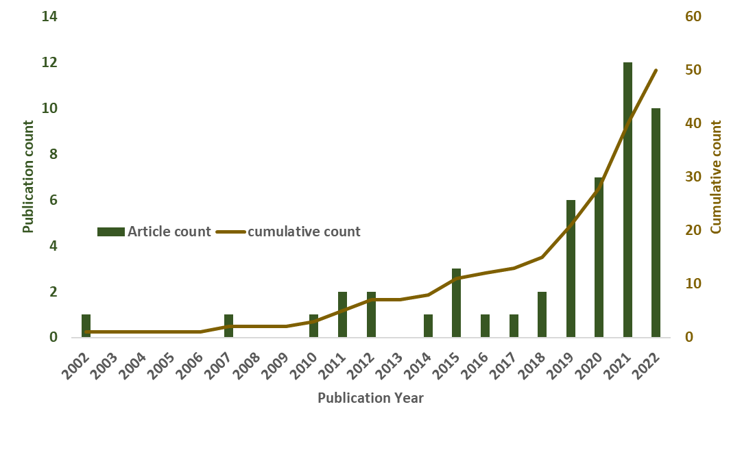
Fig. S1. The evolution of fifty UV-related articles in the last two decades. A steady rise in UV-related research was recorded in the last two decades and interest in this area was highest in 2021. At the time of writing this manuscript, publication in 2022 had recorded about two-thirds of the count in 2021, indicating satisfactory interest in innovative photoprotectants.

Similarly, Fig. S2 shows the spatial distribution of the available studies that are considered in the present work. It can be observed that among the available 50 articles that met the study criteria, the highest publication count of 12% was recorded in the United States of America (USA) while several countries have the lowest publication counts of 2%. This indicates the pressing need for more study on environmentally-friendly alternatives to conventional sunscreen technologies for ultraviolet radiation protection.
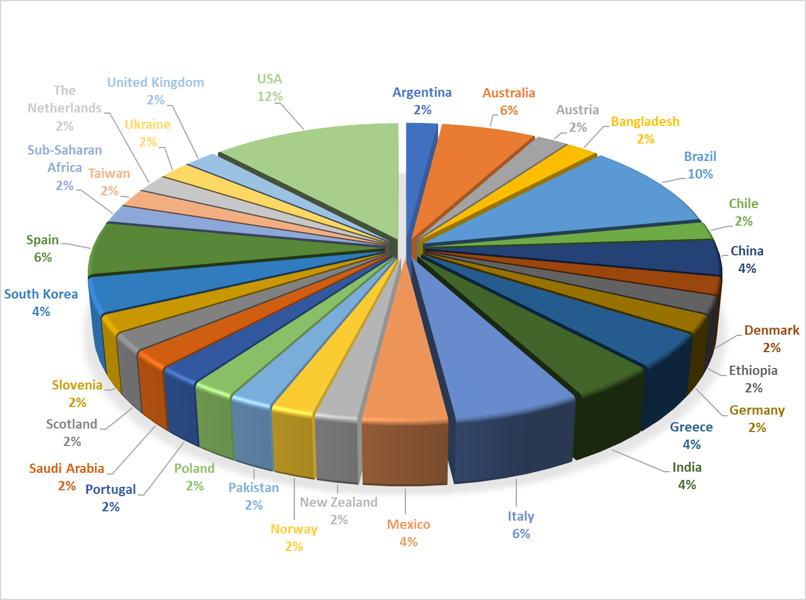
Fig. S2. Spatial distribution from a sample of 50 articles revealed that ultraviolet radiation-related studies are most predominant in the United States of America (USA = 12% publication count), followed by Brazil (10%), while several countries constitute 2% each.
The VOSviewer analysis was further employed to illustrate authors’ keyword usage per average year of publication using the overlay visualization tool, which identifies seven clusters distinguishable by colour according to the weight of occurrence and average publication per year score. Fig. S3 shows the keyword usage of articles and it can be seen that “ultraviolet radiation”, “oxidative stress”, and “skin cancer” are the most prevalent keywords. Towards the year 2022, more focus has been shifted to discovering and manufacturing natural and environmentally-safe UV photoprotectants, as clearly shown by the yellow cluster.
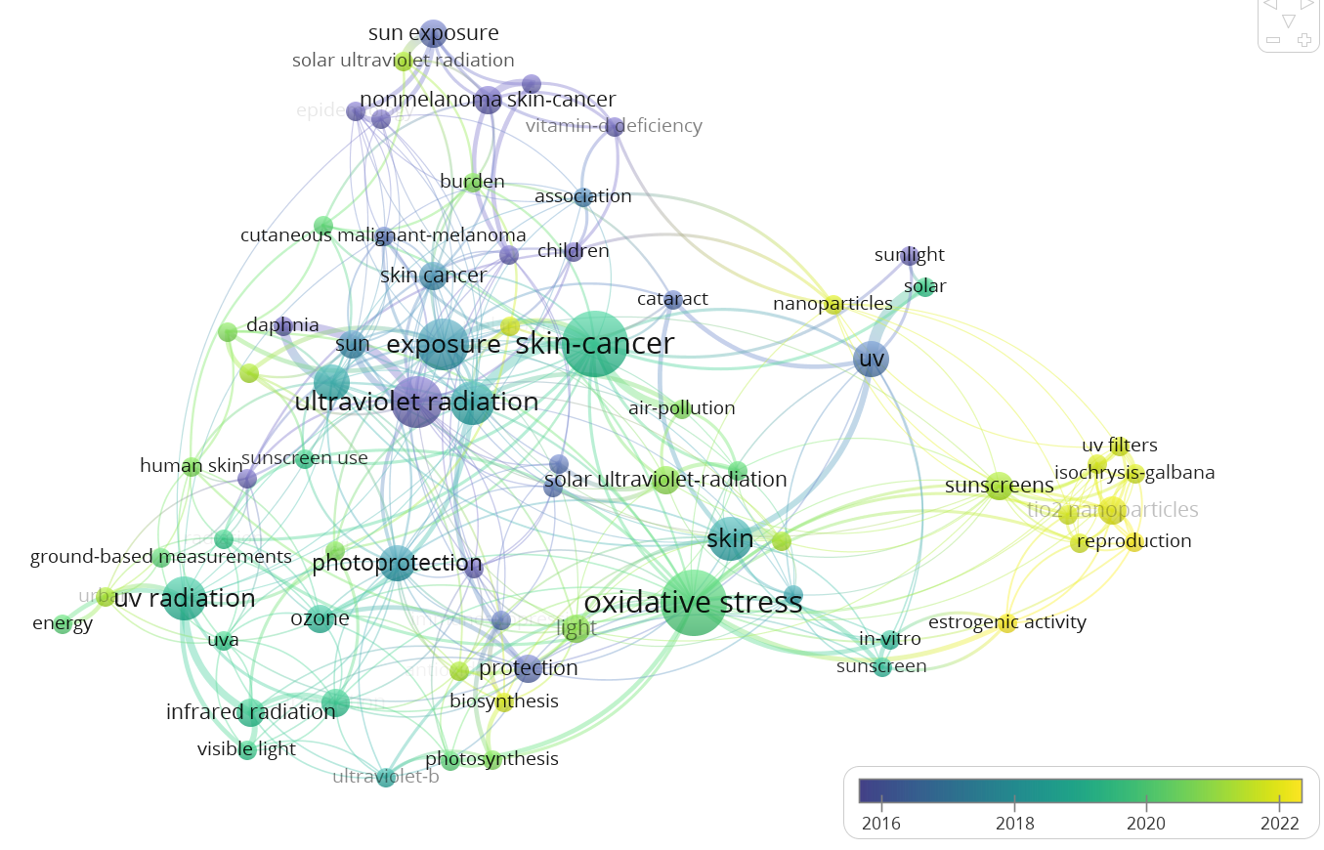
Fig. S3. The bibliometric cluster of “co-word” analysis result. The network visualization shows the most frequently used variables, depicted by the size of the node, which was produced from the co-occurrence of text words in the abstracts and keywords based on “ultraviolet radiation”, “skin cancer”, and “oxidative stress”. The Web of Science database was selected for the material source and the analysis was conducted using the VOSviewer (Version 1.6.18). The result indicates that most ultraviolet radiation studies mainly focused on addressing oxidative stress effects and skin cancer prevention. The yellow cluster reveals that recent studies in 2022 attempted to propose new photoprotectant alternatives to sunscreens.

References
Hussain M, Mahmud I (2019) pyMannKendall: a python package for non parametric Mann Kendall family of trend tests. J Open Source Softw 4:. https://doi.org/10.2307/2333424
Newson R (2002) Parameters behind “Nonparametric” Statistics: Kendall’s tau, Somers’ D and Median Differences. Stata J Promot Commun Stat Stata 2:45–64. https://doi.org/10.1177/1536867x0200200103
van Eck NJ, Waltman L (2010) Software survey: VOSviewer, a computer program for bibliometric mapping. Scientometrics 84:523–538. https://doi.org/10.1007/s11192-009-0146-3

