Supplementary Material
Artificial intelligence and machine learning-based optimisation of pharmaceutical wastewater treatment systems: a review
Voravich Ganthavee, Antoine P. Trzcinski
School of Agriculture and Environmental Science, University of Southern Queensland, Toowoomba QLD 4350 Australia. Corresponding Author’s email address: Voravich.Ganthavee@unisq.edu.au

S1. Bibliometric and review methods
The terms “pharmaceutical wastewater treatment” and “artificial intelligence” were used to search the Web of Science (Science Citation Index) and Scopus for document titles, abstract, and keywords published from 1990 to 2023. Bibliometrics has been increasingly critical for analysing and predicting research and development trends. The co-word analysis is used to identify popular terms in related topics. Figure S1 shows the technological developments and research intensity of different countries involved in artificial intelligence technologies. In addition, Figure S2 shows the subject fields applicable to artificial intelligence technologies. Figure S3 represents the source visualization and exploration software VOSviewer used to analyse the keywords in the documents obtained. Based on bibliometric analysis, a detailed literature review on the application of artificial intelligence technologies to pharmaceutical wastewater treatment systems can be conducted to include technological performance and recent advancements in artificial intelligence optimization tools.
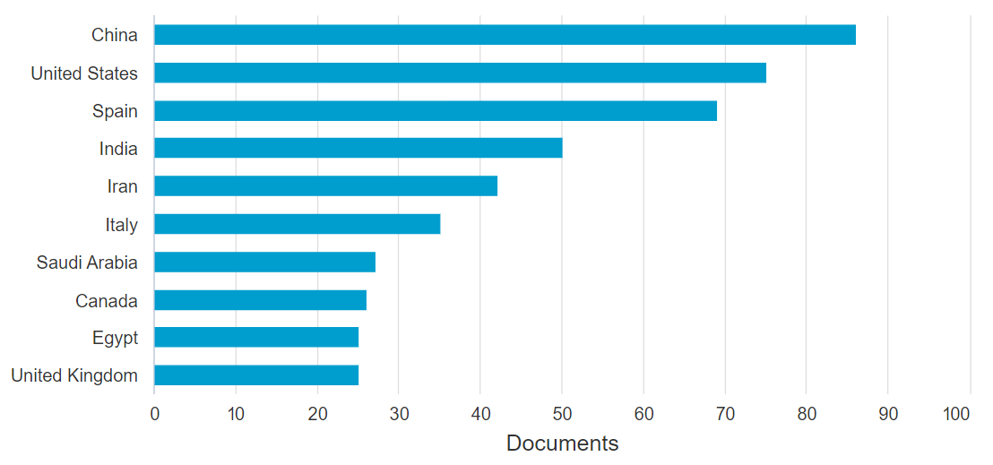
Figure S1. Number of publications by different countries in artificial intelligence technologies applied to wastewater treatment in 2023 (Scopus Citation Index).
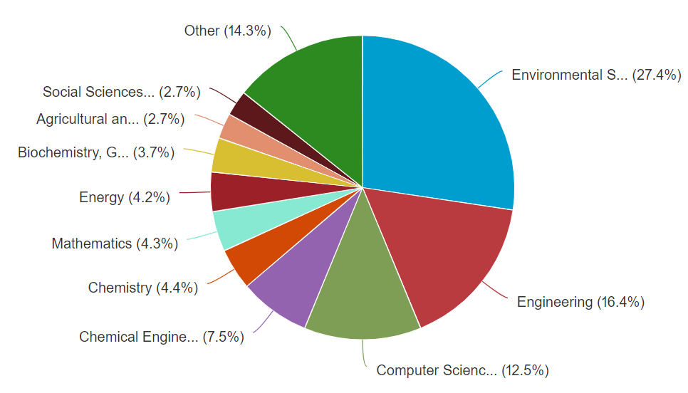
Figure S2. Subject fields of publications in artificial intelligence technologies applied to wastewater treatment in 2023 (Scopus Citation Index).
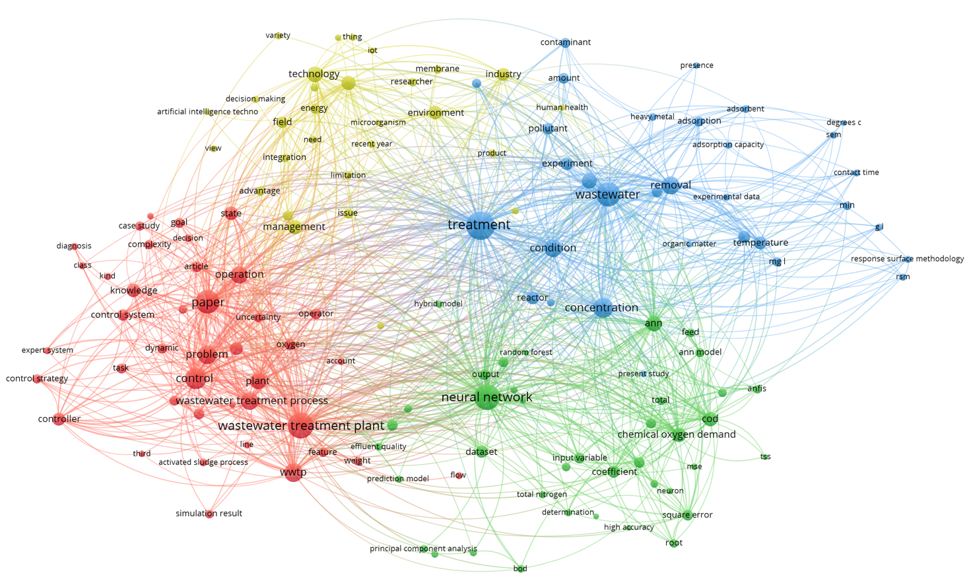
Figure S3. Network visualisation of publications on artificial intelligence applied to wastewater treatment during 1990-2023 (Web of Science, Science Citation Index).

