Supplementary Material

The dual role of tropospheric ozone in controlling COVID-19 outbreaks

Yinon Yecheskel^{1,2}, Noa Sand^{1,2}, Lu Zhang¹, Yaal Lester³, Michal Segal-Rozenhaimer^{1,4,5}, and Ines Zucker^{1,2*}

¹ Porter School of Earth and Environmental Studies, Faculty of Exact Sciences, Tel Aviv University, Tel Aviv, Israel
² School of Mechanical Engineering, Faculty of Engineering, Tel Aviv University, Tel Aviv, Israel
³ Department of Material Engineering, Azrieli College of Engineering, Jerusalem, Israel
⁴ NASA Ames Research Center, Moffett Field, Mountain View, California, USA
⁵ Bay Area Environmental Research Institute, Moffett Field, California, USA
* Corresponding author. Tel: +972 3 6408227 E-mail: ineszucker@tauex.tau.ac.il

Text S1. Experimental
S1.1 Environmental and meteorological datasets and medical records of regional
Meteorological measurements and medical records for the cities Haifa, Tel-Aviv, and Beer-Sheva, which represent the major metropolitan areas in Israel from north to south (respectively), were obtained from governmental record of health data, as reported by the Israeli Heath Department [1]. Daily atmospheric data, including temperature, absolute humidity, nitrogen dioxide (NO₂), particulate matter under 2.5 µm and 10 µm, and ozone (O₃), for the time period of March 2020 to September 2021, were obtained from the Israeli Environmental Protection Agency public records [2].
Among the available health data variables, we examined daily data of new covid cases, accumulated cases (for the entire data record analyzed), accumulated hospitalized cases, and accumulated deaths. In addition, we calculated the effective (time–varying) reproduction number (R_{eff}), which represents the number of cases that an infected person generates. It is one of the most important factors determining the spread of the pandemic under travel restrictions [3]. R_{eff} is determined by the average number of secondary infections an infected person will cause in a completely susceptible population [3]. The R_{eff} value on day t is derived from the daily values of confirmed COVID-19 cases using the following equation:
$$R_{eff}=\frac{Cu{m_C}_{t}-Cu{m_C}_{t-w}}{Cu{m_C}_{t-g}-Cu{m_C}_{t-g-w}}$$
where Cum_C_{t} is the cumulative number of confirmed cases on day t. w and g represent the size of the sliding window and the average duration of the COVID-19 generation period, respectively. w is set as 7 days and g is 4 days.

S1.2 Inactivation tests
S1.2.1 Antiviral experiments
The laboratory experiments were conducted in a 36 L sealed poly(methyl methacrylate) (PMMA) chamber, equipped with temperature and humidity sensors (INKBIRD, China). The chamber was fed by ozone-containing airflow at a rate of 3 L min⁻¹. Air humidity at the inlet was regulated by mixing dry air with humidified air at a predetermined ratio to achieve the desired relative humidity within a range of 40%–70% (± 3%). Temperature control was achieved by cooling the chamber using an ice bath, maintaining target temperatures within a range of 9 °C to 22 °C (± 1 °C). Ozone gas, produced by an air-fed ultra-violet light ozone generator (APS 450, Pool-Purity, Israel), was mixed with the humidity-controlled inflow air before entering the experimental chamber. Ozone concentration was analyzed at both the chamber’s inlet and outlet using an ozone monitor (InDevk, 2B Technologies).
Microscope glass slides were used as coupons for studying the survival of male-specific bacteriophage, MS2. The glass slides were cut to approximately 2 × 2 cm using a diamond knife and then treated with Trichloro Silan (1H,1H,2H,2H-perfluorooctyl, Sigma Aldrich) to increase hydrophobicity and enable placing relatively stable drops on their surface. Before each experiment the slides were prewashed with deionized water (Milli-Q Direct, Merck Millipore, Germany) and sterilized with 70% ethanol (Bio-Lab, Israel). After setting the chamber atmosphere to the desired experimental conditions, including temperature, humidity, and ozone concentration, the MS2 suspension was applied onto the pretreated coupons as 5 droplets of 5 µL per slide and then placed inside the chamber. To evaluate inactivation kinetics, coupons were periodically taken out of the chamber, and MS2 virions were extracted and analyzed as described below. Blank experiments were conducted to test the impact of the air stream, i.e., without ozone, and the coupon material and surface treatment on the virus’s survival rate. Each experiment was conducted on a triplicate basis, i.e., three glass coupons per time point, to ensure internal consistency and reliability. These comparative analyses and kinetic studies allowed us to draw conclusions based on observed trends rather than single measurements, thereby reinforcing the reliability of the results.

S1.2.2 Male-specific bacteriophage–MS2 propagation and enumeration
MS2 bacteriophage (ATCC 15597-B1), a widely used surrogate for SARS-CoV-2 [4–6], was propagated using an Escherichia coli host (ATCC 15597) and purified by centrifugation at 6000 rpm for 10 min at room temperature followed by filtration through a 0.22-μm low protein binding filter (PES Stericup filter, Millipore), as previously described [7]. The concentrated MS2 suspension was diluted to an initial working concentration of about 10⁸ plaque forming units (PFU)/mL in 5% fetal bovine serum diluted in pH 7.4 phosphate-buffered saline, and placed on a glass coupon for the antiviral experiments as detailed above.
After the antiviral experiments, MS2 virions were extracted from the glass coupon surface according to the Environmental Protection Agency (EPA) protocol [8], and the extracted suspensions were diluted and enumerated on the same day by the double agar layer method [9]. Detailed description of MS2 propagation and enumeration standard procedure is given elsewhere [7]. Briefly, at each time point, coupons were collected and aseptically placed into tubes containing 10 mL of 10% Dey Engley and vortexed initially at maximum speed for 5 seconds. After completing all tested coupons, all samples were vortexed for an additional 2 minutes to extract the virions. Extracted samples were serially diluted 10-fold in phosphate-buffered saline, pH 7.4, and then plated and enumerated by the double agar layer method. After overnight incubation at 37°C, plaques were enumerated to determine bacteriophage concentration (PFU/mL), where only plates with plaque count above the desired limit of quantification were used (10 PFU/mL).

Text S2: Results and discussion
S2.1: Seasonal variations of environmental parameters.
We evaluated parametric correlations between available atmospheric data and COVID-19 measures. Seasonal variations were seen for environmental parameters such as temperature, absolute humidity, NO₂ and ozone (Figure S1) for the three tested metropolitans. For example, temperatures and absolute humidity increase in summer and decrease in winter. Ozone (O₃) and nitrogen dioxide (NO₂) showed opposite trends, as expected in urban areas, since ozone is a secondary pollutant generated by NO₂ photolysis [10]. Furthermore, ozone concentrations in winter showed minimum levels, while NO₂ showed the maximum levels, pointing to the impact of solar radiation (and temperature) on ozone production, as observed in other parts of the world [10].

S2.2: inactivation tests and control experiments.
Inactivation of male-specific bacteriophage, MS2, serving as a surrogate for SARS-CoV-2, was studied in a controlled gas-tight chamber (see Figure 2A in the main text and Figure S10) by exposing it to ozone concentrations of 0.1, 1, and 80 ppm, in a series of experiments conducted at environmentally relevant temperature and humidity levels. While the tested ozone concentration range is higher than typical tropospheric ozone concertation, it allowed us to investigate the role of ozone concentration on viral inactivation in a reasonable timescale. Control experiments demonstrated the minimal effect of the coupon pretreatment and the cleaning protocol on viral inactivation (Figure S11). In addition, a reference inactivation experiment, in which a droplet was placed on a clean glass surface for four hours in ambient air (right bar, Figure S11), was conducted under identical conditions without ozone exposure. This experiment demonstrated minimal effect on MS2 reduction and served as a benchmark for the inactivation study.

Figure S1. (a) tropospheric ozone (O₃), (b) temperature, (c) absolute humidity, (d) nitrogen dioxide (NO₂), (e) particulate matter smaller than 2.5 µm (PM_{2.5}), and (f) particulate matter smaller than 10 µm (PM₁₀) concentration during the first three waves of COVID-19 in three large metropolitans in Israel

Figure S2. COVID-19 accumulated daily deaths as a function of ambient ozone (O₃) levels in three cities in Israel, at low temperatures (a), low absolute humidity (b), high temperatures (c) and high absolute humidity (d). Temperature and absolute humidity are represented as Temp and AH, respectively.

Figure S3. COVID-19 accumulated daily hospitalized cases as a function of ambient ozone (O₃) concentration in three cities in Israel, at low temperatures (a), low absolute humidity (b), high temperatures (c) and high absolute humidity (d). Temperature and absolute humidity are represented as Temp and AH, respectively.

Figure S4. COVID-19 accumulated daily cases as a function of ambient ozone (O₃) levels in three cities in Israel, at low temperatures (a), low absolute humidity (b), high temperatures (c) and high absolute humidity (d). Temperature and absolute humidity are represented as Temp and AH, respectively.

Figure S5. COVID-19 accumulated daily deaths as a function of ambient NO₂ concentration in three cities in Israel, at low temperatures (a), low absolute humidity (b), high temperatures (c) and high absolute humidity (d). Temperature and absolute humidity are represented as Temp and AH, respectively.

Figure S6. COVID-19 accumulated daily hospitalized cases as a function of ambient NO₂ concentration in three cities in Israel, at low temperatures (a), low absolute humidity (b), high temperatures (c) and high absolute humidity (d). Temperature and absolute humidity are represented as Temp and AH, respectively.

Figure S7. COVID-19 accumulated daily cases as a function of ambient NO₂ concentration in three cities in Israel, at low temperatures (a), low absolute humidity (b), high temperatures (c) and high absolute humidity (d). Temperature and absolute humidity are represented as Temp and AH, respectively.

Figure S8. COVID-19 reproduction number (R_{eff}) as a function of ambient NO₂ concentration in three cities in Israel, at low temperatures (a), low absolute humidity (b), high temperatures (c) and high absolute humidity (d). Temperature and absolute humidity are represented as Temp and AH, respectively.

Figure S9. COVID-19 reproduction number (R_{eff}) as a function of PM_{2.5} concentration in three cities in Israel, at low temperatures (a), low absolute humidity (b), high temperatures (c) and high absolute humidity (d). Temperature and absolute humidity are represented as Temp and AH, respectively.

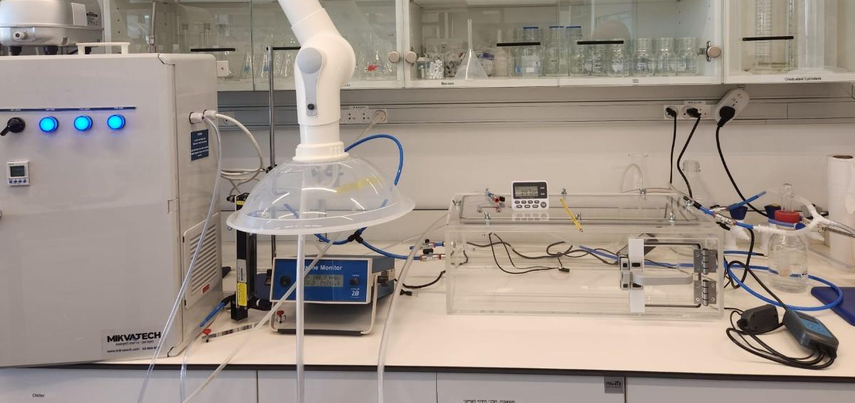
Figure S10. Bench-scale ozone system constructed of sealed chamber, ozone generator, ozone analyzer, and humidity and temperature controllers.

Figure S11. Coupon pretreatment effect on male-specific bacteriophage, MS2, inactivation, from left to right: coupon with no Trichloro Silan coating, coupon with coating but without ethanol sterilization, coupon with coating and full cleaning protocol (see main text). Right bar represents the drying effect on MS2 inactivation in the experimental setup selected, which was examined by subjecting coated and clean coupon to air (i.e., without ozone) for 4hr in the experimental system.

Figure S12. Monitoring ozone outlet concentration and absolute humidity during inactivation experiment at 22 ˚C and absolute humidity of 8.3 ± 0.6 g m⁻³ (a) or 12.4 ± 0.4 g m⁻³ (b).

Figure S13. COVID-19 reproduction number (R_{eff}) as a function of absolute humidity levels for temperatures higher than 21 ºC and temperatures lower than 21 ºC.

Figure S14. Monitoring ozone outlet concentration and temperature during inactivation experiment at absolute humidity of 5.2 ± 0.4 g m⁻³ and temperature of 9 ˚C.

References
1. COVID-19 database. In: Gov. databases. https://data.gov.il/dataset/covid-19 Accessed 24 Feb 2025
2. Israel air monitoring. In: Ministry of Environmental Protection. https://air.sviva.gov.il/ Accessed 24 Feb 2025
3. Last M (2020) The first wave of COVID-19 in Israel-initial analysis of publicly available data. PLoS One 15:e0240393. https://doi.org/10.1371/journal.pone.0240393
4. Sala-Comorera L, Reynolds LJ, Martin NA et al (2021) Decay of infectious SARS-CoV-2 and surrogates in aquatic environments. Water Res 201:117090. https://doi.org/10.1016/j.watres.2021.117090
5. String GM, White MR, Gute DM et al (2021) Selection of a SARS-CoV-2 surrogate for use in surface disinfection efficacy studies with chlorine and antimicrobial surfaces. Environ Sci Technol Lett 8:995–1001. https://doi.org/10.1021/acs.estlett.1c00593
6. Coulliette AD, Perry KA, Fisher EM et al (2014) MS2 coliphage as a surrogate for 2009 pandemic influenza A (H1N1) virus (pH1N1) in surface survival studies on N95 filtering facepiece respirators. J Int Soc Respir Prot 21:14–22
7. Horovitz I, Avisar D, Luster E et al (2018) MS2 bacteriophage inactivation using a N-doped TiO2-coated photocatalytic membrane reactor: Influence of water-quality parameters. Chem Eng J 354:995–1006. https://doi.org/10.1016/j.cej.2018.08.083
8. (2020) Results for SARS-CoV-2 surface disinfection with UV. In: EPA.gov https://www.epa.gov/emergency-response-research/results-sars-cov-2-surface-disinfection-uv-november-10-2020. Accessed 4 Dec 2024
9. Adams, MH (1959) Bacteriophages. Inter-science Publishers, New York
10. Nussbaumer CM, Cohen RC (2020) The role of temperature and NOx in ozone trends in the Los Angeles basin. Environ Sci Technol 54:15652–15659. https://doi.org/10.1021/acs.est.0c04910

