Supplementary Information
Remediation of heavy metal-contaminated soils by washing with green compost humic substances

Ilwan Meignant†, Lavinia M. Stancampiano†, Mariavittoria Verrillo‡, Zohreh Barzgar‡, Antonio G. Caporale*, Charlotte Brun, †; Riccardo Spaccini‡, Maxime C. Bridoux†*
†CEA, DAM, DIF, F-91297, Bruyères-le-Châtel, France
‡ Centro Interdipartimentale di Ricerca sulla Risonanza Magnetica Nucleare per l’Ambiente, l’Agroalimentare e Nuovi Materiali (CERMANU), Università di Napoli Federico II, Piazza Carlo di Borbone 1, Portici (NA), 80055, Italy

* Dipartimento di Agraria, Università di Napoli Federico II, Piazza Carlo di Borbone 1, Portici (NA), 80055, Italy

*Corresponding author: maxime.bridoux@cea.fr

No of Pages: 23
No of Texts: 9
No of Tables: 7
No of Figures: 10

Text S1
The coffee-based compost was piled on perforated rubber tubes for forced air insufflation, ensuring aerobic transformation. The composting process lasted 100 days, including thermophilic and mesophilic phases, followed by a curing period. The resulting compost was air-dried, milled, sieved to 2 mm, and stored at 4°C. Gardea compost, sourced from Vivai Gardea (Villafranca di Verona, Italy), was produced through the natural decomposition of pruning waste and grass cuttings over three months, under controlled conditions. This compost has an alkaline pH of 8.25, a low C/N ratio, and a significant aromatic component. For humic substance extraction, compost samples were suspended in 0.1 M KOH, shaken for 24 hours, and centrifuged. The suspension was purified with glass-wool filtration, titrated to pH 7.4 with 6 M HCl, dialyzed against deionized water, and freeze-dried for analysis.

Text S2
The primary physicochemical characteristics of the examined soils, are summarized in supplementary material (Table SM4). The three soils (agricultural, industrial and urban) exhibited a sandy-loam texture, ranging from neutral to sub-alkaline, and possessed a moderate to high (values ranging from 14.2 ± 0.4 to 32.4 ± 0.8 g.kg⁻¹) organic carbon content, with notable cation exchange capacity (values ranging from 18.9 ± 0.4 to 23.2 ± 0.2 cmol.kg⁻¹) and nutrient bioavailability, coupled with low electrical conductivity and a low to moderate concentration of total carbonates (total carbonate values ranging from 10.5 ± 0.7 to 101.7 ± 5.8). With a pH value of 7.86, the industrial soil was the most alkaline, attributed in part to its relatively elevated carbonate content (101.7 ± 5.8 g.kg⁻¹); it also showed the highest electrical conductivity (0.38 ± 0.03 dS.m⁻¹), indicative of soluble salts, and the lowest levels of organic carbon (14.2 ± 0.4 g.kg⁻¹) and total nitrogen (1.2 ± 0.1 g.kg⁻¹). Conversely, the soil sample from the urban site exhibited the coarsest textured among the samples analysed. It also contained elevated levels of organic carbon (32.4 ± 0.8 g.kg⁻¹) and total nitrogen (2.7 ± 0.1 g.kg⁻¹), as well as a relatively low amount of carbonates (10.5 ± 0.7 g.kg¹).
Text S3
Heavy metal concentrations were measured by ICP-MS after acid digestion of soil and humic substance samples. Soil digestion used aqua regia, while HS digestion used reverse aqua regia. The extracts were filtered, diluted, and analyzed by ICP-MS in collision mode using helium gas. ICP-MS analyses were conducted on humic substances extracted from fresh composts in order to assess the concentrations of HM against the geochemical background. Table 2 illustrates the range of values obtained, ranging from 0.001 to 1 ppm for all elements, except for Cu and Zn. For Gardea humic substances, Cu and Zn exhibited relatively high concentrations of 6.22 ppm and 11.96 ppm, respectively, while Coffee humic substances contained 13.21 ppm and 7.99 ppm. Given their non-negligible concentrations in the humic substances, adjustments were made by subtracting the background HS metal concentrations from the “humic substances post soil washing treatment” values.
Overall, the industrial soil was the most contaminated soil, with four heavy metals (Pb, Sb, Cd, and As) significantly exceeding those permitted by Italian regulations (Table 2). For example, with a concentration of 17178 mg.kg⁻¹, Pb concentration in the industrial soil exceeded the regulatory limit authorized in Italy for the industrial soils by a factor of 17. Similarly, concentrations of Sb, Cd, and As surpassed their limits, with concentrations respectively 12, 4, and 1.6 times higher than the regulatory levels (industrial soils). In the agricultural soil, Pb and Sb concentrations also exceeded legal limits set for agricultural soils, with concentrations 40 and 9 times higher, respectively. Conversely, the urban soil exhibits a Pb concentration 3.6 times higher than Italian recommendations for urban or agricultural soils. Additionally, Pb contamination is consistently present, with Pb being the only element that exceeds legal limits in all three soil samples.
Text S4
Freeze-dried humic substances were dissolved in a methanol-water mix, sonicated, and adjusted to pH 10 for the UHRMS-Orbitrap measurements. The ESI source voltage was maintained at 2.7 kV with a sheath gas flow rate of 10, an auxiliary gas of 9 and a sweep gas operating at 2 (arbitrary units) and was used in negative-ion mode. The ion transfer tube temperature was kept at 275°C, voltage at -10V and the vaporizer temperature was 55°C. Samples were infused at a flow rate of 5 μL.min⁻¹ for 20 min, with an UHPLC method injection. A methanol:water (50:50) blank sample was infused before and after each sample to clean up the ion source and to avoid cross-contamination and carryover from previous samples. If carryover was detected in the blank, the ion transfer tube was removed, placed in glass bicker filled with isopropanol and sonicated for 15 minutes, dried and put back into position. Before acquisition, the instrument was first externally calibrated as instructed by the manufacturer’s manual using Pierce™ FlexMix™ calibration mixture (ThermoFisher). Samples analyzed by ESI were added with 5% ammonia as a dopant agent. The mass range acquired was m/z 100−2000. The resolving power was set to 1 000 000 fwhm with 3 microscans, a maximum injection time of 1000 ms, a RF lens of 75% and a normalized AGC target of 25%. All data were acquired using the Thermo Xcalibur software.
Text S5
Before processing, mass accuracy was checked by the attribution of the elemental composition of known background compound (i.e. fatty acids). The error observed for these compounds before recalibration was systematically lower than 1 ppm. The elemental compositions were C₀₋₂₀₀, H₀₋₁₀₀₀, O₀₋₂₀, N₀₋₄, S₀₋₂, P₀₋₁ in ESI(-) with a user-defined mass tolerance of 1ppm and a Double Bond Equivalent (DBE) ranging from -0.5 to 40. The assignments were validated by checking the error distribution that was set to be between -1 and +1 ppm, and normally distributed around 0 ppm. A set of naturally occurring compounds previously identified in natural organic matter were selected to represent internal recalibrants over the mass range considered and were used to perform an internal mass calibration. The “walking recalibration” was used within Composer to recalibrate the dataset. The recalibration m/z values were divided into a set of ranges covering the mass range of the full scan spectrum. The calibration was then validated by checking that the average error corresponding to reference masses was lower than 0.5 ppm. Data processing was performed using the double bond equivalent value (DBE_{AI}), its ratio to the number of carbon atoms (DBE_{AI}/C_{AI}), and several graphical representations, such as the classification by chemical families, Van Krevelen diagrams and Violin plots. The peak’s relative intensities were used to classify compounds according to molecular families. Since the intensities of the MS peaks are a function of the abundance of compounds in the extract, the ionization efficiency, and their ability to compete for ionization with other ions in the samples, the relative intensity ratios were used to compare semi quantitatively, samples measured and analyzed exclusively in ESI. The Double Bound Equivalency (DBE_{AI}) and Aromaticity Indices (AI) were computed from the elemental formulae as follows:
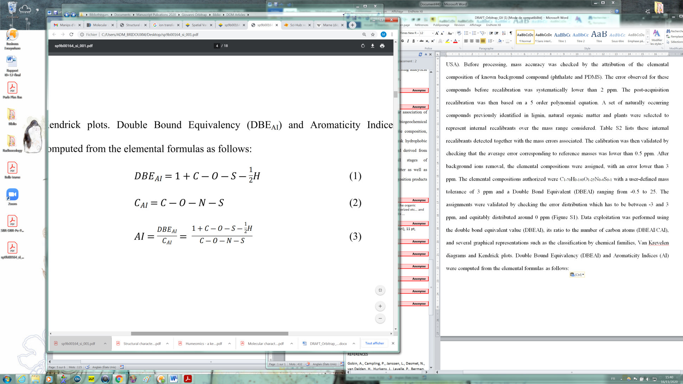
(1)
(2)
(3)

Text S6
The ¹³C NMR CPMAS analysis of two composts and their extracted humic substances were conducted using a Bruker AV-300 with a 4 mm MAS probe. Samples were packed in 4-mm zirconium rotors, and spectra were recorded with these parameters: 10,000 Hz rotor speed, 2 s recycling time, 1 ms contact time, 30 ms acquisition time, and 4000 scans. The spectra were divided into six regions corresponding to different functional groups (0-190 ppm). Functional group contributions were estimated by comparing area intensities. Key structural indices were calculated: the Alkyl ratio (A/OA) for aliphatic and O-alkyl groups, the hydrophobic index (HB) for hydrophobic/polar components, and the Lignin ratio (LR) for differentiating lignin and peptidic moieties. These indices provide insights into the organic matrix structure and functional group distribution.

Text S7
For offline thermally assisted hydrolysis and methylation (TAHM), 500 mg of HS sample was mixed with 1 mL of tetramethyl ammonium hydroxide (TMAH) solution and dried. The mixture was heated to 400°C for 30 minutes in a helium flow within a tubular reactor. The released compounds were collected in chloroform solutions, concentrated, and redissolved for Gas Chromatography-Mass Spectrometry (GC-MS) analysis. GC-MS was performed using a Perkin Elmer Autosystem XL with an RTX-5MS capillary column, operating with a temperature range of 60°C to 320°C and helium as the carrier gas.

Text S8
Toxicological assessments were conducted using a Microtox® LX system with the Basic Solid Phase Test (BSPT) to measure acute toxicity in soil samples by evaluating the inhibition of bioluminescence in Aliivibrio fischeri at 490 nm. Following the manufacturer's procedure, soil samples were diluted in nine serial dilutions starting from 200 g·L-1. Aliivibrio fischeri was added, and luminescence was measured before and 30 minutes after reagent introduction. Each experiment was performed in triplicate. The half-maximal effective concentration (EC50) was automatically calculated by the Microtox® software to determine the 50% toxic effect [13].

Text S9
Our study investigates the laboratory-scale application of humic substances (HS) derived from green composts for the remediation of heavy metal-contaminated soils. To approximate a scaled-up procedure, we considered the annual compost production in the EU, which is approximately 17.6 million metric tons (Gilbert and Siebert, 2022). Assuming an extraction yield of 15% (w/w) for humic substances (Audette et al. 2020; Song and Hayes, 2022), we estimate that managing 1 hectare of soil at a depth of 1 meter with a washing solution would require approximately 90 tons of HS (Piccolo et al. 2019; 2021). Consequently, the hypothetical amount of HS extractable from composted biomasses could potentially remediate approximately 300 km² of polluted sites annually in Europe, equivalent to 42,000 soccer fields.
The large-scale application of composting depends on sourcing sufficient quantities from bio-waste streams which is determined by factors such as bio-waste availability, collection infrastructure, processing capacity, market demand, and regulatory support. Considering that only approximately 40% of the 118–138 million tons of bio-waste generated annually in the EU is currently recycled into high-quality compost and digestate, there is significant untapped potential for large-scale HS production. Besides, up to 50% of municipal solid waste is organic, highlighting additional substantial feedstock supply if efficient segregation and collection systems are implemented. Finally, beyond household bio-waste, agricultural residues, food processing by-products, and green waste from landscaping could all potentially supplement compost production.
Efficient collection systems are crucial for scaling up composting operations, requiring well-developed bio-waste collection infrastructures. Transport infrastructure plays a vital role in minimizing transport costs and emissions, with strategic placement of composting facilities near agricultural areas, enhancing distribution efficiency. Besides, the standardization of feedstock quality is essential to mitigate contaminants like plastics and heavy metals, which may degrade compost quality; thus, investing in sorting and pre-treatment technologies is necessary to ensure high-purity input materials. The EU Green Deal and Circular Economy initiatives provide strong incentives for large-scale composting by promoting organic waste recycling and soil regeneration. Waste diversion regulations, such as landfill bans and mandatory bio-waste separation laws, can increase feedstock availability. Finally, sustainability certifications, like those from the European Compost Network, ensure consistency and boost market confidence by standardizing compost quality.

Table S1. Physical and chemical properties of three soils studied

Soil properties | Agricultural | Industrial | Urban
Sand (g.kg⁻¹) | 584 ± 28^{b} | 653 ± 36^{ab} | 723 ± 41ª | **
Silt (g.kg⁻¹) | 275 ± 13ª | 195 ± 11^{b} | 173 ± 9^{b} | ***
Clay (g.kg⁻¹) | 141 ± 9ª | 152 ± 8ª | 104 ± 5^{b} | ***
pH (in H₂0; SSR: 1:2.5) | 7.43 ± 0.05^{c} | 7.86 ± 0.07ª | 7.65 ± 0.04^{b} | ***
Electrical conductivity (dS.m⁻¹; SSR: 1:2.5) | 0.23 ± 0.04^{b} | 0.38 ± 0.03ª | 0.12 ± 0.02^{c} | ***
Total carbonates (g.kg⁻¹) | 67.4 ± 1.6^{b} | 101.7 ± 5.8ª | 10.5 ± 0.7^{c} | ***
Organic Carbon (g.kg⁻¹) | 25.8 ± 0.5^{b} | 14.2 ± 0.4^{c} | 32.4 ± 0.8ª | ***
Total Nitrogen (g.kg⁻¹) | 2.1 ± 0.1^{b} | 1.2 ± 0.1^{c} | 2.7 ± 0.1ª | ***
C/N | 12.3 ± 0.3 | 11.8 ± 0.6 | 12.0 ± 0.1 | ns
Cation Exchange Capacity (cmol⁺.kg⁻¹) | 23.2 ± 0.2ª | 21.8 ± 0.5^{b} | 18.9 ± 0.4^{c} | ***

Data are expressed as mean values ± SD (n=3). Different letters in a same row indicate statistically-significant differences (* = p<0.05; ** = p<0.01; *** = p<0.001) among the study soils, according to one-way ANOVA (Tukey’s HSD post hoc test).

Table S2. Operating parameters and settings for the Thermo Scientific iCAP Q ICP-MS (Inductively Coupled Plasma - Mass Spectrometry)

Parameters | Settings
RF power | 1550 W
Spray chamber | Quartz cyclonic, cooled at 2.7 °C
Nebulizer | PFA-ST
Plasma torch | Quartz
Injector | Quartz, 2.5 mm ID
Nebulizer gas flow | 1.1 L.min⁻¹
Auxiliary gas flow | 0.8 L.min⁻¹
Coolant gas flow | 14 L.min⁻¹
Collision cell gas | He at 3.9 mL.min⁻¹
Sampler cone | Nickel, 1.1 mm aperture
Skimmer cone | Nickel, 0.5 mm aperture with high matrix insert
Peristaltic pump speed | 40 rpm
Sample uptake/wash time | 45/50 s
Dwell times | Optimized per analyte (0.01 - 0.5 s)
Number of sweeps | 5
Number of repeats per sample | 3
Autosampler | CETAC ASX-520
Instrument tuning | Performed using a 1 µg.L⁻¹ of Ba, Bi, Ce, Co, In, Li and U solution in 2 % HNO₃ and 0.5 % HCl

Table S3. Calibration data for the Thermo Scientific iCAP Q ICP-MS analysis. Limit of detection (LOD) and limit of quantification (LOQ) were calculated as 3 and 10 times, respectively, the standard deviation of the mean of 4 different blank determinations

Analyte | Calibration range  (µg.L⁻¹) | R² | LOD  (µg.L⁻¹) | LOQ  (µg.L⁻¹)
As | 0.1 - 100 | 0.99999 | 0.014 | 0.047
Be | 0.1 - 10 | 0.99999 | 0.023 | 0.078
Cd | 0.1 - 100 | 0.99993 | 0.010 | 0.034
Co | 0.1 - 10 | 0.99999 | 0.009 | 0.029
Cr | 0.1 - 100 | 0.99999 | 0.014 | 0.048
Cu | 1 - 1000 | 0.99997 | 0.310 | 1.034
Ni | 0.1 - 100 | 0.99999 | 0.028 | 0.092
Pb | 1 - 1000 | 0.99996 | 0.134 | 0.448
Sb | 0.1 - 10 | 0.99999 | 0.005 | 0.018
Se | 0.1 - 10 | 0.99995 | 0.017 | 0.056
Tl | 0.1 - 10 | 0.99998 | 0.005 | 0.017
V | 0.1 - 100 | 0.99999 | 0.029 | 0.096
Zn | 10 - 1000 | 0.99984 | 0.942 | 3.139

Table S4. Concentration of heavy metals measured in the humic substances (HS) and in the soils before the remediation process. * Standard deviation of ICP-MS measurements.

 | Humic substances extracted from compost |  |  | Contaminated soils |  |  |  |  | Italian legislation
 | Gardea  (mg.kg⁻¹) | Coffee  (mg.kg⁻¹) |  | Agricultural  (mg.kg⁻¹) | Industrial  (mg.kg⁻¹) | Urban  (mg.kg⁻¹) |  |  |  | Agricultural  (mg.kg⁻¹) | Industrial  (mg.kg⁻¹)
Pb | 0.3  (±0.008)* | 0.1  (±0.004)* |  | 4198.3  (±702.38) | 17178.8 (±1664.05) | 361.3 (±142.86) |  |  |  | 100 | 1000
Sb | 0.7  (±0.016)* | 0.1  (±0.002)* |  | 92.9 (±13.57) | 380.8  (±53.01) | 2.5  (±0.09) |  |  |  | 10 | 30
Cd | 0.0  (±0.0002)* | 0.0  (±0.0002)* |  | 0.5  (±0.45) | 67.7  (±0.54) | 0.5  (±0.20) |  |  |  | 5 | 15
As | 0.1  (±0.001)* | 0.0  (±0.0002)* |  | 22.9  (±2.51) | 79.8  (±3.23) | 13.2  (±1.08) |  |  |  | 30 | 50
V | 0.8  (±0.02)* | 0.2  (±0.004)* |  | 85.0  (±4.88) | 63.2  (±2.01) | 83.9  (±6.12) |  |  |  | 90 | 250
Ni | 0.4  (±0.009)* | 0.2  (±0.006)* |  | 24.8  (±3.60) | 32.8  (±2.17) | 11.3  (±1.14) |  |  |  | 120 | 500
Cr | 0.6  (±0.001)* | 0.1  (±0.002)* |  | 40.0  (±1.99) | 26.7  (±3.34) | 35.2  (±2.23) |  |  |  | 150 | 800
Tl | 0.0  (±0.0002)* | 0.0  (±0.0002)* |  | 1.2  (±0.19) | 1.35  (±0.10) | 1.1  (±0.20) |  |  |  | 1 | 10
Be | 0.0  (±0.0002)* | 0.0  (±0.0002)* |  | 7.4  (±0.70) | 5.6  (±0.45) | 5.7  (±0.15) |  |  |  | 7 | 10
Co | 0.1  (±0.001)* | 0.1  (±0.001)* |  | 11.6  (±1.0) | 7.9  (±0.29) | 8.9  (±0.49) |  |  |  | 30 | 250
Se | 0.1  (±0.0002)* | 0.0  (±0.0002)* |  | 1.2  (±0.06) | 8.8  (±0.25) | 0.9  (±0.00) |  |  |  | 3 | 15
Cu | 6.2  (±0.15)* | 13.2  (±0.33)* |  | 100.3  (±20.37) | 325.1  (±10.28) | 182.9 (±6.56) |  |  |  | 200 | 600
Zn | 12.0  (±0.3)* | 8.0  (±0.2)* |  | 146.2  (±71.46) | 209.7  (±47.46) | 362.6 (±27.34) |  |  |  | 300 | 1500

Table S5. Relative (%) carbon distribution in functional groups over chemical shift range (ppm) and associated structural indexª in CPMAS spectra of green compost and corresponding HS.

CMP*_Coffee
CMP*_Gardea
HS**_Coffee
HS**_Gardea

CMP*_Coffee
CMP*_Gardea
HS**_Coffee
HS**_Gardea

* CMP: compost
** HS: humic substances extracted from compost

Table S6. Thermochemolysis products found in Humic Substances extracted from green composts

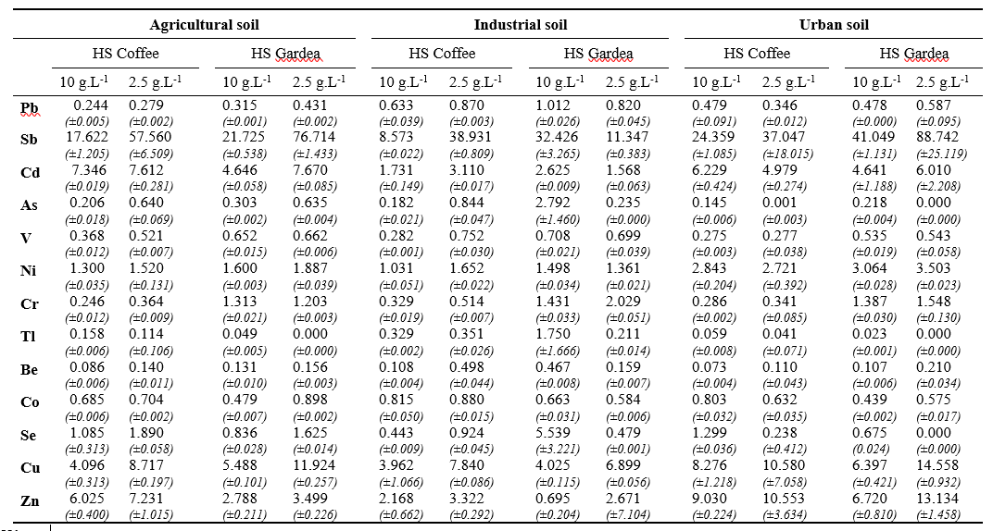
Table S7. Concentrations of heavy metals measured in humic substances after soil washing of the Agricultural, Industrial and Urban polluted soils

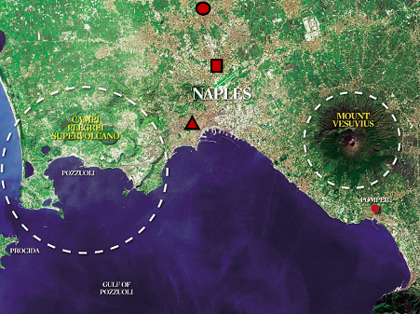

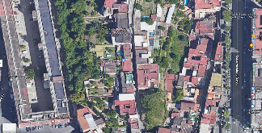
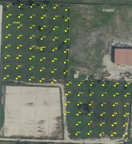
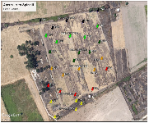
Urban Soil
Industrial Soil
Agricultural Soil

Fig. S1 Map of soil samples used in the remediation process

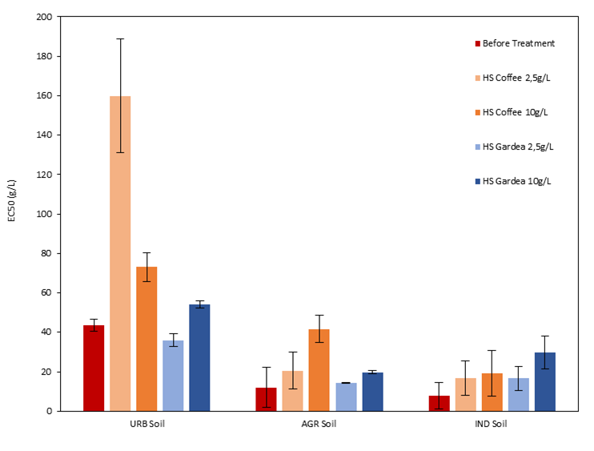
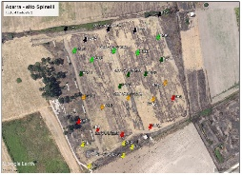

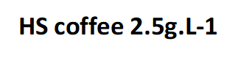
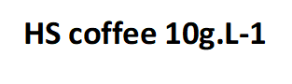
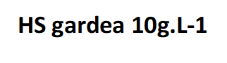
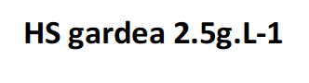
EC50 (g/L)
Urban soil
Agricultural soil
Industrial soil

Fig. S2 Histogram displaying the EC₅₀ values for three soil samples (urban soil, agricultural soil and industrial soil) before (red) and after the various soil washing treatments (Coffee humic substance at 2.5 g.L⁻¹; Coffee humic substance at 10 g.L⁻¹; Gardea humic substance at 2.5 g.L⁻¹ and Gardea humic substance at 10 g.L⁻¹)

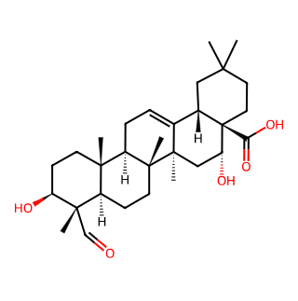
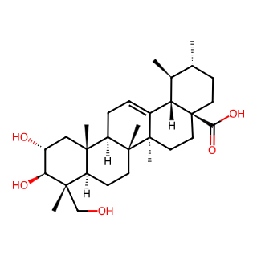
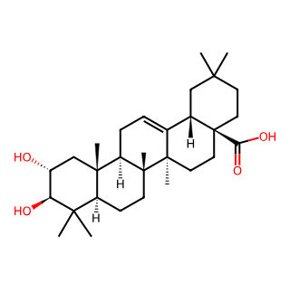
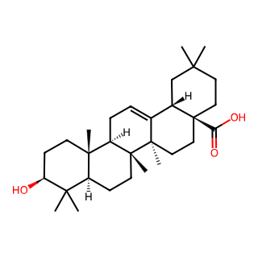
C₃₀H₄₈O₅
Asiatic Acid
C₃₀H₄₆O₅
Quillaic Acid

C₃₀H₄₈O₃
Oleanolic Acid
C₃₀H₄₈O₄
Maslinic Acid

Fig. S3 Structures of some selected pentacyclic terpenes putatively detected in Gardea humic substance control only

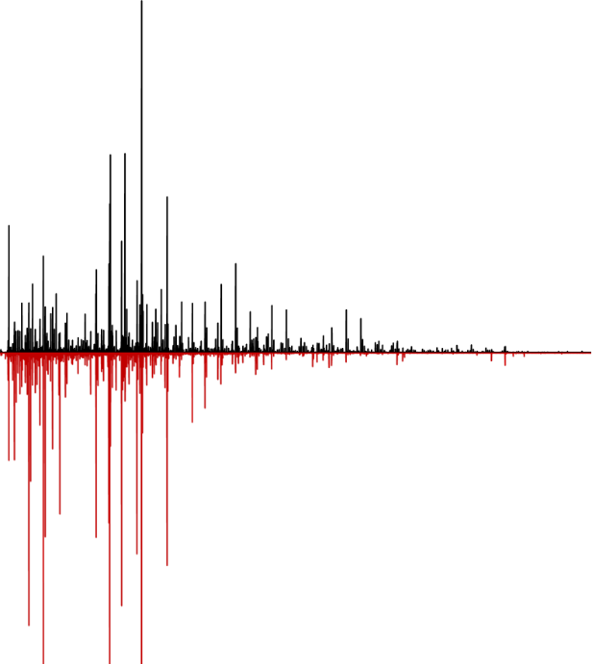
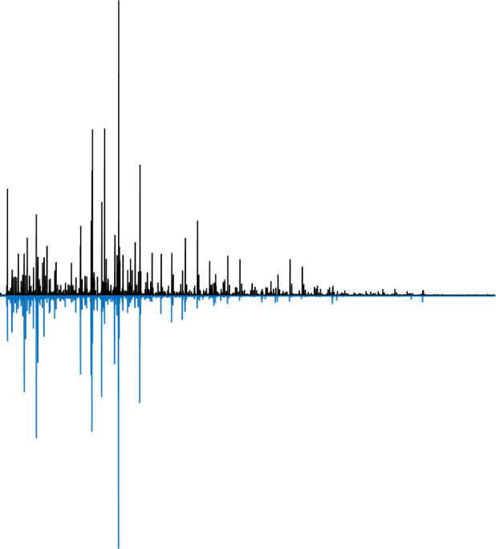
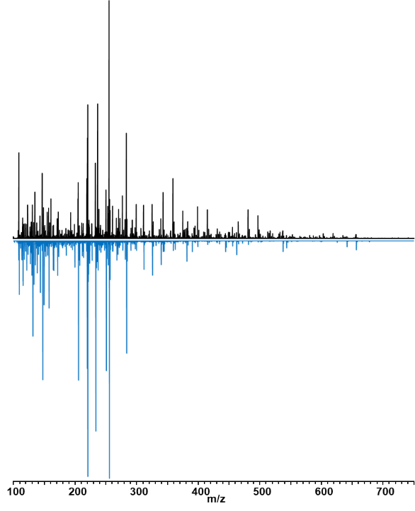
100
300
700
200
500
400
600
m/z
100
300
700
200
500
400
600
m/z
Gardea humic substance
Control
Gardea humic substance
Control

Urban Soil
Gardea humic substance
[c] = 10 g.L⁻¹
Urban Soil
Gardea humic substance
[c] = 2.5 g.L⁻¹

Fig. S4 Electrospray (-) Fourier transform Orbitrap Fusion Lumos 1M mass spectra of humic substances extracted from the Gardea compost in the control (top spectra in black) and from the Gardea compost after remediation by soil washing (bottom spectra) on polluted urban soils using a solution of 2.5 g.L⁻¹ humic substances (in red) and 10 g.L⁻¹ humic substances (in blue)

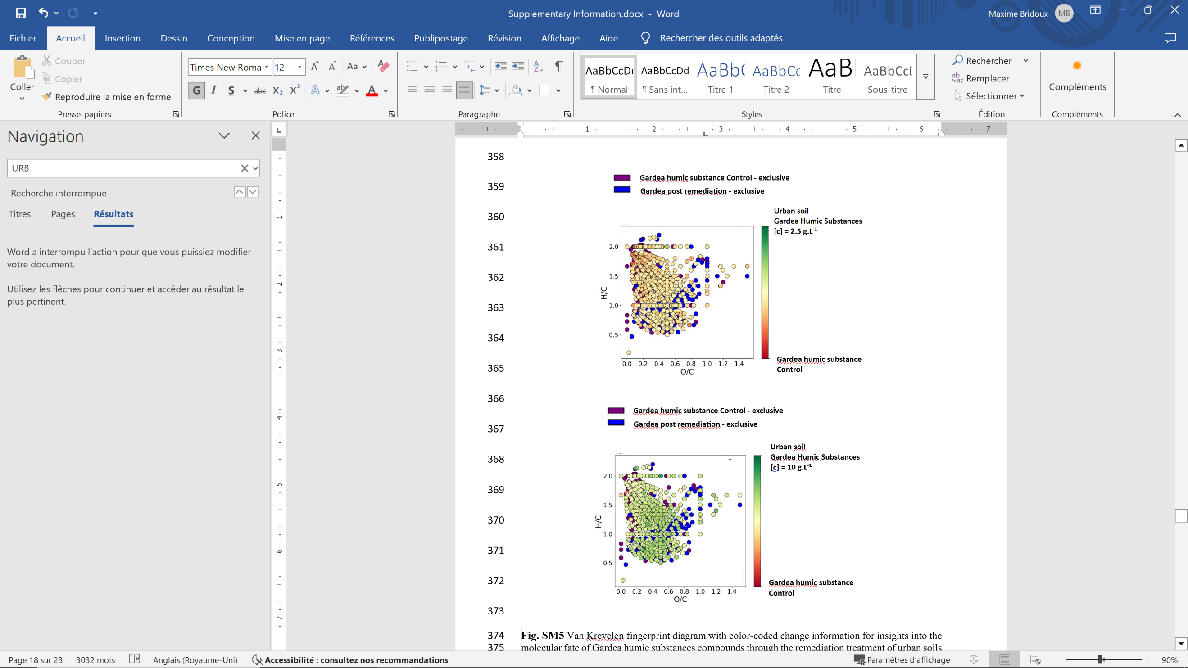
Gardea humic substance Control - exclusive
Gardea humic substance post remediation - exclusive
(A)
Urban Soil
Gardea humic substances
[c] = 2.5 g.L⁻¹

Gardea humic substance
Control


(B)
Urban Soil
Gardea humic substances
[c] = 10 g.L⁻¹

Gardea humic substance
Control

Fig. S5 Van Krevelen fingerprint diagram with color-coded change information for insights into the molecular fate of Gardea humic substances compounds through the remediation treatment of urban soils by soil washing with (A) Gardea humic substances at 2.5 g.L⁻¹ and (B) Gardea humic substances at 10 g.L⁻¹.

(A)
Gardea humic substance Control - exclusive
Gardea humic substance post remediation - exclusive
Urban Soil
Gardea humic substances
[c] = 2.5 g.L⁻¹
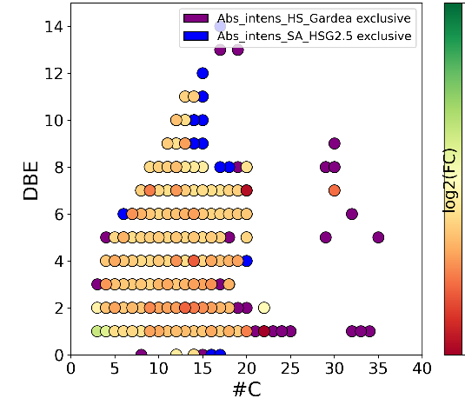

Gardea humic substance
Control

(B)

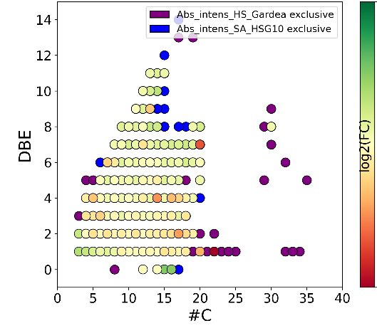
Urban Soil
Gardea humic substances
[c] = 10 g.L⁻¹

Gardea humic substance
Control

Fig. S6 DBE versus #C (number of carbons) fingerprint diagram with color-coded fold change information for insights into the molecular fate of Gardea humic substance compounds through the remediation treatment of contaminated urban soils by soil washing with (A) Gardea humic substances at 2.5 g.L⁻¹ and (B) Gardea humic substances at 10 g.L⁻¹.

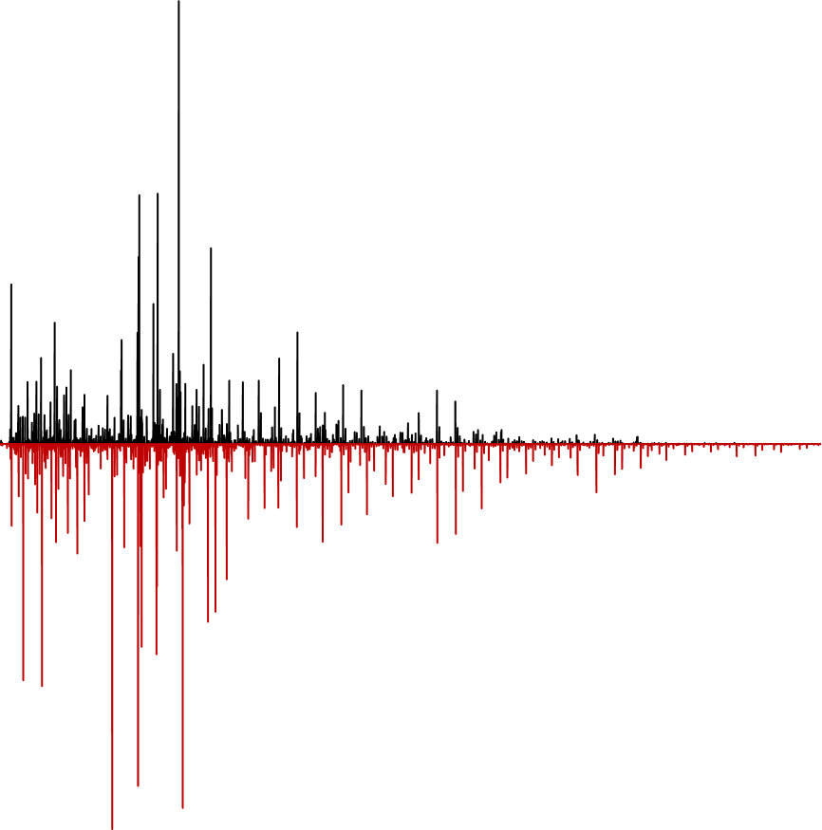
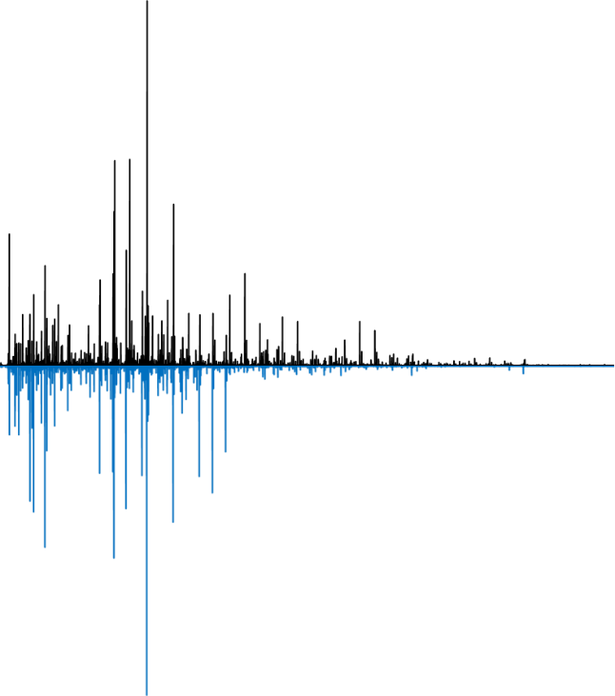
Gardea humic substance
Control
Gardea humic substance
Control

Indutrial Soil
Gardea humic substance
[c] = 10 g.L⁻¹
Indutrial Soil
Gardea humic substance
[c] = 2.5 g.L⁻¹

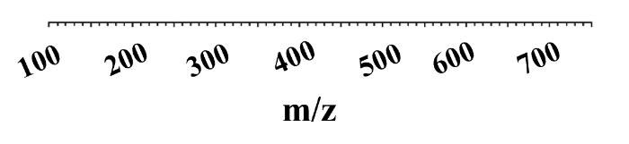
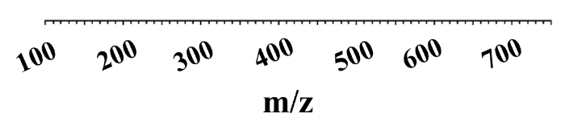

Fig. S7 A) electrospray (-) Fourier transform Orbitrap Fusion Lumos 1M mass spectra of HS extracted from the Gardea compost in the control (top spectra in black) and from the Gardea compost after remediation by soil washing (bottom spectra) on polluted industrial soils using a solution of 2.5 g.L⁻¹ humic substances (in red) and 10g.L⁻¹ humic substances (in blue).

Gardea humic substance Control - exclusive
Gardea humic substance post remediation - exclusive
(A)
Industrial Soil
Gardea humic substances
[c] = 2.5 g.L⁻¹
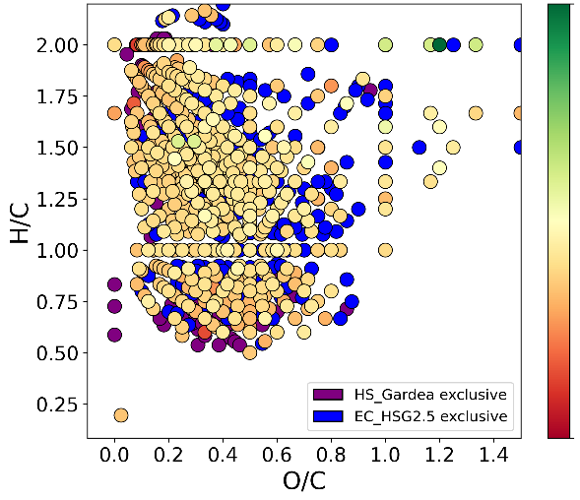

Gardea humic substance
Control

Gardea humic substance Control - exclusive
Gardea humic substance post remediation - exclusive
(B)
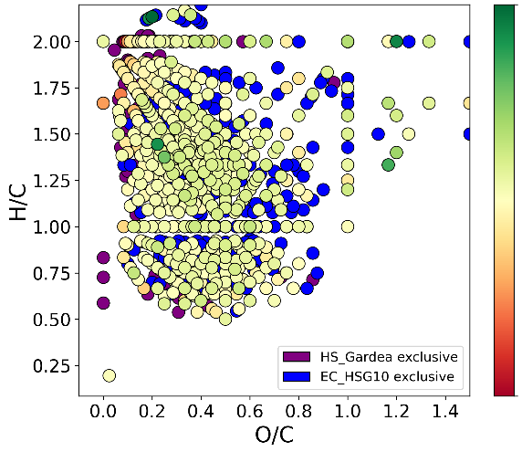
Industrial Soil
Gardea humic substances
[c] = 10 g.L⁻¹

Gardea humic substance
Control

Fig. S8 Van Krevelen fingerprint diagram with color-coded change information for insights into the molecular fate of Gardea humic substances compounds through the remediation treatment of industrial soils by soil washing with (A) Gardea humic substances at 2.5 g.L⁻¹ and (B) Gardea humic substances at 10 g.L⁻¹.

Gardea humic substance Control - exclusive
Gardea humic substance post remediation - exclusive
(A)
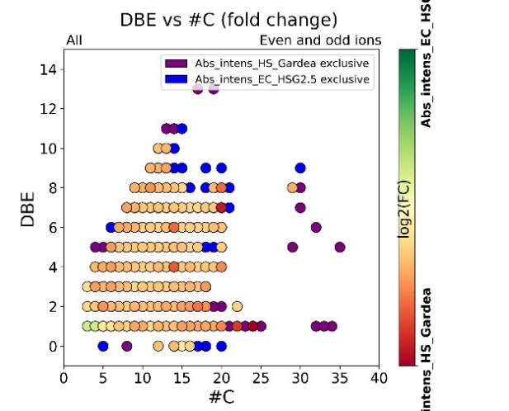
Industrial Soil
Gardea humic substances
[c] = 2.5 g.L⁻¹

Gardea humic substance
Control

(B)
Gardea humic substance Control - exclusive
Gardea humic substance post remediation - exclusive

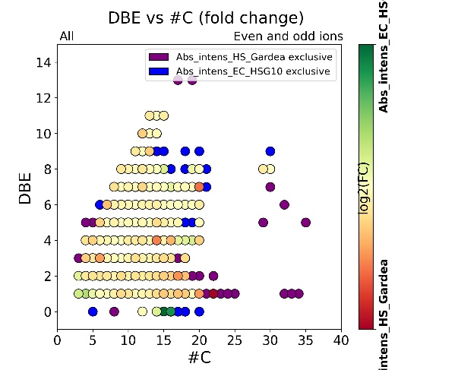
Industrial Soil
Gardea humic substances
[c] = 10 g.L⁻¹

Gardea humic substance
Control

Fig. S9 DBE versus #C (number of carbons) fingerprint diagram with color-coded fold change information for insights into the molecular fate of Gardea humic substance compounds through the remediation treatment of contaminated industrial soils by soil washing with (A) Gardea humic substances at 2.5 g.L⁻¹ and (B) Gardea humic substances at 10 g.L⁻¹.

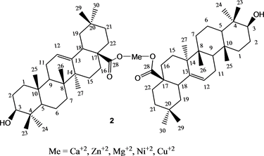

Fig. S10 Example of a molecular structure of the complex formed with calcium, magnesium, copper, zinc, and nickel with oleanolic acid (reproduced from Ribeiro et al. (2018))

