Supplementary Material
Self-destruction of a tire-derived quinone pollutant by peroxyacetic acid
Ayoung Choi¹, Changseok Han^{1,2*}, Eric Lichtfouse^{3*}, and Virender K. Sharma^{4*}
¹ Program in Environmental and Polymer Engineering, Graduate School of INHA University, 100 Inha-ro, Michuhol-gu, Incheon 22212, South Korea
² Department of Environmental Engineering, INHA University, 100 Inha-ro, Michuhol-gu, Incheon 22212, South Korea
³ State Key Laboratory of Multiphase Flow in Power Engineering, Xi’an Jiaotong University, Xi’an 710049, Shaanxi, China
⁴ Department of Chemical, Environmental, and Materials Engineering, University of Miami, 1251 Memorial Drive, Coral Gables, Florida 33146, USA

Ayoung Choi ORCID 0000-0001-9323-8840 (ayoung9789@gmail.com)
Changseok Han ORCID 0000-0002-8636-2859 (hanck@inha.ac.kr)
Eric Lichtfouse ORCID 0000-0002-8535-8073 (eric.lichtfouse@icloud.com)
Virender K. Sharma ORCID 0000-0002-5980-8675 (vks38@miami.edu)

Text S1.
Chemicals
N-(1,3-dimethylbutyl)-N’-phenyl-p-phenylenediamine quinone (6PPD-Q, C₁₈H₂₄N₂, 99.3%) was obtained from MedChem Express LLC (USA). For synthesizing peroxyacetic acid (CH₃C(O)OOH), hydrogen peroxide (H₂O₂, 34.5%), ferroin solution, 0.1 M cerium(Ⅳ) sulfate solution, potassium iodide (KI, 99.5%) and ethyl alcohol (EtOH, 99.5%) were purchased from Samchun Chemical Co. (South Korea), and starch soluble, sulfuric acid (H₂SO₄, 95%), acetic acid (CH₃COOH, 99.5%), 0.1 N sodium thiosulfate solution (Na₂S₂O₃) were purchased form Duksan Reagents Co. (South Korea). Deferoxamine Mesylate, sodium dihydrogen phosphate (NaH₂PO₄) and disodium hydrogen phosphate (Na₂HPO₄) were obtained from Sigma Aldrich (USA). Formic acid (HPLC grade), water (H₂O, HPLC grade) and methanol (HPLC grade) were purchased from Duksan Reagents Co. (South Korea). 2,4–Hexadiene (C₆H₁₀, 2,4–HD, ≥95.0%) was obtained from Tokyo Chemical Industry Co. (Japan).

Text S2.
Analytical of 2-((4-Methylpentan-2-yl)amino)-5-(phenylamino)cyclohexa-2,5-diene-1,4-dione (6PPD-Q)
The 6PPD-Q was determined using high-performance liquid chromatography (HPLC, Agilent 1260 Infinity Quaternary system, USA) equipped with a photo-diode array detector (DAD). A C18 column (ZORBAX Eclipse Plus C18, 150 mm × 4.6 mm, 5 µm, Agilent, USA) was employed and maintained at 35ºC for the analysis. The 6PPD-Q was monitored at 360 nm of wavelength. The mobile phase was composed of 80.0% MeOH and 20.0% 0.1% formic acid in water and delivered with a flow rate of 1.0 mL/min. The injection sample volume was 50.0 µL and each sample was measured in duplicate.

Table S1. Pseudo first-order rate constant for 2-((4-Methylpentan-2-yl)amino)-5-(phenylamino)cyclohexa-2,5-diene-1,4-dione (6PPD-Q) degradation under peroxyacetic acid only (without ultraviolet) and peroxyacetic acid-ultraviolet system.
 | Peroxyacetic acid only |  | Peroxyacetic acid-ultraviolet
Peroxyacetic acid (μM) | k_{obs} (10⁻² min⁻¹) | r² | k_{obs} (10⁻² min⁻¹) | r²
33 | 1.07 ± 0.10 | 0.9076 | 3.80 ± 0.12 | 0.9711
65 | 1.82 ± 0.03 | 0.9695 | 5.58± 0.08 | 0.9933
131 | 3.24 ± 0.15 | 0.8802 | 6.24 ± 0.22 | 0.9829
263 | 7.13 ± 0.03 | 0.9775 | 9.30 ± 0.24 | 0.9887

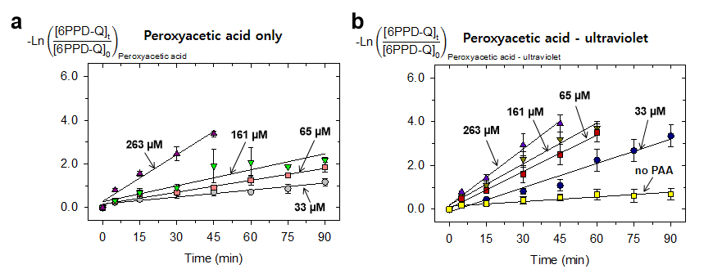Fig. S1. Pseudo first-order rate constant of 2-((4-Methylpentan-2-yl)amino)-5-(phenylamino)cyclohexa-2,5-diene-1,4-dione (6PPD-Q) at different peroxyacetic acid concentrations under (a) peroxyacetic acid only (without ultraviolet) and (b) peroxyacetic acid-ultraviolet system ([ultraviolet intensity]=0.36 mW/cm², [6PPD-Q]₀ = 1.7 μM, pH 6.8). The degradation rate increased with increasing peroxyacetic acid concentration and was further enhanced in the presence of ultraviolet irradiation.

