Supplementary Information

Numerical simulation on effects of irrigation conditions on water temperature distribution in a paddy field

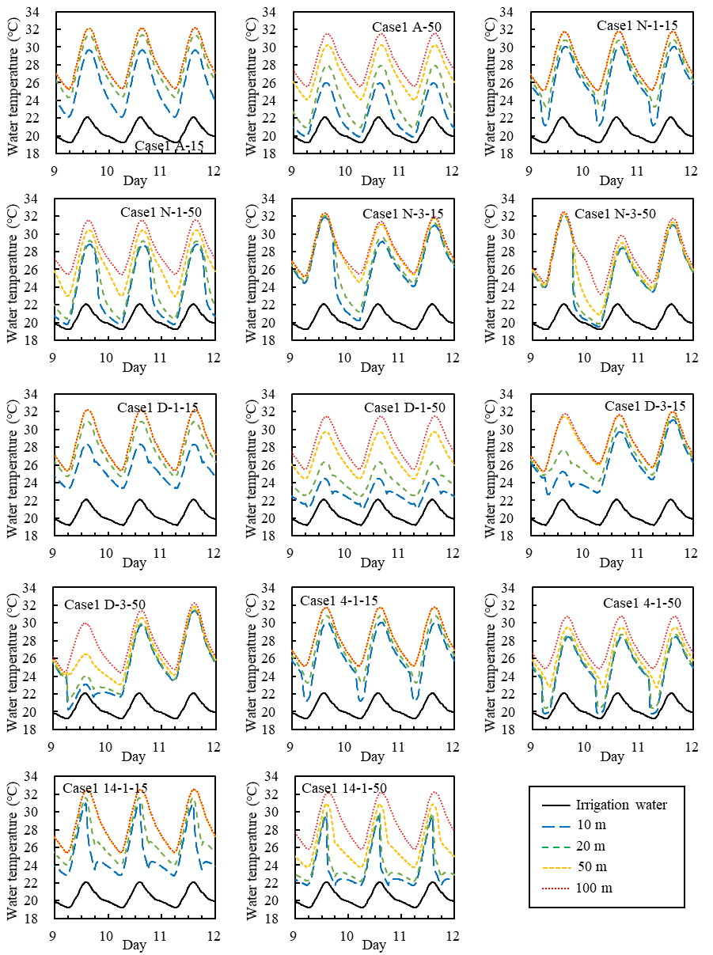
Fig. S1 Fluctuations in water temperature for Case 1

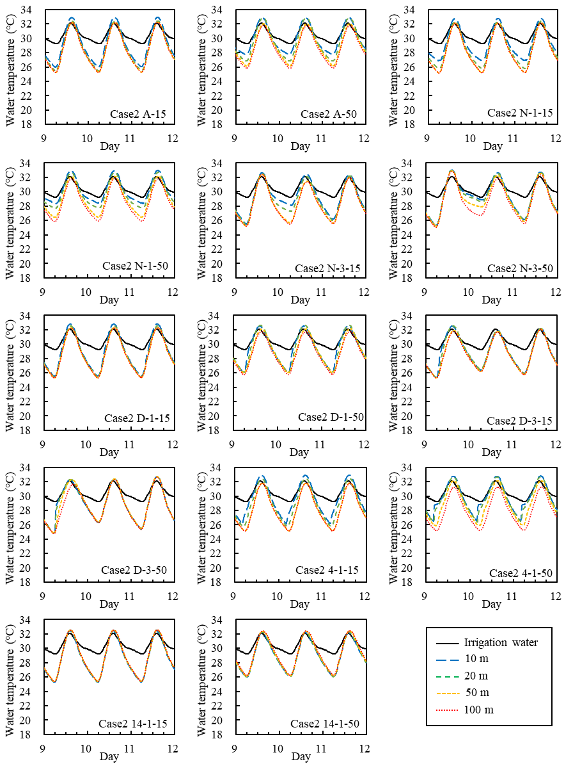
Fig. S2 Fluctuations in water temperature for Case 2

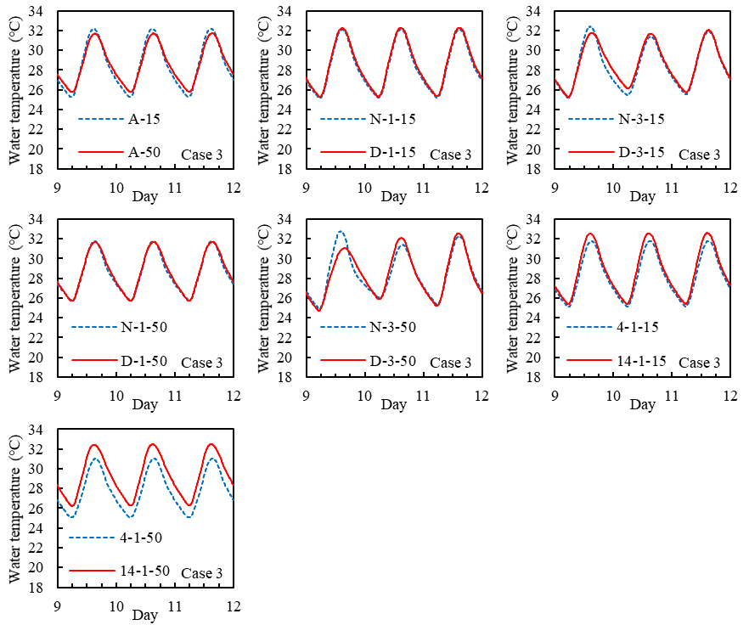
Fig. S3 Fluctuations in water temperature for Case 3

