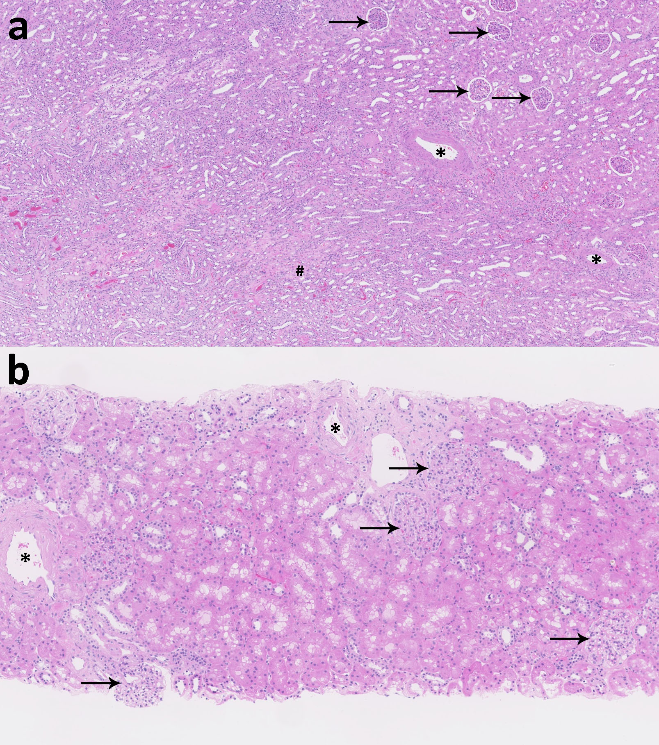
Supplemental Figure 1 Normal histology of kidney specimens. Examples of relatively unaffected kidney tissue from (a) non-tumorous kidney of a nephrectomy specimen from a patient with renal cell carcinoma and (b) a protocol biopsy three months after transplantation. No areas of inflammation or hemorrhage are present. Shown are non-sclerosed glomeruli in the cortex (arrows), patent arteries (*) and normal medulla (#).

