Sample Name | T1 (s) |  |  | T2 (s)
Sample Name | NMR | MRI - In vivo protocol | MRI - Reference protocol | NMR | MRI - In vivo protocol
0.025 mmol/L GdGl₃-EDTA | 1.246  (0.0146) | 1.384  (0.0325) | 1.342  (0.0079) | 1.272  (0.0326) | 0.901  (0.0211)
0.1% agarose mass concentration (%) | 2.241  (0.0096) | 2.392  (0.0673) | 2.229  (0.1041) | 0.604  (0.004) | 0.597  (0.0154)
0.1 mmol/L CuSO₄ | 1.695  (0.0188) | 1.743  (0.0493) | 1.731  (0.0862) | 1.901  (0.3131) | 1.007  (0.0346)
0.1 mmol/L GdGl₃-EDTA in 1.5% agarose mass concentration (%) | 0.436  (0.0042) | 0.438  (0.0071) | 0.438  (0.0038) | 0.068  (0.0007) | 0.056  (0.001)
0.5% agarose mass concentration (%) | 1.846  (0.0101) | 2.027  (0.1016) | 1.947  (0.0798) | 0.244  (0.0012) | 0.183  (0.0015)
0.75 mmol/L CuSO₄ in 0.25% agarose mass concentration (%) | 0.476  (0.0029) | 0.517  (0.0076) | 0.482  (0.0152) | 0.245  (0.0017) | 0.207  (0.0018)
1 mmol/L CuSO₄ in 1% agarose mass concentration (%) | 0.315  (0.0044) | 0.341  (0.0059) | 0.326  (0.0041) | 0.094  (0.0044) | 0.088  (0.0025)
2 mmol/L CuSO₄ | 0.235  (0.0035) | 0.222  (0.0027) | 0.219  (0.0024) | 0.222  (0.0026) | 0.216  (0.0045)
4 mmol/L NiCl₂ in 1.2% agarose mass concentration (%) | 0.328  (0.0074) | 0.335  (0.0034) | 0.329  (0.0033) | 0.087  (0.0005) | 0.078  (0.0028)
Deionized water | 2.475  (0.0223) | 2.555  (0.1022) | 2.351  (0.1474) | 2.193  (0.0829) | 1.21  (0.0417)
Table S.1 $T_{1}$ and $T_{2}$ mean and standard deviations for test samples measured for the NMR system, for the MRI system and the in vivo protocols. Also included for $T_{1}$ are measurements for the MRI system reference protocol.

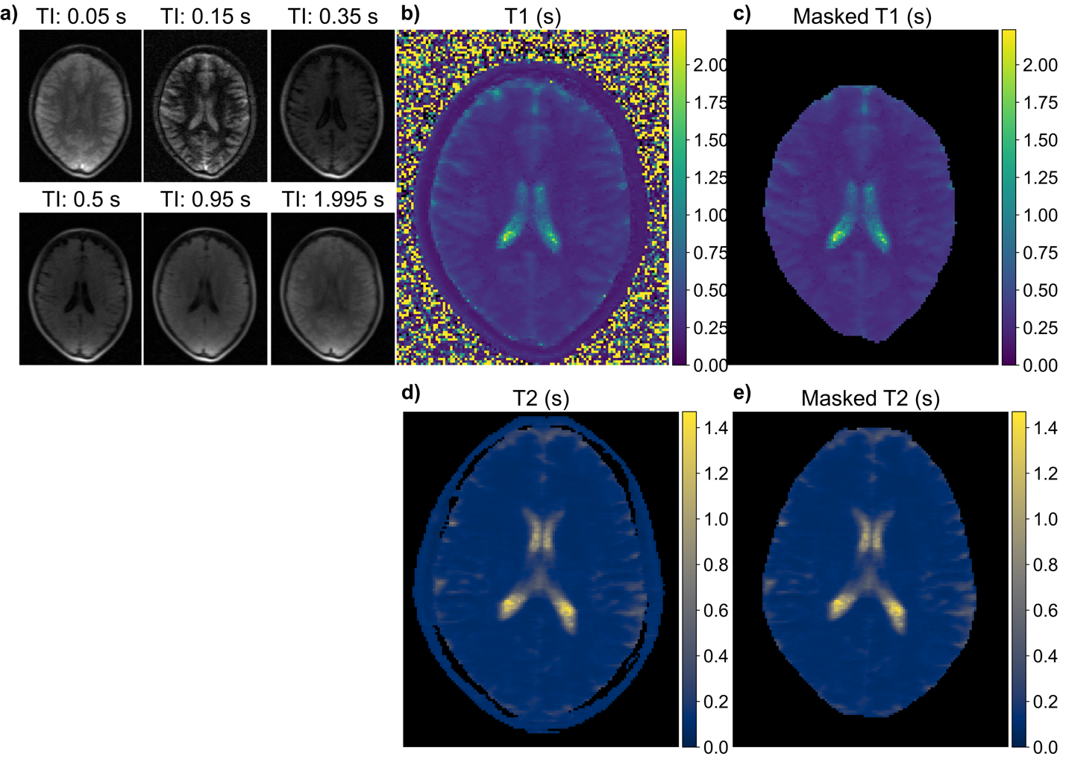
Fig. S.1 a) Example IR raw data for one subject. b) Example $T_{1}$ map for the subject in (a), and c) shows the result of the skull stripping protocol. d) Example $T_{2}$ map for a different volunteer, with e) the result of the skull stripping protocol.

Subject | T1 (s) |  |  |  |  |  | T2 (s) |  |  |  |  | Voxels
Subject | WM |  | GM |  | CSF |  | WM | WM & GM | GM | CSF |  | Voxels
Subject | Manual | Auto | Manual | Auto | Manual | Auto | Manual | Auto | Manual | Manual | Auto | Voxels
1 | 0.234  (0.01) | 0.284  (0.0339) | 0.409  (0.0155) | 0.389  (0.0411) | 1.386  (0.2561) | 1.207  (0.201) | 0.079  (0.0057) | 0.097  (0.0122) | 0.102  (0.0074) | 1.134  (0.0645) | 0.567  (0.2338) | 8782
2 | 0.259  (0.0071) | 0.27  (0.0317) | 0.38  (0.0049) | 0.374  (0.0394) | 1.107  (0.1338) | 1.089  (0.2205) | 0.082  (0.0027) | 0.097  (0.0132) | 0.116  (0.0049) | 1.104  (0.1251) | 0.504  (0.1973) | 8982
3 | 0.248  (0.0206) | 0.272  (0.0242) | 0.358  (0.0051) | 0.342  (0.0226) | 0.944  (0.1485) | 0.694  (0.1436) | 0.084  (0.0029) | 0.095  (0.0106) | 0.103  (0.0047) | 0.422  (0.0767) | 0.346  (0.1176) | 6917
4 | 0.243  (0.0179) | 0.293  (0.0387) | 0.395  (0.01) | 0.418  (0.0425) | 2.173  (0.4374) | 1.445  (0.4664) | 0.081  (0.0035) | 0.099  (0.0136) | 0.167  (0.0367) | 1.13  (0.1247) | 0.43  (0.1902) | 7453
5 | 0.266  (0.0073) | 0.298  (0.0351) | 0.434  (0.0262) | 0.406  (0.038) | 1.203  (0.139) | 2.054  (0.6738) | 0.085  (0.004) | 0.1  (0.0126) | 0.103  (0.0046) | 1.185  (0.0678) | 0.514  (0.2139) | 7631
6 | 0.296  (0.0132) | 0.326  (0.0534) | 0.351  (0.0127) | 0.738  (0.1946) | 4.43  (1.2622) | 4.716  (0.7551) | 0.082  (0.0051) | 0.097  (0.0154) | 0.085  (0.0011) | 1.655  (0.0804) | 0.779  (0.3398) | 7597
7 | 0.251  (0.008) | 0.298  (0.0316) | 0.371  (0.0074) | 0.39  (0.0349) | 1.174  (0.1456) | 1.027  (0.13) | 0.081  (0.0032) | 0.097  (0.0098) | 0.098  (0.0038) | 1.115  (0.0484) | 0.41  (0.2004) | 8387
8 | 0.25  (0.0077) | 0.312  (0.0557) | 0.389  (0.0287) | 0.588  (0.1052) | 2.81  (0.5314) | 1.938  (0.4432) | 0.077  (0.0074) | 0.096  (0.012) | 0.089  (0.0054) | 1.166  (0.1164) | 0.579  (0.2491) | 8676
9 | 0.237  (0.0086) | 0.28  (0.0356) | 0.384  (0.0121) | 0.399  (0.0435) | 1.831  (0.1938) | 1.317  (0.3497) | 0.08  (0.0019) | 0.099  (0.0142) | 0.106  (0.0023) | 1.294  (0.0317) | 0.643  (0.2597) | 8880
10 | 0.258  (0.0133) | 0.305  (0.0484) | 0.305  (0.0029) | 0.555  (0.1107) | 3.674  (1.326) | 3.057  (0.8628) | 0.084  (0.0059) | 0.098  (0.0145) | 0.082  (0.0023) | 1.516  (0.2218) | 0.753  (0.3107) | 8309
All | 0.254  (0.0177) | 0.294  (0.0179) | 0.377  (0.0351) | 0.46  (0.1258) | 2.073  (1.2007) | 1.854  (1.2097) | 0.081  (0.0024) | 0.097  (0.0016) | 0.105  (0.0241) | 1.172  (0.3234) | 0.553  (0.1422) | 81614

Table S.2 Per-subject manual and automatic segmentation $T_{1}$ and $T_{2}$ results, with standard deviations shown in parentheses. The number of voxels per slice that were considered within the skull are given. Averages over all subjects are given, along with the total number of voxels measured. Note that for the $T_{2}$ auto-segmentation results, WM and GM were indistinguishable.

