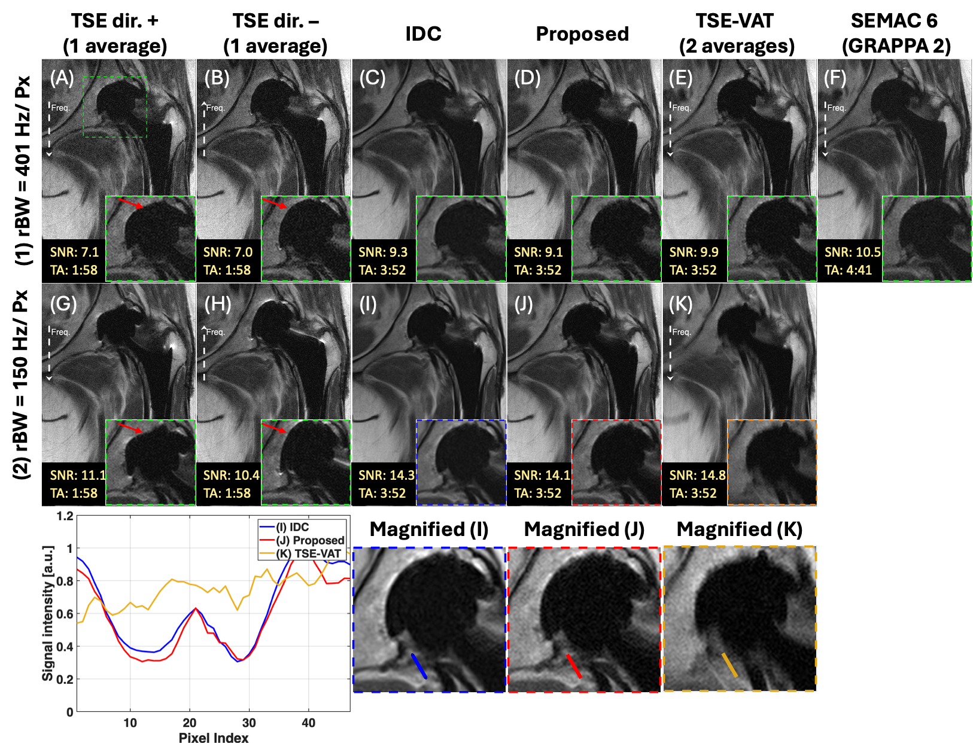
Supplementary Information Figure S1. MR images of a 61-year-old female (BMI of 29kg/m²) of right THA (titanium). aSNR and acquistion times (TA) are indicated in yellow in the lower-left corner. Frequency-encoding direction is labeled by white arrows. Opposite distortions are observed in the TSE acquisition pairs in (A)(B) and (G)(H). The zoomed-in images show that IDC, the proposed method, TSE-VAT and SEMAC correct in-plane distortion near the acetabular cup. (E)(F)(K) Blurring is evident in TSE-VAT and SEMAC at both high and low bandwidths. Line profiles for the 120 Hz/Px case are drawn on small structures to compare signal transitions and smoothness among IDC, the proposed method, and TSE-VAT.

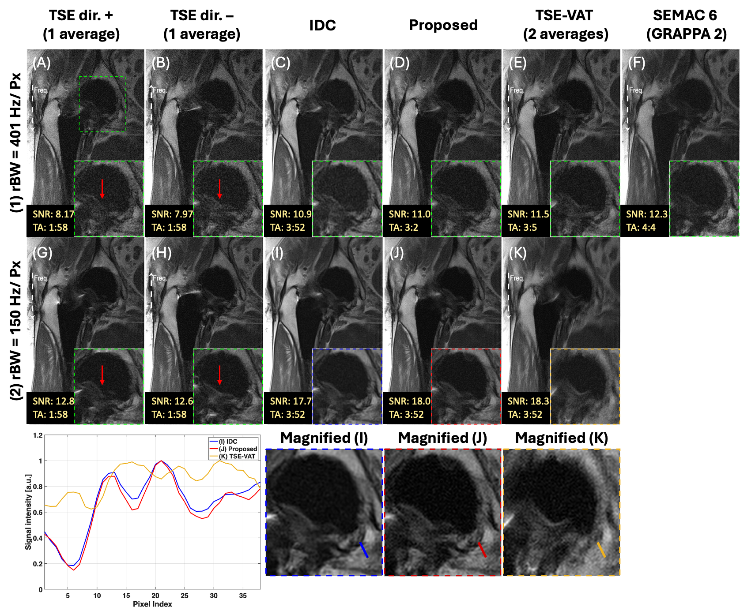
Supplementary Information Figure S2. The post-THA (titanium) subject was imaged at an in-plane resolution of 0.875 mm² (66-year-old male, BMI of 28.1kg/m²). aSNR and acquistion times (TA) are indicated in yellow in the lower-left corner. Frequency-encoding direction is labeled by white arrows. Opposite distortions are observed in the TSE acquisition pairs in (A)(B) and (G)(H). The zoomed-in images show that IDC, the proposed method, TSE-VAT and SEMAC correct in-plane distortion near the acetabular cup. (E)(F)(K) Blurring is evident in TSE-VAT and SEMAC at both high and low bandwidths. Line profiles for the 120 Hz/Px case are drawn on small structures to compare signal transitions and smoothness among IDC, the proposed method, and TSE-VAT.

Supplementary Information Table S1. Detailed imaging parameters for the hip implant phantom, scanned in the coronal plane. Note that the echo times (TE) are 37 ms for sequences with a bandwidth of 200 Hz/Px and 34 ms for those with 401 Hz/Px to obtain PD-weighted images. Scan time, 3:52, is for one bandwidth TSE experiment. RE-TSE is a pair of opposite readout TSE.

Parameter | RE-TSE | TSE-VAT | SEMAC 6
TE | 37 and 34 ms | 37 and 34 ms | 31 ms
TR | 2000 ms | 2000 ms | 2100 ms
Bandwidth | 200 and 401 Hz/Px | 200 and 401 Hz/Px | 401 Hz/Px
Slice thickness | 4 mm | 4 mm | 4 mm
Base resolution | 320 | 320 | 320
FOV read | 280 mm | 280 mm | 280 mm
FOV phase | 100 % | 100 % | 100 %
Slices | 12 | 12 | 12
Average | 1 for each direction | 2 | 1
Turbo Factor | 8 | 8 | 11
Echo Spacing | 9.34/6.86 ms | 9.34/6.86 ms | 7.82 ms
Parallel imaging | N/A | N/A | N/A
Scan time | 3:52 | 3:52 | 6:22

Supplementary Information Table S2. Detailed imaging parameters for THA subjects, scanned in the coronal plane. Note that the echo times (TE) are 33 ms for sequences with a bandwidth of 150 Hz/Px and 34 ms for those with 401 Hz/Px to obtain PD-weighted images. RE-TSE is a pair of opposite readout TSE

Parameter | RE-TSE | TSE-VAT | SEMAC 6
TE | 33 and 34 ms | 33 and 34 ms | 31 ms
TR | 2000 ms | 2000 ms | 2100 ms
Bandwidth | 150 and 401 Hz/Px | 150 and 401 Hz/Px | 401 Hz/Px
Slice thickness | 4 mm | 4 mm | 4 mm
Base resolution | 320 | 320 | 320
FOV read | 280 mm | 280 mm | 280 mm
FOV phase | 81.3 % | 81.3 % | 81.3 %
Slices | 20 | 20 | 20
Average | 1 for each direction | 2 | 1
Turbo Factor | 8 | 8 | 11
Echo Spacing | 11/6.86 | 11/6.86 | 7.82
Parallel imaging | N/A | N/A | GRAPPA-2
Scan time | 3:52 | 3:52 | 4:41

Supplementary Information Table S3. Detailed imaging parameters for in-vivo ACDF subject, scanned in the sagittal plane. Note that the echo times (TE) are 114 ms for sequences with a bandwidth of 120 Hz/Px and 110 ms for those with 401 Hz/Px to acquire T2-weighted images. RE-TSE is a pair of opposite readout TSE.

Parameter | TSE | RE-TSE | TSE-VAT
TE | 114 and 110 ms | 114 ms | 110 ms
TR | 4460 ms | 4460 ms | 4460 ms
Bandwidth | 120 and 401 Hz/Px | 120 Hz/Px | 401 Hz/Px
Slice thickness | 4 mm | 4 mm | 4 mm
Base resolution | 320 | 320 | 320
FOV read | 279 mm | 279 mm | 279 mm
FOV phase | 100 % | 100 % | 100 %
Slices | 19 | 19 | 19
Average | 2 | 1 for each direction | 2
Turbo Factor | 16 | 16 | 16
Echo Spacing | 12.7/7.88 | 12.7/7.88 | 12.7/7.88
Parallel imaging | N/A | N/A | N/A
Scan time | 3:38 | 3:38 | 3:38

