Supplementary Figure 1. A Willow Warbler male from Chaun delta (far left) placed on its back to quantify a colour score by comparing it to stuffed specimens of, from left to right, a typical grey acredula, an intermediate and a typical yellow trochilus.
Supplementary Figure 2. Variance explained by each principal component from a PCA of morphological traits presented in Fig. 1. of the main text.
Supplementary Table 1. Sample size and origin per each data type analysed. Details for feather isotope samples can be found in Bensch et al. (2006).
Supplementary Table 2. Primers and PCR conditions used for genotyping willow warblers in this study. The default PCR mix unless otherwise stated contained 10-50ng DNA , 0.125 mM of each dNTP, 1.5 mM MgCl₂, 0.4 μM of each primer, 0.5 Units of taq Polymerase (AmpliTaq®, Applied Biosystems, Branchburg, NJ, USA). a-touchdown -0.5°C / cycle, b-touchdown -0.7°C / cycle.
Supplementary Table 3. Loadings for each morphological variable of the PCA (Fig. 1 in main text).
Supplementary Table 4. Mean values (SD) of morphometric measurements of all willow warblers taken in Chaun. Sample size here is larger then used in size and morphometric analysis because individuals with some missing measurements were excluded.
Supplementary Table 5. Expected (under HWE) and observed heterozygosity of Clock genotypes in Willow Warblers. P values are estimated using 10 degrees of freedom, calculated as k(k-1)/2 where k is the number of alleles as in Nielsen and Slatkin, (2013).
Supplementary Table 6. Summary statistics of genetic variation in the sequenced loci from the divergent regions on chromosome one and five. * P > 0.05 **P < 0.01. The column Total represents willow warbler as a species, with all samples pooled.

Supplementary Figure 1.
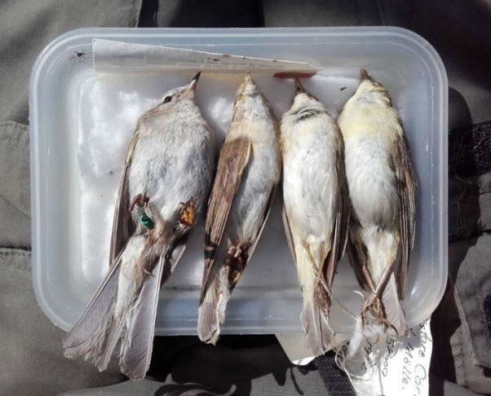

Supplementary Figure 2.
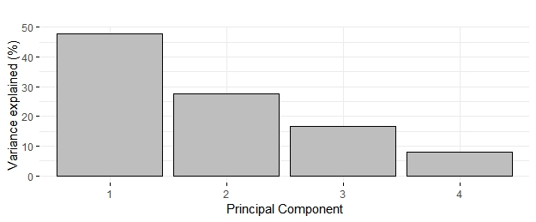

Supplementary Table 1.
Site name | Lat | Lon | Sub-  species | N
 |  |  |  | Morphometrics  PCA  Plumage | Chromosome 1 | Chromosome 3 (AFLP-WW1) | Chromosome 4 (Clock) | Chromosome 5
Kasted_Mose | 56,17 | 10,05 | trochilus | 12 |  |  | 12
Gadevang | 55,83 | 12,47 | trochilus | 11 |  |  | 11
Stensoffa | 55,7 | 13,46 | trochilus | 214 | 8 | 103 |  | 2
Haganäs | 56,25 | 14,67 | trochilus |  |  | 10 |  | 2
Vaxjö | 56,83 | 14,73 | trochilus |  |  | 7
Tåkern | 58,32 | 14,82 | trochilus |  | 2 | 9 | 8 | 2
Smedstorp | 59,58 | 14,98 | trochilus | 49 | 2 | 18 | 6 | 2
Kvismaren | 59,17 | 15,42 | trochilus |  |  | 8
Kalmar | 56,68 | 16,12 | trochilus |  |  | 8
Valdemarsvik | 58,28 | 16,47 | trochilus |  |  | 10 | 10
Gräsmarö | 58,28 | 16,98 | trochilus | 5 |  | 12 |  | 2
Oittila | 60,32 | 23,83 | acredula | 16 |  | 10 | 15
Pesu | 60,97 | 28,15 | acredula | 15 |  | 9 | 15
Rutakoski | 62,17 | 26,52 | acredula | 16 |  | 4
Tjöck | 62,28 | 21,55 | acredula | 16 |  | 3 | 12
Granö | 64,27 | 19,42 | acredula |  |  |  | 8
Kalajoki | 64,3 | 24,05 | acredula | 17 |  | 2 | 14
Klimpfjäll | 65,03 | 14,68 | acredula | 10 |  | 10 |  | 1
Piteå | 65,03 | 21,45 | acredula |  |  | 8
Kaskeluokt | 65,2 | 16,84 | acredula | 15 |  | 15
Gardiken | 65,51 | 15,64 | acredula | 13 |  | 13
Kallax | 65,53 | 22,13 | acredula | 9 |  | 9 | 5 | 2
Rönäs | 65,85 | 14,7 | acredula | 15 |  | 15 | 14
Maula | 65,9 | 24,75 | acredula | 17 |  | 2
Ammarnäs | 65,95 | 16,12 | acredula | 7 |  | 16
Kukkola | 65,96 | 24,03 | acredula |  |  |  |  | 2
Ruka | 66,18 | 29,42 | acredula | 16 |  | 14
Kvikkjokk | 66,9 | 17,83 | acredula |  |  | 10
Gällivare | 67,22 | 20,8 | acredula |  | 2 | 9 |  | 2
Lurio | 67,23 | 27,55 | acredula | 18 |  | 3
Jylkkyvaara | 67,38 | 22,05 | acredula | 13
Altajärvi | 67,83 | 20,53 | acredula |  |  |  | 8
Krokvik | 67,95 | 20,02 | acredula | 15 |  | 14
Kaisepakte | 68,28 | 19,32 | acredula | 22 |  | 6 |  | 2
Stordalen | 68,33 | 19,1 | acredula | 22 | 2 | 5 |  | 2
Tornehamn | 68,43 | 18,58 | acredula | 19 | 2 | 10 | 27 | 2
Tana_Bru | 70,18 | 28,2 | acredula |  |  |  | 13
Kjöllefjord | 70,94 | 27,42 | acredula |  |  |  | 9
Barkö | 60,27 | 18,27 | trochilus |  |  |  |  | 2
Björka | 55,66 | 13,63 | trochilus | 9 |  | 10
Fullerö | 59,55 | 16,55 | trochilus |  |  | 10
Chaun | 68,78 | 170,65 | yakutensis | 34 | 26 | 36 | 36 | 16
Sum: total  trochilus  acredula  yakutensis |  |  |  | 625 | 44 | 460 | 223 | 43
 |  |  |  | 300 | 14 | 212 | 47 | 12
 |  |  |  | 291 | 6 | 212 | 140 | 15
 |  |  |  | 34 | 29 | 36 | 36 | 16

Marker | Method | Primers/Enzyme | PCR prog. | Reaction details | Reference
Chrom 1 | PCR-Sanger | F 5'-CCCTCCCAGAAAGAAATCATATCA-3' | 95°C-3 m, 12x (94°C-30 s, 63°Cª-30 s, 72°C-30 s), 28x (94°C-30 s, 57°C-30 s, 72°C-30 s), 72°C-10 m, hold -4°C | Vol 25μl. | Liedvogel et al., 2014
Chrom 1 | PCR-Sanger | R 5'-TAGCAGCTGCAGCACATCATGAA-3' |  | Vol 25μl. | Liedvogel et al., 2014
Chrom 3 | PCR-RFLP | F 5′- TCCCATGTCTTTCAAACAGCT-3′ | 94°C-2 m, 35 x (94°C -30 s, 53°C-30 s, 72°C-30 s), 72°C-10 m | Vol 10 μl, 0.8 units of AmpliTaq® Polymerase.  Vol 10 μl. 1.5 μl of Tango buffer, 0.25 μl of DraI.  Vol 25 μl. | Bensch et al., 2002
Chrom 3 | PCR-RFLP | R1 5′- GCCTTAAATTTATGGCACAGA-3′ | 94°C-2 m, 35 x (94°C -30 s, 53°C-30 s, 72°C-30 s), 72°C-10 m |  | Bensch et al., 2002
Chrom 3 | PCR-RFLP | Restriction enzyme DraI | 94°C-2 m, 12x(94°C-30 s, 65°C^{b}-30 s, 72°C-30 s), 23x(94°C-30 s, 56°C-30 s, 72°C-30 s), 72°C-10 m |  | Bensch et al., 2002
Chrom 3 | PCR-RFLP | R2 5'-CATAAAGTTATCTTCTGTGTTTAAA-3' |  |  | Bensch et al., 2002
Chrom 4  (Clock) | PCR- length polymorphism = polyQ repeats | F 5′-TGGAGCGGTAATGGTACCAAGTA-3′ (6-FAM) | 92°C-2 m, 25x (92°C-30 s, 53°C-30 s, 72°C-30 s), 72°C-30 s, hold - 4°C | Vol 10 μl. 0.2 mM of each dNTP, 0.5 μM of each primer, 0.6 mM MgCl₂ | Johnsen et al., 2007
Chrom 4  (Clock) | PCR- length polymorphism = polyQ repeats | R 5′ TCAGCTGTGACTGAGCTGGCT 3′ |  |  | Johnsen et al., 2007
Chrom 5 | PCR-Sanger | F 5'-TCCTGTGGCTGTTGCCTCTC-3' | 95°C-3 m, 12x (94°C-30 s, 63°Cª-30 s, 72°C-30 s), 28x (94°C-30 s, 57°C-30 s, 72°C-30 s), 72°C -10 m, hold - 4°C | Vol 25 μl. | Liedvogel et al., 2014
Chrom 5 | PCR-Sanger | R 5'-CCAATATCTGATGTAGACCTGTGC-3' |  | Vol 25 μl. | Liedvogel et al., 2014
Supplementary Table 2.

Supplementary Table 3.

 | PC1 | PC2 | PC3 | PC4
Wing | 0.855427 | -0.31181 | -0.05826 | 0.40942
Tail | 0.795341 | -0.46267 | -0.0533 | -0.38798
Tarsus | 0.463507 | 0.695524 | -0.54708 | -0.04599
Bill and Head | 0.565551 | 0.552261 | 0.611446 | -0.03596

Supplementary Table 4.
 | Wing (mm) | Tail (mm) | Tarsus (mm) | Bill-head (mm) | Mass (g)
Males  (n = 39) | 72.16 (1.64) | 54.96 (1.72) | 22.19 (0.53) | 27.89 (0.51) | 10.08 (0.63)
Females  (n = 10) | 66.99 (1.14) | 51.44 (1.65) | 21.17 (0.37) | 27.56 (0.57) | 9.38 (1.03)

Supplementary Table 5.
 | trochilus  (n = 47) | acredula  (n = 140) | yakutensis  (n = 36)
Heterozygosity observed | 0.30 | 0.33 | 0.19
Heterozygosity expected | 0.35 | 0.36 | 0.38
χ² | 0.40 | 0.69 | 0.99
P | >0.05 | >0.05 | >0.05

Supplementary Table 6.
Chrom 1 | trochilus  (n = 28) | acredula  (n = 12) | yakutensis  (n = 58) | Total  (n =98)
Tajima's D | -0.650* | -1.179* | -2.193** | -1.514*
π | 0.0083 | 0.0055 | 0.0044 | 0.0071
Chrom 5 | trochilus  (n = 24) | acredula  (n = 15) | Yakutensis  (n = 32) | Total  (n = 71)
Tajima's D | -1.476* | -0.890* | -0.651* | -0.439*
π | 0.0044 | 0.0086 | 0.0053 | 0.0112

References
Bensch S, Åkesson S, Irwin DE (2002) The use of AFLP to find an informative SNP Genetic differences across a migratory divide in willow warbler. Molecular Ecology 11:2359–2366
Bensch S, Irwin DE, Irwin JH, Kvist L, Åkesson S (2006) Conflicting patterns of mitochondrial and nuclear DNA diversity in Phylloscopus warblers. Molecular Ecology 15:161–171
Johnsen A, Fidler AE, Kuhn S, Carter KL, Hoffmann A, Barr IR, Biard C, Charmantier A, Eens M, Korsten P, Siitari H, Tomiuk J, Kempenaers B (2007) Avian Clock gene polymorphism: Evidence for a latitudinal cline in allele frequencies. Molecular Ecology 16:4867–4880
Liedvogel M, Larson KW, Lundberg M, Gursoy A, Wassenaar LI, Hobson KA, Bensch S, Åkesson S (2014) No evidence for assortative mating within a willow warbler migratory divide. Frontiers in zoology 11:1–9
Nielsen R, Slatkin M (2013) An introduction to population genetics. Sinauer Associates, Sunderland

